**Create a repl.it teacher account**

1. To create a repl.it account to use with Python, navigate to <https://repl.it/>.
2. Create an account by clicking the "Sign Up" in the upper right corner:  
     
   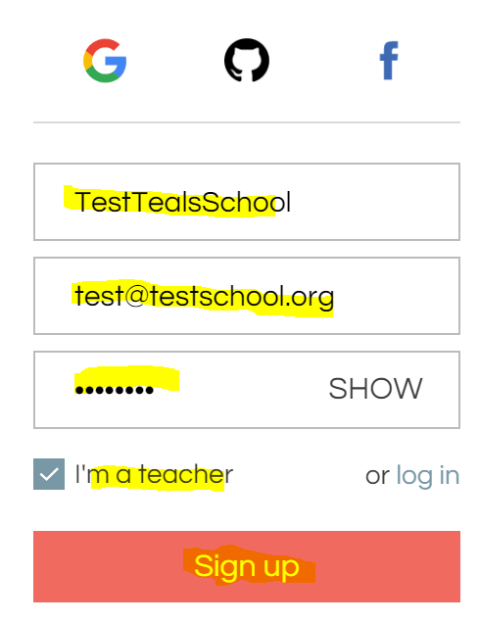
3. Enter your information for the account by filling out the "username", "email", "password", select "I'm a teacher" and click "Sign up".  
     
   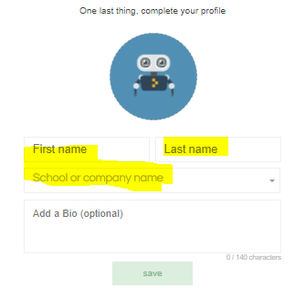
4. Enter "First name", "Last Name", and a new "School or company name" for your class(es) (i.e. '[School]-TEALS [Class]). Press enter key in "School or company name" to create new school. Your students will search for the "School or company name" when they create their accounts.  
     
   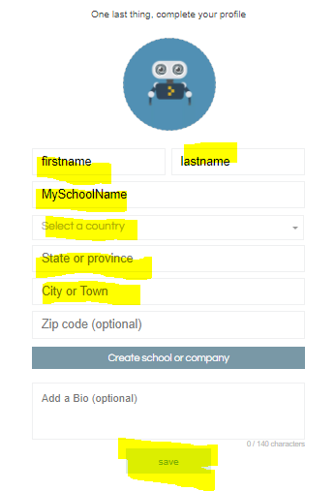
5. Enter "Select a country", "State or province", "City or Town" and click "save".  
     
   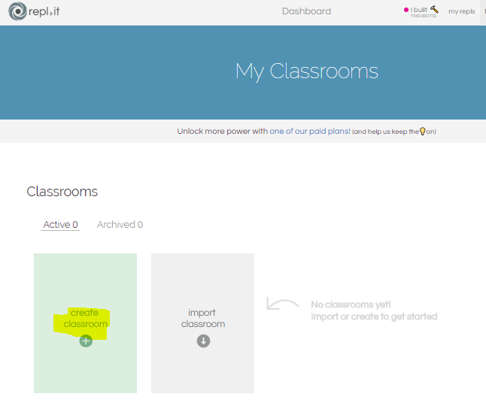
6. Click "create classroom".  
     
   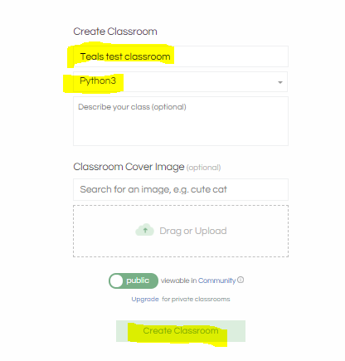
7. From the Classroom page, you can create assignments and invite students.  
     
   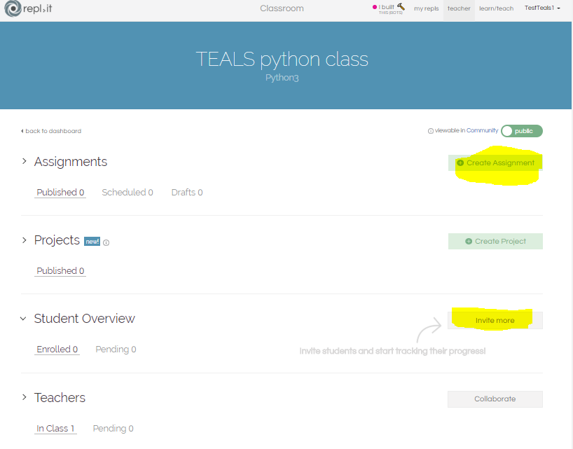
8. Classroom teacher should sign up for a Classroom K-12 account by following the instructions on: <https://repl.it/k12-form>   
     
   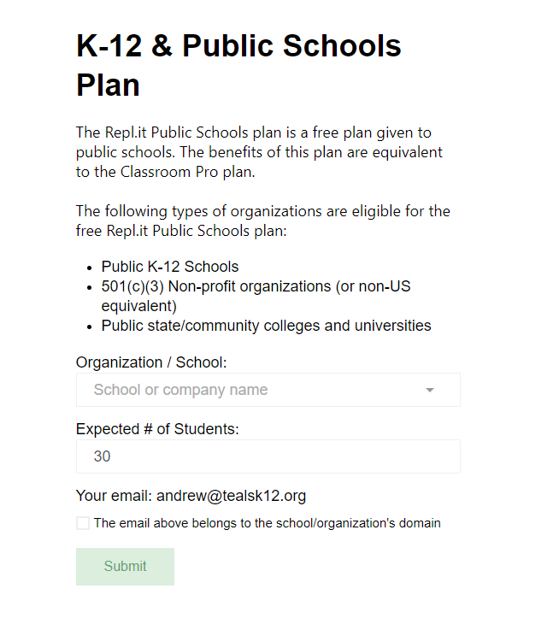
9. After being approved for a K-12 Plan, you will be able to collaborate with your TEALS volunteers in the classes you create. Click "Collaborate" to invite your volunteers to the class:  
     
   