# Lab 3.01 - Magic 8-Ball

Practice importing random** — Use randint with different arguments. Simulate a dice roll, printing out to the user what number they rolled.

Look at the [documentation](https://docs.python.org/3/library/random.html) of the random library — Experiment with another function (not randint) that returns a value.

## Create a program that simulates a [magic 8-ball](https://en.wikipedia.org/wiki/Magic_8-Ball)

1. Store all of the 8-ball’s possible responses (shown below) in a list
2. Have the program prompt the user to ask the magic 8-ball a question
3. then return and print a random response.

### Magic 8-Ball Response Examples

* Outlook is good
* Ask again later
* Yes
* No
* Most likely no
* Most likely yes
* Maybe
* Outlook is not good

## Video Explanation

[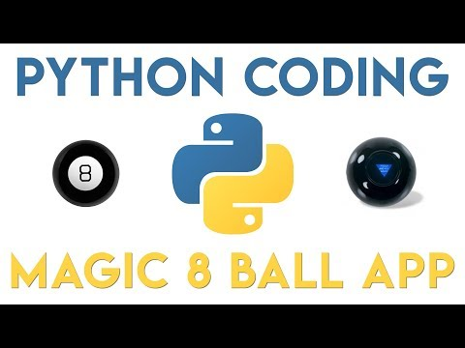](https://www.youtube.com/watch?v=gMSPH1Cnwwo)

## Bonus

Research the math library and create a program that finds the length of the hypotenuse of a right triangle given two sides.