# Lab 4.01 - de_vowel

## Remove the Vowels

Create a function, de_vowel, which will take a string as input and return a copy of that string with all the vowels removed. Otherwise, the string should be the same.

1. Create the function contract for de_vowel.
2. Write de_vowel using a for loop
3. Provide a few examples that confirm de_vowel works as expected:
   * What if the string is all vowels?
   * What if there are no vowels?
   * What if there is a mix of vowels and non-vowels and spaces?

### Example

Example of the file:

# contract goes here  
def de_vowel(a_string):  
 # your code goes here  
no_vowels = de_vowel("This sentence has no vowels")  
print(no_vowels)  
 # examples go here

Example output:

>>> python3 de_vowel_lab.py  
Ths sntnc hs n vwls

### Bonus

Use a counter (variable you define outside of a loop to keep track of a value inside a loop) to create a function count_vowels.

count_vowels takes in a string and returns an int representing the number of vowels in the string.

## SNAP Challenge – 10 Cats Drinking Milk from a Saucer

Create the following program in Python.

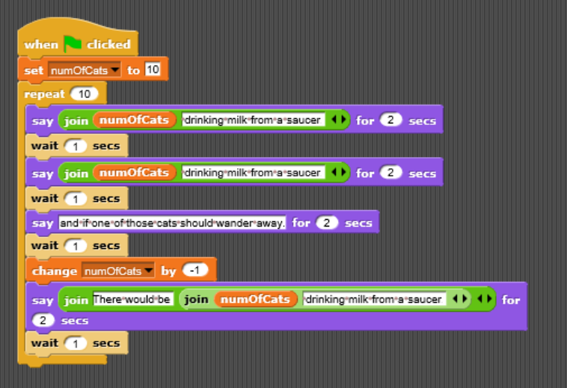

Number of Cats