**Trinket.io Connect teacher account**

**Creating a Course and inviting volunteers and students**

1. Navigate to Trinket login screen: <https://trinket.io/login> and sign in with the email address provided to TEALS, the password will be sent to the email address on record. If you already have a trinket.io account, the password will remain unchanged.

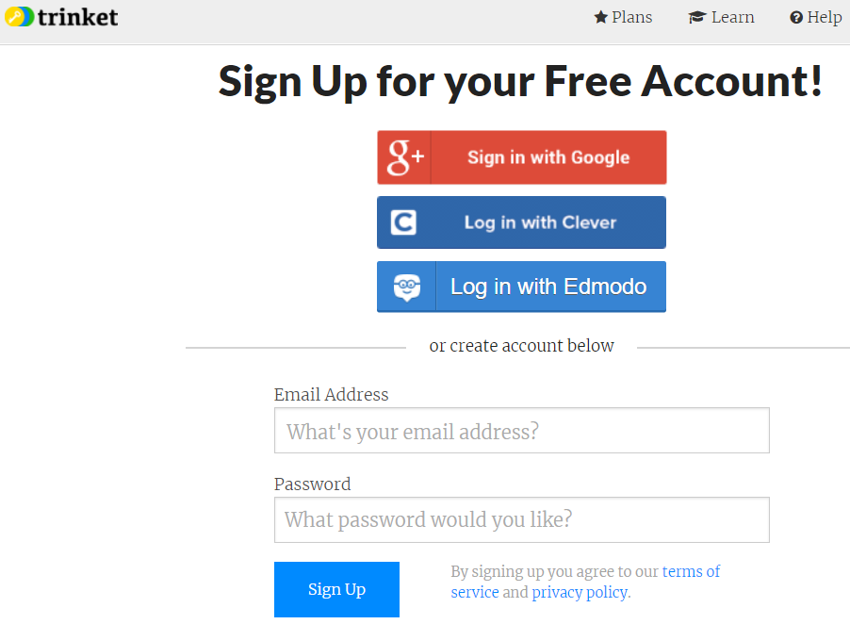

1. Verify you have a trinket.io Connect account. The Connect icon should be visible in the upper left corner next to the trinket logo. If you have a "Code" account, contact your Regional Manager.

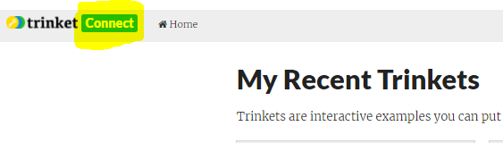

1. To create a course, navigate to your home screen <https://trinket.io/home> and click "New Course"

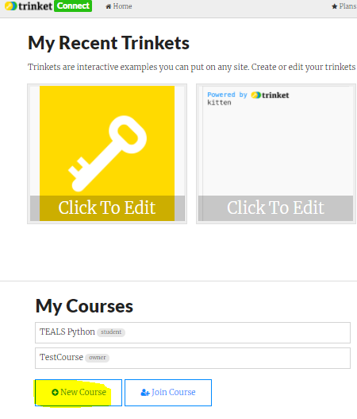

1. Enter "What's the Course Name?", description, "Private", and click "Save"

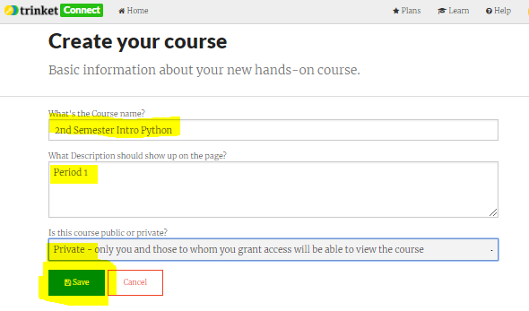

1. To add volunteers and users, from the 2nd menu bar click "Users", and then "Add Users"

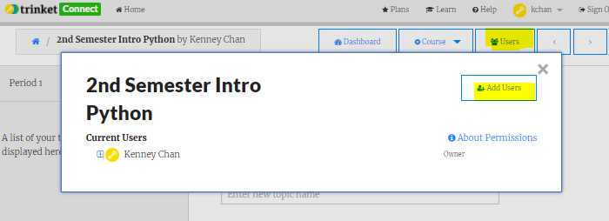

1. In the pop up window click select "Email Invitations" and past a list of volunteer and student email addresses in the list box and click "Send Invitations".

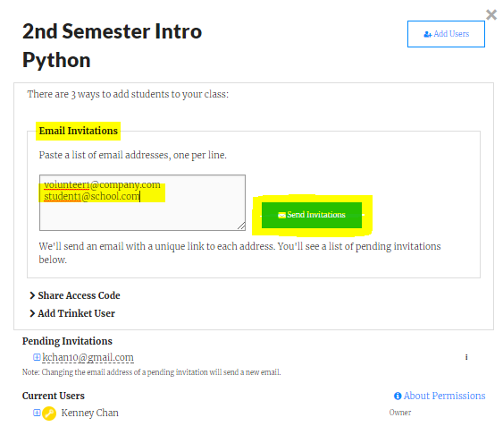

1. Volunteers and students will receive an email invitation to the course. They will be required to create an account. See Trinket_Student.docx for student instructions.
2. To grant admin privileges to your volunteers so they can manage course content, click "Users" on the 2nd row menu, drop down arrow next to volunteer name, "Admin"  
     
   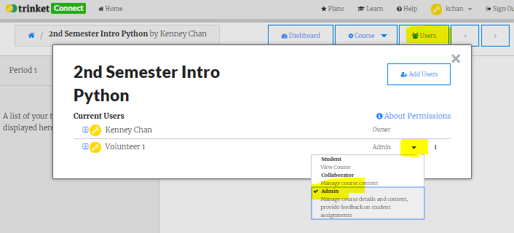
3. Add topics to your course by entering the topic name followed by the Enter key or clicking the "+Topic" button on the lower left corner.  
   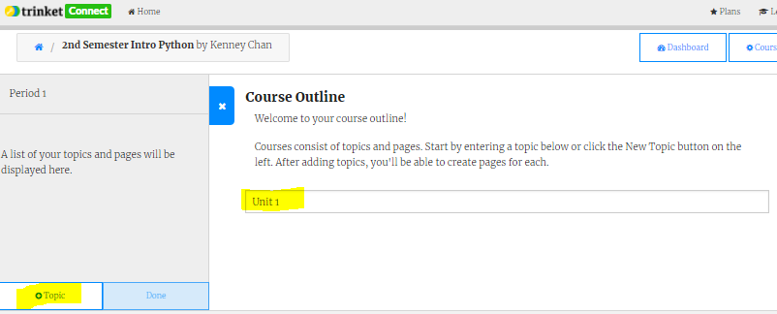

**Adding and Viewing Assignments**  
**All student work should be performed in Python 3 trinkets. This ensures strict Python 3 evaluation for accurate Python error messages.**

1. Add an Python 3 Assignment by clicking the "+Assignment", enter the "Assignment name", click the "or add a blank trinket", click "Python3"  
   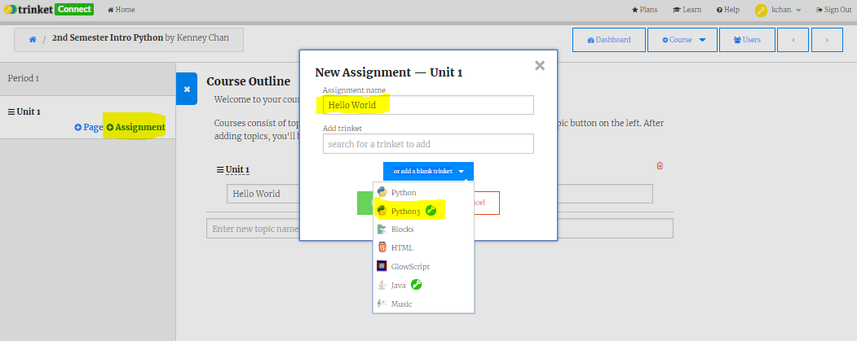
2. Click "Add Assignment" on popup  
   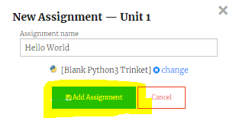
3. Add instructions by clicking the triple dots "…" next to the assignment and selecting "Edit Assignment"  
   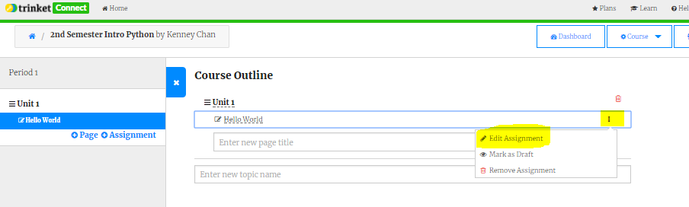
4. Enter the instructions for the assignment  
   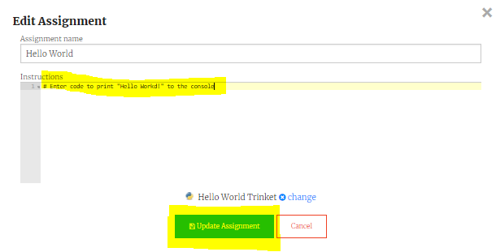
5. View student submissions by selecting the "Dashboard" in the 2nd row menu:  
   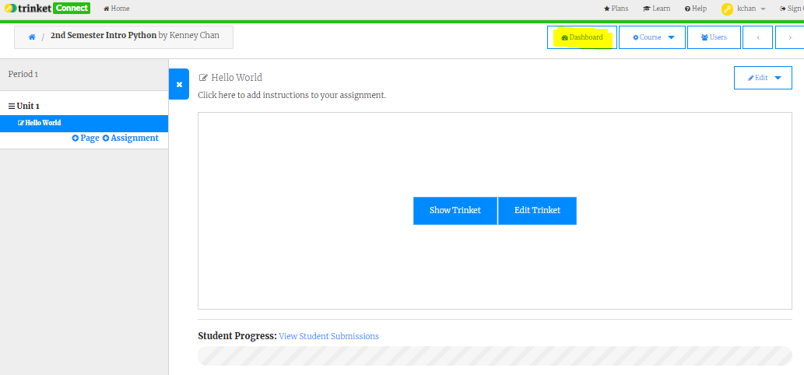
6. Click the student  
   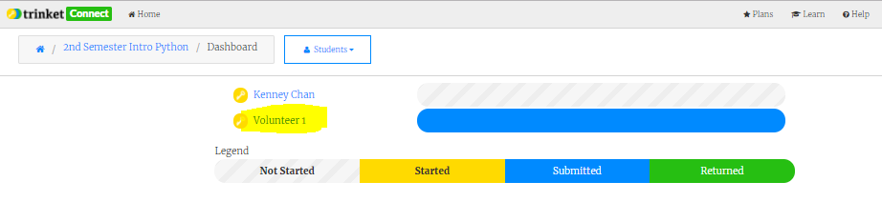
7. Click the assignment  
   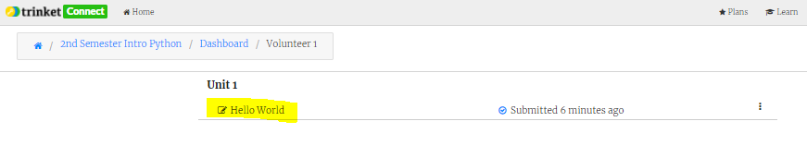
8. Run program, give feedback and grade, click "Send Feedback"  
   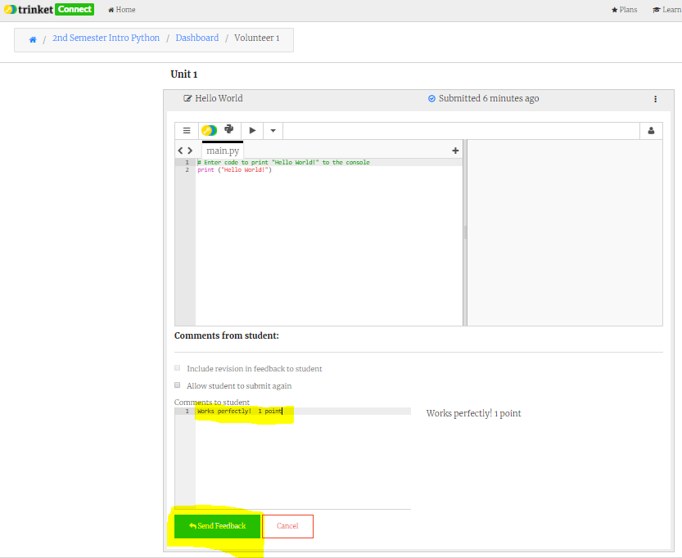
9. Teachers, volunteers and students can create Python 3 programs outside of assignments by navigating to their home page: <https://trinket.io/home>, clicking "New Trinket", and selecting "Python3"  
   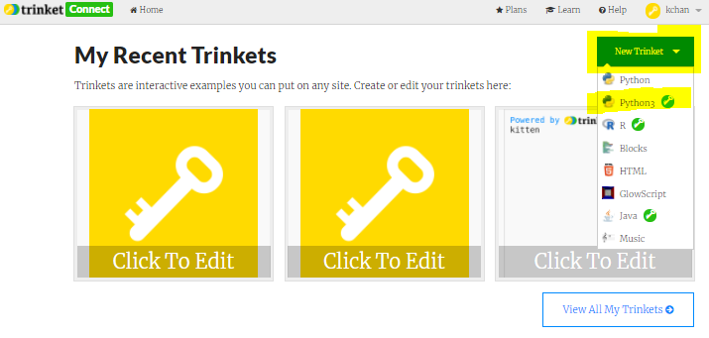
10. To share content, name the trinket, click "Share", and select "Link"  
    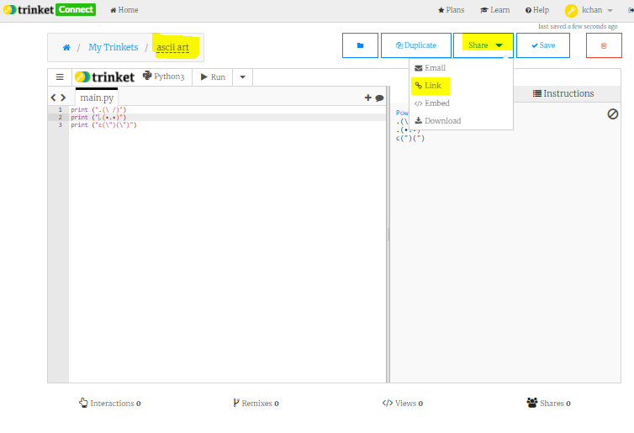
11. Click the "Copy the link or click a button above to share your code" to copy the link using your operating system copy command  
    