https://www.baeldung.com/java-collections-complexity (for collections perf project)

Creating a Maven project:
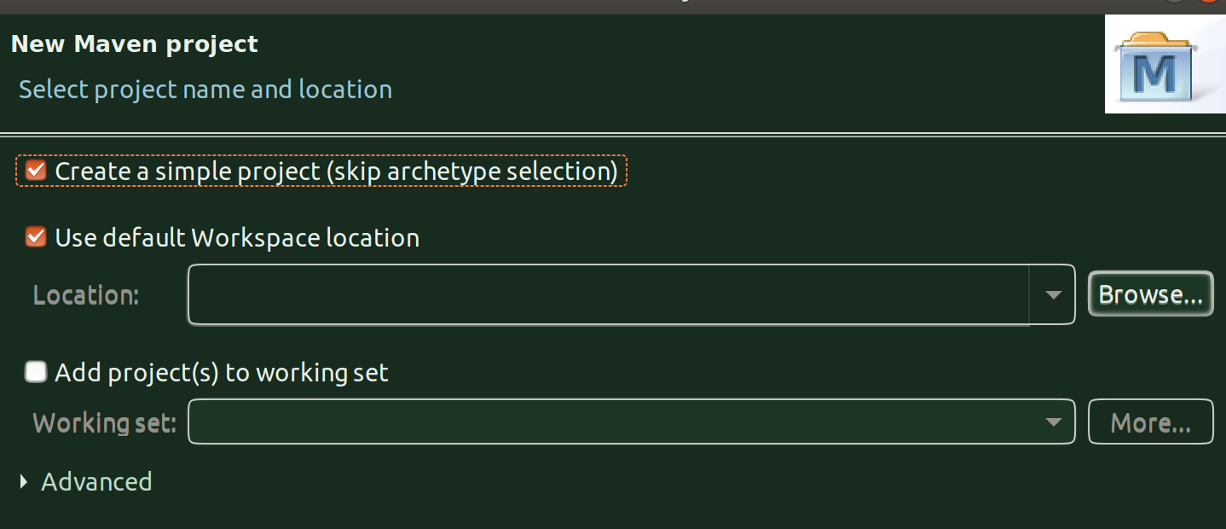

Maven project because we are going to use OpenJDK’s JMH for mcirobenchmarking for which we need to fetch it’s libraries and manage dependencies using maven, hence Maven.

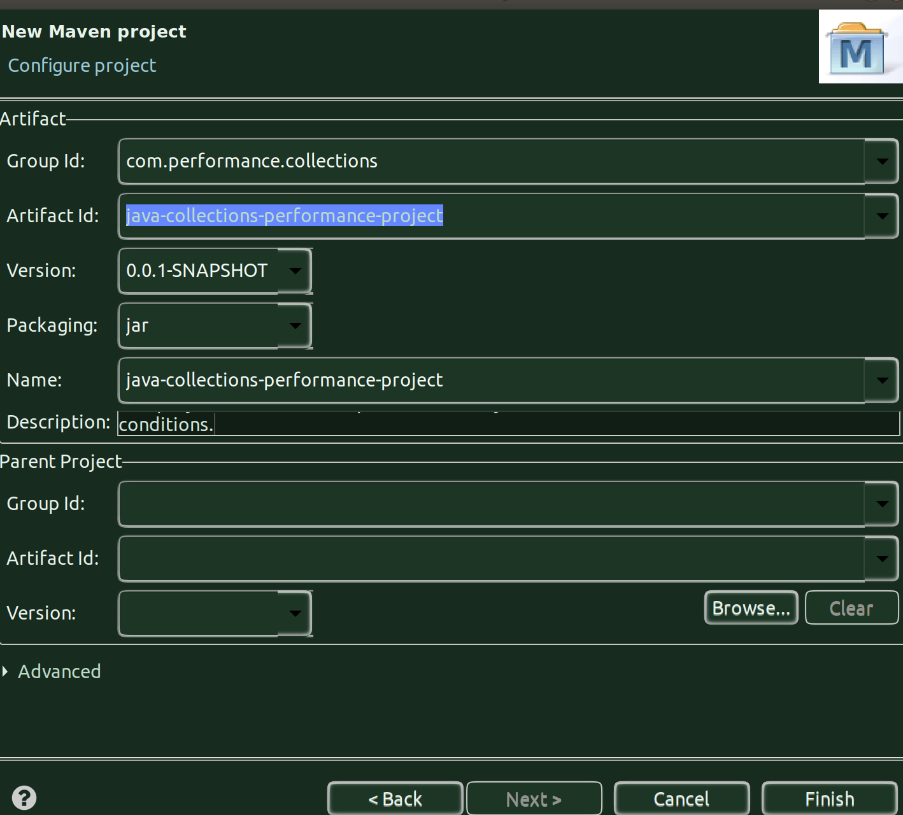
Click Finish.

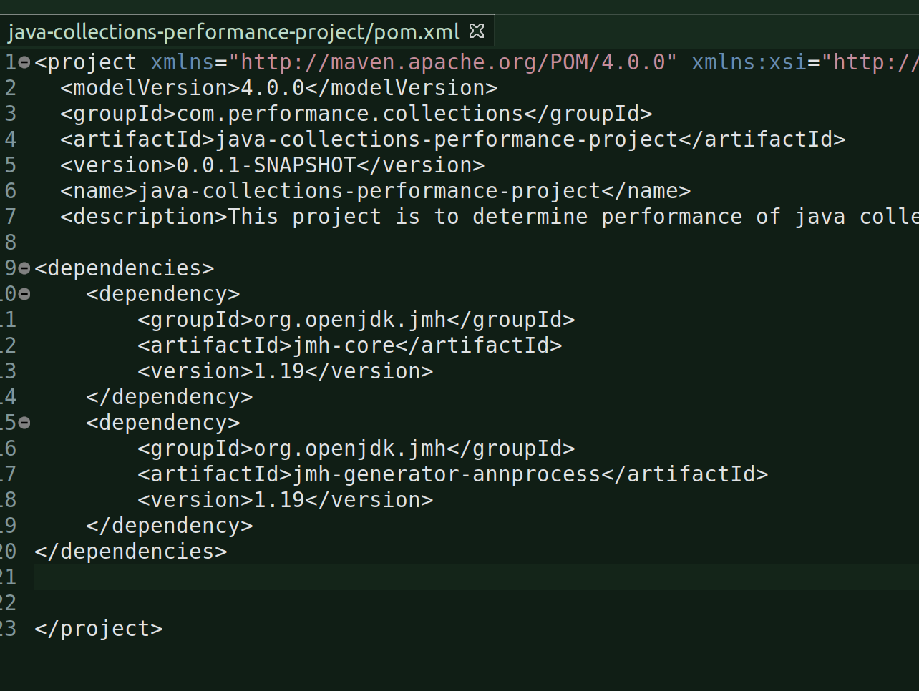
POM.xml modifications:

A clean > build from eclipse will not do anything because of some issue with jmh and eclipse-maven and hence you will need to do a mvn clean install from linux terminal:

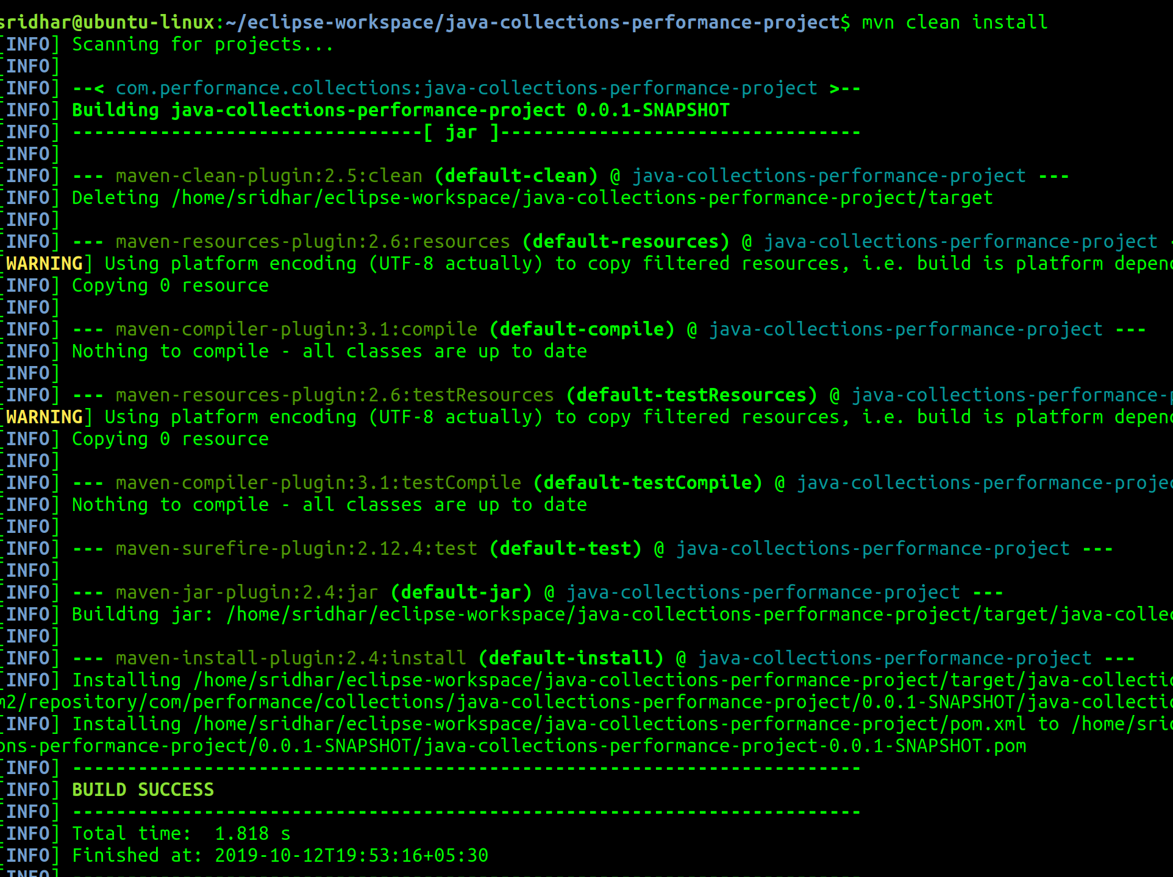
Once the build is successful, go and check your eclipse project folder:
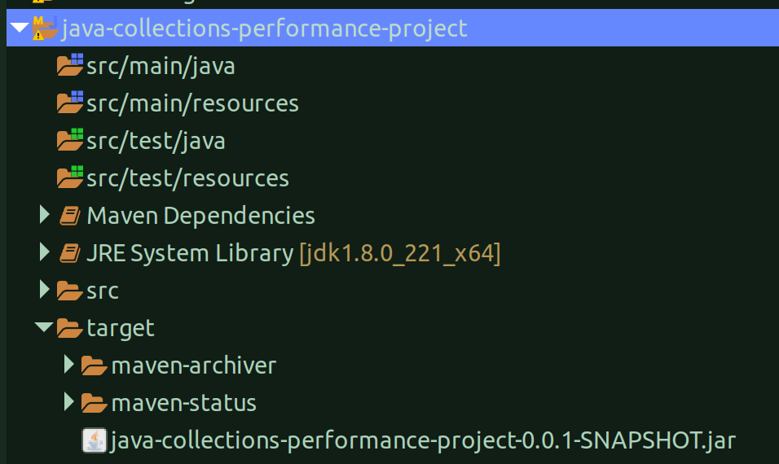
There you go, you see the jar? That is the jar that will be executed by jmh main (Runner) class.

Create an Employee class:
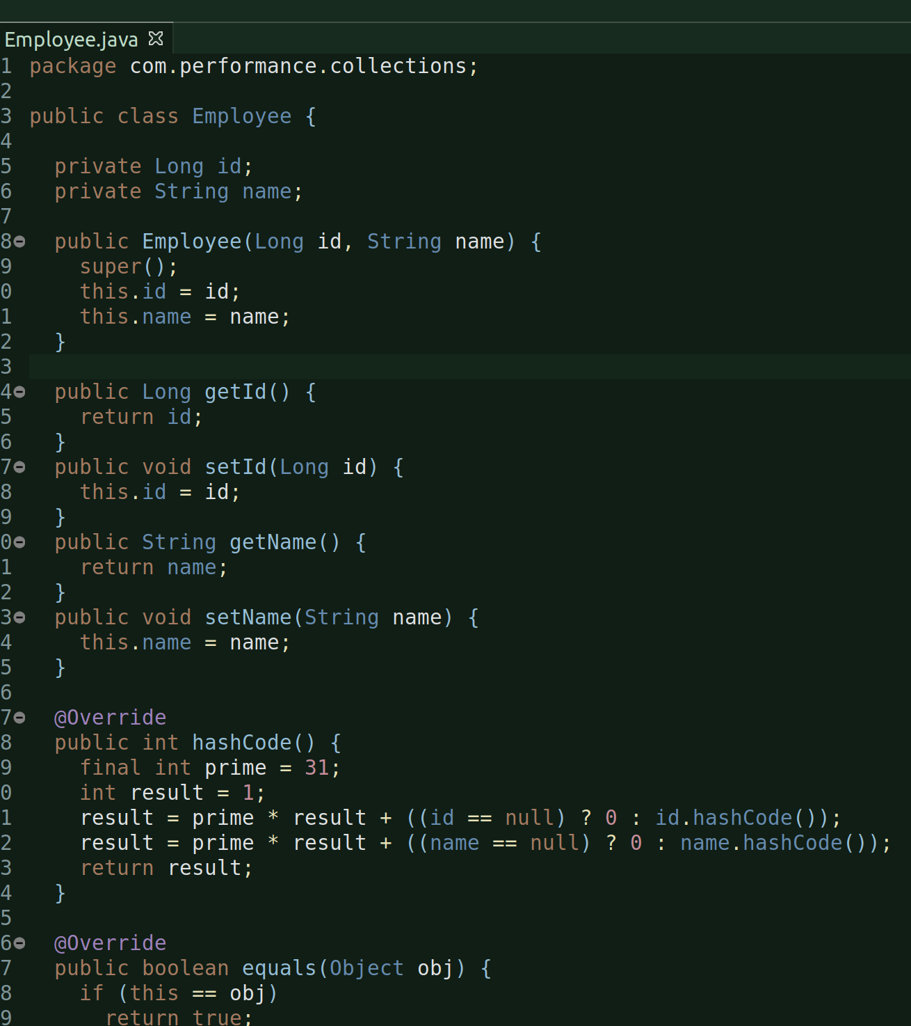

Basically with id and name and their corresponding getters, setters, hashCode and equals methods and a constructor.

List Performance:

Create a ListPerformance class:

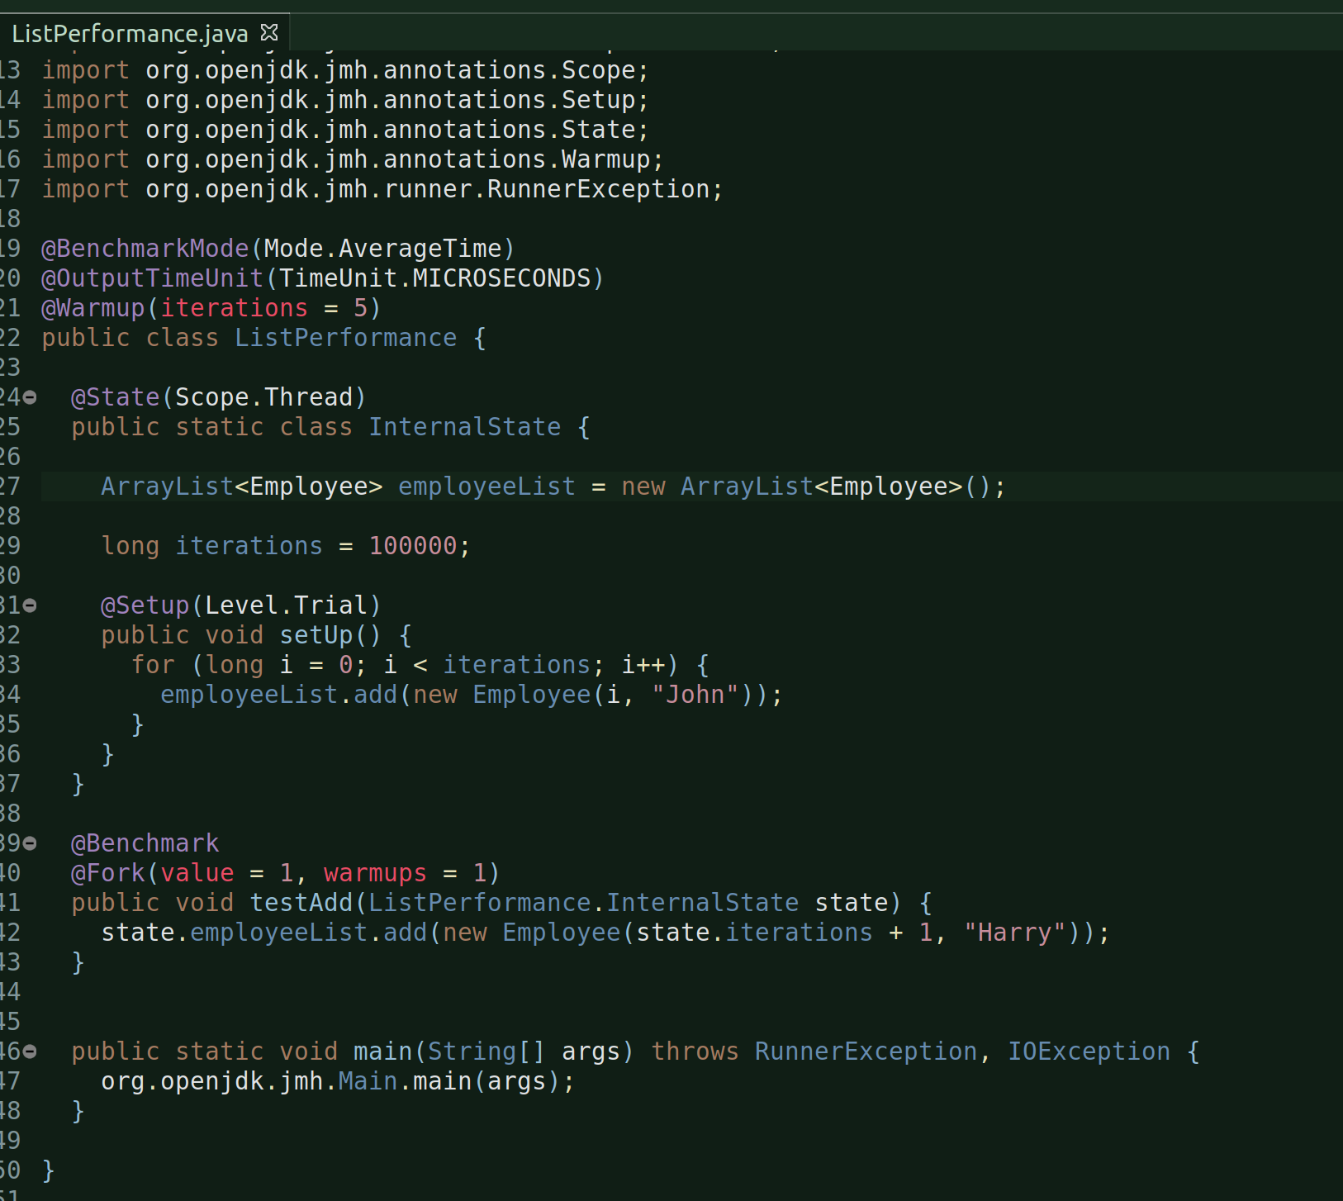

And, the during the run there was an OutofMemoryError:
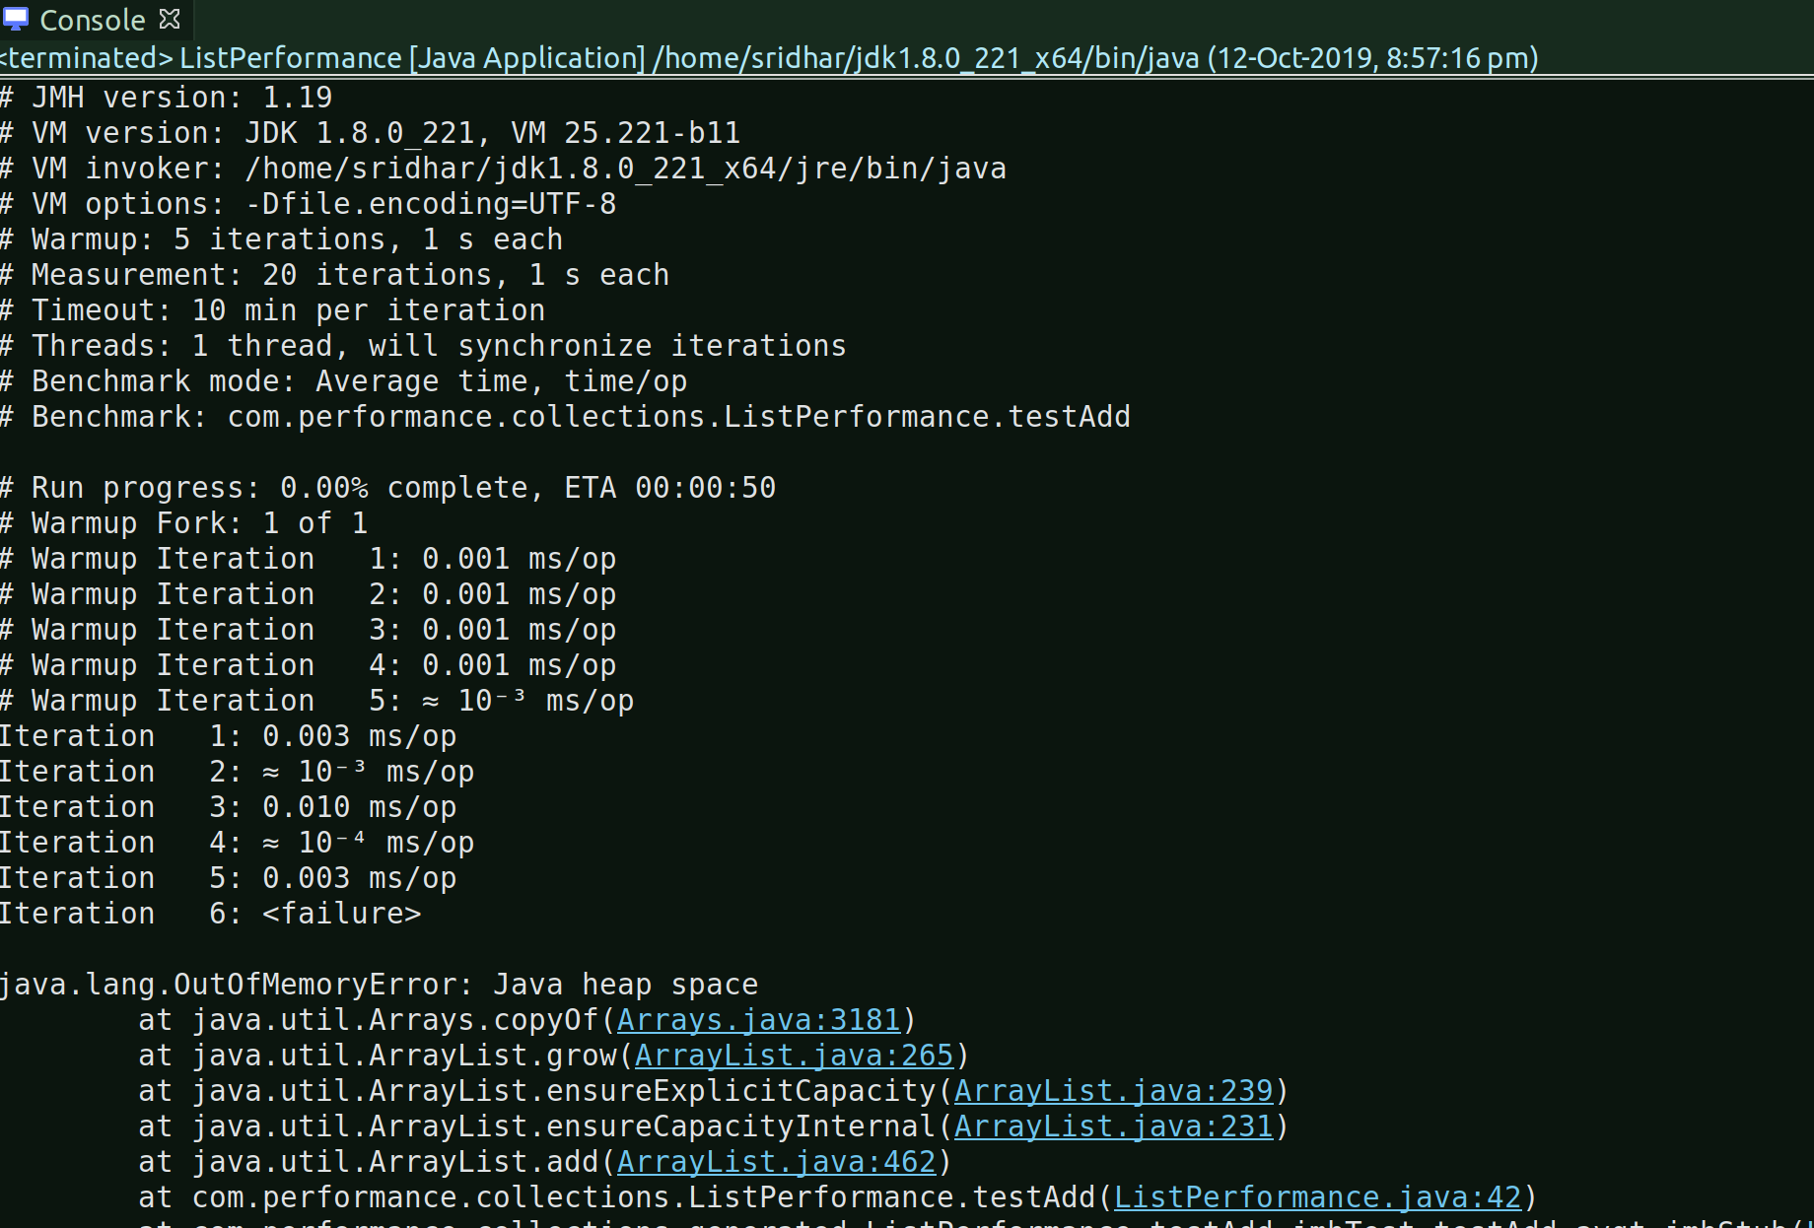
This happened just after warmup benchmark run at Iteration 6. It had completed 5 warump iterations though and then normal Iteration process started and it ran OutOfMemoryError.

VM Argument to generate heap dump when the error occurs:
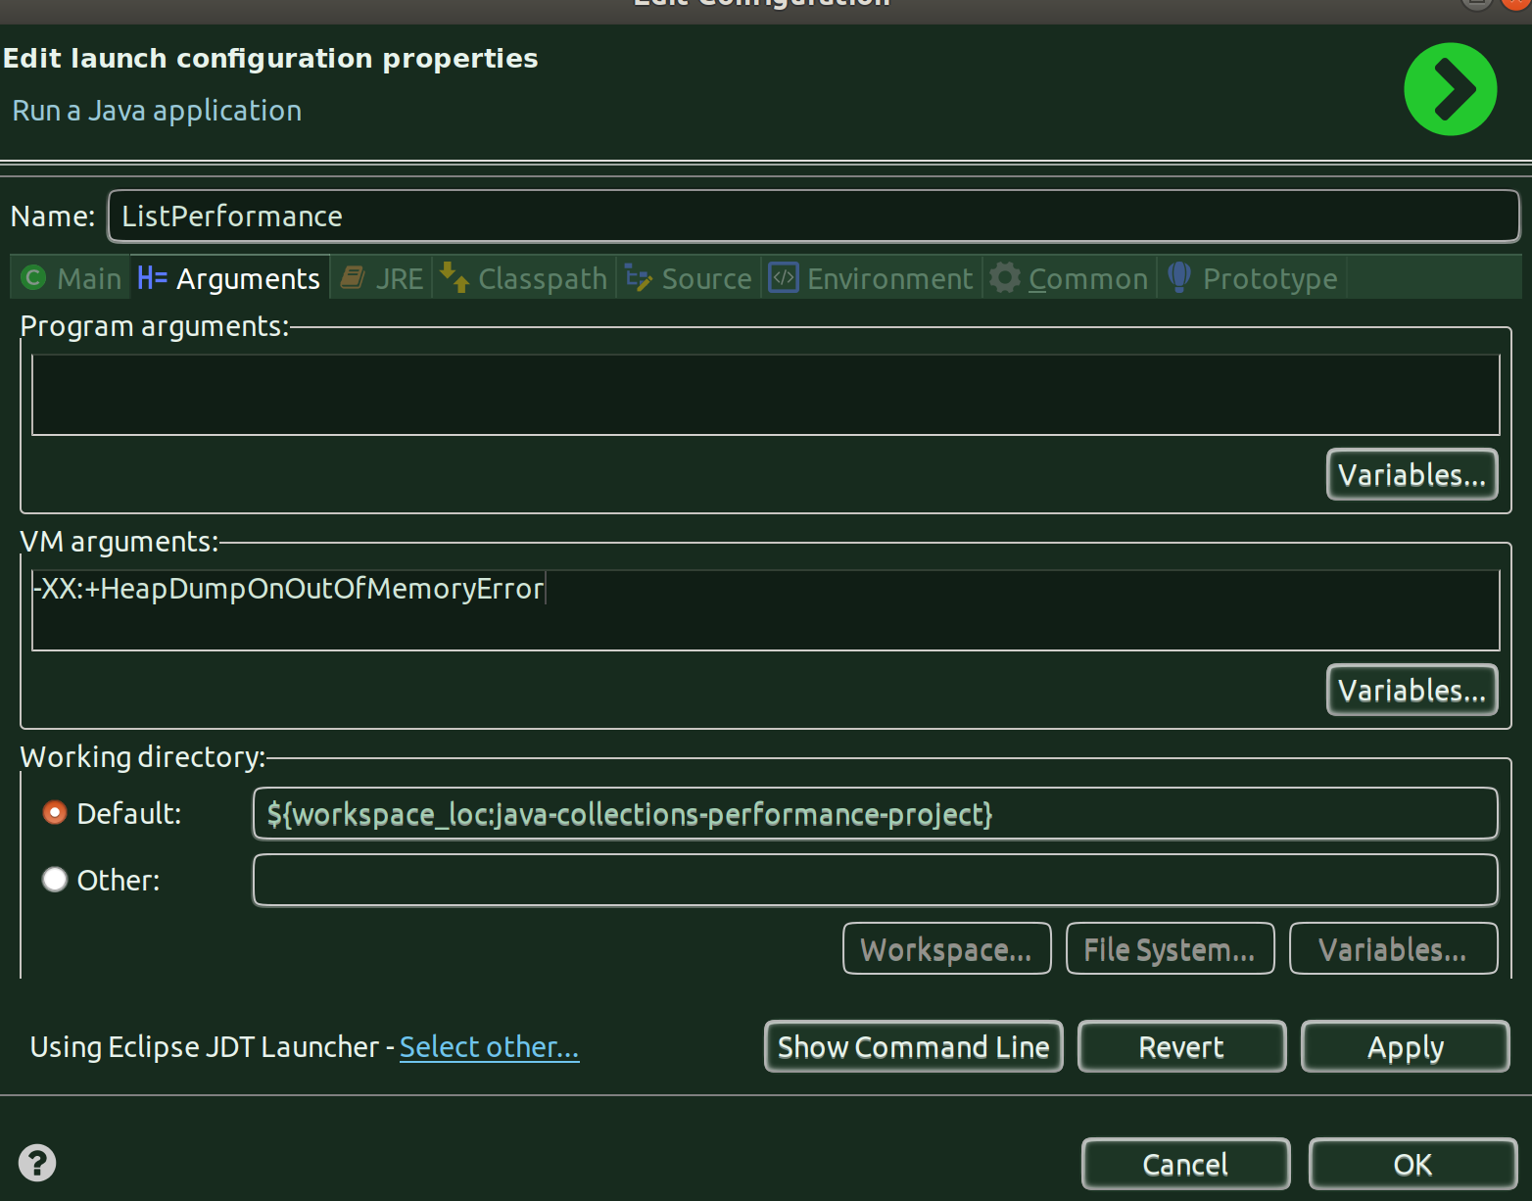

mvn clean install:
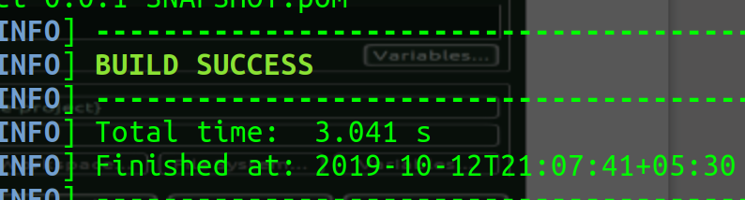
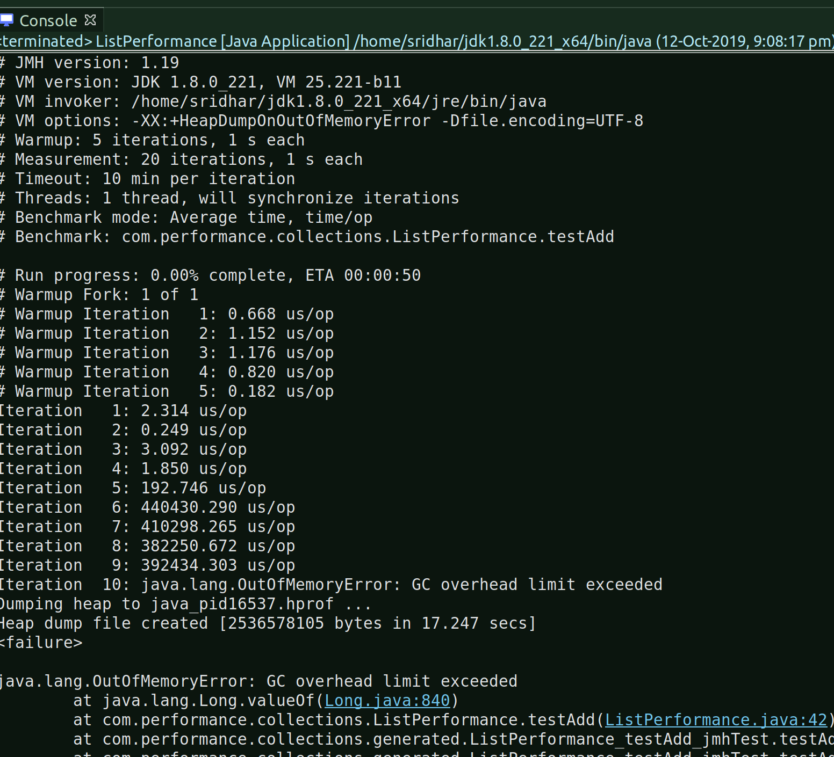
Running the program again:

Failed again but this time at 10th Iteration and the heap dump is also generated.

And, all this while look at the cpu consumption by the java process:
The only change this time around from the previous run was the @OutputTimeUnit configuration, I configured this time it to Microseconds, previously it was Milliseconds.
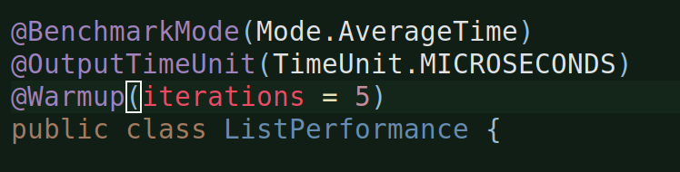

Let’s analyze the heap dump (2.5 GB) file from Eclipse MAT:
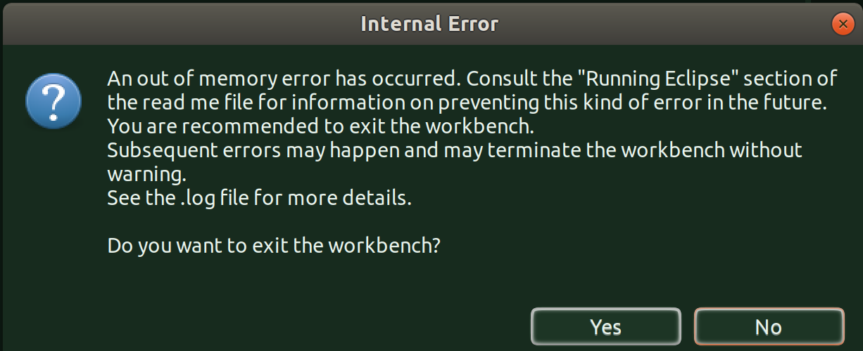

Okay, let’s try and analyze the dump with visualvm:

Running the program in debug mode to enable visualvm to be launched since in my eclipse i’ve configured visvualvm to be launched only during debug ops.

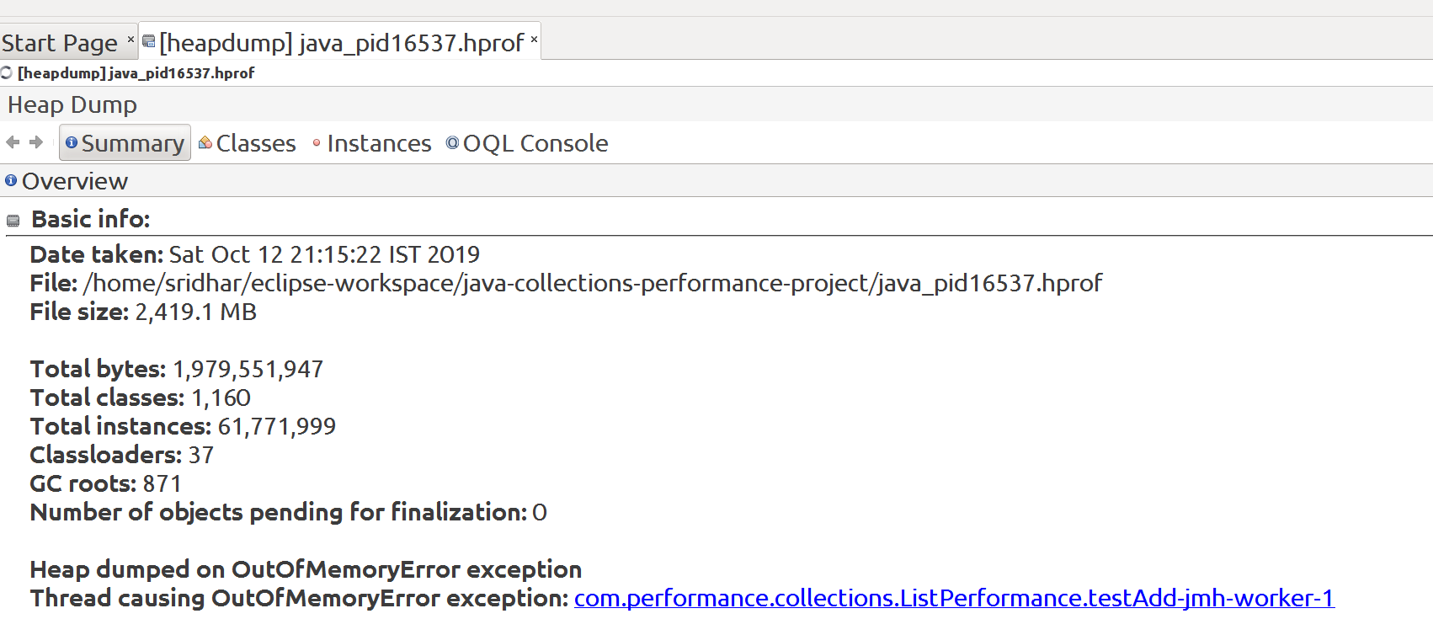

Classes View:
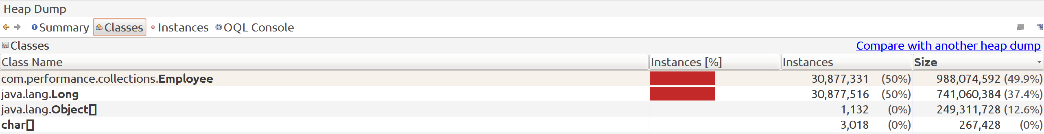

Going into instance view for Employee object:
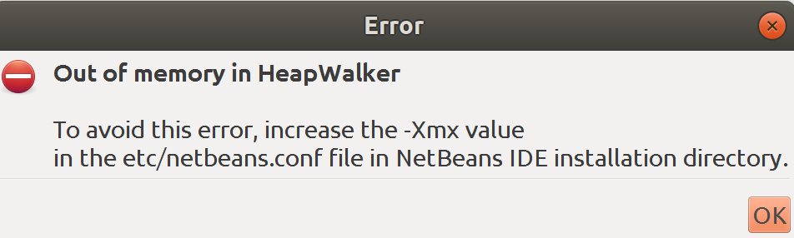

In visualvm folder, in it, under etc there is a visual.conf file:

modified the Xmx value from 256m to 512m.

Now, close visualvm, run the program from eclipse in debug mode again and let visualvm launch and open the file and go to classes view and ask it to show instances for Employee instances and:
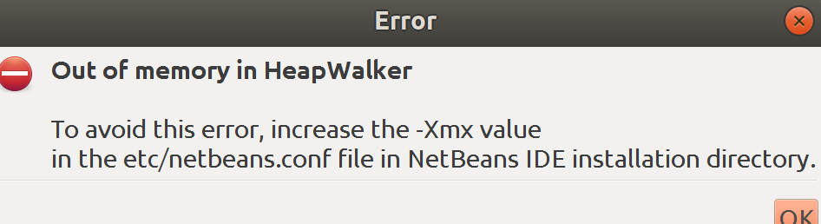
Now, incrementing the -Xmx value 2048 MB, let’s see:
No use visualvm is crashing out.

Reverting the value back to 256m.

Made some changes to the main() method of the class:
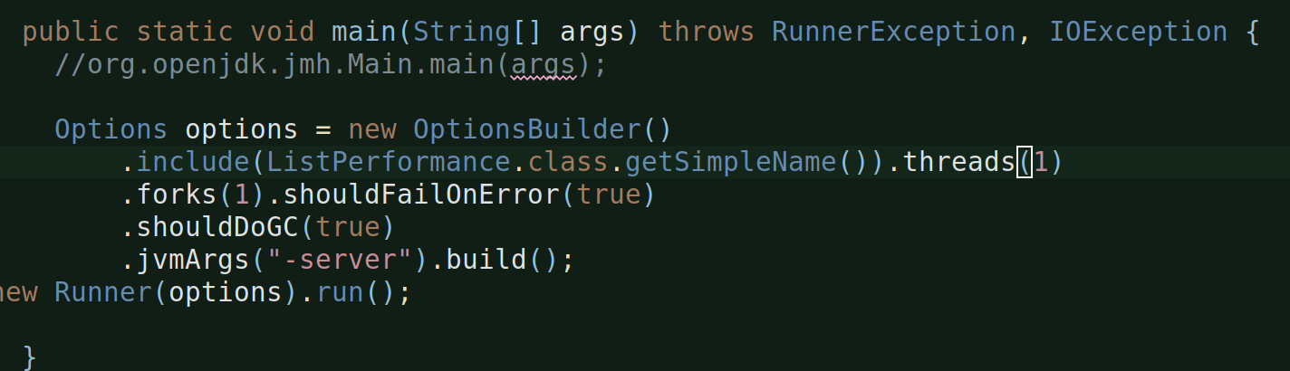

mvn clean install -> build successful -> go to eclipse -> run the program:
Failed again with OutOfMemoryError.

Made two changes in InternalState static inner class:
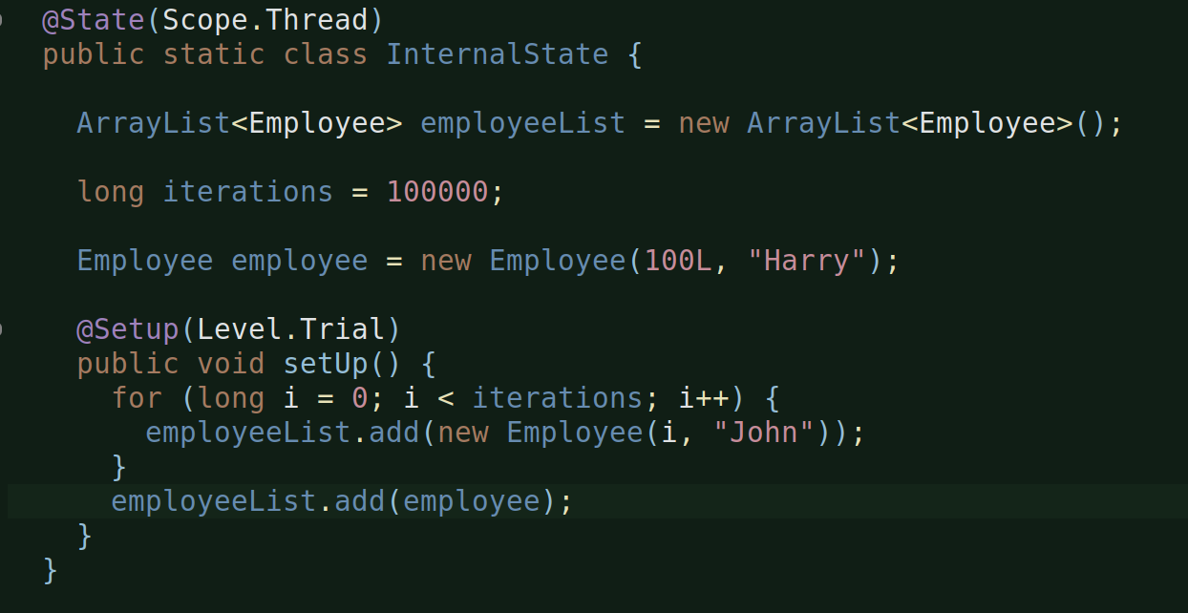
Created an employee instance and adding that in setUp() to the list i.e. after the iterative for loop.

Mvn clean install -> eclipse run program:
Same result, outoutmemory. 1 warmup benchmark completed with 5 warmup iterations and 20 iterations. Benchmark execution then began and it’s warmup iterations finished but it failed at 10th acutual iterations.

And, one interesting point that I noticed is, the setUp() is called only twice during the first warmup iteration of both warmup benchmark and actual benchmark.

And, from the console output, to me it seems that no.of times the testAdd() is called is not consisten. Sometimes it is 35k sometimes 45k. I don’t even know why is it being called that many times.

One change to iterations:
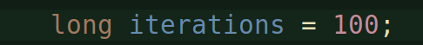

Mvn clean install -> eclipse run program:
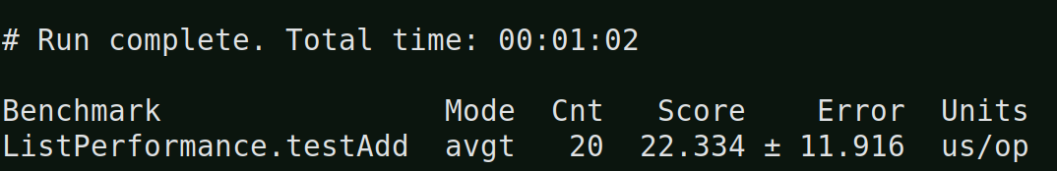
Woah, we did get a result.

1 warmup fork, 1 benchmark fork. And, 5 warmup iterations and 20 normal iterations each for the warmup fork and benchmark fork.
SetUp() was called only twice during the first warmup iteration of both warmup benchmark and actual benchmark.
And testAdd() again was invoked some 51k times for each iteration. Either the count is not inconsistent or i am just not able to count it properly. Whatever it is, I don;t know why is this method being called so many times and how is the ‘iterations’ count has any impact on the entire thing? Not able to corelate!

Okay, so did a few change now:
Changed @Warmup(iterations = 1) from 5 and also changed the no.of loop itertations from 100 to 1.
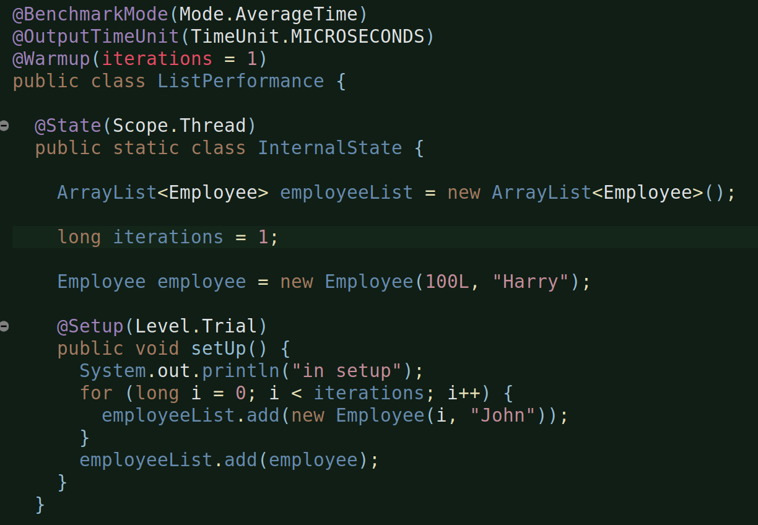
And, of course, changed my main() method code back to it’s original, because I did not see any impact of the new code:
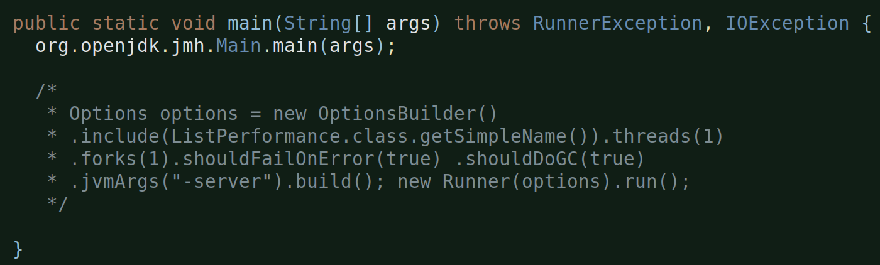
Let’s mvn clean install (from terminal) and then run the program in eclipse:
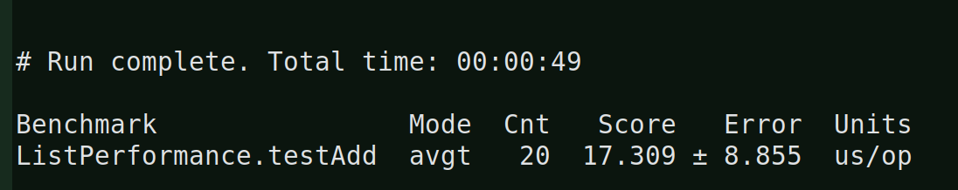
we got the result.
So, it had, 1 warmup fork, 1 benchmark and each of these with 1 warmup iterations and 20 normal iterations.
And, again the testAdd() was called some 50k times or so for each warmup fork and benchmark runs. IDK why?
While, the setUp() is called only twice, once during the warmup iteration of warmup fork and the other time during the warmup iteration of the benchmark fork, which seems fine. SO, the setUp() is bsaically called once per fork (irrespective of the number of warmup iterations per fork). This is at least true for Level.Trial, which is what I’am using.

Alright, so did a few more changes, to know things better:

In setUp():
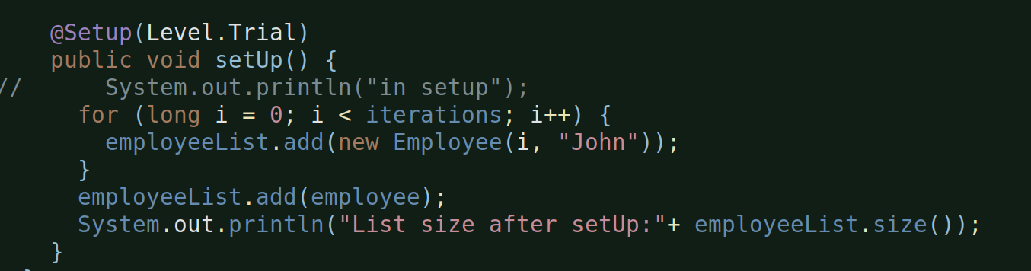
Added a print stmt to know the List size after setUp finishes.

And, other thing is the no.of iterations:
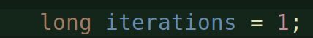

In testAdd():
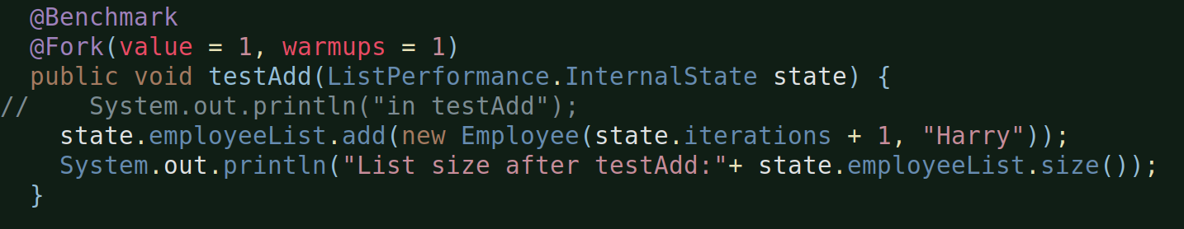

Added a print here as well, to know List size after testAdd() is done.

Mvn clean install -> let’s run the program from eclipse now:
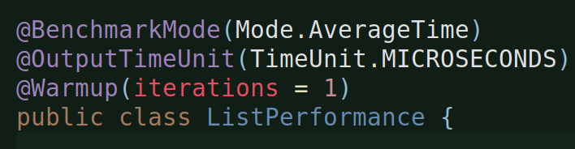

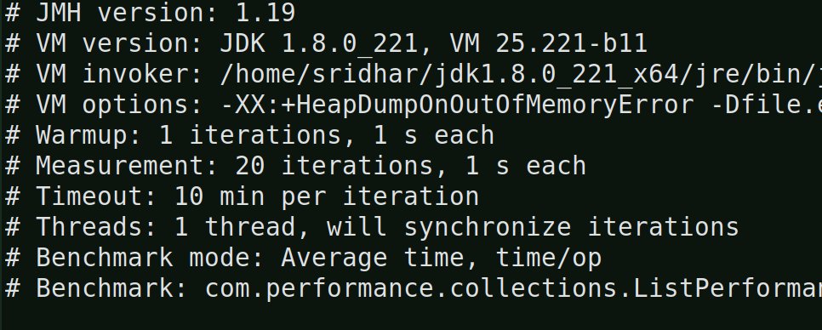

For the warmup fork, we had setup 1 warmup iteration and the list size at warmup iteration 1 was:
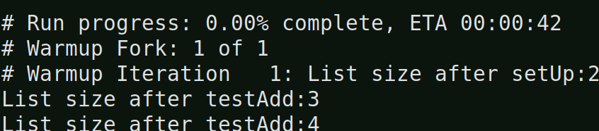
You are seeing 2 because I am already adding an element in the even before the setUp is called:

And, hence after the setUp you see 2.

Then, the testAdd for this warmup iteration for this warmup fork was called:
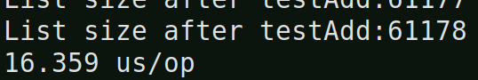

This means, the testAdd() method was called some 61k times for the warmup’s fork warmup iteration i.e. the total number of elements in tne list were 61k before the actual iteration of the warmup fork began.
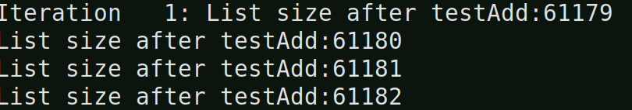
As you can see from above, the normal iteration for the warmup fork continued with the size of the list that was at the end of the warmup iteration and it went until 2nd iteration:
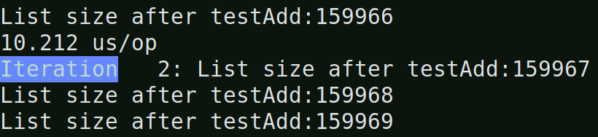
And, so on, it went until iteration 20 and at the end of 20 iterations:
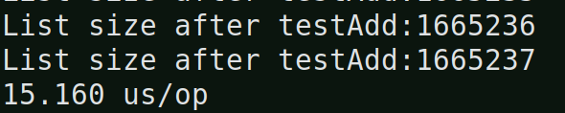

This means, the testAdd() method was 1.66 million times for the warmup fork i.e. the total number of elements in tne list were 1.66 million before it was finally discarded.

And, then benchmark fork execution began:
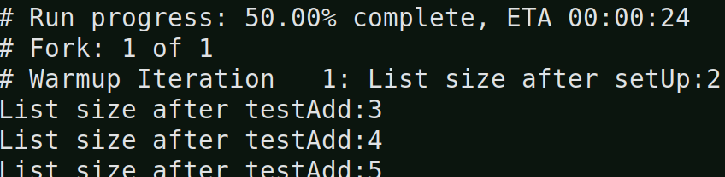
And, you can clearly see that list size after setUp is 2, that means, whatever elements that were added in the list during the warmup fork were all discarded.
And, the benchmark fork was iterated:
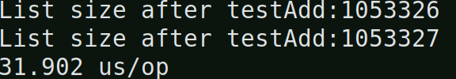

Now, making the @Warmup(iterations = 2) from 1:
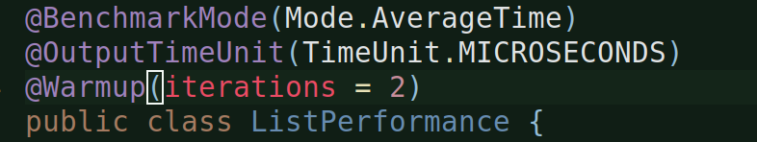
Everything else remains the same.

Let’s mvn clean install -> run from eclipse:
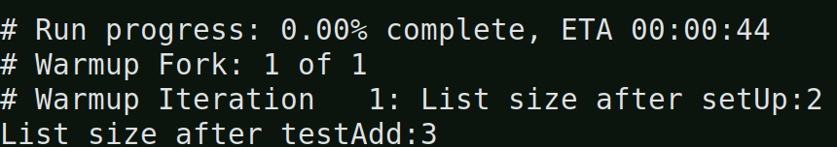
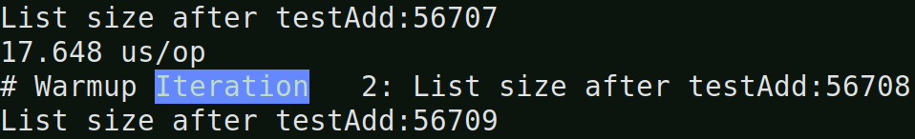
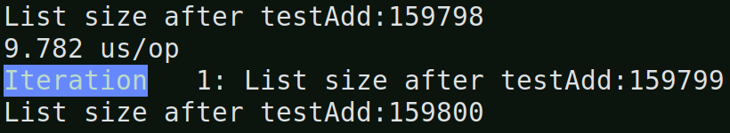
After iteration: 20:
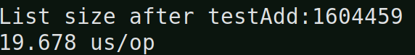

So, the elements accumulated during the warmup iteration are carried forward into iteration and are dumped only the warmup fork OR benchmark fork execution completes.

So, when you increase the no.of elements to added in the setUp(), those no.of elements will become the starting point for the other remaining iterations, meaning:
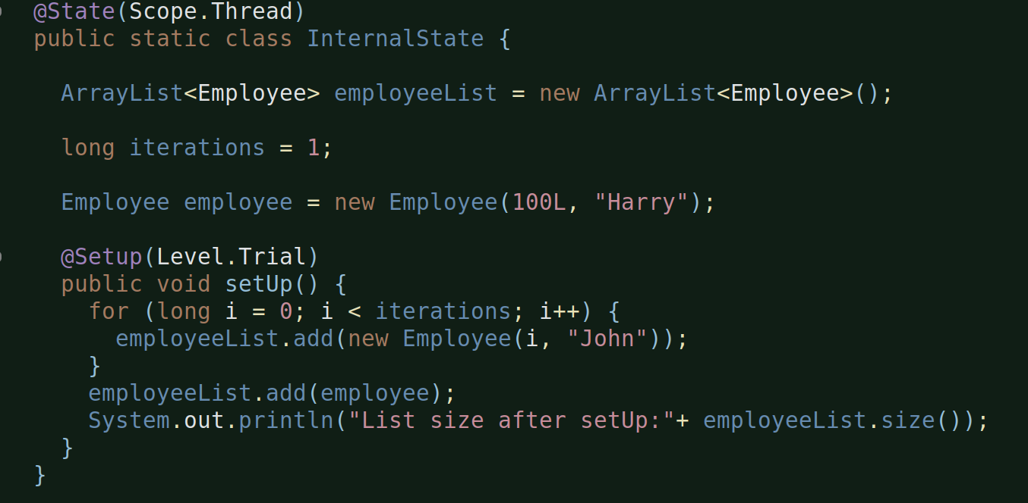
When I change the iterations val to 100. The list size after completion of setUp() will be 101 (instead of 2) i.e. after the warmup iteration is done and then normal iterations will start adding more elements to the list from 101 onwards and maybe upto 1.6 million or more.

