[GENERATING HEAPDUMPS PROGRAMMATICALLY: HeapDumper.java]

[] heapdump is a snapshot of the memory at a point-of-time, and, if you want to take multiple heapdumps at multiple moments of the program then you can either use multiple breakpoints and then a heapdump from the visualvm at each breakpoint and then later compare them or analyze individually.

[] But it is possible to generate heapdumps programmatically also.

[] The url below is the program which you can call from your code in order to generate heapdumps at will programmatically.

https://blogs.oracle.com/sundararajan/programmatically-dumping-heap-from-java-applications

[] I’ve just copied the same program into this project space with the name HeapDumper.java

[] Will be calling this class from other programs to generate heapdumps fro analysis.

[GENERATING AND ANALYSING A HEAP DUMP]

[] Here, we will write a program which will throw outofmemory error because of exceeding java heap space during operation.

[] We will make some jvm configuration for this program to manually set the available heap space for the program to 512 mb so that this program will eventually run out of heap.

[] Below is the snapshot of it. Just go project properties, right-click, and then go to run/debug settings, and click on the class for which you want to set the vm arguments and click on edit and you’ll see the below screen:
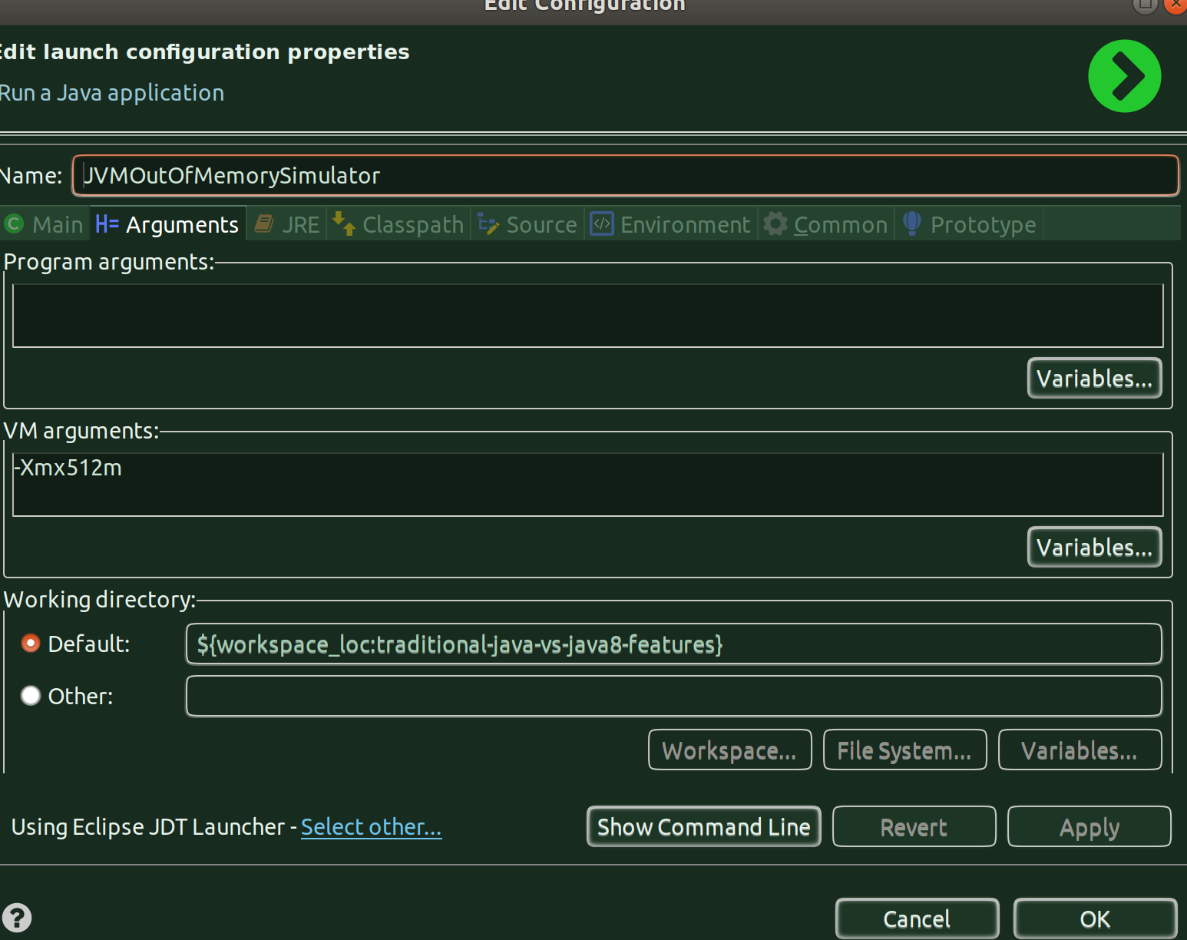
[] This program basically adds a huge string to an HashMap instance, and it does this 500k times, and every time it makes a small modification to the original string and puts the new string into the map, thereby making 500k instances on an available heap of 512mb.

[Running the program]
[] Let’s run the program now to see the output.
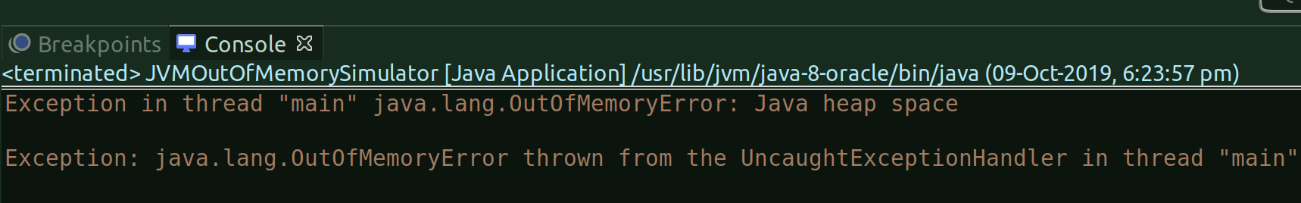
[] As you can see from the above snapshot, the program errored out with OutofMemory error.

[Configuring HeapDump generation as a VM Argument]
[] Let’s configure the vm argument which will automatically create a heap dump as and when a OutofMemory error occurs in the program.
[] In the same way you added the heap size memory above, now add the vm argument for heap dump generation:
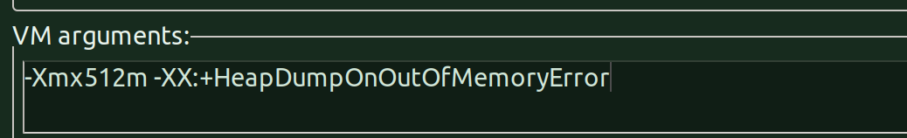

[Running the program with heap dump vm argument]
[] Since we’ve now set the vm argument in the above step, let’s now go ahead and run the program
[] Alright, as expected, the programs runs outofmemory and fails and generates the heap dump.
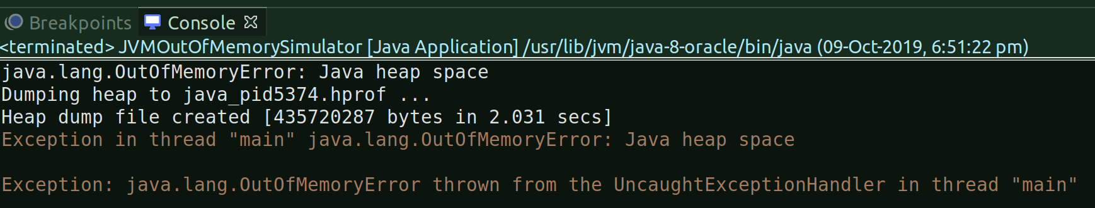

[] As you can see from the above snapshot, the vm argument that we’ve set has generated the heap dump - ‘java_pid5374.hprof’, the pid is the process of the java process which was associated in running this program and which errored out because of heap outofmemory.
[] The heap dump file, by default, is generated in the current directory where your program is running:
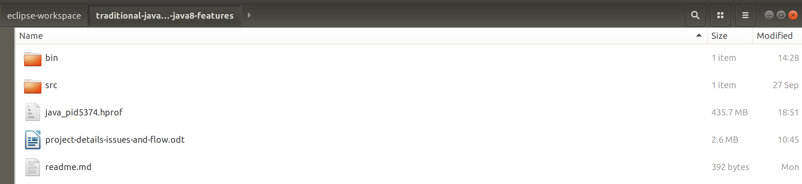
[] The file size is 435.7 MB, not much, considering what we’d get in a production environment.

[Analysing the heap dump with Eclipse Memory Analyzer Tool]
[] Since we have the Eclipse MAT already configured in eclipse, we’ll use that and also it is considered to be a better tool out there to analyze heap dumps, of course, in real-life the eclipse itself might have problems in opening huge .hprof files.

[] Leak Suspect Report:
[] Let’s choose the ‘Leak Suspect Report’ option:
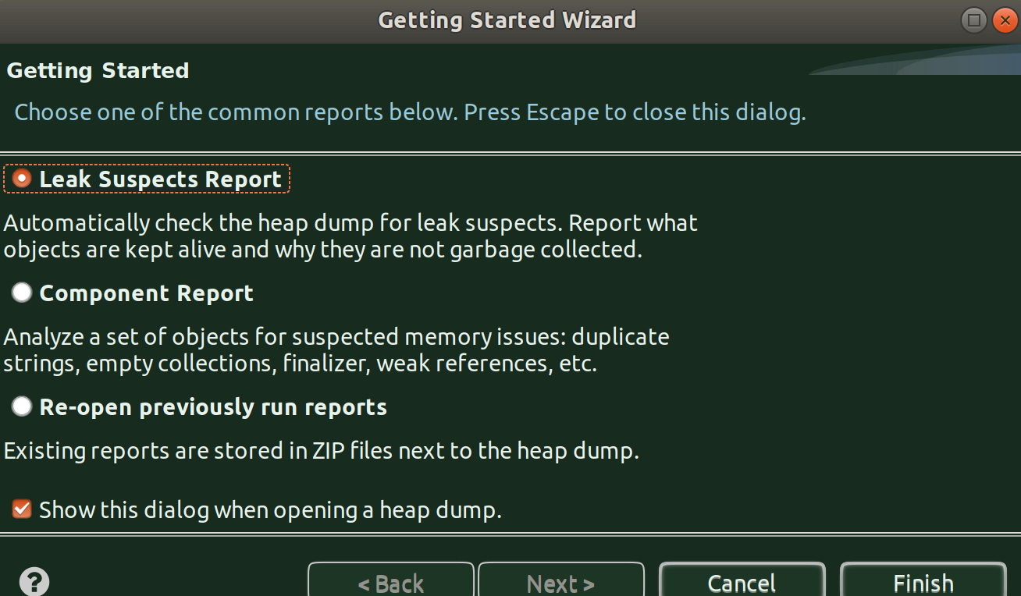
[] And, the tool finds out the ‘Problem Suspect 1’ responsible for the leak:
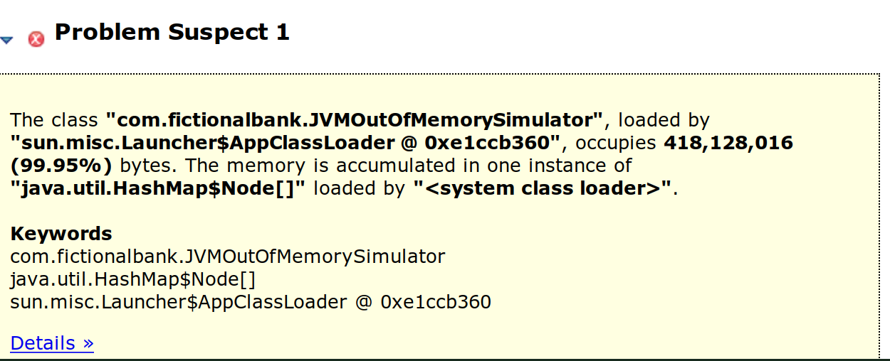
[] It says, our class, JVMOutOfMemorySimulator is where the leak is and it occupies 418 MB out of the given 512 MB on the heap.
[] Let’s click on ‘Details’ to dig further:
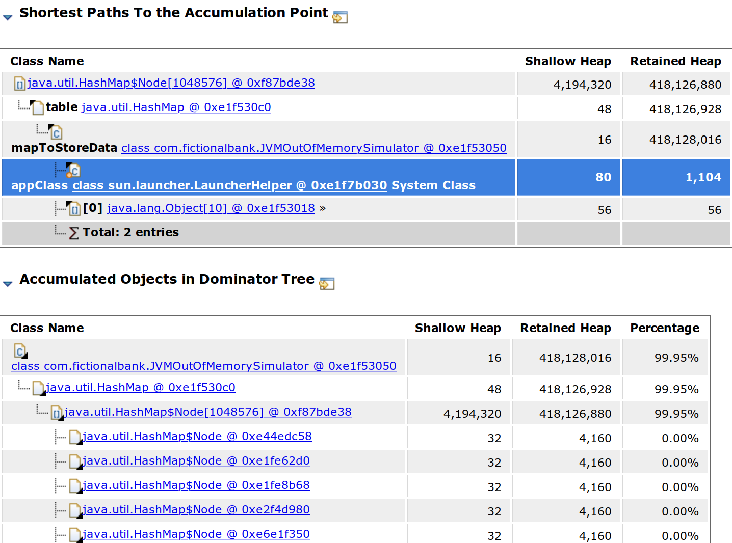

[] Okay, we can see that it’s the HashMapNode which is occupying a huge heap i.e. 420 MB almost.
[] Let’s click on that and look for all ‘incoming references’ to dig further where does this actually reflect in our program.
[] To do that, we just have to click on the link i.e. on the suspected HashMap Node instance and from the menu that pops up, choose – List Objects -> with incoming references
[] When you do that, you’ll get to see this:
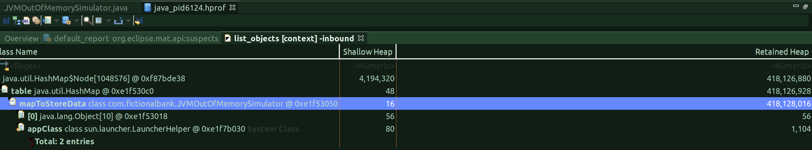
[] From the above listing, we can identify the culprit that is part of our code: mapToStoreData instance of JVMOutOfMemorySimulator class
[] The rest all details are other details but it is first important to find out what in our class is casuing the OutOfMemory and hence the identification of the cause, which in our case happens to be an HashMap instance.
[] So this identifies the problem, let’s now try a different option available in the Eclipse MAT tool to identify the suspect and the problem for the leak.
[] Oh, btw, as you keep navigating through the report generated by Eclipse MAT, there will be an array of objects in your local directory (wherever the program is running):

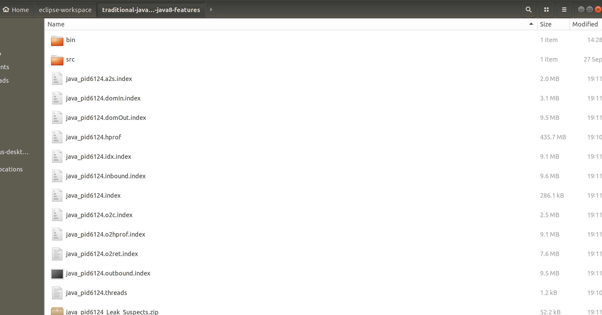

[] Component Report:
[] When you click on the ‘Component Report’ option, you’ll see a step-by-step proedure of identifying the problem:

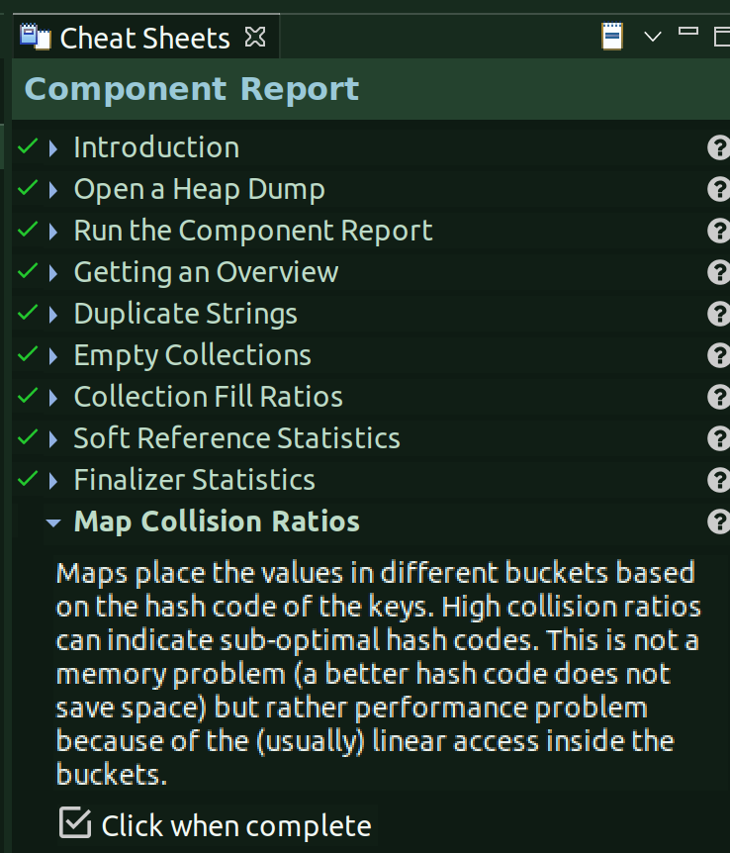

[] The key thing in this is we can run the report for each component, meaning, if you want to look at the report only from java.util.* perspective, to see what all that part of this component hierarchy are causing problems, then you just mention the name of the component and run the report.
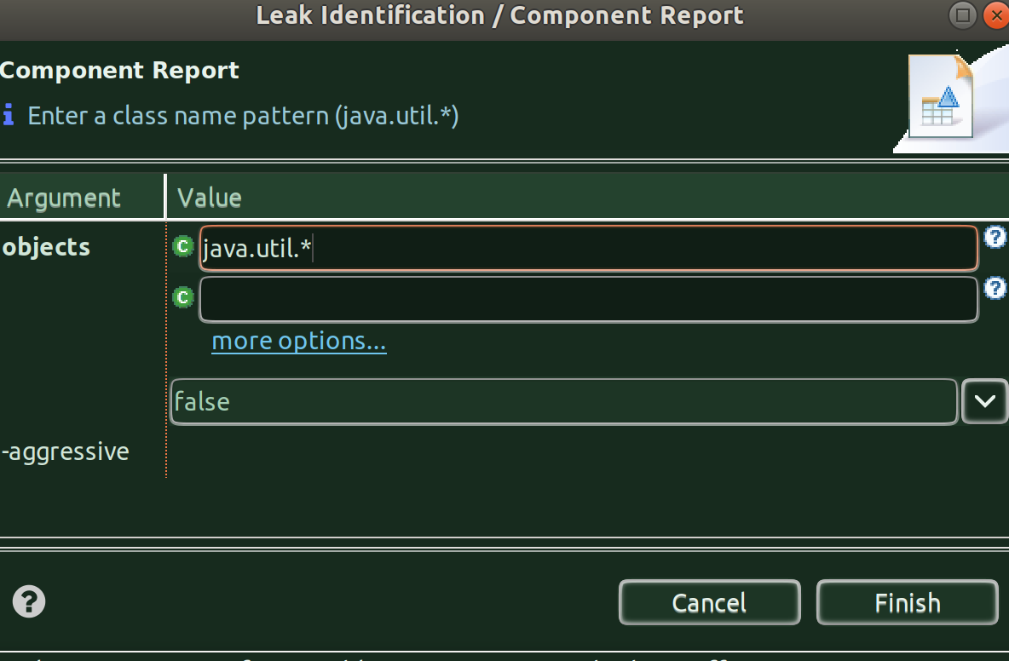

[] And, when you hit finish:
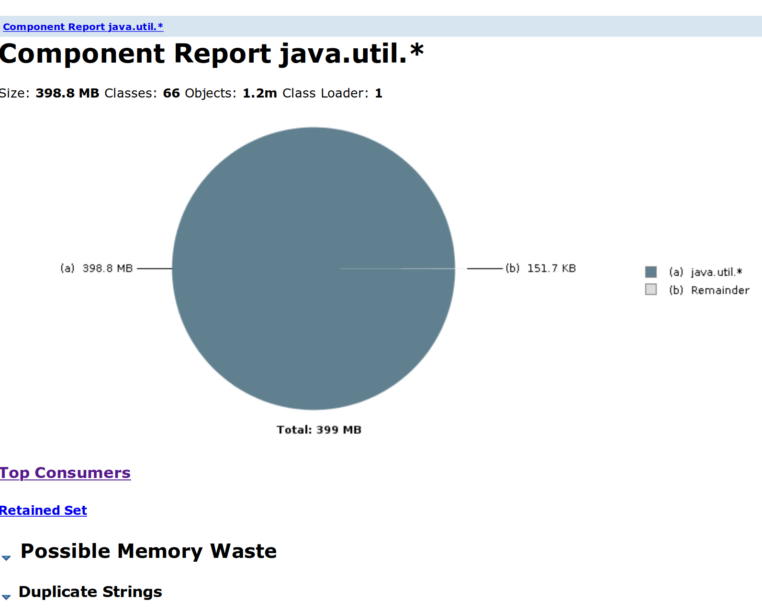

[] As you can see this report says, the size of this component is almost 400 MB out of the 512 MB. You can look into further details from here in order to zero down on the exact component of this package.
[] If you open up ‘Top Consumers’ it’ll show which actual object is consuming that much heap:
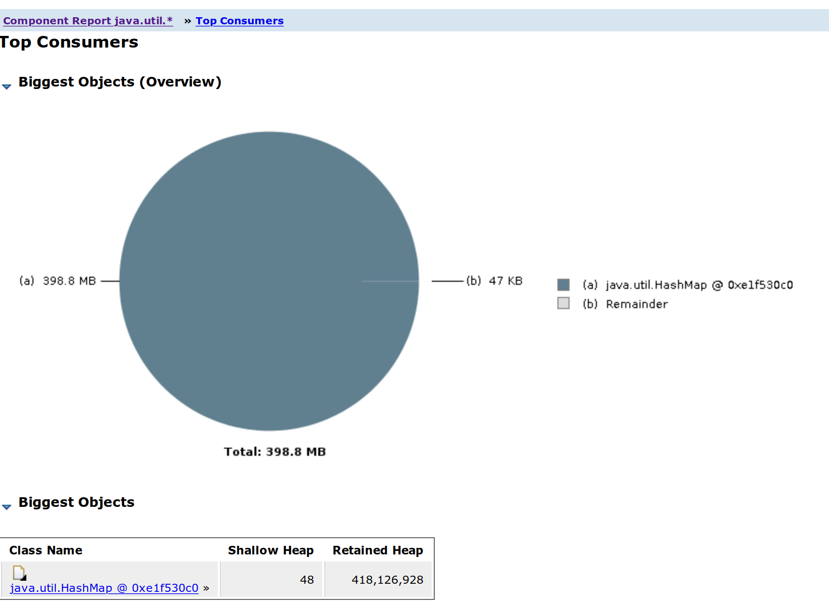

[] Here we go, it says it’s an HashMap which is casuing the trouble but we still don’t where in our code is this happening, to know that, click on the java.util.HashMap instance and choose ‘List Objects’ and ‘with incoming references’
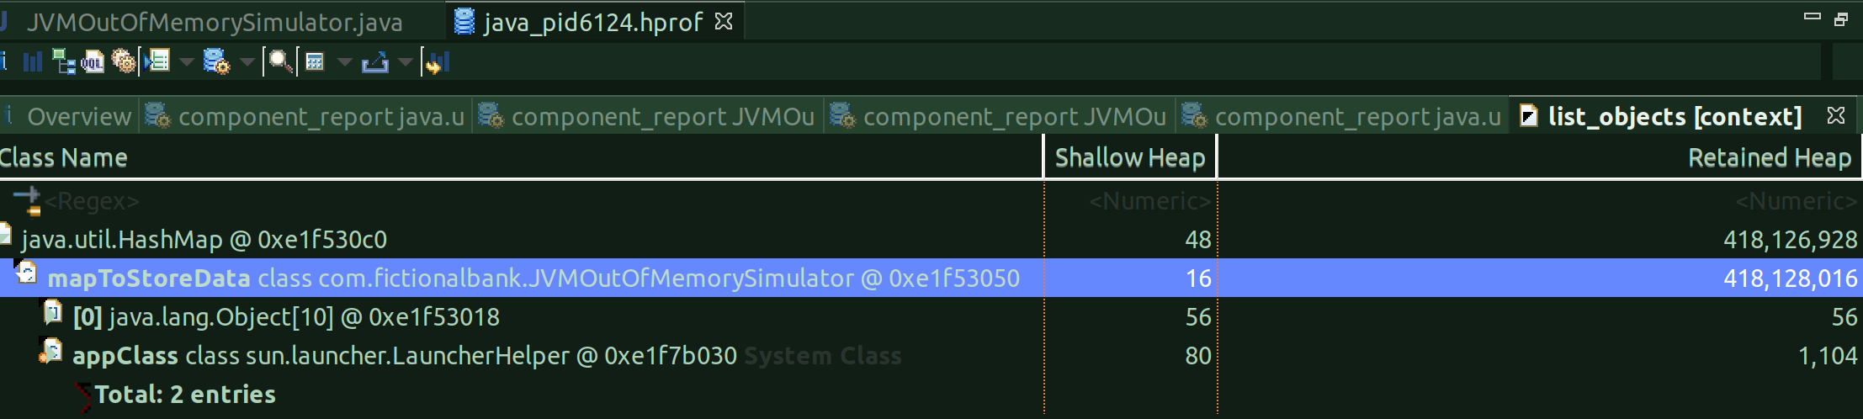
[] And, that’s it, it points out to the problem at hand.

[] Using Histogram:
[] We can also use ‘histogram’ to print all instances per class.

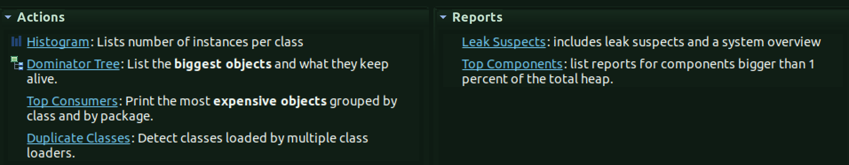

[] Once you click on that action, you’ll see this:
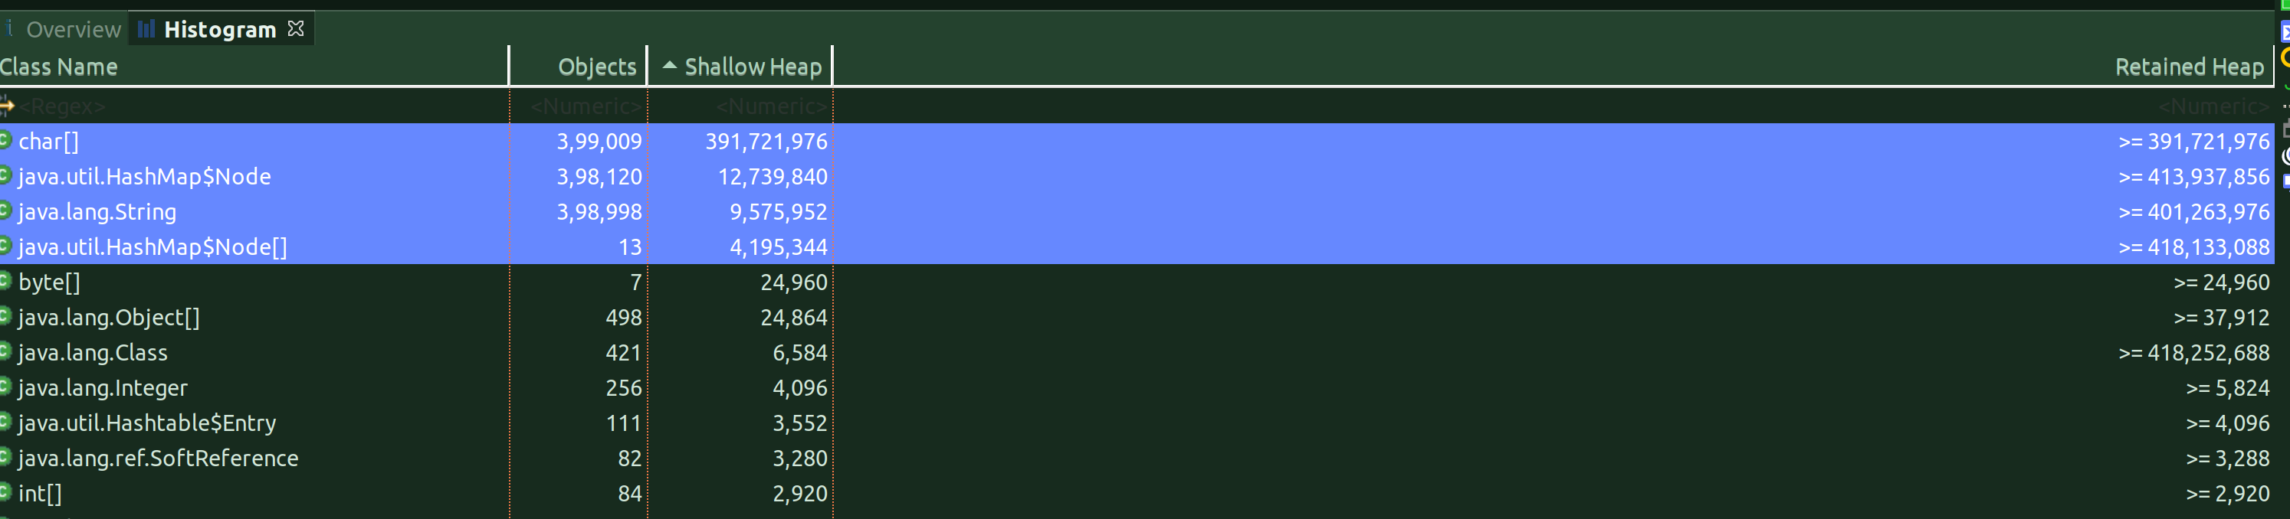
[] From the above, we can see the top classes which are occupying maximum heap. From here, you can, as usual, click on each and choose list objects => with incoming references to get to the part where it can lead to something in your class/code.

[Analysing the heap dump with VisualVM]

[] Let’s analyze the heap dump with VisualVM here.
[] Since, I’m not able to find the jvisualvm instance on my linux machine which I can directly invoke, I will, for now, invoke the instance from Eclipse.
[] Since we have already configured eclipse to launch visualvm during debug mode:
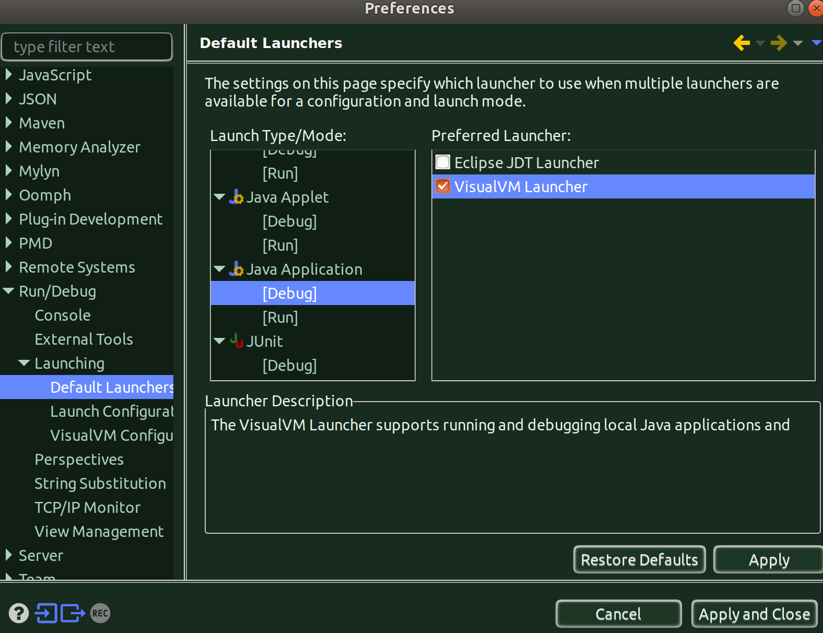
[] So, let’s run the program in debug mode.
[] And, the Java VisualVM Opens up. Go to File, Load, and choose *.hprof as the file type and load your already generated heap dump file, which you generated using the vm argument.

[] Summary Tab:
[] And,as the heap dump is loaded by visualvm, this is what you’ll first see:
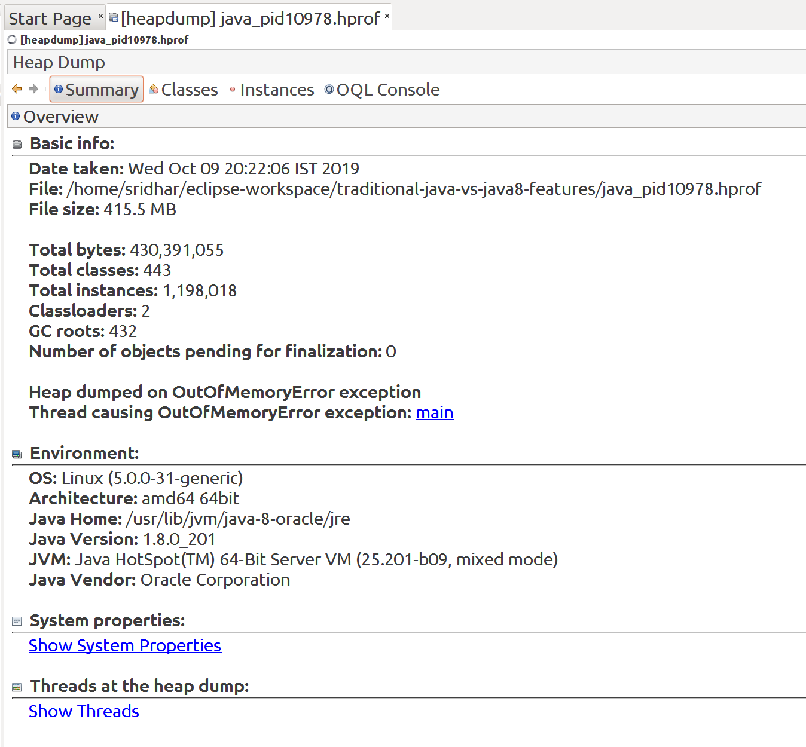
[] This summary says the instances of this heap dump are occupying 432MB of the heap space.
[] If you notice, it mentions, ‘Thread causing OutOfMemoryError Exception’ and if you click on that link, you’ll see all threads at that heap dump:
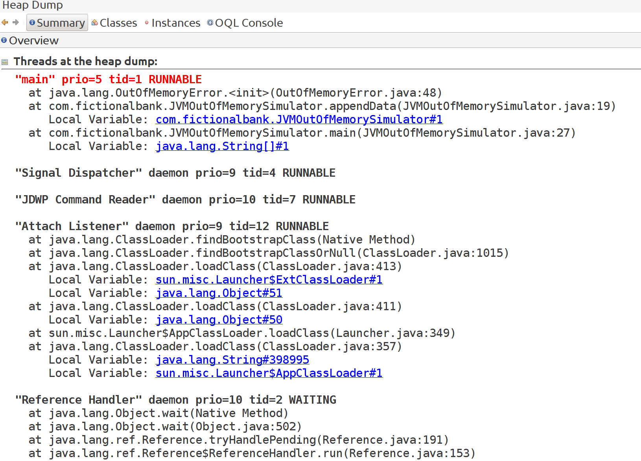
[] This does give us a lot of information.
[] If you click on the first Local variable, it’ll take you to the instance level and show what’s that:
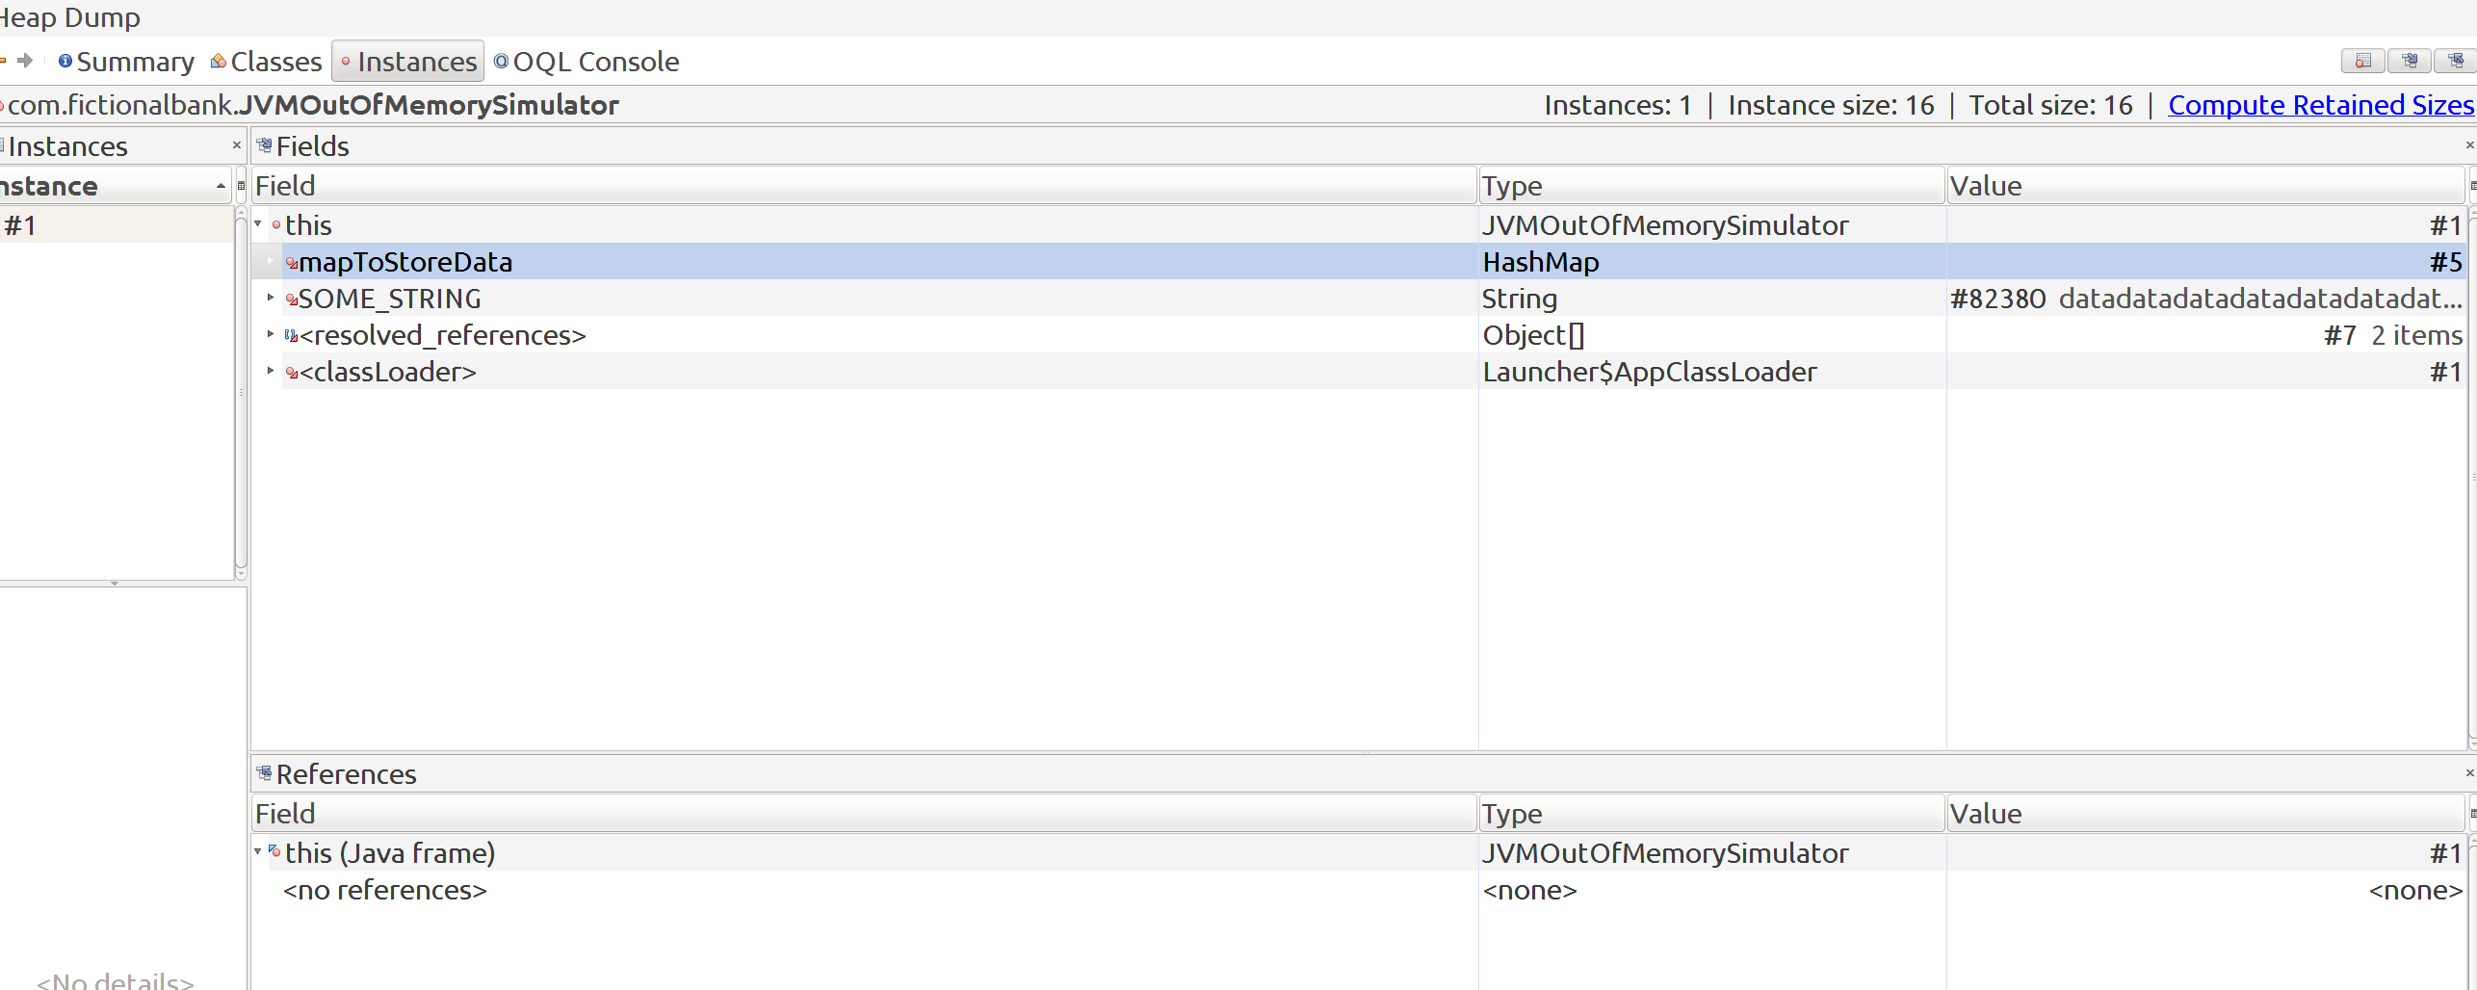

[] And, we can see that it’s poiting to our mapToStoreData HashMap instance and also to the SOME_STRING static variable. To find out more, just right-click on each and choose show instance
[] So if i choose to see all instance of mapToStoreData:
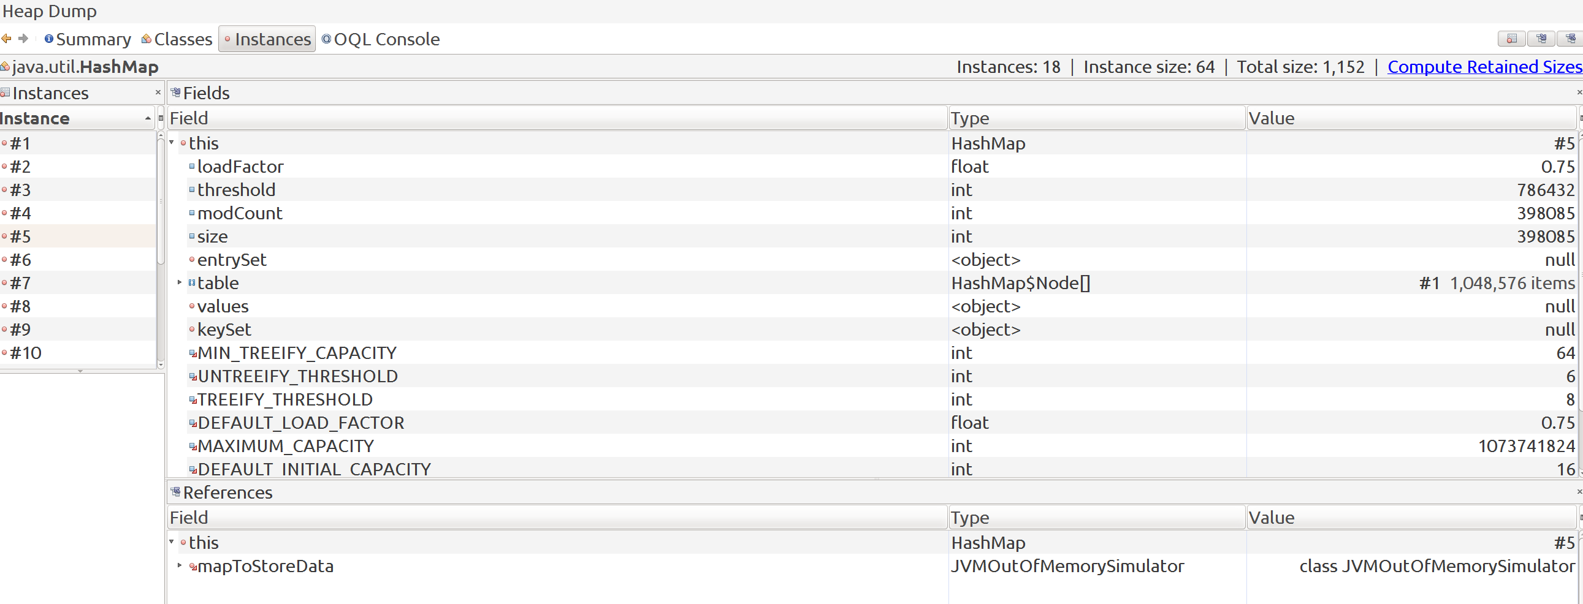

[] Classes Tab:
[] We can directly go to the classes tab and see which are the suspect classes:
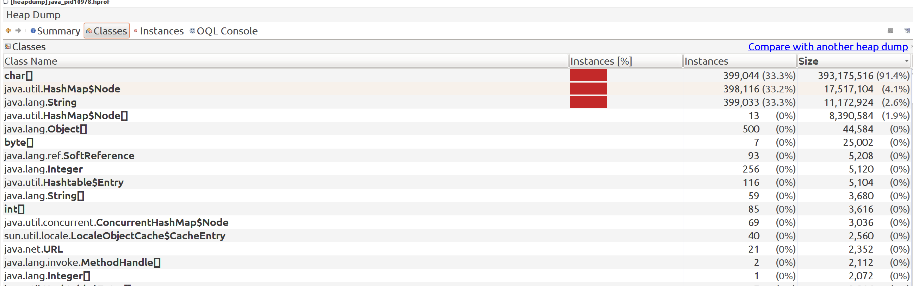

[] You can now click on each and navigate through by choosing ‘show instance’

[] Comparing HeapDumps of 2-versions of this program:

[] In this we’ll make some changes to code and take heapdumps to see how the changes are having an impact.

[] First-version: comment out string appending:
[] We’ll now make some code modifications to not append string i.e. we’ll avoid creating new strings and just put the final String value into the HashMap instance the same number of times:
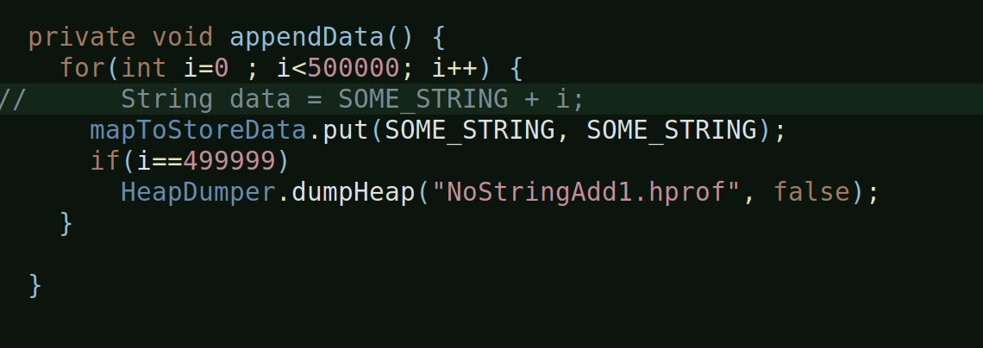
[] The HeapDumper is the prograatm which generates heapdump at the desired point-in-time programmatically. Here, I’m asking it to generate a heapdump at last but one iteration.
[] Okay, so lets open this heapdump from visualvm:
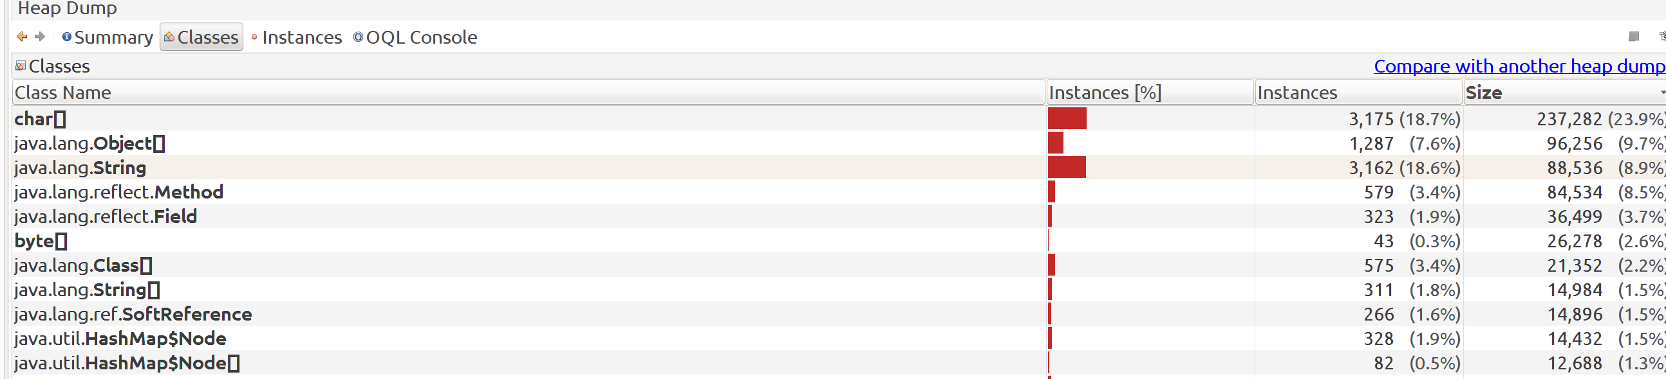
[] And, you can already see a lot of difference, for refernce, below is the heapdump classes snapshot of the original one, where we appending string:
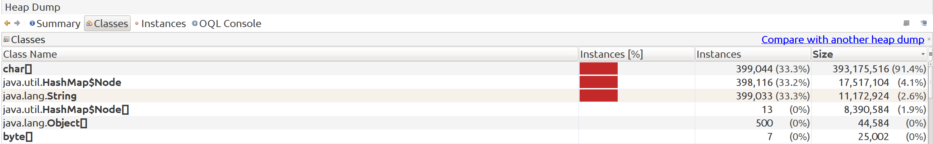
[] You can see the difference in the instances and their memory. The original one was occupying some 430 MB and the new one hardly some 0.1 MB, you can see this from the summary view:
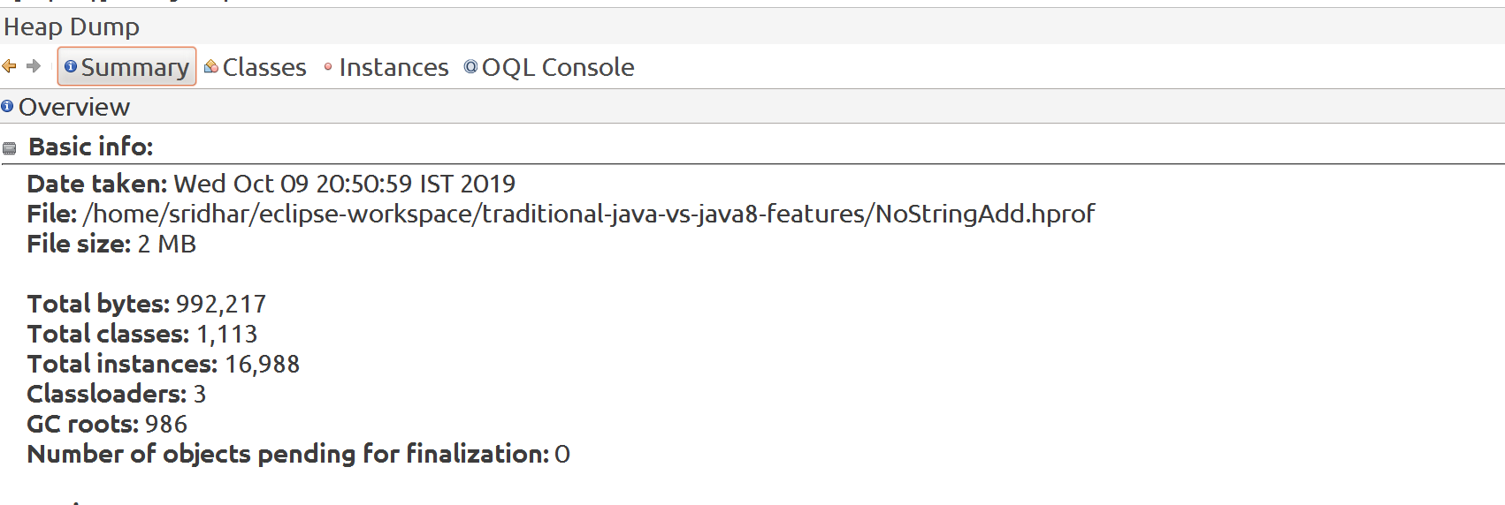

[] And, you can look at the String and HashMap node instances from the classes view.
[] So, the whole problem was started by the string appending.

[] Second-version: enable string append, comment out map addition:
[] So, here, we will enable the string appending that we were doing in the loop but comment out putting elements into the map, that means, we
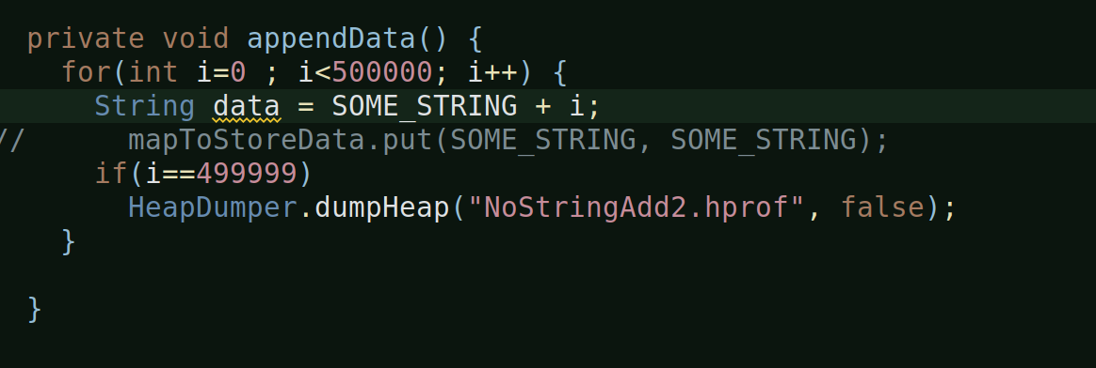
are almost taking the map out of equation:

[] After we run the program, a heapdump, will be generated programmatically.
[] Let’s analyze this with visualvm.
[] Summary view:
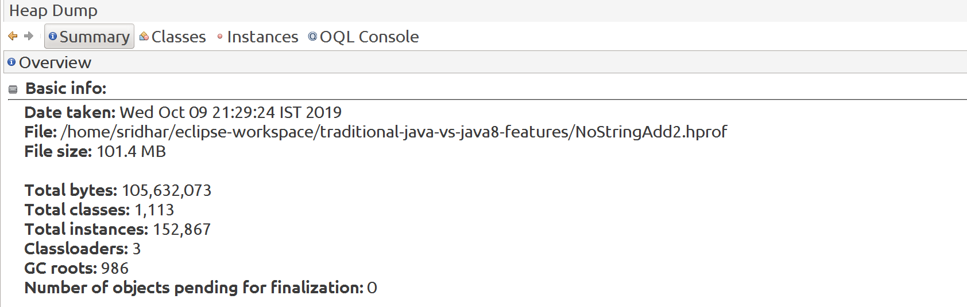
[] You can straight away see that even though this program did not run outofmemory, it still is occupying a lot of heap: 105 MB
[] This dint throw an outofmemory because we have set the heapsize as 512 MB, so it was within limits but still huge.
[] Compare it with the one where we had commented the string append, it occupied 0.1 MB, even the heapdump which showed live and inactive objects of this program (in which we commented string append), it still occupied only 4 MB. But when you enable string append and take out putting elements into Map, it still takes 105 MB.

[] Class view:

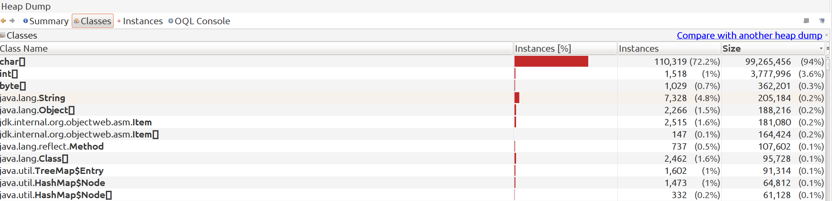
[] Look at the char[] instances, 110k in number, compare it with the heapdump of program where these is no string append, it is 3175 in number.
[] These instances are getting generated because of the new strings.
[] Look at the string instances – 7327 vs 3162.
[] So, these results show us that, it is the string append i.e. new string creation which is really causing a lot of problem.

