[GENERATING HEAPDUMPS PROGRAMMATICALLY: HeapDumper.java]

[] heapdump is a snapshot of the memory at a point-of-time, and, if you want to take multiple heapdumps at multiple moments of the program then you can either use multiple breakpoints and then a heapdump from the visualvm at each breakpoint and then later compare them or analyze individually.

[] But it is possible to generate heapdumps programmatically also.

[] The url below is the program which you can call from your code in order to generate heapdumps at will programmatically.

https://blogs.oracle.com/sundararajan/programmatically-dumping-heap-from-java-applications

[] I’ve just copied the same program into this project space with the name HeapDumper.java

[] Will be calling this class from other programs to generate heapdumps fro analysis.

[GENERATING AND ANALYSING A HEAP DUMP: JVMOutOfMemorySimulator.java]

[] Here, we will write a program which will throw outofmemory error because of exceeding java heap space during operation.

[] The core data structures of this class/program are a string and a hashmap:
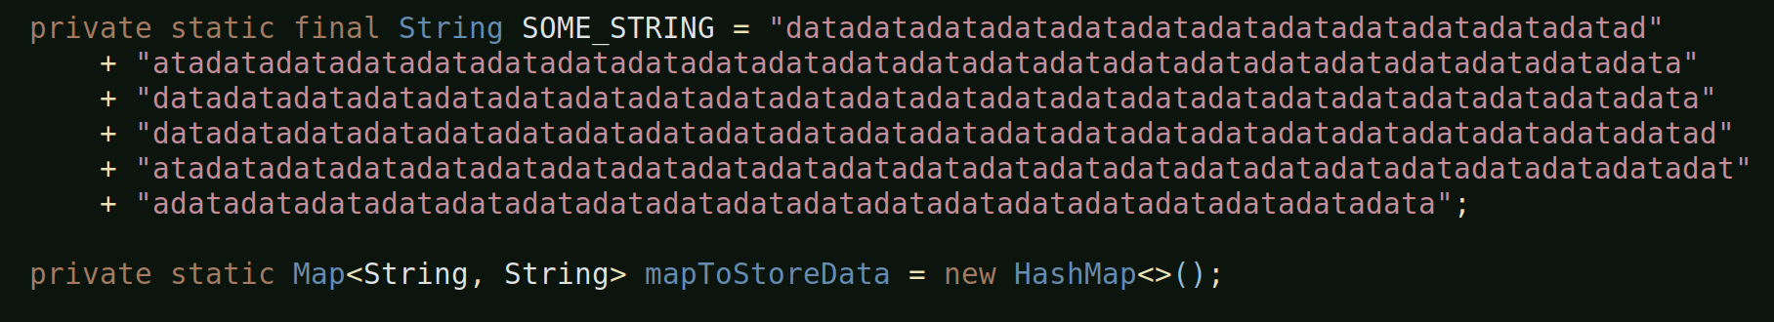
[] And, the method where all the action takes place is:
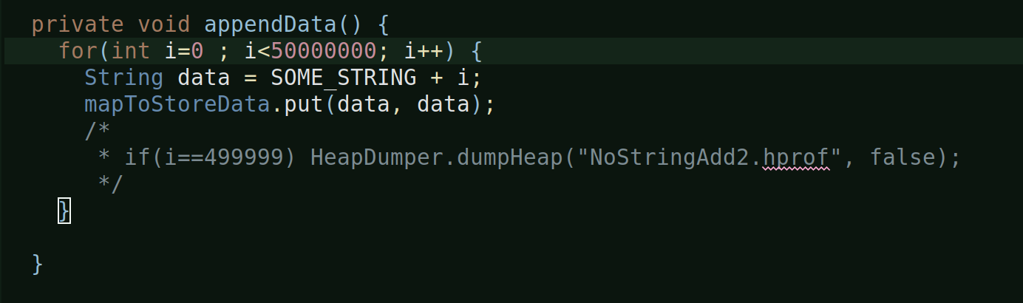

[] The appendData method:
[] This basically has a loop which iterates for 500k times.
[] In every iteration, it creates a new string instance/object, by making some small change to the existing ‘final string’
[] And, then, it puts the new string instance into the key and value of the map.
[] The commented piece of code that you see above is created by me. This i’ll explain later.

[VM Argument Configuration]
[] Now, to ensure, this program indeed runs outofmemory, we have hard set the available heap space to 512 MB by using the vm argument:
-Xmx512m
[] We have to hard set the heap space to 512 MB because by default in a 64-bit machine the amount heap space allocated is 2GB. So, in order to enable our program to generate a reasonable outofmemory error we’ve lowered the available heap space for it.
[] We also have configured a vm argument to enable the program to automatically generated a heapdump whenever it encounters outofmemory error: -XX:+HeapDumpOnOutOfMemoryError
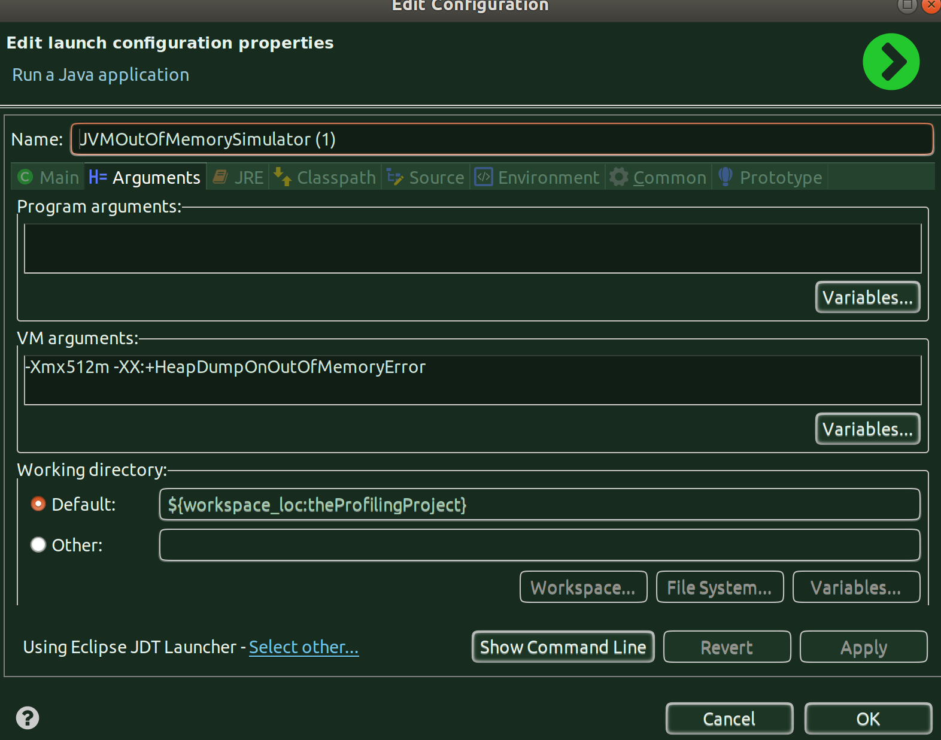
[] You can reach to the above configuration window by just right-clicking on the class and click on properties.

[Running the program]
[] Alright, as expected, the programs runs outofmemory and fails and generates the heap dump.
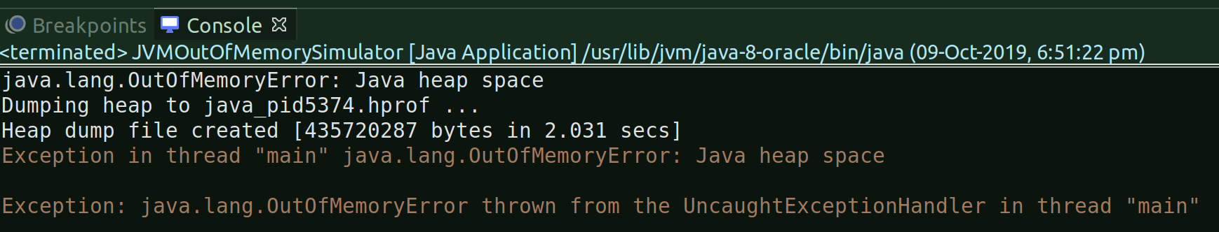

[] As you can see from the above snapshot, the vm argument that we’ve set has generated the heap dump - ‘java_pid5374.hprof’, the pid is the process of the java process which was associated in running this program and which errored out because of heap outofmemory.
[] The heap dump file, by default, is generated in the current directory where your program is running:
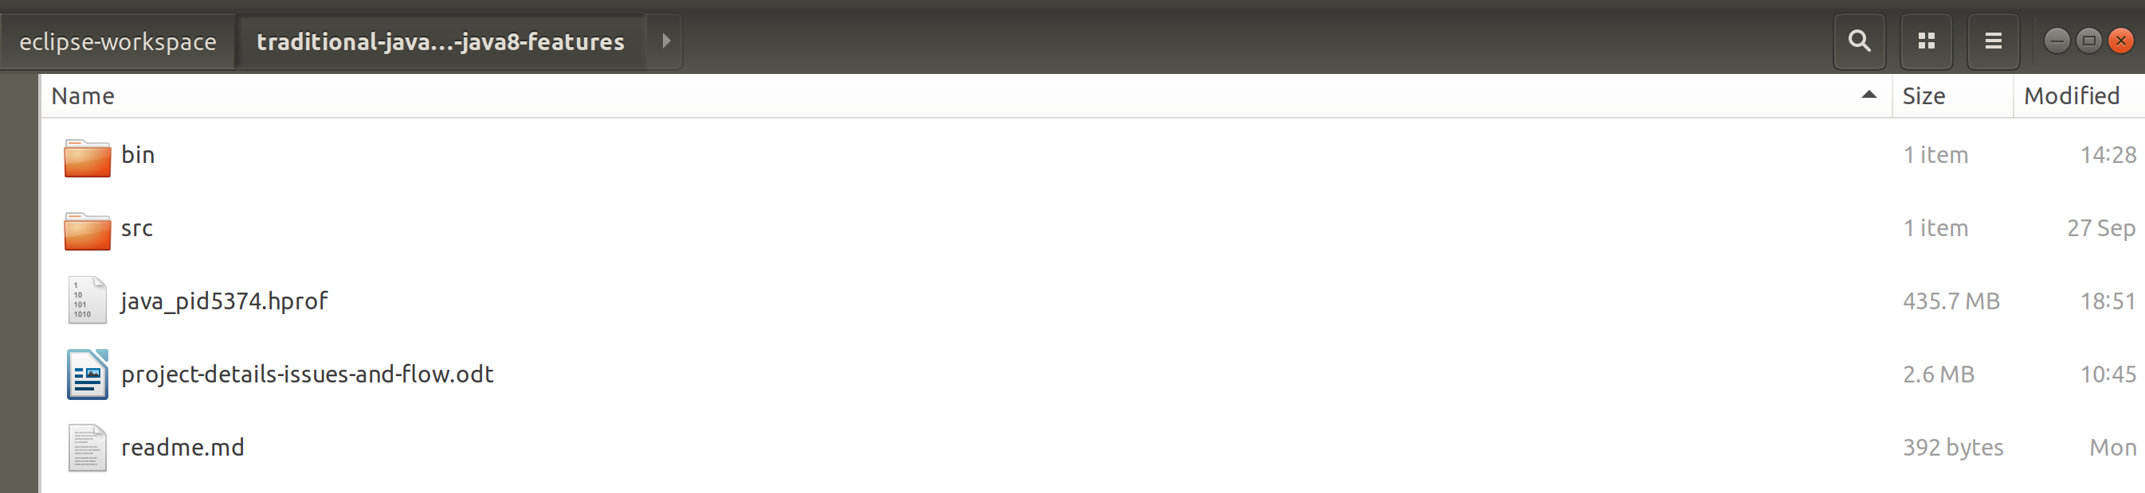
[] The file size is 435.7 MB, not much, considering what we’d get in a production environment.

[Analysing the heap dump with Eclipse Memory Analyzer Tool]
[] Since we have the Eclipse MAT already configured in eclipse, we’ll use that and also it is considered to be a better tool out there to analyze heap dumps, of course, in real-life the eclipse itself might have problems in opening huge .hprof files.

[] Leak Suspect Report:
[] Let’s choose the ‘Leak Suspect Report’ option:
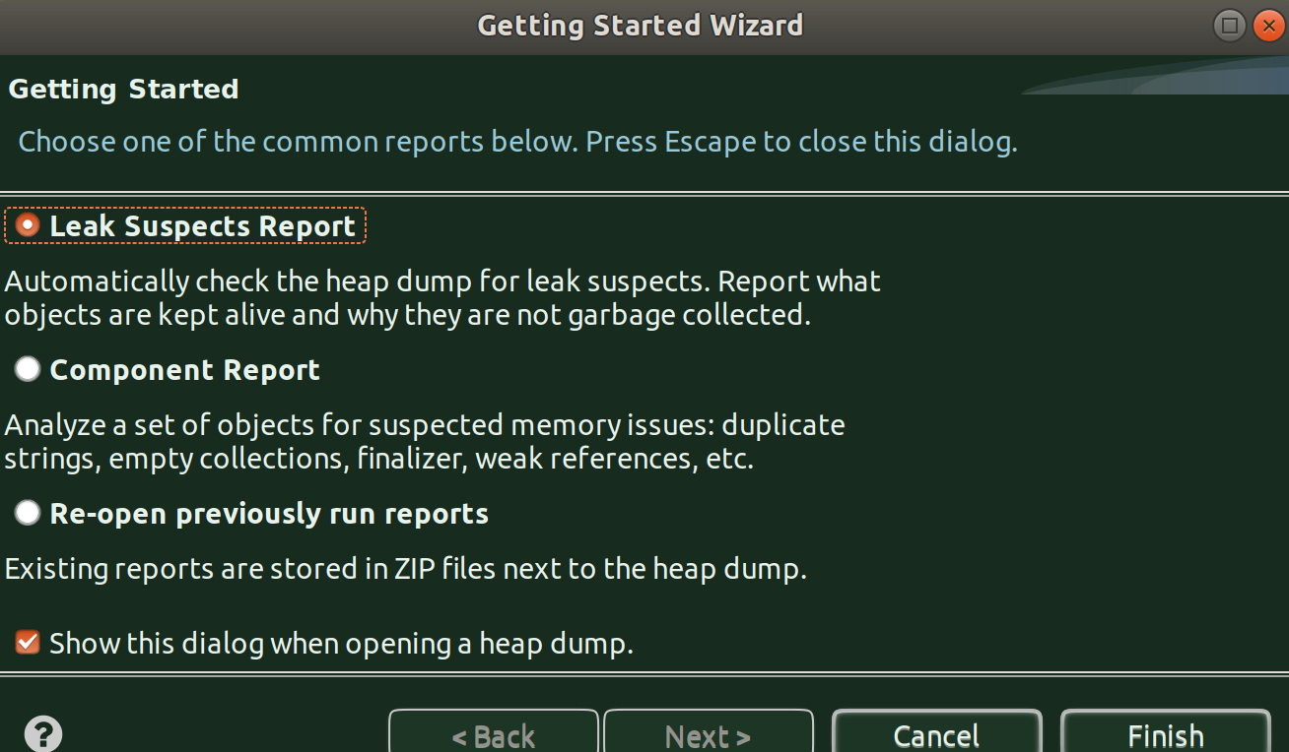
[] And, the tool finds out the ‘Problem Suspect 1’ responsible for the leak:
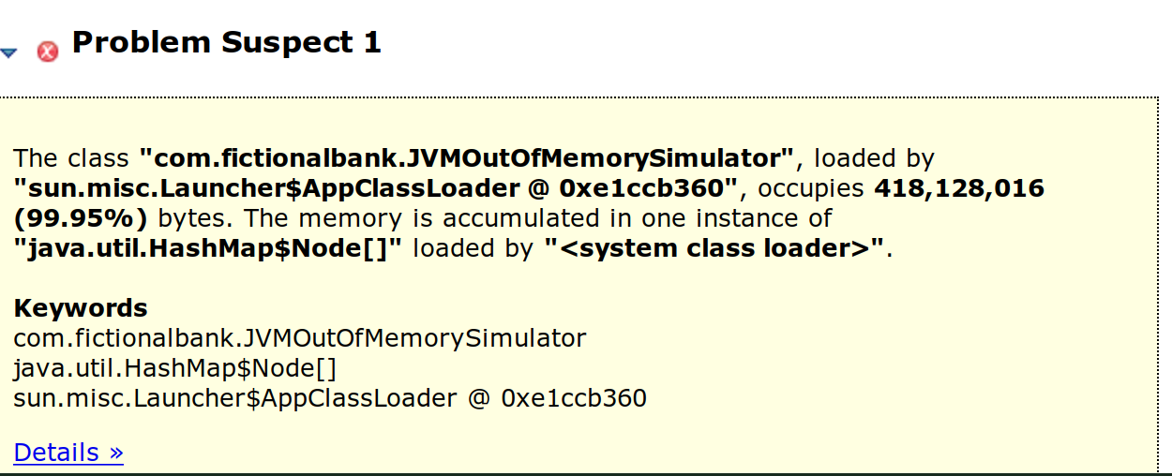
[] It says, our class, JVMOutOfMemorySimulator is where the leak is and it occupies 418 MB out of the given 512 MB on the heap.
[] Let’s click on ‘Details’ to dig further:
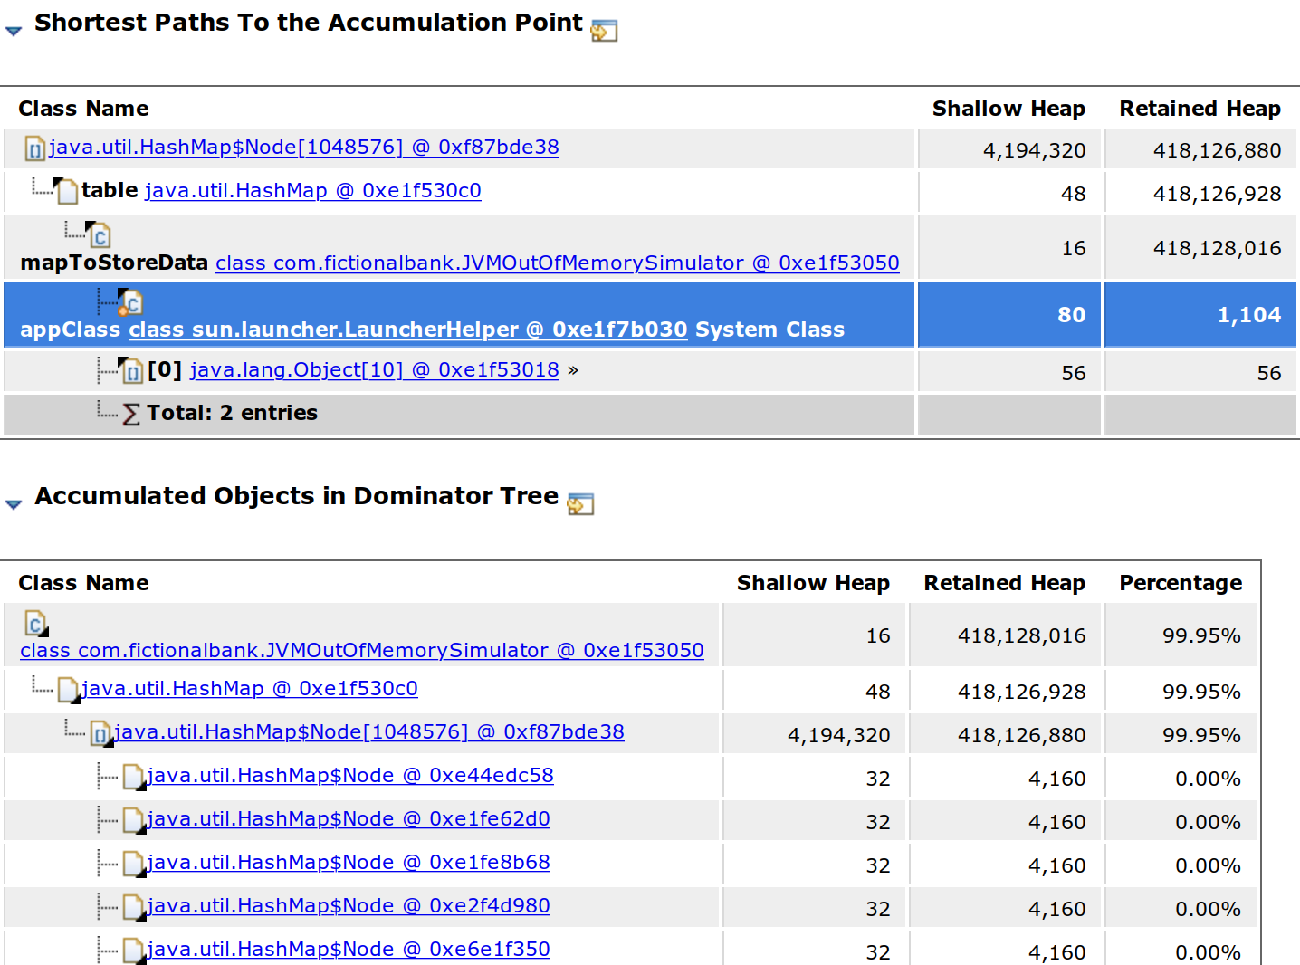

[] Okay, we can see that it’s the HashMapNode which is occupying a huge heap i.e. 420 MB almost.
[] Let’s click on that and look for all ‘incoming references’ to dig further where does this actually reflect in our program.
[] To do that, we just have to click on the link i.e. on the suspected HashMap Node instance and from the menu that pops up, choose – List Objects -> with incoming references
[] When you do that, you’ll get to see this:
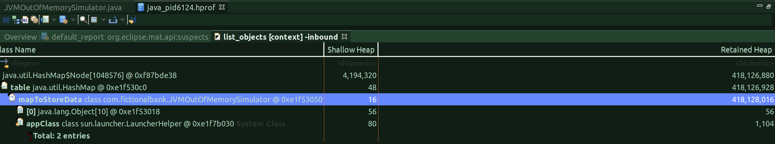
[] From the above listing, we can identify the culprit that is part of our code: mapToStoreData instance of JVMOutOfMemorySimulator class
[] The rest all details are other details but it is first important to find out what in our class is casuing the OutOfMemory and hence the identification of the cause, which in our case happens to be an HashMap instance.
[] So this identifies the problem, let’s now try a different option available in the Eclipse MAT tool to identify the suspect and the problem for the leak.
[] Oh, btw, as you keep navigating through the report generated by Eclipse MAT, there will be an array of objects in your local directory (wherever the program is running):

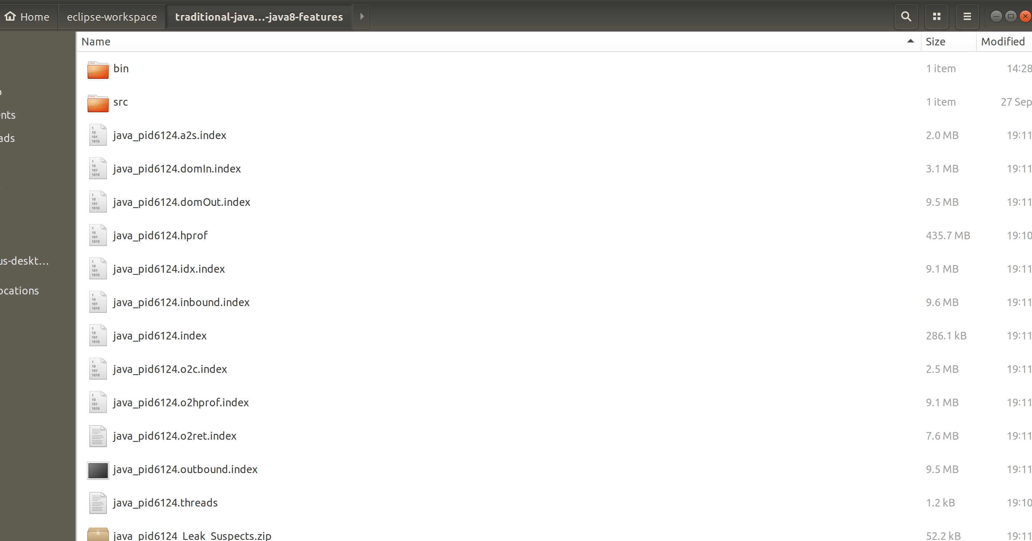

[] Component Report:
[] When you click on the ‘Component Report’ option, you’ll see a step-by-step proedure of identifying the problem:
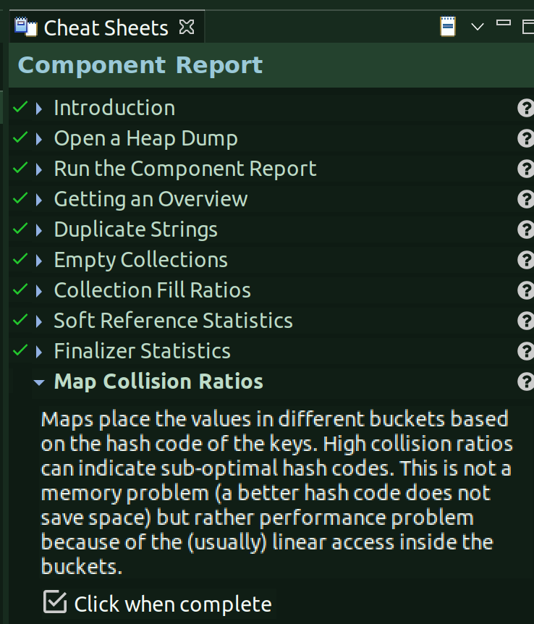

[] The key thing in this is we can run the report for each component, meaning, if you want to look at the report only from java.util.* perspective, to see what all that part of this component hierarchy are causing problems, then you just mention the name of the component and run the report.
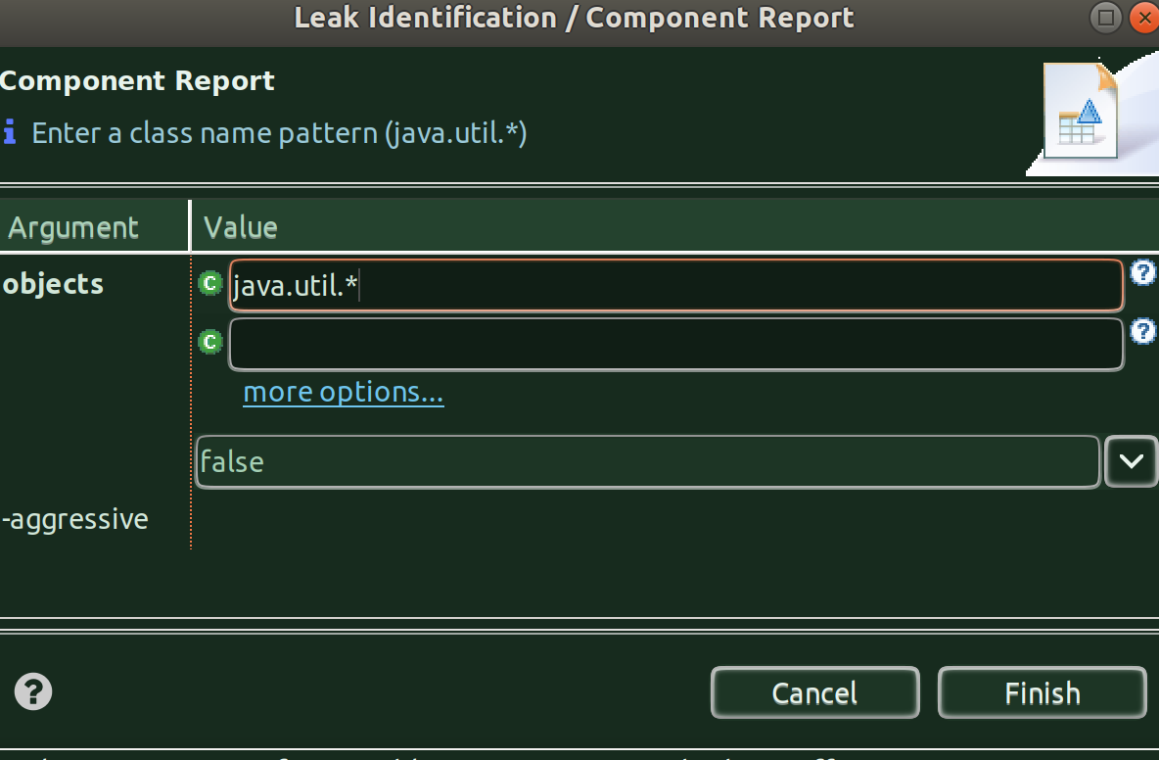

[] And, when you hit finish:
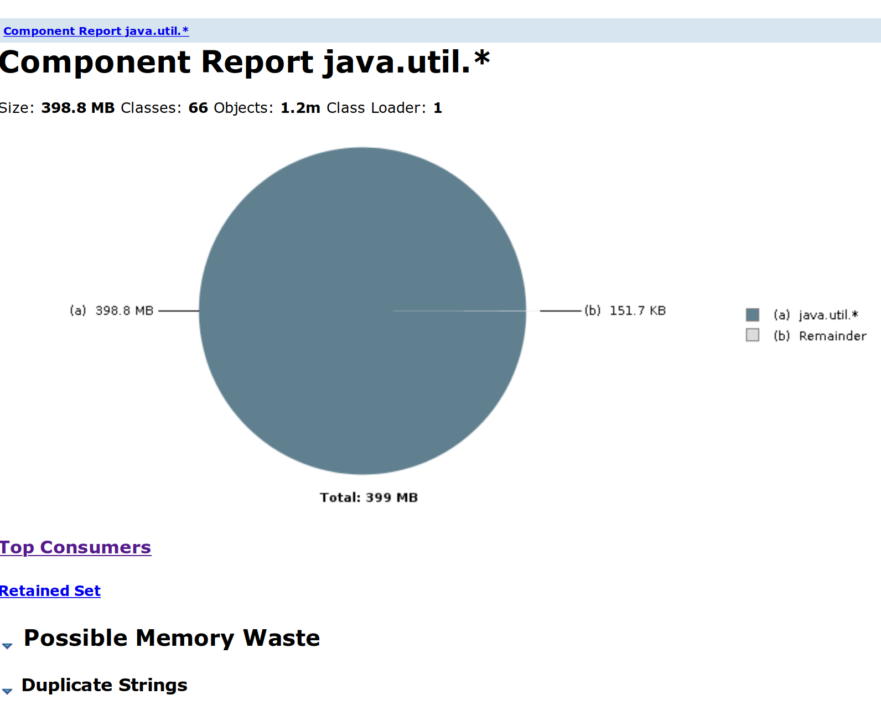

[] As you can see this report says, the size of this component is almost 400 MB out of the alloted 512 MB. You can look into further details from here in order to zero down on the exact component of this package.
[] If you open up ‘Top Consumers’ it’ll show which actual object is consuming that much heap:
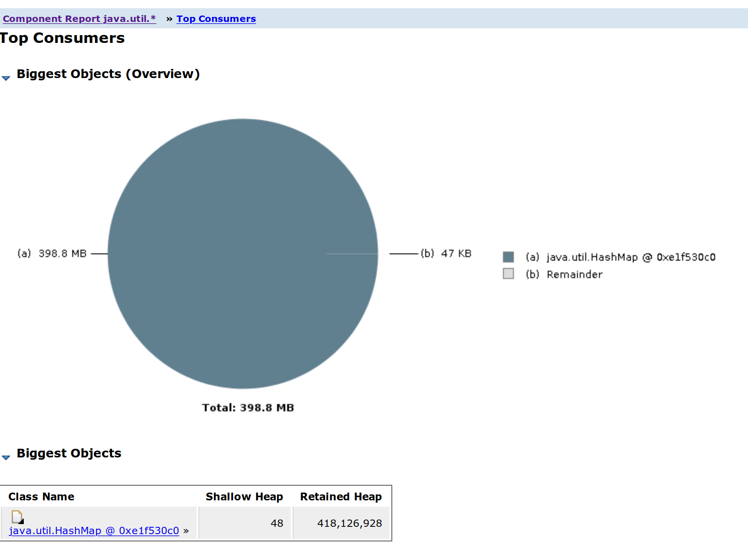

[] Here we go, it says it’s an HashMap which is casuing the trouble but we still don’t where in our code is this happening, to know that, click on the java.util.HashMap instance and choose ‘List Objects’ and ‘with incoming references’
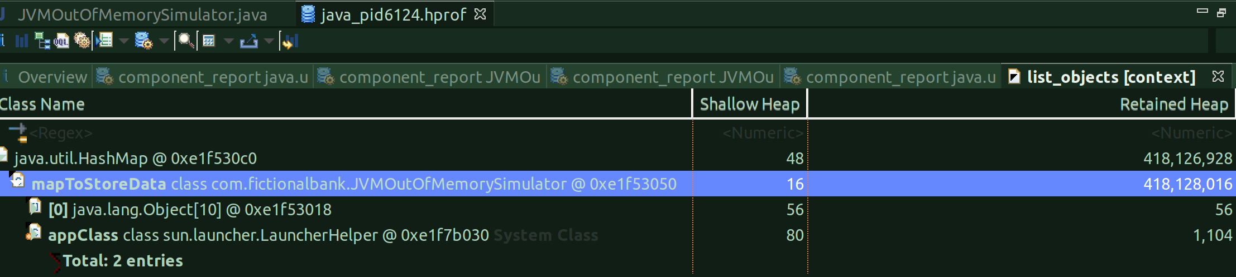
[] And, that’s it, it points out to the problem at hand.

[] Using Histogram:
[] We can also use ‘histogram’ to print all instances per class.
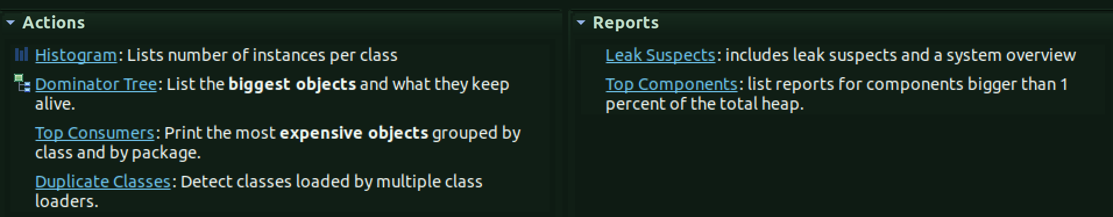
[] Once you click on that action, you’ll see this:
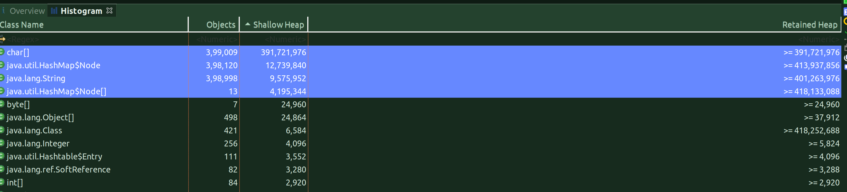
[] From the above, we can see the top classes which are occupying maximum heap. From here, you can, as usual, click on each and choose list objects => with incoming references to get to the part where it can lead to something in your class/code.

[Analysing the heap dump with VisualVM]
[] Let’s analyze the heap dump with VisualVM here.
[] Since, I’m not able to find the jvisualvm instance on my linux machine which I can directly invoke, I will, for now, invoke the instance from Eclipse.
[] Since we have already configured eclipse to launch visualvm during debug mode:
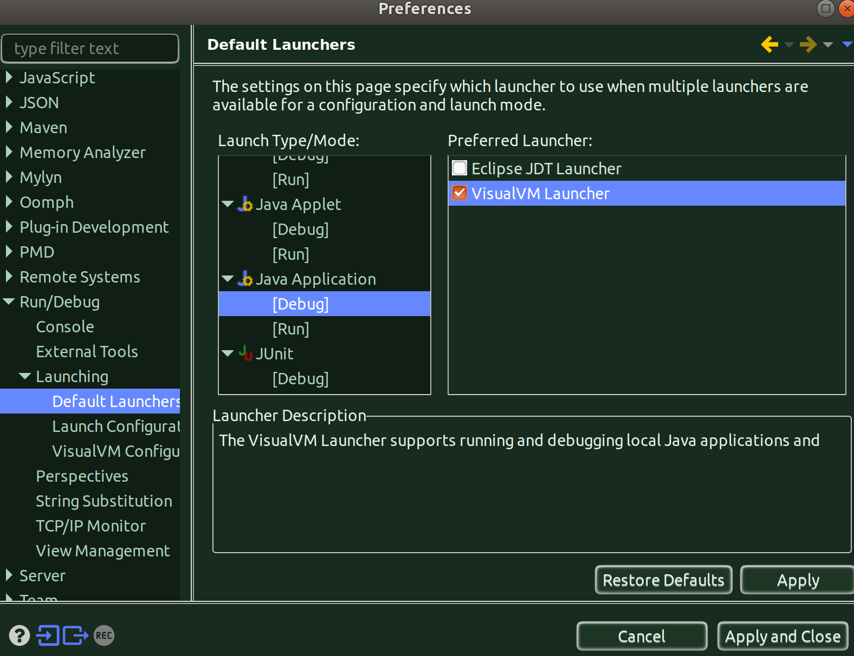
[] So, let’s run the program in debug mode.
[] And, the Java VisualVM Opens up. Go to File, Load, and choose *.hprof as the file type and load your already generated heap dump file, which you generated using the vm argument.

[] Summary Tab:
[] And,as the heap dump is loaded by visualvm, this is what you’ll first see:
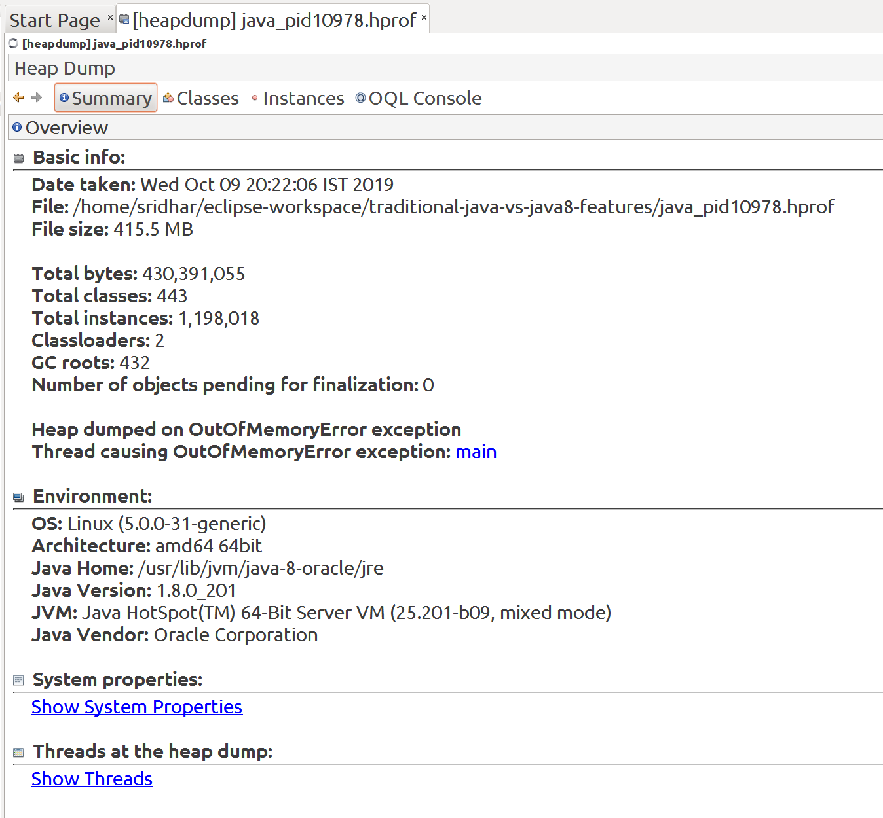
[] This summary says the instances of this heap dump are occupying 432MB of the heap space.
[] If you notice, it mentions, ‘Thread causing OutOfMemoryError Exception’ and if you click on that link, you’ll see all threads at that heap dump:
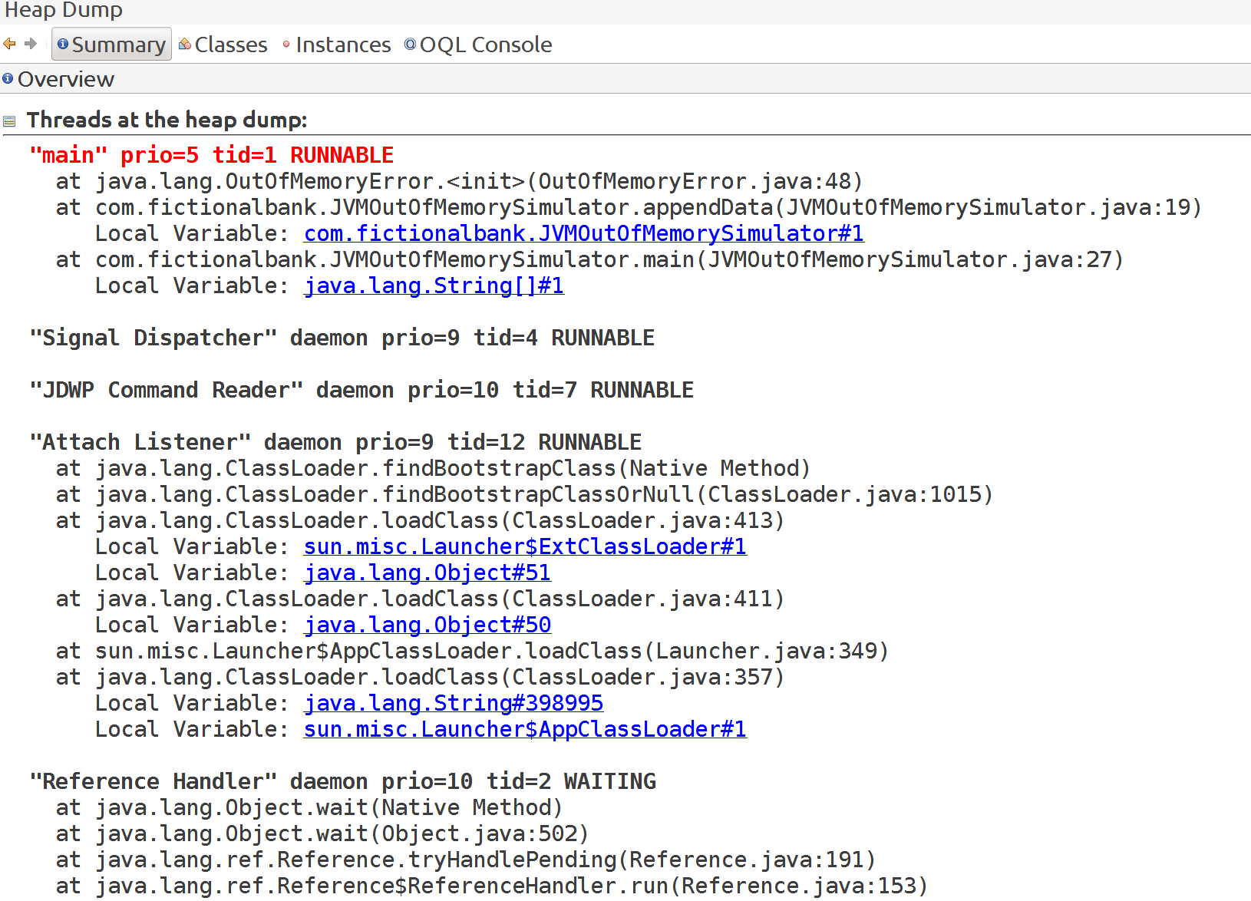
[] This does give us a lot of information.
[] If you click on the first Local variable, it’ll take you to the instance level and show what’s that:
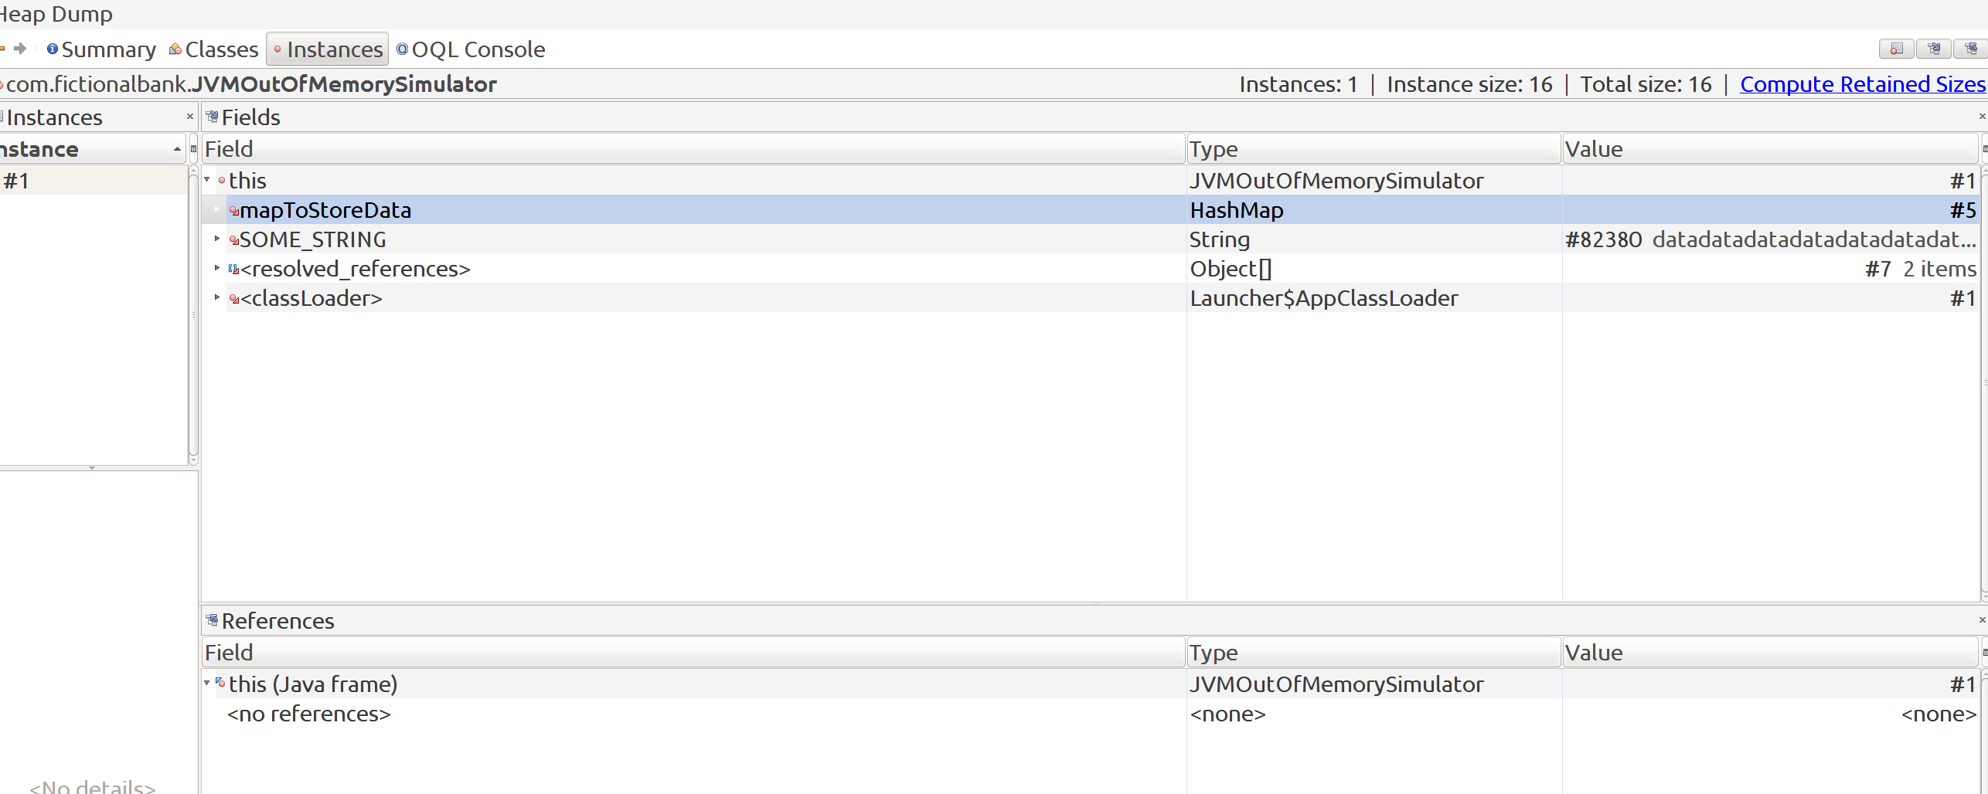

[] And, we can see that it’s poiting to our mapToStoreData HashMap instance and also to the SOME_STRING static variable. To find out more, just right-click on each and choose show instance
[] So if i choose to see all instance of mapToStoreData:
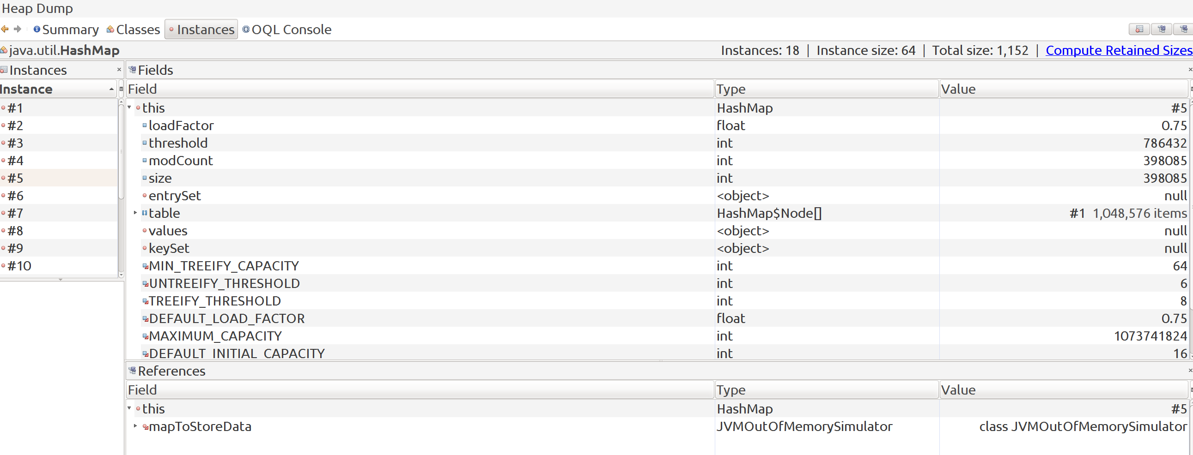

[] Classes Tab:
[] We can directly go to the classes tab and see which are the suspect classes:
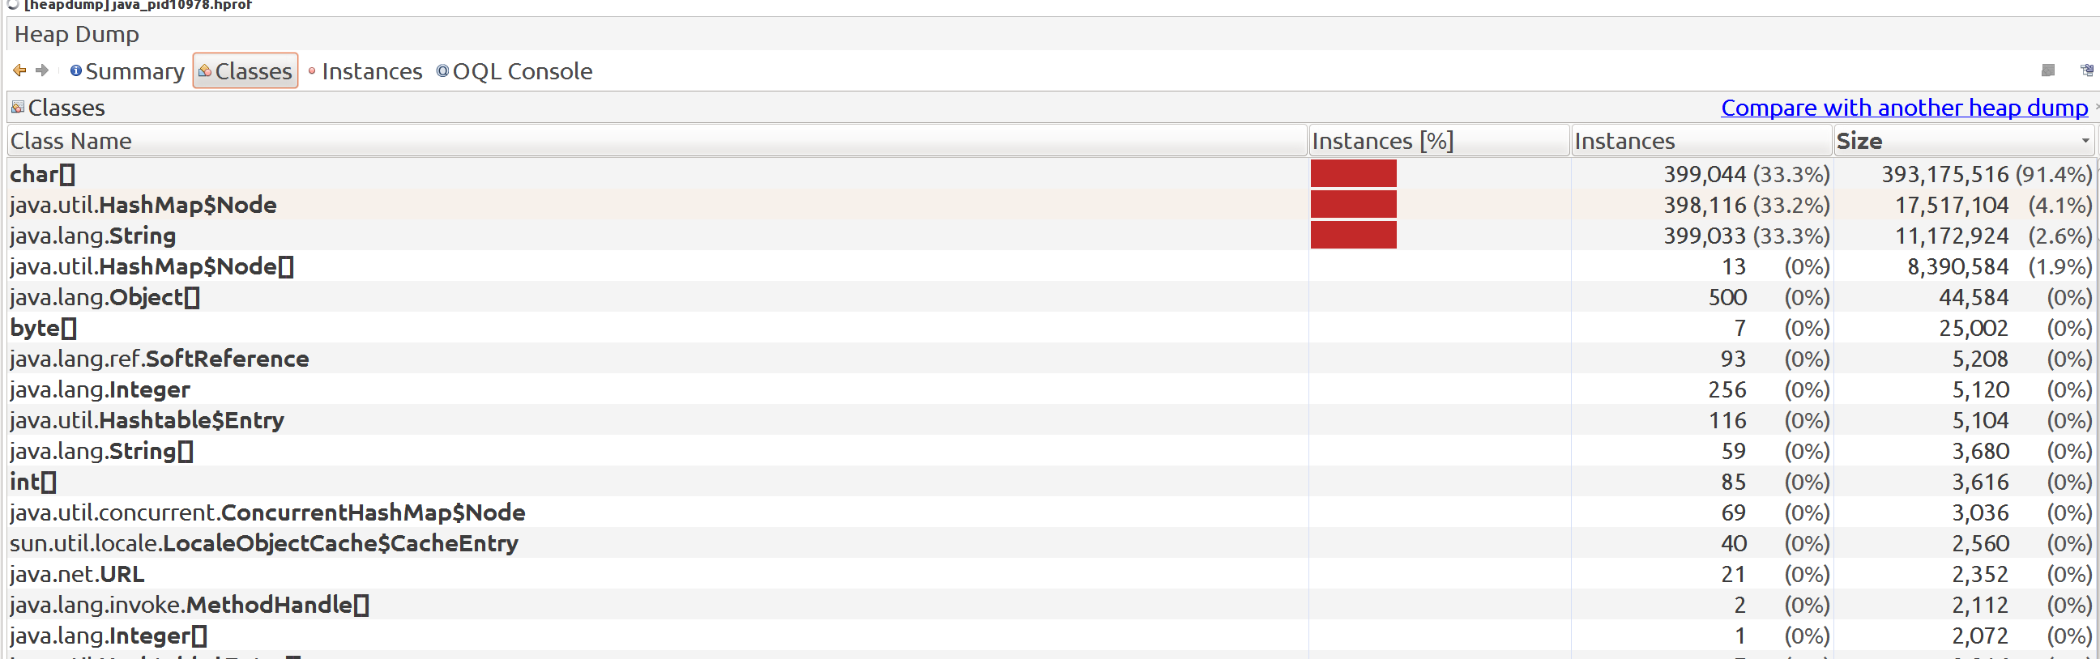
[] You can now click on each and navigate through by choosing ‘show instance’

[] COMPARING HEAPDUMPS OF 2-VERSIONS OF THIS PROGRAM:
[] In this we’ll make some changes to code and take heapdumps to see how the changes are having an impact.

[] First-version: comment out string appending:
[] We’ll now make some code modifications to not append string i.e. we’ll avoid creating new strings and just put the final String value into the HashMap instance the same number of times:
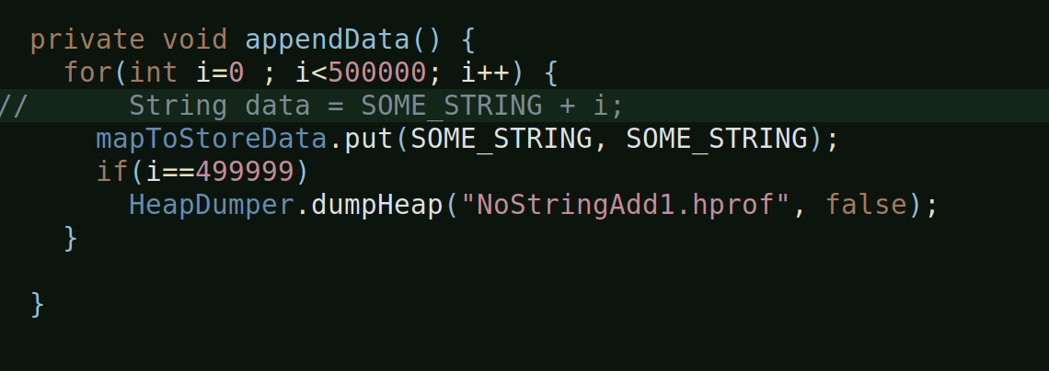
[] The HeapDumper is the prograatm which generates heapdump at the desired point-in-time programmatically. Here, I’m asking it to generate a heapdump at last but one iteration.
[] Okay, so lets open this heapdump from visualvm:
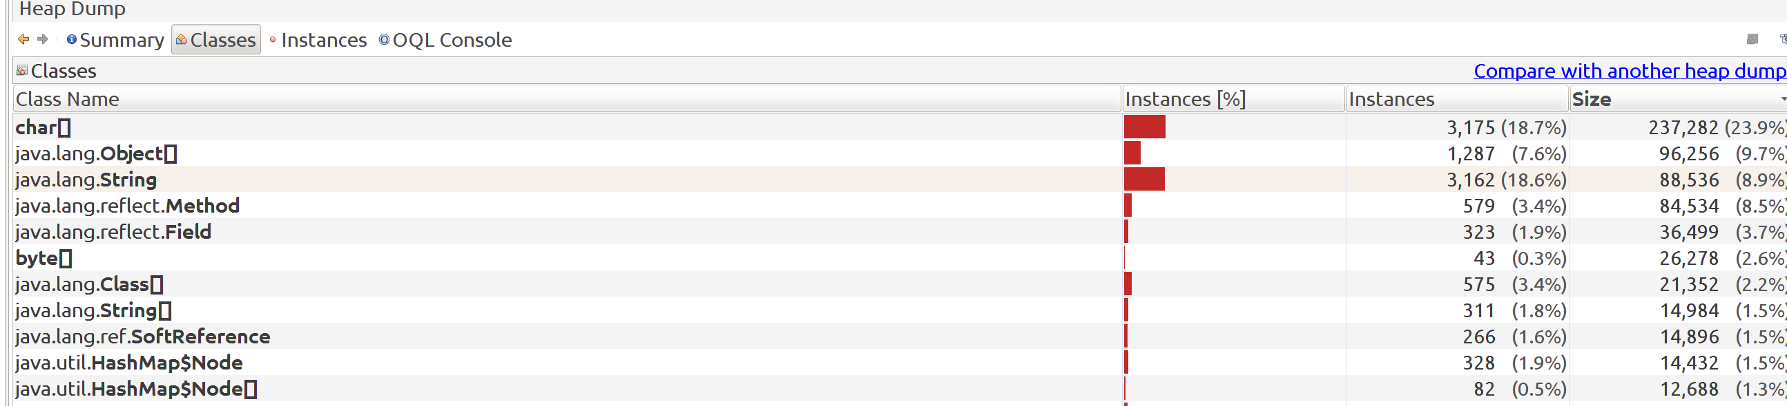
[] And, you can already see a lot of difference, for reference, below is the heapdump classes snapshot of the original one, where we appending string:
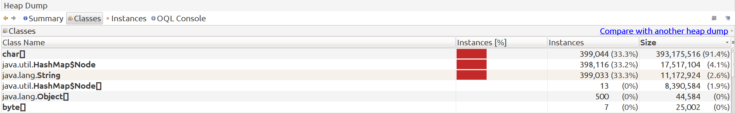
[] You can see the difference in the instances and their memory. The original one was occupying some 430 MB and the new one hardly some 0.1 MB, you can see this from the summary view:
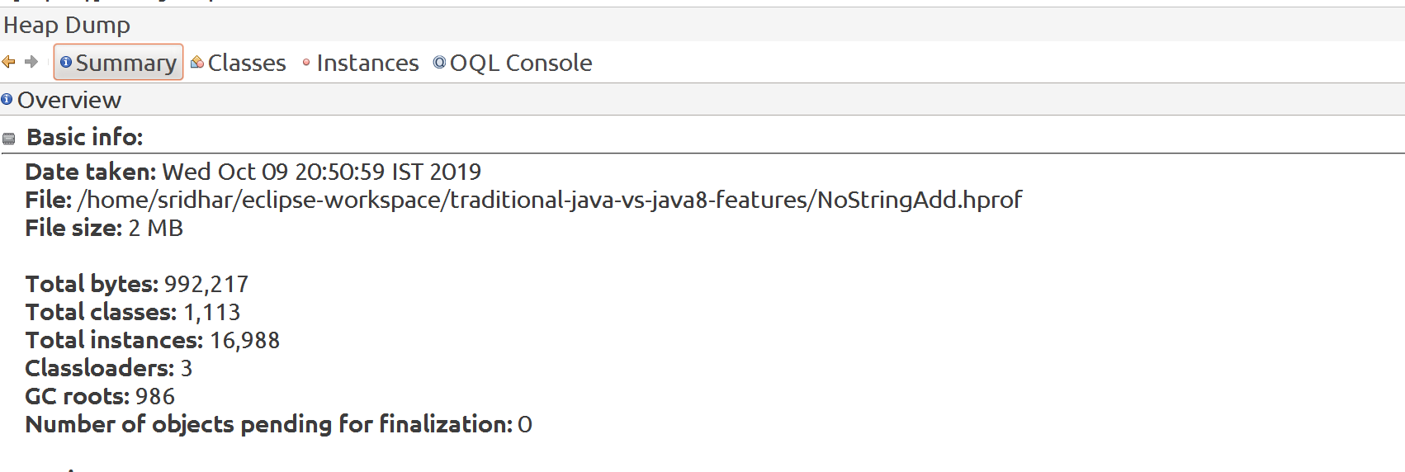

[] And, you can look at the String and HashMap node instances from the classes view.
[] So, the whole problem was probably started because of the string appending.

[] Second-version: enable string append, comment out map addition:
[] So, here, we will enable the string appending that we were doing in the loop but comment out putting elements into the map, that means, we
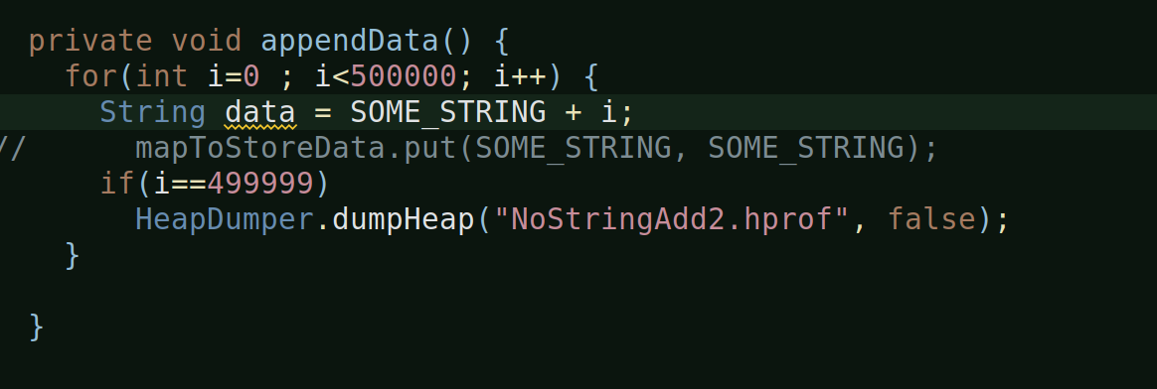
are almost taking the map out of equation:

[] After we run the program, a heapdump, will be generated programmatically.
[] Let’s analyze this with visualvm.
[] Summary view:
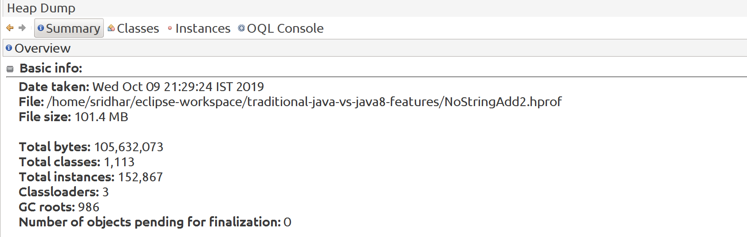
[] You can straight away see that even though this program did not run outofmemory, it still is occupying a lot of heap: 105 MB
[] This dint throw an outofmemory because we have set the heapsize as 512 MB, so it was within limits but still huge.
[] Compare it with the one where we had commented the string append, it occupied 0.1 MB, even the heapdump which showed live and inactive objects of this program (in which we commented string append), it still occupied only 4 MB. But when you enable string append and take out putting elements into Map, it still takes 105 MB.

[] Class view:

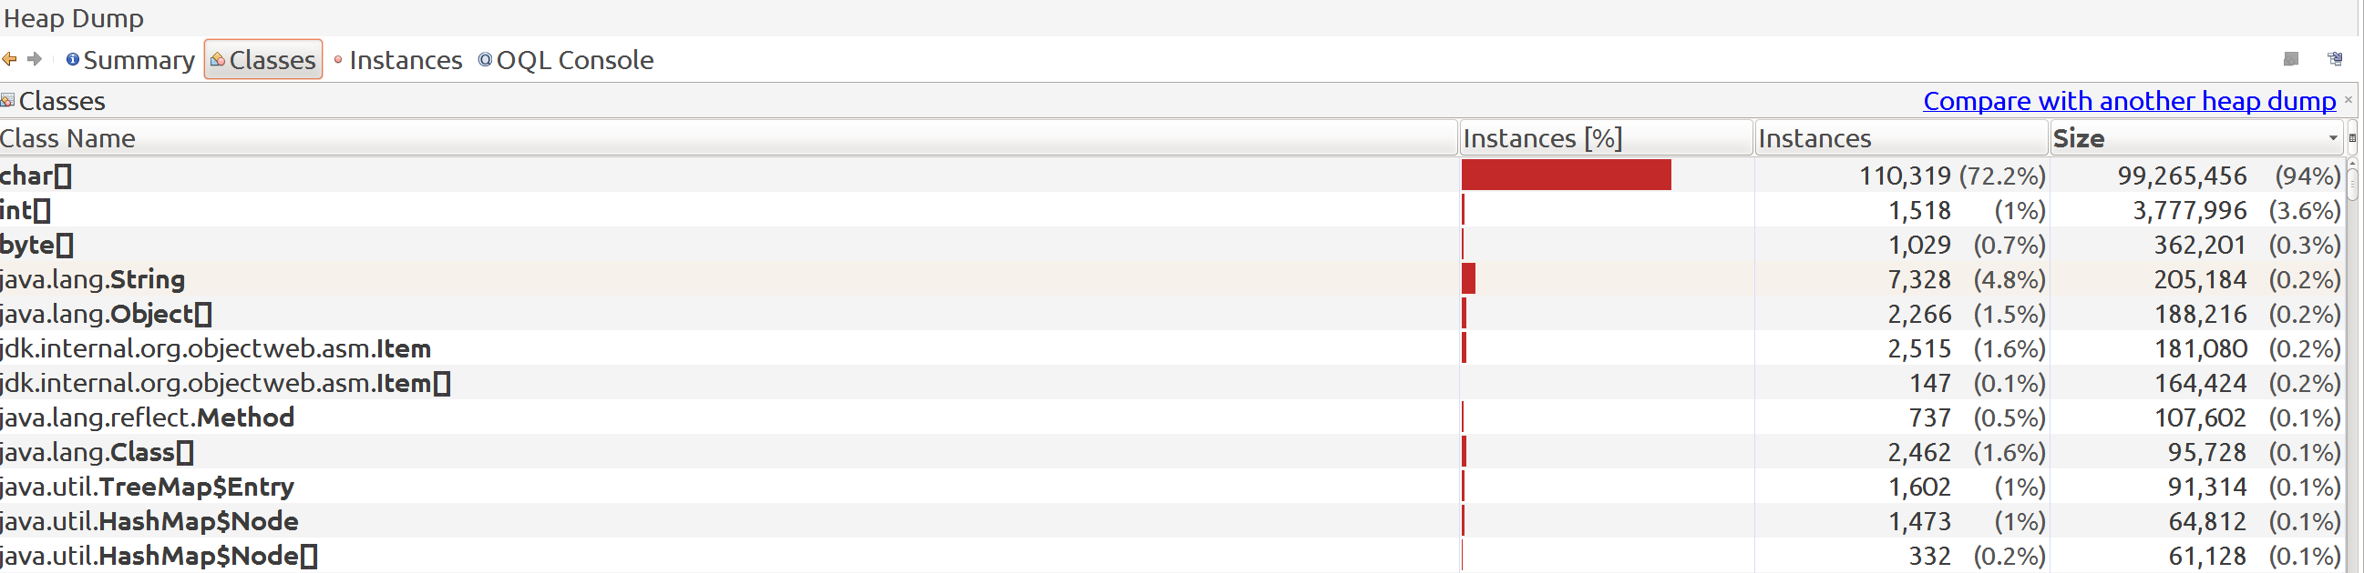
[] Look at the char[] instances, 110k in number, compare it with the heapdump of program where these is no string append, it is just 3175 in number.
[] These instances are getting generated because of the new strings.
[] Look at the string instances – 7327 vs 3162.
[] So, these results show us that, it is the string append i.e. new string creation which is really causing a lot of problem.

[PROFILING A PROGRAM AND ANALYZING : BuggyCache.java]

[] This is a sample program which purposefully makes an logical blunder and hence gives a good scenario to profile the application and learn from it.

[Methods, Nested classes and Datastructures]:

[] ObjectInCache static class:
[] This is a nested static class. It’s only purpose is to return the key (a string), passed to it by the caller as is.
[] The constructore sets the key passed to it and the getKey method returns the same.
[] Const. And getKey are public methods.
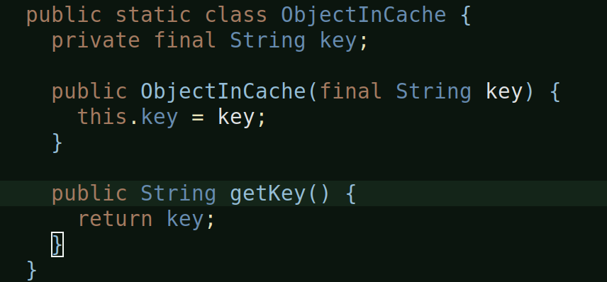
[] complexObjectFinder method:
[] This method returns an ObjectInCache instance and takes in String as input.
[] It basically calls thread sleep for 10 ms and then simply calls ObjectInCache method and returns whatever it returns and that returns nothing but what this method actually passes it to it.

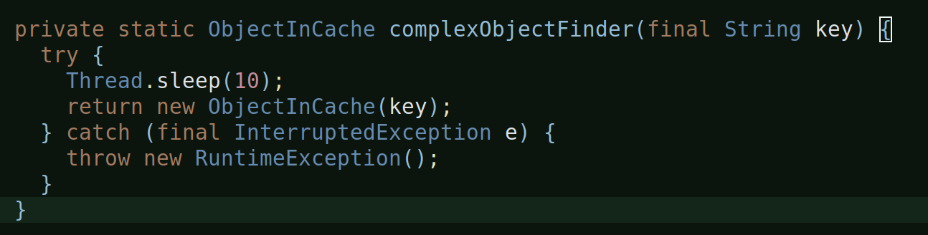
[] Main datastructure:
[] The main ds in use here is an HashMap which is synchronized:

[] computeForKey method:
[] Returns nothing and takes in a String.
[] It basically checks whether the HashMap already has the key that it is looking for, if yes, it just prints out a message saying ‘key is avilable already’ or whatever. If not, then call the complexObjectFinder method passing it the new key, which returns the ObjectInCache instance and then put that object into the map as a key.
[] Of course, the above action is an logical error, we should actually be calling a getKey on that object and put that into the key, but then the purpose of this program is to help us profile this class and learn from it.
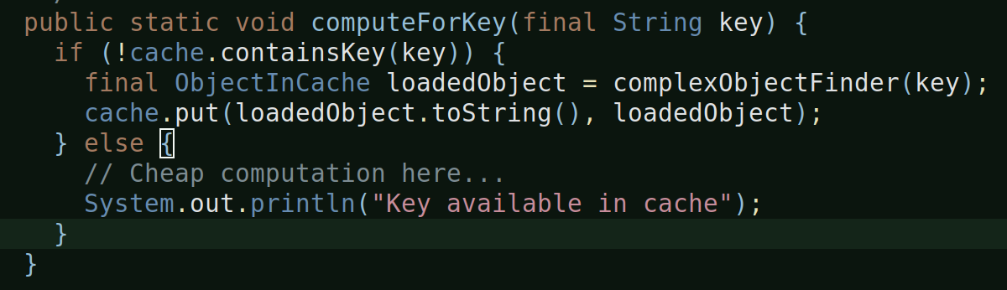

[] main method:
[] The System.in.read() waits for us until we press enter in the console, this allows the visualvm to open and be ready otherwise the program will just finish and visualvm won’t be able to profile.
[] The other way is to just put a breakpoint and we can then resume when the profiler is all ready.
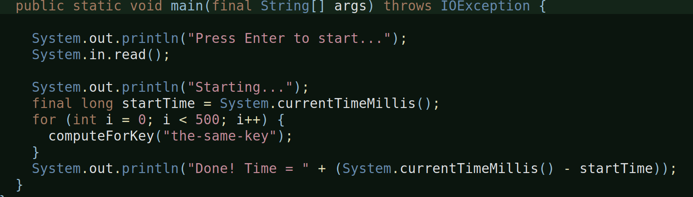

[] And, once we press enter, it calls computeForKey 500 times passing the same key every time.
[] Ideally, since it is the same key, computeForKey should check if it already exists in it’s map and if yes, it should print out a message, that is, it should not be calling the the complexObject
[] But since there is an logical error in computeForKey method where it is putting in the object (rather than the string), everytime it when checks to check if the key exists, it won’t find it, because you are comparing a string (“the-same-key”) with an object and hence it’ll end up putting 500 objects into the map instance.

[VM Configuration]:

[] As we already know that the profiler visualvm won’t be able to cpu profiling for classes which do not have -Xverify:none configured as an vm argument, we’ll make that change:
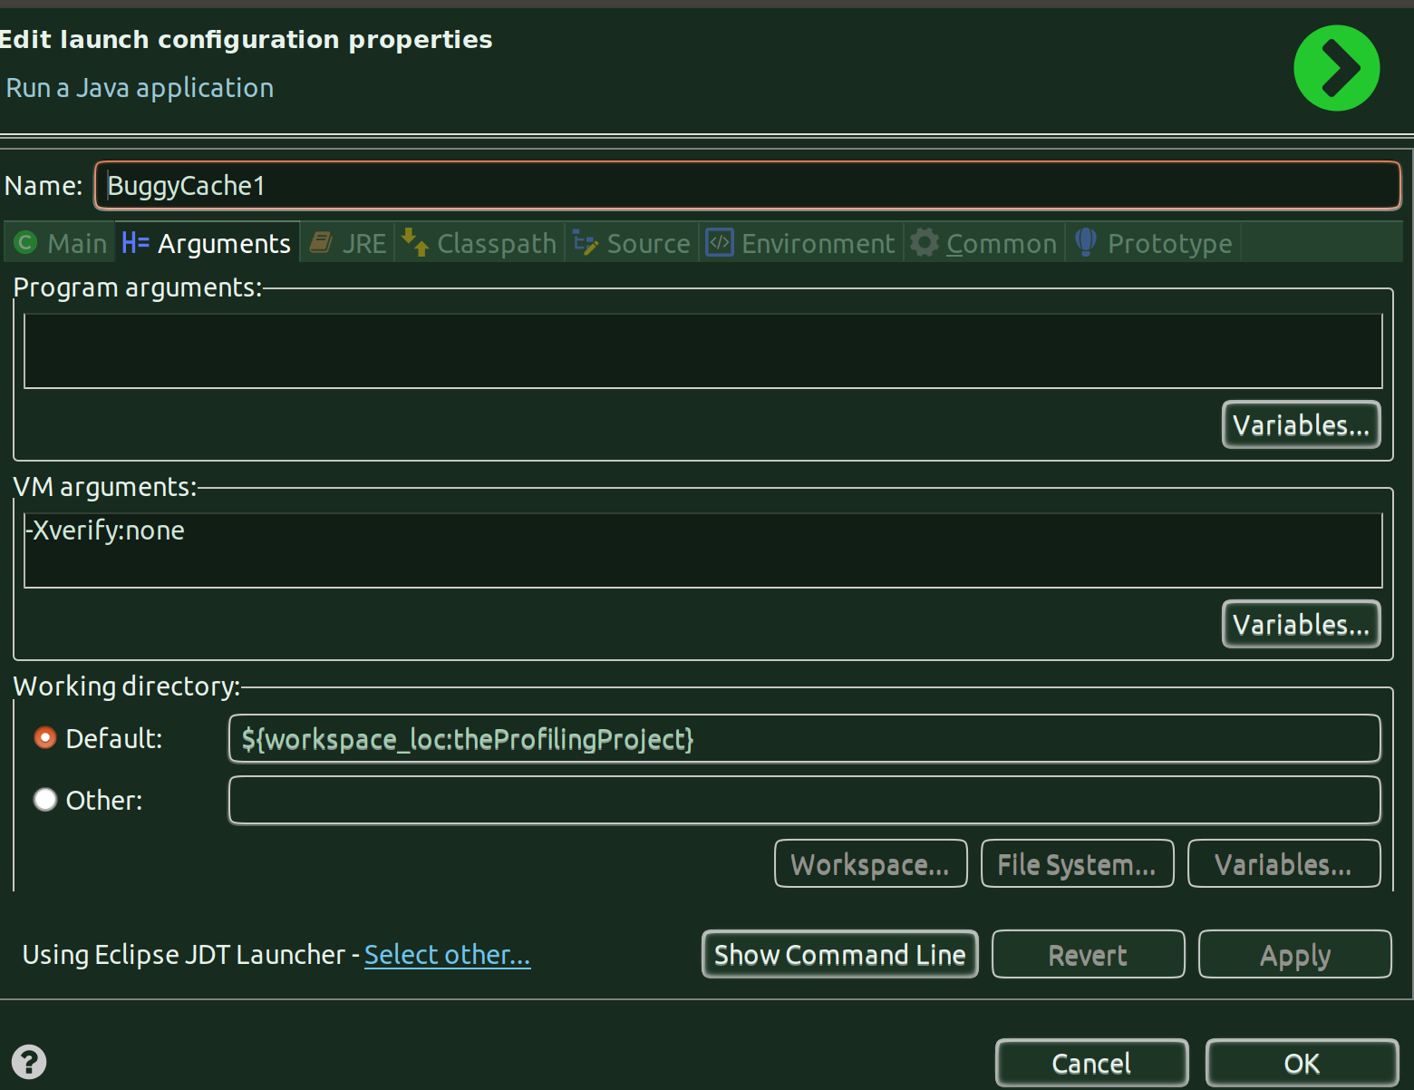
[] At this point I don’t know why doesn’t visualvm profiler work w/o this configuration but it seems this configuration is decom. From Java 13 onwards and it is not preferred at all production environemnts.
[] -Xverify:none shuts down byte code verification by the VM which can lead to security problems and hence it is discouraged. But for now, since we don’t have an option, we are just going with ti.

[Run the Program]:
[] Okay, so let’s run the program in debug mode – since we have configured visualvm to be launched only during debug mode.

[] CPU Profiling:
[] Wait for the visualvm to launch and when you can see the ‘Profiler’ tab in visualvm, go to the tab, and hit on CPU and it’ll start profiling.
[] You can see it says 20 methods instrumented.
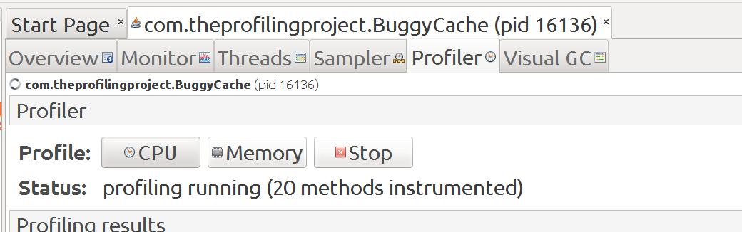
[] As soon as the program execution finishes, the visualvm profiling also finishes and you’ll see the report in visualvm:
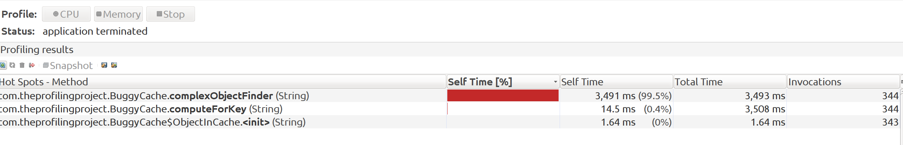
[] And, from our console in eclipse, we can see that the program took around 5.1 seconds and our program didn’t output the message it is suppose to print when it encounters an existing key.
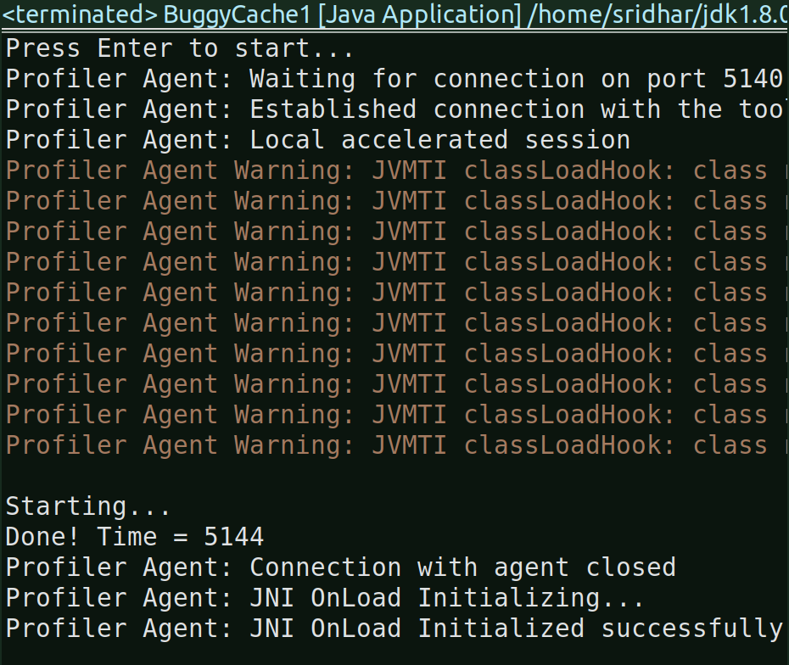
[] And from visualvm report, you can see that the complexObjectFinder method which ideally should have been called only once (since it is the same key), rather has been called 344 times, the same no.of times the computeForKey has been called.
[] You can’t go any deeper into this from visualvm since this is not a heapdump but just a cpu profile snapshot.
[] I’m not taking any action on this yet, let’s also do a memory profiling.

[] Memory Profiling:
[] Run the program again and this time hit on ‘Memory’ tab in visualvm and then press enter in the eclipse console.

[] The above snapshot says the number of classes instrumented by visualvm.
[] And, this is the summary of the profiler results:

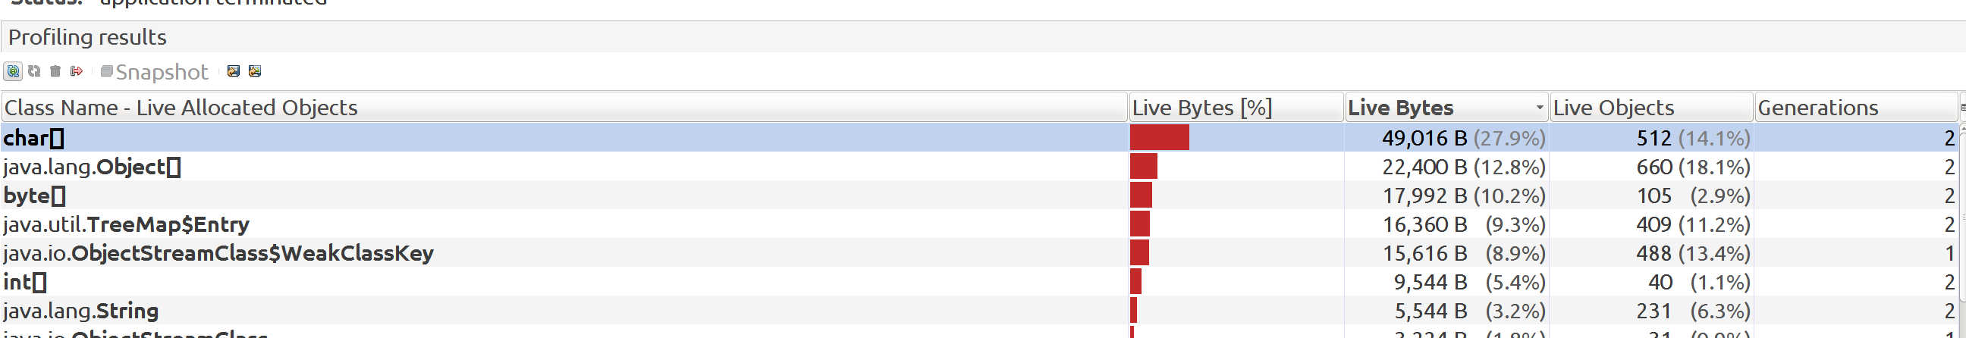
[] Okay, strictly speaking, the Memory profiling results does not point me towards anything unsual or problematic. So, I will stick to the CPU Profiling results which is definitely saying that there is problem mostly in the computeForKey method because the complexObjectFinder has been invoked the same no.of times as that of the computeForKey. So, let’s take a look at the code and do the corrections.

[Correcting the logical flaw in the program]:
[] Okay, so let’s just go ahead and correct the logical flaw in the program.
[] The fix is simple, you just have to ensure the key (which is a string) is put into the map instead of the entire object.
[] And, after the correction, this is what it looks like:
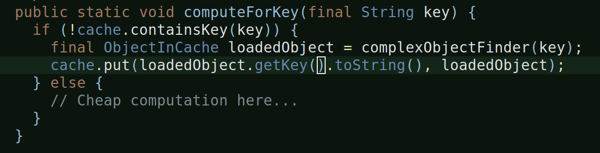
[Run the program after correcting the logical flaw]:
[] Now lets run it and see for ourself what difference do we see in visualvm.
[] Run time of corrected program:
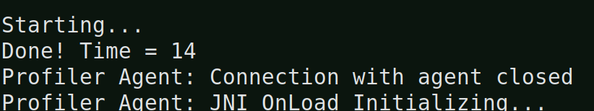
[] That’s just 14 ms i.e. 0.014 seconds
[] The buggy program was taking 5.1 seconds to complete.
[] And, it also outputs the printed message, which it should when it encounters the same key.

[] CPU Profiling:
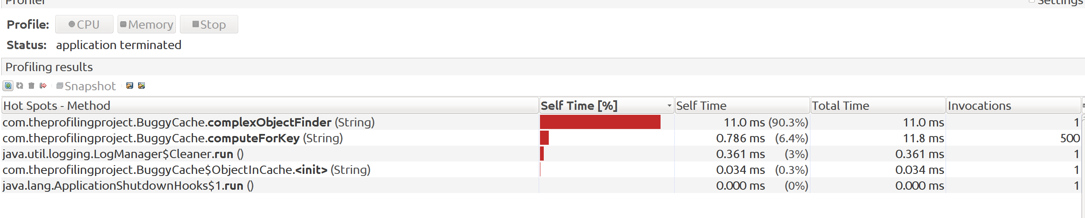
[] See, now the invocations for complexObjectFinder is 1 and computeForKey is 500 as it should be.
[] And the time it takes is also just 11 ms.

[] Memory Profiling:
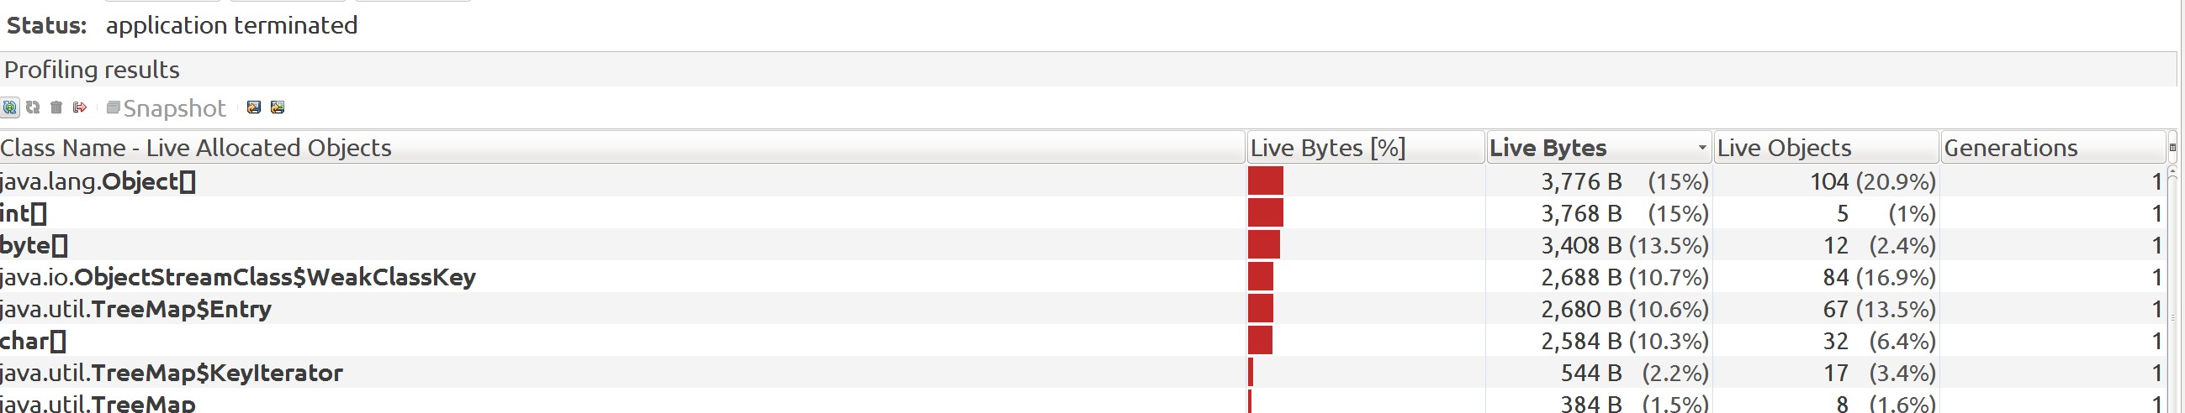
[] I definetely see a reduction in the no.of bytes, but honestly, just looking at the above memory profiling result is not pointing me to anything suspicious. I mean, how would I know what is the appropriate amount of bytes a program should be taking. The program is not running outofmemory so it is hard to tell from the above memory profiling snapshots if there is any problem or not.

[Checking with flawed code with static analysis tools]

[] So, I wanted to see if any of the existing static analysis tools i.e. PMD, Checkstyle and SpotBugs would find the flawed logic in the code.

[] PMD pointed towards RunTimeExceptions being thrown but that’s it, neither PMD nor other static analysis tools found out or warned me about the flawed logic in the code.

[] Must say, disappointing.

[] Having said that, this logical flaw ideally should be caught by an unit test, so it’s okay even if none of the static analysis tools point it out.

