[PROJECT SCOPE]
1.This is a banking application.
2.It allows users to withdraw money, check balance, get transaction details and credit money to account.
3.No persistence store is maintained and also no user details are maintained by the application, for the sake of simplicity.
4.We assume that any user doing any of the above mentioned operations on the bank account is a single user and the bank has only one user account.

[DATA STRUCTURES USED]
I’ve basically used an HashMap, an ArrayList and a String array.

The HashMap stores all the transactions for all users (in this case, we are using only one user).

So, the key in the HashMap is actually the user account id and the List<String[]> is the list of all transactions of that user.

And, each String[] will hold transactions of this sort:
Where, the first entry is the date of transaction followed by the transaction type (Credit, Debit) and the amount that was transacted and the current balance after the transaction execution.

[DUMMY DATA CREATION]
Since there is no persistence store used in this application, all dummy transaction data is constructed in the constructor.

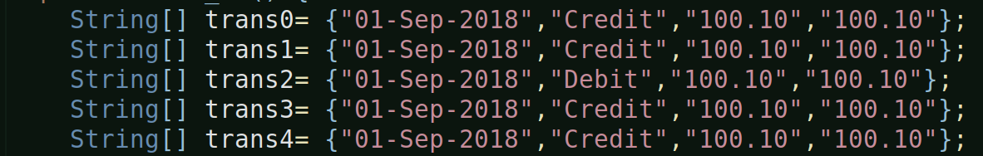

To construct the dummy data, I’ve taken help of the append functionality of excel/libre ofc document:
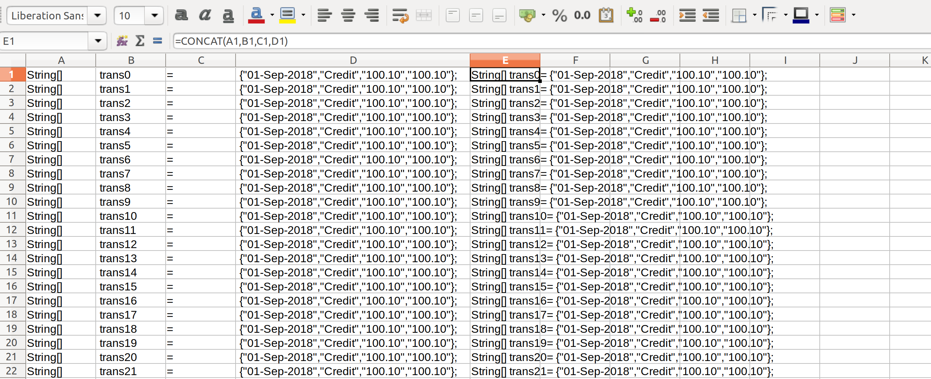
As you can see above, i’ve used the concat formula to prepare the dummy data.

[NOTE]
I’ve created two versions of the solution – one using traditional java features and the other using some of the Java 8 features.

The traditional version is Bank_v0.java and the java 8 feature verison is Bank_v1.java.

The data structures remains the same in both the versions.

[TRADTIONAL JAVA APPROACH]
The data structures, especially the List<String[]> and the HashMap<String, List<String[]>> have been given class-level scope so that all members access the same instance of these data structures.

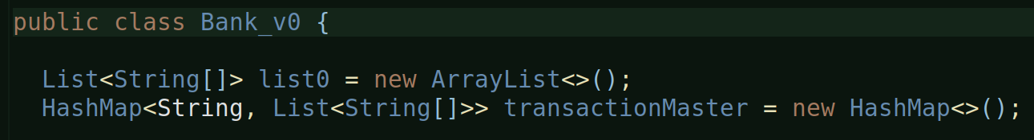

[METHODS]
Only two methods: one is the main() and the other is the transactions method.

This method is called from the main, multiple times.
‘flag’ can have values – n (to check current balance), c (to credit amount), d (to debit amount), tt-debit (to list all debit transactions) and tt-credit (to list all credit transactions).

And this method is called from main() as follows:
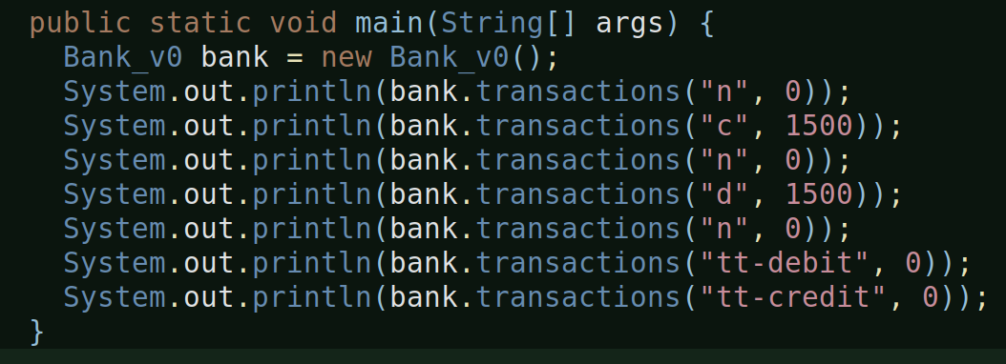

[TRANSACTIONS METHOD DETAILS]
[] To check balance:
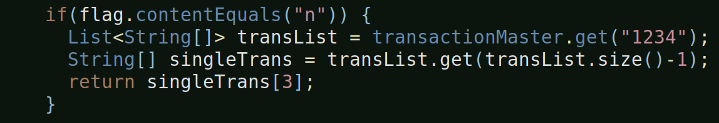
The above method returns the balance of the last transaction from the transList. Since, the List maintains insertion order, and since the List is constructed with the latest transaction being the last one, we fetch the balance of the last transaction.

[] To credit amount:
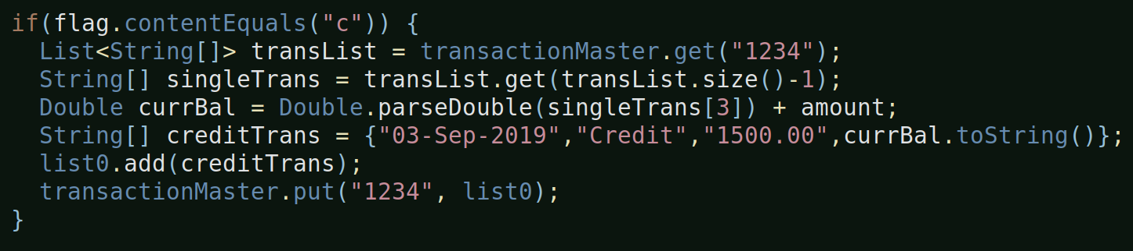
Notice, the above condition doesn’t return anything so after adding the new credit transaction to the class-level transaction master, the default return of the method (which returns null) will be returned in this case.

Same is the case with debit.

[] To get all transactions of type credit:
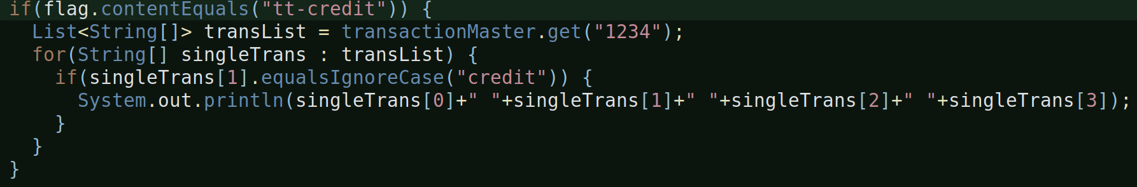
Iterates over the transaction list and checks for ‘credit’ type transactions and prints each element of those transactions.

Same is the case with debit type transactions.

[] Output will be in this format:
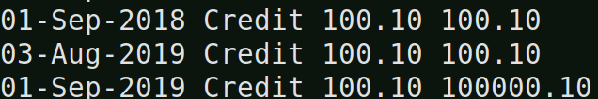
And, as already mentioned, the default return type of this method is ‘null’, so whenever any of those above mentioned ‘ifs’ do not return anything this ‘null’ gets returned.


So, all in all, this is how the traditional approach solution is. I’m purposefully returning ‘null’ here to tackle this problem with the Java 8 Optional, which we will see soon.

[OUTPUT]
When you run the traditional code, the output is as follows:
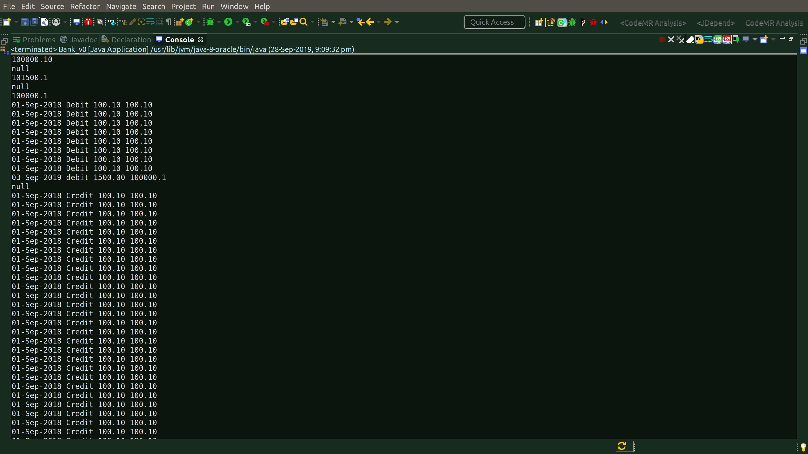

It has ‘null’ values also, as you can see.

[JAVA 8 BASED APPROACH]
The data structures used and their scope remains the same in comparision to Book_v0.java.

The dummy data is also constructed in the constructor itself, so no change here as well.

[METHODS]
Two methods, just like the traditional java approach but that’s where the commonality with the traditional approach ends.

Details of methods differ.

[TRANSACTIONS METHOD DETAILS]
This method returns an Optional<String> to tackle the ‘null’ return situation which was the case with the traditional approach.

So, whenever, any of those ‘ifs’ return nothing, the default return value of this method is an Optional, an Optional.empty to be precise:

[] To check balance:
In the traditional approach, we returned a string, here since the return type is Optional<String>, so we return:
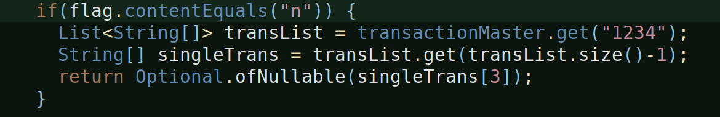
Because we always need to return something that is of type Optional, whether it is an Optional.empty or Optional.ofNullable, whatever it is, it has to be of type Optional.

[] To credit amount:
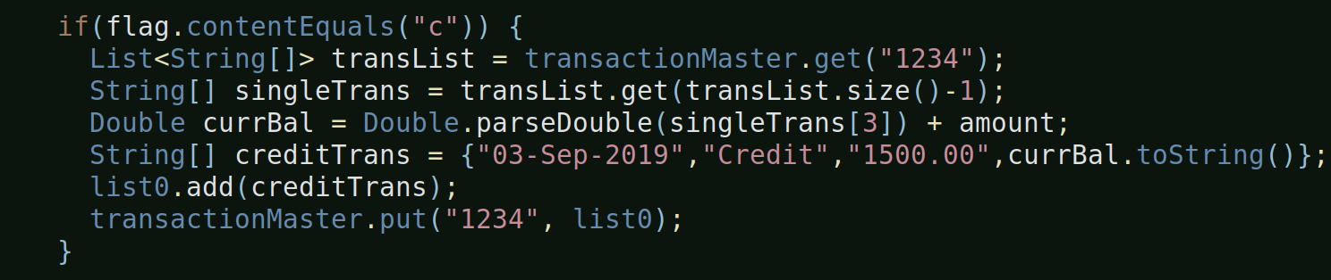
This and the ‘to debit’ functionalities do not have any change compared to the traditional approach because the HashMap (i.e. the Map) do not have the stream capabilities.
The stream capability is added to the Collection interface which is the super interface of List etc. But not Map.

So, in general, streams are available for use in Queues, Stacks, Sets, Lists but not Maps in Java.

[] To display all credit type transactions:
This is where most of the java 8 stuff like streams and lambdas are used.

We convert the list into a stream and then filter on the resulting stream to fetch only those transactions which are of type ‘credit’ and for each of those credit transactions, we print them.

a.Running a Stream on the List
So, in the above scenario when you run a stream on the List<String[]>,
you get a Stream<String[]>.

b.Applying a filter on the stream
And then the filter method on the stream takes a Predicate which is one of the functional interfaces in the java.util.function package.
The predicate takes one input and returns a boolean value. So, here, we are checking which array rows of Stream<String[]> have a ‘debit’ in the 1st index of the String[] array i.e. we are looking for those array rows which have debit in the 1st index like this:
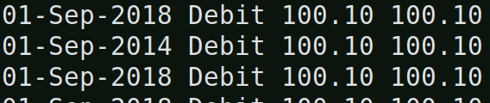

c.Perform an action on each element of the filtered stream
The forEach above takes a Consumer, which is another functional interface, which takes an input and does not return anything and hence to print the output we are using sysout. The forEach in the Stream interface is an terminal operation, meaning, once this is executed the stream ends, the stream will no longer anymore data after this.

The forEach in the above case, performs an action on each of the filtered stream elements. The action is to print each element of the filtered array, which in this case is a credit type transaction details.

In this case, since there is no return statement for this ‘if’, the default return value, that is, an empty Optional will be returned.

[] NOTE:
If you notice, in the above functionality to display all credit card type transactions, we used java 8 features, but compare it with the traditional java approach and see the difference. You’ll notice that, even though we have replaced the for-each and if of traditional java approach with a filter, we still had to use a java 8 forEach to complete the functionality, that means, purely in terms lines-of-code, there’s no difference.

[MAIN METHOD]
We make multiple calls to the transactions methods from here:

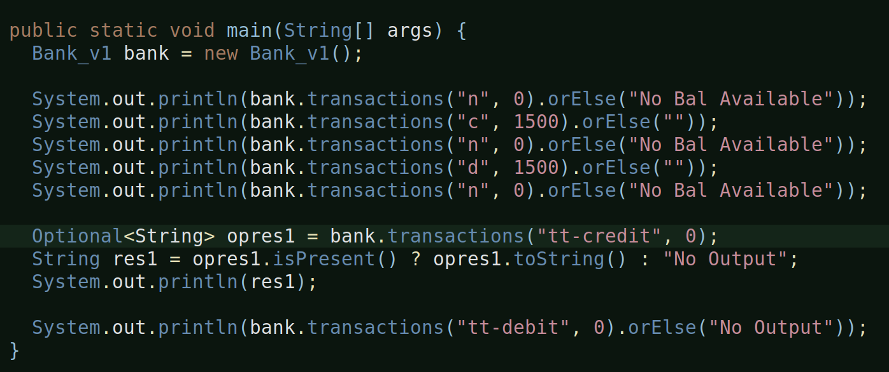
a.orElse:
Since the transactions method returns an Optinal<String>, we get the liberty to use the Optional class methods, an orElse is one of them.

It basically means, if there is a value being returned from the original method call, return it, otherwise, if there’s no value or an empty Optional then return “this message”.

OrElse can be used in place of a ternary operator.
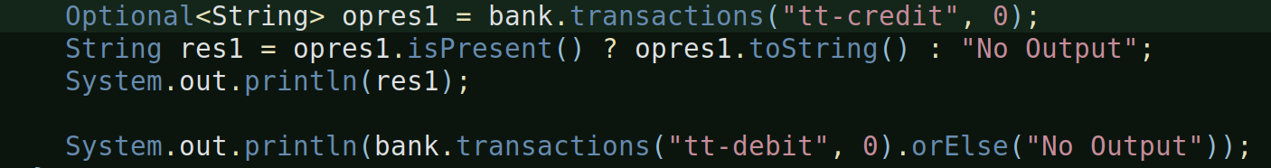
Look at the above statements, the first uses ternary and it requires three lines-of-code to get the job done and the second one uses orElse and it’s one line!

[OUTPUT]
Let’s look at the output of the entire java 8 feature program:
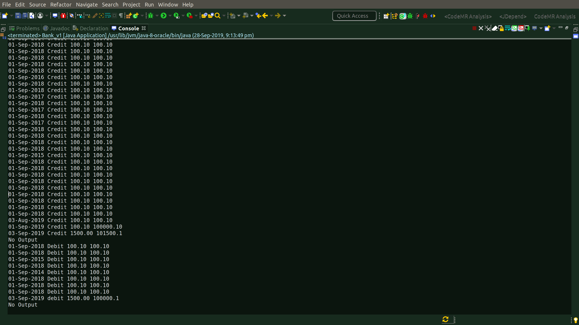
No ‘null’ values instead some text like ‘No Output’ and everything else remains same.

[NOTE]
So far, what’ve implemented in java 8 is Streams, Functional Interfaces, and Lambdas.

[PERFORMANCE MEASUREMENT]

[] One of the other significant aims of this small project was to determine the performance implications of using the new java 8 features compared to the traditional ones.

[Comparing time-of-execution]:
[] I compared execution time of traditional java blocks against the ones with java 8 features as follows:
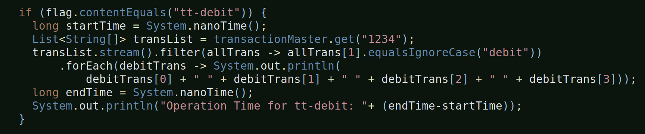
[] As you can see from the above image, I have taken-in the start-time and the end-time and calculated the total-time taken for the execution. I’ve done the same for the traditional java code block as well.

[] Following are my observations (in nano seconds):

Traditional Code | Java 8 Code
1237431 ns i.e 1.24 ms | 1204297 ns i.e. 1.2 ms
1547688 ns i.e. 1.55 ms | 1565961 ns i.e. 1.6 ms
1608758 ns i.e. 1.61 ms | 1713265 ns i.e. 1.71 ms
2195857 ns i.e. 2.2 ms | 1431995 ns i.e. 1.43 ms

[] Each code was run four times and the dataset comprised of 1140 records.

[] And, as you can see, there is not really much of a difference. At times, traditional code has been slightly better and other times the java 8 code has been. So, can’t conclude, really.

[] Note: The # of Java 8 features so far are hardly any. So, this can’t be called full-scale comparision.

[ISSUE: COULD NOT FIND OR LOAD MAIN CLASS]

[] Was trying to execute the java program (Bank_v1) from command-line and i encountered an error saying ‘could not find or load the class’ issue.

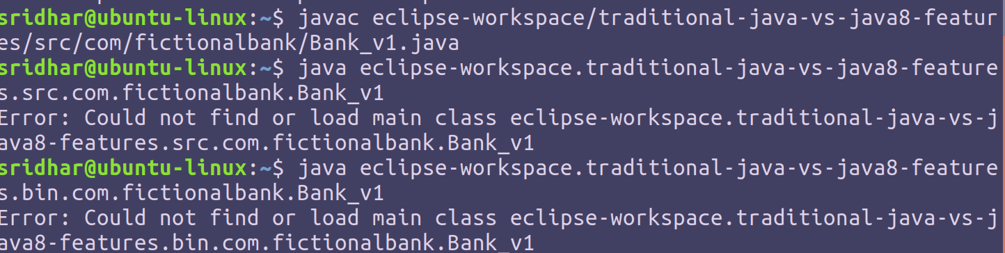
[] As you can see from the above snapshot, javac works fine but not java.

[] It’s working fine from eclipse, so it’s obviously a classpath issue.

[] PATH is used locate system executable, commands or .exe, .dll files (in Windows) and .so files (in Linux). It is also used to locate native libraries used by your Java program. While, CLASSPATH is used to locate the class file or JAR files. It's Java class loader who looked into CLASSPATH for loading classes.

[] Solution:
[] So, here, I’m not going to set up the classpath in the env variables rather i’m gonna pass it while execute using the -cp option, as follows:

[] here we go, that’s it.

[] what we basically did is, we passed the following:
homesridhar/eclipse-workspace/traditional-jankava8-features/bin which is the path to the folder where the class file resides

[] what follows next is the package name of the class followed by the class name i.e. com.fictionalbank.Bank_v1

[] even though inside bin, you will find com and fictionalbank as folders but they are actually packages in terms of java application and hence while executing the program we need to pass that info as packagename + classname.

