[BANK_v0.java and BANK_v1.java]

1.This is a banking application.
2.It allows users to withdraw money, check balance, get transaction details and credit money to account.
3.No persistence store is maintained and also no user details are maintained by the application, for the sake of simplicity.
4.We assume that any user doing any of the above mentioned operations on the bank account is a single user and the bank has only one user account.

[DATA STRUCTURES USED]
I’ve basically used an HashMap, an ArrayList and a String array.

The HashMap stores all the transactions for all users (in this case, we are using only one user).

So, the key in the HashMap is actually the user account id and the List<String[]> is the list of all transactions of that user.

And, each String[] will hold transactions of this sort:
Where, the first entry is the date of transaction followed by the transaction type (Credit, Debit) and the amount that was transacted and the current balance after the transaction execution.

[DUMMY DATA CREATION]
Since there is no persistence store used in this application, all dummy transaction data is constructed in the constructor.

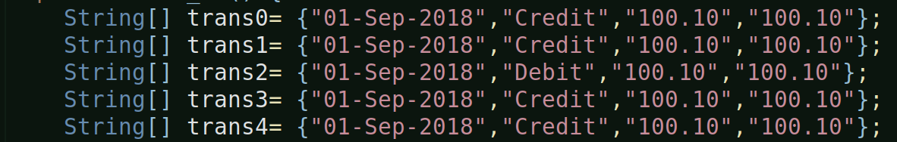

To construct the dummy data, I’ve taken help of the append functionality of excel/libre ofc document:
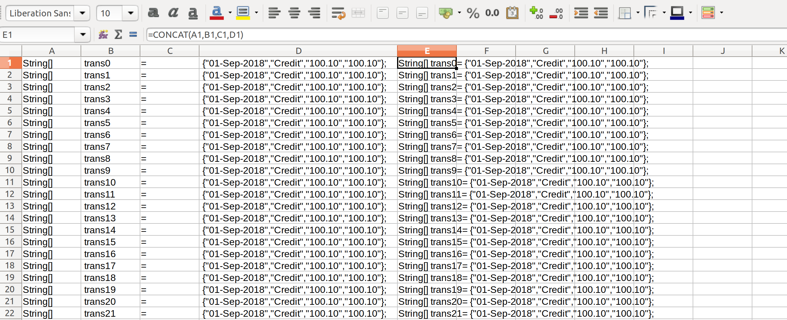
As you can see above, i’ve used the concat formula to prepare the dummy data.

[NOTE]
I’ve created two versions of the solution – one using traditional java features and the other using some of the Java 8 features.

The traditional version is Bank_v0.java and the java 8 feature verison is Bank_v1.java.

The data structures remains the same in both the versions.

[TRADTIONAL JAVA APPROACH]
The data structures, especially the List<String[]> and the HashMap<String, List<String[]>> have been given class-level scope so that all members access the same instance of these data structures.

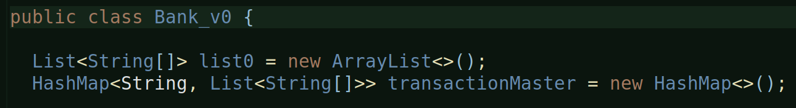

[] METHODS:
Only two methods: one is the main() and the other is the transactions method.

This method is called from the main, multiple times.
‘flag’ can have values – n (to check current balance), c (to credit amount), d (to debit amount), tt-debit (to list all debit transactions) and tt-credit (to list all credit transactions).

And this method is called from main() as follows:
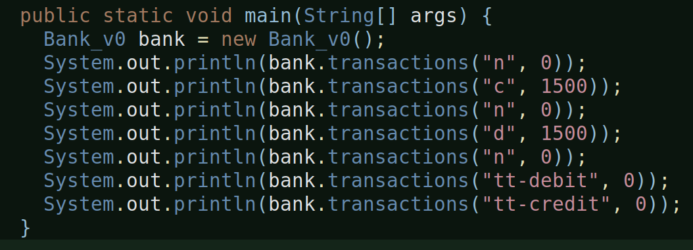

[] TRANSACTIONS METHOD DETAILS:

[] To check balance:
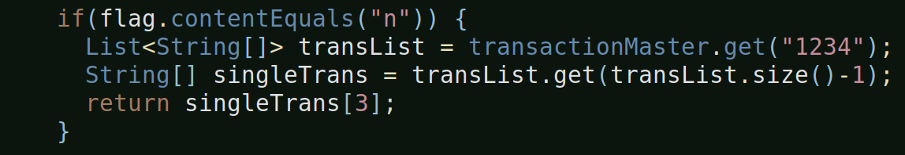
The above method returns the balance of the last transaction from the transList. Since, the List maintains insertion order, and since the List is constructed with the latest transaction being the last one, we fetch the balance of the last transaction.

[] To credit amount:
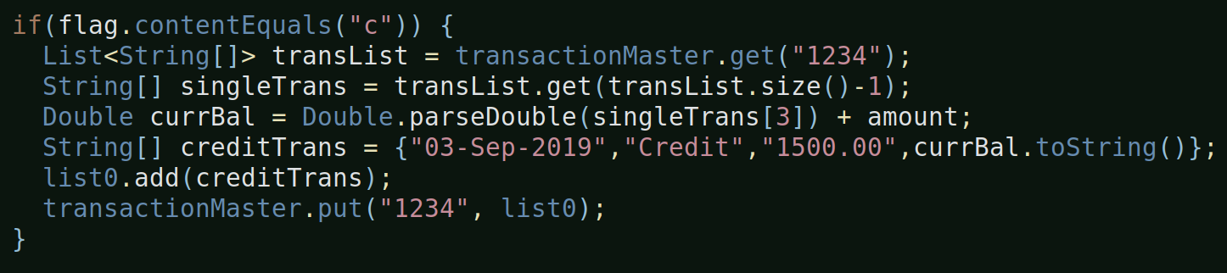
Notice, the above condition doesn’t return anything so after adding the new credit transaction to the class-level transaction master, the default return of the method (which returns null) will be returned in this case.

Same is the case with debit.

[] To get all transactions of type credit:
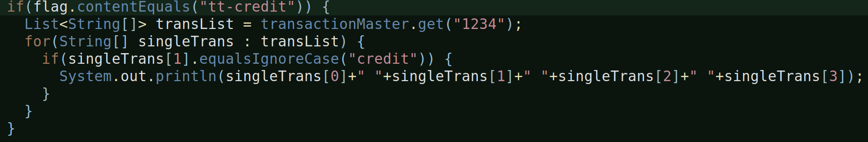
Iterates over the transaction list and checks for ‘credit’ type transactions and prints each element of those transactions.

Same is the case with debit type transactions.

[] Output will be in this format:
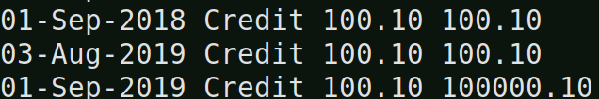
And, as already mentioned, the default return type of this method is ‘null’, so whenever any of those above mentioned ‘ifs’ do not return anything this ‘null’ gets returned.


So, all in all, this is how the traditional approach solution is. I’m purposefully returning ‘null’ here to tackle this problem with the Java 8 Optional, which we will see soon.

[] OUTPUT:
When you run the traditional code, the output is as follows:
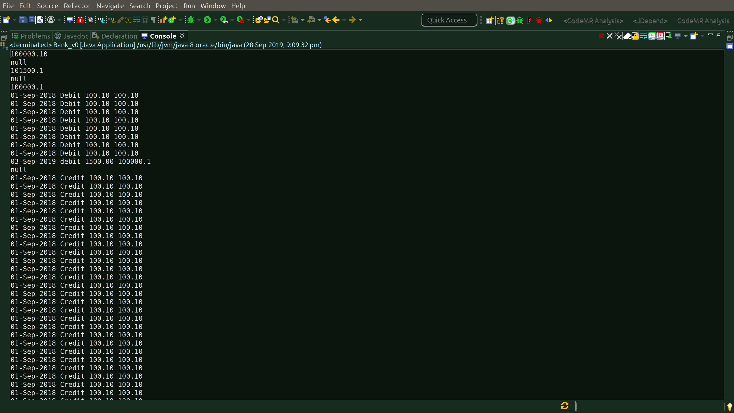

It has ‘null’ values also, as you can see.

[JAVA 8 BASED APPROACH]
The data structures used and their scope remains the same in comparision to Book_v0.java.

The dummy data is also constructed in the constructor itself, so no change here as well.

[] METHODS:
Two methods, just like the traditional java approach but that’s where the commonality with the traditional approach ends.

Details of methods differ.

[] TRANSACTIONS METHOD DETAILS:
This method returns an Optional<String> to tackle the ‘null’ return situation which was the case with the traditional approach.

So, whenever, any of those ‘ifs’ return nothing, the default return value of this method is an Optional, an Optional.empty to be precise:

[] To check balance:
In the traditional approach, we returned a string, here since the return type is Optional<String>, so we return:
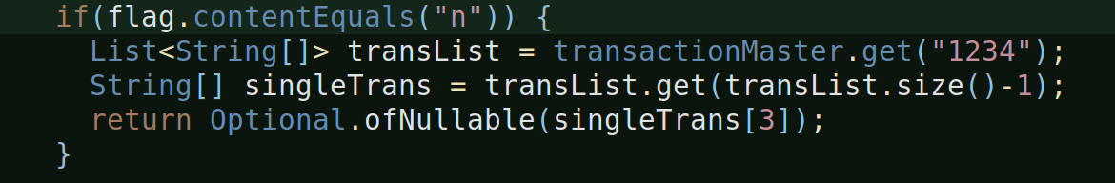
Because we always need to return something that is of type Optional, whether it is an Optional.empty or Optional.ofNullable, whatever it is, it has to be of type Optional.

[] To credit amount:
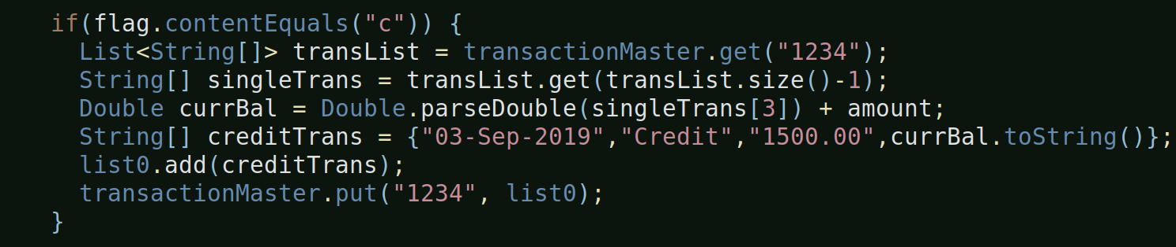
This and the ‘to debit’ functionalities do not have any change compared to the traditional approach because the HashMap (i.e. the Map) do not have the stream capabilities.
The stream capability is added to the Collection interface which is the super interface of List etc. But not Map.

So, in general, streams are available for use in Queues, Stacks, Sets, Lists but not Maps in Java.

[] To display all credit type transactions:
This is where most of the java 8 stuff like streams and lambdas are used.

We convert the list into a stream and then filter on the resulting stream to fetch only those transactions which are of type ‘credit’ and for each of those credit transactions, we print them.

a.Running a Stream on the List
So, in the above scenario when you run a stream on the List<String[]>,
you get a Stream<String[]>.

b.Applying a filter on the stream
And then the filter method on the stream takes a Predicate which is one of the functional interfaces in the java.util.function package.
The predicate takes one input and returns a boolean value. So, here, we are checking which array rows of Stream<String[]> have a ‘debit’ in the 1st index of the String[] array i.e. we are looking for those array rows which have debit in the 1st index like this:
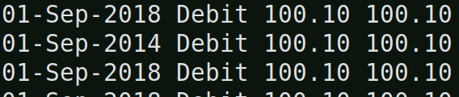

c.Perform an action on each element of the filtered stream
The forEach above takes a Consumer, which is another functional interface, which takes an input and does not return anything and hence to print the output we are using sysout. The forEach in the Stream interface is an terminal operation, meaning, once this is executed the stream ends, the stream will no longer anymore data after this.

The forEach in the above case, performs an action on each of the filtered stream elements. The action is to print each element of the filtered array, which in this case is a credit type transaction details.

In this case, since there is no return statement for this ‘if’, the default return value, that is, an empty Optional will be returned.

[] NOTE:
If you notice, in the above functionality to display all credit card type transactions, we used java 8 features, but compare it with the traditional java approach and see the difference. You’ll notice that, even though we have replaced the for-each and if of traditional java approach with a filter, we still had to use a java 8 forEach to complete the functionality, that means, purely in terms lines-of-code, there’s no difference.

[] MAIN METHOD:
We make multiple calls to the transactions methods from here:

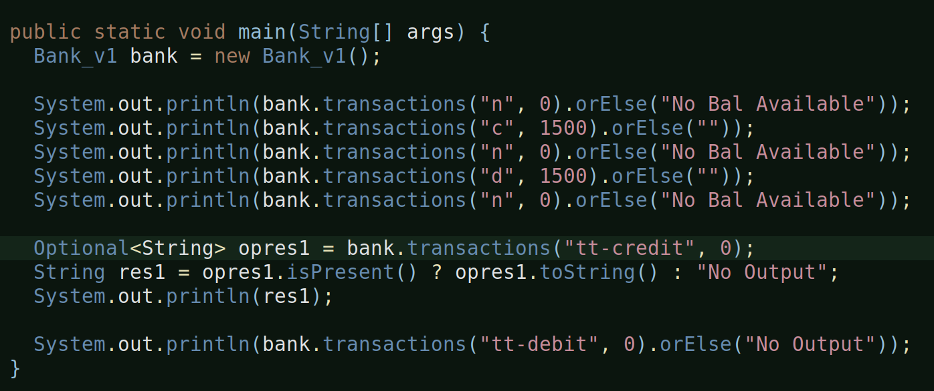
a.orElse:
Since the transactions method returns an Optinal<String>, we get the liberty to use the Optional class methods, an orElse is one of them.

It basically means, if there is a value being returned from the original method call, return it, otherwise, if there’s no value or an empty Optional then return “this message”.

OrElse can be used in place of a ternary operator.
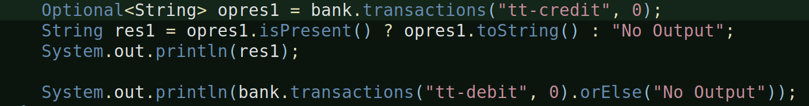
Look at the above statements, the first uses ternary and it requires three lines-of-code to get the job done and the second one uses orElse and it’s one line!

[] OUTPUT:
Let’s look at the output of the entire java 8 feature program:
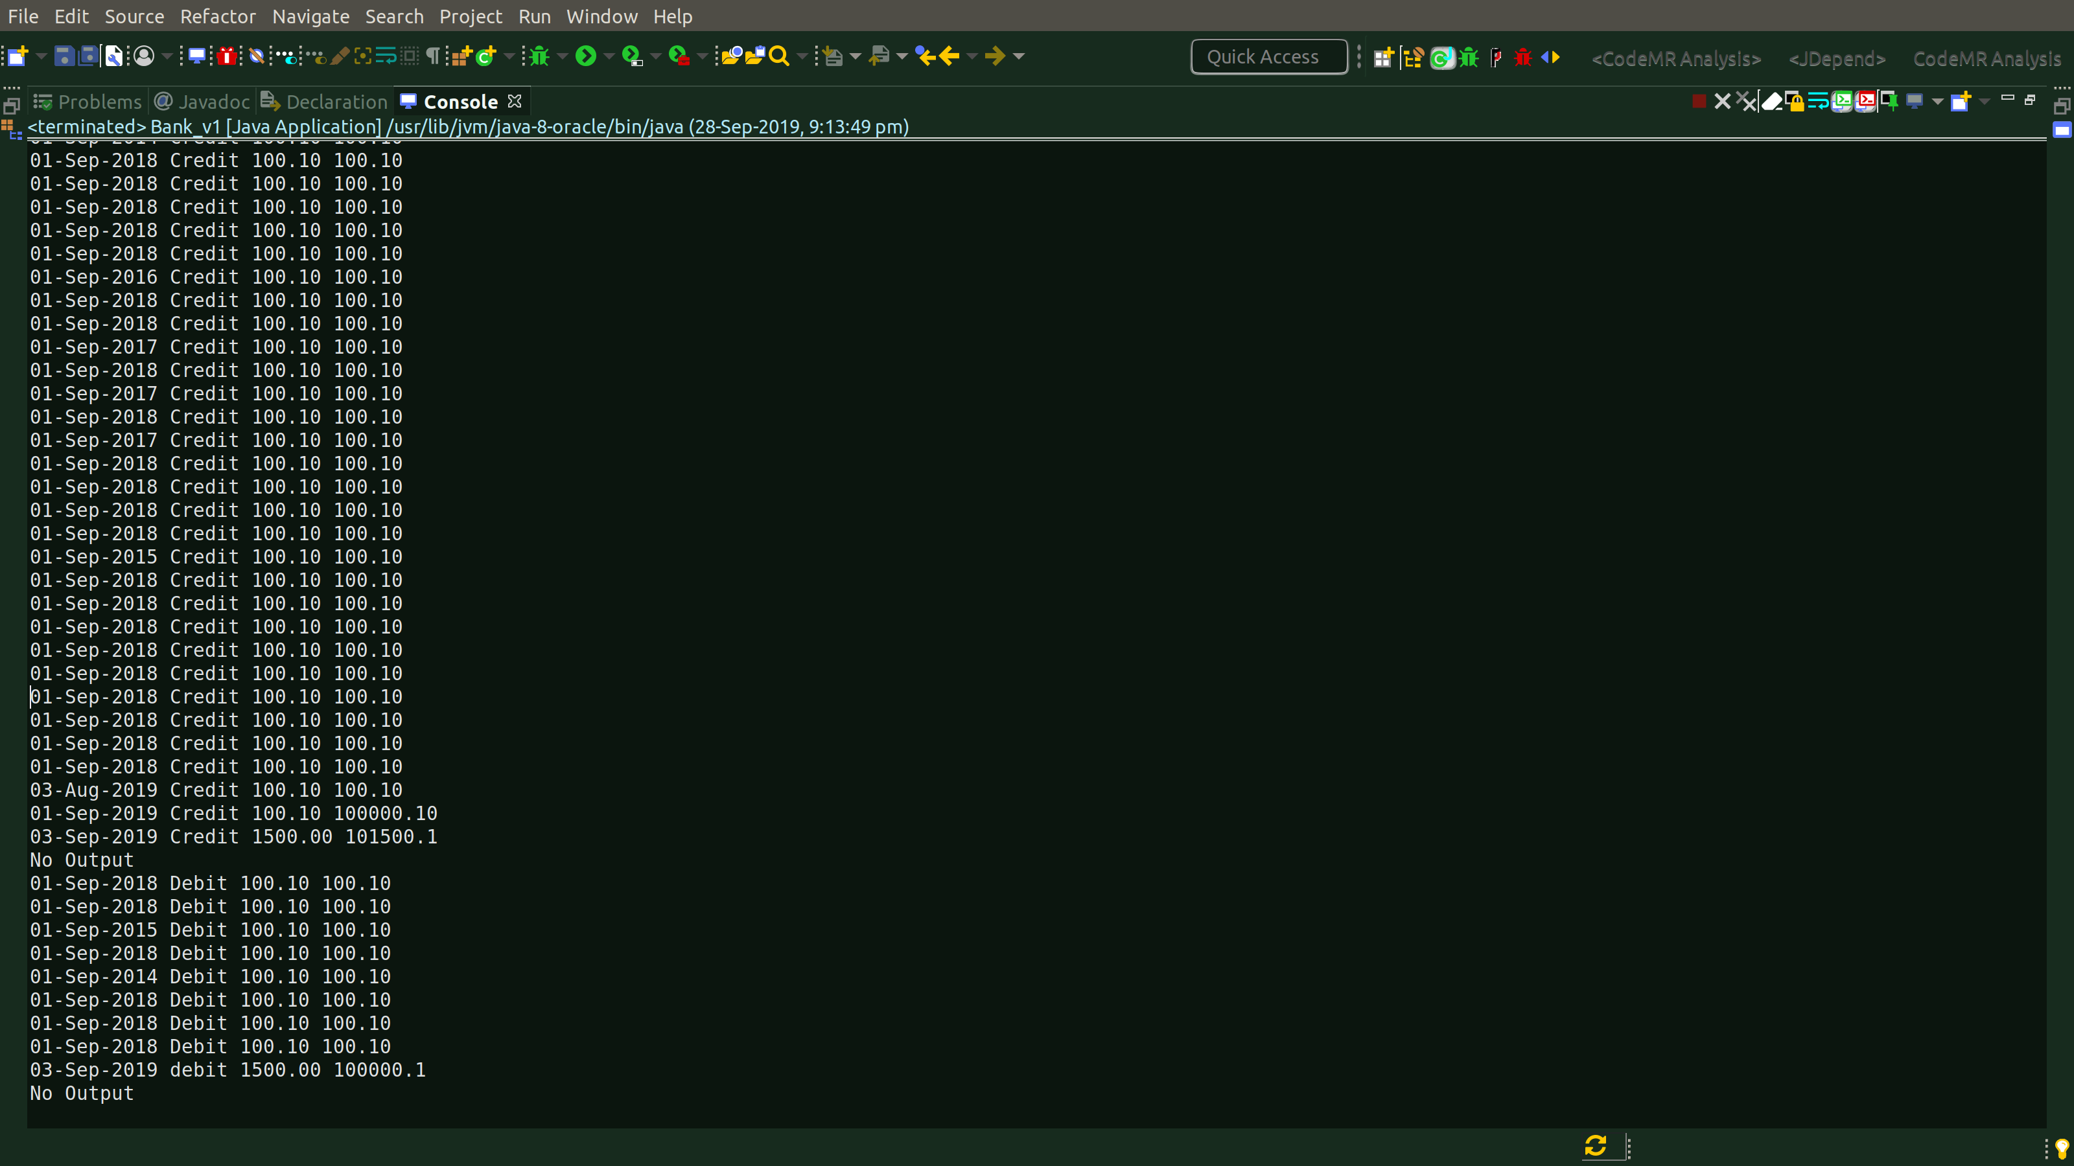
No ‘null’ values instead some text like ‘No Output’ and everything else remains same.

[NOTE]
So far, what’ve implemented in java 8 is Streams, Functional Interfaces, and Lambdas.

[PERFORMANCE MEASUREMENT]

One of the other significant aims of this small project was to determine the performance implications of using the new java 8 features compared to the traditional ones.

[Comparing time-of-execution]:
I compared execution time of traditional java blocks against the ones with java 8 features as follows:

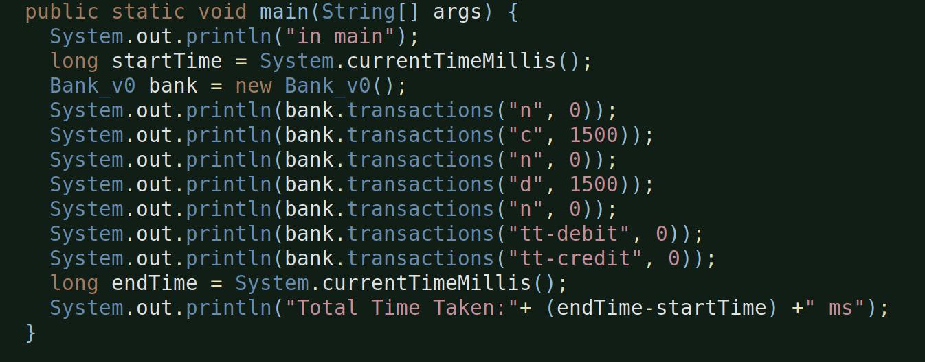

I’ve done the same even in the Bank_v1 main method also.

[] Following are my observations for all methods execution:

Traditional Code | Java 8 Code
91 ms | 422 ms
109 ms | 299 ms
65 ms | 229 ms
109 ms | 300 ms

Each code was run four times and the dataset comprised of 1140 records.

I’ve also done time-comparision of only the code block which had lambdas, which is:
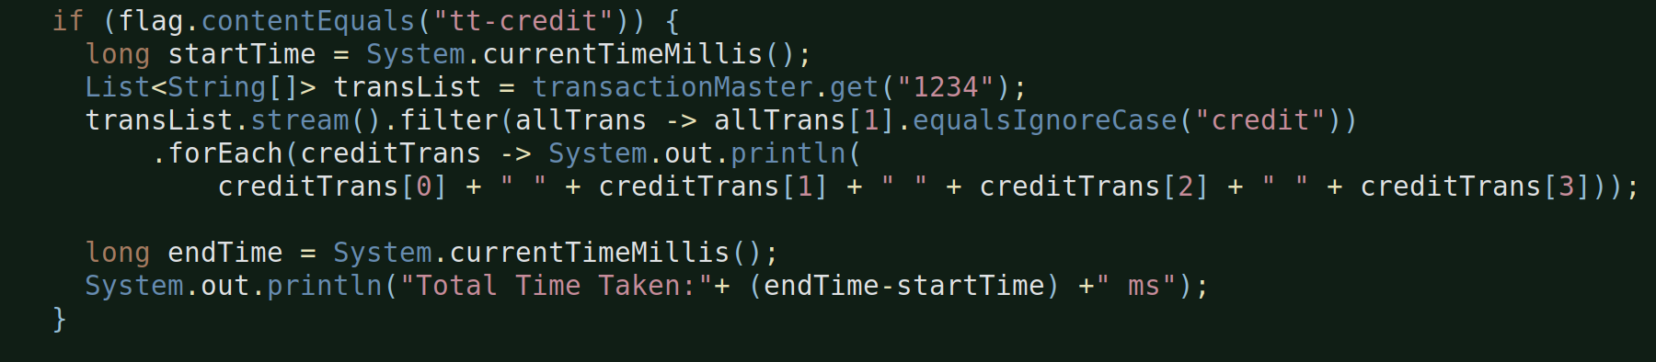

I’ve chosen tt-credit and tt-debit code block because out of 1140 records maximum (around 90%) are of tt-credit transaction type and hence this code block will have maximum records t process compared to the tt-debit one.

[] Following are my observations for only lambda related block:

Traditional Code (plain code block) | Java 8 Code (code blocke with lambdas)
85 ms | 214 ms
74 ms | 164 ms
69 ms | 159 ms
52 ms | 177 ms

So, whether you include the Optional class method operations in the main block or not, the java 8 features like lambdas are still taking lot more time than the traditional java ones.

[Profiling through VisualVM]:
Ok, let’s now go a little deeper and perform profiling i.e. cpu and memory profiling through visualvm.

First, let’s ensure the visualvm configurations are all correct.

[] Debug Mode configuration:

We want visualvm to be triggered only during debug mode operations and hence let’s go to windows -> preferences -> run/debug -> launching -> default launcher -> Java Application -> Debug -> Select VisualVM Launcher

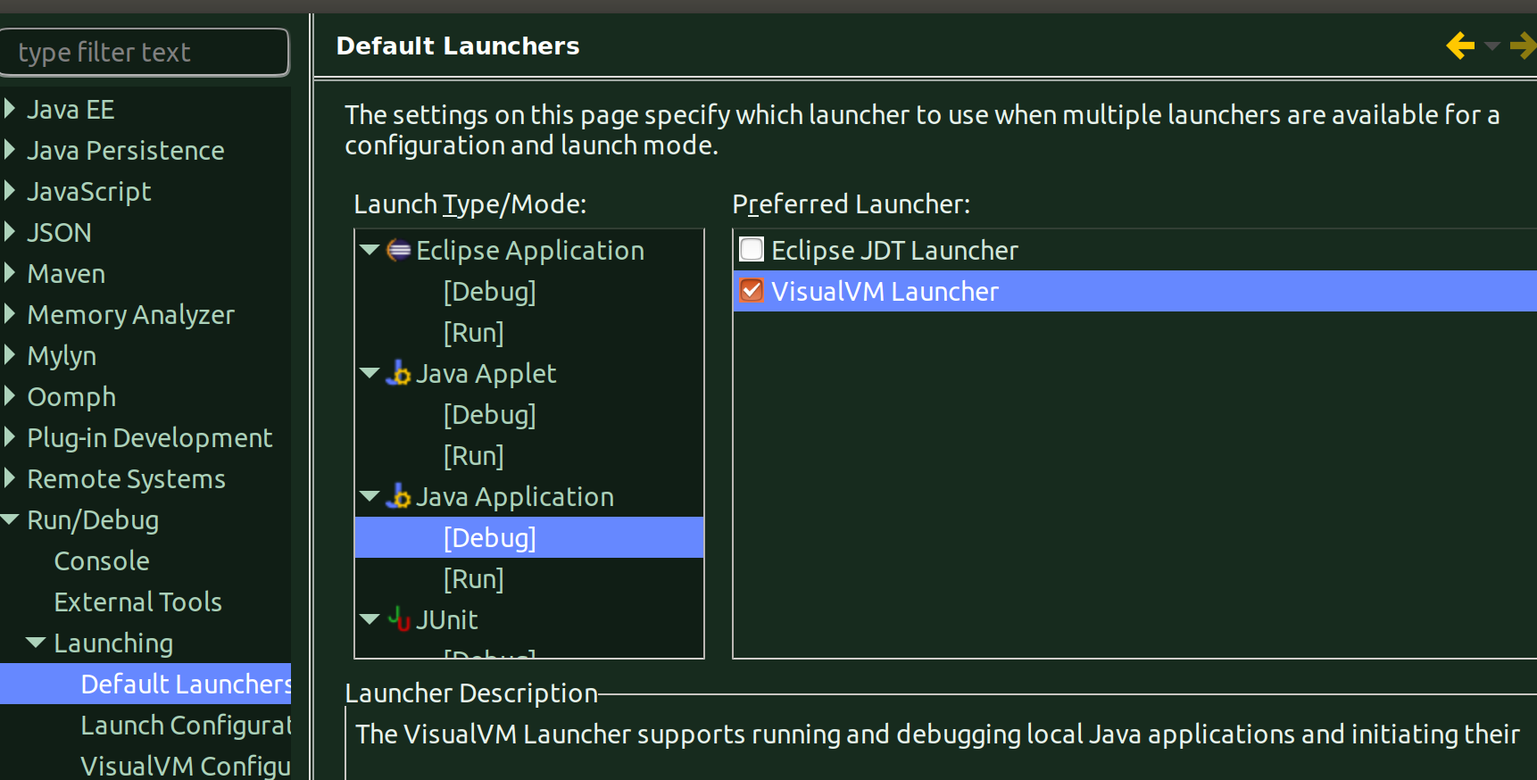
Also, ensure that the Run mode configuration has Eclipse JDT Launcher configured and not VisualVM Launcher.

[] -Xverify:none configuration

Okay, now for the cpu profiling option in visualvm to work, we have to set the vm argument for both bank_v0 and bann_v1 with -Xverify:none argument to ensure NO bytecode verification takes place.

Right-Click on the individual class -> run/debug settings -> Launch Configuration Edit -> VM argument -> -Xverify:none
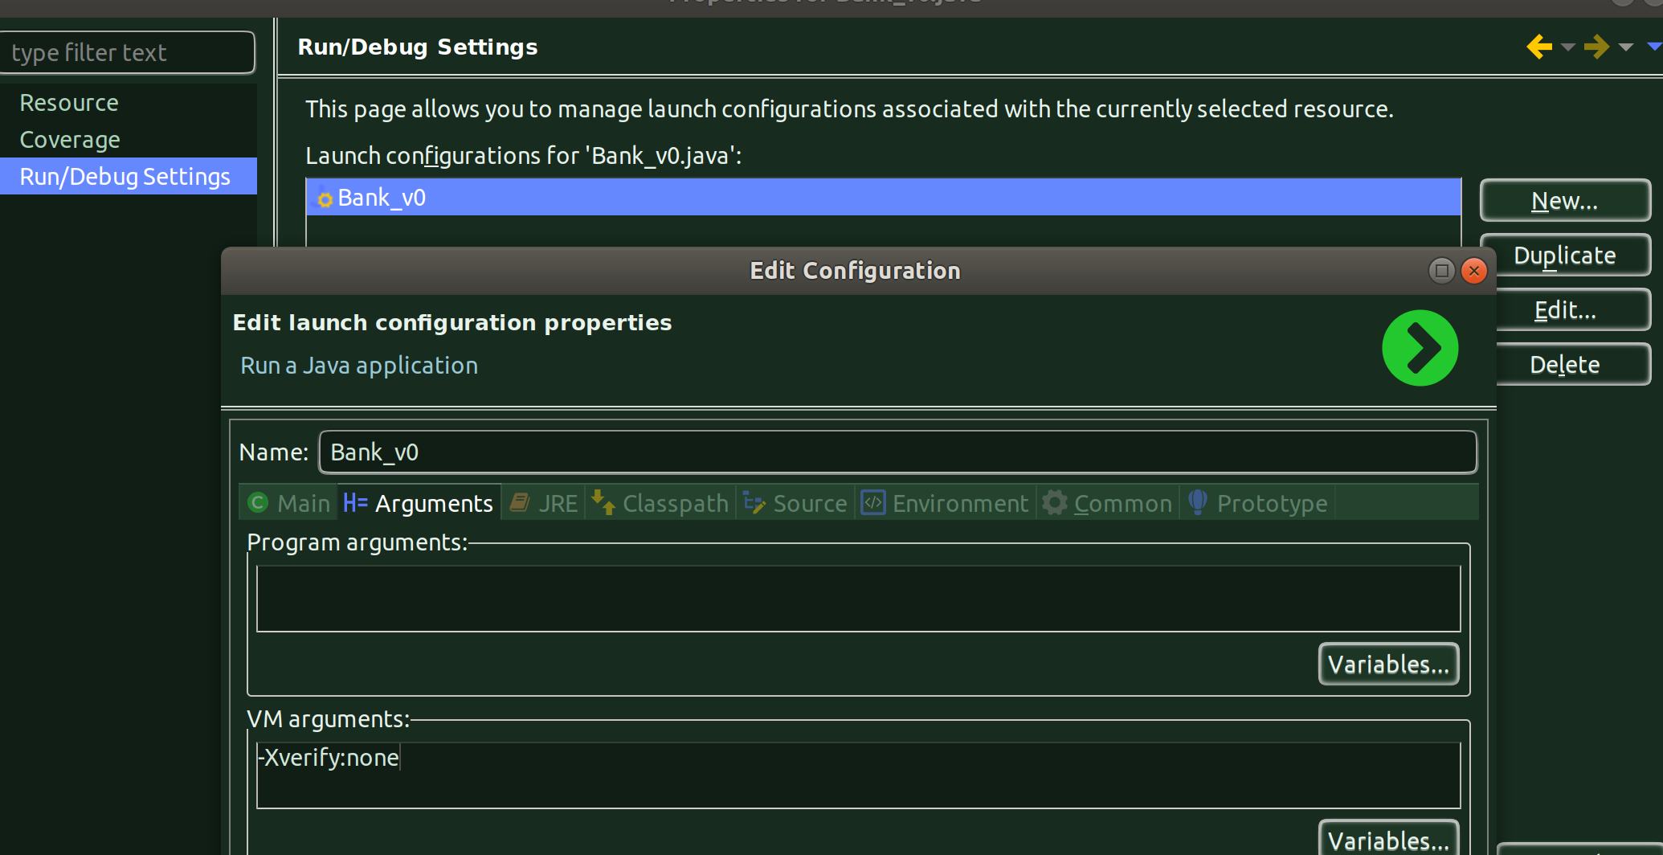
Do the same for the other class also and then that’s it we are now ready to profile the two classes from visualvm.

[] Bank_v0: Traditional Java program with VisualVM:

Okay, let;s no wrun Bank_v0 java program in debug mode, we already have a breakpoint set, which will help us for visualvm to launch and wait for until we start profiling otherwise before the visualvm can launch the program will be over.

[] ISSUE with visualvm not displaying ‘profiler’ tab:
Please note, when you are launching the visualvm for the very first time, you won’t see the ‘Profiler’ option available, simply, re-run the program again (keeping the launched visualvm open).

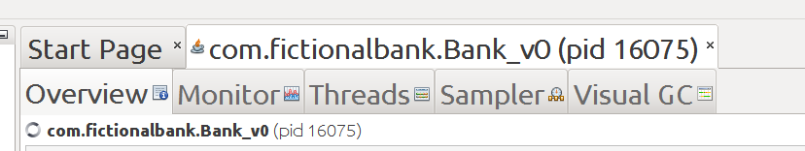

Let’s resume the program (from it’s breakpoint) and let’s re-run the program again.

Okay, now in the visualvm, go to the ‘Profiler’ tab and hit ‘CPU’ and once the profiler is 100% ready, go to eclipse and resume the program from its breakpoint and take the snapshot from the visualvm.

[] CPU Profiling:
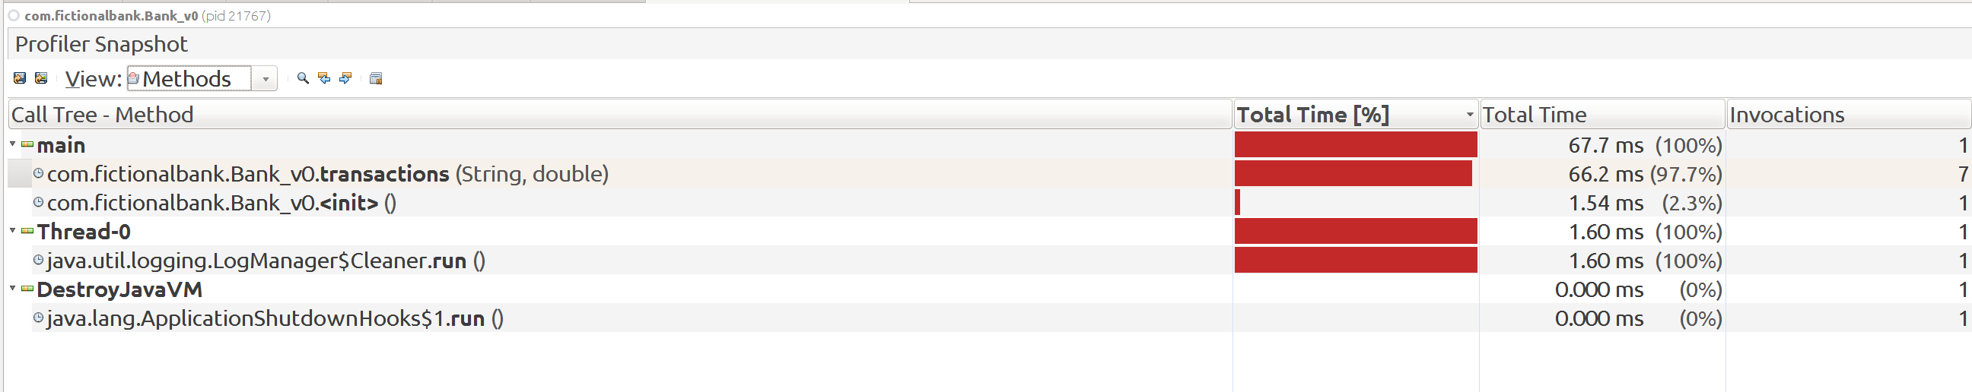

Above is the snapshot overview for Bank_v0 i.e. for traditional java program.

No.of invocations looks ok to me but let’s see, we’ll know more, when we compare both the programs profiling reports.

Monitor Overview:
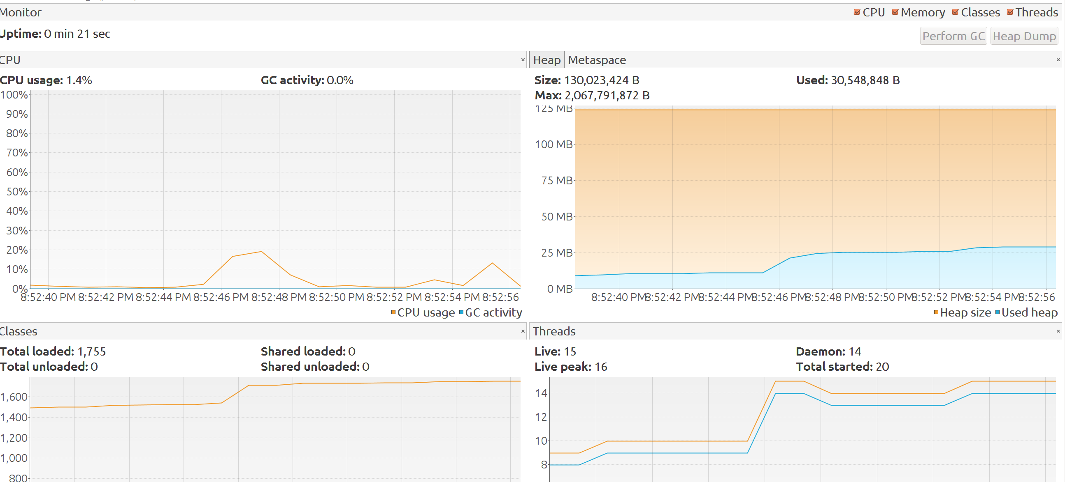
This gives us the overview. We can see the visualvm for the program for up for 21 seconds (until the program finished execution). Please note, this uptime is not the exact program runtime, this includes the time we spent waiting for proifler to warm up and be ready before we continued with resuming th ejava program execution, so thsi is basically the up time for profiler for this particular java program.

And, we can see that the heap space occupied by the program was 35 MB.

And, other deatils like Classes Loaded and Live Threads info can also be seen.

[] Memory Profiling:

Here, we will do memory profiling from visualvm. The only change from visualvm operation point-of-view is, as soon as the visualvm opens, you need to go to profiler tab and hit memory option and then once it is ready, go to eclipse and resume your program from its breakpoint and capture the snapshot in visvalvm.

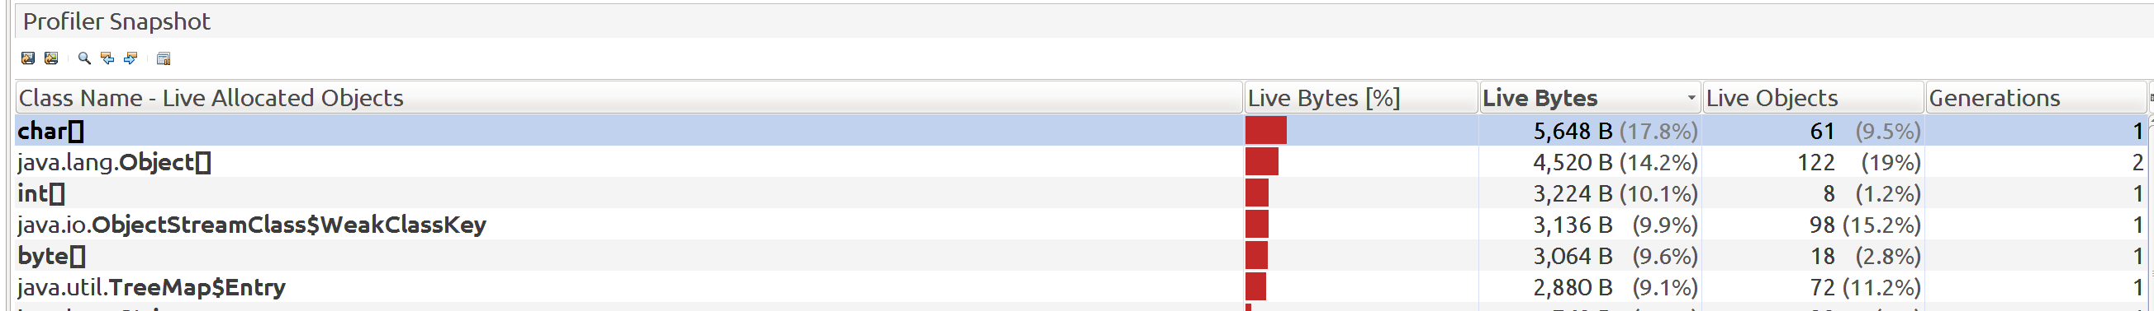

Frankly, can’t really conclude much from this unless I compare this snapshot with that of the other program.

[] Bank_v1: Java 8 program with VisualVM:

Okay, let’s first do CPU profiling for this java 8 program.

[] CPU Profiling:

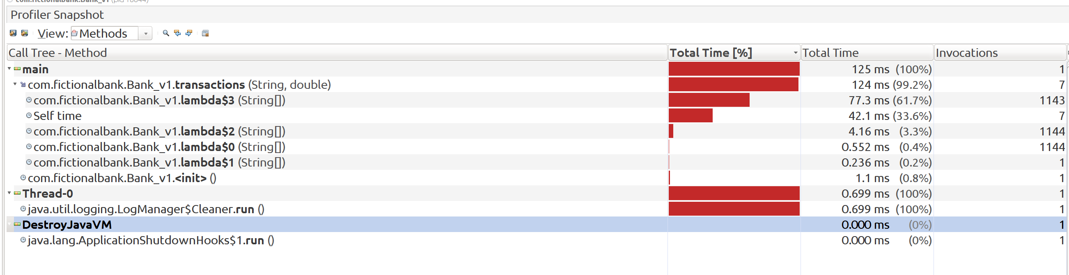

Woah, this cpu profiling report looks like a mess. Look at the time taken and also the no.of executions. Ain;t looking cool. We’ll see after compare.

Monitor Overview:

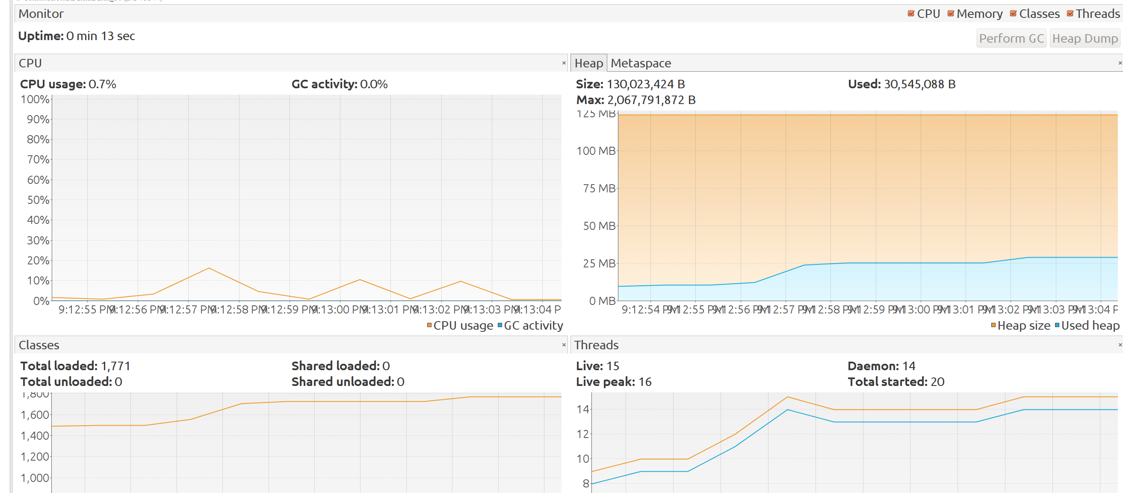

Heap space occupation is around 30 MB.

[] Memory Profiling:

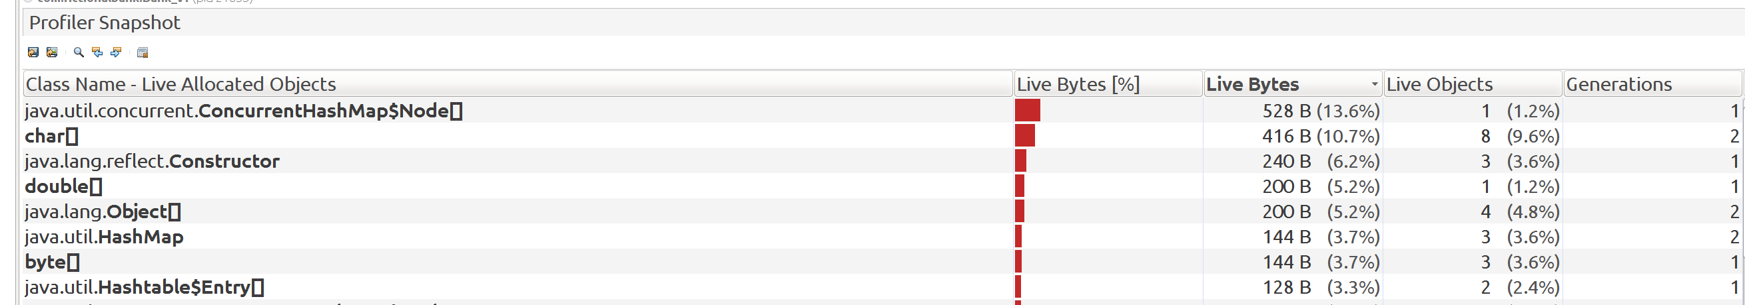

Seeing some ConcurrentHashMap entries.

[] Comparing Ban_v0 and Bank_v1 snapshots:

First, we’ll compare the CPU Profiling snapshots.

Don;t forget to save all the four snapshots to disk, it then becomes to compare them from visuvalvm.

And, you can compare snapshots from visvualvm from file -> compare snapshots option.

[] CPU Profiling comparision:

a.let’s first look at the ‘Method’ view:
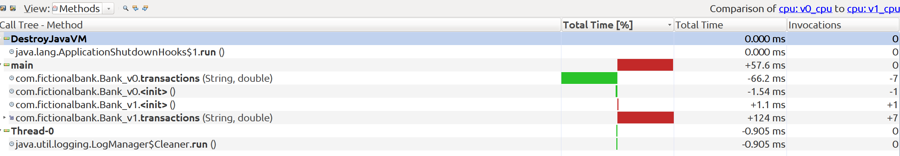

The transaction method in Bank_v0 takes 66.2 ms less than that of Bank_v1 and it has 7 less invocations. These stats are key.

b.let’s look at the ‘Classes’ view now:
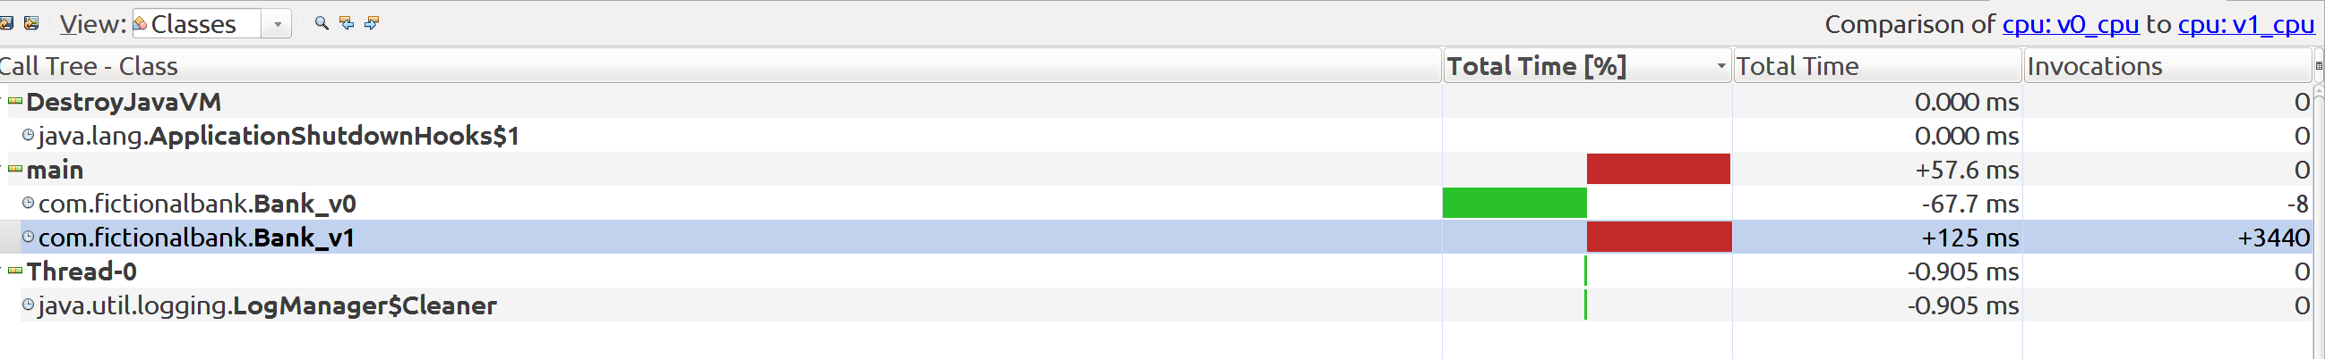
Again, some very key results. The main of Bank_v1 all-in-all takes 3440 invocations and 125 ms more than that of its counterpart in Bank_v1

We can relate these invocations to what’ve seen in the CPU profiling report of Bank_v1. It’s the lambdas. They probably make many internal invocations mutiple times and hence this increase.

We have a package view also available but more or less we got the picture in the above two views and hence not going it to.

[] Memory Profiling Comparision:

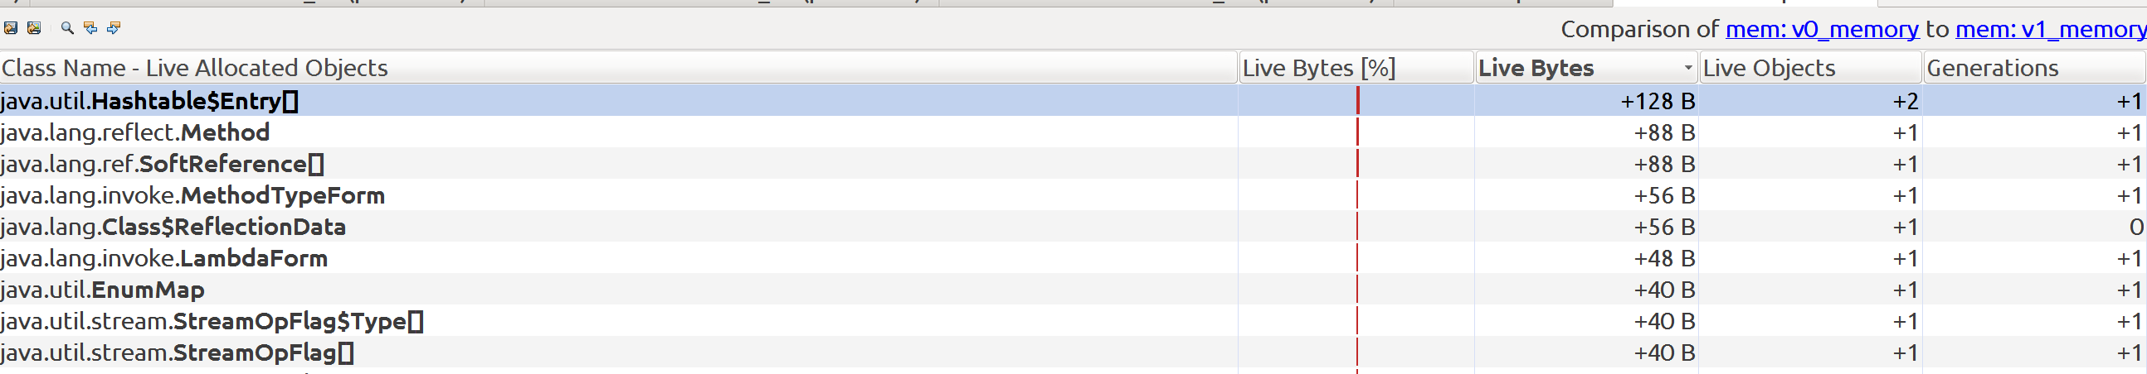
The Bank_v1 has 128 Bytes i.e.2 objects more Live than Bank_v0. All-in-all Bank_v1 has more objects live.

[] Summary of Comparision:

a.When you look at the heap space occupied by these programs (from the monitor view), I din’t find much of a difference between these two. At times, either both of them have taken less heap space (around 5 MB) or taken more (around 30 MB) but they both have fared same in terms of heap.

b.But when you look at the CPU profiling report, differences are pretty clear. The no.of invocations in Bank_v1 are pretty high (because of lambdas) and hence the time taken by main to complete is 2x compared to the one in Bank_v0 (traditional).

So, clearly, there is an performance impact, especially in terms of program execution/completion time.

