Assignment No. 1

Date: January 12, 2026
Title: Installation and Configuration of PostgreSQL and Client-Server Integration with Angular.
Objective / Aim: To install and configure the PostgreSQL database server, perform basic DDL and DML operations, and integrate the database with a web-based client using Node.js and Angular.

1. Introduction
This assignment demonstrates the implementation of a 3-tier architecture. It involves setting up a relational database (PostgreSQL), a server-side bridge (Node.js/Express), and a client-side interface (Angular). The project focuses on "CRUD" operations (Create, Read, Update, Delete) to manage student records effectively.

2. Theory / Algorithms
- PostgreSQL: An open-source object-relational database system known for reliability and data integrity.
- 3-Tier Architecture: 1. Database Tier: PostgreSQL stores student records in a relational table. 2. Application Tier: Node.js acts as a "Bridge," using the pg library to execute SQL queries and cors to allow cross-origin requests. 3. Presentation Tier: Angular provides a reactive user interface styled with Tailwind CSS.
- Algorithm for Data Flow:
  - User enters data in the Angular form.
  - Angular DataService sends an HTTP POST request to the Node.js API.
  - The Node.js server executes an INSERT query into PostgreSQL.
  - Angular refreshes the view by fetching the updated list via an HTTP GET request.
3. Documentation: Functional Block Diagram
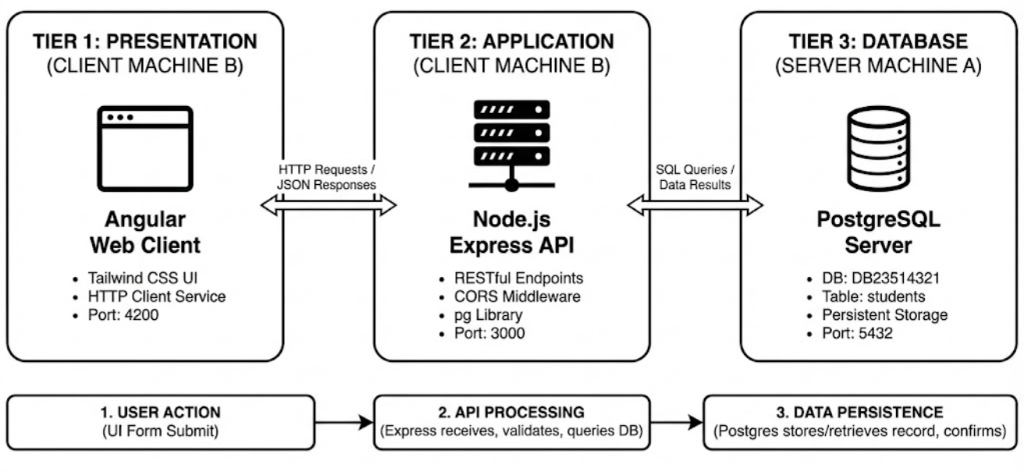
4. Procedure
- Database Layer: Installed PostgreSQL 18 and used pgAdmin 4 to create a new login role and database named DB23510014.
- Schema Design: Created a Stud1 table with columns for id, name, and prn.
- Backend Layer: Initialized a Node.js project, installed express, pg, and cors, and configured the database connection pool.
- Frontend Layer: Created an Angular project, configured Tailwind CSS, and generated a DataService to handle API communication.
- Integration: Connected the layers by ensuring the Node.js server (Port 3000) and Angular dev server (Port 4200) were running simultaneously.

5. Actual Experiments & Results

SQL Script Executed (Part 2):
SQL
CREATE TABLE IF NOT EXISTS Student (
id SERIAL PRIMARY KEY,
name VARCHAR(100) NOT NULL,
prn VARCHAR(20) UNIQUE NOT NULL,
);

INSERT INTO Student (name, prn) VALUES ('MAYUR', '23510014')
SELECT * FROM Students;

Observations:
- The pgAdmin Query Tool successfully returned the record for 'MAYUR ' with the assigned ID.
- The Angular web client (localhost:4200) successfully rendered the student list in a Tailwind-styled table.
- The "Add Student" form successfully added 'RUPESH' (23510010) to the database.
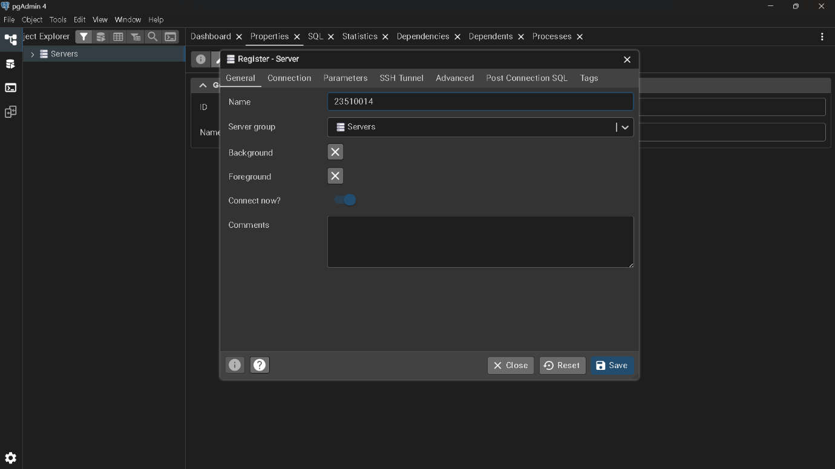

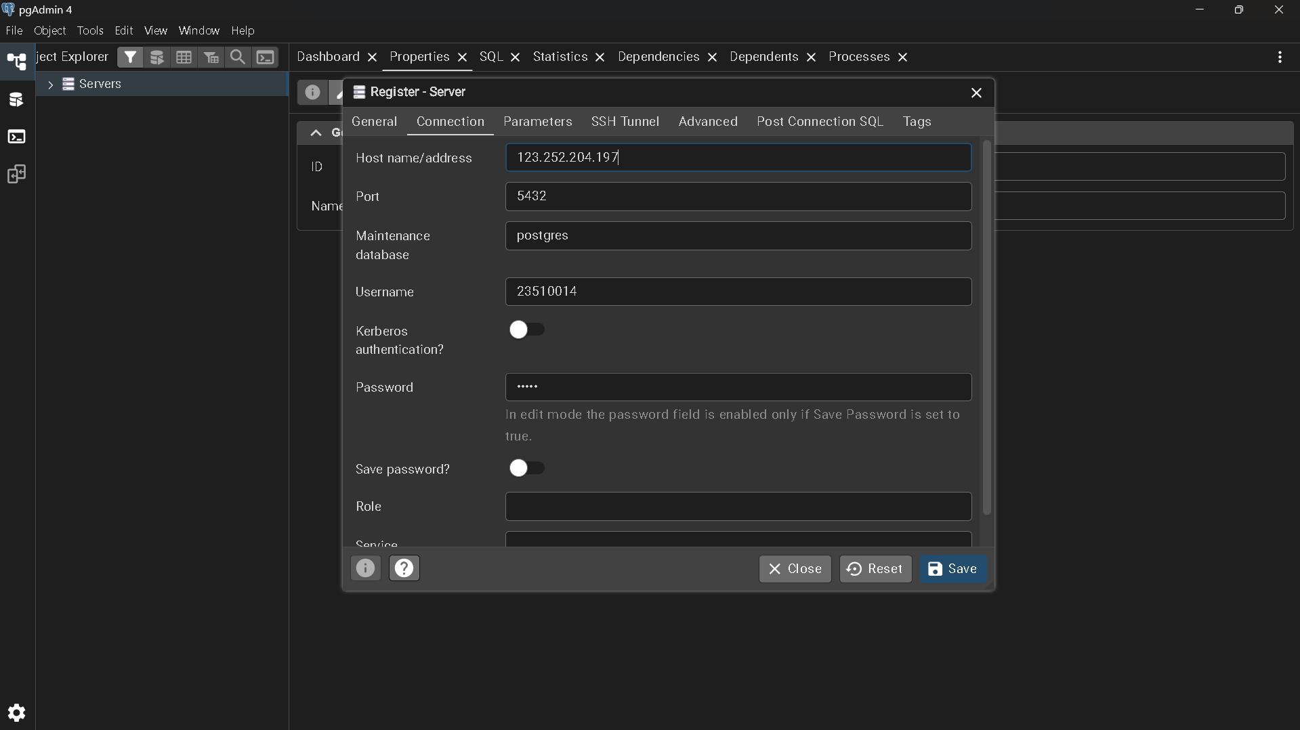
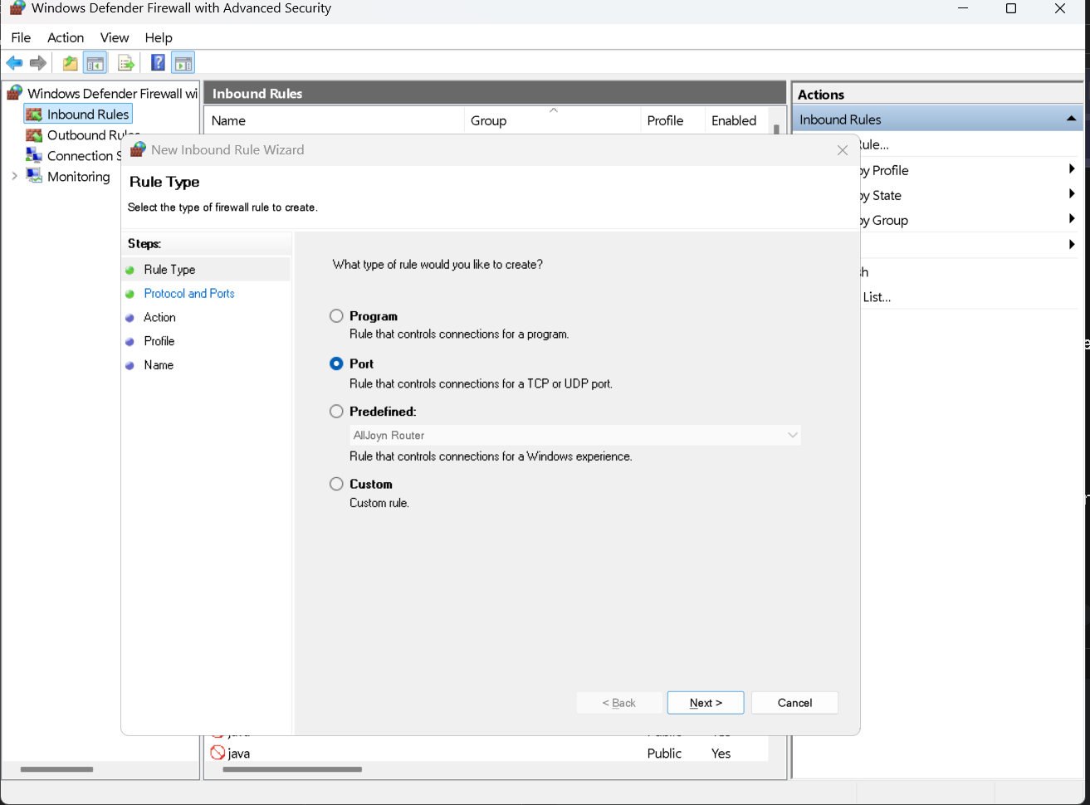
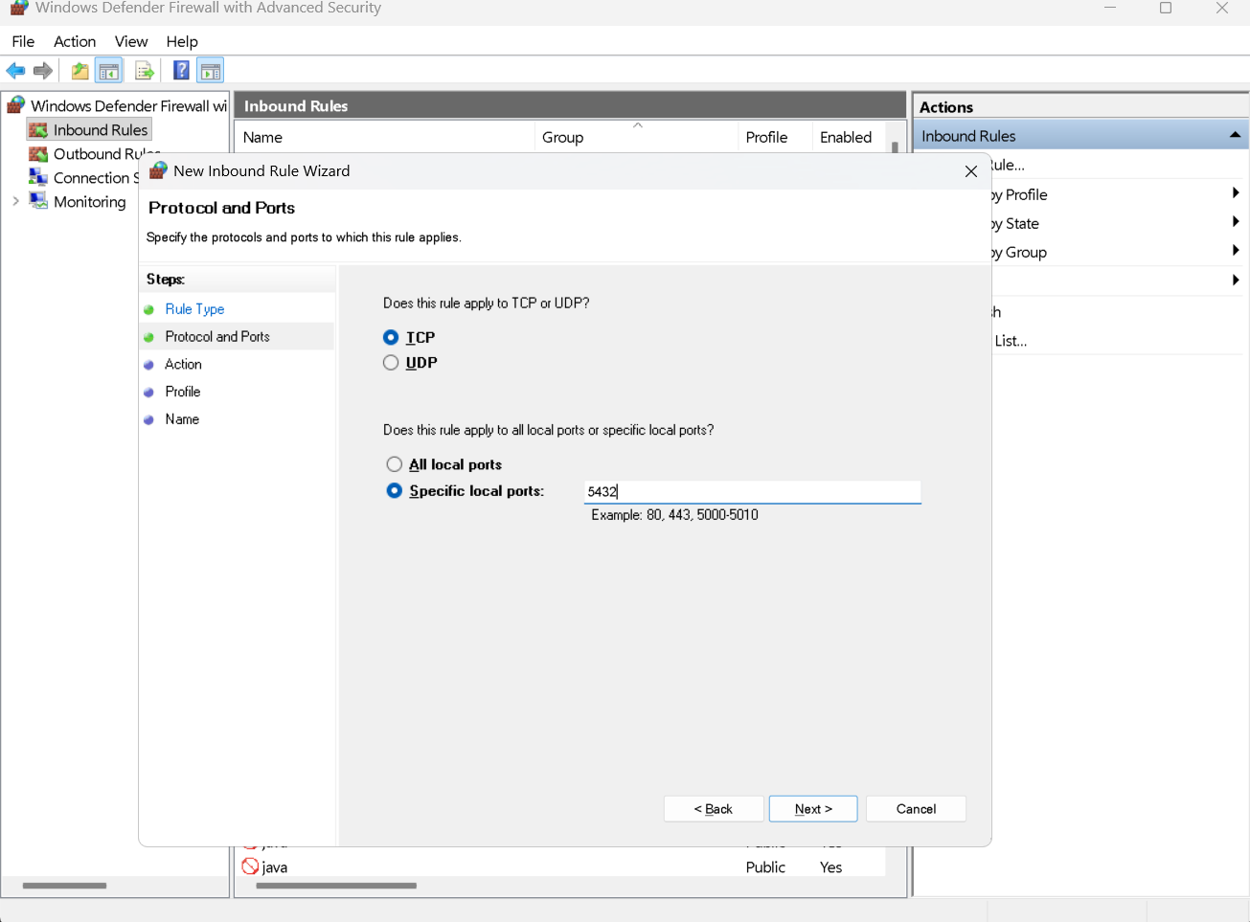
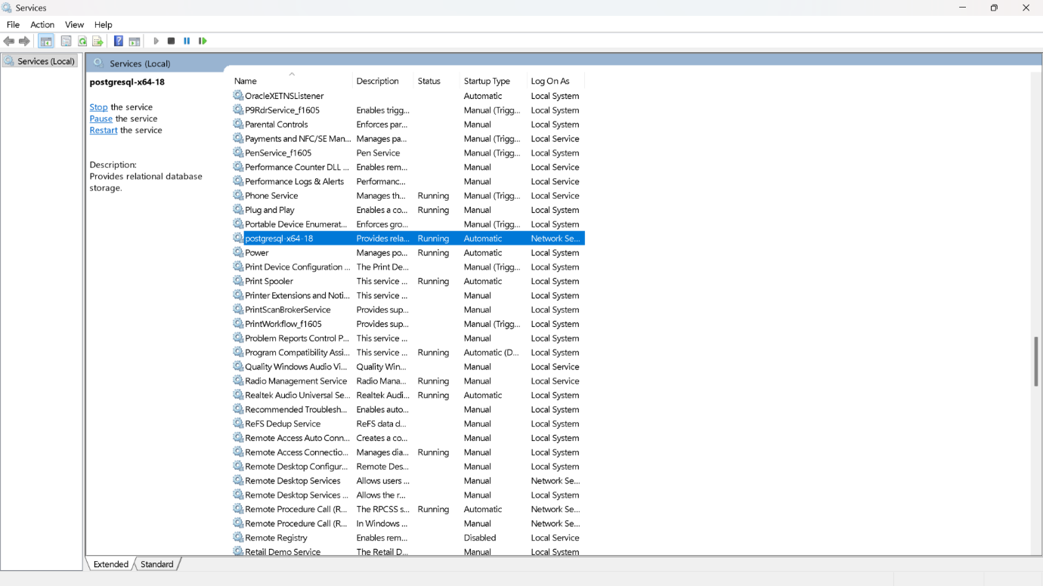
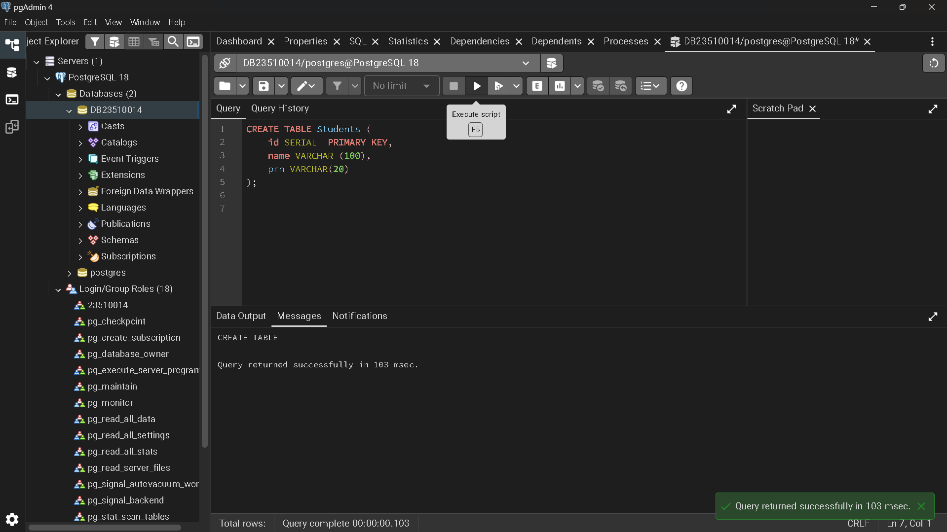

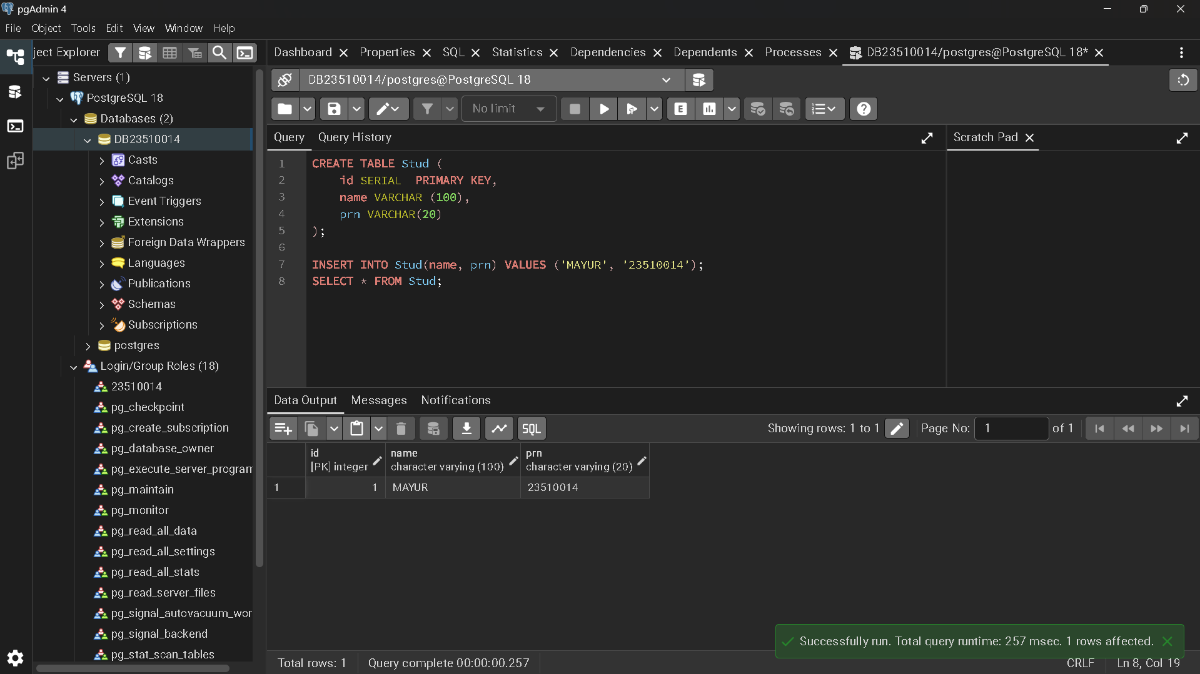
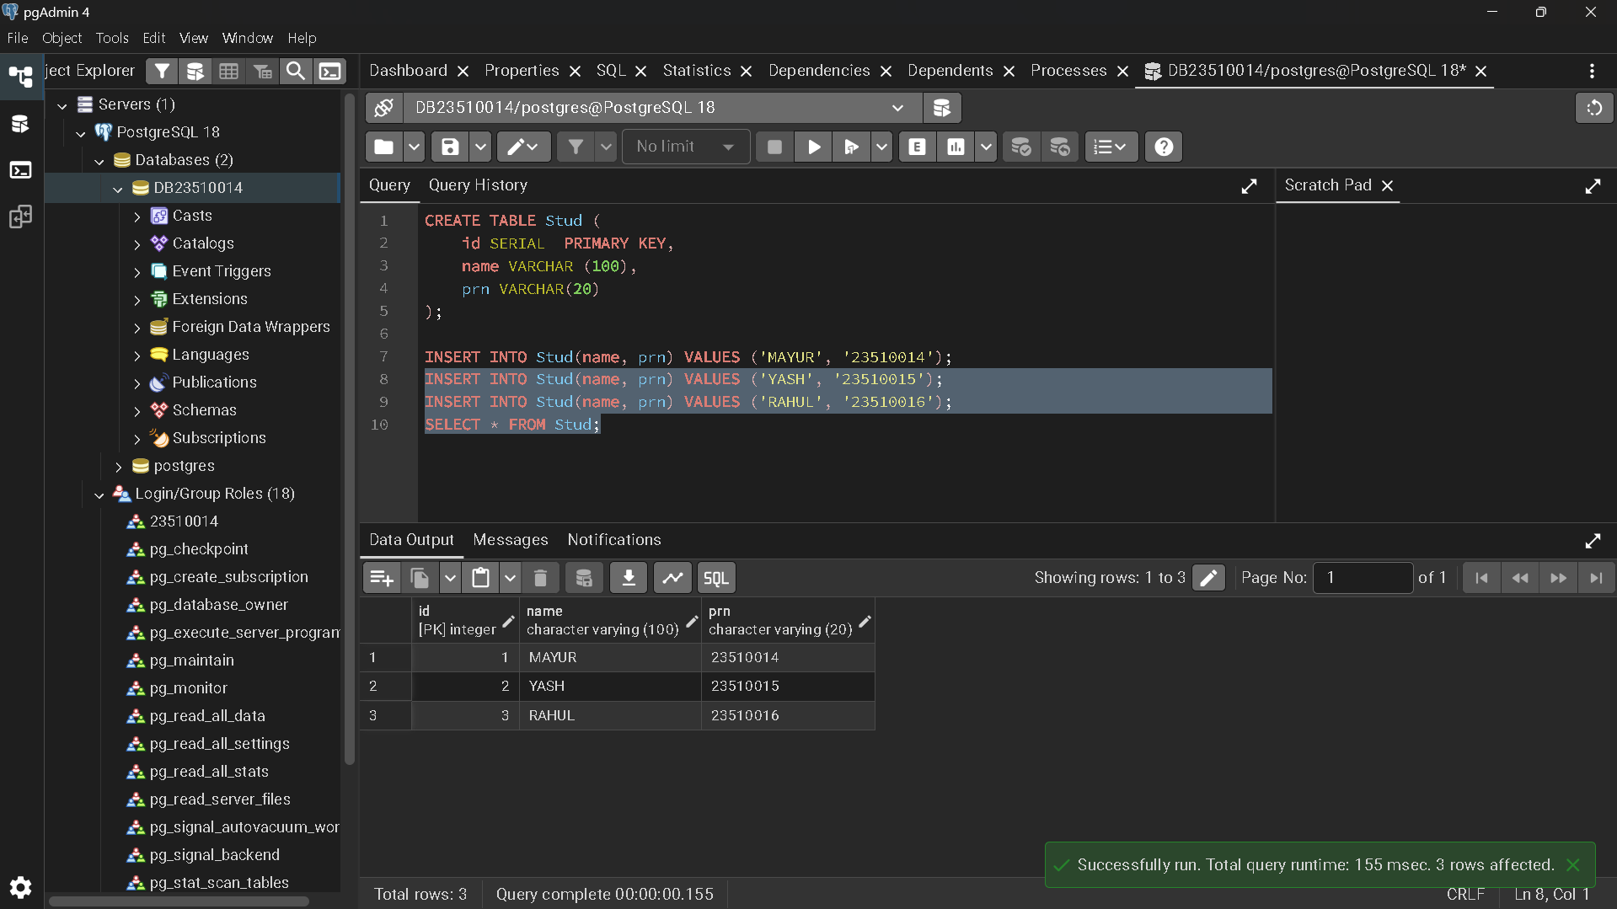
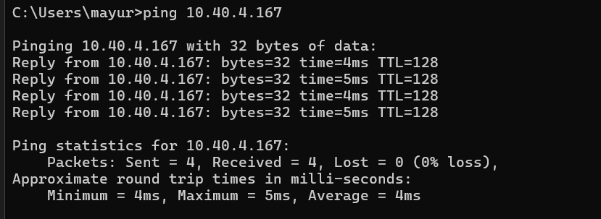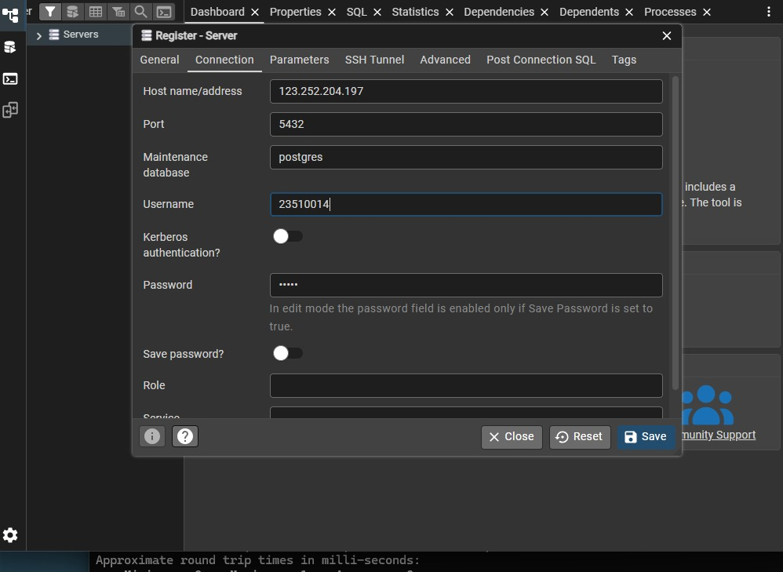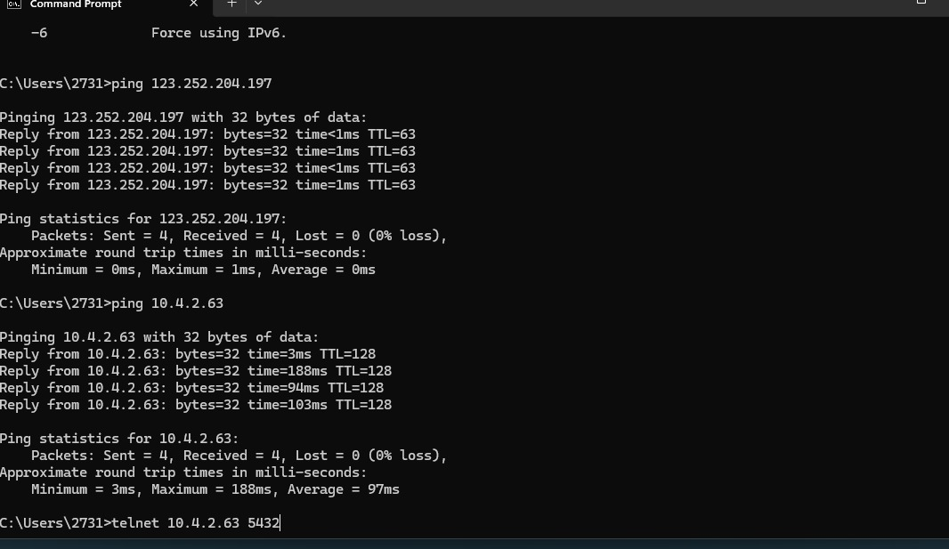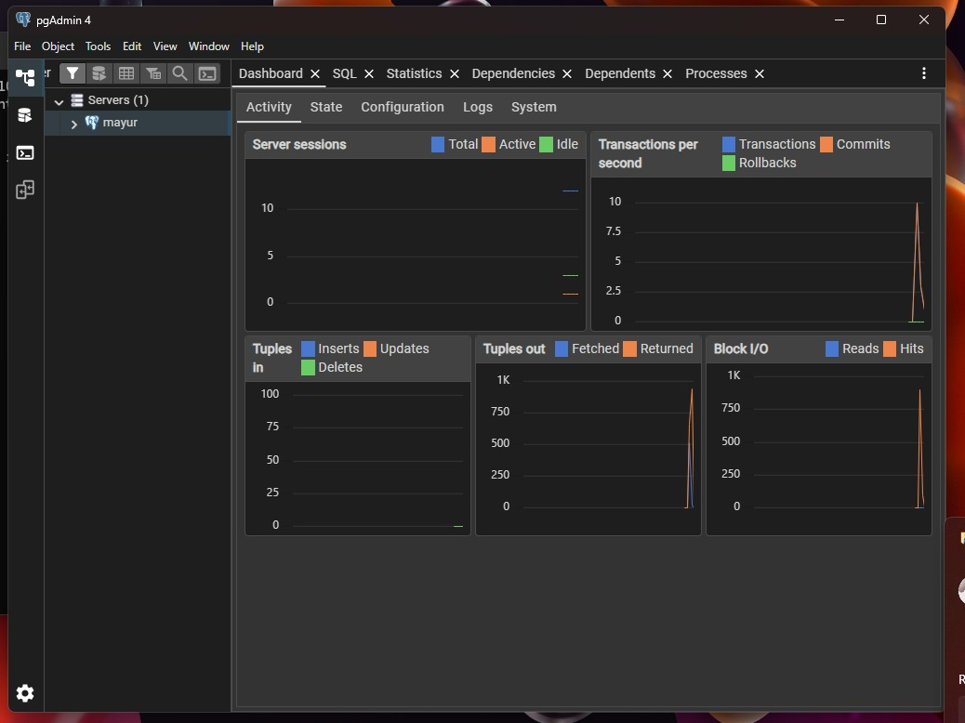
6. Conclusion

The installation and configuration of the PostgreSQL server were successfully completed. By integrating it with an Angular client via a Node.js bridge, we successfully demonstrated the capability to perform real-time CRUD operations in a 3-tier environment. The use of Tailwind CSS ensured a modern, responsive user interface.
7. References
- PostgreSQL Official Documentation: https://www.postgresql.org/docs/
- Angular Guide: https://angular.dev/
- Tailwind CSS Documentation: https://tailwindcss.com/docs/installation

