LAB REPORT: ASSIGNMENT 2
Assignment No: 2
Date: January 19, 2026
Subject: Advanced Database Management Systems
Database ID: DB23510014

1. Title
PL/pgSQL Review and Object Relational Databases

2. Objective / Aim
- To review and implement PL/pgSQL concepts including Loops and Stored Procedures.
- To understand and implement Object-Relational Database (ORDBMS) features such as Object Tables, User-Defined Types (UDT), and Methods.

3. Introduction
- PL/pgSQL: Procedural Language/PostgreSQL extends standard SQL by adding procedural elements like variables, loops, and conditional logic. This allows for complex operations to be executed directly on the database server, reducing network traffic.
- ORDBMS: An Object-Relational Database is a hybrid model that combines the structural benefits of relational tables with the flexibility of Object-Oriented programming. It allows for the creation of complex data structures and functions (methods) that reside within the database schema.

4. Theory / Algorithms

A. PL/pgSQL Procedures
- Stored Procedures: Blocks of code saved in the database for reuse.
- Looping Logic: Utilized a FOR loop (1..50) to automate repetitive tasks, such as bulk record insertion.
- Parameterized Updates: Procedures were designed to accept dynamic inputs (percentage $X$ and category $Y$) to perform targeted data modification.

B. Object-Relational Features
- User-Defined Types (UDT): Custom data structures (e.g., address_type) that group related attributes together.
- Object Tables: Specialized tables where each row is treated as an instance of a specific Type, rather than just a set of columns.
- Member Functions: Procedural logic associated with a Type to perform operations on the object data (e.g., string manipulation and word counting).

C. Functional Block Diagram
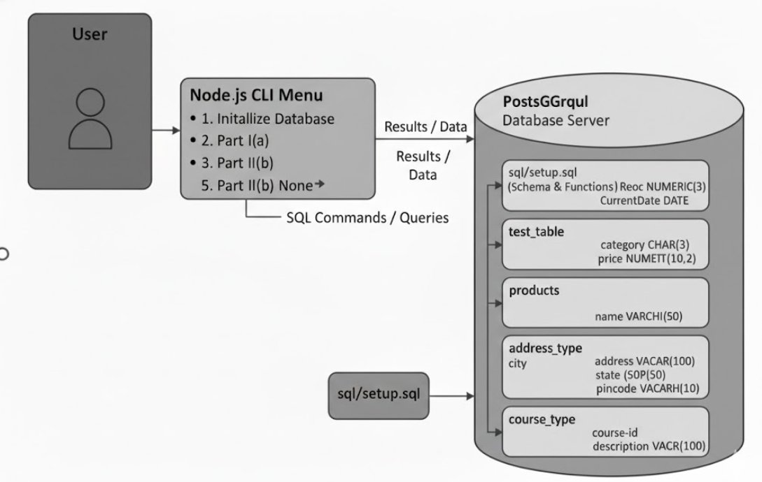

5. Procedure
- Database Setup:
  - Initialize the connection to database DB23510014.
  - Execute schema scripts to define relational tables (test_table, products) and custom types (person_type, address_type).
- Logic Implementation:
  - Part I(a): Execute the insert_test_records() procedure to verify loop execution and bulk insertion.
  - Part I(b): Execute update_product_price(X, Y) to demonstrate the use of input parameters in procedural updates.
- Object-Relational Execution:
  - Populate the Object Tables (persons, courses) with sample data.
  - Invoke member functions like countNoOfWords to demonstrate procedural analysis of object attributes.

6. Results / Observations
- Task I(a): Successfully inserted 50 records into test_table with a single procedure call.
- Task I(b): Verified that product prices were calculated and updated correctly based on the percentage input.
- Task II: Successfully mapped complex types to database rows; functions correctly parsed and returned word counts from object-based columns.
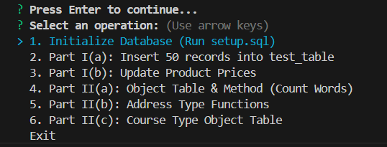
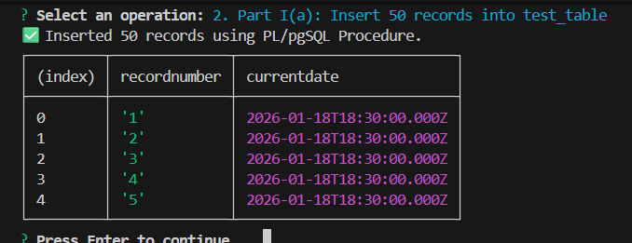

7. Conclusion
In this lab, we successfully demonstrated the efficiency of PL/pgSQL in automating database tasks through loops and procedures. Furthermore, we explored Object-Relational concepts, proving that custom types and object tables provide a more organized and intuitive way to manage real-world, complex data structures within a relational environment.

8. References
- PostgreSQL 16.0 Documentation - Chapter 43. PL/pgSQL - Procedural Language.
- Node.js pg Library Documentation for PostgreSQL Integration.

