Assignment No. 3
Date: 31/01/2026

Title: Design and Implementation of a Web-enabled Student Management Information System (MIS)
Objective / Aim:
- To design and develop a web-based application for managing student information.
- To implement Role-Based Access Control (RBAC) for different user levels (Admin, Faculty, Student).
- To create data entry forms for entities (Students, Departments) with CRUD (Create, Read, Update, Delete) functionalities.
- To implement a generic report generator to list and display database records dynamically.
- To integrate a frontend (Angular 19), backend (NodeJS), and database (PostgreSQL) into a cohesive system.

Introduction
Think of a Management Information System (MIS) as the digital brain of an organization. It helps managers organize data, evaluate performance, and keep everything running smoothly. For a university, a Student MIS is essential—it replaces piles of paperwork with a secure digital system for tracking student details, grades, and departments.
This project builds a modern web portal using the PEAN Stack (PostgreSQL, Express, Angular, Node.js). Instead of old-fashioned software installed on a single computer, this is a web-based app that users can access from anywhere, making it faster, easier, and scalable.

Technology Stack
- Frontend ( The Interface): Angular 19 – Provides a sleek, interactive dashboard where users click buttons and view data.
- Backend (The Engine): Node.js + Express – Handles the logic, processes requests, and "talks" to the database.
- Database (The Vault): PostgreSQL – Securely stores all student, user, and department records in organized tables.

Key Concepts & Logic
1. REST Architecture (How the parts talk)
Our system uses REST APIs, which act like a waiter in a restaurant taking orders between the customer (Frontend) and the kitchen (Backend).
- GET: "Show me the list of students."
- POST: "Add this new student to the database."
- PUT: "Update this student's details."
- DELETE: "Remove this record."
2. Role-Based Access Control (RBAC)
Security is about giving the right keys to the right people. We don't want a student accidentally deleting a department!
- Authentication: "Who are you?" (Checking username/password at Login).
- Authorization: "What are you allowed to do?" (e.g., An Admin can delete users, but a Student can only view their own profile).
3. Database Integrity (Keeping data clean)
We use Normalization to avoid messy, repeated data.
- Instead of typing "Computer Science" for every single student, we create a separate departments table.
- The students table just points to that department using a specific ID (Foreign Key). This keeps the database small, fast, and error-free.

Documentation: Data Flow Diagram (DFD)
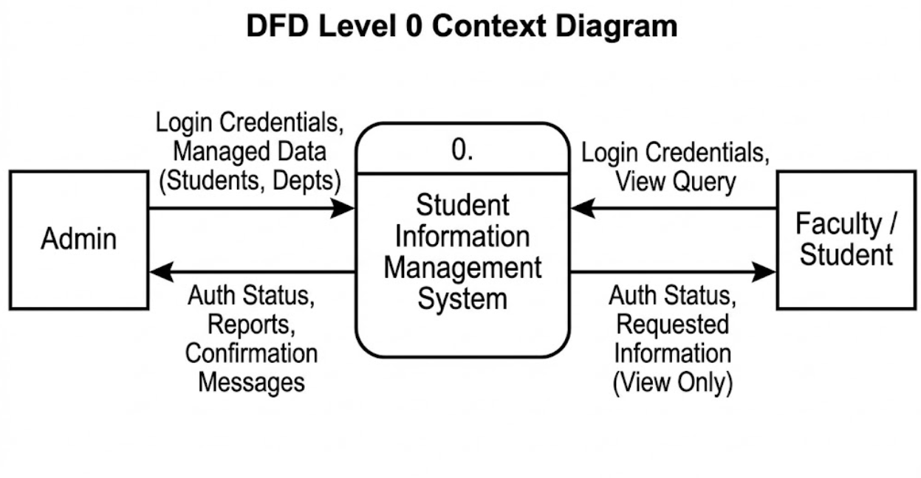Simple Explanation of the Diagram:
- User (Admin/Student): Logs in via the Angular Interface.
- Web Portal: Sends the request to the Node.js Server.
- Server: Checks the PostgreSQL Database ("Do these credentials match?").
- Database: Sends the answer back ("Yes, login successful").
- User: Sees their specific Dashboard based on their role.

Entity Relationship (Simplified):
- Department (1) ---- (M) Student
- User (Standalone entity for system access)
Procedure
- Database Setup:
  - Install PostgreSQL and pgAdmin.
  - Create a database using setup.sql script.
  - Create tables: departments, students, users.
  - Insert initial admin credentials.
- Backend Setup:
  - Initialize a Node.js project: npm init.
  - Install dependencies: npm install express pg cors body-parser.
  - Implement API endpoints in server.js for handling Login and CRUD operations.
  - Configure database connection in db.js.
  - Start the server: node server.js.
- Frontend Setup:
  - Install Angular CLI: npm install -g @angular/cli.
  - Create project: ng new frontend.
  - Generate components: Login, Dashboard, Students, Departments, Users.
  - Implement Services (api.service.ts, auth.service.ts) to communicate with the backend.
  - Design UI using HTML/CSS.
  - Run the application: ng serve.

Actual Experiments / Simulation & Observations
1. Login Page:
- Observation: User enters valid credentials (admin/admin). System token/session is created, and user is redirected to Dashboard.

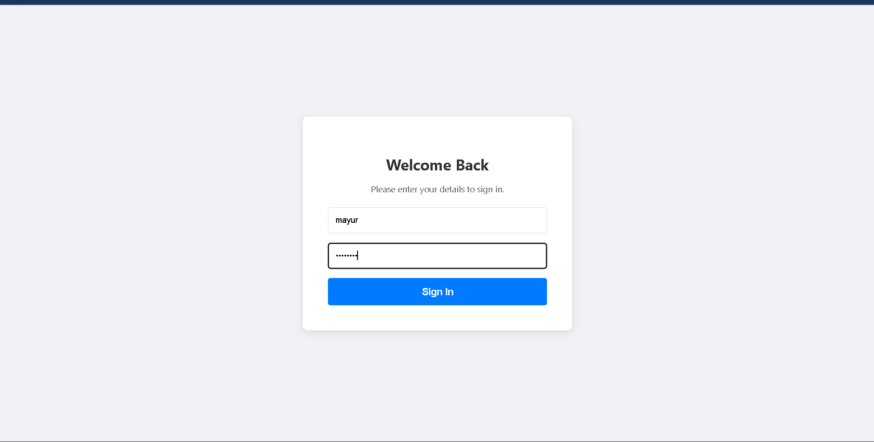
2. Dashboard:
- Observation: Displays navigation options based on the logged-in user's role. Admin sees all options; Students see limited options.
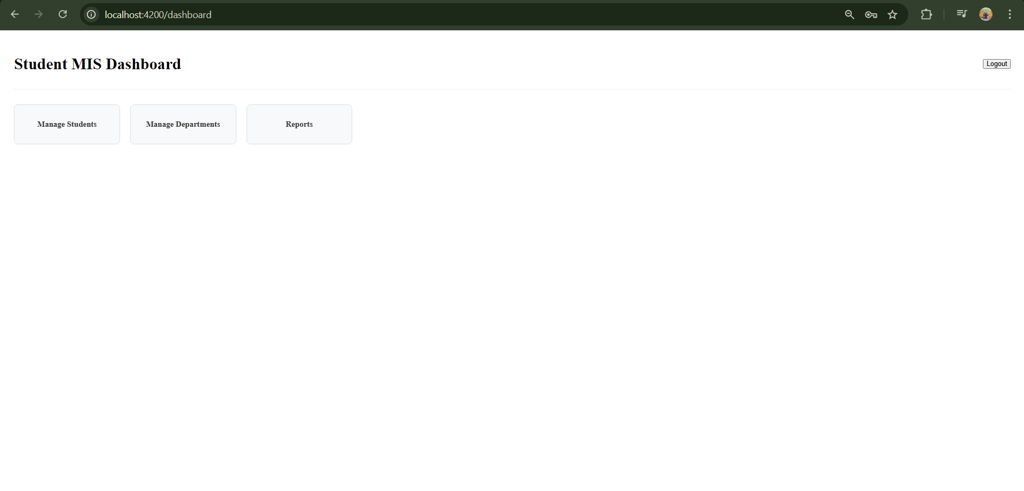
3. Student Management (CRUD):
- Observation:
  - List: Table displays all students fetched from DB.
  - Add: Form accepts Name, Email, Dept. Clicking "Add" inserts row in students table.
  - Edit/Delete: Updates or removes the record from the database immediately.
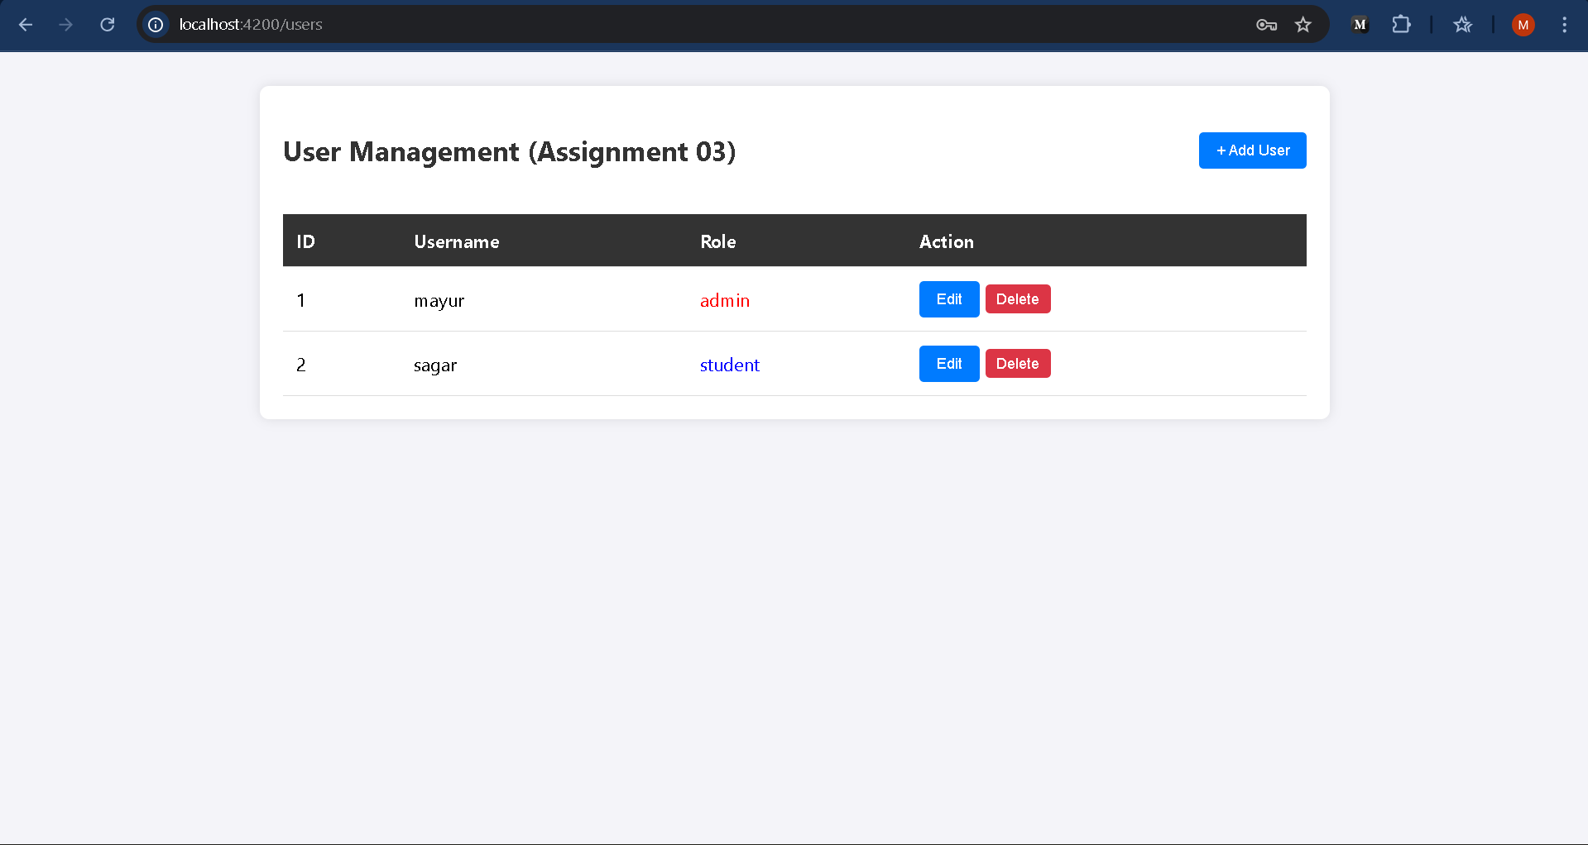
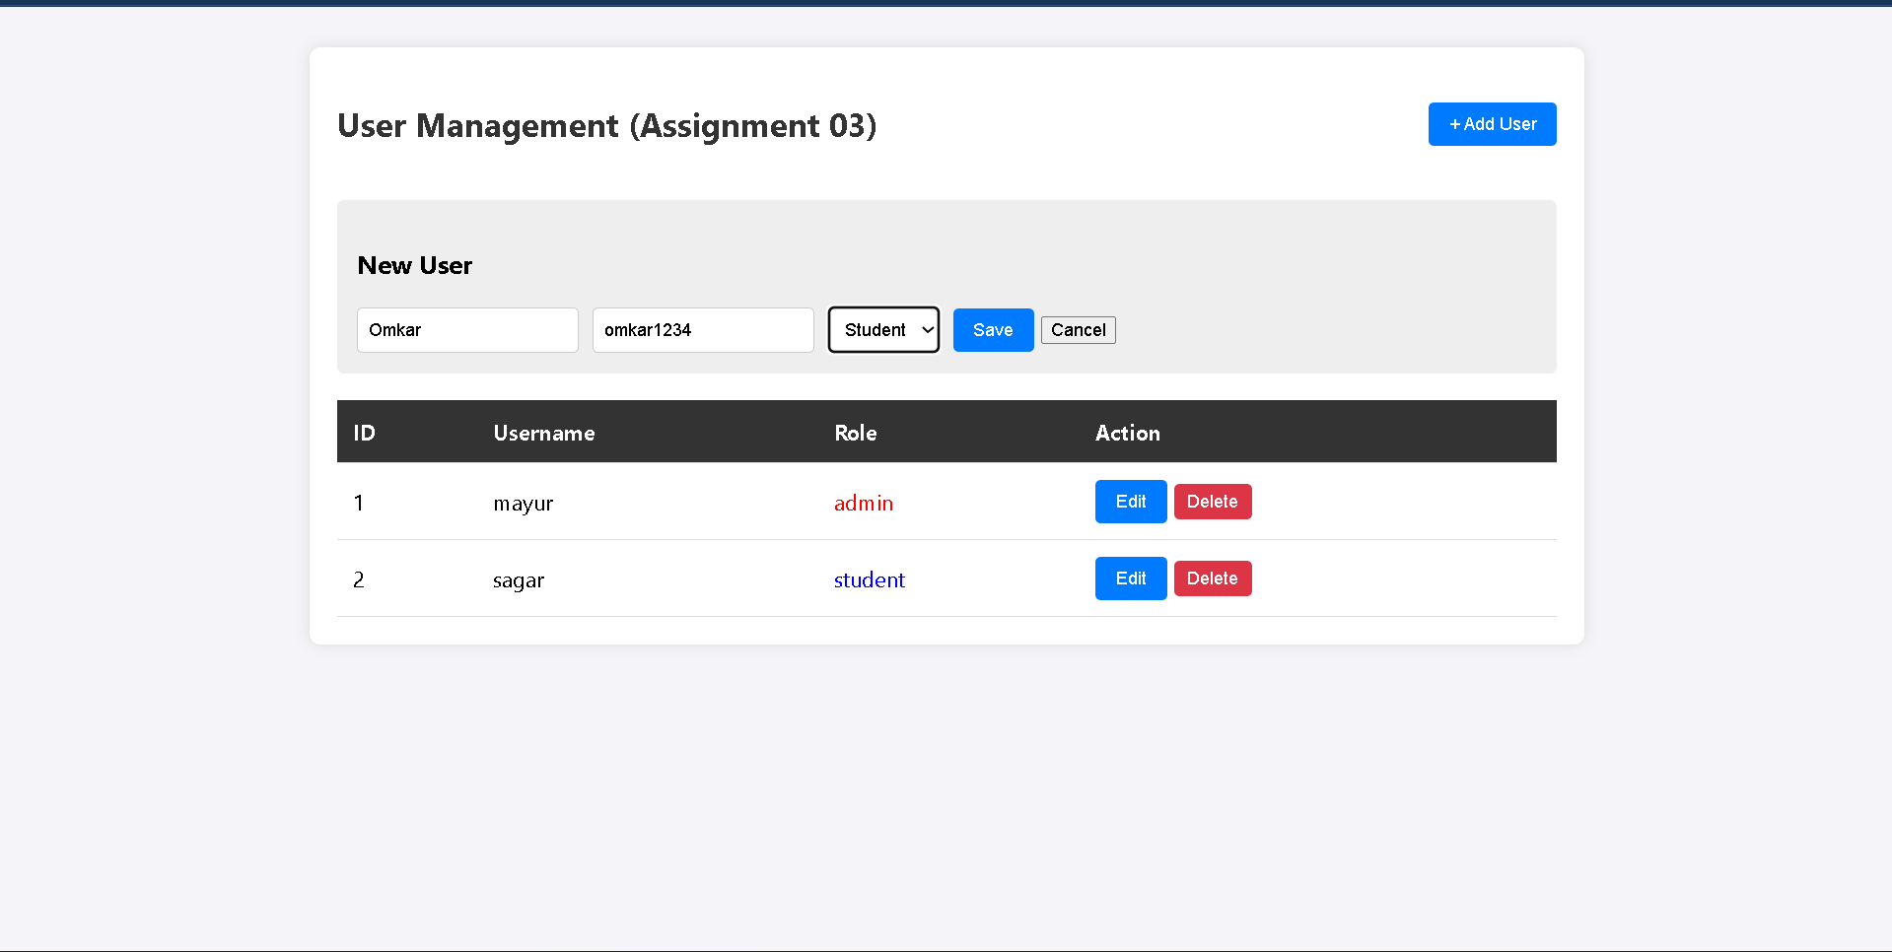

4. Generic Reports:
- Observation: Selecting "Students" or "Departments" from the dropdown dynamically loads and displays the table data without hardcoded columns.
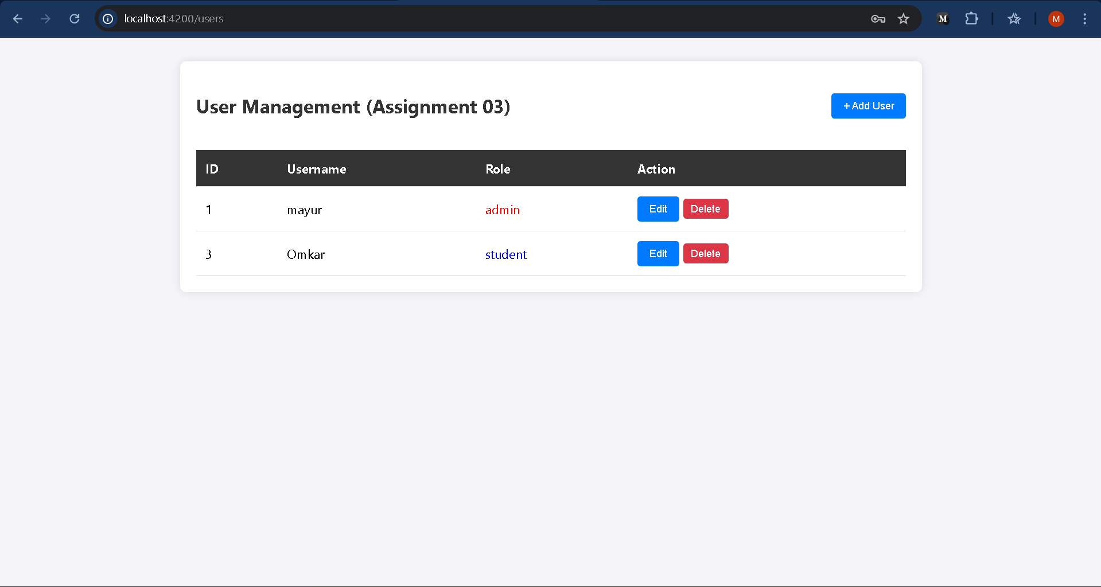

Conclusion
The Web-enabled Student MIS was successfully designed and implemented. The system effectively demonstrates full-stack development principles.
- Angular provided a responsive and dynamic Client-side interface.
- Node.js/Express served as a robust API layer handling logic and routing.
- PostgreSQL ensured structured and persistent data storage. The application fulfills the requirements of data entry, CRUD operations, and role-based security, providing a simpler alternative to complex ERP systems for basic student management.

References
- Angular Development Team. (2024). Angular: The Modern Web Developer's Platform. Google. Retrieved from https://angular.dev
- OpenJS Foundation. (2024). Node.js Documentation API Reference (v20.x). Retrieved from https://nodejs.org/api/
- The PostgreSQL Global Development Group. (2024). PostgreSQL 16.1 Documentation: SQL Syntax and Concepts. Retrieved from https://www.postgresql.org/docs/
- StrongLoop, IBM. (2024). Express - Fast, Unopinionated, Minimalist Web Framework for Node.js. Retrieved from https://expressjs.com/
- Freeman, A. (2018). Pro Angular 6. Apress. (A standard textbook reference for Angular concepts like Components, Services, and Routing).

