Assignment 08 – Distributed ERP System and MCQ Assessment System

1. Introduction
A distributed database system is a collection of multiple interconnected databases spread across different physical locations. These databases communicate with each other and appear as a single logical database to users. Distributed databases improve performance, reliability, and scalability. In modern universities, large amounts of academic data such as student records, course information, assignments, and examination data must be handled efficiently. ERP (Enterprise Resource Planning) systems help universities manage these operations in an integrated way.

2. Objective of the Assignment
The objective of this assignment is to implement a distributed PostgreSQL database environment and use it to develop two database-driven systems. The first system is a University ERP portal where students, faculty members, and administrators have role based access. The second system is an online MCQ assessment platform that allows students to take quizzes and automatically calculates their scores.

3. University Schema Overview
The University schema is a standard database model widely used in database textbooks. It contains relations such as student, instructor, department, course, section, takes, teaches, classroom, advisor, and time_slot. These relations describe the academic structure of a university. Students enroll in courses, instructors teach courses, and departments manage course offerings. This schema provides the base structure upon which the ERP system is implemented.

4. ERP System Design
The ERP system integrates academic activities into a centralized platform. It supports three types of users: students, faculty members, and administrators. Students can log in to view assignments and submit tasks. Faculty members can create assignments and evaluate submissions. Administrators have full control over the system including managing users and monitoring system activities.

Student Portal Concept
The student portal provides a personalized dashboard where students can view their enrolled courses, assigned tasks, and submission deadlines. They can upload their assignment solutions and track submission status.
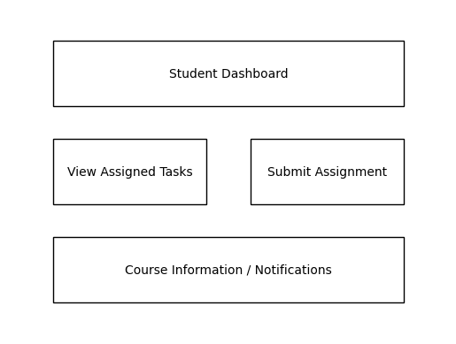

Faculty Portal Concept
The faculty portal allows instructors to create assignments for specific courses and distribute them to enrolled students. Faculty members can also review submissions and provide feedback or grades.

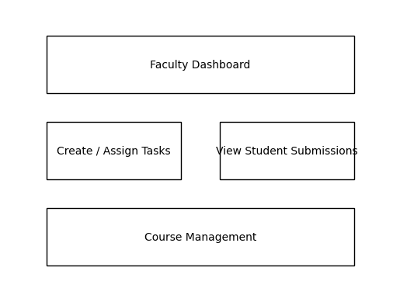

5. MCQ Assessment System
The MCQ assessment system enables online objective examinations. The system stores subjects, questions, and multiple choice options in database tables. Students select answers during the test and the system automatically evaluates responses by comparing selected options with the correct answers stored in the database.
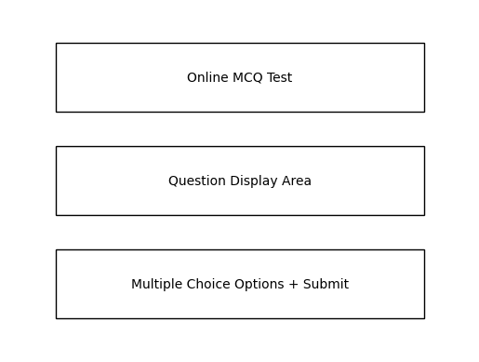

6. Distributed Database Architecture
In this assignment, PostgreSQL is configured across three database nodes. Each node stores a portion of the overall data. Node 1 stores student information, Node 2 stores faculty and course related data, and Node 3 stores assignment tasks and MCQ system data. PostgreSQL Foreign Data Wrappers (FDW) allow nodes to query tables stored in other nodes. This creates a unified distributed database system.
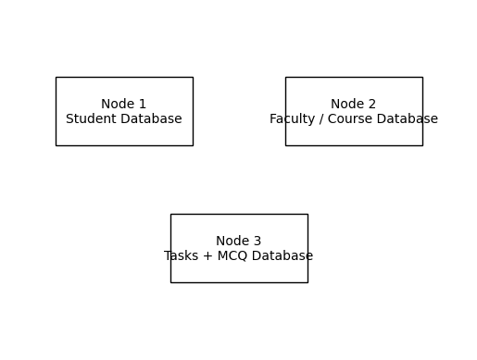

7. Advantages of Distributed Databases
Distributed database systems offer several benefits such as improved system performance, better fault tolerance, higher scalability, and improved data availability. If one node fails, the remaining nodes can continue operating. This architecture is particularly useful in large organizations and universities where data must be accessed from multiple locations simultaneously.

8. Conclusion
This assignment demonstrates the practical implementation of distributed database concepts using PostgreSQL. The ERP portal manages academic workflows such as assignment distribution and submissions, while the MCQ system provides an automated online testing platform. The distributed architecture ensures efficient data management across multiple nodes.

