Assignment No. 9

Title
- Installation and deployment of cloud databases (MongoDB and CassandraDB) and demonstration of CRUD operations using an Angular 19 web form.
Objective / Aim
- To install and deploy MongoDB and CassandraDB on Windows or Linux platforms.
- To develop a web form in Angular 19 to demonstrate Create, Read, Update, and Delete (CRUD) operations with these cloud databases as the backend.
Introduction
- This assignment focuses on working with NoSQL cloud databases, specifically document-oriented (MongoDB) and wide-column store (Cassandra) systems.
- It involves setting up a modern full-stack environment using Angular 19 for the frontend and integrating it with these distributed database systems.
Theory / Algorithms
- MongoDB: A NoSQL database that stores data in flexible, JSON-like documents.
- CassandraDB: A highly scalable, high-performance distributed database designed to handle large amounts of data across many commodity servers.
- Angular 19 CRUD: The process of using Angular services and HTTP clients to interact with a backend API (like Node.js) that communicates with MongoDB and Cassandra.
- CRUD Operations: * Create: Inserting new records/documents into the database.
  - Read: Fetching and displaying data.
  - Update: Modifying existing records based on a unique identifier.
  - Delete: Removing records from the database.
Documentation: Functional Block Diagram/DFD
- The system architecture consists of an Angular 19 Frontend that sends requests via a REST API/Node.js Server to the MongoDB and CassandraDB instances.
- The data flow ensures that user input from the web form is validated and then persisted in the database identified by the user's PRN.
Procedure
- Environment Setup: Install Node.js, Angular CLI, and VS Code.
- Database Installation: * Download and install MongoDB Community Server and MongoDB Compass.
  - Install Apache Cassandra and configure the required Java environment.
- Database Creation: Initialize a database/keyspace using your specific PRN as the name.
- Frontend Development: Create a new Angular 19 project and design a web form for data entry.
- Backend Integration: Set up a Node.js/Express server (as per standard lab practice) to act as the bridge between Angular and the cloud databases.
- Testing: Execute and verify CRUD operations through the web interface.
Actual Experiments/Simulation, Result / Observations

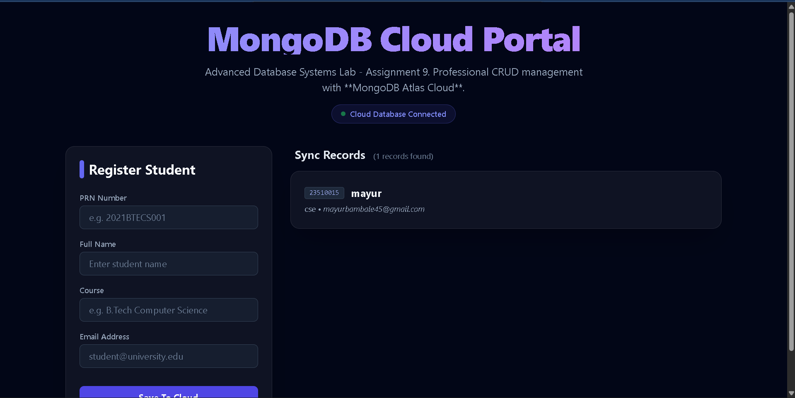

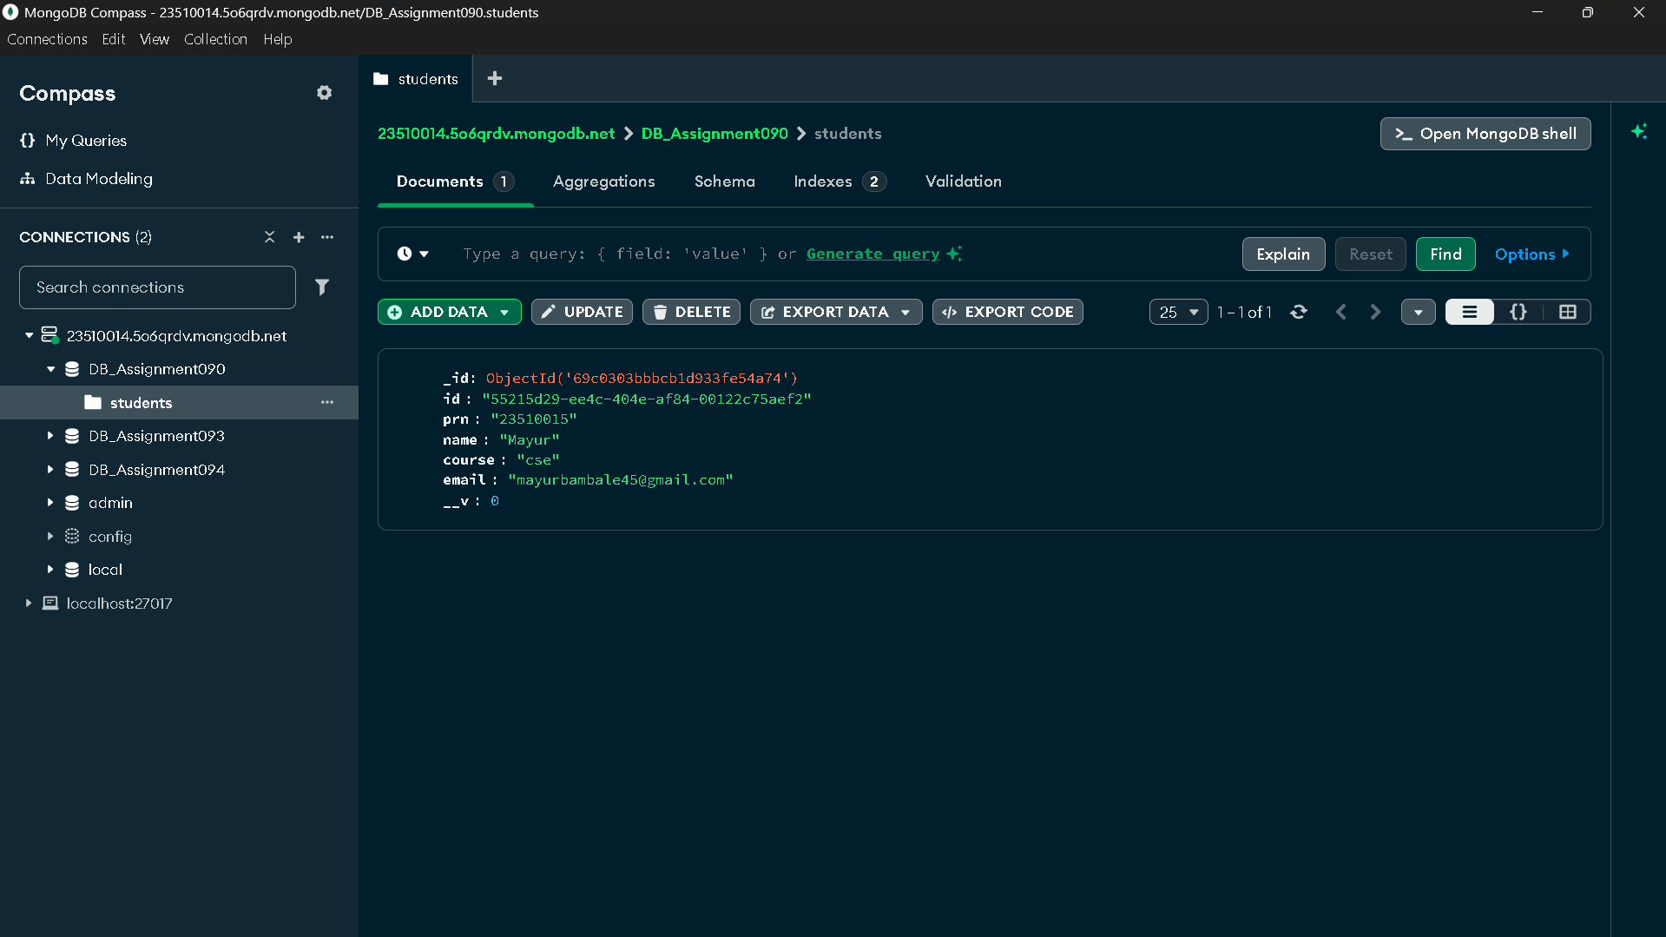
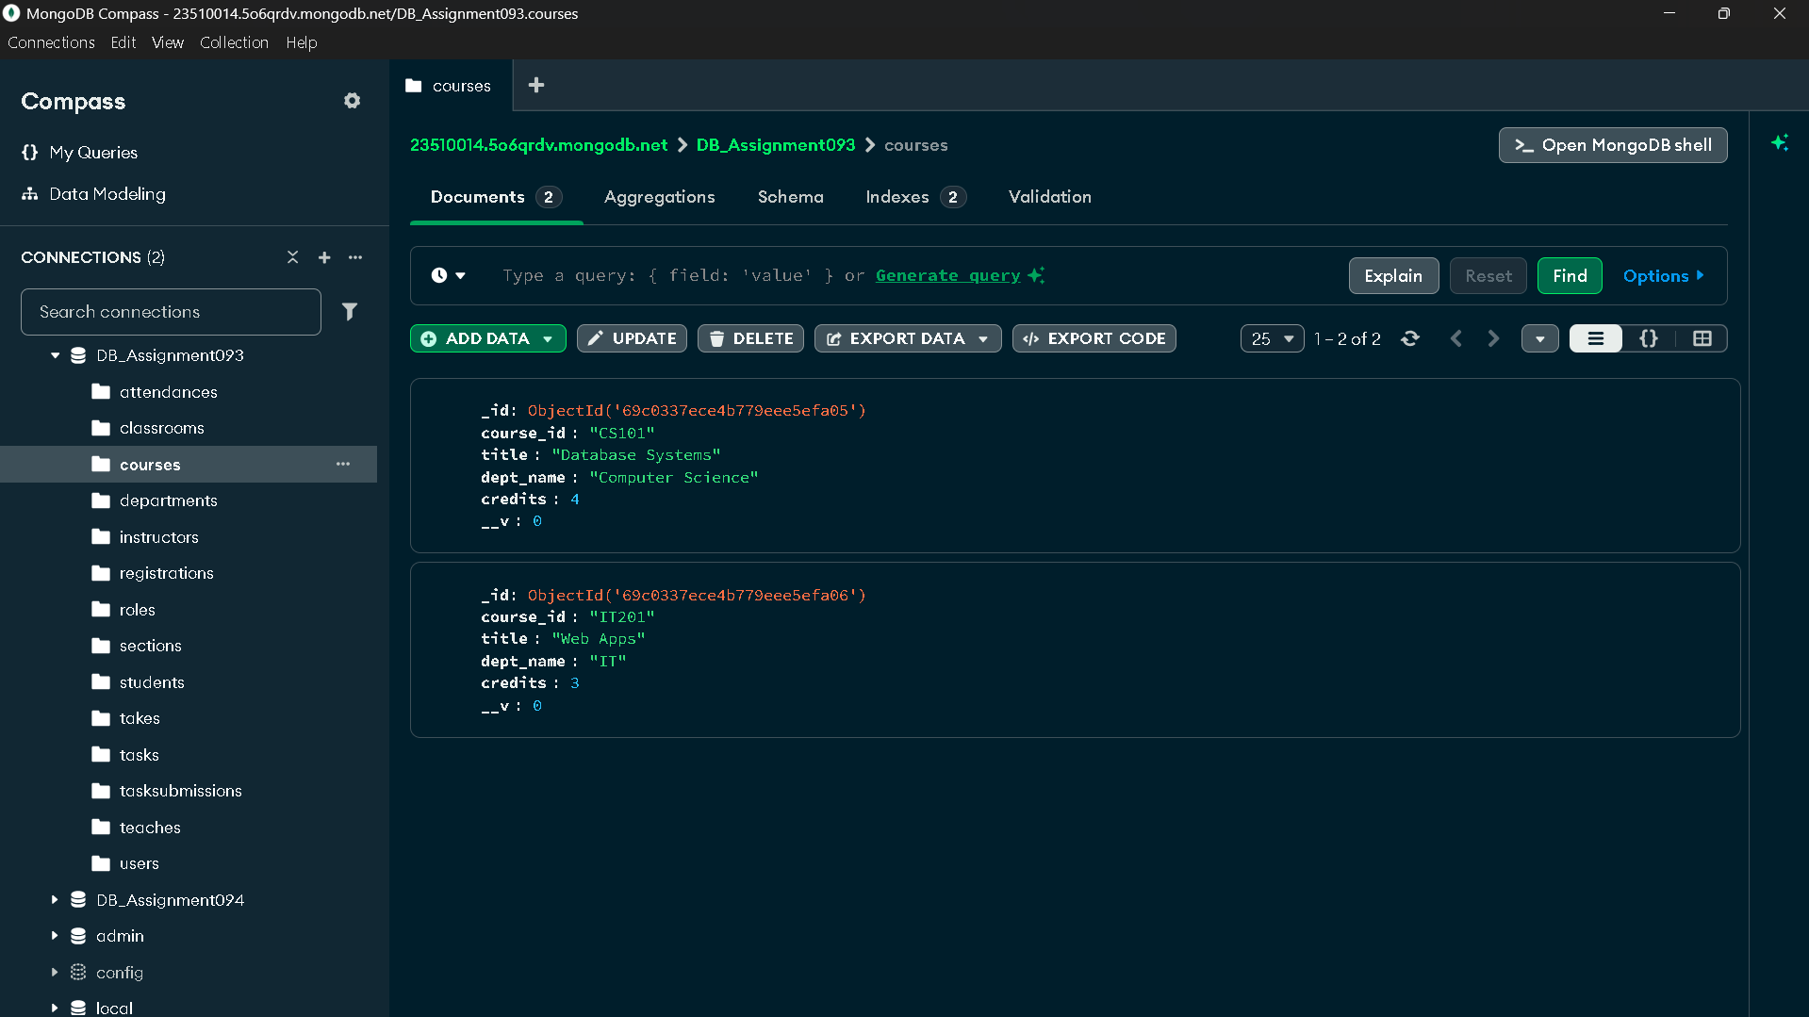
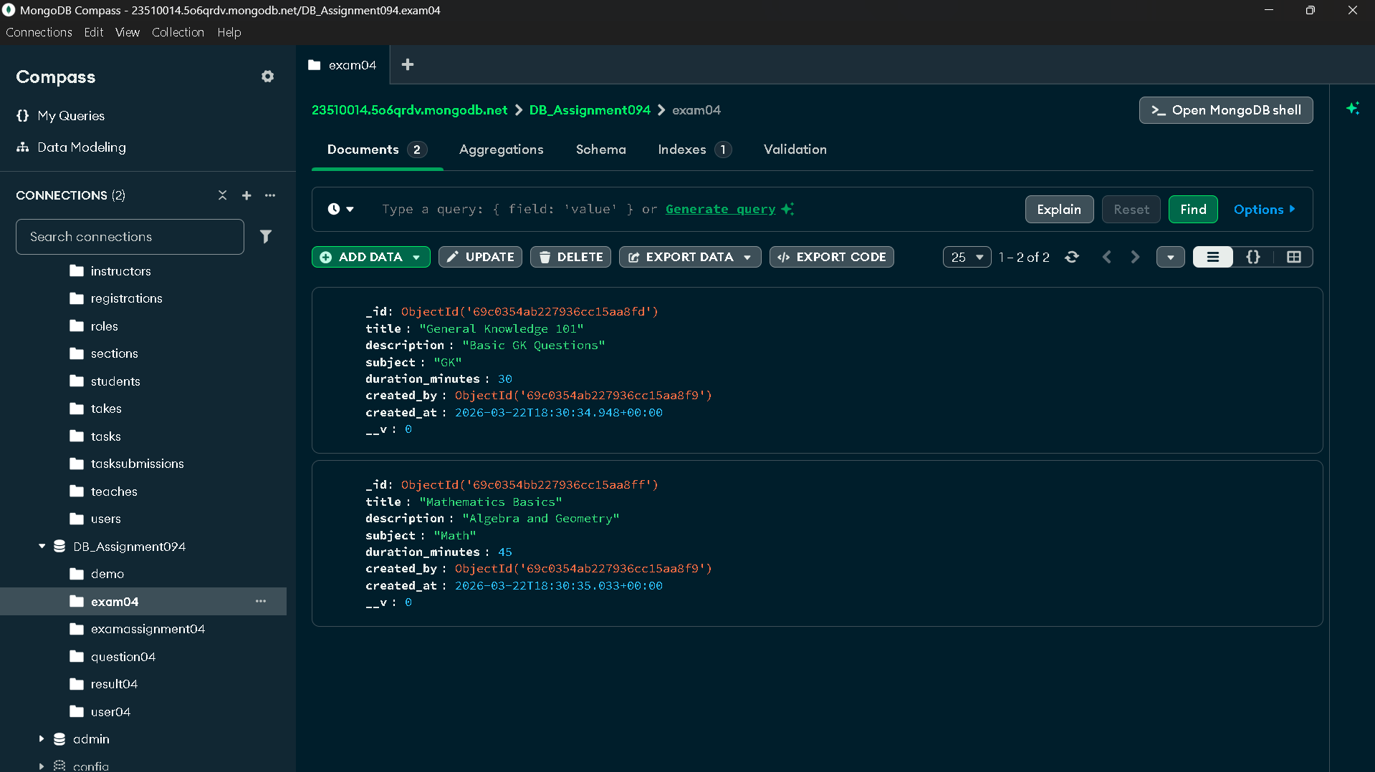

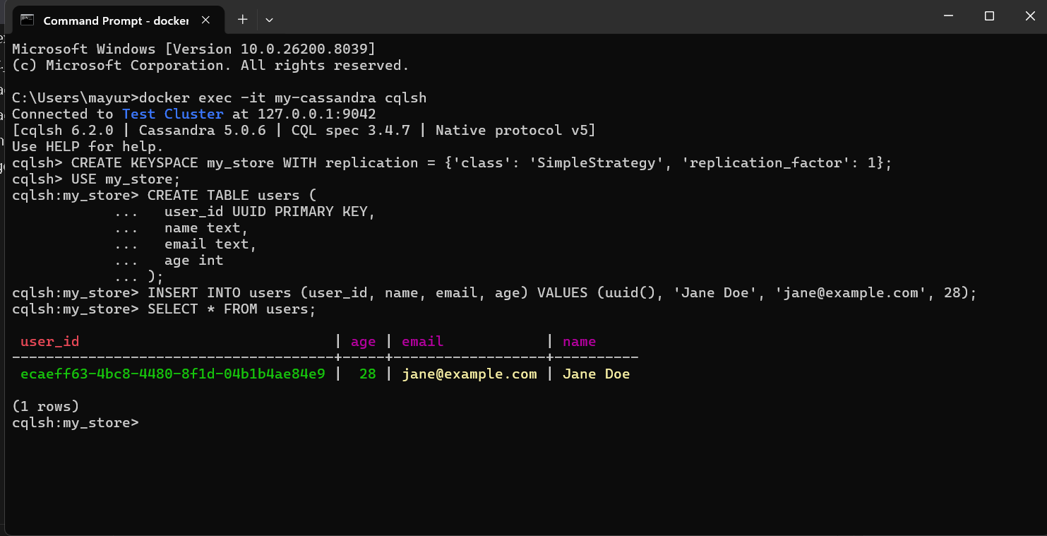

Conclusion
- The assignment successfully demonstrated the deployment of cloud-based NoSQL databases.
- The integration of Angular 19 with MongoDB and Cassandra provided practical experience in full-stack development and modern database management.
References
- Angular Official Documentation (angular.dev)
- MongoDB Manual (mongodb.com/docs)
- Apache Cassandra Documentation (cassandra.apache.org)
- ADS Lab Manual and Guidelines

