Prompts

Assignment No. 3

Prompt 1: 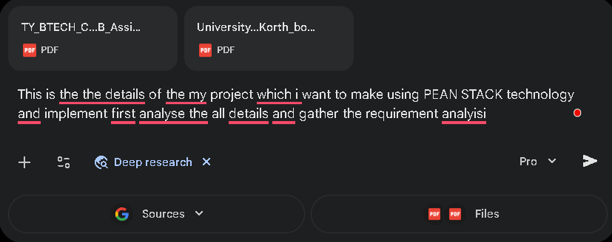

Output:- [Document using deep research feature of gemini with flash version]

Ouput in the format of doc: https://docs.google.com/document/d/1pvz3EYN2kaeUaJN-qX7TdiX6uz7Y4FJ5cs8gceUqp1U/edit?usp=sharing

Prompt 2:
make the flow diagram of the my software as a senior designer and give me full diagram image from log in to include all functions
Output: [Image using Google Gemini’s Nano Banana]
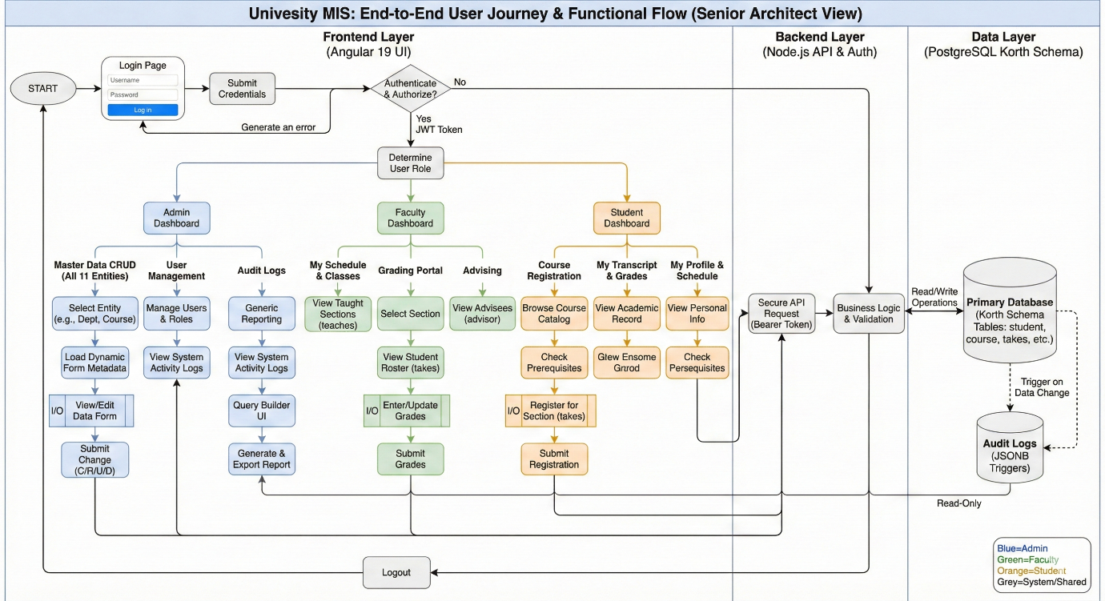

Prompt 3:- [Add Requirement analysis document and system design image and details of university schema and Assignment guidelines and give next prompt]
so i use postgre sql's pgadmin give me queries in another file and database name should be DB03 and user should have 23510014 make the project using PEAN stack and follow all other above requirements and give me functional project in frontend in frontend folder and backend in backend folder and use tailwind css to make formal design
Ouput: Implement basic structure of code using PEAN stack

- Role Alignment & Connectivity: "make the all features of the three roles with proper format and where required make the connection between students and faculty and faculty should have student access and student should have limited access of task which assign by teacher and make it workable and remove title like erp and wce and make it workable."
- Bulk Sample Data: "add at least 10 sample data in all sections of all three roles where required sample data and for that users make user id and password with first name and make password and give me workable code and query return not do it with admin only with faculty and student users."
- One-File SQL Implementation: "solve this error and give me all code which required now from users to all in one file which i want run like below with correct format [followed by the previous SQL script structure]."
- Empty Table Fix: "after running query there no table created it is empty as seen give me correct with full functional as requirements."
- Refresh & Format Correction: "i do refresh on table but still it shows no table why happen give old format of code with sample data and correct to create."
- Invalid Credentials Debug: "node why this shows invalid credentials if any wrong correct it and tell me how can i run project again."
- Visibility & Backend Sync: "esbuild now all tables visible and in terminal also show db connected they why error in 2nd ss solve it."
- pgAdmin & Error Resolution: "this is some information from the pgadmin and some error ss correct it and on pgadmin tell me how to resolve."

