ASSIGNMENT NO. 12
Date: 20 April 2026
Title:
Spatial and Geographic Data using Neo4j (Finding Things Close to Other Things)

Objective / Aim
- To understand and implement geospatial data handling using Neo4j graph database.
- To store geographic coordinates using spatial data types.
- To use Cypher Query Language (CQL) functions like point() and distance() for spatial analysis.
- To find nearest locations and perform proximity-based queries.

Introduction
Geospatial data represents objects, events, or phenomena that have a location on the Earth’s surface. Graph databases like Neo4j provide powerful support for handling such data using spatial data types.
In this assignment, we focus on storing and querying geographic data using Neo4j. Unlike traditional databases, Neo4j allows efficient querying of location-based relationships such as finding nearby places or calculating distances between points.
This experiment demonstrates how to create location nodes with latitude and longitude and perform proximity-based queries using built-in spatial functions.

Theory / Algorithms
1. Spatial Data Modeling
- Node:
  - Location
    - Properties:
      - id (unique identifier)
      - point (geographic coordinate)

2. Spatial Functions in Neo4j
point()
- Used to represent geographic coordinates.
- Takes latitude and longitude as input.
- Example:
point({latitude: 19.0760, longitude: 72.8777})

distance()
- Calculates distance between two points.
- Output is in meters.

3. Data Generation Algorithm
- Use UNWIND to generate multiple nodes.
- Use rand() to create random coordinates:
  - Latitude range: -90 to 90
  - Longitude range: -180 to 180

4. Cypher Query Language (CQL)
- Pattern Matching: MATCH (l:Location)
- Sorting: ORDER BY distance
- Filtering: WHERE distance(...) < value
- Limiting Results: LIMIT

Documentation
Database Schema (Neo4j Graph Model)
Node:
- Location
  - { id: integer, point: geographic point }
Relationships:
- None
Database Name:
- neo

Procedure
- Install and start Neo4j Desktop.
- Create a new database (neo).
- Open Neo4j Browser.
- Generate 10,000 random location nodes using Cypher query.
- Store latitude and longitude using point() function.
- Execute queries using distance() to find nearest locations.
- Perform filtering queries to find locations within a given range.
- Capture screenshots of query execution and results.

Implementation / Cypher Queries
1. Insert 10,000 Location Nodes
UNWIND range(1, 5000) AS id
CREATE (t:TrainStation {
id: id,
city: 'Copenhagen',
latitude: 55.672 + (rand() * 0.1),
longitude: 12.564 + (rand() * 0.1)
})
SET t.location = point({latitude: t.latitude, longitude: t.longitude})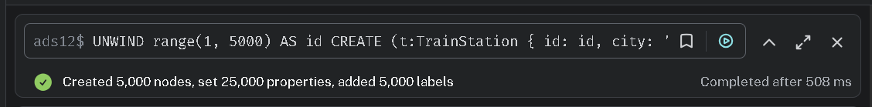

2. UNWIND range(5001, 10000) AS id
CREATE (o:Office {
id: id,
city: 'Malmo',
latitude: 55.611 + (rand() * 0.1),
longitude: 12.994 + (rand() * 0.1)
})
SET o.location = point({latitude: o.latitude, longitude: o.longitude}) 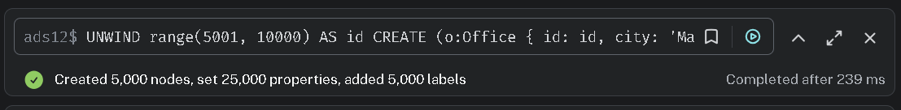

3. MATCH (t:TrainStation), (o:Office)
WITH t, o WHERE rand() < 0.001
LIMIT 5000
CREATE (t)-[:TRAVEL_ROUTE]->(o)
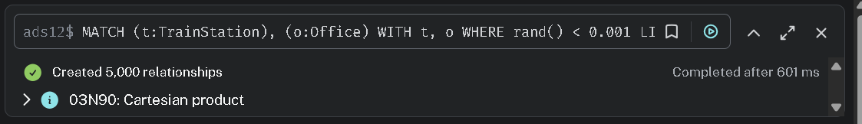

4.
MATCH (t:TrainStation {id: 1}), (o:Office {id: 5001})
RETURN point.distance(t.location, o.location) AS distance_meters
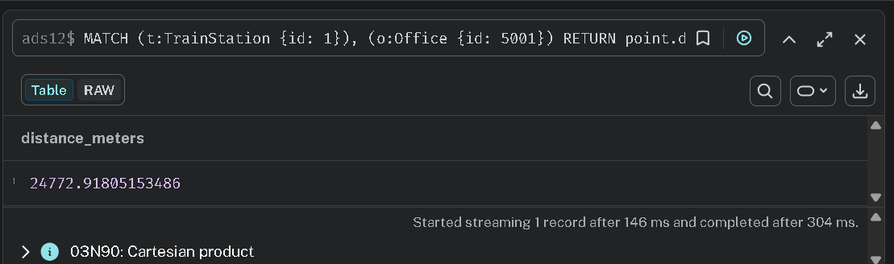

5.
MATCH (t:TrainStation {id: 100}), (o:Office)
WHERE point.distance(t.location, o.location) < 10000
RETURN o.id, o.city, point.distance(t.location, o.location) AS distance
ORDER BY distance
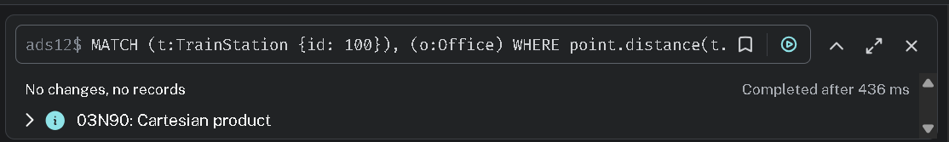

6.
MATCH (t:TrainStation {id: 500}), (o:Office)
RETURN o.id, point.distance(t.location, o.location) AS dist
ORDER BY dist ASC
LIMIT 5 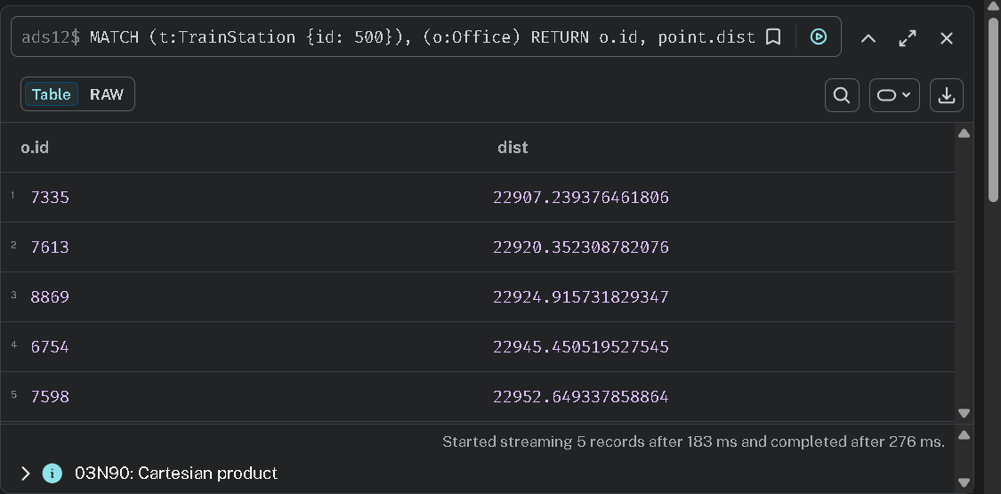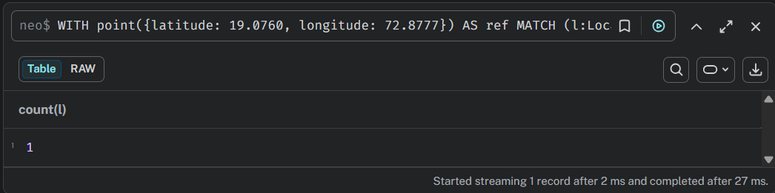

TEST-
7. Find Train Stations within a Bounding Box
(Great for location-based services on the web )
Cypher
MATCH (t:TrainStation)
WHERE point({latitude: 55.67, longitude: 12.56}).latitude <= t.latitude <= 55.68
AND point({latitude: 55.67, longitude: 12.56}).longitude <= t.longitude <= 12.57
RETURN t.id, t.city
8. Identify "Long Routes" (> 30km)
Cypher
MATCH (t:TrainStation)-[r:TRAVEL_ROUTE]->(o:Office)
WHERE point.distance(t.location, o.location) > 30000
RETURN t.id, o.id, point.distance(t.location, o.location) / 1000 AS distance_km
9. Count Stations by City within a specific Radius
Cypher
MATCH (t:TrainStation)
WHERE point.distance(t.location, point({latitude: 55.6728, longitude: 12.5645})) < 5000
RETURN t.city, count(*) AS station_count
10. Find the Average Distance of all Travel Routes
Cypher
MATCH (t:TrainStation)-[:TRAVEL_ROUTE]->(o:Office)
RETURN avg(point.distance(t.location, o.location)) AS average_route_distance
11. Find Offices that are closer to Copenhagen than Malmo
Cypher
MATCH (o:Office)
WITH o, point({latitude: 55.676, longitude: 12.568}) AS cph_center
WHERE point.distance(o.location, cph_center) < 15000
RETURN o.id, o.city
12. Find the "Central" Station (Most connections within 2km)
Cypher
MATCH (t:TrainStation), (o:Office)
WHERE point.distance(t.location, o.location) < 2000
RETURN t.id, count(o) AS nearby_offices
ORDER BY nearby_offices DESC
LIMIT 1
13. Group Offices by Distance Tiers from a Station
Cypher
MATCH (t:TrainStation {id: 1}), (o:Office)
RETURN
CASE
WHEN point.distance(t.location, o.location) < 5000 THEN 'Close'
WHEN point.distance(t.location, o.location) < 15000 THEN 'Mid-Range'
ELSE 'Far'
END AS proximity,
count(o) AS count

Actual Experiments / Results / Observations
- Successfully created 10,000 (or more) location nodes using Cypher queries.
- The point() function correctly stored geographic coordinates.
- The distance() function efficiently calculated distances between locations.
- Query A Result: The nearest location query returned top 5 closest nodes to the reference point.
- Query B Result: Filtering based on distance successfully retrieved nodes within specified range.
- Query C Result: Count query correctly returned number of nearby locations.
- Neo4j handled spatial queries efficiently without requiring external plugins.

Conclusion
This assignment demonstrates the effectiveness of Neo4j in handling spatial and geographic data. By using built-in functions like point() and distance(), complex location-based queries such as nearest neighbor search and proximity filtering can be executed efficiently.
Unlike traditional relational databases, Neo4j simplifies geospatial analysis and provides high performance for real-time location-based services. This experiment highlights the practical use of graph databases in modern applications such as navigation systems, delivery services, and location-based recommendations.

References
- Neo4j Cypher Manual – https://neo4j.com/docs/cypher-manual/current/
- Neo4j Spatial Documentation – https://github.com/neo4j-contrib/spatial
- Geospatial Concepts – https://en.wikipedia.org/wiki/Geographic_information_system

