ASPIRETSS · OPERATOR MANUAL
Shock and Awe
Operator Guide
How to build, edit, and go live with interactive scenes from the interface
Version v1.0
Audience Operators working in the AspireTSS CMS
Brands SAT (securityawarenesstraining.ai) and Aspire (aspiretss.com)
Note. Figures in this guide show the current interface. Screen labels in bold match the buttons and fields you will use.

Contents

1. What you can do here 3
2. Sign in from the AspireTSS CMS 4
3. Screens you will use 5
4. Brands: SAT and Aspire 6
5. Build a scene and go live 7
6. Setup: the scene list 8
7. The editor 10
8. Item kinds 15
9. Files and uploads 17
10. Going live 18
11. What visitors see 19
12. Habits and pitfalls 22

1. What you can do here
Shock and Awe is the editor for interactive scenes — an executive desk, a planning board, an office, a workshop, or any other stage you assemble. Visitors click props on the stage. A click opens a letter, a PDF, a video, a contact card, another scene, a download, or a web page.
You build those scenes here. SAT (securityawarenesstraining.ai) and Aspire (aspiretss.com) show live scenes to visitors. Until a scene is live, it exists only in Setup.
- Create a new scene and give it a name, background, and page address.
- Place clickable items on the stage and attach files or links.
- Set a brand to live when the scene is ready for visitors.
- Edit, re-place, rename, or take a scene back to draft.
Setup, the live index, and the Back bar on a scene are for operators who arrived from the AspireTSS CMS. Visitors on SAT or Aspire never see those controls.

2. Sign in from the AspireTSS CMS
You do not sign in on Shock and Awe itself. You are already signed in to the AspireTSS CMS. From the CMS, open Shock and Awe (the hub action for scenes). You land in Setup, already signed in.
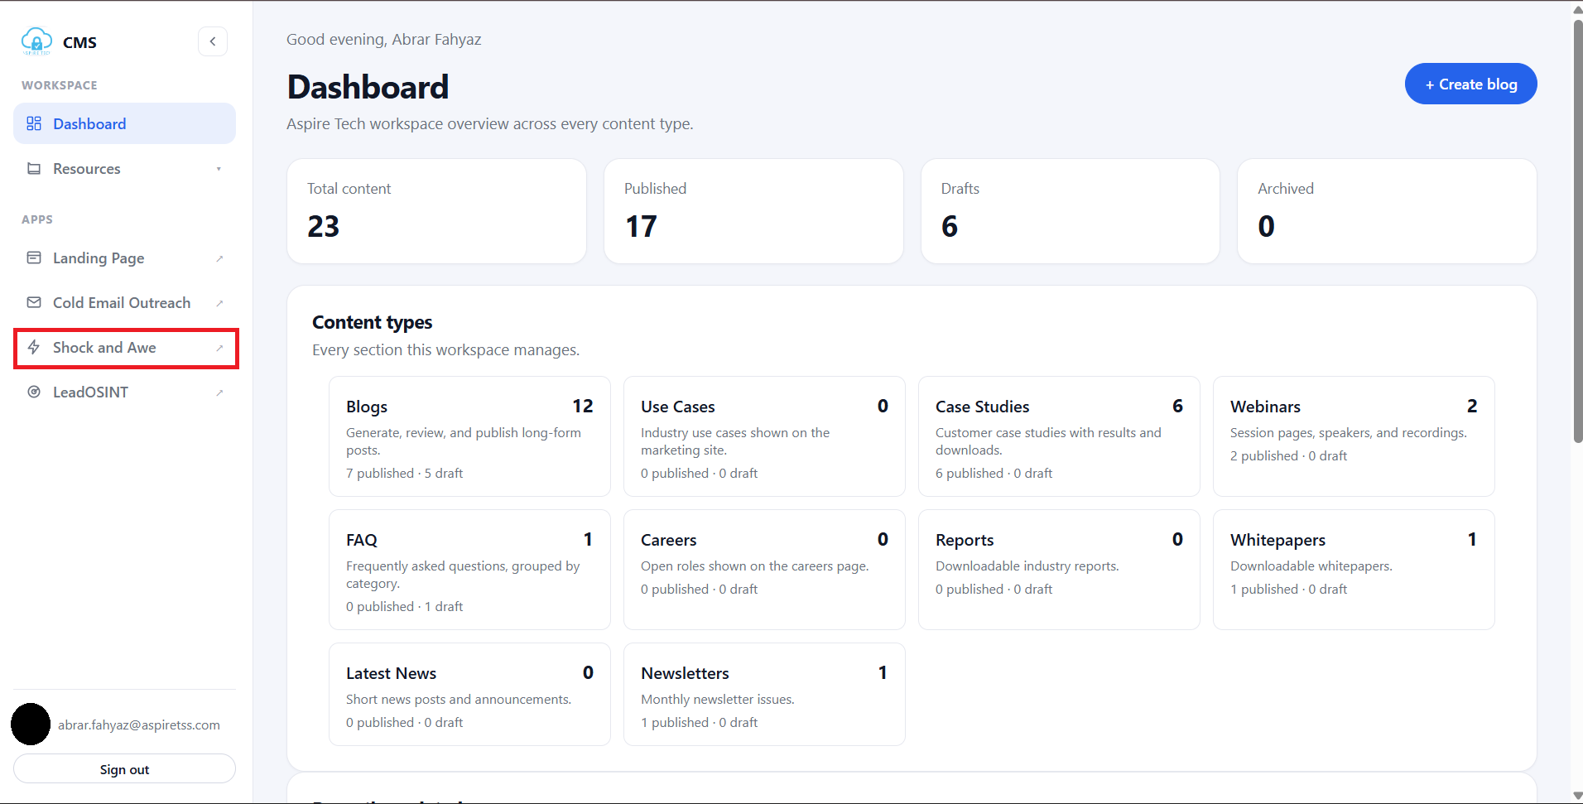
Figure 1. AspireTSS CMS — open Shock and Awe from the sidebar
While you work, the header can show:
- Return to dashboard — takes you back to the AspireTSS CMS.
- Sign out — leaves Shock and Awe and continues the CMS sign-out.
- Index — the list of live scenes (from Setup).
If a session has ended, go back to the AspireTSS CMS and open Shock and Awe again. Do not look for a separate Shock and Awe sign-in form.
Note. Live scene pages stay public. Visitors who open a scene from SAT or Aspire never see Setup, Index, Back, or CMS chrome.

3. Screens you will use

Setup
The home for operators. Every scene appears as a row. From here you add a scene, assign SAT and Aspire, open the editor, preview, delete, or remove unused files. Opening Shock and Awe from the CMS lands you here.

Editor
One scene at a time. Collapsible sections on the left (URL, Anatomy, Letter header & footer, Items) and a Stage on the right you can drag. Save writes your changes.

Index
A signed-in list of scenes that are already live on the brand this copy is showing, plus a read-only list of live scenes on the other brand. Most people stay in Setup after opening from the CMS. Use Index when you want a quick scan of what visitors can already see.
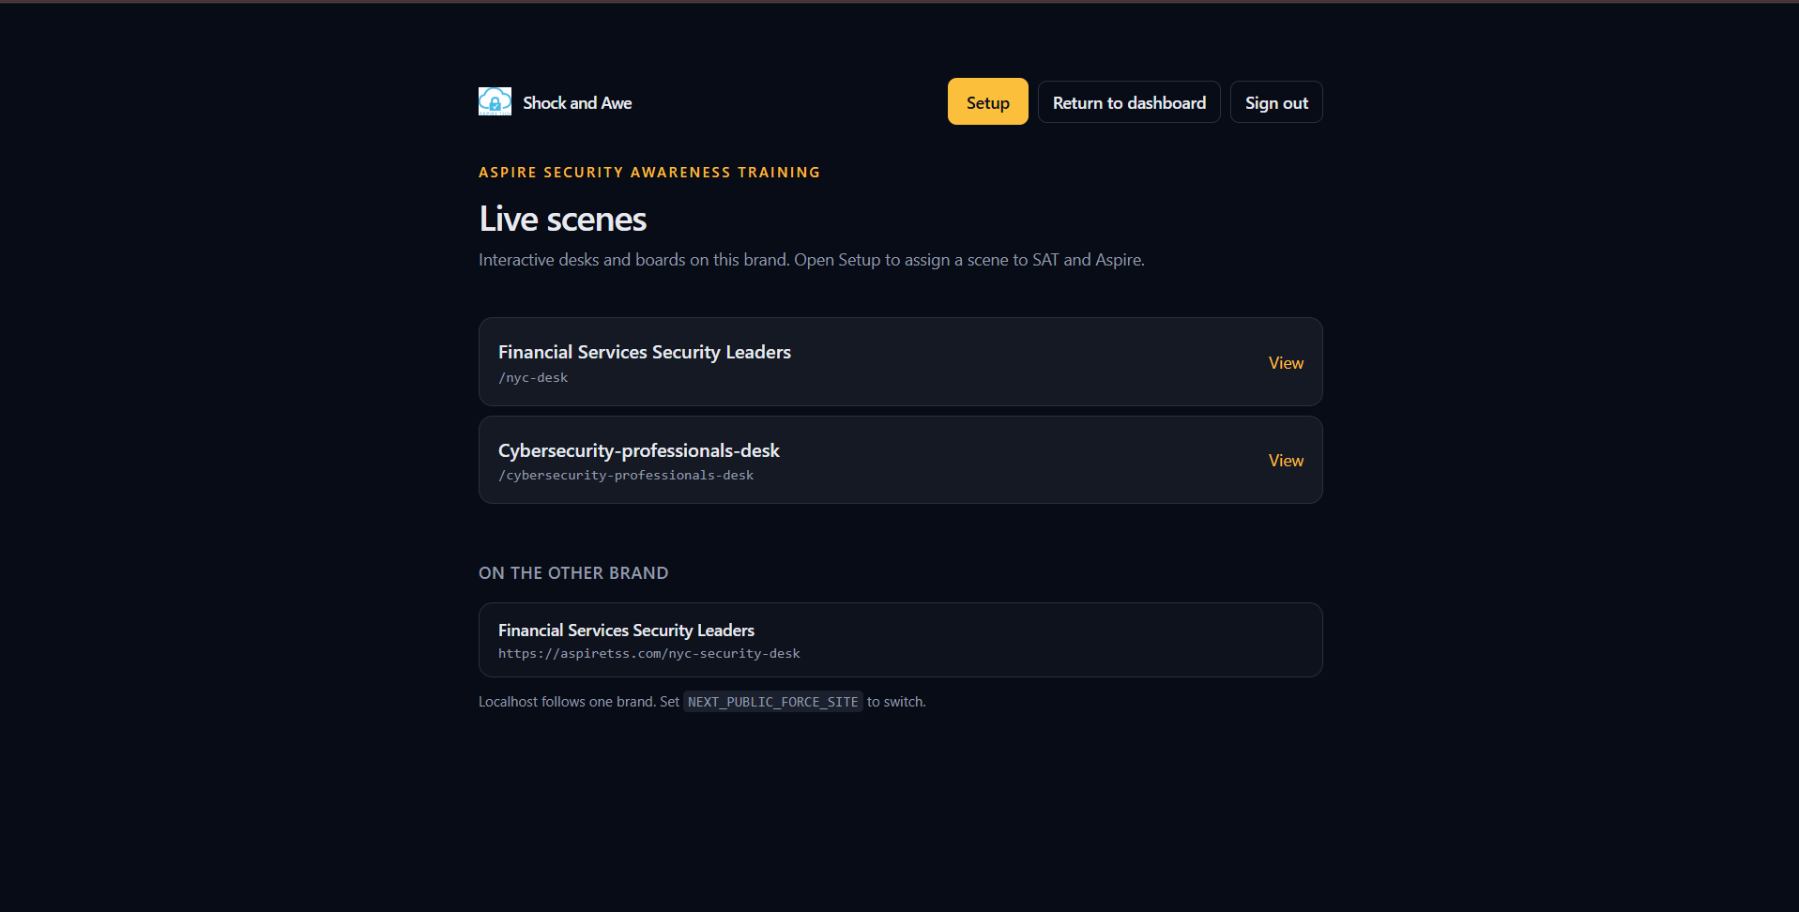
Figure 3. Index — live scenes on this brand, and on the other brand

View (the public page)
The scene as visitors will see it. From Setup or the editor, View opens that page. Because you are signed in from the CMS, a Back bar appears at the top so you can return to the editor. Visitors inside SAT or Aspire do not get that bar.

4. Brands: SAT and Aspire
Each scene can belong to SAT (Aspire Security Awareness Training), Aspire (Aspire Tech Services and Solutions), or both. Each brand has its own page address (optional campaign host plus slug) and its own status.
- off — that brand is not assigned. The scene does not appear there.
- draft — assigned, still only in Setup. Visitors do not see it.
- live — visitors on that brand can open it. SAT and Aspire will show it.
- archived — kept on the brand but not shown to visitors.
When both brands are live, SAT is the primary copy. Aspire is typically not the copy search engines should prefer.
You cannot drop the last remaining brand. Keep at least one of SAT or Aspire on every scene.

5. Build a scene and go live
A typical first scene, start to finish:
- Click Add scene. A new Untitled scene opens in the editor as a SAT draft.
- Under Anatomy, set the nameplate, upload a background, and fill the SEO title and description.
- Optional: under Letter header & footer (all letters), add header and footer images and footer text.
- Under Items, click Add item. Choose a Kind, attach a file or URL, and place it on the Stage.
- Click Save. Nothing is public until you save, and a draft is still Setup-only.
- Open the URL fold. Set Status to live for SAT and/or Aspire. Save again.
- Click View and click through the scene the way a visitor would.
Note. Draft stays in Setup. SAT and Aspire only show a scene after that brand’s Status is live and you have saved.

6. Setup: the scene list
Setup lists every scene. If there are none yet, you will see: “No scenes yet. Add one, then assign it to SAT and/or Aspire.”
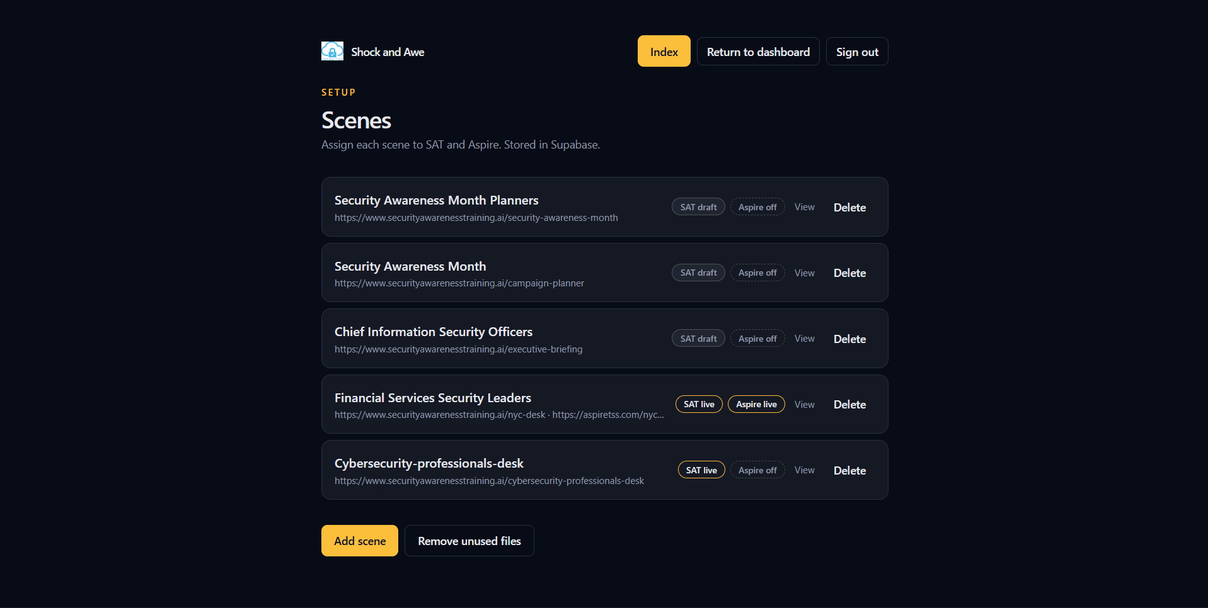
Figure 2. Setup — scene list with brand chips, View, Delete, and Add scene

Each row
- The large name is the nameplate. Click it to open the editor.
- The line under the name is the public URL for each assigned brand.
- Brand chips: SAT and Aspire, each with a status — live, draft, archived, or off.
- View — opens the public page (needs a live address; see Going live).
- Delete — asks “Delete this scene?” and removes the scene and its files.

Brand chips
A chip does not cycle live → draft → off. Clicking it assigns that brand (copies the page name and status from the brand already on the scene) or drops it. The click saves immediately. Hover a chip to see “Assign to …” or “Remove from …”.
To change draft to live (or the reverse), open the editor and use the Status menu in the URL fold. Then Save.
Brand chips appear on each row in Figure 2.

Buttons at the bottom
- Add scene — creates the scene and opens the editor.
- Remove unused files — asks first, then deletes images, PDFs, video, and audio that no scene still uses. A note reports how many unused records and files were removed.
From Setup the header also offers Index, Return to dashboard, and Sign out.

7. The editor
Open a scene from the list (click the nameplate). The editor title is the nameplate. Unsaved edits live only on this screen until you click Save.
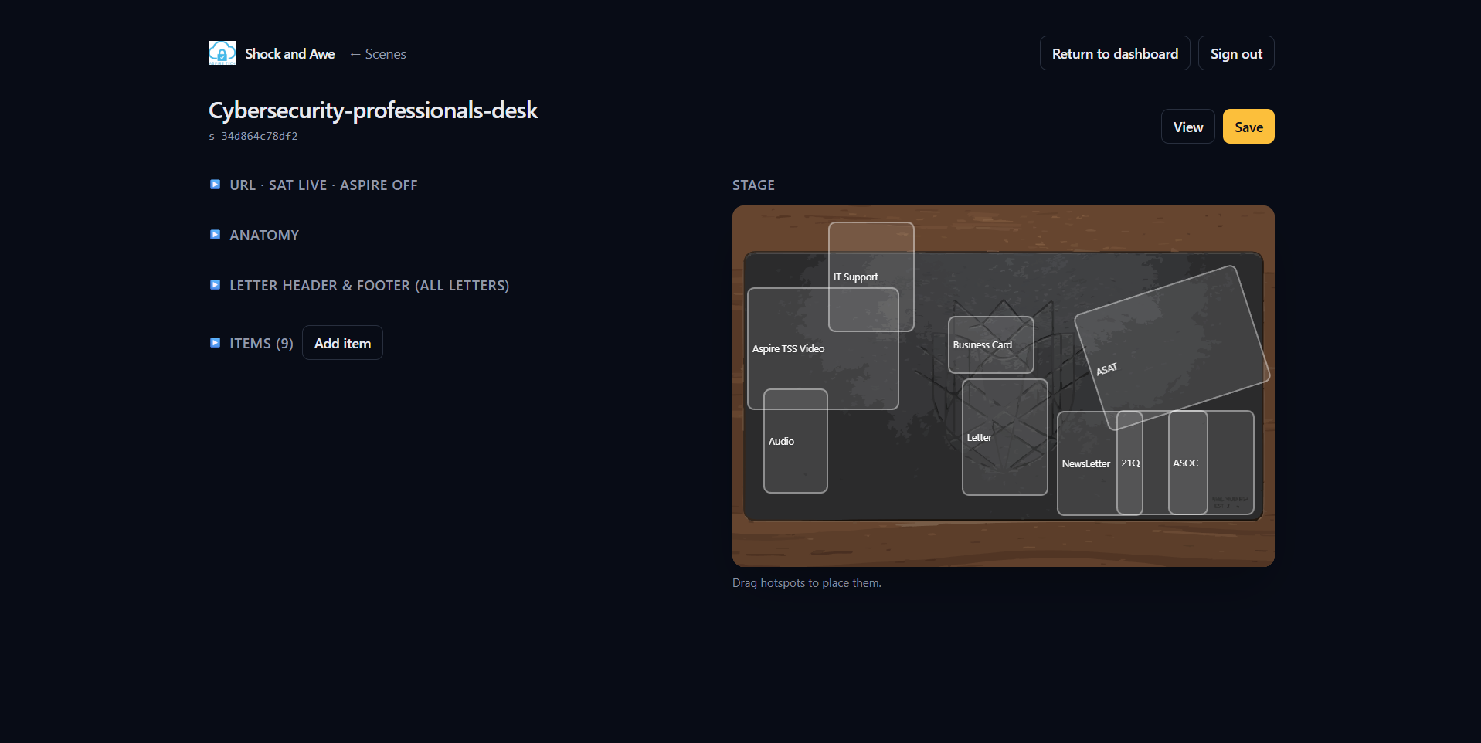
Figure 4. Editor — folds on the left, Stage on the right

7.1 Header
- Save — writes the scene. The button reads Saving while it works.
- View — opens the public page for this scene, with Back to the editor. View uses a live page name if one exists. A draft public URL will not show until Status is live.
- ← Scenes — returns to the Setup list.
If something fails, an error line appears under the title. Fix the fields and save again.

7.2 Stage
The right column is the Stage. It shows the background and a labeled box for every item. On a wide screen it stays in view as you scroll the form.
- Click a box to select that item. The matching row in Items highlights, and the item fields open.
- Drag a box to move it. Position is a percentage of the stage, so it scales on any width.
- The prompt under the stage: “Drag hotspots to place them.”
Dragging is not saved until you click Save. Use the Stage while you draft; you do not need the public page to place items.
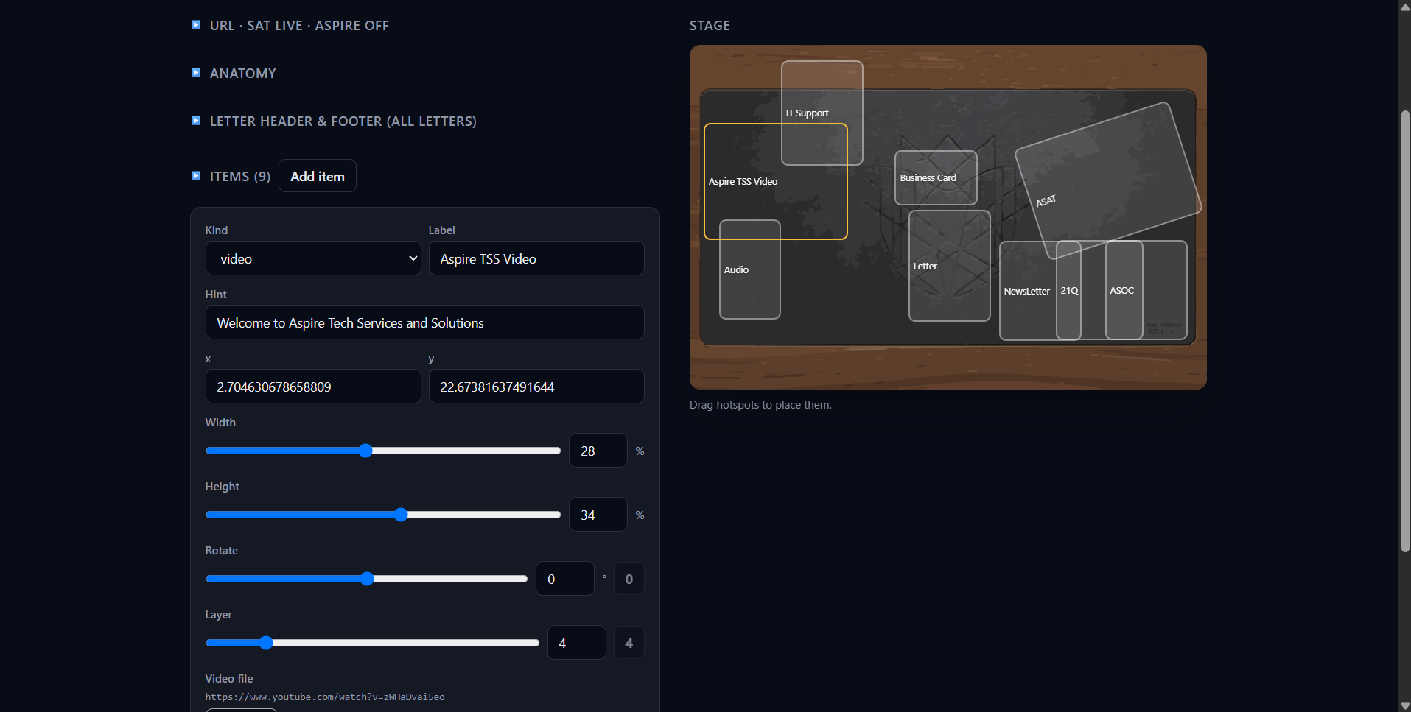
Figure 5. Selected item fields and the matching Stage hotspot

7.3 URL
The fold title summarises both brands, for example URL · SAT live · Aspire off. Expand it to edit addresses.
For each brand:
- A checkbox assigns or drops that brand (same idea as the Setup chips).
- Subdomain — optional campaign host, such as a client short name. Letters, numbers, and hyphens only.
- Slug — the page name after the site, lowercase letters, numbers, and hyphens only.
- Status — draft, live, or archived.
Under the fields, the resulting public URL is shown so you can check it before you save.
If you change a slug after the scene has been live, previous addresses keep working: they send visitors to the new name.
Do not use these as a slug: setup, api, scene, images, assets, static. Two scenes cannot share the same slug on the same brand — save will fail.
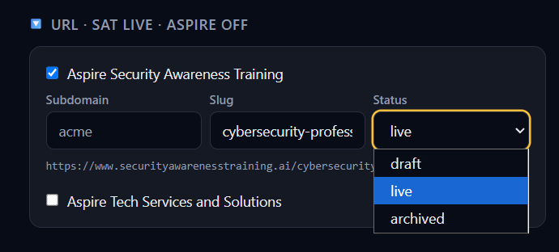
Figure 6. URL fold — subdomain, slug, and Status set to live

7.4 Anatomy
This is the scene itself — name, picture, and search text — not the clickable props.
- Nameplate — the name on the list and, when the artwork has no title baked in, on the stage. Changing it also updates the SEO title if the two still match.
- Prefix — optional small line above the nameplate (for example a campaign line).
- Preset — desk, office, board, soc, workshop, or custom. This is a category, not a layout switch. Placement is still freeform on the Stage.
- Parent — another scene this one belongs under. Used for the operator Back / Up trail when you preview nested scenes. Choose None for a root scene.
- Background — upload the stage image (JPEG, PNG, WebP, GIF, or SVG). After upload, Width and Height appear. Keep them matching the real image so boxes sit correctly.
- SEO title and SEO description — title and description for the public page.
- Banner text — optional strip at the top of the public page. Filling it shows that text with a default “Learn more” button.
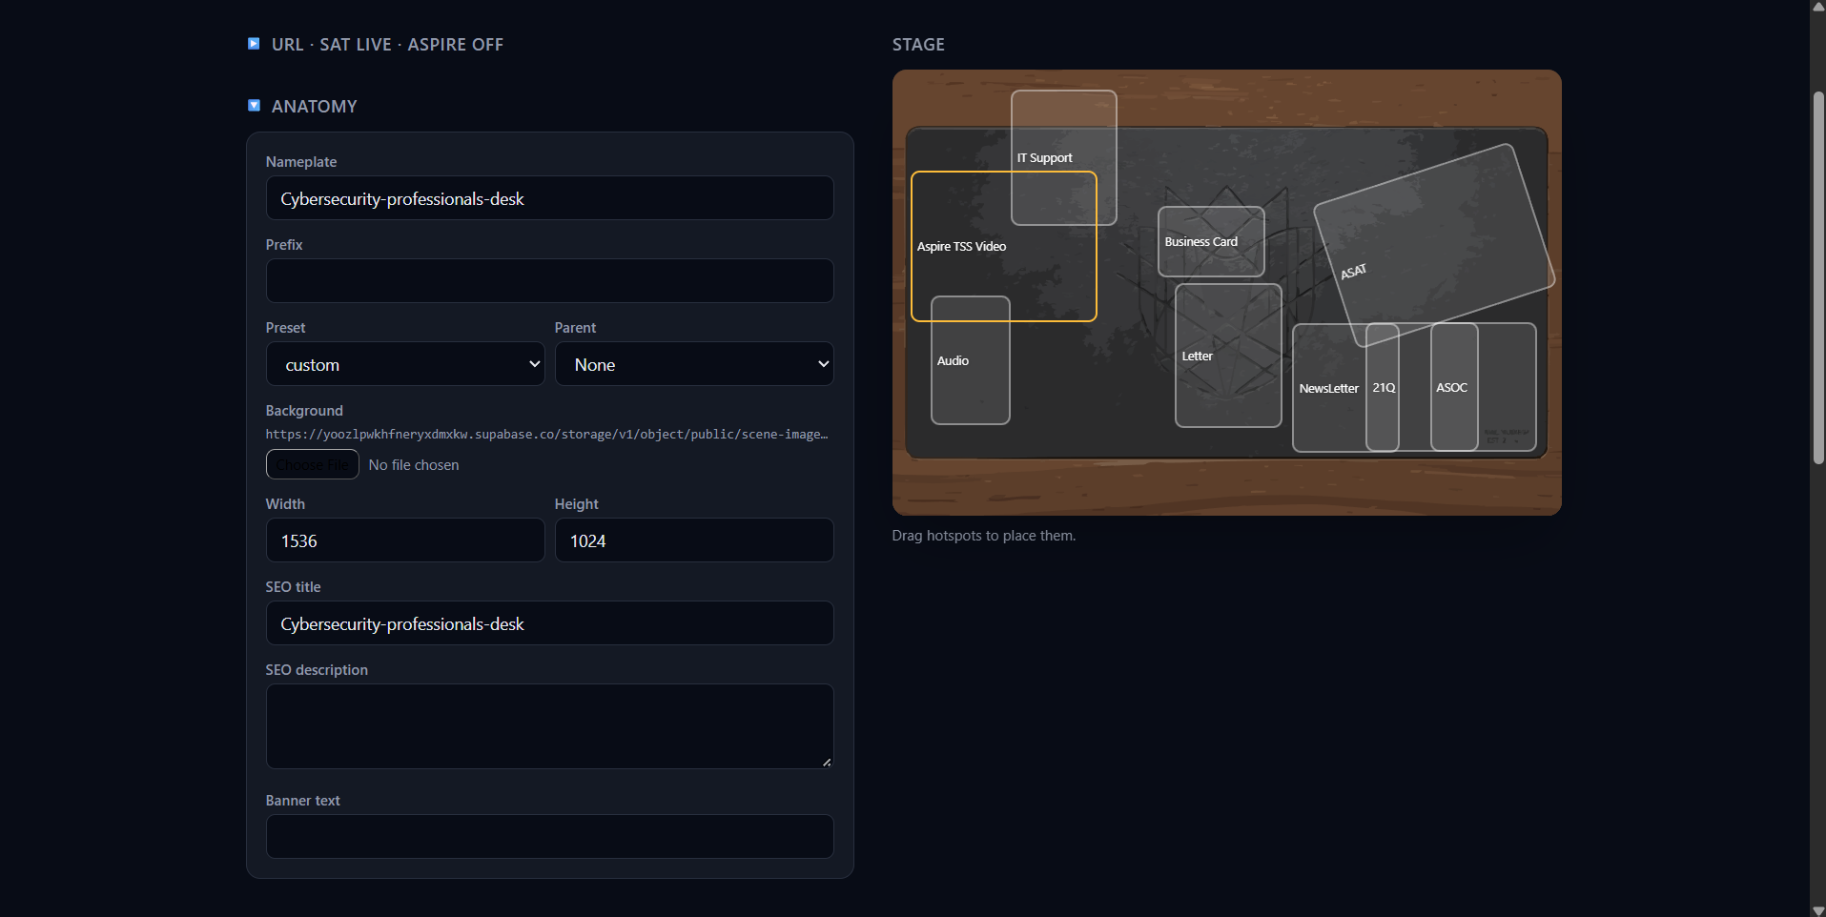
Figure 7. Anatomy — nameplate, background, SEO, and banner

7.5 Letter header & footer (all letters)
Chrome shared by every letter in this scene, including letter PDF downloads. Set it once rather than repeating it on each letter.
- Header image — upload, or paste a Header image URL.
- Footer image — upload, or paste a Footer image URL.
- Footer text — address, confidentiality line, or similar.
- Clear letter brand — removes header, footer, and footer text from the scene.
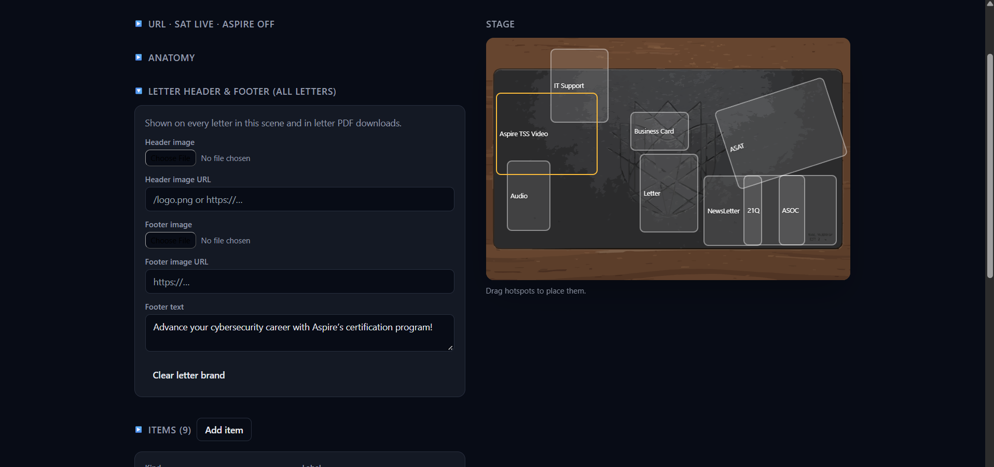
Figure 8. Letter header and footer for every letter in the scene

7.6 Items
The Items fold shows a count, for example Items (4). Add item creates a hotspot labelled “New item”, kind auto, in the middle of the stage, and selects it.
Click a row or a box on the Stage to edit that item. Shared fields:
- Kind — what happens when a visitor clicks. See Item kinds.
- Label — accessible name and overlay title.
- Hint — optional hover text, such as “Read this letter”.
- x and y — position as a percentage of the stage.
- Width and Height — size as a percentage. Slider or number. Unit is %.
- Rotate — degrees. The 0 control resets tilt.
- Layer — which item sits on top when boxes overlap. Higher is in front. The reset control returns to list order.
- Remove item — deletes this hotspot from the scene (save to keep the removal).
Give a prop a hotspot only when it carries content — a document, a screen, a letter, a person, a download. Mugs, plants, and empty folders stay dressing.
A signed cover is a letter, not a PDF. A tablet showing a player is a video. A DOWNLOAD button is a download.
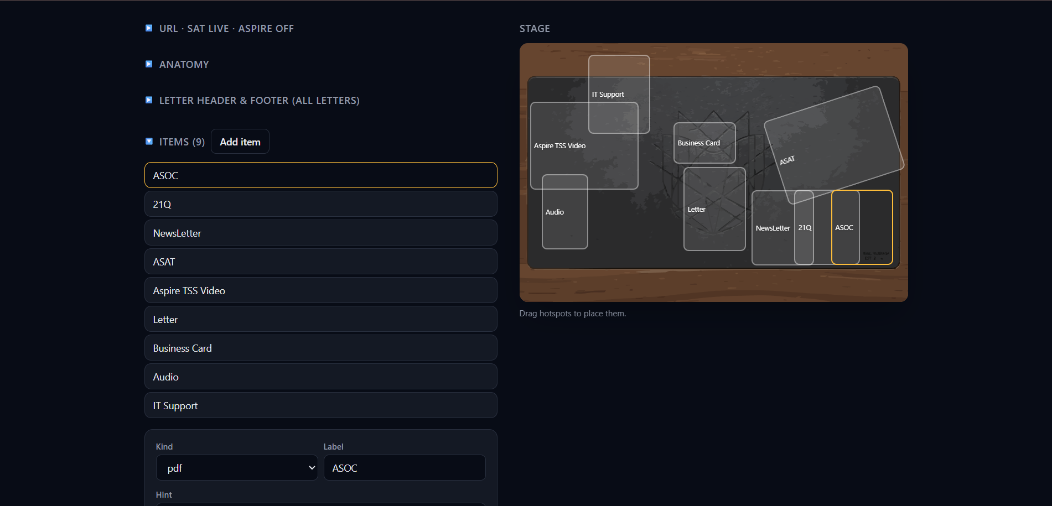
Figure 9. Items list with a selected hotspot

8. Item kinds
Kind is the dropdown on the selected item. Pick the kind that matches what the visitor should get. Changing kind keeps the label and position and asks for the fields that kind needs.

auto
Default for a new item. Upload a File. The public page chooses a viewer from the file or URL (a PDF opens as a PDF, a video as video, and so on). Use a specific kind when you need extra fields (transcript, poster, letter body).

pdf
Upload under PDF. Click opens the document in the overlay. You can also attach a Download file.
If you replace the PDF, the download copy of that file stays in step with the new upload.

image
Upload under Image. Fill Alt so the picture has a text equivalent.

video
Either:
- Upload a Video file (MP4, WebM, or MOV), or
- Paste under Or YouTube / Vimeo URL.
Optional Poster — a still shown before the video plays.
Uploaded files (and YouTube / Vimeo) can play muted on the hotspot. Click opens the overlay. Keep uploaded video small.

audio
Upload under Audio (MP3, WAV, M4A). Add a Transcript — visitors who cannot hear the clip still get the message.

embed
Paste a Page URL. Click opens that page in the overlay.

link
Paste an Href. An email or phone link leaves the page. Other web addresses open in the overlay.

letter
Type the Letter body. Separate paragraphs with a blank line. On the desk the letter is scaled to its box so the full text is visible; click opens a scrollable overlay.
You can greet the recipient by name:
- {{firstName}} — first name from a personalised campaign link, or “there” if none.
- {{company}} — organisation from that link, or “your organisation” if none.
Signature name and Signature title appear at the bottom of the letter.
Scene-wide header and footer (section 7.5) apply to every letter and to letter PDF downloads. In the overlay, visitors can download a PDF of the letter.

card
A contact card. Fields:
- Photo — upload.
- Name and Title.
- Email.
- Phone and Phone label (for example Mobile).
- Website and Address.
- Social links: LinkedIn, optional Email link (leave blank to use mailto from Email), plus Extra network / Extra href and Add link.
- vCard href — optional address of a contact-card file.

download
Upload under Download file. Click starts a download. There is no overlay. Any other kind may also attach a download so the overlay can offer a file.

scene
Target scene — choose another scene by nameplate. Click takes the visitor there (same brand). Use this for a hub office that opens inner desks or boards.
The target should be live on that brand, or the hotspot will have nowhere to go.

9. Files and uploads
Use the file picker on the field. There is no path box to type. After you choose a file, wait for “Uploading…” to finish before you save.
- Images, PDFs, audio, posters, backgrounds, and downloads: pick a file.
- Video: pick a file, or paste a YouTube / Vimeo / Loom page address — those stay as links; they are not uploaded.
- Letters: type the body; optional header and footer come from the scene letter fold.
Largest file: 50 MB. Keep uploaded video well under that so the page stays quick. If an upload fails, the field shows an error; pick a smaller file or a supported type and try again.
When you replace a PDF or image, the matching download for that item is updated too, so visitors do not get a stale file.
Remove unused files on Setup is the cleanup for files no scene still points at. Confirm the prompt. It does not delete files that items still use.

10. Going live
Going live is how you deploy a scene. There is no separate publish button. In the editor, open URL, set Status to live for SAT, Aspire, or both, then Save.
After that:
- SAT and Aspire can show the scene at the URL under the fold.
- The Setup chip reads SAT live or Aspire live.
- View opens the public page so you can click through.
To take a scene off the public sites without deleting it:
- Set Status back to draft or archived and Save.
- Or, on Setup, click the brand chip to drop that brand (not if it is the only brand left).
Use the Status menu shown in Figure 6.
Note. Save after every status change. A live chip with unsaved editor changes is not what visitors see yet.

11. What visitors see
Visitors open the scene on SAT or Aspire (often inside those sites). They never see Setup, Index, or Back.

Desktop
The stage fills the page. Hotspots sit on the artwork. A letter is scaled to its box so the writing is readable on the desk. Videos can play muted on the hotspot. Click does one thing — never a pop-up and then another click.
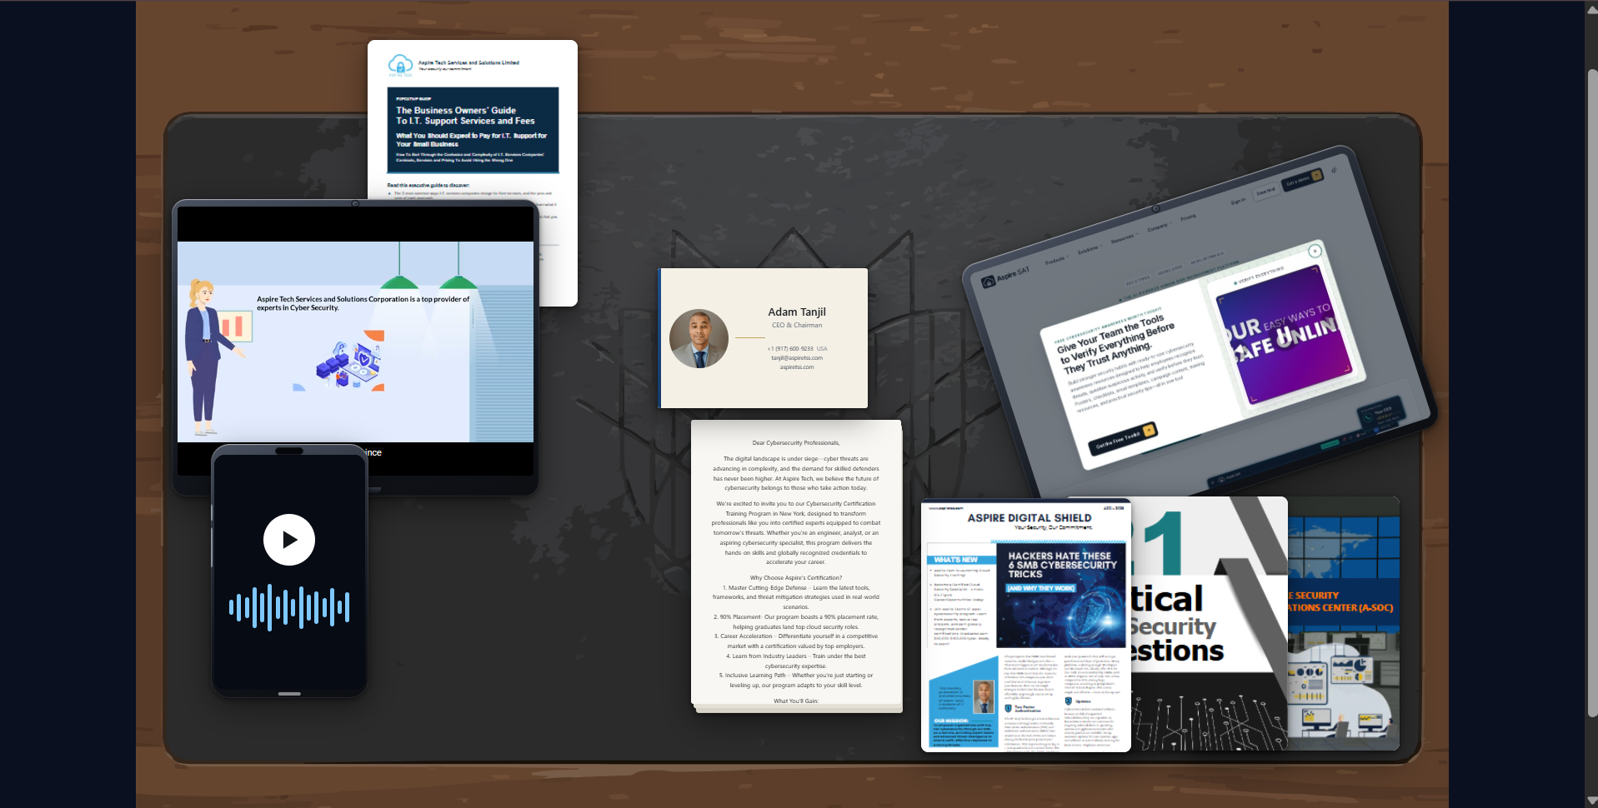
Figure 10. Public View — desktop desk

Phone
The same items appear as a list of preview + label rows, not as a tiny desk. Each row still does the same action as the desktop hotspot.

What a click does
- scene — goes to the other scene.
- download — starts the file download.
- link — email or phone leaves the page; other addresses open in the overlay.
- Everything else — PDF, letter, video, audio, image, embed, card, auto — opens the overlay.
The overlay has a title, a download when a file or letter PDF is available, and a close control.
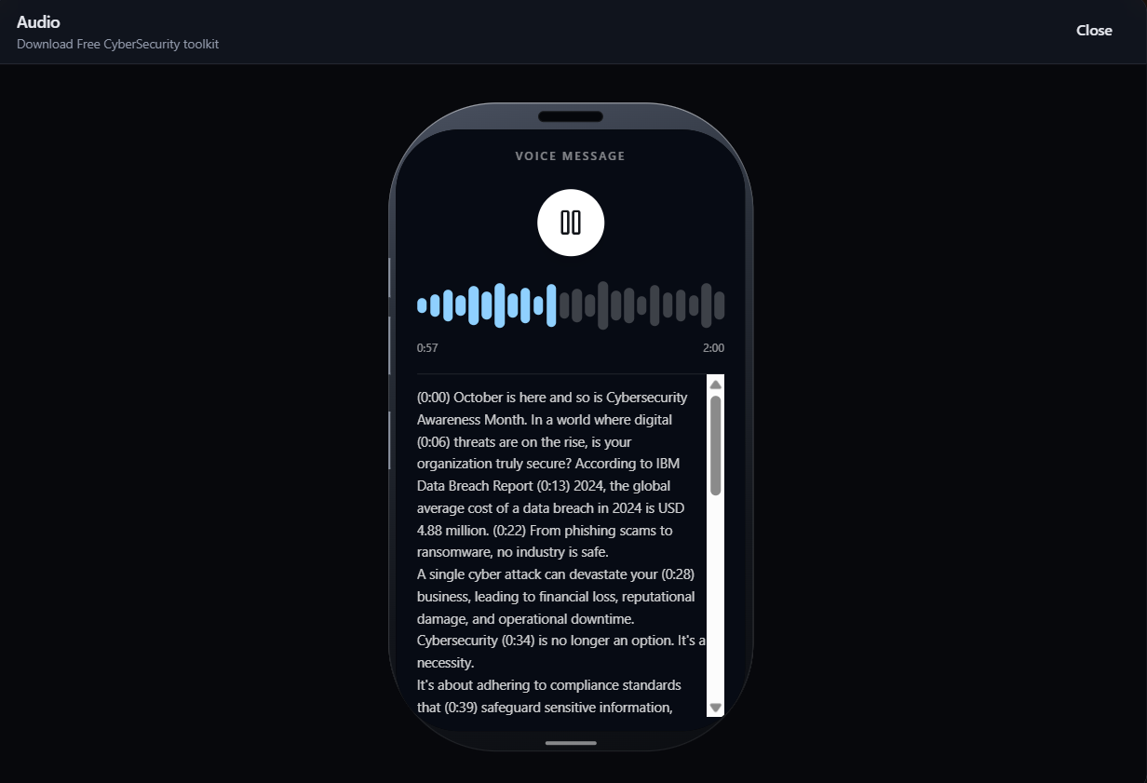
Figure 11. Overlay — audio
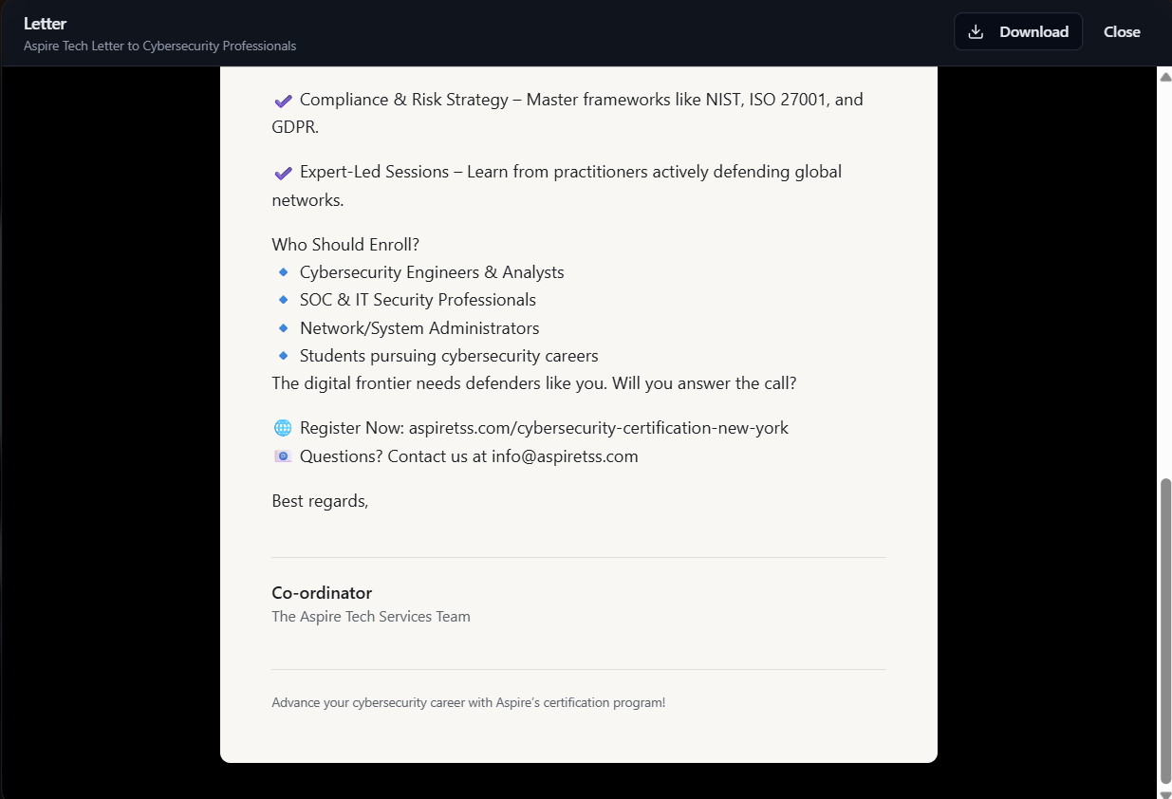
Figure 12. Overlay — letter

Sharing a specific item
When an overlay is open, the address bar keeps that item so you can copy the link and send someone straight to that document.

Personalised letters
Campaign links can carry the recipient. {{firstName}} and {{company}} in a letter fill in after the page loads. If the link has no recipient, visitors see “there” and “your organisation”.

12. Habits and pitfalls
- Click Save often. Dragging on the Stage is lost if you leave without saving.
- Place items on the editor Stage while the scene is still draft. Use View after the brand is live.
- Confirm before Delete or Remove unused files. Delete removes the scene and its files.
- Do not put a hotspot on decorative props. If it does not open content, leave it as artwork.
- Keep uploaded video small. Prefer a YouTube or Vimeo URL for long clips.
- Fill a transcript on every audio item.
- Fill Alt on every image.
- A scene-to-scene hotspot only works if the target is live on the same brand.
- You cannot remove the last brand from a scene.
- If View shows nothing, the slug is still draft or archived — set Status to live and save.
- If you are signed out, return to the AspireTSS CMS and open Shock and Awe again.
When both brands are live, double-check the SAT URL and the Aspire URL in the URL fold before you send a campaign.

