Lecture 4 report

Rafał Behrendt

2022

Table of contents

1. Box-mueller normal distribution check 2

2. Excecise 2 2

2.1. Volatility set to 0 2

2.2. Histogram of 1000 final stock prices 3

3. Amazon stocks 3

# Box-mueller normal distribution check

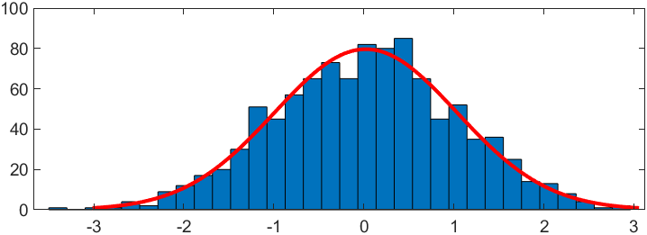

Figure 1 - Box mueller generated data

Random data seems to be normally distributed with following parameters:

* Median: 0.0217097
* Standard dev: 1.01177

# Excecise 2

## Volatility set to 0

Figure 2 - Volatility set to 0

When volatility is set to 0 the process is deterministic. Each time the result is the same.

## Histogram of 1000 final stock prices

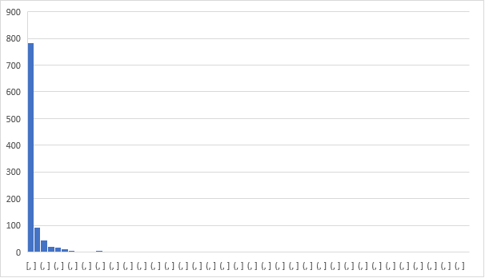

Figure 3 - 1000 final stock prices

Histogram of 1000 final stock prices is similar to log-normal. Average volatility is a little smaller than input volatility (Input = 0,1, Average ≈ 0,08)

# Amazon stocks

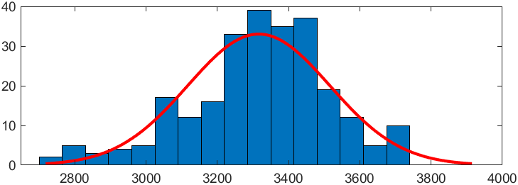

Figure 4 - Amazon stock log returns

Amazon prices log returns seems to be normally distributed with following parameters:

* Median: 3316.37
* Standard dev: 199.42