Lecture 5 report

Rafał Behrendt

2022

Table of contents

1. Exercise 1 2

2. Exercise 2 4

# Exercise 1

Stock price: values from 1 to 1000 with step 1

Strike: 200

Volatility: 10%

Risk free interest rate: 4%

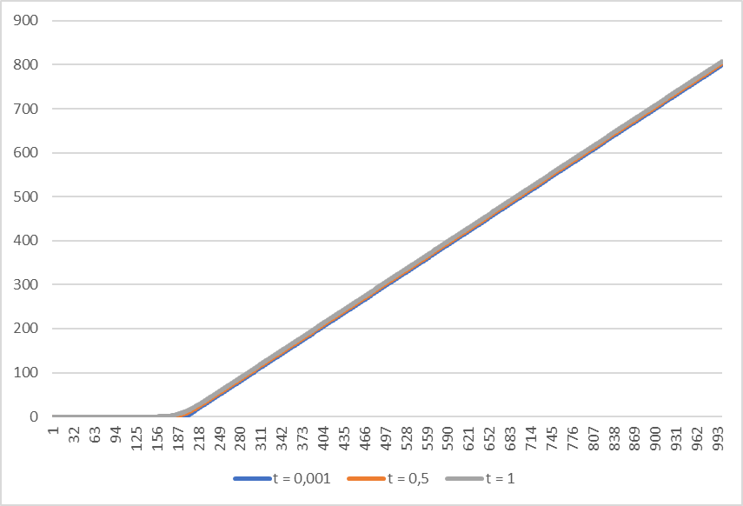

Figure 1 – Values of call

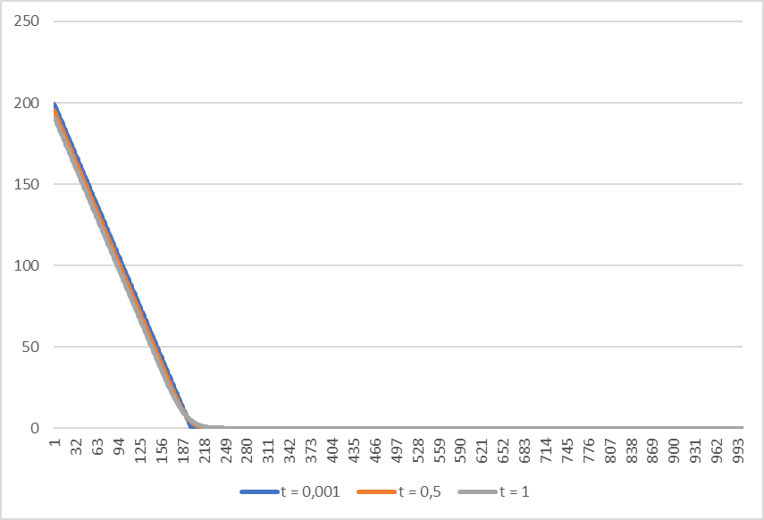

Figure 2 – Values of put

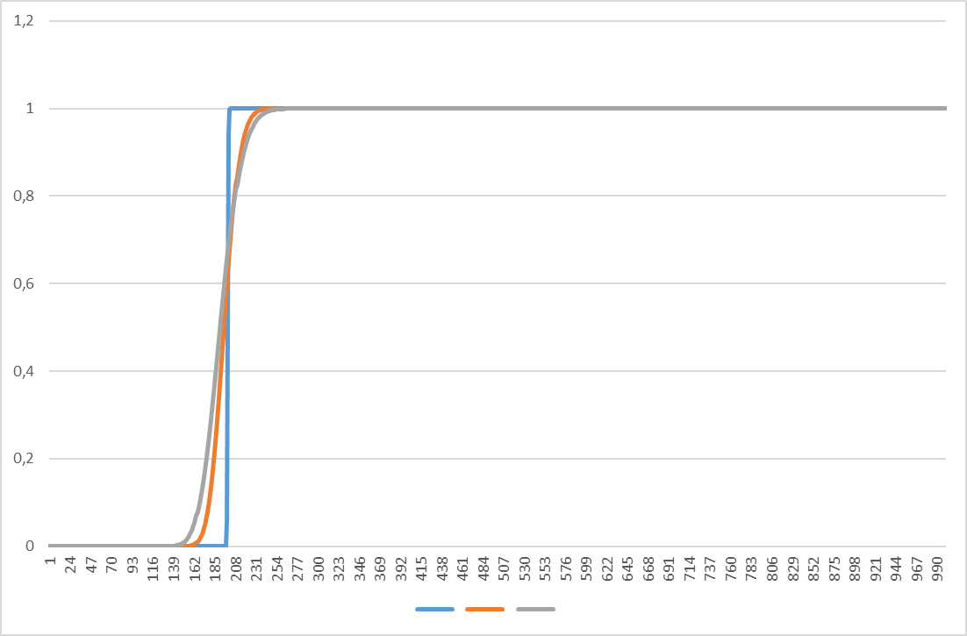

Figure 3 – Values of call deltas

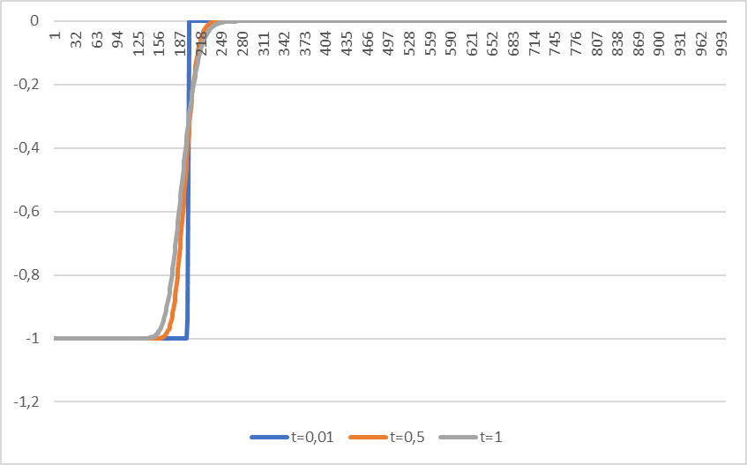

Figure 4 – Values of put deltas

According to a): on diagrams d) and e) you can see that value of call delta – put delta will always be 1.

# Exercise 2

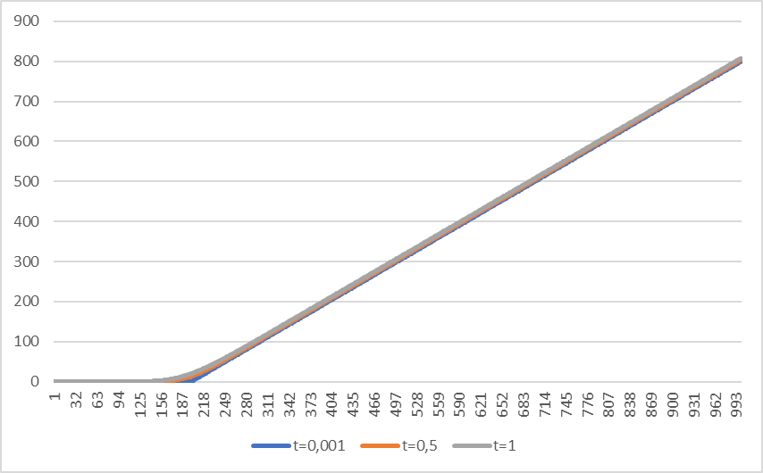

Figure 5 – Values of call with volatility 0,2

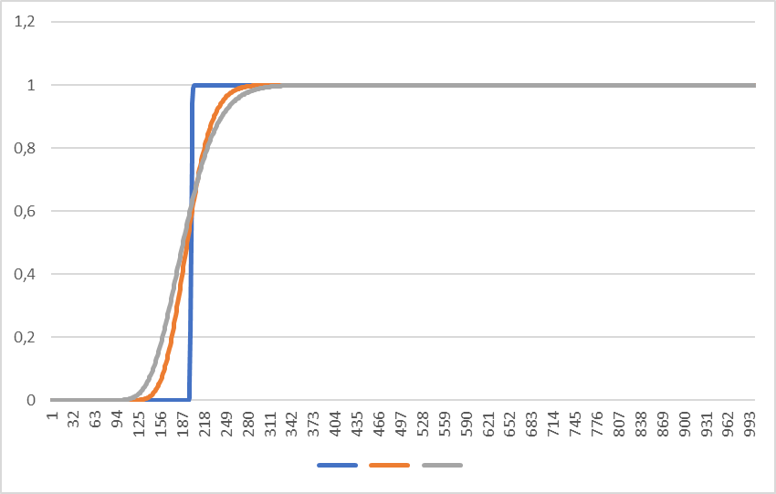

Figure 6 – Values of call delta with volatility 0,2

With increase of volatility value of d1 rises and value of d2 decreases. When volatility is higher, someone with call option will “get” more and “pay” less, so value of call goes up.