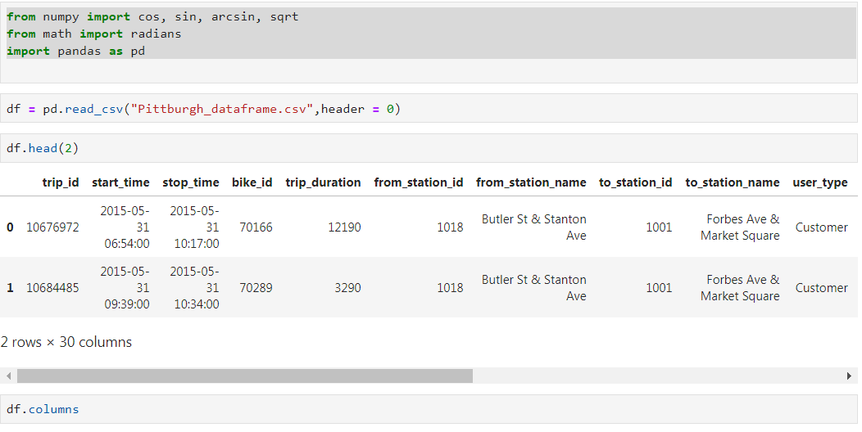

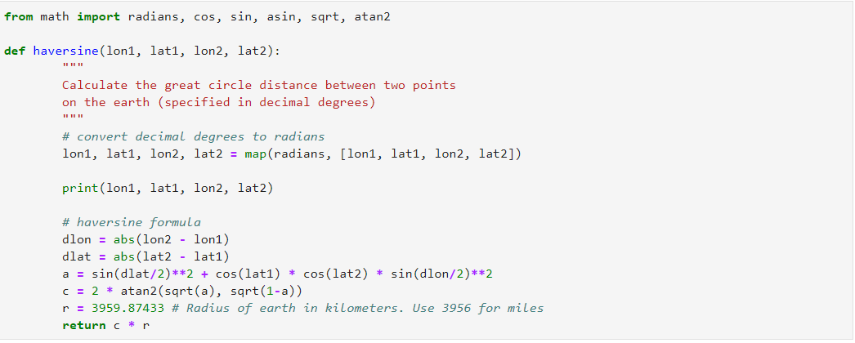

df['distance'] = df.apply(lambda row: haversine(row['from_longitude'], row['from_latitude'],row['to_longitude'], row['to_latitude']), axis=1)