

Video = E1_Challenge of missing data
Machine Learning Specialization
Handling missing data
Emily Fox & Carlos Guestrin
Machine Learning Specialization
University of Washington
©2015-2016 Emily Fox & Carlos Guestrin


video = E1_Challenge of missing data start @ 1:03
Machine Learning Specialization
3
©2015-2016 Emily Fox & Carlos Guestrin
Decision tree review
T(
x
i
) = Traverse decision tree
Loan
Application
Input: x
i
ŷ
i
Credit?
Safe
Term?
Risky
Safe
Income?
Term?
Risky
Safe
Risky
start
excellent
poor
fair
5 years
3 years
Low
high
5 years
3 years

video = E1_Challenge of missing data st @ 1:36.
Machine Learning Specialization
5
So far: data always completely observed
©2015-2016 Emily Fox & Carlos Guestrin
Credit
Term
Income
y
excellent
3 yrs
high
safe
fair
5 yrs
low
risky
fair
3 yrs
high
safe
poor
5 yrs
high
risky
excellent
3 yrs
low
risky
fair
5 yrs
low
safe
poor
3 yrs
high
risky
poor
5 yrs
low
safe
fair
3 yrs
high
safe
Known x and y
values for all
data points
video = E1_Challenge of missing data st @ 1:59
Machine Learning Specialization
6
©2015-2016 Emily Fox & Carlos Guestrin
Loan application
may be
3 or 5 years
Credit
Term
Income
y
excellent
3 yrs
high
safe
fair
?
low
risky
fair
3 yrs
high
safe
poor
5 yrs
high
risky
excellent
3 yrs
low
risky
fair
5 yrs
high
safe
poor
?
high
risky
poor
5 yrs
low
safe
fair
?
high
safe
Missing data
E1_Challenge of missing data st @ 2:25
Machine Learning Specialization
7
Missing values impact training and predictions
©2015-2016 Emily Fox & Carlos Guestrin
1.
Training data: Contains “unknown”
values
2.
Predictions: Input at prediction time
contains “unknown” values




E1_Challenge of missing data start 2:48
Machine Learning Specialization
8
©2015-2016 Emily Fox & Carlos Guestrin
Start
Credit?
Safe
excellent
Income?
poor
Term?
Risky
Safe
fair
5 years
3 years
Risky
Low
Term?
Risky
Safe
high
5 years
3 years
x
i
= (Credit = poor, Income = ?, Term = 5 years)
Missing values during prediction
What do
we do???
Start
Credit?
Income?

Income is unknown, when we get to income branch we have no data.







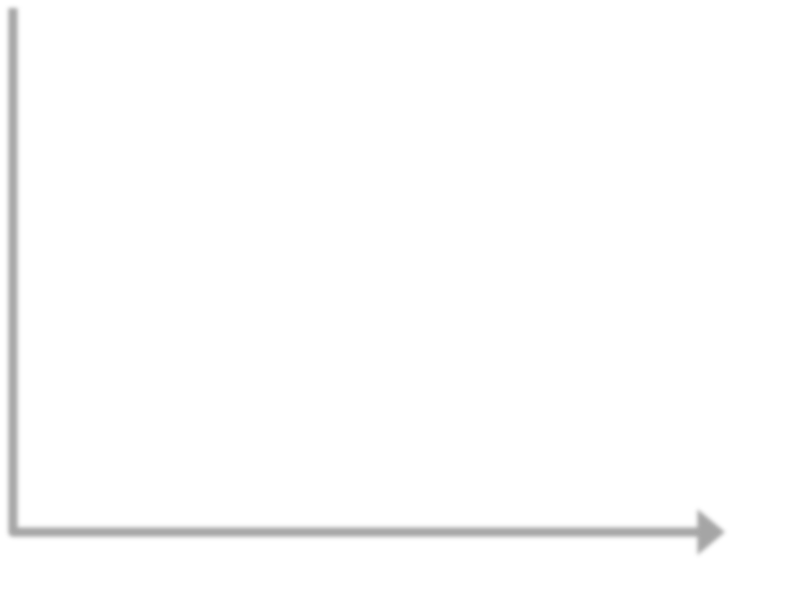


E1_Challenge of missing data start@ 3:15
Machine Learning Specialization
10
©2015-2016 Emily Fox & Carlos Guestrin
Training
Data
Feature
extraction
ML
model
Quality
metric
ML algorithm
y
h(x)
T(x)
x
ŷ
Missing values
during training
Missing values
during prediction
start lecture E2_Strategy 1 Purification by skipping missing data
Machine Learning Specialization
Handling missing data
Strategy 1: Purification by skipping
©2015-2016 Emily Fox & Carlos Guestrin
“E2_Strategy 1 Purification by skipping missing data” start @ 0:29
Machine Learning Specialization
13
Idea 1: Purification by skipping/removing
©2015-2016 Emily Fox & Carlos Guestrin
Training
Data
h(x) is a subset of the data
without any missing values
x
Feature
extraction
h(x)
Remove/skip
missing values
May contain data points
where one (or more)
features are missing
purification = throw out missing data.
Machine Learning Specialization
15
Idea 1: Skip data points
with missing values
©2015-2016 Emily Fox & Carlos Guestrin
N = 9, 3 features
Credit
Term
Income
y
excellent
3 yrs
high
safe
fair
?
low
risky
fair
3 yrs
high
safe
poor
5 yrs
high
risky
excellent
3 yrs
low
risky
fair
5 yrs
high
safe
poor
3 yrs
low
risky
poor
3 yrs
?
safe
fair
?
high
safe
N = 6, 3 features
Credit
Term
Income
y
excellent
3 yrs
high
safe
fair
3 yrs
high
safe
poor
5 yrs
high
risky
excellent
3 yrs
low
risky
fair
5 yrs
high
safe
poor
3 yrs
low
risky
h(x)
x
Skip data
points with
missing values
Machine Learning Specialization
16
The challenge with Idea 1
©2015-2016 Emily Fox & Carlos Guestrin
N = 9, 3 features
Credit
Term
Income
y
excellent
3 yrs
high
safe
fair
?
low
risky
fair
3 yrs
high
safe
poor
?
high
risky
excellent
?
low
risky
fair
?
high
safe
poor
3 yrs
low
risky
poor
?
low
safe
fair
?
high
safe
N = 3, 3 features
Credit
Term
Income
y
excellent
3 yrs
high
safe
fair
3 yrs
high
safe
poor
3 yrs
low
risky
h(x)
x
Skip data
points with
missing values
Warning: More than
50% of the loan
terms are unknown!
Idea 2 = fewer features when we skip features with missing values
Machine Learning Specialization
17
Idea 2: Skip features
with missing values
©2015-2016 Emily Fox & Carlos Guestrin
Credit
Term
Income
y
excellent
3 yrs
high
safe
fair
?
low
risky
fair
3 yrs
high
safe
poor
?
high
risky
excellent
?
low
risky
fair
5 yrs
high
safe
poor
?
high
risky
poor
?
low
safe
fair
?
high
safe
N = 9, 3 features
x
N = 9, 2 features
h(x)
Credit
Income
y
excellent
high
safe
fair
low
risky
fair
high
safe
poor
high
risky
excellent
low
risky
fair
high
safe
poor
high
risky
poor
low
safe
fair
high
safe
Skip features
with many
missing values
st @ 2:35.
Machine Learning Specialization
19
Missing value skipping: Ideas 1 & 2
©2015-2016 Emily Fox & Carlos Guestrin
Idea 1: Skip data points where any
feature contains a missing value
-

Make sure only a few data points are
skipped
Idea 2: Skip an entire feature if it’s
missing for many data points
-

Make sure only a few features are
skipped
- Does not address missing data at prediction time.
-
- Does not address missing data at prediction time.
-
Machine Learning Specialization
20
Missing value skipping: Pros and Cons
©2015-2016 Emily Fox & Carlos Guestrin
Pros
•
Easy to understand and implement
•
Can be applied to any model
(decision trees, logistic regression, linear
regression,…)
Cons
•
Removing data points and features may
remove important information from data
•
Unclear when it’s better to remove
data points versus features
•
Doesn’t help if data is missing at
prediction time
E3_Strategy 2 Purification by imputing missing data
Machine Learning Specialization
Handling missing data
Strategy 2: Prification by imputing
©2015-2016 Emily Fox & Carlos Guestrin
video = E3_Strategy 2 Purification by imputing missing data, start @ 00:15
Machine Learning Specialization
23
Main drawback of skipping strategy
©2015-2016 Emily Fox & Carlos Guestrin
N = 9, 3 features
Credit
Term
Income
y
excellent
3 yrs
high
safe
fair
?
low
risky
fair
3 yrs
high
safe
poor
5 yrs
high
risky
excellent
3 yrs
low
risky
fair
5 yrs
high
safe
poor
3 yrs
low
risky
poor
?
low
safe
fair
?
high
safe
N = 6, 3 features
Credit
Term
Income
y
excellent
3 yrs
high
safe
fair
3 yrs
high
safe
poor
5 yrs
high
risky
excellent
3 yrs
low
risky
fair
5 yrs
high
safe
poor
3 yrs
low
risky
h(x)
x
Skip data points with
missing values
Data is precious,
don’t throw
it away!
video = E3_Strategy 2 Purification by imputing missing data start @ 00:38. (slide 24 is missing from video)
Machine Learning Specialization
25
Can we keep all the data?
©2015-2016 Emily Fox & Carlos Guestrin
credit
term
income
y
excellent
3 yrs
high
safe
fair
?
low
risky
fair
3 yrs
high
safe
poor
5 yrs
high
risky
excellent
3 yrs
low
risky
fair
5 yrs
high
safe
poor
3 yrs
high
risky
poor
?
low
safe
fair
?
high
safe
Use other data points
in x to “guess” the “?”
video = E3_Strategy 2 Purification by imputing missing data start @ 00:50.
Machine Learning Specialization
26
Idea 2: Purification by imputing
©2015-2016 Emily Fox & Carlos Guestrin
Training
Data
Same number of data
points as the original data
x
Feature
extraction
h(x)
Impute/
Substitute
missing values
video = E3_Strategy 2 Purification by imputing missing data start @ 1:04
Machine Learning Specialization
28
Idea 2: Imputation/Substitution
©2015-2016 Emily Fox & Carlos Guestrin
N = 9, 3 features
Fill in each missing
value with a
calculated guess
Credit
Term
Income
y
excellent
3 yrs
high
safe
fair
?
low
risky
fair
3 yrs
high
safe
poor
5 yrs
high
risky
excellent
3 yrs
low
risky
fair
5 yrs
high
safe
poor
3 yrs
high
risky
poor
?
low
safe
fair
?
high
safe
Credit
Term
Income
y
excellent
3 yrs
high
safe
fair
3 yrs
low
risky
fair
3 yrs
high
safe
poor
5 yrs
high
risky
excellent
3 yrs
low
risky
fair
5 yrs
high
safe
poor
3 yrs
high
risky
poor
3 yrs
low
safe
fair
3 yrs
high
safe
N = 9, 3 features

video = E3_Strategy 2 Purification by imputing missing data
Machine Learning Specialization
29
Credit
Term
Income
y
excellent
3 yrs
high
safe
fair
?
low
risky
fair
3 yrs
high
safe
poor
5 yrs
high
risky
excellent
3 yrs
low
risky
fair
5 yrs
high
safe
poor
3 yrs
high
risky
poor
?
low
safe
fair
?
high
safe
Credit
Term
Income
y
excellent
3 yrs
high
safe
fair
3 yrs
low
risky
fair
3 yrs
high
safe
poor
5 yrs
high
risky
excellent
3 yrs
low
risky
fair
5 yrs
high
safe
poor
3 yrs
high
risky
poor
3 yrs
low
safe
fair
3 yrs
high
safe
Example: Replace ? with
most common value
©2015-2016 Emily Fox & Carlos Guestrin
# 3 year loans: 4
# 5 year loans: 2
Purification by
imputing
video = E3_Strategy 2 Purification by imputing missing data
Machine Learning Specialization
30
Common (simple) rules for
purification by imputation
©2015-2016 Emily Fox & Carlos Guestrin
Credit
Term
Income
y
excellent
3 yrs
high
safe
fair
?
low
risky
fair
3 yrs
high
safe
poor
5 yrs
high
risky
excellent
3 yrs
low
risky
fair
5 yrs
high
safe
poor
3 yrs
high
risky
poor
?
low
safe
fair
?
high
safe
Impute each feature with missing values:
1.
Categorical features use mode: Most
popular value (mode) of non-missing x
i
2.
Numerical features use average or median:
Average or median value of non-missing x
i
Many advanced methods exist,
e.g., expectation-maximization (EM) algorithm
End of lecture ‘E3_Strategy 2 Purification by imputing missing data’ Start @ 2:35 slide 31 missing from video.
Machine Learning Specialization
32
Missing value imputation: Pros and Cons
©2015-2016 Emily Fox & Carlos Guestrin
Pros
•
Easy to understand and implement
•
Can be applied to any model
(decision trees, logistic regression, linear regression,…)
•
Can be used at prediction time: use same
imputation rules
Cons
•
May result in systematic errors
Example: Feature “age” missing in all banks in
Washington by state law
start video lecture ‘F1_Modifying decision trees to handle missing data’
Machine Learning Specialization
Handling missing data
Strategy 3: Adapt learning algorithm
to be robust to missing values
©2015-2016 Emily Fox & Carlos Guestrin
video lecture ‘F1_Modifying decision trees to handle missing data’ start @ 0:28
Machine Learning Specialization
34
©2015-2016 Emily Fox & Carlos Guestrin
Start
Credit?
Safe
excellent
Income?
poor
Term?
Risky
Safe
fair
5 years
3 years
Risky
Low
Term?
Risky
Safe
high
5 years
3 years
x
i
= (Credit = poor, Income = ?, Term = 5 years)
Missing values during prediction: revisited
What do
we do???
Start
Credit?
Income?


video lecture ‘F1_Modifying decision trees to handle missing data’ start ~ 1’00”
In this case we don’t know income.
So we make policy to assign unknown
income branch to ‘Risky’ loan.

In this case we don’t know income.
So we make policy to assign unknown
income branch to ‘Risky’ loan.

Machine Learning Specialization
35
©2015-2016 Emily Fox & Carlos Guestrin
Start
Credit?
Safe
excellent
Income?
poor
Term?
Risky
Safe
fair
5 years
3 years
Risky
Low
Term?
Risky
Safe
high
5 years
3 years
x
i
= (Credit = poor, Income = ?, Term = 5 years)
Add missing values to the tree definition
Associate missing
values with a branch
Start
Credit?
Income?
or unknown
Risky




video lecture ‘F1_Modifying decision trees to handle missing data’ start @ 1:33
Machine Learning Specialization
37
©2015-2016 Emily Fox & Carlos Guestrin
Start
Credit?
Safe
excellent
Income?
poor
Term?
Risky
Safe
fair
5 years
3 years
Risky
Low
Term?
Risky
Safe
high
5 years
3 years
Add missing value choice to every decision node
or unknown
Every decision node includes choice
of response to missing values
or unknown
or unknown
or unknown
video = E3_Strategy 2 Purification by imputing missing data
Machine Learning Specialization
38
©2015-2016 Emily Fox & Carlos Guestrin
Start
Credit?
Term?
Safe
fair
5 years
Prediction with missing values becomes simple
x
i
= (Credit = ?, Income = high, Term = 5 years)
or unknown
Safe
excellent
Income?
poor
Risky
Low
Term?
Risky
Safe
high
5 years
3 years
or unknown
or unknown
Risky
3 years
or unknown
video = E3_Strategy 2 Purification by imputing missing data
Machine Learning Specialization
39
©2015-2016 Emily Fox & Carlos Guestrin
Start
Credit?
Income?
poor
Term?
Safe
high
5 years
Prediction with missing values becomes simple
x
i
= (Credit = poor, Income = high, Term = ?)
or unknown
Safe
excellent
Term?
Risky
Safe
fair
5 years
3 years
Risky
Low
Risky
3 years
or unknown
or unknown
or unknown
video = E3_Strategy 2 Purification by imputing missing data start @ 4:08
Machine Learning Specialization
41
Explicitly handling missing data by
learning algorithm: Pros and Cons
©2015-2016 Emily Fox & Carlos Guestrin
Pros
•
Addresses training and prediction time
•
More accurate predictions
Cons
•
Requires modification of learning algorithm
-

Very simple for decision trees
video = E3_Strategy 2 Purification by imputing missing data
Machine Learning Specialization
Feature split selection
with missing data
©2015-2016 Emily Fox & Carlos Guestrin

video = E3_Strategy 2 Purification by imputing missing data
Machine Learning Specialization
44
Pick feature split
leading to lowest
classification error
Greedy decision tree learning
©2015-2016 Emily Fox & Carlos Guestrin
•
Step 1: Start with an empty tree
•
Step 2: Select a feature to split data
•
For each split of the tree:
•
Step 3: If nothing more to,
make predictions
•
Step 4: Otherwise, go to Step 2 &
continue (recurse) on this split
Must select feature &
branch for missing values!
video = E3_Strategy 2 Purification by imputing missing data
Machine Learning Specialization
46
Feature split (without missing values)
©2015-2016 Emily Fox & Carlos Guestrin
Root
excellent
fair
poor
Credit?
Split on the
feature Credit
Data points with
Credit = poor
go here
end of lecture ‘E3_Strategy 2 Purification by imputing missing data’
Machine Learning Specialization
47
Feature split (with missing values)
©2015-2016 Emily Fox & Carlos Guestrin
Root
excellent
fair
poor
or unknown
Credit?
Data points with
Credit = poor or unknown
go here
Split on the
feature Credit
start video lecture ‘F1_Modifying decision trees to handle missing data’
Refer previous module for threshold splits.
Refer previous module for threshold splits.
Machine Learning Specialization
48
Missing value handling in threshold splits
©2015-2016 Emily Fox & Carlos Guestrin
Root
< $50K
or unknwon
>= $50K
Income
Data points with
income < $50K or unknown
Split on the
feature Income
video lecture ‘F1_Modifying decision trees to handle missing data’ start @ 1:08
start at 1:50
Machine Learning Specialization
50
Should missing go left, right, or middle?
©2015-2016 Emily Fox & Carlos Guestrin
Root
excellent
or unknown
fair
poor
Credit?
Choice 1: Missing values go
with Credit=excellent
Root
excellent
fair
or unknown
poor
Credit?
Choice 2: Missing values
go with Credit=fair
Root
excellent
fair
poor
or unknown
Credit?
Choice 3: Missing values
go with Credit=poor
Choose branch that leads to
lowest classification error!

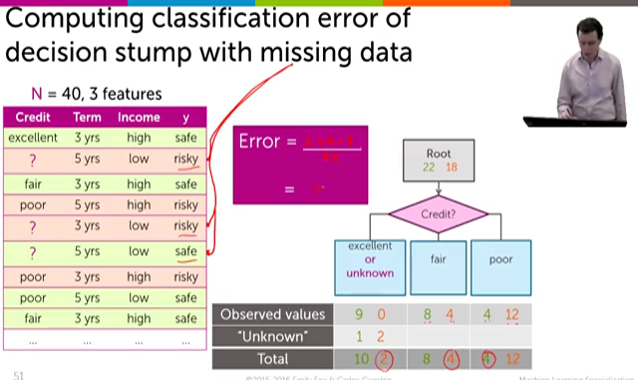
video lecture ‘Feature split selection with missing data’
Excellent branch
- predicts safe
- we have 10 safe and 2 mistakes.
Fair branch
- predicts safe
- we have 8 safe and 4 mistakes

Poor branch
- predict risky
- we have 4 mistakes and 12 risky.

So we have total
2+4+4 = 10 mistakes
And total 10+2+8+4+4+12 = 40
Total Error = 10 / 40 =0.25

Next slide repeats this exercise with ‘unknown” error assigned to excellent / fair / poor then selects lowest overall error
Machine Learning Specialization
51
Computing classification error of
decision stump with missing data
©2015-2016 Emily Fox & Carlos Guestrin
N = 40, 3 features
Credit
Term
Income
y
excellent
3 yrs
high
safe
?
5 yrs
low
risky
fair
3 yrs
high
safe
poor
5 yrs
high
risky
?
3 yrs
low
risky
?
5 yrs
low
safe
poor
3 yrs
high
risky
poor
5 yrs
low
safe
fair
3 yrs
high
safe
…
…
…
…
Root
22 18
excellent
or unknown
fair
poor
Credit?
Observed values
9 0
8 4
4 12
“Unknown”
1 2
Total
10
2
8 4
4 12
Error =
.
=

Test the unknown on each branch, evaluate
Recall previous slide showed us

we had “Unknown” values of 1 and 2.
52
Use classification error to decide
©2015-2016 Emily Fox & Carlos Guestrin
Root
22 18
excellent
or unknown
10 2
fair
8 4
poor
4 12
Credit?
Root
22 18
excellent
9 0
fair
or unknown
9 6
poor
4 12
Credit?
Root
22 18
excellent
9 0
fair
8 4
poor
or unknown
5 14
Credit?
Choice 1: error = 0.25
Choice 2: error = 0.25
Choice 3: error = 0.225
WINNER
last slide video lecture ‘F1_Modifying decision trees to handle missing data’
Machine Learning Specialization
54
Feature split selection algorithm
with missing value handling
©2015-2016 Emily Fox & Carlos Guestrin
•
Given a subset of data M
(a node in a tree)
•
For each feature h
i
(x):
1.
Split data points of M where h
i
(x) is not
“unknown” according to feature h
i
(x)
2.
Consider assigning data points with “unknown”
value for h
i
(x) to each branch
A.
Compute classification error split & branch
assignment of “unknown” values
•
Chose feature h
*
(x) & branch assignment of
“unknown” with lowest classification error
F2_Feature split selection with missing data
Machine Learning Specialization
Summary of handling missing data
©2015-2016 Emily Fox & Carlos Guestrin
Machine Learning Specialization
56
What you can do now…
©2015-2016 Emily Fox & Carlos Guestrin
Describe common ways to handling missing data:
1.
Skip all rows with any missing values
2.
Skip features with many missing values
3.
Impute missing values using other data points
Modify learning algorithm (decision trees) to handle
missing data:
1.
Missing values get added to one branch of split
2.
Use classification error to determine where missing
values go

Machine Learning Specialization
57
Thank you to Dr. Krishna Sridhar
Dr. Krishna Sridhar
Staﬀ Data Scientist, Dato, Inc.
©2015-2016 Emily Fox & Carlos Guestrin

video = G1_Recap of handling missing data

