# Office AMS: workflow Examples

|  |  |
| --- | --- |
| Summary: | Applies to: |
| This sample demonstrates a technique to show how to associate an app deployed integrated workflow to the host web.  **NOTE**: This is only an interim solution until the VS tooling is available to do this. | * Office 365 Multi-Tenant (MT) * Office 365 Dedicated (D) |
| Solution: | Workflow.AssociateToHostWeb |
| Author: |  |
| //*********************************************************  // THIS CODE IS PROVIDED *AS IS* WITHOUT WARRANTY OF  // ANY KIND, EITHER EXPRESS OR IMPLIED, INCLUDING ANY  // IMPLIED WARRANTIES OF FITNESS FOR A PARTICULAR  // PURPOSE, MERCHANTABILITY, OR NON-INFRINGEMENT.  //********************************************************* | |

## Version log

Change log between different releases.

|  |  |
| --- | --- |
| Version | Notes |
| 1.0 | Initial |

# General comments

Integrated workflow apps provide the capability to associate a workflow deployed in an app to a list in the host/parent web.

This is only an interim solution until the VS tooling has been updated to perform this activity.

# preparing the .app file for deployment

Here are the basic steps to create your app, add workflows, publish the .app file and make necessary modifications that allow you to associate your workflow(s) to the host web:

1. Create your SharePoint hosted app and then create/add your workflow(s) to the app project
2. Build and publish the app.
3. Once your .app file has been created, rename the extension to .zip
4. Extract the contents
5. Edit the WorkflowManifest.xml (which will be empty) and add the following:

<SPIntegratedWorkflow xmlns="http://schemas.microsoft.com/sharepoint/2014/app/integratedworkflow">

<IntegratedApp>true</IntegratedApp>

</SPIntegratedWorkflow>

1. Once this is done save your file, and package the app again - select all the files inside the extracted folder -> right click -> Send to -> Compressed (zipped) folder.
2. Rename the .zip file back to .app

# preparing the .app file for deployment

Once the .app file has been modified to include the WorkflowManifest.xml change:

1. Install the app
2. Go to workflow settings -> Add a workflow in the list to which workflow has to be associated.
3. Now you will see App Selection options similar to this:

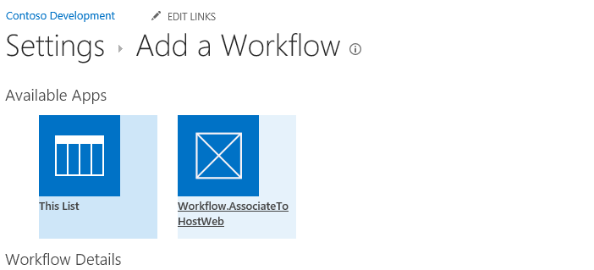

1. Select your workflow app and continue as you would for normal workflow association
2. Trigger a new workflow either by a manual start process and selecting the workflow app or other preferred start options.

# Dependencies

* Microsoft.SharePoint.Client.dll
* Microsoft.SharePoint.Client.Runtime.dll