# Table With Style 'TableNormal' :

|  |  |  |
| --- | --- | --- |
| Row 1 Column 1 | Row 1 Column 2 | Row 1 Column 3 |
| Row 2 Column 1 | Row 2 Column 2 | Row 2 Column 3 |
| Row 3 Column 1 | Row 3 Column 2 | Row 3 Column 3 |
| Row 4 Column 1 | Row 4 Column 2 | Row 4 Column 3 |
| Row 5 Column 1 | Row 5 Column 2 | Row 5 Column 3 |

# Table With Style 'TableGrid' :

|  |  |  |
| --- | --- | --- |
| Row 1 Column 1 | Row 1 Column 2 | Row 1 Column 3 |
| Row 2 Column 1 | Row 2 Column 2 | Row 2 Column 3 |
| Row 3 Column 1 | Row 3 Column 2 | Row 3 Column 3 |
| Row 4 Column 1 | Row 4 Column 2 | Row 4 Column 3 |
| Row 5 Column 1 | Row 5 Column 2 | Row 5 Column 3 |

# Table With Style 'TableGridLight' :

|  |  |  |
| --- | --- | --- |
| Row 1 Column 1 | Row 1 Column 2 | Row 1 Column 3 |
| Row 2 Column 1 | Row 2 Column 2 | Row 2 Column 3 |
| Row 3 Column 1 | Row 3 Column 2 | Row 3 Column 3 |
| Row 4 Column 1 | Row 4 Column 2 | Row 4 Column 3 |
| Row 5 Column 1 | Row 5 Column 2 | Row 5 Column 3 |

This is my first image.

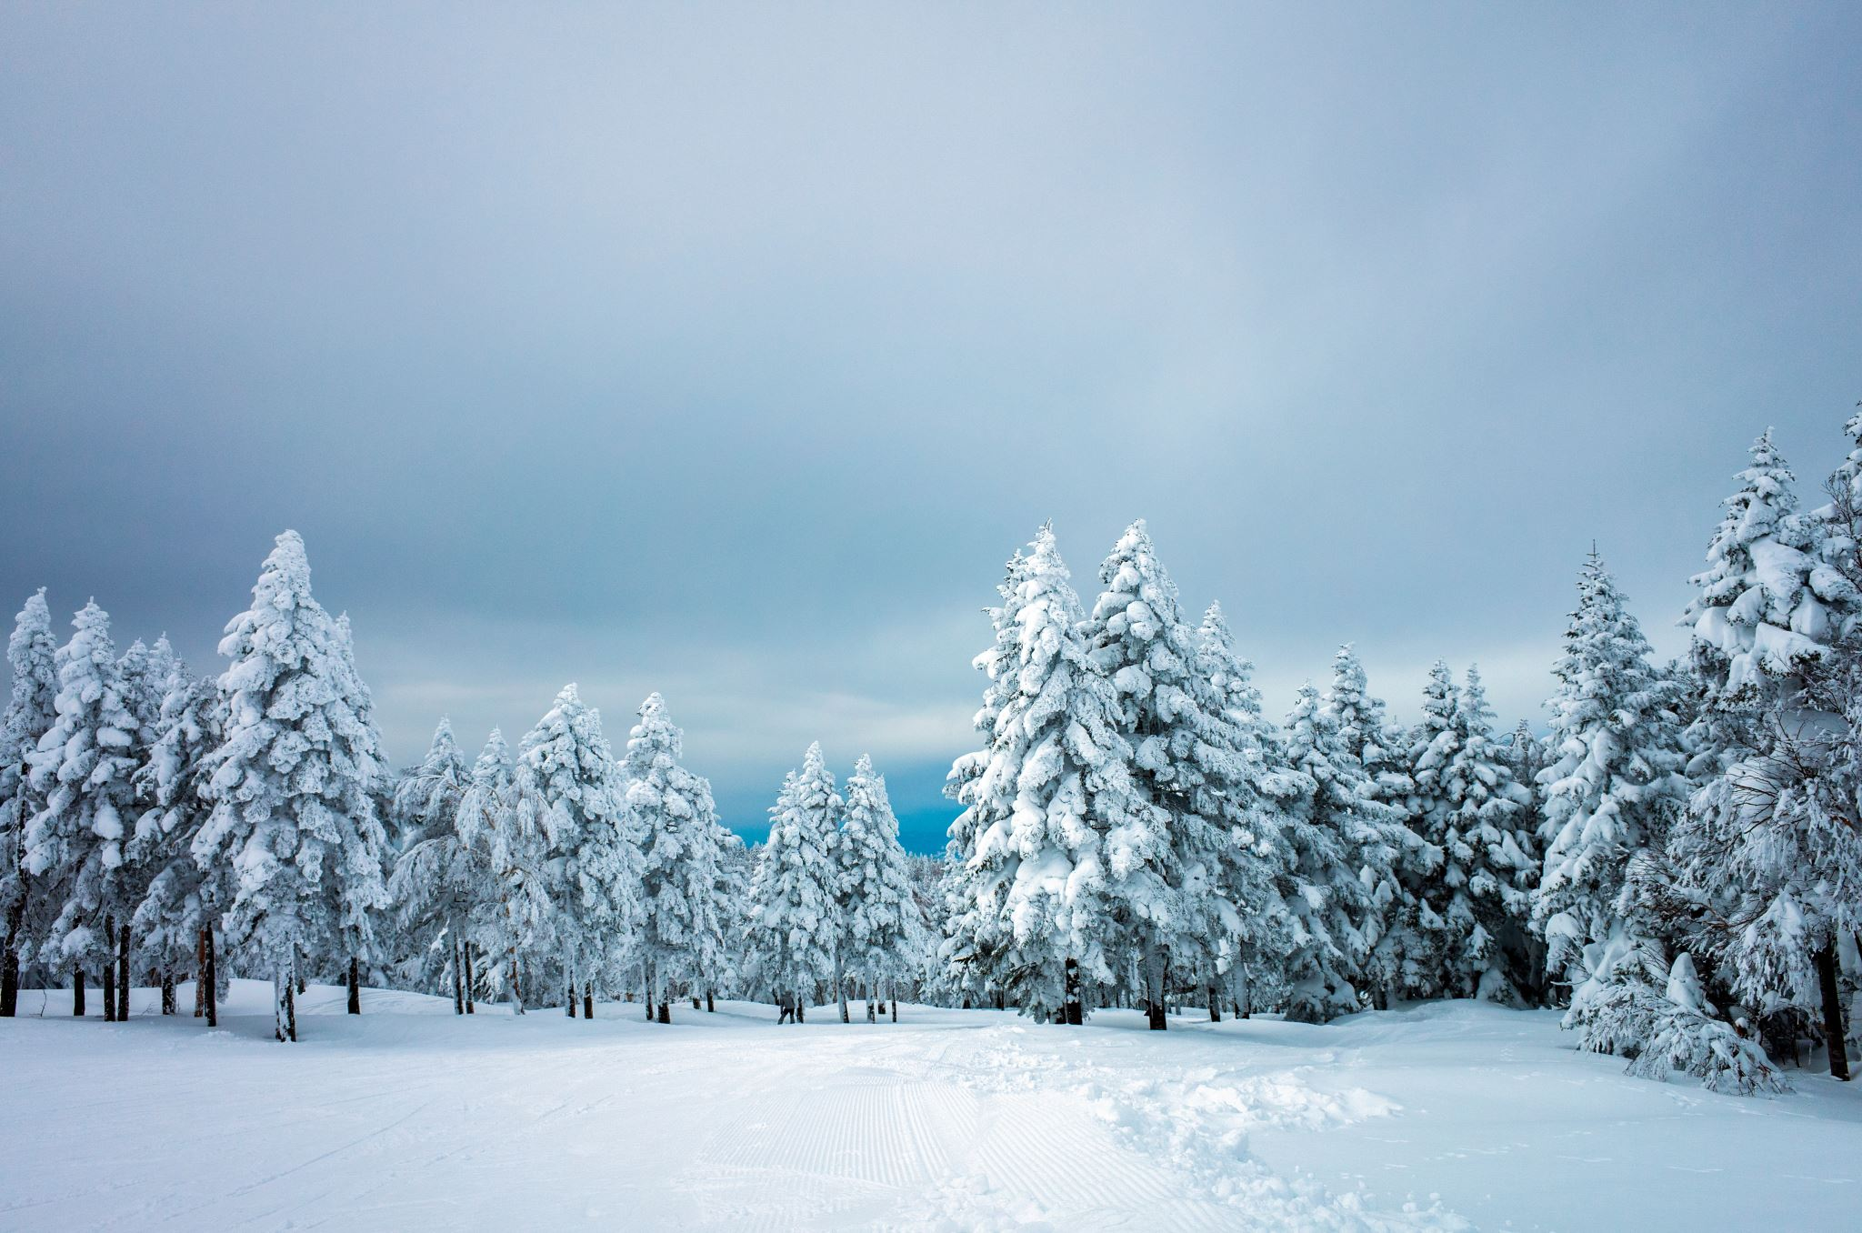  
The image ends here.