Aspose.Words converted DOC to RTF. High-fidelity conversion. | 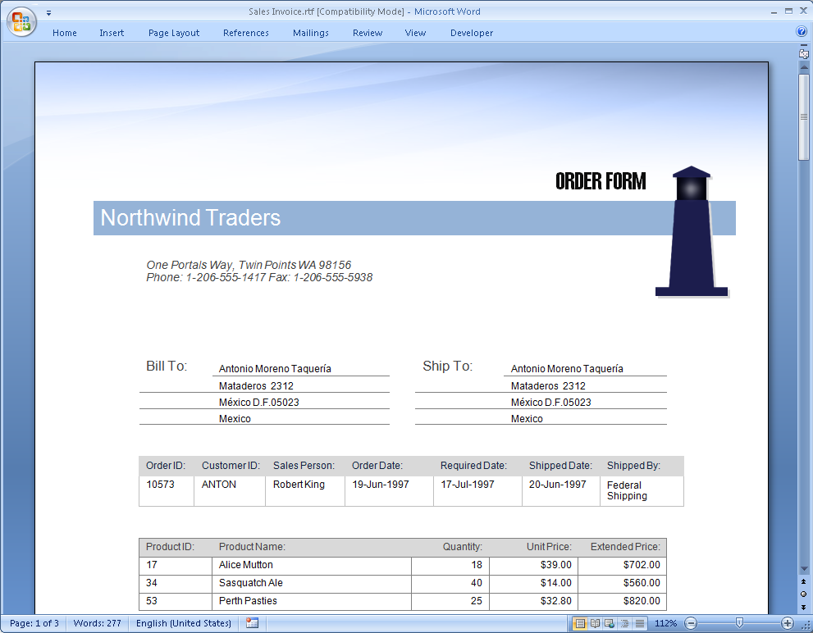
Aspose.Words converted DOC to PDF. High-fidelity conversion. | 