Aspose.Words converted DOC to ODT. High-fidelity conversion. | 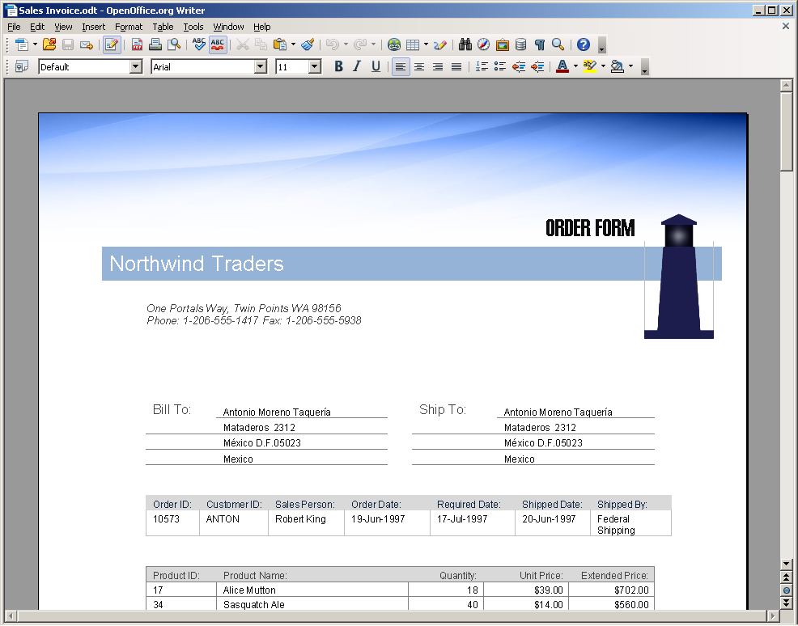
Aspose.Words converted DOC to HTML. Not “high-fidelity”, but still very good. | 