There is hidden content within this document. To view them, enable the show formatting marks button in the Paragraph toolbar.
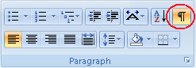
This paragraph is visible

The table below is visible
Heading1 | Heading2
Text1 | Text2

The table below is hidden

