Font Formatting
Simple text in Times New Roman 12 followed by an empty paragraph_{subscript} and^{superscript}.

Various characters: ‘ “ & < > £ ¥ § ¨ © ª « ® » ¼

Paragraph with multiple segments of text formatted in different fonts, sizes and colors. Very different sizes and colors including bold, italic, underline and 1 2 3 4 5 strikethrough. Make sure that the lines wrapped in the same way in Word and in Pdf.

This text has shading and highlighting and borders, and it is supported.

Paragraph Formatting
Paragraph shading should not form empty gaps even with spacing 12 after.
Centered paragraph with a line break had a problem.
Centered paragraph with a line break had a problem.
Right aligned paragraphs must be right aligned properly.
Right aligned paragraph with line break works well.
Right aligned paragraph with line break works well.
This paragraph has a border.
Right aligned condensed text had a problem.
Right aligned expanded text had a problem.
Spacing after and before do not add up, just the greater is used. This paragraph has 12 after. Also, when indents are different, the shading does not join.
This paragraph has 12 before, but in total there is only 12 above. Also note that shading belongs to the paragraph at the top and shading of this paragraph does not go down unless next paragraph has shading too. There are 24 points below.
There are 24 points above, but the gap between this and previous paragraph is only 24.
This paragraph is a test for double line spacing. This paragraph is a test for double line spacing. It also have 0.5” for the first line.
This is a test for 1.5 line spacing. This is a test for 1.5 line spacing. Also has -0.5” indent for the first line.
This paragraph has a page break
and centered. It actually creates two paragraphs.
This is a test for Exactly 20 points of spacing. This is a test for Exactly 20 points of spacing. TTTTTT (20, 22, 24, 26, 28, 30).
There is a continuous section break after this line.

This line is in the new section. Next here is an empty section.

This line is in the fourth section.

Paragraph Justify
This is a justified paragraph with a single segment. 111111111111111111111111111111111111111111.
Also a justified paragraph reset to left because of multiple segments. 111111111111111111111111111111111111111111.

Non-English Characters
Wingdings: , Symbol: Ω⊗
Russian: Теперь немного по русски.

Tables
Cell 1.1 Left |  | Cell 1.2 Right
Cell 2.1 Centered vertically | Cell 2.2 with background |  | Cell 2.3 with line break  and coloured border.
Cell 3.1 Bottom vertically | Cell 3.2  Centered  Horizontally |  | Cell 3.3 No border

Left red, blue top, green right and yellow bottom.

Table with left indent and merged cells.
Cell padding etc.
Cell padding.  Top: 0.1, bottom 0.2  Left: 0.5, Right 0.4 | Zero padding on all sides, right aligned.

Outer 1.1 | Outer 1.2. There is a nested table here | Outer 1.3
  Nested 1.1 | Nested 1.2

Lists
Numbered list:
- Item 1
- Item 2
  - Item 2.1
  - Item 2.2
- Item 3
Bulleted list:
- Item 1
- Item 2
  - Item 2.1
  - Item 2.2
- Item 3

Images
This section starts from a new page.
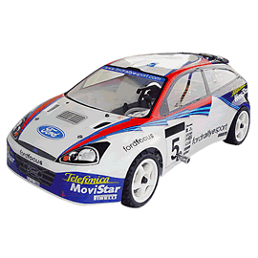
There is an image in a black border in the top right corner, but it will drop down into the text. There is also a transparent ellipse with text that overlaps the picture.
Ellipse text

Inline JPEG in a separate paragraph.
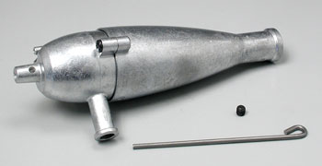

Inline GIF scaled 50% and WMF scaled 25% in a paragraph. This text is before the image and 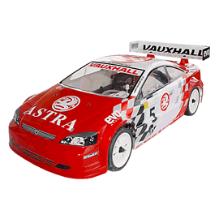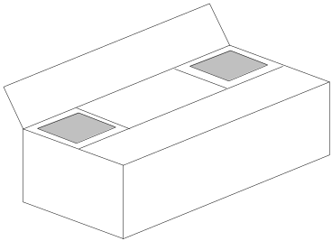 this text is after the image.

Images in a table. Left and right aligned.
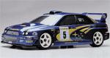 | 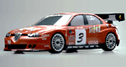

Inline text box is here and inline ellipse is here.
Textbox text.

New section that starts from a new page is here.
It has portrait orientation and margins.

Fields
Merge field «FirstName»
Page number 5
Hyperlink Aspose.com
TOC
Font Formatting 1
Paragraph Formatting 1
Non-English Characters 2
Tables 2
Lists 2
Images 4
Fields 5

Form Fields
Edit test text
Checkbox
Combobox

Footnotes and Endnotes
This line has a footnote at the end.
This line has an endnote at the end.

Footnote 1.
Endnote 1.

