Converting a Word Document (DOCX) to a Web Page using a built-in MOSS document converter.
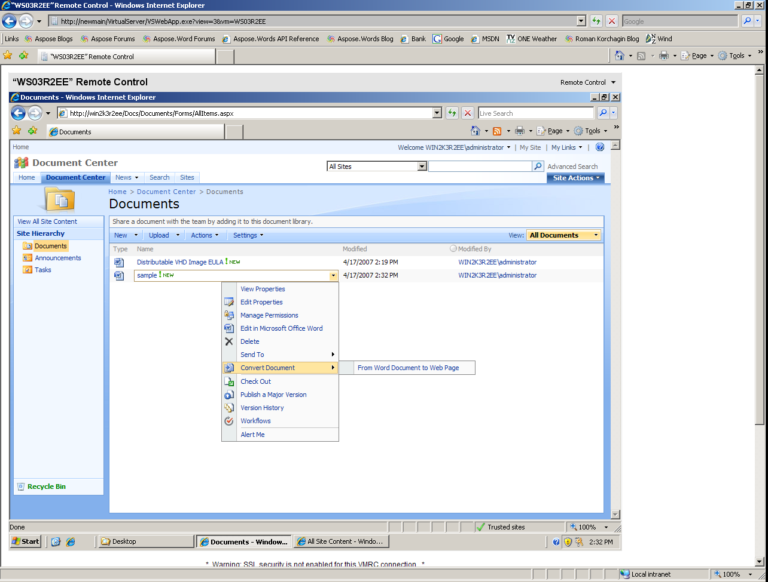
Add a reference to C:\Program Files\Aspose\Aspose.Words\Bin\net2.0\Aspose.Words.DLL.
