First paragraph.
This is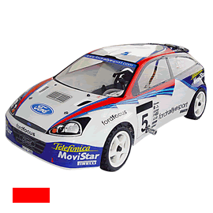 a car.
Last paragraph.

