Header
Text bold with picture: 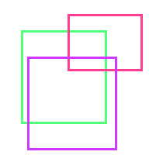
Cell2-1

