Velocity and Seismic Imaging - Parameter Estimation and Case Histories (A)
L. Sandjivy* (SeisQuaRe), A. SHTUKA (Seisquare) & M. COLLET (Seisquare)
Abstract:
PSDM velocities underlying PSDM depth interpretations are optimized for depth imaging, not for depth conversion.
PSDM velocities must then be analyzed in space for the consistency of their lateral variations before being considered for depth interpretation. Moreover they require spatial conditioning to extract their contributing part to the depth conversion.
Spatial quality assessment and conditioning of PSDM velocity data makes use of stochastic modelling (or geostatistics) for “best estimating” the spatial components of the PSDM velocity data that contribute to depth conversion and interpretation, and about “filtering-out” the spatial components that are considered as non contributing.
As a result from a stochastic model, conditioned PSDM velocities are systematically associated with reliable confidence intervals, enabling geophysicists to optimize their contribution before engaging in depth conversion and interpretation.
A North Sea case study illustrates the topic and shows how spatial quality assessment and conditioning of PSDM velocity helped to anticipate a 200m depth error on a new exploration well with deep sub salt target, and reduced it to a less than 40m error, in line with the +/- 100m depth confidence interval computed from the stochastic model.

Introduction
Pre Stack Depth Migration (PSDM) processes stack seismic cubes in the depth domain but seismic acquisition still record seismic reflection arrivals in the time domain. PSDM “interval velocity” fields then underlie the building of the PSDM depth models at the PSDM sampling scale, that are seismic velocity models and not seismic velocity measurements.
Keeping in mind that PSDM velocity models are optimized for depth imaging that is for best focusing seismic energy along seismic reflectors, the issue must be raised of their consistency for depth conversion of seismic arrival times.
Anisotropic PSDM velocity modelling now enables tying PSDM depth cubes to control well depth markers when available, so these cannot be used anymore to assess the uncertainty on the PSDM depth interpretations.
Does this means that PSDM depth interpretations are 100% accurate? Our experience with a number of case studies shows that they are not, and even sometimes lead to exploration or production failures. The geostatistical analysis of lateral spatial variations of PSDM seismic velocities in relation to the PSDM depth structural interpretation supports the design of specific stochastic models for assessing the level of consistency of the PSDM velocities and conditioning them for optimizing depth conversion.
A North Sea exploration case study shows how spatial quality assessment and conditioning of PSDM velocity helped to anticipate a 200m depth error when targeting a deep sub salt structural prospect

and reduced it to a less than 40m error, in line with the +/- 100m depth confidence interval computed from the stochastic model.

Stochastic Data Conditioning (SDC) of PSDM seismic velocities
Spatial conditioning of PSDM velocity data makes use of a stochastic model (or geostatistics) for “best estimating” the spatial components of the PSDM velocity data that contribute to depth conversion and interpretation, and about “filtering-out” the spatial components that are highlighted as non contributing.
As a result, conditioned PSDM velocities are associated with reliable confidence intervals, enabling geophysicists to optimize their contribution to building reliable structural models and supporting E&P decision making
Two basic geophysical statements:
Statement 1: PSDM time interpretation derived as the ratio between PSDM depth and PSDM average velocity must be given more trust than PSDM velocity during depth conversion. Indeed the PSDM process aims at best matching the positioning of seismic reflectors in depth with measured arrival times. In other words, seismic TWT times are measurements not seismic interval velocities.
Statement 2: In the real subsurface domain, geological lateral variations of velocity impact the seismic vertical travel times and translate as lateral variations of the time interpretation of a seismic reflector. On the contrary, local lateral variations of seismic interval velocity that do not impact seismic vertical travel time must be considered as seismic processing artefacts when building a reliable velocity model for depth conversion.
Recall on spatial trend & residual decomposition of geophysical data using geostatistics
Reminder about Matheron’s stochastic framework (see Ref 1)
The Theory of Regionalized Variables considers that the (unknown) subsurface property may be expressed as the unique outcome of a Random Function (RF) Z. At each location x, Z(x) is a random variable with average m(x) and standard deviation σ (x).
Spatial Stationarity assumption on RF Z :
Order 1: m(x) constant does not depend on x
Order 2: m(x) and σ (x) are constant and do not depend on x
Stochastic modelling of geophysical data often uses the following trend / residual decomposition: Z (x) = Zt (x) + ZR (x)
- ZT Spatial Trend or low spatial frequency ( A non stationary RF), usually expressed as a deterministic geophysical linear function of geophysical data.
- Z_{R} Spatial residual or mid and high spatial frequency ( A stationary 0 average RF ) expressing actual residual variations of Z(x) around the deterministic trend function. The spatial residuals are defined by their spatial covariance C_{R}(h).
- Spatial trend residual decomposition depends on spatial covariance of residuals, that is on the spatial frequency content of the spatial trend and spatial residuals
Stochastic modelling of PSDM depth interpretation
SQA and SDC of PSDM velocities consist in reconstructing a PSDM depth (or isopach) interpretation as the sum of:
- a spatially consistent (or conditioned) PSDM depth (or isopach) called Z_{SDC}, corresponding to a PSDM velocity field consistent with seismic time interpretation,
- a residual depth (or isopach) called ZSR , not correlated to seismic time, that should be considered as a seismic artefact for depth conversion.
The spatial decomposition of the PSDM depth interpretation is then the following:
Zpsdm ( x) = Zsdc ( x) + Zsr ( x)
- ZPsDM: PSDM depth interpreted horizon
- ZSDC : PSDM depth spatially consistent or PSDM depth trend that can be expressed as Zsdc(x) = V(x) * T(x) with V(x) itself expressed as a linear combination of spatial functions
of time V (x) = Уi aif (Tx)
(For more details on the velocity functions used in stochastic
depth conversion, see Ref (2))
- Z_{SR}: PSDM residual depth attached to PSDM residual velocities not correlated to seismic TWT with covariance CSR(h)
Using the spatial decomposition Zpsdm (x) = Zsdc(x) + Zsr(x), and an appropriate choice of
covariance model CSR(h) for stationary ZSR , factorial (co) kriging algorithm enables to “best” estimate the value ZSR(x) from available ZPSDM (x)and T(x) seismic data at location x and in a local
neighbourhood around x.
ZSDRA * (x) = ^ ZaZsD ( xa ) + У jUpaifT (xa)
a в
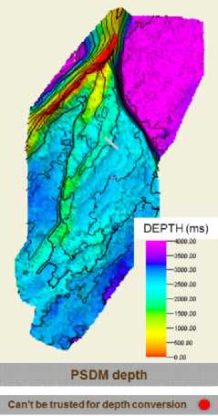
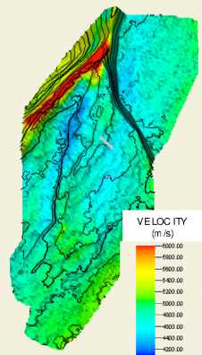
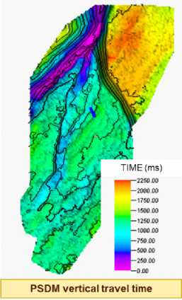
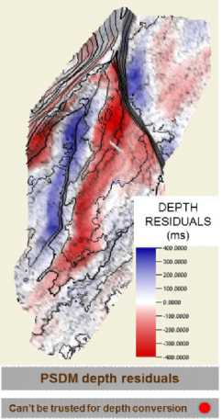
SDC PSDM average velocity
Can be trusted for de pth conversion
*
Can be trusted for depth conversion ф
+

Figure 2 SDC of PSDM velocity : Spatial (spectral) decomposition of PSDM depth interpretation using factorial kriging: Best estimating SDC V(x) such as PSDM Depth (x) = SDC V(x) *PDSMTime (x) + PSDM depth residual artefact (x) corresponding to PSDM velocity residuals not impacting the seismic interpreted time

Case study: Implementing an exploration well for targeting a North Sea prospect along major fault and below thick salt layer
A North Sea exploration well was targeted after PSDM reprocessing for assessing a structural prospect sub salt and sealed by a major fault as shown in Figure 3.
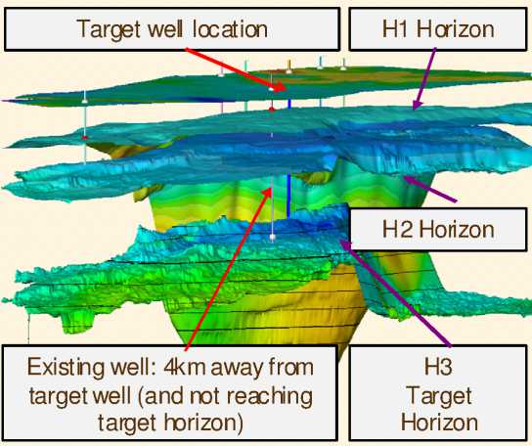
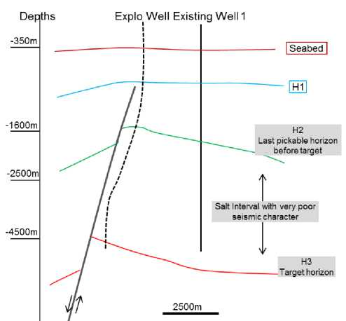
Figure 3: (left) PSDM depth interpretation and well location (right ) Structural N_S section

The well targeted location was based on the PSDM depth interpretation of the target horizon, corresponding to a local low PSDM interval velocity inside the salt layer as shown in Figure 4.
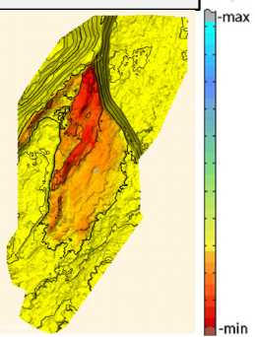
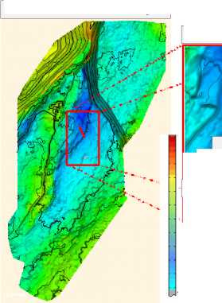
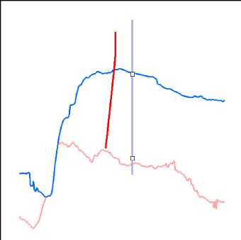
H2 H3 PSDM Thickness
H2/H3 in terval PSDM velocity
Zoom in to target area
Existing well
New well
/ Target location
Initial PSDM Depth

Figure 4: Can we rely on low PSDM velocity patch (blue) at the targeted well location (red)?
A spatial data conditioning of the PSDM salt interval velocity was conducted according to the stochastic workflow described in figure 2 above, highlighting strong (over 10%) PSDM velocity anomalies as shown in figure 5. These PSDM velocity anomalies were interpreted as due to faulting shadow effect visible on the seismic cube.
Two depth conversion scenarios were carried out using stochastic Bayesian kriging workflow as described in reference xx, using initial PSDM velocities and SDC PSDM velocities. Structural prospect was present in both cases although much smaller with the SDC scenario.
The exploration well was eventually drilled and validated the SDC PSDM scenario with 38m depth error at Target horizon, falling inside the +/- 100m depth confidence interval attached to the target layer depth kriging estimation. On the contrary scenario with initial PSDM velocities was clearly invalidated with 200m depth error at target horizon, falling way outside the +/- 100m confidence interval.
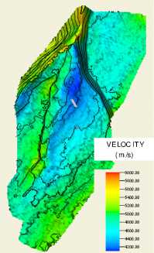
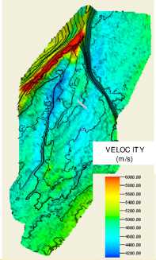
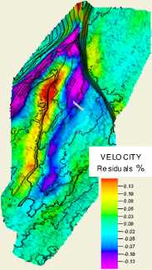
PSDM interval velocity
Can’t be trusted for depth conversion
SDC PSDM i nterval velocity
Ca n be trusted for depth convers ionI
PSDM velocity residuals
Can’t be trusted for depth conversion
Figure 1 This is an example of a figure imported from jpeg (courtesy of Gilles Lambaré).
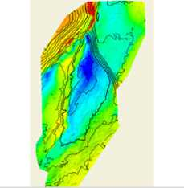
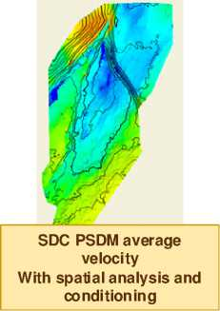
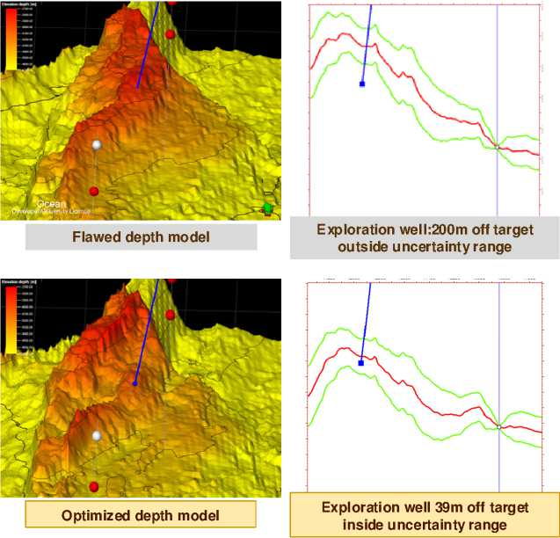
PSDM average velocity Without spatial analysis and conditioning
Conclusion
When relying on PSDM depth interpretation for depth conversion, even when anisotropy corrections tie PSDM depth to well markers, it is strongly recommended to perform stochastic spatial conditioning of the PSDM seismic velocity field using geostatistics before entering depth conversion. All case studies have shown improvement of the correlation between available well velocity data and PSDM velocity after SDC. Although this geostatistical correction is currently post PSDM processing and cannot be directly related to PSDM processing parameters, it gives a first assessment of the uncertainty on PSDM velocity field that is usefully propagated into stochastic time to depth conversion workflows.

Reference
- G. Matheron: Theory of regionalized variables, Les Cahiers du Centre de morphologie mathématique de Fontainebleau, Ecole Nationale Supérieure des Mines (1971)
- L.Sandjivy F.Merer EAGE 2014 Amsterdam!
- Luc Sandjivy, Arben Shtuka, F. 2009 Depth conversion and associated uncertainties using consistent velocity model: A probabilistic unified model based on Bayesian approach, 11th International Congress of the SBGF, Brazil, August 24-28, 2009.

