**Same or Not 4**

Write a program to find the type of array as whether it is even, odd or mixed. If all the elements of an array are even, then display the array type as even. If all the elements of an array are odd, then display the array type as odd. If an array has both even and odd elements, then display the array type as mixed.

**Input Format**

* Input consists of 1 integer and 1 array.
* Integer corresponds to the size of the array.

**Constraints**

No Constraints

**Output Format**

* print the statement whether the given array type is even, odd or mixed

**Sample Input 0**

5

9

2

1

3

5

**Sample Output 0**

Mixed

**Sample Input 1**

4

2

4

6

8

**Sample Output 1**

Even

**Sample Input 2**

3

1

3

5

**Sample Output 2**

Odd

## Solution

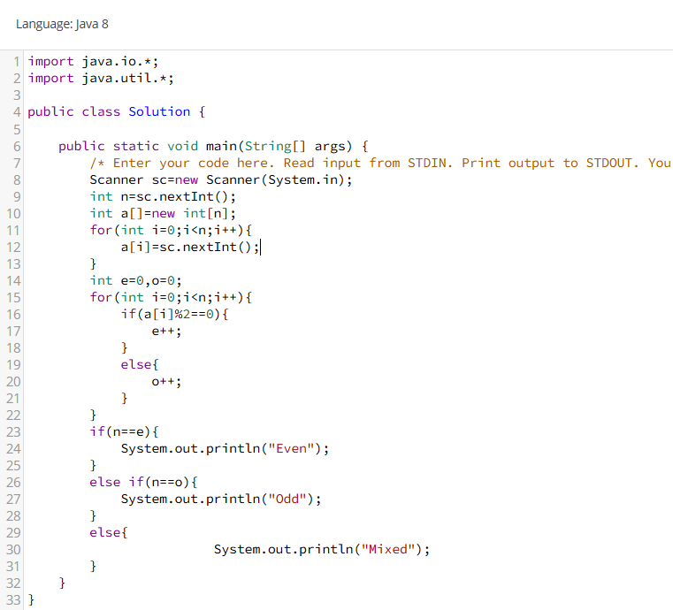

## Array-01

Geetha wants the know the best leaders in the given list.There is some condition to find the best leaders. Each leader has a score on their performance. Just take the score of the leader in reverse order and take the first score that compare with the other one who has the maximum score of the first one. Now take the current maximum score as the best leader score same as compared with the others.

Explanation: arr={16,17,4,7,3,5,2} First take the last element from the list 2,When taking the score of 2 that compare with other,5 is the maximum of 2 Now the current maximum of score is 5,When taking the score of 5 that compare with other,7 is maximum of 5. Now the current maximum of score is 7,when taking the score of 7 that compare with other,17 is maximum of 7.

Then finally the best Leader scores are {2,5,7,17}

**Input Format**

First Input corresponds as no of leaders. Second input corresponds as score of the each leader.

**Constraints**

No Constraints

**Output Format**

Find the best leaders score.

**Sample Input 0**

7

16 17 7 4 5 3 2

**Sample Output 0**

The Best Leaders are 2 3 5 7 17

**Sample Input 1**

7

1 9 5 3 6 2 4

**Sample Output 1**

The Best Leaders are 4 6 9

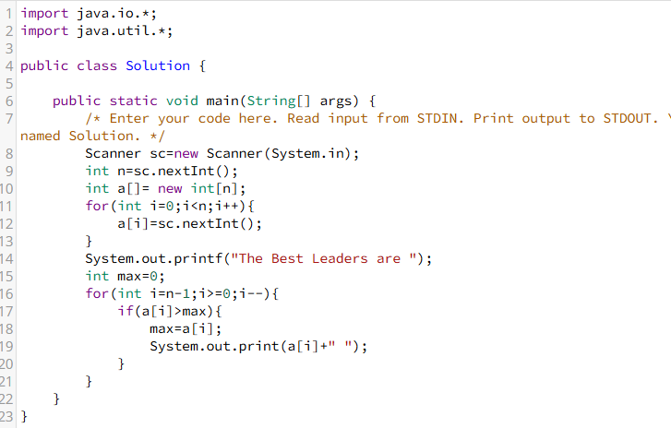

## Array-01

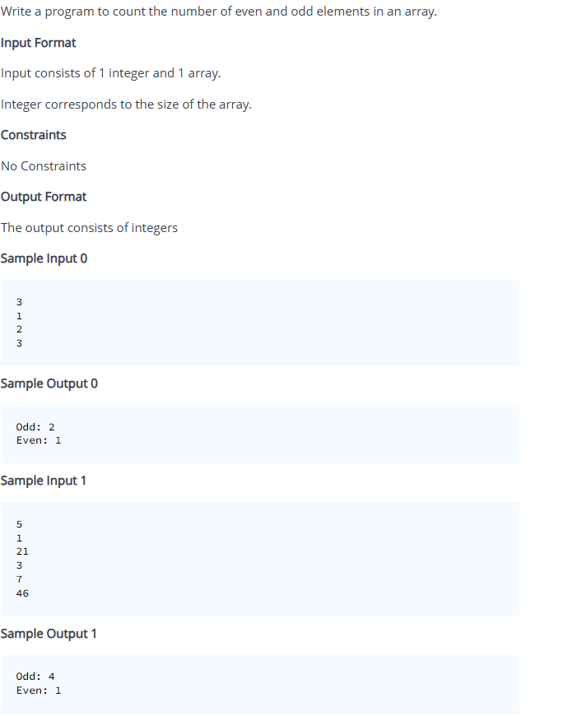

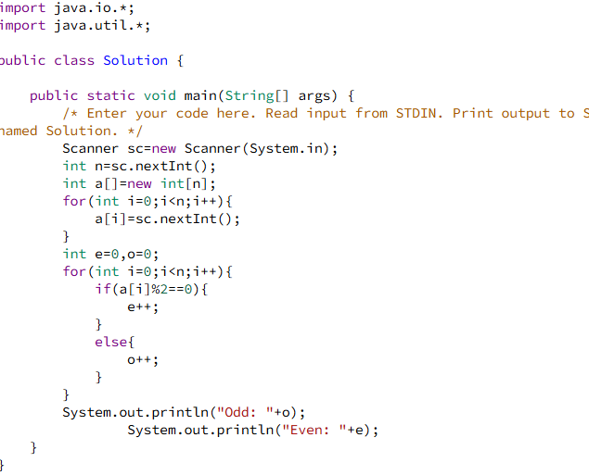

## Array-02

## 

## 

## Array-02

Write a program to reverse an array.

**Input Format**

Input consists of 1 integer and 1 array.

**Constraints**

No Constraints

**Output Format**

The first integer corresponds to the size of the array.

**Sample Input 0**

5

1

2

3

4

5

**Sample Output 0**

Reversed array is:

5

4

3

2

1

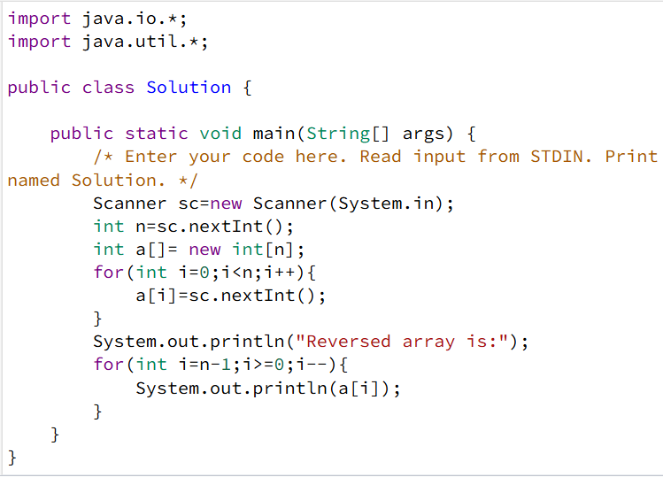

## Array-03

Sheela wants to find the common data in the two different lists. Could you please help to find it and implement the program. Both lists are non Duplicate data

Note-if the data are not found from the list return the Statement Data Not found.

**Input Format**

First Input Corresponds to the array size. Second Input Corresponds to the array elements of arr1. Third Input corresponds to the array elements of arr2.

**Constraints**

No Constraints

**Output Format**

Find the common datas from the two lists.

**Sample Input 0**

4

a b e f

e d h a

**Sample Output 0**

The Common data are a e

**Sample Input 1**

4

m o d g

a b c e

**Sample Output 1**

Data Not Found

## 

## Array-03

Write a program to find the maximum element in an array.

**Input Format**

Input consists of 1 integer and 1 array. Integer corresponds to the size of the array.

**Constraints**

No Constraints

**Output Format**

Find max value in the array.

**Sample Input 0**

4

67

33

89

45

**Sample Output 0**

Max=89

**Sample Input 1**

7

9

14

23

2

11

4

6

**Sample Output 1**

Max=23

## 

## Array-04

Pravin wants to give a surprise to his girlfriend on Valentine's Day. So he decided to give a rose to his girlfriend. He got the Valentine's surprise gift box. In that box, Each section has Multiple roses that are mentioned with some numbers. He needs to choose the best one from the gift box for his girlfriend. so the condition of choosing the rose is mentioned the rose number should be a double-digit integer and at the same time it should be a maximum number of the Integer.

Note - If he didnt find any roses from the box return the statement as "**Roses are not Found**".

**Input Format**

First Input Corresponds to no of rose in the box. Second Input Corresponds to numbers mentioned in each rose section.

**Constraints**

No Constraints

**Output Format**

Find the best roses from the box to surprise her girlfriend.

**Sample Input 0**

6

9 15 6 167 55 34

**Sample Output 0**

The rose he chose from the box is 55

**Sample Input 1**

7

8 764 678 9 222 7 2

**Sample Output 1**

Roses are not Found

## 

## Array-04

Write the program to find the second-largest element in the array.

**Input Format**

Input consists of 1 integer and 1 array. Integer corresponds to the size of the array.

**Constraints**

No Constraints

**Output Format**

Find the second largest number

**Sample Input 0**

3

1

3

2

**Sample Output 0**

The Second Largest Number is 2

**Sample Input 1**

4

11

44

22

55

**Sample Output 1**

The Second Largest Number is 44

## 

## Array-05

In this program, we will learn how to find the mean of an array. Here, we are reading N elements and finding their mean element.

**Input Format**

The first input consists of an array size.

The Second input consists of elements of an array.

**Constraints**

No Constraints

**Output Format**

Find the Mean Value of an array.

**Sample Input 0**

5

9 4 1 2 3

**Sample Output 0**

Mean:3.80

**Sample Input 1**

4

9 7 2 5

**Sample Output 1**

Mean:5.75

## 

## Array-05

Karthick decided to go to his friend's home. He has reached his friend's home Street. In that place, lots of buildings are there. Then he started to search for his friend's home. He forgot the door number. But he knows the address very well. Finally, he found his friend's home. He wants to know the door number of his friend's home address. Could you please tell me how did he find the door number of his friend's home?

**Input Format**

Input consists of number of buildings in that street and Door numbers for the each home. Karthick friend's home address.

**Constraints**

No Constraints

**Output Format**

If he found the home addrress after that returns the door number. If he not found the home,Return the value -1.

**Sample Input 0**

5

7 9 5 3 2

5

**Sample Output 0**

Door Number is 002-DN

**Sample Input 1**

7

8 6 5 3 2 1 7

2

**Sample Output 1**

Door Number is 004-DN

**Sample Input 2**

4

8 9 6 4

0

**Sample Output 2**

-1

## 

## Sum of Zig-Zag 6

Write a program to find the sum of Zig-Zag pattern in a given matrix.

**Input Format**

* Input consists of 2 integers and 1 2D-array.
* first input correspond to the size of rows and columns.
* second input correspond to the array elements.

**Constraints**

No Constraints

**Output Format**

* print the sum of zig zag value.

**Sample Input 0**

3

3

1 2 3

4 5 6

7 8 9

**Sample Output 0**

Sum of Zig-Zag pattern is 35

**Sample Input 1**

2

2

1 1

1 2

**Sample Output 1**

Sum of Zig-Zag pattern is 5

## 

## Sum of Boundaries 1

Write a program to find the sum of boundaries of a given matrix

**Input Format**

* first input corresponds to the array size of row and column.
* second input corresponds to the array elements.

**Constraints**

No Constraints

**Output Format**

* print the sum of boundaries value.

**Sample Input 0**

3

3

5 8 2

3 6 8

1 5 9

**Sample Output 0**

Sum of boundary is 41

**Sample Input 1**

5

5

1 3 6 9 3

-5 7 2 8 1

4 8 0 2 5

-11 5 7 2 8

2 5 13 25 30

**Sample Output 1**

Sum of boundary is 99

## 

## Transpose Matrix 23

Write a program to execute the transpose of the given 2D matrix.

**Input Format**

* first input consists of array size(row and column)
* second input consists of array elements.

**Constraints**

No Constraint

**Output Format**

Execute the transpose of the given matrix

**Sample Input 0**

3

1

2

3

4

5

6

7

8

9

**Sample Output 0**

Array elements are:

1 2 3

4 5 6

7 8 9

Transpose matrix is:

1 4 7

2 5 8

3 6 9

## 

## Sparse Matrix 6

Given a matrix, and we have to check whether the matrix is a sparse matrix or not.

Explanation for sparse matrix:A sparse matrix is a matrix in which most of the elements are zero.

**Input Format**

* First input consists of row and column size.
* Secong input consists of array elements.

**Constraints**

No Constraints

**Output Format**

Execute the statement based the question conditions

**Sample Input 0**

3

4 5 6

7 0 0

0 0 0

**Sample Output 0**

Matrix is a Sparse Matrix

**Sample Input 1**

4

1 2 3 4

6 7 8 9

1 2 3 0

6 7 7 4

**Sample Output 1**

Matrix is not a Sparse Matrix

## 

## ODD OR EVEN NUMBER

Seela wants to find whether the given number is even or odd with in the range of 1 to 100.Could you please help her to find it.

**Input Format**

Input Consists of Integer

**Constraints**

N value is 1 to 100

**Output Format**

If the given number is even, Print the Statement based on the test case. If the given number is odd,Print the statement based on the test case. If the given number is not upto the constraints,Print the statement as "Invalid Input".

**Sample Input 0**

18

**Sample Output 0**

The Given Number 018 is Even.

**Sample Input 1**

7

**Sample Output 1**

The Given Number 007 is Odd.

**Sample Input 2**

200

**Sample Output 2**

Invalid Input

## 

## Discount and Revenue

Revenue can be calculated as the selling price of the product times the quantity sold,

i.e. revenue = price × quantity.

Write a program that asks the user to enter product price and quantity and then calculate the revenue. **If the revenue is more than 5000 a discount is 10% offered.** Program should display the discount and net revenue.

**Input Format**

First input consists of price Second input consists of quantity

**Constraints**

No Constraints

**Output Format**

Display the value of Discount and revenue

**Sample Input 0**

2000

45

**Sample Output 0**

The discount is Rs.9000.00

The net revenue is Rs.81000.00

**Sample Input 1**

3000

2

**Sample Output 1**

The discount is Rs.600.00

The net revenue is Rs.5400.00

**Sample Input 2**

1500

2

**Sample Output 2**

The discount is Rs.0

The net revenue is Rs.3000.00

## 

## Valid Triangle

A triangle is valid if the sum of all the three angles is equal to 180 degrees. Write a program that asks the user to enter three integers as angles and check whether a triangle is valid or not.

**Input Format**

Inputs consist of angle1,angle2 and angle3.

**Constraints**

No Constraints

**Output Format**

Display the statement based on the testcase.

**Sample Input 0**

67

45

44

**Sample Output 0**

Triangle is not valid

**Sample Input 1**

49

50

81

**Sample Output 1**

Triangle is valid

## 

## NEON-NUMBER

Write a program to check whether a given number is Neon number or not.

Note-A neon number is a number where the sum of digits of square of the number is equal to the number. The task is to check and print neon numbers in a range. sum of the digits of the square is 9. + 4 + 4) which is not equal to 12

**Input Format**

Input consists of Single Integer.

**Constraints**

Given inputs between the range of 1 to 9

**Output Format**

If the Conditions is true Print the Statement depends on the testcases. If the Condidtions is false Print the statement depends on the testcases. If the input is not upto the range Print the statement "Invalid Input".

**Sample Input 0**

6

**Sample Output 0**

0006 is not a Neon Number.

**Sample Input 1**

9

**Sample Output 1**

009 is a Neon Number.

**Sample Input 2**

23

**Sample Output 2**

Invalid Input

## 

## Smarty Affix

Given a pair of positive integers m and n, write a program to smartly affix zeroes, while printing the numbers from m to n.

**Input Format**

Input consists of two integers.

**Constraints**

(m < n; 0 < m < 999; 1 < n < = 999),

**Output Format**

Execute the range value, and add it with affix zeros(depending on the digit's range values)

**Sample Input 0**

9

100

**Sample Output 0**

009 010 011 012 013 014 015 016 017 018 019 020 021 022 023 024 025 026 027 028 029 030 031 032 033 034 035 036 037 038 039 040 041 042 043 044 045 046 047 048 049 050 051 052 053 054 055 056 057 058 059 060 061 062 063 064 065 066 067 068 069 070 071 072 073 074 075 076 077 078 079 080 081 082 083 084 085 086 087 088 089 090 091 092 093 094 095 096 097 098 099 100

**Sample Input 1**

5

10

**Sample Output 1**

05 06 07 08 09 10

## 

## Fibonacci series

Write the program to calculate the sum of the Fibonacci series between the range of the two values. The n is the start of the range value and m is the end of the range value. Finally, return the sum of the range value of the Fibonacci Series.

**Input Format**

Input consists of two integers.

**Constraints**

N is greater than equal to one and lesser than equal to 20

M is greater than equal to one and lesser than equal to 20

**Output Format**

The sum of the range value.

If the constraints are more than the input print the statement is "Invalid Input".

**Sample Input 0**

3

5

**Sample Output 0**

The Sum of Fibonacci value is 6.0

**Sample Input 1**

11

15

**Sample Output 1**

The Sum of Fibonacci value is 898.0

**Sample Input 2**

22

23

**Sample Output 2**

Invalid Input

## 

## Sum of cubes 6

Given two integers, M and N, calculate the sum of the cubes of all integers from M to N inclusive. If M is greater than N, the result should be zero or an appropriate message should be displayed.

**Input Format**

Input:

M = 2 N = 4

**Constraints**

NO Constraints

**Output Format**

Output:

63

Explanation: The sum of the cubes of 2, 3, and 4 is 8 + 27 + 64 = 99.

**Sample Input 0**

9 15

**Sample Output 0**

13104

**Sample Input 1**

24 5

**Sample Output 1**

M should be less than or equal to N

## 

## Divisible-by-specified-number

Write a program to create a new array from a given array with the elements divisible by a specific number and count the number of elements divisible by a specific number in an array and find the sum of value divisible by a specific number in an array .

**Input Format**

First input consist of array size Second input consist of array elements. Third inpust consist of Divisor for an array elements.

**Constraints**

No Constraints

**Output Format**

Find the elements which is divisible by a specific number. Count the number of elements divisible by a specific number. find the sum of value divisible by a specific number in an array.

**Sample Input 0**

6

23 45 11 20 12 17

5

**Sample Output 0**

The elements that are divisible by 5 is 45 20

The Count of the value that is divisible by 5 is 2

The Sum of value that is divisible by 5 is 65

**Sample Input 1**

4

6 7 9 2

3

**Sample Output 1**

The elements that are divisible by 3 is 6 9

The Count of the value that is divisible by 3 is 2

The Sum of value that is divisible by 3 is 15

## Replace-odd-even

Write the program to replace all EVEN elements by 0 and Odd by 1 in One Dimensional Array.

**Input Format**

First input consists of array size and second input consist of array size.

**Constraints**

No Constraints.

**Output Format**

Replace all the even elements by 0 and replace all the odd elements by 1.

**Sample Input 0**

5

6 4 3 1 2

**Sample Output 0**

Before Replacement of value 0 and 1:6 4 3 1 2

After Replacement of value 0 and 1:0 0 1 1 0

**Sample Input 1**

4

8 4 3 2

**Sample Output 1**

Before Replacement of value 0 and 1:8 4 3 2

After Replacement of value 0 and 1:0 0 1 0

## Youngest-oldest

The Pan Am 73 flight from Bombay to New York en route to Karachi and Frankfurt was hijacked by a few Palestinian terrorists at the Karachi International Airport.

The senior flight purser Neerja Banhot had to wither her fear and start evacuating the passengers on board. She pleaded the hijackers to release the oldest and the youngest person in the aircraft. Heeding to her plea the chief of the hijacker agreed to let go the oldest and the youngest. Given the ages of the passengers find the oldest and the youngest.

**Input Format**

The first line of input consists of an integer n, corresponding to the number of passengers in the aircraft.

The next line consists of the age of passengers separated by a space.

**Constraints**

No Constraints

**Output Format**

The output prints the youngest and oldest separated by a space.

Print Invalid Input if n or any one of the ages is negative.

**Sample Input 0**

5

18 17 19 12 16

**Sample Output 0**

Youngest=12

Oldest=19

**Sample Input 1**

7

67 23 44 77 24 21 56

**Sample Output 1**

Youngest=21

Oldest=77

## String-sorting

Write a program to sort the given string.

**Input Format**

Input consists of 1 string.

**Constraints**

No Constraints

**Output Format**

Output print the ascending order of given string.

**Sample Input 0**

god

**Sample Output 0**

The sorted string is dgo

## Deleting-Vowels

Write a program to delete the vowels in the given string and display the string without vowels.

**Input Format**

Input consists of String1 and string2.

**Constraints**

No Constrainst

**Output Format**

Output Consists of Statements.

**Sample Input 0**

face

**Sample Output 0**

fc

## String-anagram

Write a program to check whether the given strings are anagrams or not.

**Input Format**

Input consists of 2 string.

**Constraints**

No constraints

**Output Format**

Output should print "Strings are anagrams" or "Strings aren't anagrams".

**Sample Input 0**

recitals

articles

**Sample Output 0**

Strings are anagrams

**Sample Input 1**

book

cook

**Sample Output 1**

Strings aren't anagrams

## Fuel Consumption

Write a program to calculate the fuel consumption of your truck.The program should ask the user to enter the quantity of diesel to fill up the tank and the distance covered till the tank goes dry.Calculate the fuel consumption and display it in the format (liters per 100 kilometers).

Convert the same result to the U.S. style of miles per gallon and display the result. If the quantity or distance is zero or negative display ” is an Invalid Input”.

[Note: The US approach of fuel consumption calculation (distance / fuel) is the inverse of the European approach (fuel / distance ). Also note that 1 kilometer is 0.6214 miles, and 1 liter is 0.2642 gallons.]

The result should be with two decimal place.To get two decimal place refer the below-mentioned print statement :

float cost=670.23;

System.out.printf(“You need a sum of Rs.%.2f to cover the trip”,cost);

**Input Format**

Example: Sample Input 1:

Enter the no of liters to fill the tank 20

Enter the distance covered 150

**Constraints**

quantity or distance is non-negative values.

**Output Format**

Sample Output 1:

Liters/100KM 13.33

Miles/gallons 17.64

**Explanation:**

* For 150 KM fuel consumption is 20 liters,
* Then for 100 KM fuel consumption would be (20/150)*100=13.33,
* Distance is given in KM, we have to convert it to miles (150*0.6214)=93.21,
* Fuel consumption is given in liters, we have to convert it to gallons (20*0.2642)=5.284,
* Then find (miles/gallons)=(93.21/5.284)=17.64

**Sample Input 0**

23

12

**Sample Output 0**

Liters/100KM

191.67

Miles/gallons

1.23

**Sample Input 1**

23

-2

**Sample Output 1**

Invalid Input

**Sample Input 2**

-21

13

**Sample Output 2**

Invalid Input

## Bill Generator 2

ohra went to a movie with his friends in a Wave theatre and during break time he bought pizzas, puffs and cool drinks. Consider the following prices :

Rs.100/pizza Rs.20/puffs Rs.10/cooldrink Generate a bill for What Vohra has bought.

**Input Format**

Sample Input 1:

Enter the no of pizzas bought:10

Enter the no of puffs bought:12

Enter the no of cool drinks bought:5

**Constraints**

Constraints: No Constraints

**Output Format**

Sample Output 1:

Bill Details

No of pizzas:10

No of puffs:12

No of cooldrinks:5

Total price=1290

**Sample Input 0**

12

7

3

**Sample Output 0**

Bill Details

No of pizzas:12

No of puffs:7

No of cooldrinks:3

Total price=1370

ENJOY THE SHOW!!!

**Sample Input 1**

11

12

19

**Sample Output 1**

Bill Details

No of pizzas:11

No of puffs:12

No of cooldrinks:19

Total price=1530

ENJOY THE SHOW!!!

## Dept repay

Alice wanted to start a business and she was looking for a venture capitalist. Through her friend Bob, she met the owner of a construction company who is interested to invest in an emerging business. Looking at the business proposal, the owner was very much impressed with Alice's work. So he decided to invest in Alice's business and hence gave a green signal to go ahead with the project.

Alice bought Rs.X for a period of Y years from the owner at R% interest per annum. Find the rate of interest and the total amount to be given by Alice to the owner. The owner impressed by proper repayment of the financed amount decides to give a special offer of 2% discount on the total interest at the end of the settlement. Find the amount given back by Alice and also find the total amount. (Note: All rupee values should be in two decimal points).

**Input Format**

Input consists of 3 integers. - The first integer corresponds to the principal amount borrowed by Alice. - The second integer corresponds to the rate of interest - The third integer corresponds to the number of years.

**Constraints**

No Constraints

**Output Format**

The output consists of 4 floating point values. - The first value corresponds to the interest. - The second corresponds to the amount. - The third value corresponds to the discount. - The last value corresponds to the final settlement. - All floating point values are to be rounded off to two decimal places

**Sample Input 0**

100

1

10

**Sample Output 0**

10.00

110.00

0.20

109.80

**Sample Input 1**

7000

3

5

**Sample Output 1**

1050.00

8050.00

21.00

8029.00

## The newspaper agency

Each Sunday, a newspaper agency sells w copies of a special edition newspaper for Rs.x per copy. The cost to the agency of each newspaper is Rs.y. The agency pays a fixed cost for storage, delivery and so on of Rs.100 per Sunday. The newspaper agency wants to calculate the profit which it obtains only on Sundays. Can you please help them out by writing a program to compute the profit if w, x, and y are given.

**Input Format**

* Input consists of 3 integers: w, x, and y.
* w is the number of copies sold, x is the cost per copy and y is the cost the agency spends per copy.

**Constraints**

No Constraints

**Output Format**

The output consists of a single integer which corresponds to the profit obtained by the newspaper agency.

**Sample Input 0**

1000

2

1

**Sample Output 0**

900

**Sample Input 1**

200

4

2

**Sample Output 1**

300

## Treaser finder

Lucy and Tina are close friends. They both are studying in the same school. Now they are on their summer vacation. As they are bored, they ask their parents to take them to an exhibition. There Lucy and Tina play a game. In this game, there are three boxes with some number written on their top. There is a treasure in one of the three boxes and the treasure is present in the box with the second largest number on its top. Also, to open the box, they need to decode the correct code of this box. The clue given to them to find the code is that it is the largest number which divides all the three given numbers.So, now help Lucy and Tina to decode the code.

**Input Format**

* Input consists of three integers.
* First input corresponds to the number of the first box.
* Second input corresponds to the number of the second box.
* Third input corresponds to the number of the third box.

**Constraints**

No Constraints

**Output Format**

Execute the Lucy and Tina to decode the code.

**Sample Input 0**

2

4

6

**Sample Output 0**

The treasure is in the box which has number 4.

The code to open the box is 2.

## Harry potter and the sorcerer's stone

Having crossed the three-headed dog, Harry, Ron, and Hermoine went through a secret trap door in search of Sorcerer's stone. On the way, they passed through a room and found that the room has only one door opposite to them and the door through which they entered has shut once they entered the room. The door was very large with a four digit number imprinted on it. When Harry and Ron tried to open it by casting out spells, it didn't open. Having tried various spells both of them got fed up and they left the task to Hermoine. Hermoine on curiously observing the room found that a statement was written on the top of the room. It was written as follows "I will be always four" “I can only be opened when you add my first and last and enter it” “If you find a sign, you should not consider it” Help Hermoine break the code and open the door so that they can save the sorcerer's stone.

**Input Format**

Input consists of a single integer which is present on the door.

**Constraints**

No Constraints

**Output Format**

The output is a single integer.

**Sample Input 0**

1001

**Sample Output 0**

2

**Sample Input 1**

1543

**Sample Output 1**

4

## Time 23

On one fine Sunday, Sita and Radha decided to solve puzzles. Sita asked Radha to solve her puzzle. Sita gave the puzzle on time. She gave Radha the number of hours, number of minutes and number of seconds as input. With the given input, Radha should find out the total number of hours, the total number of minutes and the total number of seconds. Help Radha by writing a program for this. For example, the input given by Sita is 1, 70, 5. Now, 70 minutes is equal to 1 hour 10 minutes. So the output will be Total number of hour(s) is 2 Total number of minutes is 10 Total number of seconds is 5

**Input Format**

* Input consists of three integers.
* First input corresponds to the number of hours.
* Second input corresponds to the number of minutes.
* Third input corresponds to the number of seconds.

**Constraints**

No Constraints

**Output Format**

Execute the Time, Minutes and Second

**Sample Input 0**

1

15

10

**Sample Output 0**

Total Number of hours is 1

Total Number of minutes is 15

Total Number of seconds is 10

**Sample Input 1**

1

50

120

**Sample Output 1**

Total Number of hours is 1

Total Number of minutes is 52

Total Number of seconds is 0

## Theater Discount

In a theater, there is a discount scheme announced where one gets a 10% discount on the total cost of tickets when there is a bulk booking of more than 20 tickets, and a discount of 2% on the total cost of tickets if a special coupon card is submitted. Develop a program to find the total cost as per the scheme. The cost of the k class ticket is Rs.75 and q class is Rs.150. Refreshments can also be opted by paying an additional of Rs. 50 per member.

**Hint: **k and q and You have to book minimum of 5 tickets and maximum of 40 at a time. If fails display “Minimum of 5 and Maximum of 40 Tickets”. If circle is given a value other than ‘k’ or ‘q’ the output should be “Invalid Input”.

The ticket cost should be printed exactly to two decimal places.

**Input Format**

First input consist of no of tickets second input consists of refreshment Third input consist of coupon Forth input consist of ticket type

**Constraints**

No Constraints

**Output Format**

Execute the price of the tickects and the statements.

**Sample Input 0**

15

y

y

k

**Sample Output 0**

Ticket cost:1852.50

**Sample Input 1**

45

y

y

k

**Sample Output 1**

Minimum of 5 and Maximum of 40 tickets

**Sample Input 2**

12

y

y

b

**Sample Output 2**

Invalid Input

## Unpredictable Rhythms

To speed up his composition of generating unpredictable rhythms, Blue Bandit wants the list of prime numbers available in a range of numbers. Can you help him out?

Write a program to print all prime numbers in the interval [a,b] (a and b, both inclusive).

Note

Input 1 should be lesser than Input 2. Both the inputs should be positive. Range must always be greater than zero. If any of the condition mentioned above fails, then display “Provide valid input” Use a minimum of one for loop and one while loop

**Input Format**

Get to integer value from the user

**Constraints**

No Constraints

**Output Format**

Execute the prime series

**Sample Input 0**

34

78

**Sample Output 0**

37 41 43 47 53 59 61 67 71 73

**Sample Input 1**

33

11

**Sample Output 1**

Provide valid input

## FOE college

FOE college wants to recognize the department which has succeeded in getting the maximum number of placements for this academic year. The departments that have participated in the recruitment drive are CSE,ECE, MECH. Help the college find the department getting maximum placements. Check for all the possible output given in the sample snapshot

Note : If any input is negative, the output should be “Input is Invalid”. If all department has equal number of placements, the output should be “None of the department has got the highest placement”.

**Input Format**

Get input from the user for the no of students placed in the year.

**Constraints**

No constraints

**Output Format**

Find the highest placement record

**Sample Input 0**

102

90

77

**Sample Output 0**

Highest Placement:

CSE

**Sample Input 1**

0

0

0

**Sample Output 1**

None of the department has got the highest placement

**Sample Input 2**

65

56

65

**Sample Output 2**

Highest Placement:

CSE

MECH

**Sample Input 3**

45

-23

-12

**Sample Output 3**

Input is Invalid

## Difference of the character

Given a string S(input consisting) of '*' and '#'. The length of the string is variable. The task is to find the minimum number of '*' or '#' to make it a valid string. The string is considered valid if the number of '*' and '#' are equal. The '*' and '#' can be at any position in the string.

Note : The output will be a positive or negative integer based on number of '*' and '#' in the input string.

(*>#): positive integer

(#>*): negative integer

(#=*): 0

Example 1:

Input 1:

###*** -> Value of S

Output :

0 → number of * and # are equal

**Input Format**

Input consist of one string

**Constraints**

No Constraints

**Output Format**

Execute the given output format.check the output data whether it is odd or even.

**Sample Input 0**

#**#**

**Sample Output 0**

The Difference of the character in the given string: 02

**Sample Input 1**

**##**#

**Sample Output 1**

The Difference of the character in the given string: 001

## Chain Marketing Organization 1

Chain Marketing Organization has has a scheme for income generation, through which its members generate income for themselves. The scheme is such that suppose A joins the scheme and makes R and V to join this scheme then A is Parent Member of R and V who are child Members. When any member joins the scheme then the parent gets total commission of 10% from each of its child members. Child members receive commission of 5% respectively. If a Parent member does not have any member joined under him, then he gets commission of 5%. Take name of the members joining the scheme as input. Display how many members joined the scheme including parent member.Calculate the Total commission gained by each members in the scheme. The fixed amount for joining the scheme is Rs.5000 on which commission will be generated SchemeAmount = 5000

Example 1: When there are more than one child members

Input : (Do not give input prompts.Accept values as follows. )

Amit //Enter parent Member as this

Y //Enter Y if Parent member has child members otherwise enter N

Rajesh,Virat //Enter names of child members of Amit in comma separated

Output:(Final Output must be in format given below.)

TOTAL MEMBERS:3

COMISSION DETAILS

Amit: 1000 INR

Rajesh :250 INR

Virat: 250 INR

Example 2: When there is only one child member in the hierarchy Input :

Amit

Y

Rajesh

Output:

Total Members: 2

Comission Details

Amit: 500 INR

Rajesh: 250 INR

**Input Format**

1. Input corresponds to the parents name
2. Input corresponds to the child members(Y or N)
3. Input corresponds to the child name separated by comma.

**Constraints**

No Constraints

**Output Format**

Execute the given format output.

**Sample Input 0**

Amit

Y

Rajesh,Virat

**Sample Output 0**

TOTAL MEMBERS:3

COMISSION DETAILS

Amit: 1000 INR

Rajesh: 250 INR

Virat: 250 INR

**Sample Input 1**

Amit

N

**Sample Output 1**

Total Members: 1

Comission Details

Amit: 250 INR

## Rotate String 9

Given two strings s and goal, return true if and only if s can become goal after some number of shifts on s.

A shift on s consists of moving the leftmost character of s to the rightmost position.

For example, if s = "abcde", then it will be "bcdea" after one shift

**Input Format**

Example 1:

Input: s = "abcde", goal = "cdeab" Output: true

Example 2:

Input: s = "abcde", goal = "abced" Output: false

**Constraints**

1 <= s.length, goal.length <= 100 s and goal consist of lowercase English letters.

**Output Format**

Execute the Boolean statement.

**Sample Input 0**

abcde

cdeab

**Sample Output 0**

true

**Sample Input 1**

abcde

cedba

**Sample Output 1**

false

## Spiral pattern 6

write the program to execute the spiral pattern of the string.

**Input Format**

* input consist of string

**Constraints**

No constraints

**Output Format**

* print the spiral pattern of string

**Sample Input 0**

Hello

**Sample Output 0**

Hello

e l

l l

l e

olleH

## Replace All Digits with Characters 1

You are given a 0-indexed string s that has lowercase English letters in its even indices and digits in its odd indices.

You must perform an operation shift(c, x), where c is a character and x is a digit, that returns the xth character after c.

For example, shift('a', 5) = 'f' and shift('x', 0) = 'x'. For every odd index i, you want to replace the digit s[i] with the result of the shift(s[i-1], s[i]) operation.

Return s after replacing all digits. It is guaranteed that shift(s[i-1], s[i]) will never exceed 'z'.

Note that shift(c, x) is not a preloaded function, but an operation to be implemented as part of the solution.

**Input Format**

Example 1:

Input: s = "a1c1e1"

Output: "abcdef"

Explanation: The digits are replaced as follows:

* s[1] -> shift('a',1) = 'b'
* s[3] -> shift('c',1) = 'd'
* s[5] -> shift('e',1) = 'f' Example 2:

Input: s = "a1b2c3d4e"

Output: "abbdcfdhe"

Explanation: The digits are replaced as follows:

* s[1] -> shift('a',1) = 'b'
* s[3] -> shift('b',2) = 'd'
* s[5] -> shift('c',3) = 'f'
* s[7] -> shift('d',4) = 'h'

**Constraints**

Constraints:

1 <= s.length <= 100 s consists only of lowercase English letters and digits. shift(s[i-1], s[i]) <= 'z' for all odd indices i.

**Output Format**

Execute the output in given sample input format

**Sample Input 0**

a1c1e1

**Sample Output 0**

abcdef

**Sample Input 1**

a1b2c3d4e

**Sample Output 1**

abbdcfdhe

## Score of String

You are given a string s. The score of a string is defined as the sum of the absolute difference between the ASCII values of adjacent characters.

Return the score of s.

**Input Format**

Example 1:

Input: s = "hello"

Output: 13

Explanation:

The ASCII values of the characters in s are: 'h' = 104, 'e' = 101, 'l' = 108, 'o' = 111. So, the score of s would be |104 - 101| + |101 - 108| + |108 - 108| + |108 - 111| = 3 + 7 + 0 + 3 = 13.

Example 2:

Input: s = "zaz"

Output: 50

Explanation:

The ASCII values of the characters in s are: 'z' = 122, 'a' = 97. So, the score of s would be |122 - 97| + |97 - 122| = 25 + 25 = 50.

**Constraints**

2 <= s.length <= 100 s consists only of lowercase English letters.

**Output Format**

Execute the output in given input format.

**Sample Input 0**

zaz

**Sample Output 0**

50

**Sample Input 1**

hello

**Sample Output 1**

13

## Furnishing company 3

A furnishing company is manufacturing a new collection of curtains. The curtains are of two colors aqua(a) and black (b). The curtains color is represented as a string(str) consisting of a’s and b’s of length N. Then, they are packed (substring) into L number of curtains in each box. The box with the maximum number of ‘aqua’ (a) color curtains is labeled. The task here is to find the number of ‘aqua’ color curtains in the labeled box.

Note :

If ‘L’ is not a multiple of N, the remaining number of curtains should be considered as a substring too. In simple words, after dividing the curtain in sets of ‘L’, any curtains left will be another set(refer example 1)

**Input Format**

The input format for testing

The candidate has to write the code to accept two inputs separated by a new line.

First input- Accept string that contains character a and b only

Second input- Accept value for N(Positive integer number)

Example 1:

Input :

bbbaaababa -> Value of str

3 -> Value of L

Output:

3 -> Maximum number of a’s

Explanation:

From the input given above.

Dividing the string into sets of 3 characters each

Set 1: {b,b,b}

Set 2: {a,a,a}

Set 3: {b,a,b}

Set 4: {a} -> leftover characters also as taken as another set

Among all the sets, Set 2 has more number of a’s. The number of a’s in set 2 is 3.

Hence, the output is 3.

Example 2:

Input :

abbbaabbb -> Value of str

5 -> Value of L

Output:

2 -> Maximum number of a’s

Explanation:

From the input given above,

Dividing the string into sets of 5 characters each.

Set 1: {a,b,b,b,b}

Set 2: {a,a,b,b,b}

Among both the sets, set 2 has more number of a’s. The number of a’s in set 2 is 2.

Hence, the output is 2.

**Constraints**

1<=L<=10

1<=N<=50

**Output Format**

The output should be a positive integer number of print the message(if any) given in the problem statement.(Check the output in Example 1, Example 2).

**Sample Input 0**

baabaaab

4

**Sample Output 0**

The Maximum number of a's is 003...

**Sample Input 1**

baaaabbbbaaab

2

**Sample Output 1**

The Maximum number of a's is 02...

## K Target

Given 2 numbers N and K followed by N elements,print the number of repetition of K otherwise print '-1' if the element not found.

**Input Format**

* first input consists of array size
* second input consists of target value
* third input consists of array elements

**Constraints**

No Constraints

**Output Format**

Execute the output of given format

**Sample Input 0**

6 2

1 2 3 5 8 7

**Sample Output 0**

0

**Sample Input 1**

6 2

1 2 3 2 8 7

**Sample Output 1**

1

**Sample Input 2**

7 3

1 3 3 2 8 7 3

**Sample Output 2**

2

**Sample Input 3**

7 3

1 3 3 2 8 7 3

**Sample Output 3**

2

**Sample Input 4**

8 2

1 2 3 2 8 2 3 2

**Sample Output 4**

3

## Collatz Sequence 6

The rules for generating Collatz Sequence are:

If n is even: n = n / 2

If n is odd: n = 3n + 1

For example, if the starting number is 5 the sequence is:

5 -> 16 -> 8 -> 4 -> 2 -> 1

It has been proved that for almost all integers, the repeated application of the above rule will result in a sequence that ends at 1.

Given a positive integer, write a program to print this sequence and the number of times this rule needs to be applied in order to reach 1.

**Input Format**

Input consists of a positive integer.

**Constraints**

No Constraints

**Output Format**

Print the numbers in the sequence, one per line and finally print the number of times the rule has to be applied in order to reach 1.

**Sample Input 0**

5

**Sample Output 0**

Enter a number

5

16

8

4

2

1

count:5

**Sample Input 1**

6

**Sample Output 1**

Enter a number

6

3

10

5

16

8

4

2

1

count:8

## Queue 38

A bus stop queue has n groups of people. The i-th group from the beginning has ai people. Every 30 minutes an empty bus arrives at the bus stop, it can carry at most m people. Naturally, the people from the first group enter the bus first. Then go the people from the second group and so on. Note that the order of groups in the queue never changes. Moreover, if some group cannot fit all of its members into the current bus, it waits for the next bus together with other groups standing after it in the queue. Your task is to determine the number of buses needed to transport all n groups to the dacha countryside.

**Input Format**

* The first line contains two integers n and m.
* The next line contains n integers: a1, a2, ...

**Constraints**

* 1 ≤ n, m ≤ 100
* 1 ≤ ai ≤ m

**Output Format**

* Print a single integer — the number of buses needed to transport all n groups to the dacha countryside

**Sample Input 0**

4

3

2 3 2 1

**Sample Output 0**

3

**Sample Input 1**

4

4

3 3 3 3

**Sample Output 1**

3

## Maximum elements in Subarrays

Given an array and a integer k.we need to find the maximum element in each of the contiguous subarrays.

**Input Format**

Input: 2 4 7 1 6 3 K=3

**Constraints**

No Constraints

**Output Format**

Output:7776

The subarrays will be [2,4,7], [4,7,1],[7,1,6] and [1,6,3]. The maximum numbers from the subarrays are

7 7 7 6

**Sample Input 0**

2 4 7 1 6 3

3

**Sample Output 0**

7 7 7 6

**Sample Input 1**

2 4 7 1 6 3

2

**Sample Output 1**

4 7 7 6 6

## SUBARRAY SUM EQUALS K 7

Given a sequence of integers, referred to as ‘nums’, and another integer ‘k’, the task is to find the total count of subarrays where the sum equals ‘k’. A subarray is defined as a continuous, non-empty sequence of elements within the array.

Example 1:

Input: nums = [1,1,1], k = 2

Output: 2

Example 2:

Input: nums = [1,2,3], k = 3

Output: 2

**Input Format**

* Input corresponds to the array elements and the target values.

**Constraints**

1. The length of ‘nums’ is between 1 and 2 * 10^4 inclusive.
2. Each element in ‘nums’ is between -1000 and 1000 inclusive.
3. ‘k’ is between 10^7 and 10^7 inclusive.

**Output Format**

Execute the total count of subarray whereas equals to the target values.

**Sample Input 0**

4 3 2 1

7

**Sample Output 0**

The count of the subarray whereas equals to the target is : 1

## Sum of values

Given an integer, we need to find the sum of values of that table.

Explanation: 3

3*1 + 3*2 + 3*3 =3 + 6 + 9 = 18

**Input Format**

Input:10

**Constraints**

No Constraints

**Output Format**

Output:550

**Sample Input 0**

8

**Sample Output 0**

288

**Sample Input 1**

4

**Sample Output 1**

40

## Stock span 12

The stock span problem is a financial problem where we have a series of n daily price quotes for a stock and we need to calculate the span of stock’s price for all n days. The span Si of the stock’s price on a given day I is defined as the maximum number of consecutive days just before the given day, for which the price of the stock on the current day is less than or equal to its price on the given day. Now, you need to find out the span values for the given number of days and their daily prices. For example, if an array of 7 day’s prices is given as {100, 80, 60, 70, 60, 75, 85}, then the span values for corresponding 7 days are {1, 1, 1, 2, 1, 4, 6}

**Input Format**

Input consists of n+1 integers. The first integer corresponds to n, the number of days. The next n integers correspond to stock prices on days 1, 2…n.

**Constraints**

No Constraints

**Output Format**

The output consists of n integers that correspond to the span values.

**Sample Input 0**

7

80

100

70

70

55

85

80

**Sample Output 0**

1

2

1

2

1

4

1