## Oops-Class-Object

Write a Java program to create a class called "Rectangle" with width and height attributes. Calculate the area and perimeter of the rectangle.

**Input Format**

* Input Consists of two integer.
* First one is for width and second one is for height.

**Constraints**

Both value should be lesser than equals to 10

**Output Format**

Execute the values of both are and perimeter of the rectangle.

**Sample Input 0**

5

4

**Sample Output 0**

Here your Answers!!!

Area of the Rectangle is 20.00

Perimeter of the Rectangle is 18.00

**Sample Input 1**

12

4

**Sample Output 1**

Hello User,Kindly Enter the valid Input.

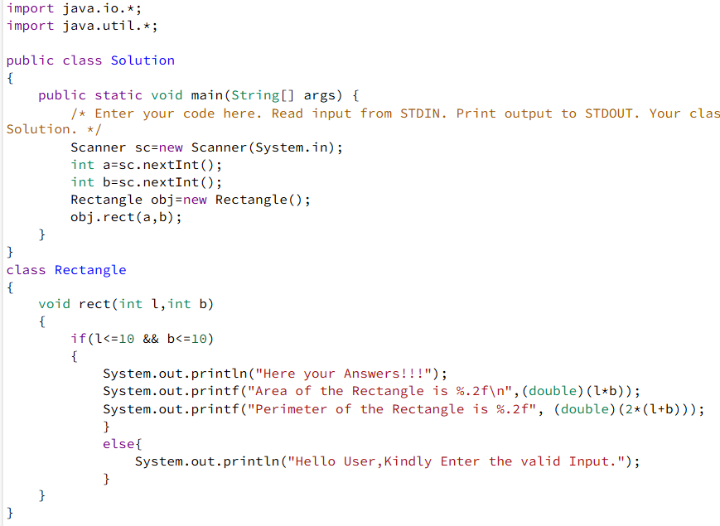

## Oops-Class-Object-Setter-Getter 1

Write a Java program to create a class called "Circle" with a radius attribute. You can access and modify this attribute. Calculate the area and circumference of the circle.

Formula: Area of the Circle is πr^2

circumference of the circle 2πr

**Input Format**

Input Consists of integer.

**Constraints**

Input value should be lesser than or equals to 10

**Output Format**

Execute the values of both area and circumference of the circle.

**Sample Input 0**

4

**Sample Output 0**

Hello User,Here your Answer!!!!

Area of the Circle is 50.26548

Circumference of the Circle is 25.13274

**Sample Input 1**

67

**Sample Output 1**

Hello User,Kindly Enter the valid Input...

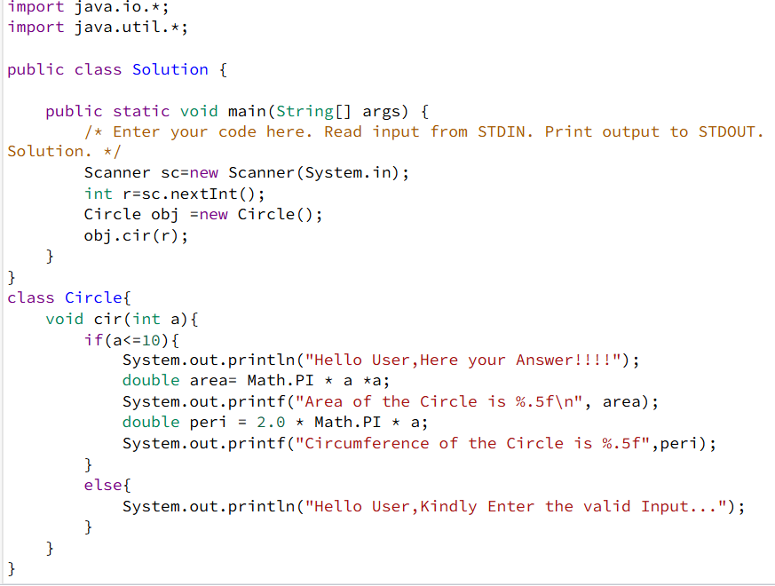

**Oops-constructor 1**

­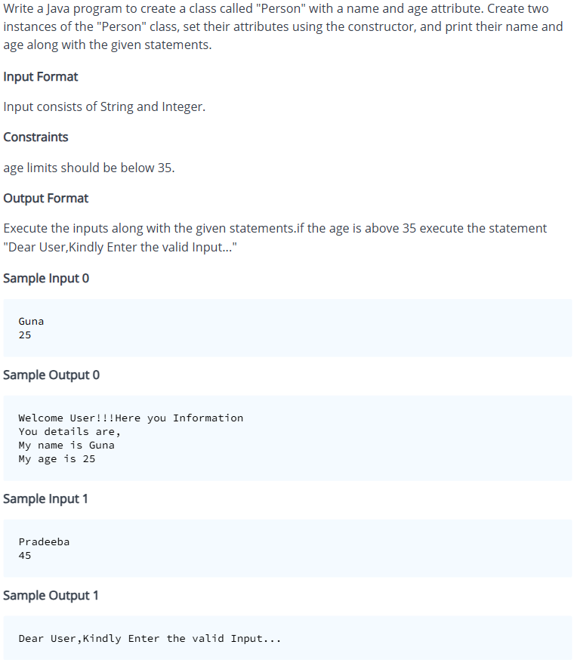

## Oops-constructor-and-getter-setter 1

Write a Java program to create a class called "Dog" with a name and breed attribute. Create two instances of the "Dog" class, set their attributes using the constructor and modify the attributes using the setter methods and print the updated values.

**Input Format**

Input Consists of two String

**Constraints**

No Constraints

**Output Format**

Execute the inputs along with the given statements.

**Sample Input 0**

Henry

Bulldog

**Sample Output 0**

Hello User,Here Your Information!!!!

Dog Name is Henry

Breed is Bulldog

## Oops-Abstract 1

Write a Java program to create a class called "Shape" with abstract methods for calculating area and perimeter, and subclasses for "Square", and "Triangle".

**Input Format**

Input consists of 3 integer. First input corresponds to the area. Second and third input corresponds to the length and breadth.

* Note: Consider the input values for Perimeter of the traingle a,b and c as the input of area, length and breadth.

**Constraints**

No Constraints

**Output Format**

Execute the area and perimeter of the given shape.

**Sample Input 0**

5

6

4

**Sample Output 0**

Shape of the Square details are,

Area of Square is 25.0

Perimeter of square is 20.0

Shape of the Triangle details are,

Area of Triangle is 12.0

Perimeter of Triangle is 15.0

## Oops-Inheritance 1 1

Write a Java program to create a class called "Employee" with a name, job title, and salary attributes, and methods to calculate and update current salary of the employee after getting hike.

**Input Format**

* Input consists of two String and two Integer.
* First input corresponds to employee name.
* Second input corresponds to empoyee job role.
* Third input corresponds to employee initial salary.
* Fourth input corresponds to the employee hike percentage value.

**Constraints**

salary should not below 50000k

**Output Format**

Execute the output in the given format.If the given data is not match with the required limits execute the statement "Dear Employee,Salary Increment only for above 50000k."

**Sample Input 0**

Pradeeba

Software Engineer

65000

12

**Sample Output 0**

Dear Employee,Here Your Details!!!!

Employee Name:Pradeeba

Employee Role:Software Engineer

Employee Salary:65000.00

After hike,Employee Salary:72800.00

**Sample Input 1**

Venky

Business Analyst

45000

23

**Sample Output 1**

Dear Employee,Salary Increment only for above 50000k.

## Oops-Inheritance 1 2

Write a Java program to create a class called "Bank" with a collection of accounts and method to deposit and withdraw money. Also define a class called "Account" to maintain account details of a particular customer.

**Input Format**

* First Input Corresponds to Account Holder Name
* Second input Corresponds to Account Number
* Third Input Corresponds to Account Branch
* Fourth input Corresponds to Enter the Bank process either Withdraw or Deposit
* Fifth input Corresponds to Enter the Bank Account either Major or Minor,If its Minor Account Enter the Guardian Name otherwise go to Next process.
* Sixth input Corresponds to Either its a Current or Saving Account.
* Seventh input Corresponds to old Bank Balance.
* Eighth input Corresponds to Amount for Deposit or WithDraw.

**Constraints**

WithDraw limit only 10000

**Output Format**

Execute the Customer Details and Bank Balance Details.The Customer wants to Withdraw the Money,if its below than the Bank balance Execute the statement "Dear Customer,You not have a sufficient Amount in Your Account" and if its not in the limit Execute the statement "Dear Customer,Please Enter your Limited Withdraw Amount"

**Sample Input 0**

Varshini

78784455120

Erode

Deposit

Major

Current

45000

23700

**Sample Output 0**

Dear Customer,Here Your Account and Bank Details!!!

Account Holder Name:Varshini

Account Number:78784455120

Bank Branch:Erode

Amount Process:Deposit

Account Holder Major or Minor:Major

Account Type:Current

Old Bank Balance:45000.00

Current Bank Balance:68700.00

**Sample Input 1**

Venkatesh

78784455021

Coimbatore

Withdraw

Minor

Hari

Savings

51000

7000

**Sample Output 1**

Dear Customer,Here Your Account and Bank Details!!!

Account Holder Name:Venkatesh

Account Number:78784455021

Bank Branch:Coimbatore

Amount Process:Withdraw

Account Holder Major or Minor:Minor

Guardian Name:Hari

Account Type:Savings

Old Bank Balance:51000.00

Current Bank Balance:44000.00

**Sample Input 2**

Varshini

78784455120

Erode

Withdraw

Major

Current

45000

50000

**Sample Output 2**

Dear Customer,You not have a sufficient Amount in Your Account.

**Sample Input 3**

Swetha

78881455120

Coimbatore

Deposit

Minor

Senthil

Savings

54000

45000

**Sample Output 3**

Dear Customer,Here Your Account and Bank Details!!!

Account Holder Name:Swetha

Account Number:78881455120

Bank Branch:Coimbatore

Amount Process:Deposit

Account Holder Major or Minor:Minor

Guardian Name:Senthil

Account Type:Savings

Old Bank Balance:54000.00

Current Bank Balance:99000.00