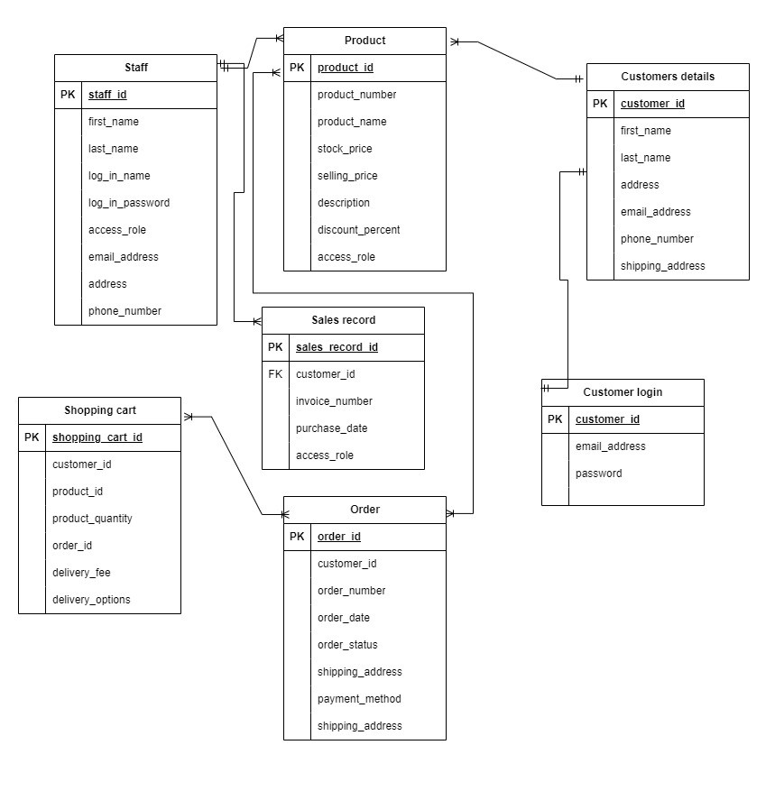Initial ERD

Task 1

1. Buat normalisasi dari ERD diatas (1NF,2NF dan 3NF)
2. Buat ERD lagi stelah normalisasi
3. 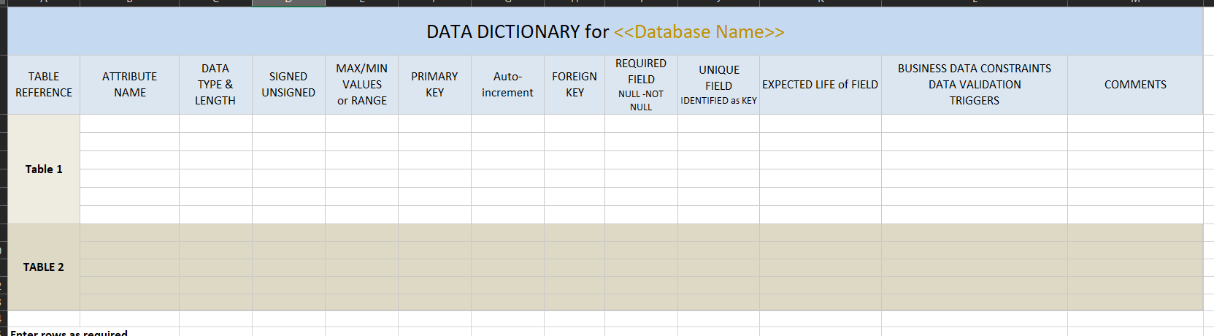Buat data dictionary
4. Buat **Integrity constraints dan Referential integrity constraints**

Contoh:

|  |  |  |  |  |
| --- | --- | --- | --- | --- |
| **TABLE and FOREIGN KEY (FK)** | **TABLE & PRIMARY KEY it REFEENCES (PK)** | **REFERENTIAL INTEGRITY CONSTRAINTS** | | **REFERENTIAL ACTIONS** |
| **RULE 1**  FK has the same declaration (data type and domain) that the PK it references | **RULE 2**  FK value is equal to value in PK or NULL |
| tbl_customer_detail (id_user) | tbl_user (id_user) | Yes | Yes | ON DELETE CASCADE,  ON UPDATE CASCADE |
| tbl_detail_cart (product_id) | tbl_product (product) | Yes | Yes | ON DELETE CASCADE,  ON UPDATE CASCADE |
| tbl_sales_order (shopping_cart_id) | tbl_shopping_cart (shopping_cart_id) | Yes | Yes | ON DELETE CASCADE,  ON UPDATE CASCADE |
| tbl_shopping_cart (customer_id) | tbl_customer_detail (customer_id) | Yes | Yes | ON DELETE CASCADE,  ON UPDATE CASCADE |
| tbl_shopping_cart (cart_detail_id) | tbl_detail_cart (cart_detail_id) | Yes | Yes | ON DELETE CASCADE,  ON UPDATE CASCADE |

1. **Semantic, trigger and other constraints** tambahkan ke table no 3
2. **Buat Index**

Contoh index:

|  |  |  |  |  |
| --- | --- | --- | --- | --- |
| **INDEX NAME** | **COLUMN NAME** | **TABLE** | **INDEX TYPE**  (e.g. HASH or B-Tree) | **SEARCH BENEFITS** |
| PRIMARY | customer_id | tbl_detail_customer | BTREE |  |
| id_user | id_user | tbl_detail_customer | BTREE |  |
|  |  |  |  |  |
| PRIMARY | cart_detail_id, product_id | tbl_detail_cart | BTREE |  |
| PRIMARY | product_id | tbl_product | BTREE |  |
| PRIMARY | so_id | tbl_sales_order | BTREE |  |
| PRIMARY | shopping_cart_id | tbl_shopping_cart | BTREE |  |
| cart_detail_id | cart_detail_id | tbl_shopping_cart | BTREE |  |
| customer_id | customer_id | tbl_shopping_cart | BTREE |  |
| PRIMARY | id_user | tbl_user | BTREE |  |

Task 2 (Membuat database di MySQL berdasarkan table Task 1 no 3)

1. Buat Database dan Mengaksesnya

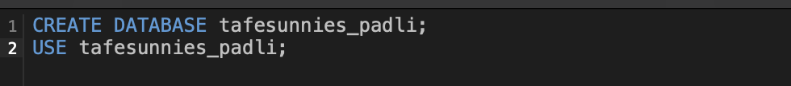

1. Buat Table Customer Detail

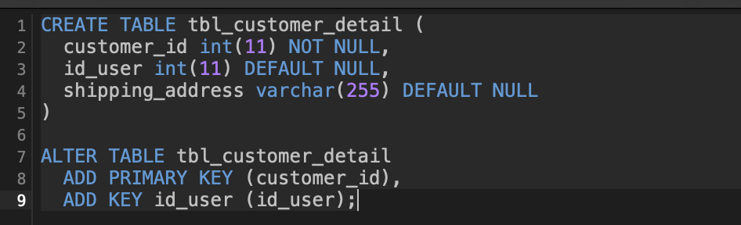

1. Insert data Customer Detail



1. Buat Table Detail Cart & Setup Primary Key

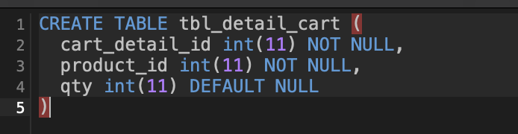

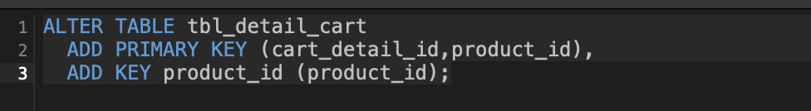

1. Insert data Detail Chart

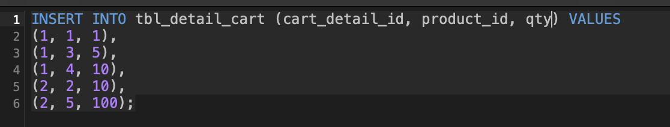

1. Buat Table Produk & Setup Primary Key

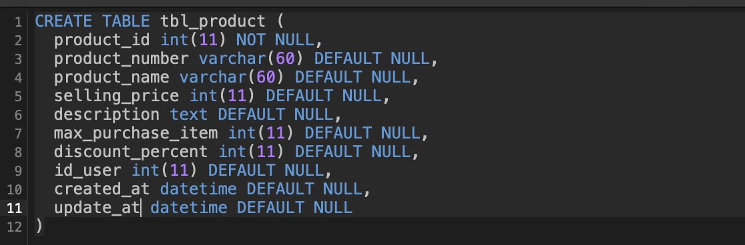



1. Insert data Table Produk

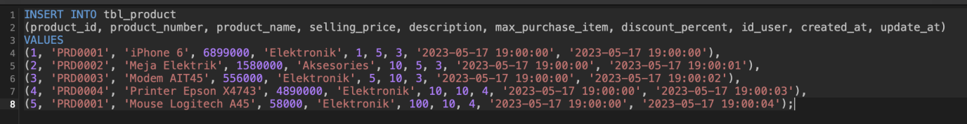

1. Buat Table Sales Order & Setup Primary Key

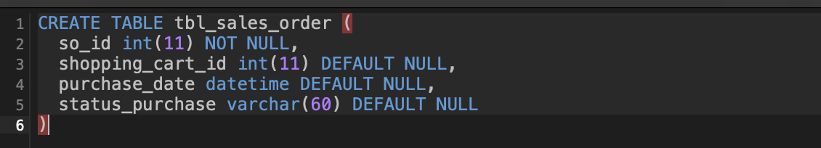

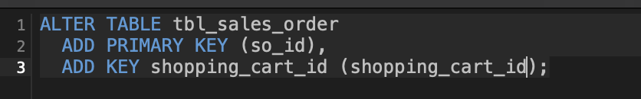

1. Insert data Sales Order



1. Buat Table Shopping Cart & Setup Primary Key

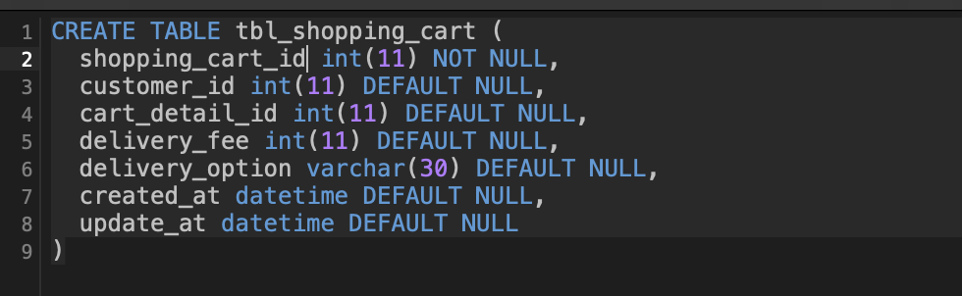

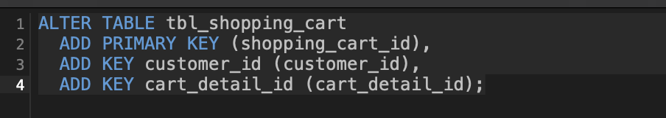

1. Insert data Table Shoppping Cart



1. Buat Table User & Setup Primary Key

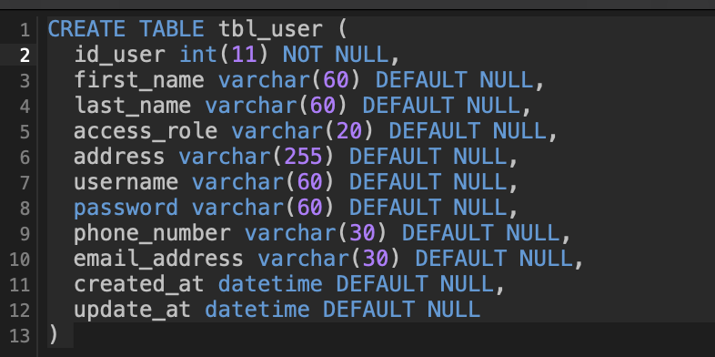



1. Insert data Table User



1. Relasikan Table Customer Detail dengan Table User

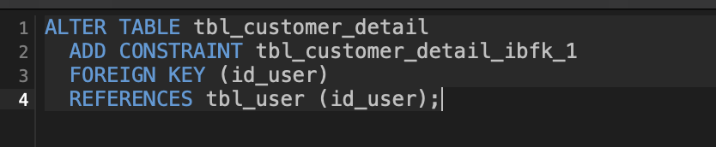

1. Relasikan Table Detail Cart dengan Table Produk

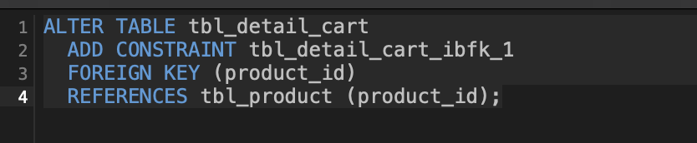

1. Relasikan Table Sales Order dengan Table Shopping Cart

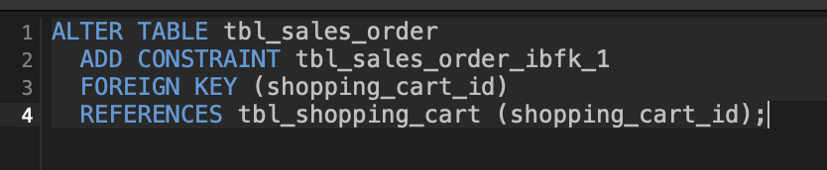

1. Relasikan Table Shopping Cart dengan Table Customer Detail, Table Shopping Cart dengan Table Detail Cart



1. Diagram Table

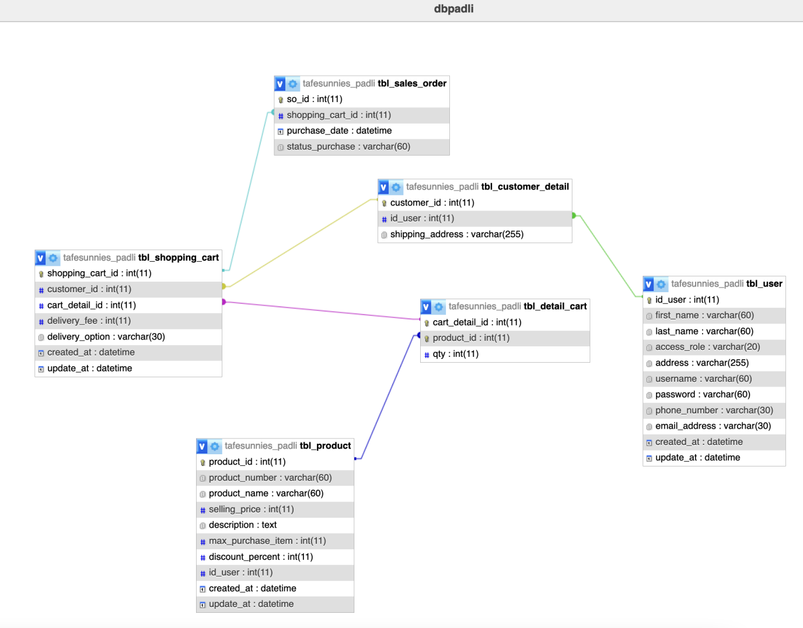

Normalisasi Database

**1NF: First Normal Form**

|  |  |
| --- | --- |
| Table | Attribute |
| tbl_sales_order | so_id, shopping_cart_id, purchase_date, status_purchase |
| tbl_product | product_id, product_name, selling_price, description, max_purchase_item, discount_percent, id_user, created_at, update_at |
| |  |  | | --- | --- | |  | [tbl_detail_cart](http://localhost/phpmyadmin/index.php?route=/sql&db=tafesunnies_padli&table=tbl_detail_cart&pos=0" \o ") | | cart_detail_id, product_id, qty |
| |  |  | | --- | --- | |  | [tbl_customer_detail](http://localhost/phpmyadmin/index.php?route=/sql&db=tafesunnies_padli&table=tbl_customer_detail&pos=0" \o ") | | customer_id, id_user, shipping_address |
| [tbl_shopping_cart](http://localhost/phpmyadmin/index.php?route=/sql&db=tafesunnies_padli&table=tbl_shopping_cart&pos=0" \o ") | shopping_cart_id, customer_id, cart_detail_id, delivery_fee, delivery_option, created_at, update_at |
| |  |  | | --- | --- | |  | [tbl_user](http://localhost/phpmyadmin/index.php?route=/sql&db=tafesunnies_padli&table=tbl_user&pos=0" \o ") | | id_user, first_name, last_name, access_role, address, username, password, phone_number, email_address, created_at, update_at |

**2NF: Second Normal Form**

|  |  |
| --- | --- |
| Table | Attribute |
| tbl_sales_order | so_id, shopping_cart_id, purchase_date, status_purchase |
| tbl_product | product_id, product_name, selling_price, description, max_purchase_item, discount_percent, id_user, created_at, update_at |
| |  |  | | --- | --- | |  | [tbl_detail_cart](http://localhost/phpmyadmin/index.php?route=/sql&db=tafesunnies_padli&table=tbl_detail_cart&pos=0" \o ") | | cart_detail_id, product_id, qty |
| |  |  | | --- | --- | |  | [tbl_customer_detail](http://localhost/phpmyadmin/index.php?route=/sql&db=tafesunnies_padli&table=tbl_customer_detail&pos=0" \o ") | | customer_id, id_user, shipping_address |
| [tbl_shopping_cart](http://localhost/phpmyadmin/index.php?route=/sql&db=tafesunnies_padli&table=tbl_shopping_cart&pos=0" \o ") | shopping_cart_id, customer_id, cart_detail_id, delivery_fee, delivery_option, created_at, update_at |
| |  |  | | --- | --- | |  | [tbl_user](http://localhost/phpmyadmin/index.php?route=/sql&db=tafesunnies_padli&table=tbl_user&pos=0" \o ") | | id_user, first_name, last_name, access_role, address, username, password, phone_number, email_address, created_at, update_at |

All values in the 1NF are atomic

**3NF: Third Normal Form**

Sales order table

|  |  |
| --- | --- |
| tbl_sales_order | so_id, shopping_cart_id, purchase_date, status_purchase |

Product Table

|  |  |
| --- | --- |
| tbl_product | product_id, product_name, selling_price, description, max_purchase_item, discount_percent, id_user, created_at, update_at |

Detail Cart Table

|  |  |  |  |
| --- | --- | --- | --- |
| |  |  | | --- | --- | |  | [tbl_detail_cart](http://localhost/phpmyadmin/index.php?route=/sql&db=tafesunnies_padli&table=tbl_detail_cart&pos=0" \o ") | | cart_detail_id, product_id, qty |

Customer Detail Table

|  |  |  |  |
| --- | --- | --- | --- |
| |  |  | | --- | --- | |  | [tbl_customer_detail](http://localhost/phpmyadmin/index.php?route=/sql&db=tafesunnies_padli&table=tbl_customer_detail&pos=0" \o ") | | customer_id, id_user, shipping_address |

Shopping Cart Table

|  |  |
| --- | --- |
| [tbl_shopping_cart](http://localhost/phpmyadmin/index.php?route=/sql&db=tafesunnies_padli&table=tbl_shopping_cart&pos=0" \o ") | shopping_cart_id, customer_id, cart_detail_id, delivery_fee, delivery_option, created_at, update_at |

User Table

|  |  |  |  |
| --- | --- | --- | --- |
| |  |  | | --- | --- | |  | [tbl_user](http://localhost/phpmyadmin/index.php?route=/sql&db=tafesunnies_padli&table=tbl_user&pos=0" \o ") | | id_user, first_name, last_name, access_role, address, username, password, phone_number, email_address, created_at, update_at |