HYPERUNIT NETWORK
HyperUnit Network White Paper
From Information Digitization to Reality-Validated Capability Digitization
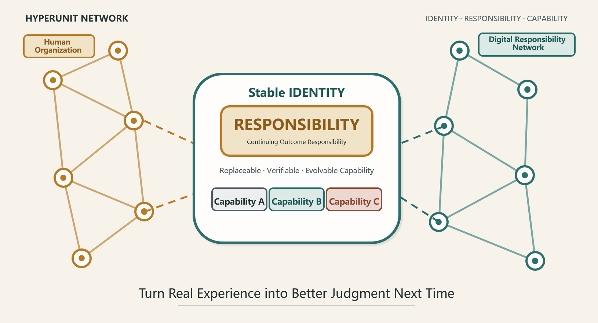
Official Release v1.2 · September 2026
HyperUnit Network Project Team

About This Version
This white paper introduces HyperUnit as the fundamental digital unit of organizational capability and describes a set of protocol principles and a framework for open interoperability. Its concern is not how to build yet another file system, knowledge base, or automation product. Instead, it asks how organizations can connect the facts, judgments, decisions, interventions, actions, and real-world outcomes generated in day-to-day operations, so that individual experience can gradually become digital capability that is verifiable, transferable, reusable, and evolvable.
This release completes the seven main chapters, glossary, and summary of core principles. The main text retains the conceptual backbone and white-paper-level protocol principles. Engineering details—including Manifest fields, the Capability Contract, Registry, signature algorithms, Event Bus, and persistence implementation—will be covered separately in the planned Core Protocol Specification and Technical Companion.
This is a theoretical and engineering white paper. It is not a product manual, implementation contract, legal opinion, basis for accounting recognition, or roadmap for a fully autonomous enterprise. The scenarios presented are intended to explain mechanisms and do not constitute factual claims about any particular company, industry, or project.
In one sentence HyperUnit Network moves enterprises from preserving information to accumulating digital capabilities validated by reality.

At a Glance
Enterprises have preserved vast amounts of data, documents, and processes, yet they still relearn and repeat mistakes after personnel changes because what is truly lost is often not information but judgment capability. HyperUnit Network uses identity- and responsibility-bearing HTML as its fundamental digital unit, connecting facts, judgments, capabilities, human interventions, and real-world validation. Through daily operations, it enables enterprises to gradually turn individual experience into digital Capability Assets that are verifiable, transferable, reusable, and evolvable. It neither replaces existing systems nor allows AI to take over decisions without responsibility, permission, risk thresholds, and rollback boundaries. Instead, it creates an organizational capability network in which people, data, models, LLMs, and Agents all accept validation by reality.

Executive Summary
Enterprise digitization has progressed through several stages: converting analog materials into electronic form, connecting information through systems, and making operations data-driven. More and more business activities are now recorded, connected, and computed, while models and generative AI are entering decision processes. Yet in many organizations, the judgment that truly determines operating quality still depends heavily on a small number of individuals. When key people leave, change roles, or when market conditions shift, the organization discovers that it has retained a vast amount of material but cannot reconstruct why a judgment was made, which facts were used, which options were rejected, or how subsequent reality validated the decision.
These problems are often attributed to weak knowledge management, insufficient process standardization, or limited AI adoption, but their root cause runs deeper: existing digital objects are organized primarily around information, not responsibility and capability. Files preserve content, processes standardize steps, databases retain records, models perform computations, and Agents execute tasks. All are important, but none inherently possesses a stable identity, continuing responsibility, epistemic boundaries, validation relationships, or a capability lifecycle. Without such a fundamental unit, an organization struggles to answer: Who continues to carry this digital responsibility? Is this conclusion a fact or a judgment? Which versions of data and capability produced this output? Did later reality show it to be effective? When should one capability be replaced?
HyperUnit responds to this gap. Every HyperUnit has a stable and unique unit_id, takes Responsibility as the core of its identity, and allows Capability to evolve while that responsibility remains unchanged. It explicitly separates Fact, Configuration, Runtime State, Claim, and Evidence. Every Claim is bound to all typed inputs actually used, the relevant Configuration, and its source of generation. Every cross-unit information flow leaves a Trace; the actual dependencies involved in an Output are frozen in a Dependency Snapshot; a formal decision creates an immutable Decision Snapshot; and when real-world outcomes emerge, Evidence connects the earlier judgment to later facts. Trustworthiness therefore no longer means that “the system never makes mistakes.” It means the organization can know what happened at the time, what the judgment was based on, who intervened, what was ultimately executed, and what should be learned from the result.
HyperUnit uses HTML as its practical carrier not because HTML should serve as a database or operating system, but because it is simultaneously human-readable, machine-parsable, interactive, offline-capable, and portable. A structured Manifest and Configuration can be embedded within it, and ordinary readers can directly open a low-privilege, constrained Portable View. Higher-privilege capabilities require a Managed Run, in which an external Runtime Engine verifies identity, signatures, permissions, and dependencies, then executes in a sandbox. Formal state changes are completed through an atomic commit. Large datasets, complete history, retrieval indexes, and high-frequency transactions remain the responsibility of the Persistence Layer. HTML is the protocol-bearing unit, not a replacement for all infrastructure.
HyperUnit Network also treats human complexity as a first-class design variable. Human acceptance, challenge, suspension, Override, and resource reallocation all belong to a Decision Episode. Interventions must not overwrite the system Baseline; they should form a traceable Intervention DAG. The system assumes neither that people are always rational nor that models, LLMs, or historical experience possess inherent authority. When evidence is insufficient, Attribution = Indeterminate is permitted. Historical Evidence may be down-weighted, retired from active use, and reactivated, but it cannot be silently deleted or turned into a permanent label on a person. Traceability is not intended to create punitive surveillance. Its purpose is to let organizations acknowledge uncertainty, preserve disagreement, and accept validation by reality at a lower organizational cost.
In implementation, HyperUnit Network does not require an enterprise to replace ERP, CRM, TMS, Excel, databases, or existing scripts first, nor does it advocate building an enterprise-wide platform in one step. It begins with a task whose responsibility is relatively mature and connects existing systems through Adapters into the smallest closed loop: Fact → Capability → Claim → Decision → Execution → Reality → Evidence. The core principles cannot be compromised from day one, but governance intensity, degree of automation, and network scale can increase in stages. The first release only needs to prove that one real judgment can be preserved end to end—from creation through validation—and invoked when a similar environment appears again.
Over the long term, HyperUnit Network seeks to give enterprises a digital responsibility network that operates alongside the human organizational structure. The human structure carries goal setting, value judgments, negotiation, innovation, and exception handling. Within authorized boundaries, digital responsibility units can assume some responsibilities that are stable, verifiable, and continuously operable, while turning daily experience into organizational memory and Capability Assets. The network does not guarantee that an enterprise will always be right. It aims to reduce organizational forgetting, increase the Organizational Learning Rate and Capability Retention Rate, and give each real experience a chance to become the starting point for a better judgment next time.

Reading Guide
Audience | Primary Question | Recommended Reading Path
Executive management, boards, and business leaders | Why it matters, which business problem it solves, and how to begin | Executive Summary; Chapters 1, 6, and 7
Digital, finance, operations, and transformation leaders | How capability accumulates, how the organization implements it, and how governance is designed | Complete main text
Architects, engineers, and data and AI teams | Whether the protocol is coherent, how the system operates, and how it integrates | Main text + Core Protocol Appendix + planned Technical Companion
Investors, reviewers, researchers, and ecosystem partners | Originality, differentiation, openness, long-term value, and risk | Executive Summary; Chapters 2, 3, 4, and 7; and Appendix

Contents
Preface Why This White Paper Is Needed Now | 7
Chapter 1 Why the Next Stage Is Capability Digitization | 8
Chapter 2 HyperUnit: The Fundamental Responsibility Unit of a Digital Organization | 12
Chapter 3 Facts, Judgments, and Evidence | 18
Chapter 4 From Individual Experience to Organizational Memory | 22
Chapter 5 People, Systems, and Continuous Correction | 26
Chapter 6 From Principles to Operation: An Incremental Implementation Architecture | 30
Chapter 7 From Capability Digitization to the Adaptive Organization | 37
Conclusion Let Reality Retain the Final Veto | 42
Glossary | 43
Appendix A Core Protocol Principles | 45
Note: Page numbers refer to this Word release and may shift slightly when the document is opened with different software or font environments.

Preface: Why This White Paper Is Needed Now
Enterprises have no shortage of experience. Daily operations generate anomalies, trade-offs, compromises, innovations, and outcomes. Every forecast, approval, resource allocation, and risk response teaches the organization a little more about reality. Yet experience does not automatically become capability simply because it occurred. It is usually scattered across email, meetings, Excel, system logs, instant messages, and human memory. As time passes, people change, or the business environment shifts, an organization may be able to find what was ultimately done, but it struggles to reconstruct why it was done—and struggles even more to determine whether the old method still applies today.
Generative AI makes this problem more urgent. Information is being generated faster; models can produce outputs that increasingly resemble answers; and Agents can execute ever-longer chains of tasks across systems. Without clear fact boundaries, responsible objects, and mechanisms for real-world validation, AI can amplify epistemic confusion even as it improves efficiency. Forecasts may be treated as facts, historical bias may be packaged as experience, authoritative language may acquire unwarranted certainty in the system, and automation may continue applying invalid assumptions without anyone noticing.
This white paper does not attempt to propose yet another “more intelligent system.” It begins with a more fundamental question: What object in the digital world should continuously carry an organizational responsibility? If such an object can have stable identity, explicit responsibility, replaceable capability, complete provenance, boundaries around judgment, validation relationships, and a lifecycle, then people, data, models, LLMs, Agents, and existing systems may be able to collaborate within a common framework rather than overwrite or misunderstand one another.
HyperUnit Network therefore begins with a restrained commitment. It does not promise to be perpetually correct, assume that either people or AI are inherently more trustworthy, or require an organization to complete every transformation at once. It asks only that each important judgment preserve, as fully as possible, the facts, methods, configurations, interventions, and outcomes that existed at the time, so that reality can respond to the judgment in the future—and so that, once it does, the experience can become an organizational asset that can be invoked, challenged, and improved the next time.
Reading note This white paper explains the problem before introducing HyperUnit, and explains responsibility and capability before expanding into protocol and technology.
CHAPTER 01
Chapter 1 Why the Next Stage of Digitization Is Capability Digitization
Core question of this chapter
Why should the next stage of organizational digitization be built around capability rather than continuing to be built around information?
Position of this chapter
What enterprises find hardest to replicate is not the material itself, but the capability to keep making high-quality judgments in a complex reality and to learn from outcomes.

Nearly every growing enterprise reaches a similar moment: systems multiply and data becomes more complete, yet critical judgment still depends on a handful of people. When they leave, change roles, or are simply unavailable for a time, the organization discovers that much of what appeared to be mature experience never truly belonged to the organization.

1.1 Judgment Is What Enterprises Find Hardest to Replicate
Running an enterprise is not simply a matter of executing predetermined steps faster. Reality constantly changes: customer demand departs from plan, supply chains encounter disruptions, exchange rates and interest rates alter costs, competitors adjust strategy, regulators impose new constraints, and resources conflict within the organization. Under such conditions, outcomes are determined less by whether a particular dataset exists than by whether the organization can continue making sufficiently good judgments with limited time, limited evidence, and only partial control.
This judgment capability normally combines many elements: recognizing facts; distinguishing noise from anomalies; understanding historical patterns; knowing the limits within which a model applies; anticipating stakeholders; assessing execution conditions; and having the discipline to admit uncertainty when evidence is insufficient. It is not merely knowledge, a fixed process, or a model's accuracy rate. It is a method system that supports the assumption of responsibility in the real world, accepts feedback from outcomes, and continually corrects itself.
When this capability exists only in people's minds, the enterprise cannot sustainably grow faster than its ability to develop and retain key talent and organize that talent to collaborate. It may hire more people, buy more software, and accumulate more data, yet still wait at critical moments for “the person who understands it best.” This does not diminish individual value. On the contrary, it shows that individuals perform a great deal of connective work that has never been digitized: they know which data can be trusted, which anomalies have historical causes, which rules permit exceptions, who must be consulted in advance, and which apparently correct outcomes cannot actually be executed.
Capability digitization does not mean copying the whole of human experience into machines. It means identifying the observable, verifiable, reusable, and evolvable parts so they can gradually become capabilities the organization can invoke continuously and for which it can assume the corresponding responsibility.

1.2 Existing Digitization Primarily Preserves Information and Results
Electronic conversion moved information from paper into files; informatization enabled it to flow through processes and systems; datafication made operations computable, monitorable, and optimizable. Word, Excel, PDF, ERP, BI, databases, knowledge bases, models, and AI now form the basic infrastructure of the modern enterprise. The problem is not that these tools lack value, but that they are organized around different forms of information and operations.
Files excel at presenting content but rarely carry continuing responsibility. Processes excel at prescribing steps but struggle to preserve the judgment behind each deviation. Databases excel at storing transactions and records but do not inherently distinguish an observed value from a forecast or a human assumption. Models excel at computation but do not necessarily retain the exact data versions, configurations, and external interventions used at the time. Knowledge bases excel at retrieval but struggle to determine whether an experience still applies to the current environment. Agents excel at execution but, without clear responsibility boundaries, may turn a local objective into a system-wide consequence.
As a result, an enterprise can often answer what happened, what was done, and what the final result was, but cannot fully answer a different set of questions: Why was this judgment made at the time? Which facts and methods were used? Which options were rejected? Who changed the system recommendation? Was the change based on new facts, a trade-off among interests, or avoidance of responsibility? How did later reality validate it? When a similar situation appears again, can this experience be invoked?
Existing Object | What It Carries Well | Common Gap
File / Report | Content, expression, and conclusions | Lacks stable identity, responsibility, dependency snapshots, and a validation lifecycle
Process / SOP | Steps, roles, and approvals | Struggles to express nonstandard judgment, environmental change, and competing methods
Database | High-frequency facts, transactions, and retrieval | A record does not inherently create an epistemic boundary or automatically form a responsibility unit
Model / Algorithm | Computation, forecasting, and optimization | Version, applicable environment, interventions, and real-world validation are often scattered
Knowledge Base / RAG | Retrieval and context enrichment | Being found does not mean still applicable, and citation cannot upgrade a Claim to a Fact
LLM / Agent | Generation, reasoning, and execution | Prone to fluent but untraceable answers; local objectives may exceed their boundaries

1.3 Capabilities That Cannot Accumulate Create a Ceiling on Organizational Growth
Without a mechanism for carrying capability, an organization repeatedly pays the same hidden costs. New employees must reinterpret historical definitions; cross-functional projects must rebuild trust; similar risks recur in different regions; proven methods are abandoned because no one knows about them; and invalid experience continues to be used because the authority who established it remains. On the surface, these look like communication costs, training costs, or process defects. In substance, they indicate a low Organizational Learning Rate: experience is not being reliably transformed into capability that can be invoked the next time.
Organizational forgetting also magnifies key-person risk. Key employees do not necessarily hoard knowledge deliberately; many capabilities are intrinsically difficult to express in conventional documents. An experienced leader may spot an abnormal report in seconds but struggle to write a complete rule. A business expert may know that a number “does not look right,” yet the judgment depends on signals across several systems. A manager's resource allocation may appear subjective while actually integrating long-term strategy, team capacity, and real-world constraints. Traditional digitization often asks these people to enter only the result, without providing an appropriate carrier for the judgment process.
More dangerously, an organization may assume that more data and stronger AI will make the problem disappear on its own. In fact, if responsibility, provenance, and epistemic type are undefined, stronger generation may produce unvalidated Claims faster, while stronger automation may execute assumptions that have never been tested against reality more consistently. Speed cannot replace direction, and computing power cannot replace epistemic discipline.

1.4 From Information-Centric to Capability-Centric
Capability digitization does not reject information digitization. It adds a new organizational object on top of it. Data remains in databases, processes continue to run in business systems, files continue to support communication and presentation, and models continue to perform specialized computation. What changes is that the organization begins building connections around who continuously carries which responsibility, which capability produces which judgment, and how that judgment is validated by reality.
Electronic conversion addresses how information exists; informatization addresses how information flows; datafication addresses how operations are computed. Capability digitization goes further by asking how an organization can continually accumulate what it knows how to do. This “know-how” is not a one-off script or static SOP. It is a capability structure with responsibility, inputs, method, configuration, outputs, evidence, lineage, and lifecycle. It can be invoked and challenged; replaced by a new capability or down-weighted when the environment changes; and implemented by a model or through human-machine collaboration.
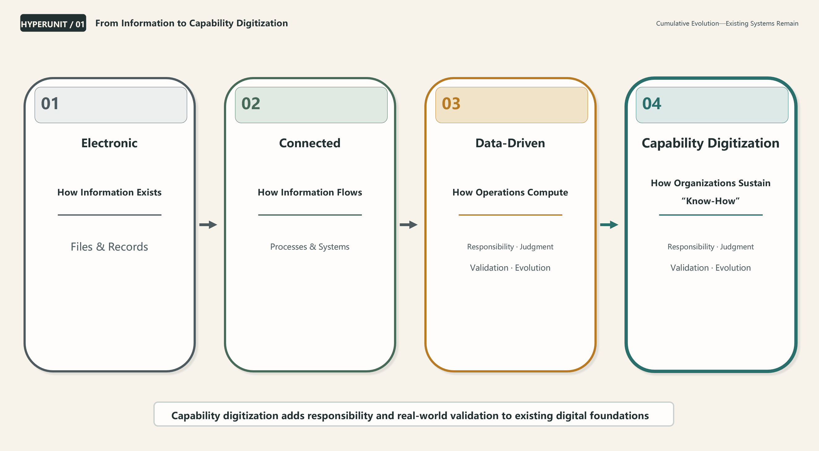
Figure 1 From Information Digitization to Capability Digitization

1.5 Failure Case: Complete Records, Yet the Organization Still Forgets
Consider a long-established enterprise with complete project files, approval records, operating reports, and a data warehouse. A major risk occurred three years ago, and the team invested substantial effort in analysis and remediation. Three years later, the responsible personnel have changed and a similar risk appears in another region. The new team can find the old report, but cannot determine which numbers were facts and which were assumptions; why Option B was selected over Option A; who proposed a particular exception; or whether the later reduction in risk resulted from the original plan or from an external change in conditions.
The team can only interview, analyze, and experiment again. The earlier experience exists inside the enterprise but never became enterprise capability. The organization pays not just the cost of one mistake, but the cost of learning the same lesson repeatedly. This is the starting point for capability digitization: a real experience should leave behind not only a file, but a judgment structure that can be understood, validated, and invoked in the future.
Scope note This chapter does not define HyperUnit technically; discuss the Manifest, Runtime, signatures, or Capability Contract; or equate capability digitization with automating all work.
Transition / If the problem is not that information was never saved, but that capability had no carrier, what should the fundamental digital unit that carries capability look like?
CHAPTER 02
Chapter 2 HyperUnit—The Fundamental Responsibility Unit of a Digital Organization
Core question of this chapter
If capability rather than information is to be preserved, what should the fundamental unit look like?
Position of this chapter
Only when a digital object has stable identity, explicit responsibility, replaceable capability, and a complete lifecycle can organizational capability be transferred, compared, and validated.

Perhaps the problem is not that we have been optimizing the wrong tools, but that we have been optimizing the wrong objects. Files, processes, databases, models, and Agents are all important, yet organizations still lack a fundamental digital unit that directly carries responsibility and capability.

2.1 An Object That Carries Capability Must Be Identifiable
An object that cannot be identified consistently cannot accumulate a continuous history. Conventional files are often identified by filename, path, date, or Hash, but all of these can change: files are renamed, moved, copied, and re-exported; content updates change the Hash; and identical content may carry different responsibilities. HyperUnit therefore uses a stable and unique unit_id as its identity anchor. Identity is not a filename, storage path, version number, or Hash; these are manifestations and states at a particular point in time. Replicas, Mirrors, or Archives created through copying may share the same logical unit_id, but v0.1 permits only one Authoritative Writable Instance at a time. Conflicts in write authority or Hash must enter a Conflict state and must not be merged silently.
Stable identity matters for more than technical addressing. It lets an organization connect years of Facts, Configurations, Claims, Evidence, Interventions, Branches, and Lifecycle events to the same responsible object. Without Identity, history is only a collection of similar files. With Identity, the organization can determine how a capability evolved, the environments in which it worked, when it was replaced, and whether the replacement improved results.

2.2 Responsibility Is the Core of a HyperUnit's Identity
A HyperUnit is not an arbitrary content container. It must continuously carry a describable, clearly bounded responsibility for an outcome. Responsibility does not answer “What is inside this file?” It answers “For which outcome is this digital unit accountable over time?” For example, “produce a weekly report” describes a task; “continuously provide a verifiable thirteen-week liquidity forecast and identify funding gaps” is closer to a responsibility. “Call a model” is an implementation method; “make a verifiable judgment about a specific risk state” is a responsibility.
The stability of Responsibility allows capability to change while identity remains continuous. As long as the responsibility does not change, a statistical model, machine-learning model, rules engine, LLM, external API, or human-machine combination can serve as a different Capability implementation. Once the responsibility changes materially—for example, from forecasting funding gaps to deciding fund transfers and executing payments—a new HyperUnit should be created instead of quietly expanding the authority of the existing object.
This boundary has governance significance. In real organizations, scope often expands through “doing one more thing while we are here,” eventually producing unclear accountability, excessive authority, and errors that are difficult to attribute. By anchoring identity in Responsibility, HyperUnit makes changes in accountability explicit so the organization can discuss whether a change is reasonable, who authorizes it, and what validation and security level it requires.
Core principle Different implementations of the same Responsibility are Branches; a change in Responsibility creates a new HyperUnit.

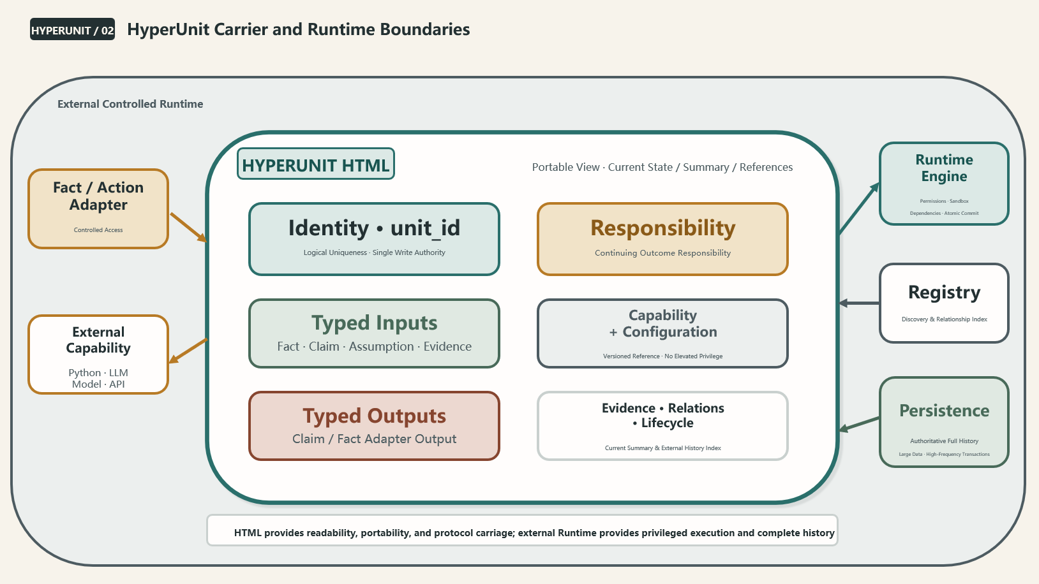
Figure 2 HyperUnit: The Digital Responsibility Unit and the Boundaries of Its HTML Carrier

2.3 Capability Can Evolve, but It Cannot Inherit Unvalidated Performance
The same responsibility may require different capabilities at different stages. It may begin with human rules, adopt statistical models once data accumulates, use machine learning as the business grows more complex, and later add an LLM to interpret unstructured information. HyperUnit does not hard-code capability into identity. It allows Capability to branch continually and to pass through Branch, Validation, Observation, Promotion, Replacement, and Retirement.
This evolution must avoid inherited prestige. Even if a new Branch descends from a historically high-performing parent, it cannot automatically inherit the parent's Validation record. Parameter tuning, a changed data source, a new model structure, an external API update, or a prompt change can all alter behavior. Every new Branch must prove itself again through independent validation. Lineage explains where it came from; it does not mean that it has already been validated.
Capability competition is not a winner-takes-all contest. A Branch may lead in one environment and fail in another; remain stable during an observation period and then be down-weighted after structural change. HyperUnit records how a capability performs under particular conditions rather than maintaining a permanent leaderboard. This enables the organization to use history without turning past success into a new form of authority.
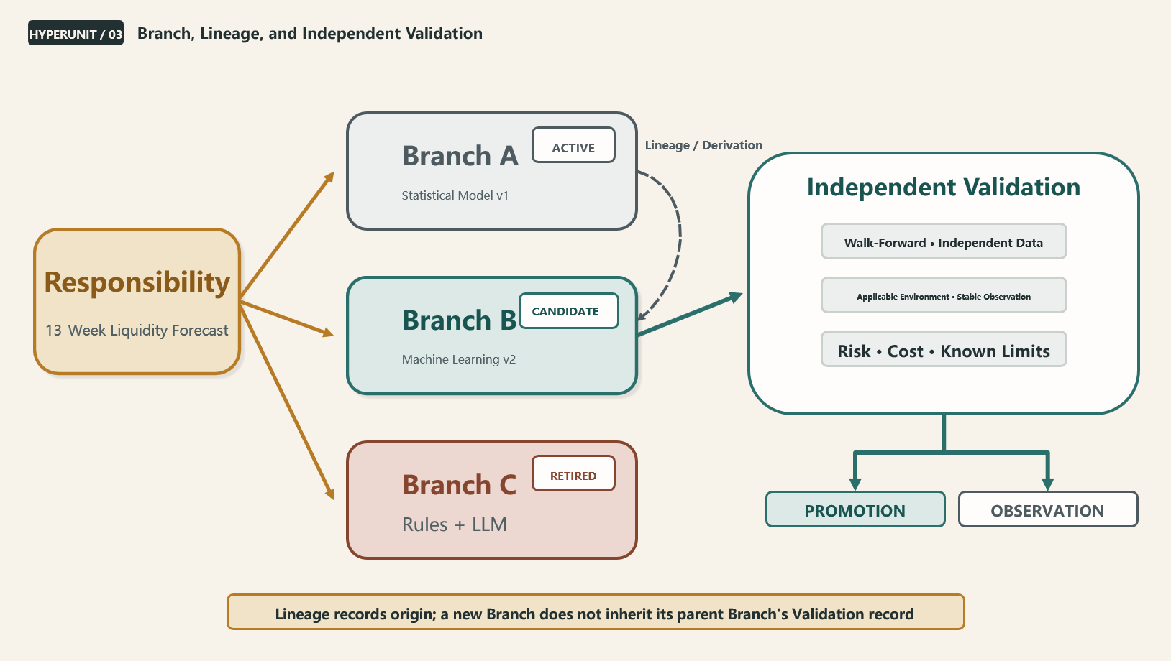
Figure 3 Branches, Lineage, and Capability Competition

2.4 The Minimum Structure of a HyperUnit
To serve both management and engineering, HyperUnit must remain conceptually simple while retaining a rigorous internal structure. The main text uses the following minimum structure: Identity defines who it is; Responsibility defines what it continuously carries; Inputs preserve the original epistemic types and provenance of Fact, Claim, Assumption, Evidence, and other inputs; Capability defines how it processes them; Configuration defines the intent of a particular run; Outputs are explicitly typed as well—forecasts and recommendations are Claims, while a fact adapter may output Facts; Evidence records how reality responds to historical judgments; and Relations and Lifecycle preserve dependencies, lineage, status, and evolution.
Identity
Responsibility
Typed Inputs
Capability
Configuration
Typed Outputs
Evidence
Relations
Lifecycle

A minimum structure does not mean that every HyperUnit must independently store all raw data and complete history. Large datasets should be referenced under the Reference over Copy principle; complete Evidence history may be stored by the Persistence Layer; and runtime state may be reconstructed. What matters is that identity, responsibility, epistemic types, dependencies, and validation relationships remain intact regardless of implementation changes.

2.5 Why HTML Is the Practical Carrier
HTML is the most easily questioned choice in the HyperUnit design because it is normally understood as a web presentation technology rather than an enterprise data carrier. HyperUnit chooses HTML not because it is the strongest data-storage format, but because it combines three uncommon properties: people can read it directly, machines can parse its structure, and browsers can provide an interactive interface. For a digital responsibility unit that must be understandable to business users, managed by a Runtime, and portable offline, this dual human-machine readability has foundational value.
Although HTML is not optimized for purely structured data, clearly defined structured sections can preserve machine-readable information while the same carrier provides text, charts, interaction, and a Portable View. Unlike a database, HTML can form a portable file with independent identity that remains readable outside a platform. Unlike a proprietary client, the browser ecosystem is open and mature, helping reduce the risk that organizational capability becomes locked into one product. The Manifest, Configuration, Claim summary, and visual interface can coexist in a single carrier, so the protocol object and the business-readable interface are no longer completely separate.
These advantages hold only if the boundaries are stated rigorously. HTML is not suitable for indefinitely storing high-frequency history or large binary data, nor for performing high-privilege execution; JavaScript also introduces security risks. HyperUnit therefore distinguishes Portable View from Managed Run. Portable View is a low-privilege, constrained reading mode in which active scripts, external connections, credentials, and local bridges should be disabled or strictly limited, and untrusted content should be opened in isolation. Managed Run must be performed by a Runtime Engine that verifies identity, signatures, permissions, and dependencies and executes in a sandbox. HTML may declare a Capability, but it cannot grant itself higher privileges. Formal state changes must pass through a Runtime-mediated Atomic Commit.
Question | Value of HTML | Boundary That Must Be Compensated For
Shared human-machine understanding | Content, structure, and interaction coexist in one portable carrier | Structured sections must be explicit and cannot rely on the visual page alone
Offline and portable | A browser can open Portable View directly | High-privilege actions must not execute when the file is opened normally
Protocol carrier | Can embed a Manifest, Configuration, signature zone, and relationship index | The complete specification still requires an independent Schema and Core Protocol
Long-term history | Can retain current effective state, recent summaries, and a history index | Complete history is externalized to the Persistence Layer
Security | Can carry signatures, Hashes, and permission declarations and display Restricted mode | Only the Runtime Sandbox can authorize and execute
Versions and differences | An open text format can work with version-control systems | Signed Zones, Revision, and structured sections are needed to improve Diff

Boundary that must be repeated HTML is the protocol-bearing unit, not a database, operating system, or high-privilege execution engine.

2.6 Running Example: Responsibility for a Thirteen-Week Liquidity Forecast
To show that HyperUnit is not an abstract container, consider a responsibility unit for a group-wide thirteen-week liquidity forecast. Its unit_id remains stable for years. Its Responsibility is to continuously provide verifiable cash-flow forecasts, identify funding gaps, and output Claims to decision units. Its Inputs must preserve their original epistemic types: bank balances, signed contracts, and approved funding arrangements already in force may be Facts; business forecasts are upstream Claims; and accounts-receivable and accounts-payable schedules should be typed separately as contractual facts, planning assumptions, or human judgments. A Capability then generates the forecast, while Configuration defines the forecast horizon, confidence interval, currency-conversion method, and anomaly handling. The output remains a Claim, not a future fact.
When the model is updated or the business structure changes, a new Capability Branch can be created for parallel observation. Independent Validation and an observation period determine which Branch enters formal use. Each week's actual cash flows later become Reality Facts and form Evidence in relation to the historical Claim. Human adjustments to the forecast, liquidity buffers, and changes in resource priorities are preserved as Interventions rather than overwriting the system output. The organization thereby accumulates not a succession of weekly reports, but a continuing capability for making liquidity judgments in specific environments.
Scope note This chapter does not specify all Manifest fields, mandate a language or database product for the Runtime Engine, or claim that HTML replaces JSON, databases, or existing business systems.
Transition / Once such responsibility units begin producing judgments, how can the organization ensure that facts, forecasts, opinions, and subsequently formed evidence do not become mixed together?
CHAPTER 03
Chapter 3 Facts, Judgments, and Evidence—The Boundaries of Trustworthy Knowledge
Core question of this chapter
How does the system distinguish fact, judgment, and evidence and avoid treating the subjective as objective?
Position of this chapter
A trustworthy system need not be correct every time, but facts, run intent, judgments, and real-world validation must always retain their distinct epistemic identities.

In an organization, a statement can gradually become accepted as fact simply by being repeated often enough, written into enough reports, or passed through enough layers. AI accelerates the creation and circulation of information, making this epistemic confusion even more dangerous.

3.1 Fact and Claim Must Remain Separate
A Fact answers: What has already happened in the world? It must include source, time, version, and Provenance, enabling the organization to assess completeness and trustworthiness. For Facts that require traceability, the time of the event (event_time), the time it was observed by the system (observed_at), and the time it was formally committed (committed_at) should be distinguished. A late-arriving Fact affects subsequent judgments through a Correction or new Evidence; it does not rewrite a historical Decision Snapshot. A bank balance displayed at a particular time, signed contract terms, completed orders, and published interest rates can all be Facts. They may still contain errors, but their epistemic type is an observation of reality.
A Claim answers: What do we think may happen, or what do we recommend doing? Forecasts, risk assessments, budget assumptions, model outputs, management opinions, LLM recommendations, and strategic options are all Claims. Fluency of expression, seniority of the speaker, and a model's historical accuracy cannot change that epistemic identity. A Claim can be highly valuable and can be adopted in a formal decision, but it cannot quietly become a Fact as it travels through the organization.
This distinction is not semantic fastidiousness; it is a foundation of decision quality. Only when an organization knows which information can be directly verified against reality and which still requires waiting can it allocate appropriate buffers for uncertainty and clarify accountability. Treating a Claim as a Fact can hide risk signals as they move through reporting chains. Treating a Fact as a Claim can leave an already observed reality open to endless debate.
Claim Preservation Rule Model forecasts, management opinions, and LLM recommendations remain Claims no matter how confidently they are expressed.

3.2 Configuration and Runtime State Must Not Be Confused
Configuration expresses run intent: which forecast horizon to use, which threshold to apply, how to prioritize data sources, which anomalies require human confirmation, and what risk appetite to adopt. It must be versioned because different Configurations change the behavior of the same Capability and affect how results are interpreted. Without a Configuration Version, an organization cannot reproduce why a conclusion was reached at the time.
Runtime State describes only where the system currently is in its operation—for example, whether a task is queued, a dependency is waiting, a cache was hit, or when the last check occurred. It may be discarded and reconstructed and must not be mistaken for a basis of decision. Mixing runtime state with run intent allows temporary conditions to change business meaning silently and eliminates the boundaries needed for audit and reproducibility.
Epistemic Type | Question Answered | Key Requirement
Fact | What has already happened in the world? | Source, time, version, and Provenance; correction is allowed, but silent overwriting is not
Configuration | How is this run intended to operate? | Expresses intent, must be versioned, and must be included in dependencies
Runtime State | Where is the current run in its execution? | Reconstructable and not a source of business truth
Claim | What do we think may happen, or what should be done? | Bound to the Facts, Configuration, and Capability Version actually used
Evidence | How did later reality respond to the judgment made at the time? | Connects a Claim to a later Fact and is Append-only in principle

3.3 A Claim Does Not Automatically Upgrade as It Travels
In conventional organizations, epistemic type is often lost through layers of retelling. A model output initially labeled “forecast” becomes “expected revenue” in a summary, then a “revenue plan” in the budget, and is later cited as “known cash flow” in a risk report. Each transformation may have a valid business purpose, but without preservation of the original type and dependencies, the final reader cannot know which numbers have already occurred and which still depend on assumptions.
HyperUnit requires a Claim to remain a Claim while it is transmitted, cited, and combined. A downstream unit may produce a new Claim from it or adopt it in a formal Decision Snapshot, but the number of citations, the level of the organization, and the persuasiveness of the language cannot upgrade it to a Fact. Every cross-HyperUnit information flow must leave a traceable record, allowing downstream units to see the source, version, time, confidence, and dependency state.
The same rule applies to generative AI. An LLM can summarize, explain, and reorganize large volumes of information, but reorganization does not change the factual status of the inputs. An answer synthesized from multiple Claims remains a Claim. A natural-language conclusion that sounds certain must retain its labels if it depends on forecasts, assumptions, or missing data.

3.4 Evidence Is Reality's Response to a Judgment
When a judgment is created, the system can record only what it was based on and how it was formed; it cannot possess validation results in advance. Evidence can be formed only after a later Reality Fact appears: the error between a forecast and the actual result; whether an assessed risk materialized; the relationship between an intervention and a change in execution outcome; or whether a capability remained stable in a particular environment. Evidence is not another kind of Fact. It is the validation relationship between a Claim and a Fact that appeared later.
Validation does not turn the original Claim into a Fact. Even if a forecast is perfectly accurate, it remains the forecast that was made at the time; its accuracy becomes Evidence. Even if a recommendation proves effective in reality, it remains the recommendation made at the time; its effectiveness becomes Evidence. Preserving this historical identity prevents retrospective rewriting: success must not erase the uncertainty that existed, and failure must not be used to pretend the system never made the recommendation.
Evidence is Append-only in principle. When an error is found, the system adds a Correction rather than silently overwriting history. This is not an attempt to create a rigid and unchangeable archive; it protects sequence in time: who knew what and when, when an error was later discovered, and what supported the correction. Learning can be trustworthy only if the temporal sequence is trustworthy.
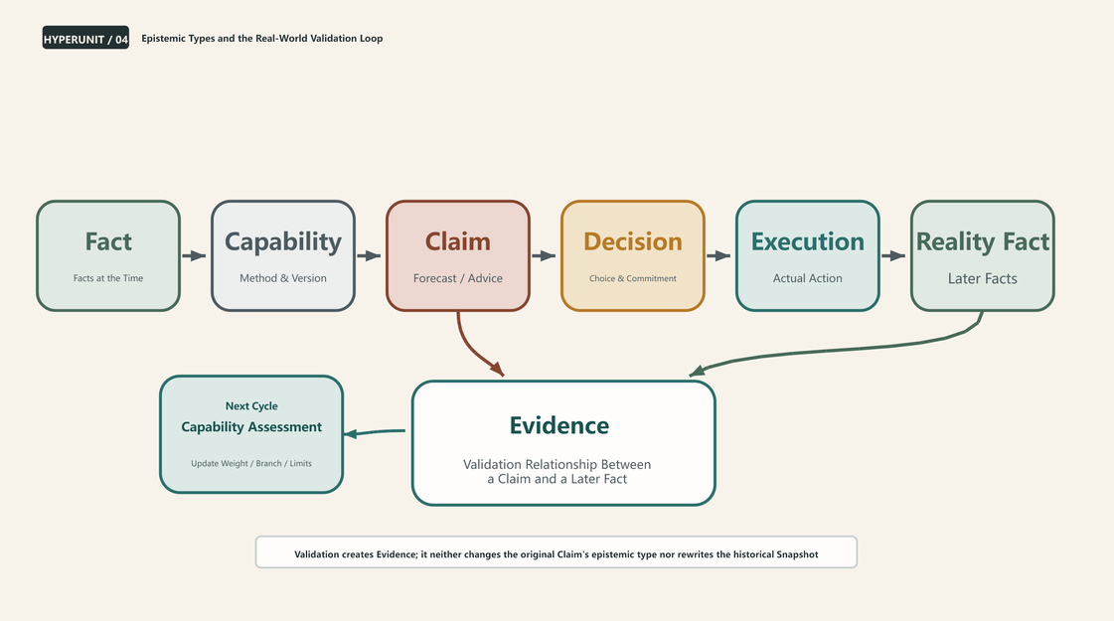
Figure 4 Epistemic Types and the Real-World Validation Loop

3.5 Decision and Execution Must Remain Separate
A Decision is the choice and commitment an organization makes on the basis of particular facts and judgments. Execution is the action that actually occurs in the real world. The two often differ: a decision may not be executed promptly; execution may deviate because of permissions, resources, markets, or human intervention; and someone may even act without a formal decision. If the system preserves only the final result, it cannot determine whether the problem came from an incorrect judgment, a delayed decision, or a deviation in execution.
A formal decision must create an immutable Decision Snapshot and freeze the minimum complete dependency closure for that decision: the Facts, Configurations, Capability Versions, Claims, and approval information used at the time. Execution is connected to the Decision through a separate record. This allows a retrospective review to distinguish whether the choice was reasonable at the time from whether reality followed the choice, while preserving a basis for Counterfactual analysis.

3.6 Failure Case: A Forecast Becomes a Fact Through Repetition
Consider a cash-flow model that forecasts receipts over the next thirteen weeks from an order plan. The model output is correctly labeled as a forecast in the first report. To set targets, the business team copies it into a planning sheet; the finance team then aggregates it into budgeted cash flow; and management treats the budget figure as funds that will certainly be available and approves new spending. Orders are later delayed, exposing a funding gap.
The problem is not merely model error. The systemic failure is that the Claim label was lost in transmission, leaving every dependent layer unable to see the original assumptions or Stale state. HyperUnit does not prevent an organization from making decisions based on forecasts. It ensures that the decision knows it depends on a forecast and, after an upstream change propagates Stale, requires validation against the latest dependencies and any necessary recomputation when the output is requested.
Scope note This chapter does not define the complete structure of organizational memory, specify thresholds for Capability Promotion, or interpret Evidence as retrospective proof that one party is permanently correct.
Transition / If an organization can preserve the relationship between judgments and reality over time, how can these distributed records truly turn individual experience into capability the organization can invoke?
CHAPTER 04
Chapter 4 From Individual Experience to Organizational Memory
Core question of this chapter
How can an organization prevent experience from disappearing as people move and turn individual experience into organizational capability?
Position of this chapter
Organizational memory is not material that has been stored; it is historical experience that can be recognized, compared, validated, and used in current judgment under a new context.

The longer an enterprise operates, the more it should theoretically understand its market, its customers, and itself—and the less often it should pay for the same mistake. In reality, many enterprises grow older without accumulating capability at the same pace. Having experienced something does not mean having learned it; preserving material does not mean preserving capability.

4.1 Enterprises Preserve Outcomes, but Not the Relationships Behind Judgment
The most common misconception about organizational memory is equating information retention with the accumulation of experience. Meeting minutes preserve conclusions, approval workflows preserve who agreed, reports preserve numbers, emails preserve discussion, and system logs preserve actions. But these records are usually scattered across different media and lack a common Identity and Responsibility. People who arrive later struggle to reconstruct the relationships among Fact, Claim, Decision, Execution, and Outcome.
The most valuable questions often cross multiple systems. Which facts were visible at the time? Which data was considered unreliable? What did the model recommend? Who proposed an exception? Did the exception arise from new facts, a strategic trade-off, avoidance of responsibility, or a communication difference? Which path was ultimately executed? Did the outcome result from the original plan, human intervention, or an external change? Unless these relationships are preserved together, the organization can see only what ultimately happened, not what it should learn.

4.2 Organizational Memory Must Participate in the Present
An archive belongs to history once it is stored. An experience truly belongs to organizational memory only if it can be recognized and invoked when a similar environment appears again. At minimum, it must answer four questions: How similar is the current situation to the past? Which conditions did the earlier method depend on? What Evidence supported it at the time? Which environmental changes may have invalidated it?
Organizational memory is therefore not a list of “best practices,” but a capability network with conditions of applicability and a validation history. Past success cannot directly become today's instruction, and past failure should not permanently prohibit another attempt. The system must compare current Facts with historical environments and surface relevant Decision Episodes, Evidence, and Capability Branches, while preserving “not applicable,” “insufficient evidence,” and “environment changed” as valid states.
This also changes the role of RAG and knowledge bases. Retrieving a relevant document is only the first step. HyperUnit Network is more concerned with whether the content is a Fact or Claim, which responsibility unit produced it, which Configuration applied at the time, whether Evidence emerged later, and whether the current dependencies remain valid. The organization does not simply need more context; it needs context with stronger epistemic structure.

4.3 How Individual Experience Becomes Organizational Capability
Individual experience cannot be directly “extracted” as organizational truth. Experience first occurs in a specific context and includes unexpressed observations, temporary trade-offs, and non-replicable factors. HyperUnit uses a gradual conversion chain: individual judgment enters a Decision Episode; real-world outcomes form Reality; Evidence is established between the Claim and Reality; repeatable patterns emerge across multiple Episodes; a pattern is extracted as a Candidate Capability; the candidate is subjected to Validation using independent data, time windows, or parallel runs; and only after its applicability boundaries, stability, and governance requirements are satisfied does it become a reusable Organizational Capability.
This chain distinguishes “one person once succeeded” from “the organization now possesses a reusable capability.” The former deserves to be recorded and studied; the latter requires independent validation. It also prevents personal style from being mistaken for a universal rule. A leader may have completed a task using relationships, authority, or unique resources. If those conditions cannot be observed and reused, the experience should not be packaged as a general Capability.
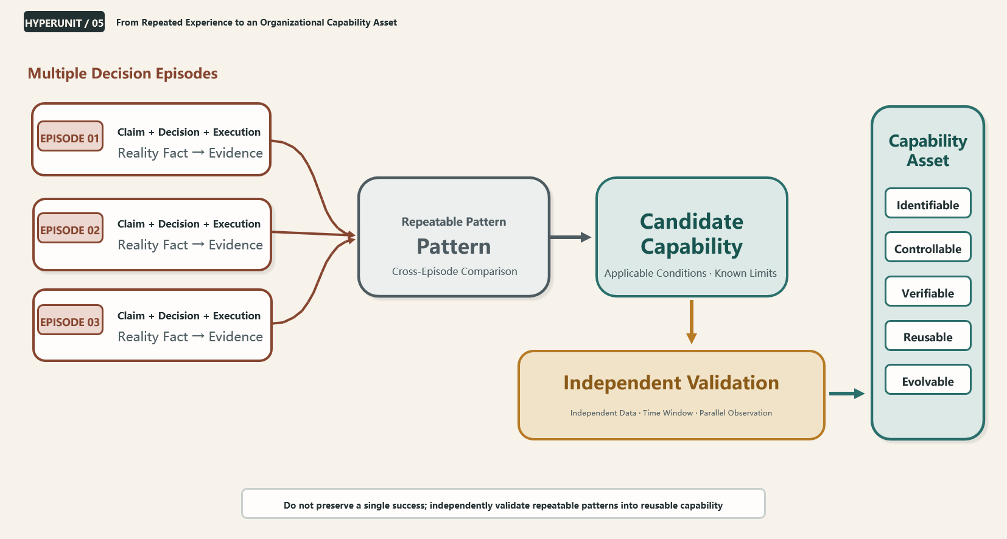
Figure 5 From Individual Experience to an Organizational Capability Asset

4.4 From Capability to Enterprise Digital Asset
A capability can be considered a Capability Asset in the enterprise sense only after reaching a certain level of maturity. Identifiable means it has a stable Identity and clear Responsibility. Controllable means the organization has mechanisms for permission, versioning, and replacement. Verifiable means its output can be tested against real-world facts. Reusable means it can be invoked across multiple situations or cycles. Evolvable means new Branches can compete, old Evidence can be down-weighted, and historical Lineage is not lost.
This “asset” is first a business and organizational concept; it is not equivalent to an intangible asset that can be recognized directly under accounting standards. Its value may come from cost substitution, risk reduction, reuse at scale, the speed of organizational learning, and future optionality, but recognition in financial statements requires separate accounting criteria. HyperUnit Network argues here that enterprises should begin identifying and governing reality-validated digital capabilities just as they manage data assets, software assets, and workforce capabilities.
Maturity Condition | Core Question | Typical Evidence
Identifiable | What is this capability, and which responsibility does it carry? | unit_id, Responsibility, Owner, Lifecycle
Controllable | Who can invoke, modify, replace, and retire it? | Permission, Approval, Signature, Atomic Commit
Verifiable | Can its output be tested against later reality? | Claim, Reality Fact, Evidence, Validation
Reusable | Can it be invoked reliably across cycles or similar contexts? | Dependency Contract, applicable environment, and invocation history
Evolvable | Can new methods compete, and can old methods be down-weighted? | Branch, Lineage, Observation, Promotion, Retirement

4.5 Why Employees Would Contribute Capability
No mechanism for accumulating capability can assume that employees will cooperate automatically. For many people, putting experience into a system may appear to let the organization replicate what makes them indispensable. Recording the complete judgment process may be perceived as increasing exposure to blame. Sharing facts across departments may affect established power and interests. If these realities are ignored, even the most elegant protocol will be reduced to formalities, circumvented, or gamed through metrics during implementation.
HyperUnit Network does not treat human factors as defects to be eliminated. It treats avoidance of responsibility, pursuit of self-interest, conflicts of interest, differences in expression, and metric manipulation as first-class design variables. The mechanism must reduce the practical cost of honest recording and experience sharing: give capability contributors recognition and new governance roles; except for major safety, fraud, and compliance red lines, use errors first for learning and correction rather than automatic punishment; permit “unknown,” “insufficient evidence,” and Attribution = Indeterminate; avoid binding historical failure permanently to a person's identity; distinguish high-risk traceability from low-risk daily records; and let employees see how capability accumulation reduces repetitive work and improves decision quality, rather than showing them only how their roles could be replicated.
Organization-wide implementation still requires management authorization. Management must define capability ownership, boundaries of use, incentives for contribution, treatment of errors, and the evolution of roles. Frontline teams can propose innovations, but if the institutional narrative remains “replicate employee capability and reduce headcount,” employees will rationally hide experience, retain tacit steps, or submit only formalized material. The implementation principle should be: establish institutions and psychological safety from the top down, and contribute experience and innovation from the bottom up.
Traceability is not intended to make people afraid of mistakes. It enables the organization to distinguish facts, judgments, interventions, and outcomes, reducing the repeated cost of the same types of errors.

4.6 Failure Case: An Employee Leaves Many Files, but No Capability
During a handover, a critical role leaves behind hundreds of files, a complete folder structure, and detailed work checklists. The successor can find templates but does not know which fields are the truly critical risk signals; can run scripts but does not know where to stop when the data is abnormal; and can see historical options but not why another choice was rejected. More files make it harder, not easier, to establish priorities.
If the work were organized as HyperUnits, the successor would first see not a file directory but a responsibility map: the Identity, Owner, Inputs, Capability, Current Claim, Evidence, Known Limitations, Dependencies, and Lifecycle of every responsibility unit. The historical materials would still exist, but they would be restored to their place in the judgment relationships. Handover would no longer mean copying information; it would mean transferring capability that can continue to run, be validated, and evolve.
Scope note This chapter does not design employee performance scoring, equate organizational memory with a document-database product, advocate automated personality assessment, or digitize employees as whole persons.
Transition / If organizational memory can be invoked, will experience that worked in the past gradually become a new authority? How can a system that learns avoid treating the past as an eternal answer?
CHAPTER 05
Chapter 5 People, Systems, and Continuous Correction
Core question of this chapter
How can a system learn without becoming overconfident and always preserve space for human judgment?
Position of this chapter
The system learns conditions of applicability, not permanent answers. Human intervention is not noise outside the system, but a real component that must be preserved, validated, and corrected.

The greatest organizational risk is not only forgetting the past; it is also trusting the past too much. A method that repeatedly succeeded before may no longer apply today.

5.1 The System Learns Conditions of Applicability, Not Permanent Answers
The applicability of experience depends on its environment, not on a conclusion detached from that environment. A forecasting model that performs exceptionally during stable operations may fail quickly after structural change. An approval rule that works in a small organization may create bottlenecks in global operations. An expert's past accuracy may have depended on the relationships and information available at the time. HyperUnit therefore records not only what worked, but under which environment it worked, which facts it depended on, what limitations applied, and whether it remained applicable after conditions changed.
Conditions of applicability cannot be fully defined in one pass. The system can gradually identify environmental features from Facts, Configuration, Dependency Snapshots, and Evidence, while people can declare Known Limitations. What matters is that historical win rates do not become permanent authority. Confidence in a capability should depend jointly on the similarity of the current environment, recent Evidence, data quality, and structural change.

5.2 Forgetting Means Managing Influence, Not Deleting History
A system that learns must also know how to forget. Here, forgetting does not mean deleting history; it means changing how strongly history influences current judgment. Old Evidence may be down-weighted, retired from active use, archived, removed from default paths, and reactivated when a similar environment returns. A formerly successful Capability may move from Active to Observation or Retired while its Lineage, Claims, and Evidence remain.
This design protects both organizational memory and adaptation to reality. Allowing all history to retain permanent influence drags the system backward into old environments; silently deleting history destroys auditability, retrospective learning, and rediscovery. HyperUnit Network adopts the principle that history must not be silently erased, but its influence may change. A Behavioral Forget Gate can use time, environmental change, new Evidence, and governance requirements to decide whether a part of history enters default retrieval and decision paths.
The same applies to records about people. One mistaken intervention must not become a permanent label on a person, and one success must not grant permanent exemption. The system should use rolling time windows and contextual labels, and support the rebuilding of trust through new Evidence. Otherwise, the rational strategy for a person is always to obey the system and avoid any visible judgment, depriving the organization of the exception detection and innovation that matter most.

5.3 Human Intervention Is Part of a Decision Episode
Real decisions rarely follow system recommendations exactly. People accept, challenge, suspend, modify, Override, and reallocate resources. Communication, interests, accountability, and organizational power may also alter the path. Treating these actions as noise “outside the system” only separates the formal record from the real world.
HyperUnit includes human intervention in the Decision Episode. The system first preserves the Decision Baseline—the original recommendation formed under the Facts, Configuration, and Capability available at the time. Every intervention records the Intervention Type, Declared Rationale, proposer, time, new facts relied upon, and scope of impact. The final Decision is frozen separately; Execution records the actual path; the subsequent result is recorded as Outcome; relevant real-world observations are preserved as Reality Facts; and Evidence is formed from them.
A human Override must not overwrite the Baseline. The Declared Rationale remains a Claim even when it comes from the highest level of management, and it must be distinguished from fact sources and subsequent reality. This protects human decision space while preventing the organization from rewriting history after success or shifting blame after failure.

5.4 Intervention DAG: Preserve Complex Paths Instead of Forcing a Single Responsible Person
A complex decision may involve simultaneous interventions at multiple nodes: the business asks to preserve growth investment, treasury asks for a larger liquidity buffer, compliance restricts a particular path, and management reallocates resources between strategy and short-term cost. Interventions may occur in parallel, in sequence, or offset one another, making it difficult to attribute the final outcome to a single person or action.
A Decision Episode therefore uses an Intervention DAG to preserve the actual path instead of recording only the final approver. Under explicit assumptions, methods, and uncertainty, the system may compare the Actual Path with a Counterfactual Path. Reality can directly validate only the Actual Path; an unexecuted path can produce only a Counterfactual Claim through Replay, simulation, or controlled estimation, and must not masquerade as a Reality Fact. If the effect of an individual intervention on the Outcome cannot be distinguished reliably, Attribution = Indeterminate is allowed. Admitting what is unknown is more trustworthy than assigning false causality and reduces incentives to manipulate records for self-protection.
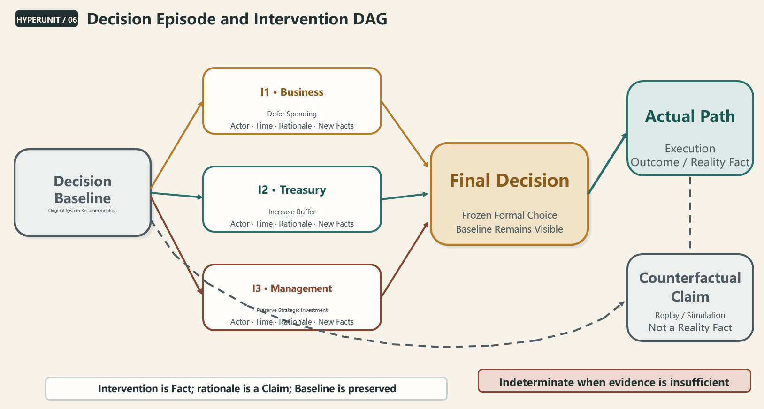
Figure 6 Decision Episode and Intervention DAG

5.5 Inaction Must Not Become the Safest Strategy
If the system counts only the number of Overrides, or every unsuccessful challenge permanently lowers an individual's score, the safest behavior is inaction: obey the system, raise no objections, and assume no new judgment. In the short term, the organization may appear standardized. Over time, it loses anomaly detection, cross-disciplinary transfer, and sensitivity to structural change.
Judgment Calibration asks not whether a person always agrees with the system, but whether the person knows when to trust it, when to challenge it, whether a basis can be stated when challenging it, and whether the person later accepts validation by reality. High-quality judgment may mean accepting a mature system most of the time while raising an Override based on a new Fact at a few critical moments. It may also mean admitting that the available evidence is insufficient and declining to force an answer.
Governance must therefore not turn traceability into punitive surveillance. Light, Standard, and Full Profiles can be assigned according to risk. Low-risk contexts can reduce the friction of recordkeeping, while high-risk contexts can require stronger signatures, approvals, and dependency snapshots. The goal is to bring real behavior into the system, not drive it outside.

5.6 Neither People nor AI Has Inherent Epistemic Privilege
People make mistakes because of interests, emotions, entrenched experience, power, and differences in expression. Models fail because of data bias, incorrect assumptions, concept drift, and out-of-boundary inputs. LLMs produce fluent inferences without provenance. Governance rules can be distorted by metric gaming or a lagging environment. HyperUnit does not decide in advance which party to trust; it imposes the same discipline on provenance, type, dependencies, and validation.
Expert opinion remains a Claim, model output remains a Claim, and AI interpretation remains a Claim. They may carry different confidence levels, permissions, and applicable contexts, but all must await validation by Reality. A Signature proves identity and integrity, not that a conclusion is correct. Validation results describe historical performance, not the future. Majority voting demonstrates consistency, not fact.
This epistemic equality does not weaken human responsibility or deny professional authority. It shifts the basis for trusting a judgment from “who I am” to “what my judgment is based on, the conditions under which it works, and how reality later responded.” Epistemic evaluation can become more symmetrical, while authorization, legal responsibility, and organizational governance authority remain asymmetric and must still be carried explicitly by the human governance structure. Over time, genuinely reliable authority comes from continuously calibrated Evidence.
Shared human-machine principle Preserve provenance, record disagreement, and await validation by Reality.

5.7 Human Factors Are Design Inputs, Not Vulnerabilities
Organizational systems often begin with an idealized model of people: accountable individuals will report truthfully, departments will share proactively, metrics will not be gamed, approvers will read carefully, and model users will understand boundaries. Reality is different. People pursue advantage and avoid harm, choose paths that minimize personal responsibility, gain asymmetric resources through stronger expression, and optimize the metric rather than the objective once the metric becomes a performance target.
HyperUnit Network does not try to eliminate these behaviors through more rules. It designs mechanisms that are traceable, low-friction, incremental, and verifiable so that individual rationality can converge as much as possible with long-term organizational goals. Preserving the Baseline reduces retrospective blame shifting. Allowing Attribution = Indeterminate reduces forced attribution. Append-only Correction allows errors to be acknowledged without erasing history. Different governance Profiles control recording costs. A Decision Snapshot prevents goals from changing silently during execution. Down-weighting rather than deleting Evidence prevents permanent stigma.
Mechanisms can never eliminate strategic behavior completely, but they can make it more visible, make costs more symmetric, and make correction easier. A trustworthy organizational system is not one without human disturbance; it is one that can continue correcting itself through real-world feedback while disturbance exists.
Scope note This chapter does not establish personnel rankings or an automated punishment system, provide a complete behavioral-scoring formula, or turn historical Evidence into permanent assessments of a person.
Transition / If the system must preserve history yet allow forgetting, support automated operation yet allow human intervention, and provide complete traceability without crushing the organization under complexity, how can it be implemented in practice?
CHAPTER 06
Chapter 6 From Principles to Operation—An Incremental Implementation Architecture
Core question of this chapter
Without sacrificing rigor, how can HyperUnit begin with one responsibility, one task, and one existing system, then become operational incrementally?
Position of this chapter
The core principles cannot be compromised from day one, but governance intensity, degree of automation, and network scale can increase in stages: start small, but do not start wrong.

New systems often fall into one of two extremes: omitting responsibility, versioning, and validation in the interest of rapid launch, only to add another layer of automation; or attempting to build a complete enterprise platform at once in the interest of theoretical completeness, and never getting started. HyperUnit takes a third path.

6.1 Start with Work Whose Responsibility Is Relatively Mature
The cold-start target for HyperUnit should not be “the most impressive AI use case.” It should be work whose responsibility boundaries are relatively clear, whose results can be validated, whose repetition is frequent enough, and whose cost of error can be assessed. A suitable initial target has a relatively stable objective, Trigger, Inputs, Outputs, Owner, and Validation method. It does not require a perfect SOP or complete agreement on every data definition, but it must make clear what the unit is continuously responsible for.
Responsibility maturity matters more than technical maturity. A data-rich process with unclear accountability is likely to automate existing disputes; a technically simple task with clear accountability is better suited to the minimum closed loop. Possible use cases include periodic liquidity forecasting, reconciliation anomaly detection, inventory-replenishment recommendations, customer-risk review, and compliance-document completeness checks. The industry is not the key criterion; the question is whether a subsequent Reality Fact can validate the output.
Before launch, a minimum responsibility description should be completed: Who is the Owner? What event triggers the unit? Which typed Inputs does it read? Which Claim or Action Request does it produce? Who may Override it? Which kind of later Reality Fact validates it? What are the cost of error and the security level? This description alone exposes many accountability gaps that have long remained hidden in conventional processes.
Do not begin with “What should AI do?” Begin with “Which continuing responsibility deserves a digital carrier?”

6.2 Connect Existing Systems to the Responsibility Loop Instead of Replacing Them
ERP, CRM, TMS, Excel, databases, Python scripts, and external platforms continue doing what they do well. HyperUnit Network reads facts through Fact Adapters, requests or performs actions through Action Adapters, and invokes models, LLMs, APIs, and external programs through the Capability Contract. Existing systems do not need to migrate to a new platform first, and data should not be copied without limit into HTML merely to make it “HyperUnit-based.”
Reference over Copy is the default principle. A HyperUnit preserves the references, versions, Hashes, times, and Dependency Snapshot actually used in a run, while large raw datasets remain in authoritative systems. This avoids both file bloat and the creation of a new data silo. Only the minimum complete dependency closure required for a Decision Snapshot needs to be frozen, ensuring that the judgment made at the time can later be reproduced.
Existing systems
→ Fact / Action Adapter
→ HyperUnit
→ Claim / Decision / Evidence

6.3 The First Release Should Complete Only the Minimum Closed Loop
The goal of the first release is not to implement every protocol feature, but to prove that one real judgment can be preserved completely from creation through validation. The minimum loop is: a Fact enters; a Capability runs under a versioned Configuration; it outputs a Claim; a person or rule forms a Decision; Execution occurs; a Reality Fact later appears; and the system forms Evidence.
Once this chain is complete, the organization already has something different from conventional automation: it knows what the output was based on, how people changed the path, how reality responded, and how historical Evidence can be invoked in the next run. A Registry, complex Event Bus, enterprise-grade high availability, Capability Marketplace, and cross-enterprise network can all wait.
The companion example released with this white paper, “Pre-Publication Validation of Weekly Bank Account Balances,” applies this minimum loop to a treasury-management context with clear responsibility boundaries, repetition, and verifiable outcomes. The account register and weekly balance sheet serve as sourced Inputs; the validation capability outputs a Claim; Role B makes the publication Decision; discrepancy confirmation and human exceptions are preserved as Interventions; and subsequent platform acceptance and error feedback become Reality Facts and Evidence. The HTML is published as a Portable View and does not gain higher privileges or direct write access to enterprise systems merely because it is opened locally.Companion HTML example
Fact
→ Capability
→ Claim
→ Decision
→ Execution
→ Reality
→ Evidence

6.4 Dependencies, Stale State, and Pre-Invocation Validation
When multiple HyperUnits form a network, propagation of upstream change becomes a central problem. Forcing every change to trigger immediate network-wide recomputation wastes enormous resources and can produce cascading instability; relying entirely on downstream units to pull updates can leave old conclusions in place indefinitely. HyperUnit combines Event Push with Dependency Pull.
When the version or state of any actual dependency—including a Fact, Configuration, Capability Version, or upstream Output/Claim—changes, the system propagates Stale first to indicate that a related output may be outdated rather than forcing immediate recomputation. When an Output is formally requested, enters a Decision, or reaches a policy threshold, downstream units must validate against the latest available dependencies and recompute as necessary. Event Push makes update notification efficient; Dependency Pull supports dependency-freshness checks and necessary recomputation when an output is requested.
Every Output stores the Dependency Snapshot actually used in its computation. Even if upstream dependencies change later, the organization still knows what the historical output was based on. At the same time, a current output cannot continue to be used merely because it was computed once. Computation Dependency Graph v1 must remain a directed acyclic graph (DAG) so circular dependencies cannot make recomputation non-terminating; a Semantic/Relation Graph may contain cycles. References across tasks and projects are permitted, but the overall constraint remains unchanged.

6.5 Governance Intensity Can Vary, but Epistemic Integrity Cannot
Different contexts do not need equally heavy governance. If exploratory analysis requires comprehensive signatures, approvals, and Hash Chains from day one, users will work around the system. If high-risk treasury, compliance, and execution contexts preserve only a result, they cannot meet accountability and audit requirements. HyperUnit therefore defines three governance Profiles: Light, Standard, and Full.
Profile | Applicable Context | Core Requirement
Light | Exploration, low risk, and prototypes | Identity, Responsibility, epistemic types, and basic provenance
Standard | Continuous production of judgments | Configuration Version, Dependency, Decision Baseline, Override, Evidence
Full | Treasury, compliance, and high risk | Signature, Sandbox, Approval, complete Snapshot, Hash Chain, and long-term audit

A Profile may determine recording granularity, approval intensity, signature requirements, and history-retention policy. It cannot permit Fact and Claim to be confused, Responsibility to change implicitly, or a formal decision to overwrite historical dependencies. Governance intensity can be tiered; epistemic integrity cannot.

6.6 Expand Automation Incrementally
Joining HyperUnit Network and deciding how far to automate are separate decisions. A responsibility may begin as Observable, where the system only observes and preserves facts; then become Structured, where inputs, outputs, and epistemic types are structured; then Assisted, where a Capability advises but a person decides; then Managed, where a Runtime orchestrates dependencies and actions within explicit boundaries; and only eventually Autonomous within Boundaries, where it runs automatically within authorization, risk thresholds, and rollback mechanisms.
This path lets an organization gain visibility and learning before gradually increasing execution authority. For many use cases, full automation may never be the long-term optimum. Tasks with high uncertainty, significant value conflicts, or limited verifiability may remain human-machine collaborations indefinitely. HyperUnit seeks clear responsibility and validation by reality, not a high percentage of automation as an end in itself.

6.7 Runtime Encapsulates Engineering Complexity
HyperUnit HTML serves people and the protocol; the Runtime Engine serves execution and governance. The Runtime discovers dependency changes, checks Stale state, schedules Capability, verifies Permissions and Signatures, runs Capability in a Sandbox, creates a Decision Snapshot, performs an Atomic Commit, and writes complete history to Persistence. Organizational memory logically belongs to the Network. Persistence is the physical storage layer, the RAG/Memory Access Layer is the access layer, and the Registry is the discovery and relationship index; none is the Source of Truth for Identity, content, or organizational memory.
A Runtime may organize multiple HyperUnits by task and coordinate multiple tasks at the project level. Task-level and project-level Runtime here refer to a logical Runtime Scope whose orchestration responsibility may be carried by an Orchestration HyperUnit; one physical Runtime Engine may host multiple Scopes. Management responsibility can be layered while operational dependencies remain expressed through a Graph. Cross-task resource allocations, dependencies, and constraints are connected through explicit references rather than by placing every capability in one giant unit. As scale grows, the network preserves responsibility granularity while the runtime layer absorbs orchestration complexity.
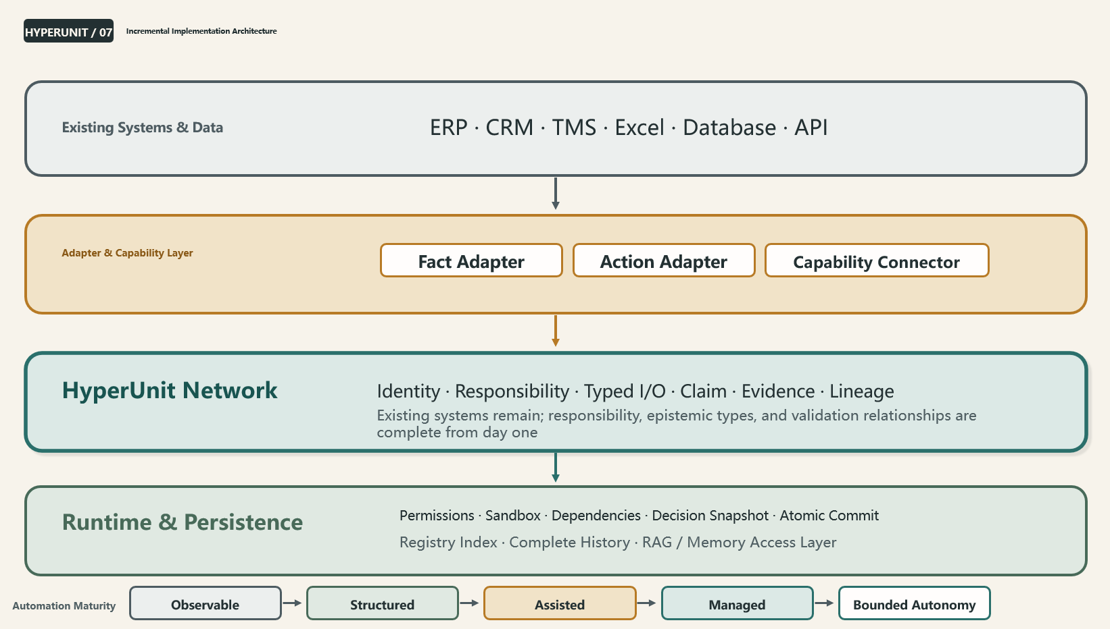
Figure 7 Incremental Implementation Architecture

6.8 Permission, Signature, and Atomic Commit
Permission is denied by default and granted explicitly. A HyperUnit may declare the facts it needs to read, the Capabilities it needs to invoke, and the actions it needs to request, but only the Runtime can grant permission according to role, environment, risk, and validity period. HTML in Portable View does not gain execution capability merely by being opened. When a signature is invalid, a structure has been modified manually, or dependencies cannot be verified, the unit should enter Restricted or Quarantine rather than continue production operation silently.
A Signature proves signer identity and content integrity; it does not prove that a conclusion is correct. A Claim with a valid signature but a wrong conclusion remains a wrong Claim. A formal protocol Revision must pass through a Runtime-mediated Atomic Commit so that dependency checks, approvals, and formal writes either all succeed or none takes effect. Events use reliable post-commit publication or an in-transaction Outbox; they may be duplicated or temporarily omitted, with idempotent handling and Dependency Pull providing safeguards. An Action with real-world side effects that cannot be made reliably idempotent must not be retried automatically.

6.9 Management Authorization and Aligned Incentives
HyperUnit innovation can originate on the front line, but organization-wide implementation must be driven by management. It affects data sharing, Responsibility, capability ownership, permissions, role evolution, incentives, and the treatment of errors—none of which can be decided by a technical team alone.
Management must establish a safe narrative: capability accumulation is intended to improve organizational learning and reduce repetitive work, not to preserve every mistake permanently as a basis for punishment. Contributors should receive attribution, governance authority, validation roles, or new paths for professional growth. Some roles can gradually shift toward exception handling, validation, boundary governance, innovation, and coordination across responsibilities rather than simply being understood as disappearing. Real experience enters the system only when individuals see that contributing capability does not conflict with their long-term value.
Implementation must also prevent articulate participants from receiving disproportionate resources. Resource conflicts should escalate to the nearest common superior Runtime Scope, first satisfying hard constraints such as safety, survival, and compliance, then comparing potential impact, probability, uncertainty, opportunity cost, discounted future returns, and Evidence, while allowing non-quantifiable value to be declared explicitly. A HyperUnit can preserve each party's Claims and dependencies, but cannot pretend that a formula can eliminate every value conflict. The governance structure remains accountable for the final Decision.

6.10 What v0.1 Deliberately Does Not Do
The first release does not seek enterprise-grade high-availability clusters, thousands of nodes, network-wide PKI, Multi-master operation, an automated Capability Marketplace, comprehensive behavioral scoring, cross-enterprise responsibility networks, or accounting recognition of capability assets. Implementing these features too early could obscure the most important questions: Does the protocol loop truly exist? Can the organization preserve the complete path of a judgment from creation through validation?
The success criteria for v0.1 should remain restrained. The management-visible minimum business acceptance summary in this white paper is: a responsibility unit has stable Identity and Responsibility; epistemic types do not become confused; dependencies are traceable and support on-demand validation; human intervention does not overwrite the Baseline; a formal Decision preserves a Snapshot; a Reality Fact can form Evidence; a new Branch is validated without inheriting past performance; manual modification or loss of trust can move a unit into Restricted/Quarantine; one logical unit has a single write authority; and existing systems need not be replaced. Complete engineering acceptance criteria will be defined separately in the Core Protocol Specification and Technical Companion.

6.11 Failure Case: A Misguided AI Transformation Driven by Headcount Reduction
An enterprise with inconsistent data definitions and unclear responsibility boundaries deploys an LLM directly, hoping to gain rapid returns by generating reports automatically and reducing roles. People on the original team who corrected data, identified anomalies, and reconciled differences across systems are treated as “manual steps” and removed. Report generation becomes much faster, but errors also become more consistent: the model cannot know that certain fields use temporary definitions, recognize that particular anomalies require offline confirmation, or explain why numbers differ across systems.
The problem is not that the LLM is too weak. The enterprise mistook the team's tacit capabilities for data governance and epistemic connection as inefficiency. A more robust path is to make those responsibilities explicit first, forming Facts, Claims, Adapters, Exceptions, and Evidence, and only then decide which capabilities AI should carry. HyperUnit cannot begin with a narrative of “replicate employee capabilities and reduce headcount,” or automation may strip the organization of its connecting layer to the real world.
Scope note The main text does not specify the complete Manifest Schema, Runtime source code, or database Collections; promise enterprise-grade high availability or a cross-enterprise capability market in v0.1; or treat automation level as the only maturity metric.
Transition / As more real responsibilities enter the network and continually turn real-world experience into Evidence and Capability, how will the enterprise itself change?
CHAPTER 07
Chapter 7 From Capability Digitization to the Adaptive Organization
Core question of this chapter
What is the long-term organizational significance of HyperUnit Network?
Position of this chapter
A truly adaptive organization is not one that never makes mistakes, but one that recognizes changes in reality faster, forgets less of its experience, and lets capability evolve continuously while responsibility remains stable.

Operating for longer does not necessarily make an enterprise smarter. What determines whether it becomes more effective over time is not how many events it has experienced, but how many of those experiences have truly become capabilities it can invoke the next time.

7.1 From Information Digitization to Capability Digitization
HyperUnit Network explores how the observable and verifiable parts of individual experience and organizational judgment can become digital capabilities that are identifiable, operable, transferable, and evolvable. It does not replace the human organization or turn all work into nodes. It provides a long-term carrier for capabilities that recur, have material costs of error, possess relatively mature responsibility boundaries, and produce verifiable outcomes.
When capabilities have Identity, Responsibility, Evidence, and Lineage, an enterprise can manage what it knows how to do as systematically as it manages systems, data, and processes: it can know where a capability resides, who governs it, which method it uses, the environments in which it works, how it has performed recently, what it depends on, and when it should be replaced. Organizational capability gradually moves from vague impressions of talent and scattered documents into a discoverable and composable network.

7.2 Digital Capabilities Become Enterprise Assets
The value of a Capability Asset can appear in several dimensions. Operating contribution comes from better judgment and execution. Cost substitution comes from reducing repeated analysis, training, and trial and error. Risk reduction comes from clearer responsibility, dependencies, and validation. Reuse at scale comes from one capability being invoked by multiple tasks or regions. Network coordination comes from combining capabilities. Future optionality comes from the organization's ability to test, replace, and promote new Branches more quickly.
This value does not have to become an accounting number immediately to be meaningful. An enterprise can first establish a capability catalog, maturity levels, invocation volume, Evidence quality, scope of applicability, and replacement cost, creating an asset view for operating management. Recognition as an intangible asset under accounting standards requires separate research; this white paper makes no direct commitment.

7.3 Reduce the Cost of Organizational Forgetting
The cost of organizational forgetting is often invisible because it is spread across every repeated interview, duplicated analysis, delayed decision, wait for a key person, and recurring mistake. By continuously connecting Decision Episodes with Evidence, HyperUnit Network helps increase the Organizational Learning Rate. Through stable Identity, Responsibility, and Lineage, it helps increase the Capability Retention Rate.
A higher learning rate does not mean pushing all historical material into every current decision. On the contrary, mature organizational memory can determine what should be invoked, what should be down-weighted, which environment has changed, and what remains unknown. It turns “remembering more” into “using the past more appropriately.”

7.4 A Bridge Between Data-Driven and LLM-Driven
AI Readiness begins with Data Readiness and Capability Readiness. Giving Raw Data directly to an LLM and expecting reliable answers ignores data governance, epistemic type, responsibility, method, and validation. An LLM may be a Capability or help people interpret and combine information, but its output remains a Claim. It must be bound to source, Configuration, and version and be validated by Reality.
Data
→ Governance
→ Representation
→ Capability Network
→ LLM Reasoning
→ Claim
→ Reality Validation

Along this path, HyperUnit Network provides an LLM with governed context: which items are Facts, which are historical Claims, which Evidence supports or contradicts them, which Responsibility is requesting a judgment, which Dependencies are Stale, and what the Runtime permits it to execute. The LLM no longer confronts an ungoverned, boundaryless collection of information; it works within a framework of responsibility and real-world validation.

7.5 Human Organizational Structure and the Digital Responsibility Network
Future enterprises may have two networks at once. The human organizational structure carries values, strategic decisions, allocation of authority, negotiation mechanisms, creative activity, and social responsibility. The digital responsibility network carries a subset of responsibilities that are stable, verifiable, and continuously operable. The two are connected but do not map one-to-one: one role may govern multiple HyperUnits, and one HyperUnit may be maintained jointly by several teams. A digital unit does not lose its Identity when personnel change, while its human governance relationships can change as the organization changes.
The digital responsibility network is not a digital replica of people. It need not copy personality, motivation, or all experience; it retains only responsibility-bound capability that is observable and verifiable. In this framework, human roles focus more on goal setting, exception judgment, coordination across responsibilities, ethical boundaries, innovation, and perception of the unknown. Within authorized boundaries, digital units can perform stable processing and execution, preserve dependencies, form Evidence, and make history invocable. The two networks evolve together in Reality.
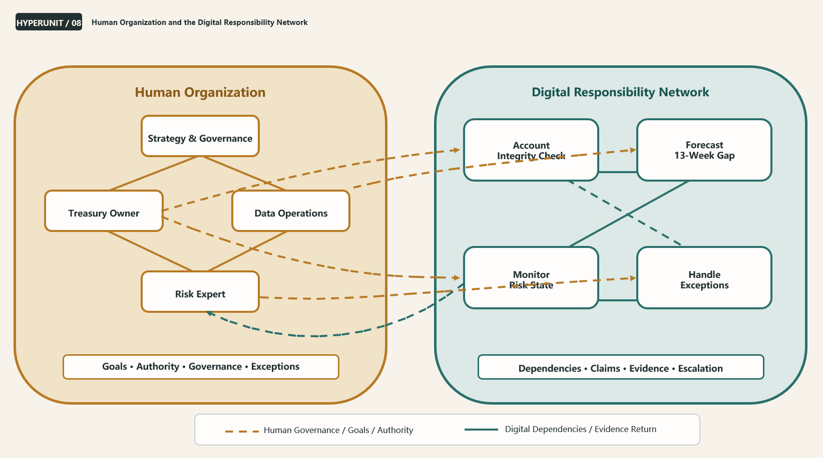
Figure 8 Human Organization and the Digital Responsibility Network

7.6 Which Work Should Become a HyperUnit
Not every file, meeting, or activity should become a HyperUnit. Suitability depends on the value of capability accumulation, operating complexity, repetition frequency, cost of error, verifiability, and responsibility maturity. One-off creative discussion, purely emotional support, and activities with unobservable outcomes and highly ambiguous responsibility may not merit a formal responsibility unit. Recurring judgment, high-risk execution, cross-system dependencies, high turnover costs, and work with verifiable outcomes are better candidates for early entry into the network.
Organizations should also consider governance cost. If the cost of recording and validation exceeds the value of capability reuse, a Light Profile or an ordinary document may be enough. HyperUnit is not a contest to maximize digitization coverage; it is a mechanism for accumulating capability where doing so is worthwhile.
Assessment Dimension | Better Suited to a HyperUnit | Better Kept Lightweight
Frequency of repetition | Periodic, high-frequency, or reused across regions | One-off and not reusable
Cost of error | Material impact on treasury, compliance, customers, or strategy | Low risk and easy to recover
Verifiability | Later Reality is observable and can form Evidence | Outcomes remain unobservable over time or cannot be distinguished
Responsibility maturity | Objective, Owner, inputs, and outputs are relatively clear | Responsibility changes continuously and has no accountable owner
Dependency complexity | Cross-system, cross-team, and easily becomes Stale | Temporary task performed by one person
Value of capability accumulation | High cost of personnel turnover and scarce experience | General knowledge or a mature external service already exists

7.7 An Open Protocol and Capability Ecosystem
Over time, the HyperUnit Protocol, Manifest, Capability Contract, and Runtime Interface can be opened so different editors, Runtimes, models, databases, and enterprise systems interoperate around the same responsible object. What is open are the rules for identity, responsibility, epistemic type, dependencies, validation, and lifecycle. An enterprise's own Facts, Evidence, Capability History, and operating relationships remain proprietary digital assets.
Once the protocol is stable, a Capability Marketplace, cross-enterprise HyperUnit Network, licensing and trading of digital capabilities, high-availability clusters, and automatic Capability generation may emerge. These are Future Directions and must not be confused with the practical capabilities of v0.1. The prerequisite for an open ecosystem is not node count, but consistent preservation of the core principles across implementations.

7.8 Risks That Must Be Confronted Directly
Capability digitization also creates new risks. Historical Evidence may entrench bias; organizations may over-quantify values that cannot be quantified; metrics may be gamed; traceability may become digital surveillance; employee knowledge rights may be ignored; network dependencies may create new systemic fragility; cross-regional data flows may implicate privacy and data sovereignty; and capabilities that succeeded in the past may receive too much trust in a new environment.
Principled statements about “responsible AI” alone are insufficient. The protocol must preserve “unknown” and “not quantifiable” as valid states and prohibit equating the absence of digital Evidence with absence of value. Governance must follow data minimization, purpose limitation, access control, and retention periods while protecting contributor rights. The system must allow Evidence to be down-weighted, Capabilities to be retired, and people to challenge outputs. The architecture must reduce fragility through permissions, sandboxing, signatures, isolation, and minimized dependencies.
Bottom line “Unknown” is a valid state. The absence of digital Evidence does not mean the absence of value.

7.9 Reality Has the Final Veto
No person, model, LLM, governance rule, or version of the HyperUnit Protocol can be treated as permanently correct, no matter how successful it has been. Real environments change, value conflicts cannot be fully quantified, and organizations will discover new responsibilities and boundaries. The long-term trustworthiness of HyperUnit Network comes not from claiming correctness, but from allowing Reality to keep correcting its judgments and rules.
The protocol itself must therefore preserve an evolution mechanism. The core principles of Identity, Responsibility, epistemic type, and validation must remain stable, while implementation guidance, governance parameters, and future capabilities can be updated as Evidence accumulates. Design history is retained through a Decision Log, errors are added through Correction, and each new version must state what changed, why it changed, and how the change will be validated.
Scope note This chapter does not advocate turning all work into HyperUnits, directly claim that digital capabilities can be recognized in financial statements, or promise that AI will replace people or prevent organizations from ever making mistakes.

Conclusion: Let Reality Retain the Final Veto
What enterprises find hardest to replicate is not only their data, software, and models, but the judgment, experience, and capacity for continuous learning formed through years of operation. HyperUnit Network attempts to give these capabilities—which would otherwise dissipate with personnel changes and time—a digital carrier through which they can be identified, connected, validated, transferred, and continuously evolved.
It begins with a small object: a digital responsibility unit with stable Identity and explicit Responsibility. It requires Fact, Configuration, Claim, and Evidence to maintain their boundaries; outputs to preserve their actual dependencies; formal decisions to freeze the minimum complete snapshot; human interventions not to overwrite the system Baseline; and every authoritative judgment ultimately to accept validation by Reality. It chooses HTML as a practical carrier readable by both people and machines, while assigning high-privilege execution, complete history, and security controls to an external Runtime.
HyperUnit does not guarantee that an organization will always be right. It seeks only to prevent the same mistakes from being relearned again and again and to let one real experience become the starting point for a better judgment next time. What matters is not how many nodes exist in the network, but whether the organization begins turning “it happened” into “we learned how,” “one person knows how” into “the organization can carry the responsibility continuously,” and “the system produced an answer” into “reality has responded to this judgment.”
As these responsibility units gradually connect, an enterprise may develop a digital responsibility network alongside its human organizational structure. People continue to carry goals, values, exceptions, and innovation. Digital responsibility units carry stable responsibilities and preserve history, while specific Capabilities implement them and accept validation. The two are not substitutes; they learn, correct, and evolve together in reality.
Let one real experience become the starting point for a better judgment next time.

Glossary
Term | Definition
HyperUnit | The fundamental digital responsibility unit, with stable identity, explicit responsibility, evolvable capability, epistemic boundaries, and a validation lifecycle.
HyperUnit Network | A digital responsibility network formed by multiple HyperUnits and their dependency, lineage, decision, intervention, and Evidence relationships.
unit_id | A stable and unique identity identifier; not a filename, path, version, or Hash.
Identity | The identity structure that defines who a HyperUnit is and preserves its continuity.
Responsibility | The outcome responsibility continuously carried by a HyperUnit and the core of its identity; a material change creates a new HyperUnit.
Capability | The method that implements Responsibility; it may be a model, algorithm, LLM, API, rule, or human-machine combination.
Fact | An observation record of an event or real-world state that has already occurred, with source, time, version, and Provenance.
Configuration | The intent and parameters of a particular run; must be versioned.
Runtime State | The current operating state, which may be discarded and reconstructed and is not a source of business truth.
Claim | A forecast, recommendation, interpretation, or opinion; it does not automatically upgrade to a Fact through transmission or citation.
Evidence | The validation relationship between a Claim and a later Reality Fact; Append-only in principle.
Decision | A formal choice and commitment made on the basis of particular Facts and Claims.
Execution | The action that actually occurs in reality, recorded separately from the Decision.
Decision Episode | The complete event structure of a judgment, from Baseline through Intervention, Decision, Execution, and Outcome.
Intervention / Override | A challenge, suspension, modification, or resource reallocation applied by a person or another unit to the system Baseline; it must not overwrite the Baseline. Acceptance of the Baseline should also be recorded in the Decision Episode but is not an Override.
Branch | A different Capability implementation under the same Responsibility.
Lineage | The origin and evolutionary lineage of a Branch; it does not imply inherited validation results.
Validation | The process of testing a Capability with independent data, time windows, parallel runs, or real-world observation.
Dependency Snapshot | The record of dependencies, versions, times, and states actually used to compute an output.
Decision Snapshot | The minimum complete dependency closure frozen for a formal decision.
Stale | A state indicating that an existing output may be outdated after an upstream change and requires validation or recomputation.
Runtime Engine | The external execution layer responsible for permissions, sandboxing, dependencies, scheduling, signature verification, Snapshots, Atomic Commit, and persistence.
Portable View | The safe, readable, and portable presentation mode for HTML in an ordinary browser.
Managed Run | A controlled execution mode in which the Runtime verifies identity, permissions, signatures, and dependencies.
Atomic Commit | Formal state changes are committed in the Runtime so that either all succeed or none takes effect, preventing partial updates.
Reality Fact | An observation record of the real-world result or environmental state after Execution, used to establish Evidence in relation to a historical Claim.
Outcome | The business result actually produced after an Execution; it may be described by one or more Reality Facts.
Decision Baseline | The original system recommendation formed from the dependencies available before human intervention; subsequent Interventions must not overwrite it.
Counterfactual Path | A Replay, simulation, or controlled estimate of a path that was not executed; its result remains a Counterfactual Claim, not a Reality Fact.
Runtime Scope | A logical orchestration boundary at the task or project level that may be carried by an Orchestration HyperUnit; not the same as a physical Runtime Engine.
Registry | The index layer used to discover HyperUnits, Responsibilities, Branches, and relationships; it is not the Source of Truth for Identity, content, or organizational memory.
RAG / Memory Access Layer | The access layer that retrieves context from governed Facts, Claims, Evidence, and historical Episodes; it is not organizational memory itself.

Appendix A: Core Principles of the HyperUnit Core Protocol
The following twenty-four principles form the white-paper-level summary of the core principles and explain the design boundaries; they are not a complete implementation-conformance checklist. The planned Core Protocol Specification will publish the complete MUST/SHOULD/MAY requirements, Manifest fields, error handling, and Conformance criteria.

A. Identity and Responsibility
1. Every HyperUnit has a stable and unique unit_id.
2. Identity is not a filename, path, version, or Hash.
3. Responsibility is the core of a HyperUnit's Identity.
4. Different implementations of the same Responsibility are Branches; a change in Responsibility creates a new HyperUnit.
5. Capability may continue to evolve, but a new Branch does not inherit its parent's historical Validation record.

B. Epistemic Integrity
6. Fact, Configuration, Runtime State, Claim, and Evidence must maintain distinct epistemic boundaries.
7. A Fact must include source, time, version, and Provenance.
8. Configuration expresses run intent and must be versioned.
9. Every Claim must be bound to all typed inputs actually used, its Configuration, and its source of generation. A computed Claim must also be bound to its Invocation and Capability Version; a human Claim must be bound to its Actor, authorization, time, and Provenance.
10. A Claim does not automatically upgrade to a Fact while being transmitted, cited, or combined.
11. Validation does not turn a Claim into a Fact; it forms Evidence between the Claim and a later Fact.
12. Evidence is Append-only in principle. Errors are added through Correction and are not silently overwritten.
13. Decision and Execution must remain separate.

C. Network and Runtime
14. Every cross-HyperUnit information flow must leave a traceable record.
15. Every Output must preserve the Dependency Snapshot actually used in its computation.
16. An upstream change propagates Stale first; it does not force immediate network-wide recomputation.
17. When an Output is requested, it must be validated against the latest available dependencies and recomputed as necessary.
18. Event Push improves update-notification efficiency; Dependency Pull supports dependency-freshness checks and necessary recomputation when an output is requested.
19. Computation Dependency Graph v1 must remain a terminating DAG.
20. A formal decision must create an immutable Decision Snapshot and freeze the minimum complete dependency closure for that decision.

D. People, Governance, and Security
21. A human Override must not overwrite the system Decision Baseline; the Declared Rationale remains a Claim.
22. Human intervention is part of the system. Complex decisions are preserved through Decision Episodes and Intervention DAGs; when evidence is insufficient, Attribution = Indeterminate is permitted.
23. HyperUnit does not assume that people or AI are always rational or correct. Historical Evidence may be down-weighted and retired from active use but must not be silently deleted. If applicable law, retention policy, or authorization requirements mandate removal, an auditable deletion event and necessary proof must be preserved, and no permanent label may be attached to a person.
24. Permission is denied by default and granted explicitly. A Signature proves identity and integrity, not that a conclusion is correct. Formal state changes must pass through a Runtime-mediated Atomic Commit.

Document Set and Planned Publications
Document | Purpose
HyperUnit Network White Paper | Explains why, what, value, architecture, boundaries, and future direction.
HyperUnit Core Protocol Specification (planned) | Defines the protocol rules that must not be violated.
HyperUnit Technical Companion (planned) | Covers implementation of the Manifest, Runtime, Registry, Capability, security, and storage.
HyperUnit Adoption Guide (planned) | Explains cold start, responsibility maturity, governance tiers, and bridging to existing systems.
Handoff / Decision Log | Preserves the complete design state, rationale for decisions, and evolution of ideas.
Pre-Publication Validation of Weekly Bank Account Balances — HTML Example | Uses the Standard Profile to demonstrate the minimum responsibility loop, epistemic types, human intervention, and Portable View boundaries.

The main text retains the conceptual backbone; implementation details move into a separate specification and Technical Companion. Protocol and product remain separate, as do present capabilities and future directions.

HYPERUNIT NETWORK
HyperUnit Network
Let one real experience become the starting point for a better judgment next time
Official Release v1.2 · September 2026

