Vision Document

Ace Academy

# **1.** **Introduction**

This document intends to establish our product’s positioning in the marketplace, the problem it solves, the role and involvement of stakeholders in the product development, the different users the product is intended for, and the user environment. Our product is intended to provide a more holistic educational experience to instructors, tutors, and students alike, by centralizing typical services offered by platforms like Moodle, Omnivox, and Gradesavers, into one application for greater ease of use and organization for end users.

## **1.1 References**

Stern, “REVIEW OF RISK MANAGEMENT METHODS”, <https://condor.depaul.edu/dmumaugh/readings/handouts/SE477/SERIM_Article_3.pdf>

TMAP, “Difference between product and process risks”,

<https://tmap.net/wiki/difference-between-product-and-process-risks>

Spacey, “6 Types of Process Risk”, Simplicable,

<https://simplicable.com/new/process-risk>

# **2.** **Positioning**

## **2.1.** **Problem Statement**

| The problem of | Requiring multiple platforms to track academic progress, submit assignments, engage with course/tutoring content and pay tuition instead of having everything combined in one application. |
| --- | --- |
| Affects | Employees (i.e.: website administrators, site maintainers, etc.) |
| The impact of which is | Students and instructors have difficulty organizing themselves in their courses because not everything is in one place. The current decentralization of course related materials, content and activities creates confusion and makes it difficult to stay on track with important deadlines, payments, and communications. |
| A successful solution would be | A centralized system, where students, tutors and instructors can access course content, grades, classroom and school communications, and payments and registration all in one application. This would improve overall course organization, and could help students (and their respective parent(s)) and tutors stay on track of their educational goals. |

## 

## **2.2.** **Product Position Statement**

| For | Students, tutors, instructors, and parents of students |
| --- | --- |
| Who | Need a centralized place to access course related content, materials, and payment info. |
| The Ace Academy | Is an educational services and course hosting and tutoring platform. |
| That | Centralizes the learning experience for both educators and their students to interact with their course material, grading, and tutoring services. |
| Unlike | A decentralized Moodle, which does not provide tutoring services, or course enrollment information, and access to registration and payment tools. |
| Our product | Allows for better organization and structure for both students and instructors alike, and gives users an overall more holistic educational experience than our competitors’ platforms. |

# 

# **3.** **Stakeholder Descriptions**

## **3.1.** **Stakeholder Summary**

| **Name** | **Description** | **Responsibility** |
| --- | --- | --- |
| Employees | Employees are internal stakeholders, and interact directly with the business by working for them in a variety of different ways. They are primary stakeholders. | The employees have the responsibility to do the job they are assigned to, work to their fullest potential, and ensure success in the field they are assigned to. Employees are paid as their performance is up to par, and must ensure the work they do is also done safely, does not harm others, and uses proper techniques.Examples of employees: web developers, software and application developers, information technology managers, etc. |
| Investors | This stakeholder invests in the project and are external stakeholders. | Their responsibility is to fund the project, and take out money when necessary. They provide proper funding so that the project can have all the necessary funds to succeed |
| Suppliers | Suppliers are external stakeholders who provide/sell their products to your business. They are secondary stakeholders. The better the project does, the more money they make. | Suppliers responsibilities are to sell their products to your business so they can rely on your business to make a revenue on the sale/use of their products. Suppliers must make sure their products are safe and comply with the law, and must make sure their product is up to date and works to its maximized potential. Moreover, there can be many external suppliers of software that may be used to build this application for hosting, data storage, testing, etc. |

## 

## 

## **3.2** **User Summary**

| **Name** | **Description** | **Responsibilities** | **Stakeholder** |
| --- | --- | --- | --- |
| Students | Primary user of the E-Academy system | The responsibilities of the students as users is to use the E-Academy to learn, vote on final assignments, participate in pop-up quizzes, communicate with other students, and request tutors. | Self |
| Tutors | Tutors are Primary users of the E-Academy. | The responsibilities of the tutors are to give lessons/tutorials to students in need, provide necessary grades for certain assessments, give stickers/badges to students, give extracurricular courses, and be ASL certified. | Self |
| Administrators | End users of the E-Academy. | The responsibilities of the Administrator is to manage the website's theme based on different events and the seasons. Also have the responsibility to manage the tutors and make sure they are qualified. | Self |

## 

## 

## 

## **3.3** **User Environment**

The working environment of the target user includes a variety of different aspects. Firstly, the E-Academy will be used by students regardless of age and educational backgrounds. Anyone who is willing to learn can use the E-Academy platform, and doesn’t need to be considered a full time student to do so. It will also be used by tutors who need to have a certain level of experience in the material they are teaching. The number of people involved in completing a task depends on the size of the tutoring session, and is therefore changing. A task will have at least one student in it or one tutor in it, sometimes both (example: tutoring session). The length of a task cycle depends on the task being performed. The task cycle length for creating an account will depend on how fast the user can fill in their information, but will most likely take two-five minutes.

Activity length will also depend on the activity being performed. If the activity being performed is a tutoring session, the length will be however long the student and tutor agree on, but will mostly be offered in blocks of one hour. Other activities like pop-up quizzes will also depend on the tutor, but will often be offered in 20 minute time blocks. Activities time blocks are continuously changing. Here is a general length for all activities:

* Tutoring session: One hour
* ASL tutoring session: One hour and fifteen minutes
* Extracurricular courses: One hour and fifteen minutes
* Pop-Up Quizzes: 20 minutes

There are no unique environmental constraints for our platform. As long as the user is connected to the internet in any way, the user will be able to use and benefit from our platform. The student will also be able to download pre-recorded lectures in case they will be in a situation where the internet is not accessible, such as a flight. The platform can be used from all around the world.

Evidently, a learning platform is not new to the domain of online education, and there are many alternatives that can act as competition for our product, such as Omnivox, Moodle, Khan Academy, and Gradesavers. Without thorough inspection, the E-Academy platform can appear as a clone to stakeholders. However, upon a closer look, one can see that the E-Academy combines all the aforementioned applications and closes the gap between each of them, tightly knitting all the functionalities in one place. For example, Khan Academy and Gradesavers offer online tutorials, but there is no place to manage a student’s academic portfolio, such as grades, assignments, etc. On the other hand, Moodle and Omnivox offer a platform to host a student’s academic record, but do not offer online tutorials. The E-Academy will handle both types of uses, thereby rendering it a one-of-a-kind application.

## 

## 

## 

## **3.4 Key Stakeholder or User Needs**

As mentioned in the previous section, there are existing E-learning platforms that are in use today. They are by no means perfect, however. There is a substantial lack of features in the current solutions, which is why many of them need to be paired together to create a functional stack for online learning. Since there are many options, finding the right combination of applications is a difficult task for users and still does not lead to harmony or functionality as a unit. Among the many problems with the current solutions:

* No one application offers every functionality; If one offers management for a student’s academic portfolio, it does not offer online tutorials, and vice-versa, creating a gap.
* Lack of user-friendliness and aging interface.
* Lack of quality control. Some tutorials on GradeSavers are low quality and are not up to par with academic standards.
* Reliability. Applications such as Moodle and Omnivox tend to have server failures due to lack of maintenance and lack of infrastructure management.

The E-Academy platform aims to bridge the gap created by the current solutions. Currently, the users must think of the best combination of platforms to meet their needs for academic success. In some instances, institutions must sometimes build their own application since their needs are not met. For example, Concordia University relies on Moodle and their own system (MyCUAccount) to fulfill their needs. With E-Academy, the functionalities offered by the various applications are brought together in a single place, rendering the issue of combining multiple applications to meet user needs obsolete.

Users find it difficult enough to alternate between applications. To make matters worse, the UI of the current solutions is often outdated and is difficult to use and find the things they need. the UI of the E-Academy will be on par with the standards of today and aim to be as clear as possible to use, with the layout organized in a way to make it easy to comprehend for users like students, tutors, and administrators.

Some applications in the current domain do not filter the content that is uploaded, or do not have high enough standards. For example, GradeSavers often has paid tutorials with content that is not relevant to material taught in class. With E-Academy, the content will be relevant and up to date with material taught in classrooms, ensuring the highest quality education available.

Finally, applications like Moodle and Omnivox tend to fail in the field of reliability. On numerous occasions, the servers have failed to respond during crucial moments for users, such as finals period or at the time of a midterm. This can be attributed to poor system architecture or low quality infrastructure used to host the application. The architecture and hosting of the new application will also meet modern standards, and aim to be available all the time. Availability is an extremely important characteristic in the educational domain, where deadlines and timed examinations are prevalent. In return, customer trust is built resulting in a good reputation.

Stakeholders and users need a solution that offers reliability, ease to use, vast functionality and a modern user interface. The E-Academy platform provides these features, where the current solutions do not.

| Need | Priority | Concerns | Current Solution | Proposed Solutions |
| --- | --- | --- | --- | --- |
| *All Features in one application* | *HIGH* | Size of application, architecture, structure. | *Not implemented* | *Offer every service in the platform* |
| *UI and interface* | *MEDIUM* | Design, ease of use. | *Aging, difficult to use* | *Keep a sleek, modern UI with reduced clutter* |
| *Content Quality Control* | *HIGH* | Quantifying the quality, as it can be subjective. | *Moderate quality control, often with issues.* | *Establish a set of standards. Establish strict quality control, remove any content that does not meet standards.* |
| *Reliability* | *HIGH* | Managing server stress, maintenance, testing | *Relatively unreliable* | *Have DevOps in case of failure, maintain frequent testing, have fail safes and redundancies.* |

# 4. Product Overview

## 4.1 Product Perspective

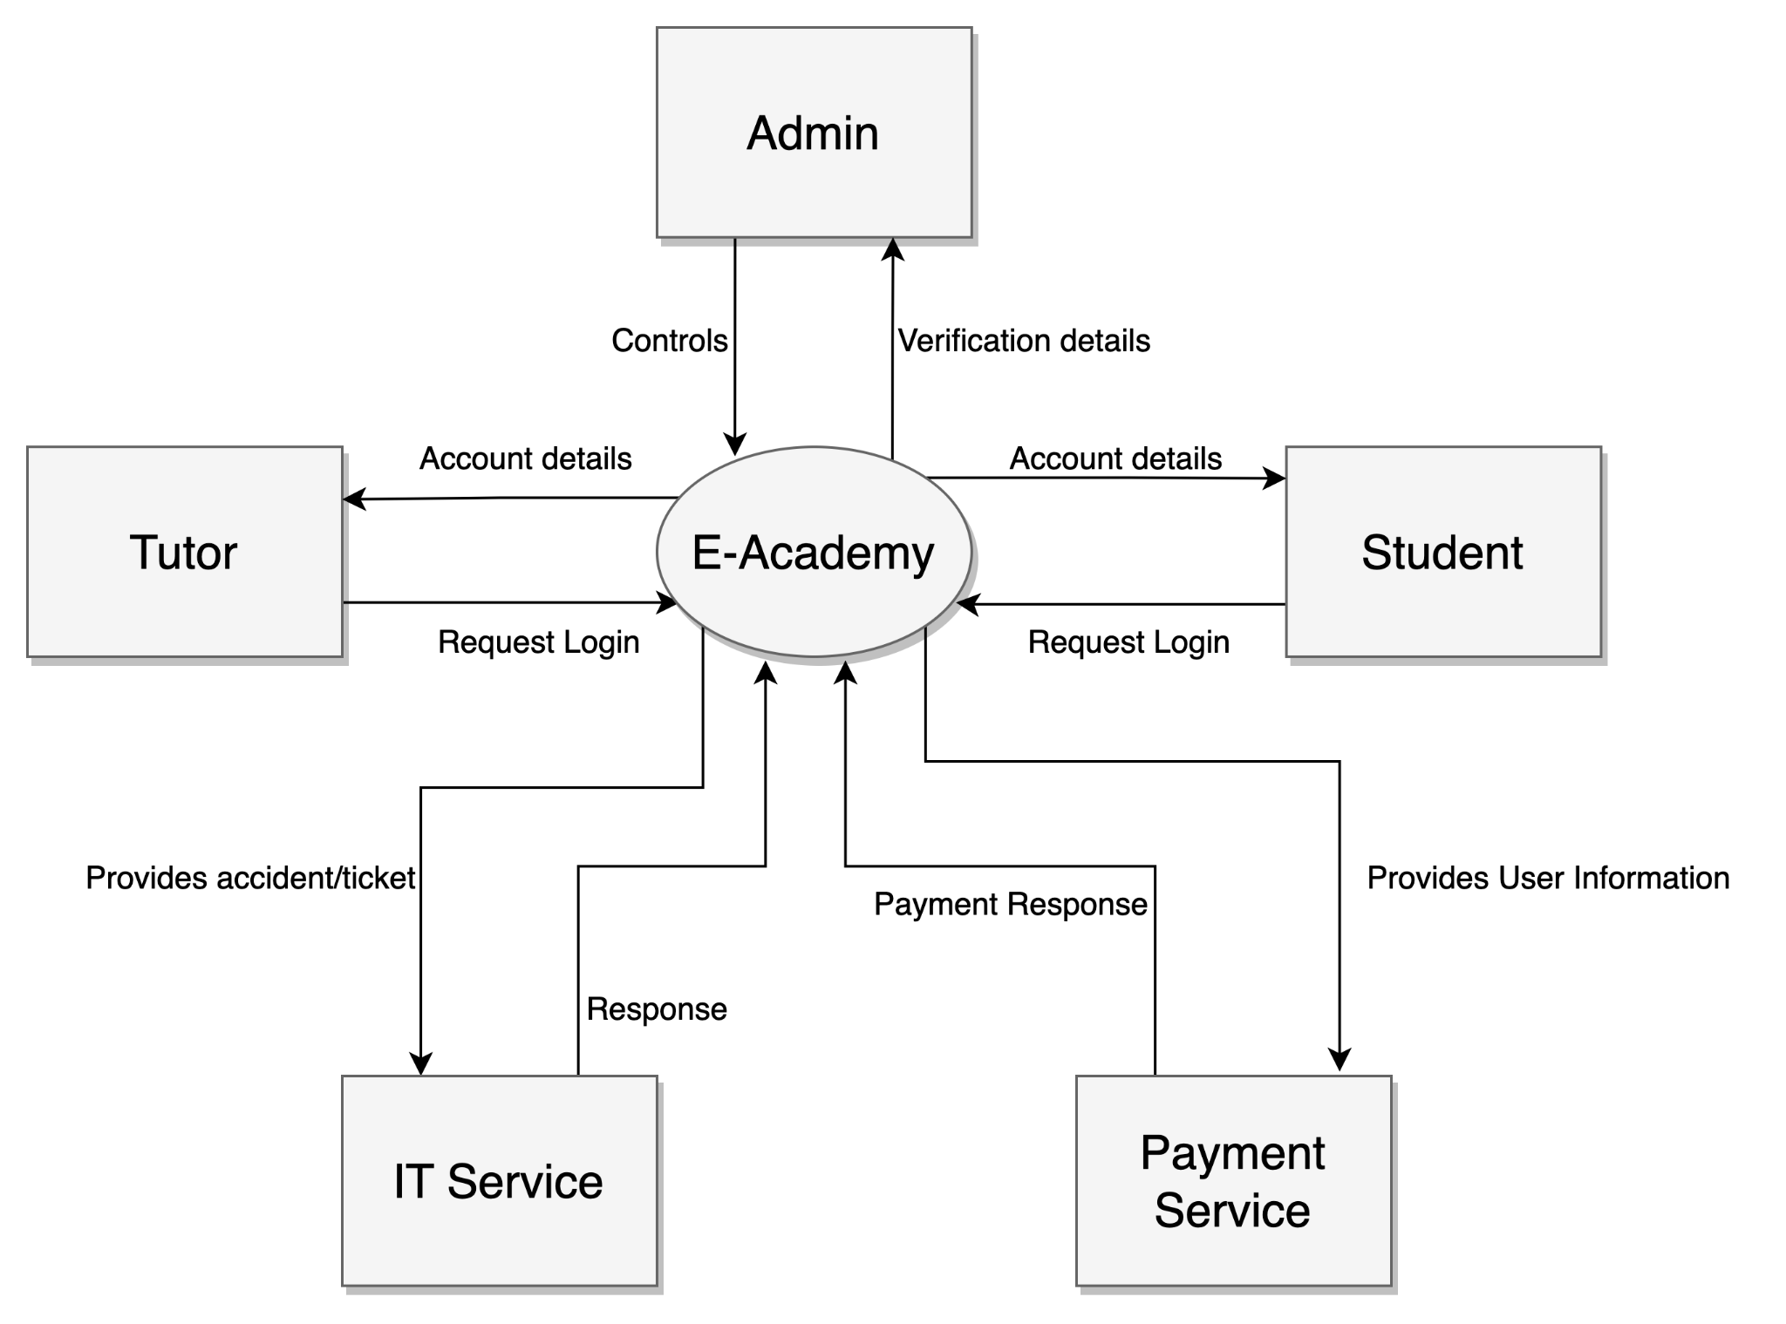

## 

## 

## 

## 

## 4.2 Assumptions and Dependencies

| Assumptions | Dependencies |
| --- | --- |
| User is in possession of a device has access to the platform | Any computer, smartphone, tablet that support a web application |
| Tutor has the required material to give an online teaching lesson | Tutor has an internet connection, a working computer, working camera, working microphone and internet speed that supports video streaming |
| Student has the required material to attend the online lessons | User has a correct internet connection, a working device with a microphone |
| Enough tutors are available to give lesson | A reasonable number of teachers is hired to be able to keep up with the students demand |
| Enough students are registered/payed | A minimum of student must be paying to pay the teachers |
| The IT service must be fully functional | The IT service is set before the launch of the platform |
| The online payment service must be fully functional | The online payment service is set before the launch of the platform |

# 

# 5. Product Features

## 5.1 Core Features

* Users register an account to gain full access to the application
  + Students include information on their program of study
  + Tutors include relevant experience and employment information
* Courses recommended to students based on area of study
  + Offered courses may be irrelevant to student’s interests, but may be ignored if unwanted
* Students or parents/guardians can register as part of the accessibility center and gain access to more tailored services
  + They gain access to specific technologies or tutors based on their needs
* Students with hearing impairments can take courses with ASL (american sign language) certified tutors
  + As part of the accessibility center; can be requested by parent/guardian for student
* One weekly free demo course for guests:
  + Limited videos will be available for view-on-demand per subject for non-paying visitors (guests) of the website.
* Chat function to get course registration help from a manager or administrator
  + Live chat for assistance with selecting courses and adding them to list of courses
* Students can be notified when a course registration opens and future course events
  + Students may opt-in or out of notifications as they see fit.
  + Other course events include quiz dates, lecture dates, or assignment deadlines.
* Tutors can be notified of vacancies in courses that they may tutor in
  + Based on tutor preferences, courses they are interested in teaching notify them when the course opens.
* Tutors poll students to request types of assessments
  + The tutor may overrule the assessment type chosen by the students.
* Students can request control of a virtual whiteboard during lectures
  + Access granted by tutor during live lectures for improved interaction.
* Schedule builder portal that allows students to register for their classes directly
  + Schedule should only show offered courses for the next semester, no further
* Students can directly contact their tutors
  + Messaging system and notification system allow for organized chatting amongst users.
* Students can chat with other students from their classes with a messaging system
* Access to practice questions/quizzes available for students
  + Submission of answers can be corrected by tutors for feedback.
* Extracurricular courses based on tutor interests
  + Tutors may request to offer courses based on mixed knowledge areas or topics external to school courses

## 5.2 Other Product Requirements

### 5.2.1 Privacy and security

* Ensuring encrypted video streaming for anonymity and privacy of students and tutors

### 5.2.2 Performance requirements

* Video and audio streaming -> need good network bandwidth, network quality to view it at high quality
* Capability of voice chat from students and tutors
* Multiple students writing on virtual whiteboard live
* Server should handle up to 100 concurrent users in a unique virtual classroom, with audio and video

### 5.2.3 Environmental requirements

* Users can use microphone and camera
* Tutors must use microphone and camera

### 5.2.4 Dependencies

* IT department must be available for customer assistance

### 5.2.5 Online help resources

* Tutorial / walkthrough of the application for first-time users
* Virtual assistant (chatbot) for FAQ and common problems
* IT help center for live help

### 5.2.6 Priority of requirements

* Security and privacy is of top priority for the students. Ensuring virtual classrooms are hidden from outsiders, and anonymous where the students choose, is of most importance. Students may choose whether they would like to have their voice and/or video in class at any time.
* Performance is of second priority, to ensure flow and focus when learning. Frequent call drops, lag, or buffering in a live classroom severely impacts learning and teaching quality.
* Online Help Resources are the third priority. Troubleshooting any existing problems and ensuring a comfortable user experience on the platform maximizes customer retention and satisfaction.

# 6. Risk and Feasibility

## 6.1 Risk list and mitigation techniques

Domain risks

| Risk | Severity level | Risk likelihood | Mitigation Strategy |
| --- | --- | --- | --- |
| Popularity of the website. There needs to be a certain number of students registered to the course in order to pay the teachers. | Low | Unlikely | Having ads featuring the services provided by the platform on other websites. Tutors having youtube channels can also promote the website. |
| The response time from the IT call center for customer assistance and Virtual assistant (chatbot) | Low | Unlikely | Having a Virtual assistant covering a high number of potential issues to lower the call volume of the IT help center |
| Wrong assessment of the stakeholders need for specific functionalities of the website | Low | Possible | Having a section for review and improvement of new features that could be missing |

Process risks

| Risk | Severity level | Risk likelihood | Mitigation Strategy |
| --- | --- | --- | --- |
| Credential Stuffing is always a type of external process risk where people username or password information can get leak during a data breach | Severe | Unlikely/Possible | Have different passwords for each website a user subscribes to. |
| Personnel shortfall: having less experienced developers working on certain parts of the project | High | Likely | Increase the risk of failure for these specific parts and assure to test them more than other components of the system. Assigning experienced developers to supervise and approve is also a solution. |
| Unrealistic Schedules and Budgets: | High/moderate | Possible | In order to avoid schedule issues, incremental development is vital. Ensuring other sources of revenue than students subscriptions to stay within budget. |

## 

## 

## 

## 

## 

## 

## 6.2 Feasibility

1. Technical Feasibility

* Due to the Ace Academy being a term project, it must be completed within a small time frame of 14 weeks. All the necessary technology for this project has already been discovered and invented. This means that creating the Ace Academy is feasible, as similar projects have been, and are being built within similar timeframes. This anecdotal knowledge of other similar projects being completed within similar timeframes allows the Ace Academy team to feel confident in the feasibility of our project.

1. Organizational Feasibility

* The responsible stakeholders who will be part of the work are the employees and the suppliers. The employees will fulfil their responsibilities to their company by doing the job they were hired to do safely and properly. These employees, depending on their role, will communicate with the suppliers, who will in turn fulfill their role as a secondary stakeholder by selling Ace Academy their products. The suppliers must also, like the employees of Ace Academy, ensure that what they have sold to the company complies with the necessary laws, and is safe. These products, along with the employees, will build Ace Academy.

1. Financial Feasibility

* Ace Academy is financed by investors, who are non-user stakeholders in the company. They control the amount of money that is flowing in and out of Ace Academy. They provide funds, and in turn expect that the project progresses in a timely manner. As long as all employees and suppliers fulfill their roles, the investors will fulfill their role in funding Ace Academy.

## 

## 

## 

# 7. Use Case Diagram

| **Actor** | **Actor’s Objective** | **Use Case Name** |
| --- | --- | --- |
| Guest | To sign up for the e-learning platform | Register (UC-1) |
| Parent, Student | To add their student information into the system | AddStudentDetails (UC-2) |
| Tutor | To add their tutor information into the system | AddTutorDetails (UC-3) |
| User | To modify their personal information | ModifyUserDetails (UC-4) |
| Ace Academy | To recommend courses to students based on their area of study | RecommendCourse (UC-5) |
| Student | To sign up for a course on the e-learning platform | SignUpCourse (UC-6) |
| Parent, Student | To register as part of the accessibility center for more tailored experiences | RegisterAccessibility (UC-7) |
| Parent, Student | To register student for ASL certified courses | RegisterASLStudent (UC-8) |
| Tutor | To register as an ASL certified tutor | RegisterASLTutor (UC-9) |
| Guest | To access a free week of courses to test out the platform | AccessFreeCourse (UC-10) |
| Parent, Student | To get help registering for classes by chatting with managers or administrators | ChatWithManager (UC-11) |
| Tutor | To notify anyone who is waiting for a course to open that the course is now open | CourseOpening (UC-12) |
| Parent, Student | To notify a tutor that a student in one of their courses will be vacant for a period of time | CourseVacancyStudent (UC-13) |
| Tutor | To poll students on what type of assessment they prefer | CoursePoll (UC-14) |
| Tutor | To assign an assessment to their students in a class | CourseAssessment (UC-15) |
| Student | To request access to a virtual whiteboard during a live lecture | LectureBoardAccess (UC-16) |
| Parent, Student | To use the schedule builder tool to register for courses | SignUpCourseSchedule (UC-17) |
| Parent, Student | To contact their tutor directly though the platform | ChatWithTutor (UC-18) |
| Student | To chat with other students in their classes | ChatWithStudent (UC-19) |
| Student | To do and submit assessments assigned by the tutor | CourseAssessmentSubmit (UC-20) |
| Student | To do practice assessments that can be corrected by tutors | CoursePracticeSubmit (UC-21) |
| Tutor | To request an extracurricular course that the tutor will teach | ExtracurricularCourseRequest (UC-22) |

