**GINA CODY School of Engineering and Computer Science**

**Department of Computer Science and Software Engineering**

**Concordia University**

**SOEN 342**

**Phase 1**

## Abstract

In the following document, an in depth market analysis is made in order to understand all components of our E-Academy. This market analysis includes the study of already existing products and features, along with comparing them to our E-Academy. The market analysis also covers identifying potential customers, the target market, and competitive platforms. This document will also hold the presentation of our E-Academy, which will clearly present the users of the academy, all proposed features the academy will offer, and the overall value of the E-Academy.

## Part I: Market analysis

### Existing Products and Features

* + **Udemy**: Fully remote learning with a variety of subjects.
    - Course Marketplace
    - LogIn and Registration
    - Courses can be purchased online directly
    - Course can be taken at the students’ desired pace (self paced classes)
    - Question Forum for students
    - Course review section
  + **Moodle**: A course hub for students and teachers.
    - LogIn and Registration
    - Teachers can post videos, powerpoints, lessons, online tests, and announcements directly on the platform.
    - Teachers can change the visibility of everything they post.
    - Students can submit assignments
    - Message classmates/teachers,
    - Students can check their grades
    - Quiz/test reviews are available for students.
    - Time slot bookings.
    - Forums for teachers and students
    - Email linking to all announcements
    - Course progress tracking
    - Calendar Access
    - School Announcements
    - Notifications
  + **Grade Savers**: Tutoring Company
    - LogIn and Registration
    - Weekly Tutorials
    - Private Tutoring
    - Crash Courses
    - Mini Groups: Open tutoring sessions to all students registered. The more students who sign up for the tutoring session, the cheaper it is. Good way to bring cost down for students
    - Forums where students can post assignments and ask questions to tutors
    - List of schools with announcements and courses that are available. Corresponding course numbers.
  + **Omnivox**: Course hub for students and teachers.
    - School announcements
    - Léa:
      * Teachers can manage all document sharing directly on platform
      * Teachers can change the visibility of their post
      * Students can submit assignments
      * Students can check their grades
    - MIO (Message classmates/teachers)
    - Customize the platform for the specific school (example:<https://dawsoncollege.omnivox.ca>)
    - Course Schedule
    - Event Calendar
    - Notifications
    - Tutor booking

### Comparative study

The platforms chosen during the brainstorm are Moodle, Omnivox, and Gradesavers. Moodle and Omnivox are organizational applications that are used by learning institutions across Quebec. They are also known as Learning Management Systems (LMS) and are available in both mobile and web formats for ease of access. In the case of GradeSavers, it is a private tutoring company that offers thousands of lessons and crash-courses on any topic imaginable, for all difficulty levels. Students simply subscribe to a course they want to learn, and all necessary resources for success are provided. There is no mobile application for Gradesavers like there is for Moodle and Omnivox. However, this is attributable to the fact it is not a learning management system and is instead a tutoring service, therefore it differs substantially in terms of features.

Although Moodle and Omnivox appear similar at first glance, their architecture is where the differences begin to show. Omnivox is divided into four major components, Home, Léa, Mio, and Services. The homepage contains the academic calendar and is where news for the school is posted. Léa is the student hub, where assignments can be submitted and grades can be viewed. For teachers, it is where important documents are posted and accessed, and where visibility is managed. Mio is Omnivox’s proprietary messaging service, where students and teachers within the same domain (i.e. same college) can contact each other. Mio is also what teachers use to post important announcements regarding the course. Although Omnivox contains a Services tab for announcements, it is not accessible by teachers for course announcements and it is instead used by the school for important notifications, such as emergency closures. Moreover, the Services tab can be used for peripheral actions such as making payments, checking final grades, managing course registration, among many other things. In Moodle’s case, the student hub and messaging services don’t seem to have a clear boundary. Both features are integrated within one service. Like Omnivox, Moodle offers a place for students to view their grades and submit their assignments, and for teachers to post documents and manage visibility. However, teachers do not have to use the messaging system to notify students of important events. Instead, they have the ability to set up an announcement section where they can post information which is then notified to students via email notification. The messaging system can be used by both professors and students within the domain to communicate. Moodle, however, does not offer the same abilities as Omnivox in the realm of services such as making online payments and registering for courses. Because of this, institutions using Moodle must often create their own separate services to complete such tasks. Another substantial difference between the two services is that Moodle is much more customizable when creating a new course in comparison to Omnivox, where the user must follow a strict format. Moodle’s model is very convenient for teachers that prefer to organize their course in a certain way, which is a luxury not offered by Omnivox. In the world of Gradesavers, one must simply look for the course they are struggling in and are able to access resources, one-on-one tutoring sessions, weekly tutorials and scheduled crash-courses on the topic after paying a fee. Clearly, it is not intended to be used the same way as Moodle and Omnivox, but it is nevertheless an online learning platform and truly shows that this service can come in many different forms. 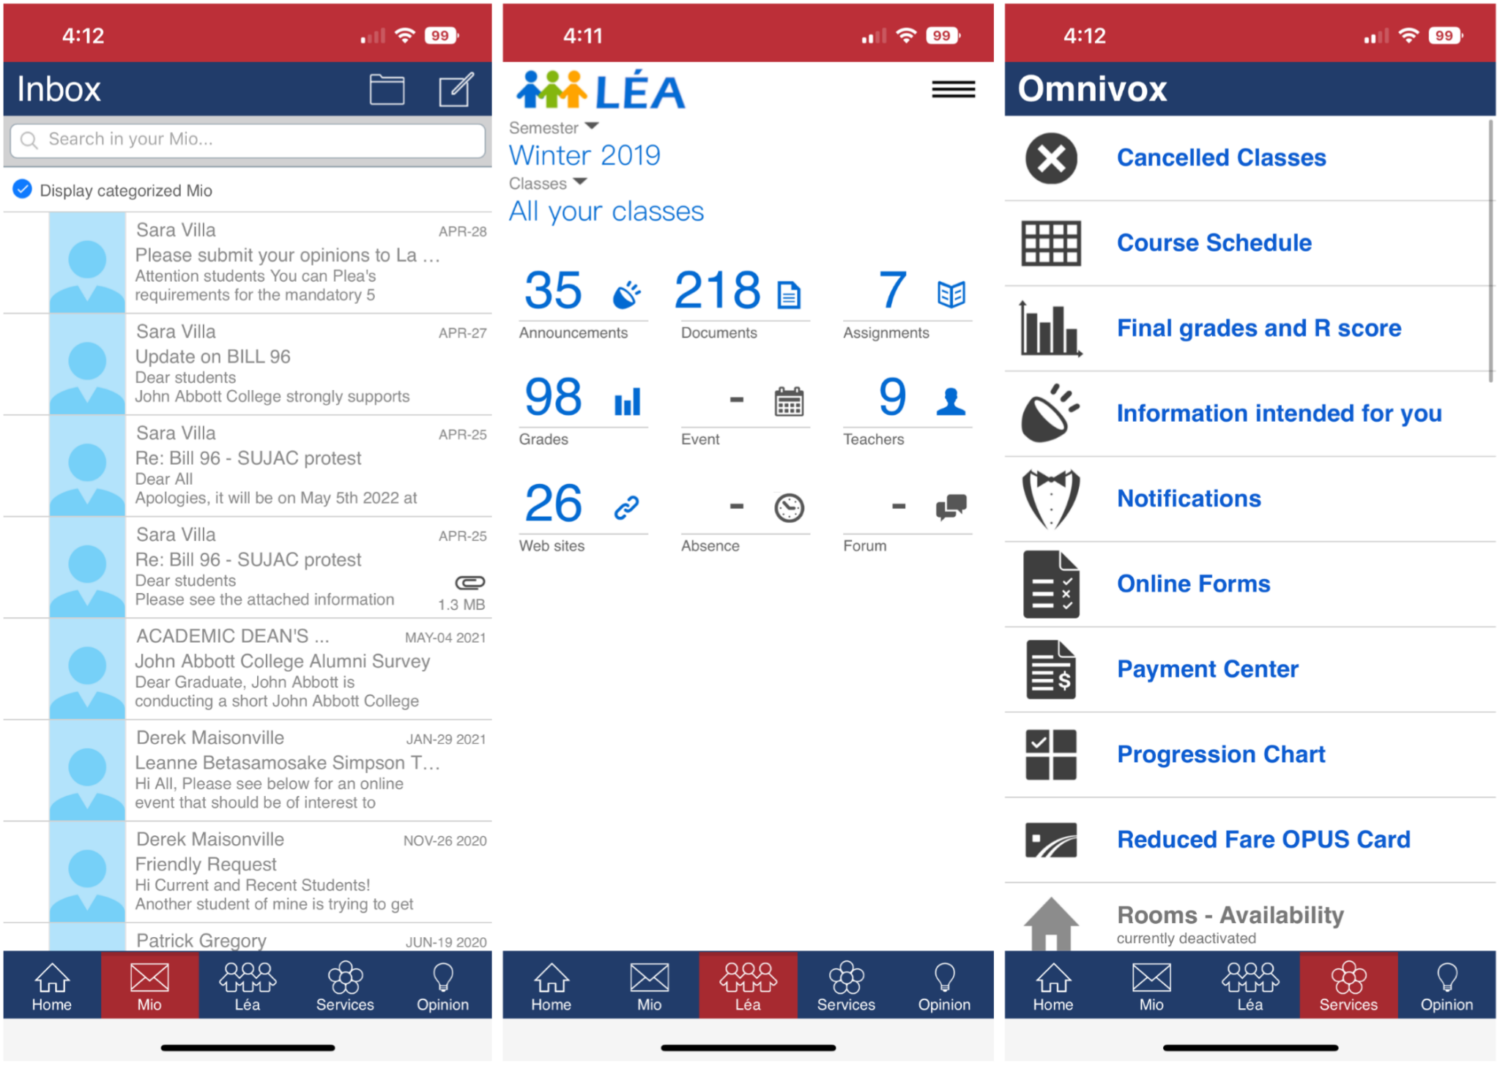

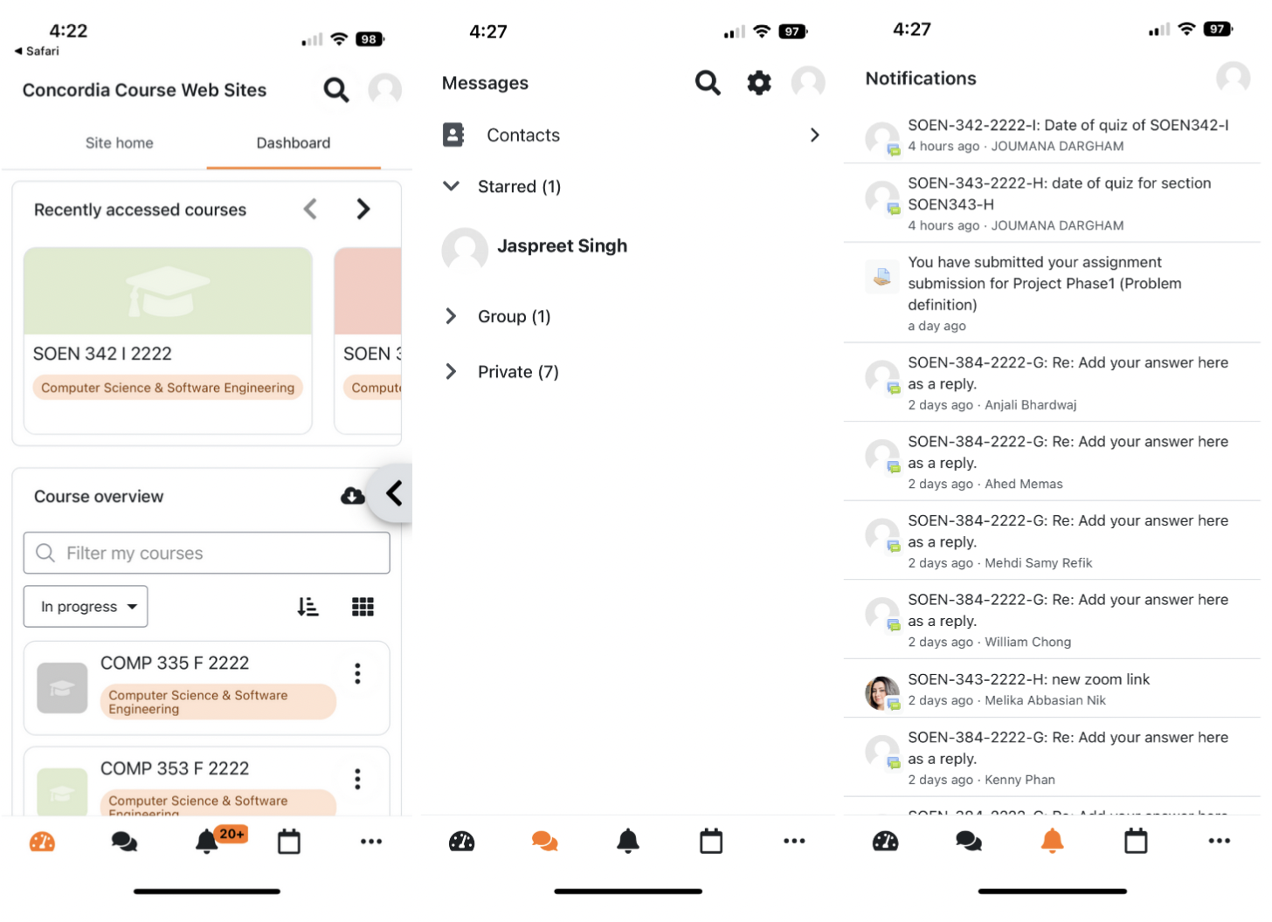

## Part II: E-Academy presentation

### Users

• Guests

* Enter email to be notified when registration for “watched” class opens, or when class starts
  + For both tutor and student guests
* Guests may join one weekly free class

• Students (and/or parent/guardian):

* Students vote on the final assignment.
  + For example: propose an idea for a case study instead of having a normal exam.
* Students participate in in-class pop quizzes which award points based on correct answers.
* Students can chat with other students from their classes with a messaging system
* Accessibility portal to request and have access to specialized tutors and services

• Tutors

* Give stickers/badges to students
  + “Extra credit” stickers for doing extra problems/quizzes/participation
* Extracurricular courses based on tutor interests
* Students with hearing impairments can take courses with ASL (american sign language) certified tutors

• Administrator

* Change website theme (seasonal, event-based, …)
* Admins have access to a bank of tutors qualified to help students with disabilities

### Proposed Features

• Accounts creation

* Users register with an email and password
* There are selection boxes for each role of student, parent/guardian, or tutor

• Requests Management

* Chat function to get course registration help from a manager/admin
* Polls from tutors to request types of assessments
* Schedule builder portal that allows students to register for their classes directly
* Students or parents/guardians can register as part of the accessibility center and gain access to more tailored services
* Students can directly email or message their tutors for help/requests

### 

### Project Value

This project allows students, tutors and parents to benefit from a cohesive and organized platform that caters to the educational needs of every type of student. This project has been developed with great care as thorough market research was conducted to figure out what are the best features to include in our platform and what features to exclude based on the opinions of those who have interacted with the learning platforms studied. As our team is made up of students, we have had the opportunity to use many different learning platforms, which makes us uniquely fit to design the most optimal platform.

We have elicited the requirements for our system-to-be by using certain techniques during the comparative study phase of our project. In having used several of the studied e-learning platforms in the past, our team was able to take advantage of knowledge reuse as well as observation to further understand features of the as-is systems, and tailor the requirements of our build to boast improvements and new features. In addition to this, armed with the acquired information gathered from these techniques, interviews have been scheduled with the stakeholders of our product in order to fine-tune the requirements of our software solution, by asking questions and discussing the needs of the clients, ensuring that they are feasible.

Currently, a lot of learning platforms are too complex and have a steep learning curve. Creating our platform with that in mind allows us to prioritize education, because students will focus more on class content instead of navigating an overly complex learning portal. This is of immense value to students and tutors alike because more time and energy can be devoted to learning and improving their understanding.