

**CSE3021**

**Social and Information Networks**

**FACULTY: PUNITHA K – SCOPE**

**SLOT: B2 + TB2**

**PROJECT REPORT**

**EXAMINING AND ANALYISING 9/11 ATTTACK AS A SOCIAL NETWORK**

**TEAM MEMBERS:**

**AAKASH AGGARWAL-18BLC1060**

**MILLENA DEBAPRADA JENA-18BCE1030**

**ABSTRACT**

This project looks at mapping covert networks using data available from news sources on the World Wide Web. Specifically, we examine the network surrounding the tragic events of September 11th 2001. Through public data we are able to map a portion of the network centered on the 19 dead hijackers. This map gives us some insight into the terrorist organization, yet it is incomplete. Suggestions for further work and research are offered.

Famous dataset of the terrorists involved in the 9/11 bombing of the World Trade Centres in 2001. Data was extracted from news reports and ties range from at school with to on same plane. Ties are undirected and binary. Relations are a mix of prior-contacts like trained together, lived together, financial transactions, at school with, on same flight

## **INTRODUCTION AND BACKGROUND**

We were all shocked by the tragic events of September 11, 2001. In the non-stop stream of news and analysis one phrase was continuously repeated - "terrorist network." Everyone talked about this concept, and described it as amorphous, invisible, resilient, and dispersed.

We will set out to map this network of terrorist cells that had so affected all of the lives.

Our aim would be to uncover network patterns that would reveal Al Qaeda's preferred methods of stealth organization. If we know what patterns of organization they prefer, we may know what to look for as we search them out in countries across the world.

**DATA SOURCE**

Our data sources were publicly released 4 research papers

For guidance we turned to previous work by social network theorists who had studied covert, secret, or illegal networks. We found four excellent papers that formed a working foundation for the knowledge we would use to pursue this project.

1. Uncloaking Terrorist Network(By Valdis E.Krebs) November 4th-1st April.This Reasearch paper is our main source for our project.This research paper provides us the Complete Dataset required for this project
2. Malcolm Sparrow (Sparrow, 1991) examines the application of social network analysis to criminal activity. Sparrow describes three problems of criminal network analysis that I soon encountered.
3. Incompleteness - the inevitability of missing nodes and links that the investigators will not uncover.
4. Fuzzy boundaries - the difficulty in deciding who to include and who not to include.
5. Dynamic - these networks are not static, they are always changing.

Instead of looking at the presence or absence of a tie between two individuals, Sparrow suggests looking at the waxing and waning strength of a tie depending upon the time and the task at hand.

1. Wayne Baker and Robert Faulkner (Baker and Faulkner, 1993) suggest looking at archival data to derive relationship data. The data they used to analyze illegal price-fixing networks were mostly court documents and sworn testimony. This data included accounts of observed interpersonal relationships from various witnesses.
2. Bonnie Erickson (Erickson, 1981) reveals the importance of trusted prior contacts for the effective functioning of a secret society. The 19 hijackers appeared to have come from a network that had formed while they were completing terrorist training in Afghanistan. Many were school chums from many years ago, some had lived together for years, and others were related by kinship ties. Deep trusted ties, that were not easily visible to outsiders, wove this terror network together.

**DATA GATHERING**

## 

Within one week of the attack, information from the investigation started to become public. We soon knew there were 19 hijackers, which planes they were on, and which nation's passports they had used to get into America. As more information about the hijackers' past was uncovered he decided to map links of three strengths (and corresponding thickness). The tie strength would largely be governed by the amount of time together by a pair of terrorists. Those living together or attending the same school or the same classes/training would have the strongest ties. Those traveling together and participating in meetings together would have ties of moderate strength and medium thickness. Finally, those who were recorded as having a single transaction together, or an occasional meeting, and no other ties, we classified as weak ties that were shown with the thinnest links in the network.

We started our mapping project upon seeing several summaries of data about the hijackers in major newspapers (Sydney Morning Herald, 2001; Washington Post, 2001). These data collections contained information about the nodes/hijackers and their links/relationships. From two to six weeks after the event, it appeared that a new relationship or node was added to the network on a daily basis. Several false stories appeared about a cell in Detroit. These stories, originally reported with great fanfare, were proven false within one week. This made us very cautious about adding a link or a node to the network.

The network was created iteratively as data became available.

.

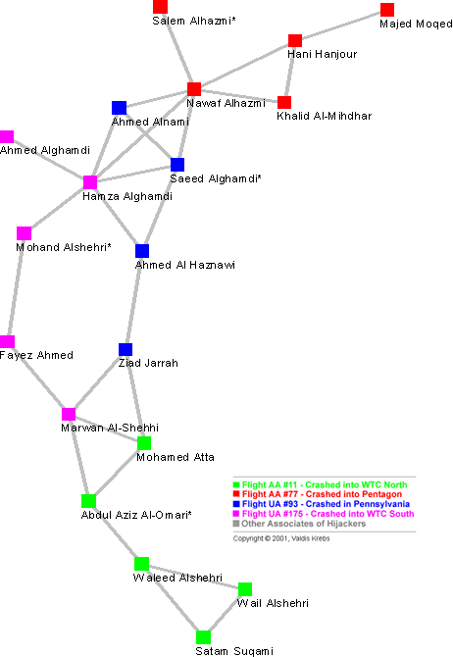

The network metrics for the network in [Figure 2](https://firstmonday.org/ojs/index.php/fm/article/download/941/863?inline=1#fig2) are found in [Table 1](https://firstmonday.org/ojs/index.php/fm/article/download/941/863?inline=1#tab1). For a small network of less than 20 nodes, we see a long average path length of 4.75 steps. Several of the hijackers are separated by more than 6 steps. From this metric and bin Laden's comments above we see that covert networks trade efficiency for secrecy.

**Table 1: Small-World Network Metrics**

|  |  |  |
| --- | --- | --- |
|  | **Clustering Coefficient** | **Average Path Length** |
| **Contacts** | 0.41 | 4.75 |
| **Contacts + Shortcuts** | 0.42 | 2.79 |

Yet, work has to be done, plans have to be executed. How does a covert network accomplish its goals? Through the judicious use of transitory shortcuts (Watts, 1999) in the network. Meetings were held that connected distant parts of the network to coordinate tasks and report progress. After coordination was accomplished, the cross-ties went dormant. One well documented meeting of the hijacker network took place in Las Vegas. The ties from this and other meetings are shown in gold in [Figure 3](https://firstmonday.org/ojs/index.php/fm/article/download/941/863?inline=1#fig3).

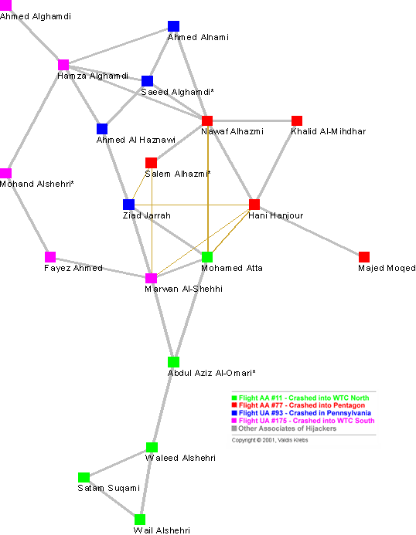

**Figure 3**

Six (6) shortcuts were added to the network temporarily in order to collaborate and coordinate. These shortcuts reduced the average path length in the network by over 40% thus improving the information flow in the network - see [Table 1](https://firstmonday.org/ojs/index.php/fm/article/download/941/863?inline=1#tab1). When the network is brought closer together by these shortcuts, all of the pilots ended up in a small clique - the perfect structure to efficiently coordinate tasks and activities. There is a constant dynamic between keeping the network hidden and actively using it to accomplish objectives (Baker and Faulkner, 1993).

The 19 hijackers did not work alone. They had other accomplices that did not get on the planes. These co-conspirators were conduits for money and also provided needed skills and knowledge. [Figure 4](https://firstmonday.org/ojs/index.php/fm/article/download/941/863?inline=1#fig4) shows the hijackers and their network neighborhood - their direct and indirect associates.

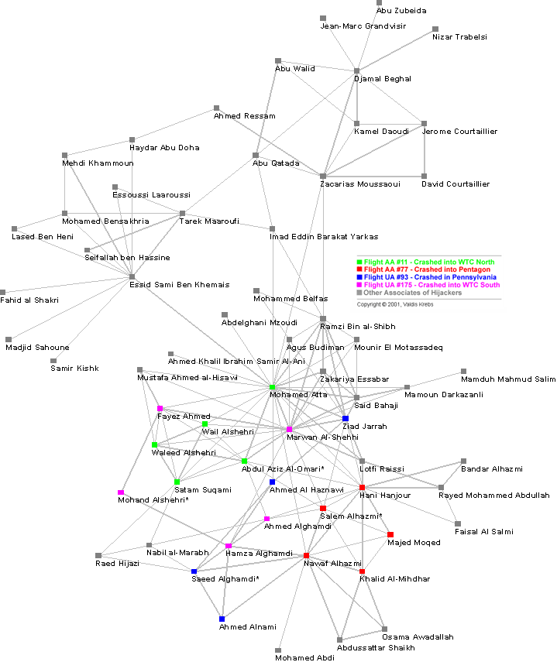

**Figure 4**

After one month of investigation it was 'common knowledge' that Mohamed Atta was the ring leader of this conspiracy. Again, bin Laden verified Atta's leadership role in the video tape (U.S. Department of Defense, 2001). Looking at the diagram he has the most connections. In [Table 2](https://firstmonday.org/ojs/index.php/fm/article/download/941/863?inline=1#tab2) we see that Atta scores the highest on all network centrality metrics - Degrees, Closeness, and Betweenness (Freeman, 1979). The network metric Degrees reveals Atta's *activity* in the network. Closeness measures his ability to *access* others in the network and monitor what is happening. Betweenness shows his *control* over the flow in the network - he plays the role of a *broker* in the network. These metrics support his leader status.

 DATA SET

Xml file:

<?xml version="1.0" encoding="UTF-8" standalone="true"?>

<DynamicNetwork><MetaNetwork><propertyIdentities><propertyIdentity singleValued="**false**" type="**number**" id="**autoCalc-componentStatistics-dyadCount**"/><propertyIdentity singleValued="**false**" type="**number**" id="**autoCalc-componentStatistics-isolateCount**"/><propertyIdentity singleValued="**false**" type="**number**" id="**autoCalc-componentStatistics-triadCount**"/><propertyIdentity singleValued="**false**" type="**number**" id="**autoCalc-density**"/><propertyIdentity singleValued="**false**" type="**number**" id="**autoCalc-densityAutoDetect**"/><propertyIdentity singleValued="**false**" type="**number**" id="**autoCalc-diagonalEdgeStatistics-binary**"/><propertyIdentity singleValued="**false**" type="**number**" id="**autoCalc-diagonalEdgeStatistics-len**"/><propertyIdentity singleValued="**false**" type="**number**" id="**autoCalc-diagonalEdgeStatistics-max**"/><propertyIdentity singleValued="**false**" type="**number**" id="**autoCalc-diagonalEdgeStatistics-min**"/><propertyIdentity singleValued="**false**" type="**number**" id="**autoCalc-diagonalEdgeStatistics-sum**"/><propertyIdentity singleValued="**false**" type="**number**" id="**autoCalc-diagonalEdgeStatistics-sumOfSquares**"/><propertyIdentity singleValued="**false**" type="**number**" id="**autoCalc-largeComponentStats-binary**"/><propertyIdentity singleValued="**false**" type="**number**" id="**autoCalc-largeComponentStats-len**"/><propertyIdentity singleValued="**false**" type="**number**" id="**autoCalc-largeComponentStats-max**"/><propertyIdentity singleValued="**false**" type="**number**" id="**autoCalc-largeComponentStats-min**"/><propertyIdentity singleValued="**false**" type="**number**" id="**autoCalc-largeComponentStats-sum**"/><propertyIdentity singleValued="**false**" type="**number**" id="**autoCalc-largeComponentStats-sumOfSquares**"/><propertyIdentity singleValued="**false**" type="**number**" id="**autoCalc-nonDiagonalEdgeStatistics-binary**"/><propertyIdentity singleValued="**false**" type="**number**" id="**autoCalc-nonDiagonalEdgeStatistics-len**"/><propertyIdentity singleValued="**false**" type="**number**" id="**autoCalc-nonDiagonalEdgeStatistics-max**"/><propertyIdentity singleValued="**false**" type="**number**" id="**autoCalc-nonDiagonalEdgeStatistics-min**"/><propertyIdentity singleValued="**false**" type="**number**" id="**autoCalc-nonDiagonalEdgeStatistics-sum**"/><propertyIdentity singleValued="**false**" type="**number**" id="**autoCalc-nonDiagonalEdgeStatistics-sumOfSquares**"/><propertyIdentity singleValued="**false**" type="**number**" id="**autoCalc-symmetric**"/><propertyIdentity singleValued="**true**" type="**number**" id="**unionCount**"/></propertyIdentities><sources/><property id="**autoCalc-componentStatistics-dyadCount**" value="**0**"/><property id="**autoCalc-componentStatistics-isolateCount**" value="**0**"/><property id="**autoCalc-componentStatistics-triadCount**" value="**0**"/><property id="**autoCalc-density**" value="**1.45085154827**"/><property id="**autoCalc-densityAutoDetect**" value="**1.45085154827**"/><property id="**autoCalc-diagonalEdgeStatistics-binary**" value="**3**"/><property id="**autoCalc-diagonalEdgeStatistics-len**" value="**0**"/><property id="**autoCalc-diagonalEdgeStatistics-max**" value="**0**"/><property id="**autoCalc-diagonalEdgeStatistics-min**" value="**0**"/><property id="**autoCalc-diagonalEdgeStatistics-sum**" value="**0**"/><property id="**autoCalc-diagonalEdgeStatistics-sumOfSquares**" value="**0**"/><property id="**autoCalc-largeComponentStats-binary**" value="**0**"/><property id="**autoCalc-largeComponentStats-len**" value="**3**"/><property id="**autoCalc-largeComponentStats-max**" value="**242**"/><property id="**autoCalc-largeComponentStats-min**" value="**242**"/><property id="**autoCalc-largeComponentStats-sum**" value="**242**"/><property id="**autoCalc-largeComponentStats-sumOfSquares**" value="**21188**"/><property id="**autoCalc-nonDiagonalEdgeStatistics-binary**" value="**1**"/><property id="**autoCalc-nonDiagonalEdgeStatistics-len**" value="**443**"/><property id="**autoCalc-nonDiagonalEdgeStatistics-max**" value="**11**"/><property id="**autoCalc-nonDiagonalEdgeStatistics-min**" value="**3**"/><property id="**autoCalc-nonDiagonalEdgeStatistics-sum**" value="**919**"/><property id="**autoCalc-nonDiagonalEdgeStatistics-sumOfSquares**" value="**2955**"/><property id="**autoCalc-symmetric**" value="**0**"/><property id="**unionCount**" value="**3**"/><nodes><nodeclass type="**Agent**" id="**Agent**"><node title="**Majed Moqed**" id="**Majed Moqed**"/><node title="**Khalid Al-Mihdhar**" id="**Khalid Al-Mihdhar**"/><node title="**Hani Hanjour**" id="**Hani Hanjour**"/><node title="**Nawaf Alhazmi**" id="**Nawaf Alhazmi**"/><node title="**Salem Alhazmi\***" id="**Salem Alhazmi\***"/><node title="**Ahmed Alnami**" id="**Ahmed Alnami**"/><node title="**Ahmed Alghamdi**" id="**Ahmed Alghamdi**"/><node title="**Saeed Alghamdi\***" id="**Saeed Alghamdi\***"/><node title="**Hamza Alghamdi**" id="**Hamza Alghamdi**"/><node title="**Ahmed Al Haznawi**" id="**Ahmed Al Haznawi**"/><node title="**Mohand Alshehri\***" id="**Mohand Alshehri\***"/><node title="**Fayez Ahmed**" id="**Fayez Ahmed**"/><node title="**Ziad Jarrah**" id="**Ziad Jarrah**"/><node title="**Marwan Al-Shehhi**" id="**Marwan Al-Shehhi**"/><node title="**Mohamed Atta**" id="**Mohamed Atta**"/><node title="**Abdul Aziz Al-Omari\***" id="**Abdul Aziz Al-Omari\***"/><node title="**Waleed Alshehri**" id="**Waleed Alshehri**"/><node title="**Wail Alshehri**" id="**Wail Alshehri**"/><node title="**Satam Suqami**" id="**Satam Suqami**"/><node title="**Raed Hijazi**" id="**Raed Hijazi**"/><node title="**Nabil al-Marabh**" id="**Nabil al-Marabh**"/><node title="**Mustafa Ahamend al-Hisawi**" id="**Mustafa Ahamend al-Hisawi**"/><node title="**Mamoun Darkazanli**" id="**Mamoun Darkazanli**"/><node title="**Zakariya Essabar**" id="**Zakariya Essabar**"/><node title="**Said Bahaji**" id="**Said Bahaji**"/><node title="**Mounir El Motassadeq**" id="**Mounir El Motassadeq**"/><node title="**Zacarias Moussaoui**" id="**Zacarias Moussaoui**"/><node title="**Ramzi Bin al-Shibh**" id="**Ramzi Bin al-Shibh**"/><node title="**Agus Budiman**" id="**Agus Budiman**"/><node title="**Ahed Khalil Ibrahim Samir Al-Ani**" id="**Ahed Khalil Ibrahim Samir Al-Ani**"/><node title="**Lofti Raissi**" id="**Lofti Raissi**"/><node title="**Rayed Mohammed Abdullah**" id="**Rayed Mohammed Abdullah**"/><node title="**Bandar Alhazmi**" id="**Bandar Alhazmi**"/><node title="**Faisal Al Salmi**" id="**Faisal Al Salmi**"/><node title="**Osama Awadallah**" id="**Osama Awadallah**"/><node title="**Abdussattar Shaikh**" id="**Abdussattar Shaikh**"/><node title="**Mohamed Abdi**" id="**Mohamed Abdi**"/><node title="**Mohamed Belfas**" id="**Mohamed Belfas**"/><node title="**Imad Eddin Baraat Yarkas**" id="**Imad Eddin Baraat Yarkas**"/><node title="**Tarek Maaroufi**" id="**Tarek Maaroufi**"/><node title="**Abu Qatada**" id="**Abu Qatada**"/><node title="**Djamal Benghal**" id="**Djamal Benghal**"/><node title="**Jerome Courtaillier**" id="**Jerome Courtaillier**"/><node title="**David Courtaillier**" id="**David Courtaillier**"/><node title="**Ahmen Ressam**" id="**Ahmen Ressam**"/><node title="**Abu Walid**" id="**Abu Walid**"/><node title="**Jean-Marc Grandvisir**" id="**Jean-Marc Grandvisir**"/><node title="**Abu Zubeida**" id="**Abu Zubeida**"/><node title="**Nizar Trabelsi**" id="**Nizar Trabelsi**"/><node title="**Haydar Abu Doha**" id="**Haydar Abu Doha**"/><node title="**Mehdi Khammoun**" id="**Mehdi Khammoun**"/><node title="**Mohammed Bensakhria**" id="**Mohammed Bensakhria**"/><node title="**Lased Ben Heni**" id="**Lased Ben Heni**"/><node title="**Essid Sami Ben Khemail**" id="**Essid Sami Ben Khemail**"/><node title="**Seifallah ben Hassine**" id="**Seifallah ben Hassine**"/><node title="**Essoussi Laaroussi**" id="**Essoussi Laaroussi**"/><node title="**Fahid al Shakri**" id="**Fahid al Shakri**"/><node title="**Madjid Sahoune**" id="**Madjid Sahoune**"/><node title="**Samir Kishk**" id="**Samir Kishk**"/><node title="**Kamel Daoudi**" id="**Kamel Daoudi**"/><node title="**Takek Maaroufi**" id="**Takek Maaroufi**"/></nodeclass><nodeclass type="**Role**" id="**Role**"><node title="**Majed Moqed**" id="**Majed Moqed**"/><node title="**Khalid Al-Mihdhar**" id="**Khalid Al-Mihdhar**"/><node title="**Hani Hanjour**" id="**Hani Hanjour**"/><node title="**Nawaf Alhazmi**" id="**Nawaf Alhazmi**"/><node title="**Salem Alhazmi\***" id="**Salem Alhazmi\***"/><node title="**Ahmed Alnami**" id="**Ahmed Alnami**"/><node title="**Ahmed Alghamdi**" id="**Ahmed Alghamdi**"/><node title="**Saeed Alghamdi\***" id="**Saeed Alghamdi\***"/><node title="**Hamza Alghamdi**" id="**Hamza Alghamdi**"/><node title="**Ahmed Al Haznawi**" id="**Ahmed Al Haznawi**"/><node title="**Mohand Alshehri\***" id="**Mohand Alshehri\***"/><node title="**Fayez Ahmed**" id="**Fayez Ahmed**"/><node title="**Ziad Jarrah**" id="**Ziad Jarrah**"/><node title="**Marwan Al-Shehhi**" id="**Marwan Al-Shehhi**"/><node title="**Mohamed Atta**" id="**Mohamed Atta**"/><node title="**Abdul Aziz Al-Omari\***" id="**Abdul Aziz Al-Omari\***"/><node title="**Waleed Alshehri**" id="**Waleed Alshehri**"/><node title="**Wail Alshehri**" id="**Wail Alshehri**"/><node title="**Satam Suqami**" id="**Satam Suqami**"/><node title="**Raed Hijazi**" id="**Raed Hijazi**"/><node title="**Nabil al-Marabh**" id="**Nabil al-Marabh**"/><node title="**Mustafa Ahamend al-Hisawi**" id="**Mustafa Ahamend al-Hisawi**"/><node title="**Mamoun Darkazanli**" id="**Mamoun Darkazanli**"/><node title="**Zakariya Essabar**" id="**Zakariya Essabar**"/><node title="**Said Bahaji**" id="**Said Bahaji**"/><node title="**Mounir El Motassadeq**" id="**Mounir El Motassadeq**"/><node title="**Zacarias Moussaoui**" id="**Zacarias Moussaoui**"/><node title="**Ramzi Bin al-Shibh**" id="**Ramzi Bin al-Shibh**"/><node title="**Agus Budiman**" id="**Agus Budiman**"/><node title="**Ahed Khalil Ibrahim Samir Al-Ani**" id="**Ahed Khalil Ibrahim Samir Al-Ani**"/><node title="**Lofti Raissi**" id="**Lofti Raissi**"/><node title="**Rayed Mohammed Abdullah**" id="**Rayed Mohammed Abdullah**"/><node title="**Bandar Alhazmi**" id="**Bandar Alhazmi**"/><node title="**Faisal Al Salmi**" id="**Faisal Al Salmi**"/><node title="**Osama Awadallah**" id="**Osama Awadallah**"/><node title="**Abdussattar Shaikh**" id="**Abdussattar Shaikh**"/><node title="**Mohamed Abdi**" id="**Mohamed Abdi**"/><node title="**Mohamed Belfas**" id="**Mohamed Belfas**"/><node title="**Imad Eddin Baraat Yarkas**" id="**Imad Eddin Baraat Yarkas**"/><node title="**Tarek Maaroufi**" id="**Tarek Maaroufi**"/><node title="**Abu Qatada**" id="**Abu Qatada**"/><node title="**Djamal Benghal**" id="**Djamal Benghal**"/><node title="**Jerome Courtaillier**" id="**Jerome Courtaillier**"/><node title="**David Courtaillier**" id="**David Courtaillier**"/><node title="**Ahmen Ressam**" id="**Ahmen Ressam**"/><node title="**Abu Walid**" id="**Abu Walid**"/><node title="**Jean-Marc Grandvisir**" id="**Jean-Marc Grandvisir**"/><node title="**Abu Zubeida**" id="**Abu Zubeida**"/><node title="**Nizar Trabelsi**" id="**Nizar Trabelsi**"/><node title="**Haydar Abu Doha**" id="**Haydar Abu Doha**"/><node title="**Mehdi Khammoun**" id="**Mehdi Khammoun**"/><node title="**Mohammed Bensakhria**" id="**Mohammed Bensakhria**"/><node title="**Lased Ben Heni**" id="**Lased Ben Heni**"/><node title="**Essid Sami Ben Khemail**" id="**Essid Sami Ben Khemail**"/><node title="**Seifallah ben Hassine**" id="**Seifallah ben Hassine**"/><node title="**Essoussi Laaroussi**" id="**Essoussi Laaroussi**"/><node title="**Fahid al Shakri**" id="**Fahid al Shakri**"/><node title="**Madjid Sahoune**" id="**Madjid Sahoune**"/><node title="**Samir Kishk**" id="**Samir Kishk**"/><node title="**Kamel Daoudi**" id="**Kamel Daoudi**"/></nodeclass><nodeclass type="**Event**" id="**Event**"><node title="**Network Strength**" id="**Network Strength**"/><node title="**Ties**" id="**Ties**"/><node title="**Las Vegas Meeting**" id="**Las Vegas Meeting**"/></nodeclass><nodeclass type="**Action**" id="**Action**"><node title="**Network Strength**" id="**Network Strength**"/><node title="**Ties**" id="**Ties**"/><node title="**Las Vegas Meeting**" id="**Las Vegas Meeting**"/></nodeclass></nodes><networks><network id="**Agent x Role**" allowSelfLoops="**true**" isBinary="**false**" isDirected="**true**" target="**Role**" targetType="**Role**" source="**Agent**" sourceType="**Agent**"><property id="**autoCalc-componentStatistics-dyadCount**" value="**0**"/><property id="**autoCalc-componentStatistics-isolateCount**" value="**6**"/><property id="**autoCalc-componentStatistics-triadCount**" value="**0**"/><property id="**autoCalc-density**" value="**0.0519444444444**"/><property id="**autoCalc-densityAutoDetect**" value="**0.0519444444444**"/><property id="**autoCalc-diagonalEdgeStatistics-binary**" value="**1**"/><property id="**autoCalc-diagonalEdgeStatistics-len**" value="**0**"/><property id="**autoCalc-diagonalEdgeStatistics-max**" value="**0**"/><property id="**autoCalc-diagonalEdgeStatistics-min**" value="**0**"/><property id="**autoCalc-diagonalEdgeStatistics-sum**" value="**0**"/><property id="**autoCalc-diagonalEdgeStatistics-sumOfSquares**" value="**0**"/><property id="**autoCalc-largeComponentStats-binary**" value="**0**"/><property id="**autoCalc-largeComponentStats-len**" value="**1**"/><property id="**autoCalc-largeComponentStats-max**" value="**114**"/><property id="**autoCalc-largeComponentStats-min**" value="**114**"/><property id="**autoCalc-largeComponentStats-sum**" value="**114**"/><property id="**autoCalc-largeComponentStats-sumOfSquares**" value="**12996**"/><property id="**autoCalc-nonDiagonalEdgeStatistics-binary**" value="**1**"/><property id="**autoCalc-nonDiagonalEdgeStatistics-len**" value="**187**"/><property id="**autoCalc-nonDiagonalEdgeStatistics-max**" value="**1**"/><property id="**autoCalc-nonDiagonalEdgeStatistics-min**" value="**1**"/><property id="**autoCalc-nonDiagonalEdgeStatistics-sum**" value="**187**"/><property id="**autoCalc-nonDiagonalEdgeStatistics-sumOfSquares**" value="**187**"/><property id="**autoCalc-symmetric**" value="**0**"/><link target="**Hani Hanjour**" source="**Majed Moqed**"/><link target="**Hani Hanjour**" source="**Khalid Al-Mihdhar**"/><link target="**Nawaf Alhazmi**" source="**Khalid Al-Mihdhar**"/><link target="**Majed Moqed**" source="**Hani Hanjour**"/><link target="**Khalid Al-Mihdhar**" source="**Hani Hanjour**"/><link target="**Nawaf Alhazmi**" source="**Hani Hanjour**"/><link target="**Khalid Al-Mihdhar**" source="**Nawaf Alhazmi**"/><link target="**Hani Hanjour**" source="**Nawaf Alhazmi**"/><link target="**Salem Alhazmi\***" source="**Nawaf Alhazmi**"/><link target="**Ahmed Alnami**" source="**Nawaf Alhazmi**"/><link target="**Saeed Alghamdi\***" source="**Nawaf Alhazmi**"/><link target="**Hamza Alghamdi**" source="**Nawaf Alhazmi**"/><link target="**Nawaf Alhazmi**" source="**Salem Alhazmi\***"/><link target="**Saeed Alghamdi\***" source="**Ahmed Alnami**"/><link target="**Hamza Alghamdi**" source="**Ahmed Alnami**"/><link target="**Hamza Alghamdi**" source="**Ahmed Alghamdi**"/><link target="**Ahmed Alnami**" source="**Hamza Alghamdi**"/><link target="**Ahmed Alghamdi**" source="**Hamza Alghamdi**"/><link target="**Saeed Alghamdi\***" source="**Hamza Alghamdi**"/><link target="**Ahmed Al Haznawi**" source="**Hamza Alghamdi**"/><link target="**Mohand Alshehri\***" source="**Hamza Alghamdi**"/><link target="**Saeed Alghamdi\***" source="**Ahmed Al Haznawi**"/><link target="**Hamza Alghamdi**" source="**Ahmed Al Haznawi**"/><link target="**Ziad Jarrah**" source="**Ahmed Al Haznawi**"/><link target="**Hamza Alghamdi**" source="**Mohand Alshehri\***"/><link target="**Fayez Ahmed**" source="**Mohand Alshehri\***"/><link target="**Mohand Alshehri\***" source="**Fayez Ahmed**"/><link target="**Marwan Al-Shehhi**" source="**Fayez Ahmed**"/><link target="**Ahmed Al Haznawi**" source="**Ziad Jarrah**"/><link target="**Marwan Al-Shehhi**" source="**Ziad Jarrah**"/><link target="**Mohamed Atta**" source="**Ziad Jarrah**"/><link target="**Fayez Ahmed**" source="**Marwan Al-Shehhi**"/><link target="**Ziad Jarrah**" source="**Marwan Al-Shehhi**"/><link target="**Mohamed Atta**" source="**Marwan Al-Shehhi**"/><link target="**Abdul Aziz Al-Omari\***" source="**Marwan Al-Shehhi**"/><link target="**Ziad Jarrah**" source="**Mohamed Atta**"/><link target="**Marwan Al-Shehhi**" source="**Mohamed Atta**"/><link target="**Abdul Aziz Al-Omari\***" source="**Mohamed Atta**"/><link target="**Marwan Al-Shehhi**" source="**Abdul Aziz Al-Omari\***"/><link target="**Mohamed Atta**" source="**Abdul Aziz Al-Omari\***"/><link target="**Waleed Alshehri**" source="**Abdul Aziz Al-Omari\***"/><link target="**Abdul Aziz Al-Omari\***" source="**Waleed Alshehri**"/><link target="**Wail Alshehri**" source="**Waleed Alshehri**"/><link target="**Satam Suqami**" source="**Waleed Alshehri**"/><link target="**Waleed Alshehri**" source="**Wail Alshehri**"/><link target="**Satam Suqami**" source="**Wail Alshehri**"/><link target="**Waleed Alshehri**" source="**Satam Suqami**"/><link target="**Wail Alshehri**" source="**Satam Suqami**"/><link target="**Saeed Alghamdi\***" source="**Raed Hijazi**"/><link target="**Satam Suqami**" source="**Raed Hijazi**"/><link target="**Nabil al-Marabh**" source="**Raed Hijazi**"/><link target="**Ahmed Alghamdi**" source="**Nabil al-Marabh**"/><link target="**Saeed Alghamdi\***" source="**Nabil al-Marabh**"/><link target="**Satam Suqami**" source="**Nabil al-Marabh**"/><link target="**Raed Hijazi**" source="**Nabil al-Marabh**"/><link target="**Fayez Ahmed**" source="**Mustafa Ahamend al-Hisawi**"/><link target="**Marwan Al-Shehhi**" source="**Mustafa Ahamend al-Hisawi**"/><link target="**Mohamed Atta**" source="**Mustafa Ahamend al-Hisawi**"/><link target="**Waleed Alshehri**" source="**Mustafa Ahamend al-Hisawi**"/><link target="**Marwan Al-Shehhi**" source="**Mamoun Darkazanli**"/><link target="**Mohamed Atta**" source="**Mamoun Darkazanli**"/><link target="**Said Bahaji**" source="**Mamoun Darkazanli**"/><link target="**Ziad Jarrah**" source="**Zakariya Essabar**"/><link target="**Marwan Al-Shehhi**" source="**Zakariya Essabar**"/><link target="**Mohamed Atta**" source="**Zakariya Essabar**"/><link target="**Said Bahaji**" source="**Zakariya Essabar**"/><link target="**Ramzi Bin al-Shibh**" source="**Zakariya Essabar**"/><link target="**Ziad Jarrah**" source="**Said Bahaji**"/><link target="**Marwan Al-Shehhi**" source="**Said Bahaji**"/><link target="**Mohamed Atta**" source="**Said Bahaji**"/><link target="**Mamoun Darkazanli**" source="**Said Bahaji**"/><link target="**Zakariya Essabar**" source="**Said Bahaji**"/><link target="**Mounir El Motassadeq**" source="**Said Bahaji**"/><link target="**Ramzi Bin al-Shibh**" source="**Said Bahaji**"/><link target="**Marwan Al-Shehhi**" source="**Mounir El Motassadeq**"/><link target="**Mohamed Atta**" source="**Mounir El Motassadeq**"/><link target="**Said Bahaji**" source="**Mounir El Motassadeq**"/><link target="**Ramzi Bin al-Shibh**" source="**Mounir El Motassadeq**"/><link target="**Mohamed Atta**" source="**Zacarias Moussaoui**"/><link target="**Ramzi Bin al-Shibh**" source="**Zacarias Moussaoui**"/><link target="**Abu Qatada**" source="**Zacarias Moussaoui**"/><link target="**Djamal Benghal**" source="**Zacarias Moussaoui**"/><link target="**Jerome Courtaillier**" source="**Zacarias Moussaoui**"/><link target="**David Courtaillier**" source="**Zacarias Moussaoui**"/><link target="**Ahmen Ressam**" source="**Zacarias Moussaoui**"/><link target="**Ziad Jarrah**" source="**Ramzi Bin al-Shibh**"/><link target="**Marwan Al-Shehhi**" source="**Ramzi Bin al-Shibh**"/><link target="**Mohamed Atta**" source="**Ramzi Bin al-Shibh**"/><link target="**Zakariya Essabar**" source="**Ramzi Bin al-Shibh**"/><link target="**Said Bahaji**" source="**Ramzi Bin al-Shibh**"/><link target="**Mounir El Motassadeq**" source="**Ramzi Bin al-Shibh**"/><link target="**Zacarias Moussaoui**" source="**Ramzi Bin al-Shibh**"/><link target="**Agus Budiman**" source="**Ramzi Bin al-Shibh**"/><link target="**Ziad Jarrah**" source="**Agus Budiman**"/><link target="**Marwan Al-Shehhi**" source="**Agus Budiman**"/><link target="**Mohamed Atta**" source="**Agus Budiman**"/><link target="**Ramzi Bin al-Shibh**" source="**Agus Budiman**"/><link target="**Mohamed Atta**" source="**Ahed Khalil Ibrahim Samir Al-Ani**"/><link target="**Hani Hanjour**" source="**Lofti Raissi**"/><link target="**Ziad Jarrah**" source="**Lofti Raissi**"/><link target="**Marwan Al-Shehhi**" source="**Lofti Raissi**"/><link target="**Mohamed Atta**" source="**Lofti Raissi**"/><link target="**Rayed Mohammed Abdullah**" source="**Lofti Raissi**"/><link target="**Hani Hanjour**" source="**Rayed Mohammed Abdullah**"/><link target="**Rayed Mohammed Abdullah**" source="**Rayed Mohammed Abdullah**"/><link target="**Bandar Alhazmi**" source="**Rayed Mohammed Abdullah**"/><link target="**Faisal Al Salmi**" source="**Rayed Mohammed Abdullah**"/><link target="**Hani Hanjour**" source="**Bandar Alhazmi**"/><link target="**Rayed Mohammed Abdullah**" source="**Bandar Alhazmi**"/><link target="**Hani Hanjour**" source="**Faisal Al Salmi**"/><link target="**Rayed Mohammed Abdullah**" source="**Faisal Al Salmi**"/><link target="**Khalid Al-Mihdhar**" source="**Osama Awadallah**"/><link target="**Nawaf Alhazmi**" source="**Osama Awadallah**"/><link target="**Abdussattar Shaikh**" source="**Osama Awadallah**"/><link target="**Khalid Al-Mihdhar**" source="**Abdussattar Shaikh**"/><link target="**Nawaf Alhazmi**" source="**Abdussattar Shaikh**"/><link target="**Osama Awadallah**" source="**Abdussattar Shaikh**"/><link target="**Nawaf Alhazmi**" source="**Mohamed Abdi**"/><link target="**Agus Budiman**" source="**Mohamed Belfas**"/><link target="**Ahed Khalil Ibrahim Samir Al-Ani**" source="**Mohamed Belfas**"/><link target="**Mohamed Atta**" source="**Imad Eddin Baraat Yarkas**"/><link target="**Ramzi Bin al-Shibh**" source="**Imad Eddin Baraat Yarkas**"/><link target="**Abu Qatada**" source="**Imad Eddin Baraat Yarkas**"/><link target="**Imad Eddin Baraat Yarkas**" source="**Tarek Maaroufi**"/><link target="**Abu Qatada**" source="**Tarek Maaroufi**"/><link target="**Mohammed Bensakhria**" source="**Tarek Maaroufi**"/><link target="**Essid Sami Ben Khemail**" source="**Tarek Maaroufi**"/><link target="**Seifallah ben Hassine**" source="**Tarek Maaroufi**"/><link target="**Essoussi Laaroussi**" source="**Tarek Maaroufi**"/><link target="**Zacarias Moussaoui**" source="**Abu Qatada**"/><link target="**Imad Eddin Baraat Yarkas**" source="**Abu Qatada**"/><link target="**Djamal Benghal**" source="**Abu Qatada**"/><link target="**Abu Walid**" source="**Abu Qatada**"/><link target="**Zacarias Moussaoui**" source="**Djamal Benghal**"/><link target="**Abu Qatada**" source="**Djamal Benghal**"/><link target="**Jerome Courtaillier**" source="**Djamal Benghal**"/><link target="**David Courtaillier**" source="**Djamal Benghal**"/><link target="**Abu Walid**" source="**Djamal Benghal**"/><link target="**Jean-Marc Grandvisir**" source="**Djamal Benghal**"/><link target="**Abu Zubeida**" source="**Djamal Benghal**"/><link target="**Nizar Trabelsi**" source="**Djamal Benghal**"/><link target="**Zacarias Moussaoui**" source="**Jerome Courtaillier**"/><link target="**Djamal Benghal**" source="**Jerome Courtaillier**"/><link target="**David Courtaillier**" source="**Jerome Courtaillier**"/><link target="**Kamel Daoudi**" source="**Jerome Courtaillier**"/><link target="**Zacarias Moussaoui**" source="**David Courtaillier**"/><link target="**Jerome Courtaillier**" source="**David Courtaillier**"/><link target="**Zacarias Moussaoui**" source="**Ahmen Ressam**"/><link target="**Haydar Abu Doha**" source="**Ahmen Ressam**"/><link target="**Abu Qatada**" source="**Abu Walid**"/><link target="**Djamal Benghal**" source="**Abu Walid**"/><link target="**Kamel Daoudi**" source="**Abu Walid**"/><link target="**Djamal Benghal**" source="**Jean-Marc Grandvisir**"/><link target="**Djamal Benghal**" source="**Abu Zubeida**"/><link target="**Djamal Benghal**" source="**Nizar Trabelsi**"/><link target="**Ahmen Ressam**" source="**Haydar Abu Doha**"/><link target="**Essid Sami Ben Khemail**" source="**Haydar Abu Doha**"/><link target="**Madjid Sahoune**" source="**Haydar Abu Doha**"/><link target="**Haydar Abu Doha**" source="**Mehdi Khammoun**"/><link target="**Mohammed Bensakhria**" source="**Mehdi Khammoun**"/><link target="**Essid Sami Ben Khemail**" source="**Mehdi Khammoun**"/><link target="**Mehdi Khammoun**" source="**Mohammed Bensakhria**"/><link target="**Lased Ben Heni**" source="**Mohammed Bensakhria**"/><link target="**Essid Sami Ben Khemail**" source="**Mohammed Bensakhria**"/><link target="**Mohammed Bensakhria**" source="**Lased Ben Heni**"/><link target="**Essid Sami Ben Khemail**" source="**Lased Ben Heni**"/><link target="**Mohamed Atta**" source="**Essid Sami Ben Khemail**"/><link target="**Haydar Abu Doha**" source="**Essid Sami Ben Khemail**"/><link target="**Mehdi Khammoun**" source="**Essid Sami Ben Khemail**"/><link target="**Mohammed Bensakhria**" source="**Essid Sami Ben Khemail**"/><link target="**Lased Ben Heni**" source="**Essid Sami Ben Khemail**"/><link target="**Seifallah ben Hassine**" source="**Essid Sami Ben Khemail**"/><link target="**Essoussi Laaroussi**" source="**Essid Sami Ben Khemail**"/><link target="**Fahid al Shakri**" source="**Essid Sami Ben Khemail**"/><link target="**Madjid Sahoune**" source="**Essid Sami Ben Khemail**"/><link target="**Samir Kishk**" source="**Essid Sami Ben Khemail**"/><link target="**Essid Sami Ben Khemail**" source="**Seifallah ben Hassine**"/><link target="**Essid Sami Ben Khemail**" source="**Essoussi Laaroussi**"/><link target="**Essid Sami Ben Khemail**" source="**Fahid al Shakri**"/><link target="**Essid Sami Ben Khemail**" source="**Madjid Sahoune**"/><link target="**Essid Sami Ben Khemail**" source="**Samir Kishk**"/><link target="**Zacarias Moussaoui**" source="**Kamel Daoudi**"/><link target="**Abu Qatada**" source="**Kamel Daoudi**"/><link target="**Djamal Benghal**" source="**Kamel Daoudi**"/><link target="**Jerome Courtaillier**" source="**Kamel Daoudi**"/><link target="**David Courtaillier**" source="**Kamel Daoudi**"/><link target="**Abu Walid**" source="**Kamel Daoudi**"/></network><network id="**Agent x Event**" allowSelfLoops="**true**" isBinary="**false**" isDirected="**true**" target="**Event**" targetType="**Event**" source="**Agent**" sourceType="**Agent**"><property id="**autoCalc-componentStatistics-dyadCount**" value="**0**"/><property id="**autoCalc-componentStatistics-isolateCount**" value="**0**"/><property id="**autoCalc-componentStatistics-triadCount**" value="**0**"/><property id="**autoCalc-density**" value="**0.699453551913**"/><property id="**autoCalc-densityAutoDetect**" value="**0.699453551913**"/><property id="**autoCalc-diagonalEdgeStatistics-binary**" value="**1**"/><property id="**autoCalc-diagonalEdgeStatistics-len**" value="**0**"/><property id="**autoCalc-diagonalEdgeStatistics-max**" value="**0**"/><property id="**autoCalc-diagonalEdgeStatistics-min**" value="**0**"/><property id="**autoCalc-diagonalEdgeStatistics-sum**" value="**0**"/><property id="**autoCalc-diagonalEdgeStatistics-sumOfSquares**" value="**0**"/><property id="**autoCalc-largeComponentStats-binary**" value="**0**"/><property id="**autoCalc-largeComponentStats-len**" value="**1**"/><property id="**autoCalc-largeComponentStats-max**" value="**64**"/><property id="**autoCalc-largeComponentStats-min**" value="**64**"/><property id="**autoCalc-largeComponentStats-sum**" value="**64**"/><property id="**autoCalc-largeComponentStats-sumOfSquares**" value="**4096**"/><property id="**autoCalc-nonDiagonalEdgeStatistics-binary**" value="**0**"/><property id="**autoCalc-nonDiagonalEdgeStatistics-len**" value="**128**"/><property id="**autoCalc-nonDiagonalEdgeStatistics-max**" value="**5**"/><property id="**autoCalc-nonDiagonalEdgeStatistics-min**" value="**1**"/><property id="**autoCalc-nonDiagonalEdgeStatistics-sum**" value="**366**"/><property id="**autoCalc-nonDiagonalEdgeStatistics-sumOfSquares**" value="**1384**"/><property id="**autoCalc-symmetric**" value="**0**"/><link target="**Network Strength**" source="**Majed Moqed**"/><link value="**2**" target="**Ties**" source="**Majed Moqed**"/><link target="**Network Strength**" source="**Khalid Al-Mihdhar**"/><link value="**2**" target="**Ties**" source="**Khalid Al-Mihdhar**"/><link target="**Network Strength**" source="**Hani Hanjour**"/><link value="**2**" target="**Ties**" source="**Hani Hanjour**"/><link target="**Las Vegas Meeting**" source="**Hani Hanjour**"/><link target="**Network Strength**" source="**Nawaf Alhazmi**"/><link value="**2**" target="**Ties**" source="**Nawaf Alhazmi**"/><link target="**Las Vegas Meeting**" source="**Nawaf Alhazmi**"/><link target="**Network Strength**" source="**Salem Alhazmi\***"/><link value="**2**" target="**Ties**" source="**Salem Alhazmi\***"/><link target="**Las Vegas Meeting**" source="**Salem Alhazmi\***"/><link target="**Network Strength**" source="**Ahmed Alnami**"/><link value="**3**" target="**Ties**" source="**Ahmed Alnami**"/><link target="**Network Strength**" source="**Ahmed Alghamdi**"/><link value="**4**" target="**Ties**" source="**Ahmed Alghamdi**"/><link target="**Network Strength**" source="**Saeed Alghamdi\***"/><link value="**3**" target="**Ties**" source="**Saeed Alghamdi\***"/><link target="**Network Strength**" source="**Hamza Alghamdi**"/><link value="**4**" target="**Ties**" source="**Hamza Alghamdi**"/><link target="**Network Strength**" source="**Ahmed Al Haznawi**"/><link value="**3**" target="**Ties**" source="**Ahmed Al Haznawi**"/><link target="**Network Strength**" source="**Mohand Alshehri\***"/><link value="**4**" target="**Ties**" source="**Mohand Alshehri\***"/><link target="**Network Strength**" source="**Fayez Ahmed**"/><link value="**4**" target="**Ties**" source="**Fayez Ahmed**"/><link target="**Network Strength**" source="**Ziad Jarrah**"/><link value="**3**" target="**Ties**" source="**Ziad Jarrah**"/><link target="**Las Vegas Meeting**" source="**Ziad Jarrah**"/><link target="**Network Strength**" source="**Marwan Al-Shehhi**"/><link value="**4**" target="**Ties**" source="**Marwan Al-Shehhi**"/><link target="**Las Vegas Meeting**" source="**Marwan Al-Shehhi**"/><link target="**Network Strength**" source="**Mohamed Atta**"/><link target="**Ties**" source="**Mohamed Atta**"/><link target="**Las Vegas Meeting**" source="**Mohamed Atta**"/><link target="**Network Strength**" source="**Abdul Aziz Al-Omari\***"/><link target="**Ties**" source="**Abdul Aziz Al-Omari\***"/><link target="**Network Strength**" source="**Waleed Alshehri**"/><link target="**Ties**" source="**Waleed Alshehri**"/><link target="**Network Strength**" source="**Wail Alshehri**"/><link target="**Ties**" source="**Wail Alshehri**"/><link target="**Network Strength**" source="**Satam Suqami**"/><link target="**Ties**" source="**Satam Suqami**"/><link value="**2**" target="**Network Strength**" source="**Raed Hijazi**"/><link value="**5**" target="**Ties**" source="**Raed Hijazi**"/><link value="**2**" target="**Network Strength**" source="**Nabil al-Marabh**"/><link value="**5**" target="**Ties**" source="**Nabil al-Marabh**"/><link value="**2**" target="**Network Strength**" source="**Mustafa Ahamend al-Hisawi**"/><link value="**5**" target="**Ties**" source="**Mustafa Ahamend al-Hisawi**"/><link value="**2**" target="**Network Strength**" source="**Mamoun Darkazanli**"/><link value="**5**" target="**Ties**" source="**Mamoun Darkazanli**"/><link value="**2**" target="**Network Strength**" source="**Zakariya Essabar**"/><link value="**5**" target="**Ties**" source="**Zakariya Essabar**"/><link value="**2**" target="**Network Strength**" source="**Said Bahaji**"/><link value="**5**" target="**Ties**" source="**Said Bahaji**"/><link value="**2**" target="**Network Strength**" source="**Mounir El Motassadeq**"/><link value="**5**" target="**Ties**" source="**Mounir El Motassadeq**"/><link value="**2**" target="**Network Strength**" source="**Zacarias Moussaoui**"/><link value="**5**" target="**Ties**" source="**Zacarias Moussaoui**"/><link value="**2**" target="**Network Strength**" source="**Ramzi Bin al-Shibh**"/><link value="**5**" target="**Ties**" source="**Ramzi Bin al-Shibh**"/><link value="**2**" target="**Network Strength**" source="**Agus Budiman**"/><link value="**5**" target="**Ties**" source="**Agus Budiman**"/><link value="**2**" target="**Network Strength**" source="**Ahed Khalil Ibrahim Samir Al-Ani**"/><link value="**5**" target="**Ties**" source="**Ahed Khalil Ibrahim Samir Al-Ani**"/><link value="**2**" target="**Network Strength**" source="**Lofti Raissi**"/><link value="**5**" target="**Ties**" source="**Lofti Raissi**"/><link value="**2**" target="**Network Strength**" source="**Rayed Mohammed Abdullah**"/><link value="**5**" target="**Ties**" source="**Rayed Mohammed Abdullah**"/><link value="**2**" target="**Network Strength**" source="**Bandar Alhazmi**"/><link value="**5**" target="**Ties**" source="**Bandar Alhazmi**"/><link value="**2**" target="**Network Strength**" source="**Faisal Al Salmi**"/><link value="**5**" target="**Ties**" source="**Faisal Al Salmi**"/><link value="**2**" target="**Network Strength**" source="**Osama Awadallah**"/><link value="**5**" target="**Ties**" source="**Osama Awadallah**"/><link value="**2**" target="**Network Strength**" source="**Abdussattar Shaikh**"/><link value="**5**" target="**Ties**" source="**Abdussattar Shaikh**"/><link value="**2**" target="**Network Strength**" source="**Mohamed Abdi**"/><link value="**5**" target="**Ties**" source="**Mohamed Abdi**"/><link value="**2**" target="**Network Strength**" source="**Mohamed Belfas**"/><link value="**5**" target="**Ties**" source="**Mohamed Belfas**"/><link value="**2**" target="**Network Strength**" source="**Imad Eddin Baraat Yarkas**"/><link value="**5**" target="**Ties**" source="**Imad Eddin Baraat Yarkas**"/><link value="**2**" target="**Network Strength**" source="**Tarek Maaroufi**"/><link value="**5**" target="**Ties**" source="**Tarek Maaroufi**"/><link value="**2**" target="**Network Strength**" source="**Abu Qatada**"/><link value="**5**" target="**Ties**" source="**Abu Qatada**"/><link value="**2**" target="**Network Strength**" source="**Djamal Benghal**"/><link value="**5**" target="**Ties**" source="**Djamal Benghal**"/><link value="**2**" target="**Network Strength**" source="**Jerome Courtaillier**"/><link value="**5**" target="**Ties**" source="**Jerome Courtaillier**"/><link value="**2**" target="**Network Strength**" source="**David Courtaillier**"/><link value="**5**" target="**Ties**" source="**David Courtaillier**"/><link value="**2**" target="**Network Strength**" source="**Ahmen Ressam**"/><link value="**5**" target="**Ties**" source="**Ahmen Ressam**"/><link value="**2**" target="**Network Strength**" source="**Abu Walid**"/><link value="**5**" target="**Ties**" source="**Abu Walid**"/><link value="**2**" target="**Network Strength**" source="**Jean-Marc Grandvisir**"/><link value="**5**" target="**Ties**" source="**Jean-Marc Grandvisir**"/><link value="**2**" target="**Network Strength**" source="**Abu Zubeida**"/><link value="**5**" target="**Ties**" source="**Abu Zubeida**"/><link value="**2**" target="**Network Strength**" source="**Nizar Trabelsi**"/><link value="**5**" target="**Ties**" source="**Nizar Trabelsi**"/><link value="**2**" target="**Network Strength**" source="**Haydar Abu Doha**"/><link value="**5**" target="**Ties**" source="**Haydar Abu Doha**"/><link value="**2**" target="**Network Strength**" source="**Mehdi Khammoun**"/><link value="**5**" target="**Ties**" source="**Mehdi Khammoun**"/><link value="**2**" target="**Network Strength**" source="**Mohammed Bensakhria**"/><link value="**5**" target="**Ties**" source="**Mohammed Bensakhria**"/><link value="**2**" target="**Network Strength**" source="**Lased Ben Heni**"/><link value="**5**" target="**Ties**" source="**Lased Ben Heni**"/><link value="**2**" target="**Network Strength**" source="**Essid Sami Ben Khemail**"/><link value="**5**" target="**Ties**" source="**Essid Sami Ben Khemail**"/><link value="**2**" target="**Network Strength**" source="**Seifallah ben Hassine**"/><link value="**5**" target="**Ties**" source="**Seifallah ben Hassine**"/><link value="**2**" target="**Network Strength**" source="**Essoussi Laaroussi**"/><link value="**5**" target="**Ties**" source="**Essoussi Laaroussi**"/><link value="**2**" target="**Network Strength**" source="**Fahid al Shakri**"/><link value="**5**" target="**Ties**" source="**Fahid al Shakri**"/><link value="**2**" target="**Network Strength**" source="**Madjid Sahoune**"/><link value="**5**" target="**Ties**" source="**Madjid Sahoune**"/><link value="**2**" target="**Network Strength**" source="**Samir Kishk**"/><link value="**5**" target="**Ties**" source="**Samir Kishk**"/><link value="**2**" target="**Network Strength**" source="**Kamel Daoudi**"/><link value="**5**" target="**Ties**" source="**Kamel Daoudi**"/><link value="**2**" target="**Network Strength**" source="**Takek Maaroufi**"/><link value="**5**" target="**Ties**" source="**Takek Maaroufi**"/></network><network id="**Agent x Action**" allowSelfLoops="**true**" isBinary="**false**" isDirected="**true**" target="**Action**" targetType="**Action**" source="**Agent**" sourceType="**Agent**"><property id="**autoCalc-componentStatistics-dyadCount**" value="**0**"/><property id="**autoCalc-componentStatistics-isolateCount**" value="**0**"/><property id="**autoCalc-componentStatistics-triadCount**" value="**0**"/><property id="**autoCalc-density**" value="**0.699453551913**"/><property id="**autoCalc-densityAutoDetect**" value="**0.699453551913**"/><property id="**autoCalc-diagonalEdgeStatistics-binary**" value="**1**"/><property id="**autoCalc-diagonalEdgeStatistics-len**" value="**0**"/><property id="**autoCalc-diagonalEdgeStatistics-max**" value="**0**"/><property id="**autoCalc-diagonalEdgeStatistics-min**" value="**0**"/><property id="**autoCalc-diagonalEdgeStatistics-sum**" value="**0**"/><property id="**autoCalc-diagonalEdgeStatistics-sumOfSquares**" value="**0**"/><property id="**autoCalc-largeComponentStats-binary**" value="**0**"/><property id="**autoCalc-largeComponentStats-len**" value="**1**"/><property id="**autoCalc-largeComponentStats-max**" value="**64**"/><property id="**autoCalc-largeComponentStats-min**" value="**64**"/><property id="**autoCalc-largeComponentStats-sum**" value="**64**"/><property id="**autoCalc-largeComponentStats-sumOfSquares**" value="**4096**"/><property id="**autoCalc-nonDiagonalEdgeStatistics-binary**" value="**0**"/><property id="**autoCalc-nonDiagonalEdgeStatistics-len**" value="**128**"/><property id="**autoCalc-nonDiagonalEdgeStatistics-max**" value="**5**"/><property id="**autoCalc-nonDiagonalEdgeStatistics-min**" value="**1**"/><property id="**autoCalc-nonDiagonalEdgeStatistics-sum**" value="**366**"/><property id="**autoCalc-nonDiagonalEdgeStatistics-sumOfSquares**" value="**1384**"/><property id="**autoCalc-symmetric**" value="**0**"/><link target="**Network Strength**" source="**Majed Moqed**"/><link value="**2**" target="**Ties**" source="**Majed Moqed**"/><link target="**Network Strength**" source="**Khalid Al-Mihdhar**"/><link value="**2**" target="**Ties**" source="**Khalid Al-Mihdhar**"/><link target="**Network Strength**" source="**Hani Hanjour**"/><link value="**2**" target="**Ties**" source="**Hani Hanjour**"/><link target="**Las Vegas Meeting**" source="**Hani Hanjour**"/><link target="**Network Strength**" source="**Nawaf Alhazmi**"/><link value="**2**" target="**Ties**" source="**Nawaf Alhazmi**"/><link target="**Las Vegas Meeting**" source="**Nawaf Alhazmi**"/><link target="**Network Strength**" source="**Salem Alhazmi\***"/><link value="**2**" target="**Ties**" source="**Salem Alhazmi\***"/><link target="**Las Vegas Meeting**" source="**Salem Alhazmi\***"/><link target="**Network Strength**" source="**Ahmed Alnami**"/><link value="**3**" target="**Ties**" source="**Ahmed Alnami**"/><link target="**Network Strength**" source="**Ahmed Alghamdi**"/><link value="**4**" target="**Ties**" source="**Ahmed Alghamdi**"/><link target="**Network Strength**" source="**Saeed Alghamdi\***"/><link value="**3**" target="**Ties**" source="**Saeed Alghamdi\***"/><link target="**Network Strength**" source="**Hamza Alghamdi**"/><link value="**4**" target="**Ties**" source="**Hamza Alghamdi**"/><link target="**Network Strength**" source="**Ahmed Al Haznawi**"/><link value="**3**" target="**Ties**" source="**Ahmed Al Haznawi**"/><link target="**Network Strength**" source="**Mohand Alshehri\***"/><link value="**4**" target="**Ties**" source="**Mohand Alshehri\***"/><link target="**Network Strength**" source="**Fayez Ahmed**"/><link value="**4**" target="**Ties**" source="**Fayez Ahmed**"/><link target="**Network Strength**" source="**Ziad Jarrah**"/><link value="**3**" target="**Ties**" source="**Ziad Jarrah**"/><link target="**Las Vegas Meeting**" source="**Ziad Jarrah**"/><link target="**Network Strength**" source="**Marwan Al-Shehhi**"/><link value="**4**" target="**Ties**" source="**Marwan Al-Shehhi**"/><link target="**Las Vegas Meeting**" source="**Marwan Al-Shehhi**"/><link target="**Network Strength**" source="**Mohamed Atta**"/><link target="**Ties**" source="**Mohamed Atta**"/><link target="**Las Vegas Meeting**" source="**Mohamed Atta**"/><link target="**Network Strength**" source="**Abdul Aziz Al-Omari\***"/><link target="**Ties**" source="**Abdul Aziz Al-Omari\***"/><link target="**Network Strength**" source="**Waleed Alshehri**"/><link target="**Ties**" source="**Waleed Alshehri**"/><link target="**Network Strength**" source="**Wail Alshehri**"/><link target="**Ties**" source="**Wail Alshehri**"/><link target="**Network Strength**" source="**Satam Suqami**"/><link target="**Ties**" source="**Satam Suqami**"/><link value="**2**" target="**Network Strength**" source="**Raed Hijazi**"/><link value="**5**" target="**Ties**" source="**Raed Hijazi**"/><link value="**2**" target="**Network Strength**" source="**Nabil al-Marabh**"/><link value="**5**" target="**Ties**" source="**Nabil al-Marabh**"/><link value="**2**" target="**Network Strength**" source="**Mustafa Ahamend al-Hisawi**"/><link value="**5**" target="**Ties**" source="**Mustafa Ahamend al-Hisawi**"/><link value="**2**" target="**Network Strength**" source="**Mamoun Darkazanli**"/><link value="**5**" target="**Ties**" source="**Mamoun Darkazanli**"/><link value="**2**" target="**Network Strength**" source="**Zakariya Essabar**"/><link value="**5**" target="**Ties**" source="**Zakariya Essabar**"/><link value="**2**" target="**Network Strength**" source="**Said Bahaji**"/><link value="**5**" target="**Ties**" source="**Said Bahaji**"/><link value="**2**" target="**Network Strength**" source="**Mounir El Motassadeq**"/><link value="**5**" target="**Ties**" source="**Mounir El Motassadeq**"/><link value="**2**" target="**Network Strength**" source="**Zacarias Moussaoui**"/><link value="**5**" target="**Ties**" source="**Zacarias Moussaoui**"/><link value="**2**" target="**Network Strength**" source="**Ramzi Bin al-Shibh**"/><link value="**5**" target="**Ties**" source="**Ramzi Bin al-Shibh**"/><link value="**2**" target="**Network Strength**" source="**Agus Budiman**"/><link value="**5**" target="**Ties**" source="**Agus Budiman**"/><link value="**2**" target="**Network Strength**" source="**Ahed Khalil Ibrahim Samir Al-Ani**"/><link value="**5**" target="**Ties**" source="**Ahed Khalil Ibrahim Samir Al-Ani**"/><link value="**2**" target="**Network Strength**" source="**Lofti Raissi**"/><link value="**5**" target="**Ties**" source="**Lofti Raissi**"/><link value="**2**" target="**Network Strength**" source="**Rayed Mohammed Abdullah**"/><link value="**5**" target="**Ties**" source="**Rayed Mohammed Abdullah**"/><link value="**2**" target="**Network Strength**" source="**Bandar Alhazmi**"/><link value="**5**" target="**Ties**" source="**Bandar Alhazmi**"/><link value="**2**" target="**Network Strength**" source="**Faisal Al Salmi**"/><link value="**5**" target="**Ties**" source="**Faisal Al Salmi**"/><link value="**2**" target="**Network Strength**" source="**Osama Awadallah**"/><link value="**5**" target="**Ties**" source="**Osama Awadallah**"/><link value="**2**" target="**Network Strength**" source="**Abdussattar Shaikh**"/><link value="**5**" target="**Ties**" source="**Abdussattar Shaikh**"/><link value="**2**" target="**Network Strength**" source="**Mohamed Abdi**"/><link value="**5**" target="**Ties**" source="**Mohamed Abdi**"/><link value="**2**" target="**Network Strength**" source="**Mohamed Belfas**"/><link value="**5**" target="**Ties**" source="**Mohamed Belfas**"/><link value="**2**" target="**Network Strength**" source="**Imad Eddin Baraat Yarkas**"/><link value="**5**" target="**Ties**" source="**Imad Eddin Baraat Yarkas**"/><link value="**2**" target="**Network Strength**" source="**Tarek Maaroufi**"/><link value="**5**" target="**Ties**" source="**Tarek Maaroufi**"/><link value="**2**" target="**Network Strength**" source="**Abu Qatada**"/><link value="**5**" target="**Ties**" source="**Abu Qatada**"/><link value="**2**" target="**Network Strength**" source="**Djamal Benghal**"/><link value="**5**" target="**Ties**" source="**Djamal Benghal**"/><link value="**2**" target="**Network Strength**" source="**Jerome Courtaillier**"/><link value="**5**" target="**Ties**" source="**Jerome Courtaillier**"/><link value="**2**" target="**Network Strength**" source="**David Courtaillier**"/><link value="**5**" target="**Ties**" source="**David Courtaillier**"/><link value="**2**" target="**Network Strength**" source="**Ahmen Ressam**"/><link value="**5**" target="**Ties**" source="**Ahmen Ressam**"/><link value="**2**" target="**Network Strength**" source="**Abu Walid**"/><link value="**5**" target="**Ties**" source="**Abu Walid**"/><link value="**2**" target="**Network Strength**" source="**Jean-Marc Grandvisir**"/><link value="**5**" target="**Ties**" source="**Jean-Marc Grandvisir**"/><link value="**2**" target="**Network Strength**" source="**Abu Zubeida**"/><link value="**5**" target="**Ties**" source="**Abu Zubeida**"/><link value="**2**" target="**Network Strength**" source="**Nizar Trabelsi**"/><link value="**5**" target="**Ties**" source="**Nizar Trabelsi**"/><link value="**2**" target="**Network Strength**" source="**Haydar Abu Doha**"/><link value="**5**" target="**Ties**" source="**Haydar Abu Doha**"/><link value="**2**" target="**Network Strength**" source="**Mehdi Khammoun**"/><link value="**5**" target="**Ties**" source="**Mehdi Khammoun**"/><link value="**2**" target="**Network Strength**" source="**Mohammed Bensakhria**"/><link value="**5**" target="**Ties**" source="**Mohammed Bensakhria**"/><link value="**2**" target="**Network Strength**" source="**Lased Ben Heni**"/><link value="**5**" target="**Ties**" source="**Lased Ben Heni**"/><link value="**2**" target="**Network Strength**" source="**Essid Sami Ben Khemail**"/><link value="**5**" target="**Ties**" source="**Essid Sami Ben Khemail**"/><link value="**2**" target="**Network Strength**" source="**Seifallah ben Hassine**"/><link value="**5**" target="**Ties**" source="**Seifallah ben Hassine**"/><link value="**2**" target="**Network Strength**" source="**Essoussi Laaroussi**"/><link value="**5**" target="**Ties**" source="**Essoussi Laaroussi**"/><link value="**2**" target="**Network Strength**" source="**Fahid al Shakri**"/><link value="**5**" target="**Ties**" source="**Fahid al Shakri**"/><link value="**2**" target="**Network Strength**" source="**Madjid Sahoune**"/><link value="**5**" target="**Ties**" source="**Madjid Sahoune**"/><link value="**2**" target="**Network Strength**" source="**Samir Kishk**"/><link value="**5**" target="**Ties**" source="**Samir Kishk**"/><link value="**2**" target="**Network Strength**" source="**Kamel Daoudi**"/><link value="**5**" target="**Ties**" source="**Kamel Daoudi**"/><link value="**2**" target="**Network Strength**" source="**Takek Maaroufi**"/><link value="**5**" target="**Ties**" source="**Takek Maaroufi**"/></network></networks></MetaNetwork></DynamicNetwork>

**USING R STUDIO**

Code:

#LOADING PACKAGES

library (igraph)

library (readr)

library (haven)

library (ggplot2)

C_Network <- read.csv('D:\\Documents\\Social Networks\\9_11_hijackers.csv')

D_Network <- read.csv('D:\\Documents\\Social Networks\\9_11_hijackers.csv')

#####################################################################

# Formatting the Data to Create an iGraph Style Edge List and Graph #

#####################################################################

#Creating an iGraph Style Edgelist

C_EdgeList <- C_Network

#Creating a Graph Obeject for Subsequent Analyses

#Importantly, we define here whether the graph will be directed or not

C_Graph=graph.data.frame(C_EdgeList, directed=TRUE)

#Creating an iGraph Style Edgelist

D_EdgeList <- D_Network

#Creating a Graph Obeject for Subsequent Analyses

#Importantly, we define here whether the graph will be directed or not

D_Graph=graph.data.frame(D_EdgeList, directed=TRUE)

#####################

# Visualizations #

#####################

#C Network: First Try

#Layout Options

set.seed(3952) # set seed to make the layout reproducible

layout1 <- layout.fruchterman.reingold(C_Graph) #Creating a layout object to tell iGraph what layout I want

#Node or Vertex Options: Color

V(C_Graph)$color <- "grey"

V(C_Graph)[degree(C_Graph, mode="in")>8]$color <- "yellow" #Destinguishing High Degree Nodes as yellow

#Edge Options: Siz

E(C_Graph)$color <- "grey"

#Plotting

plot(C_Graph)

#Verdict: Pretty Ugly, let's try to fix this.

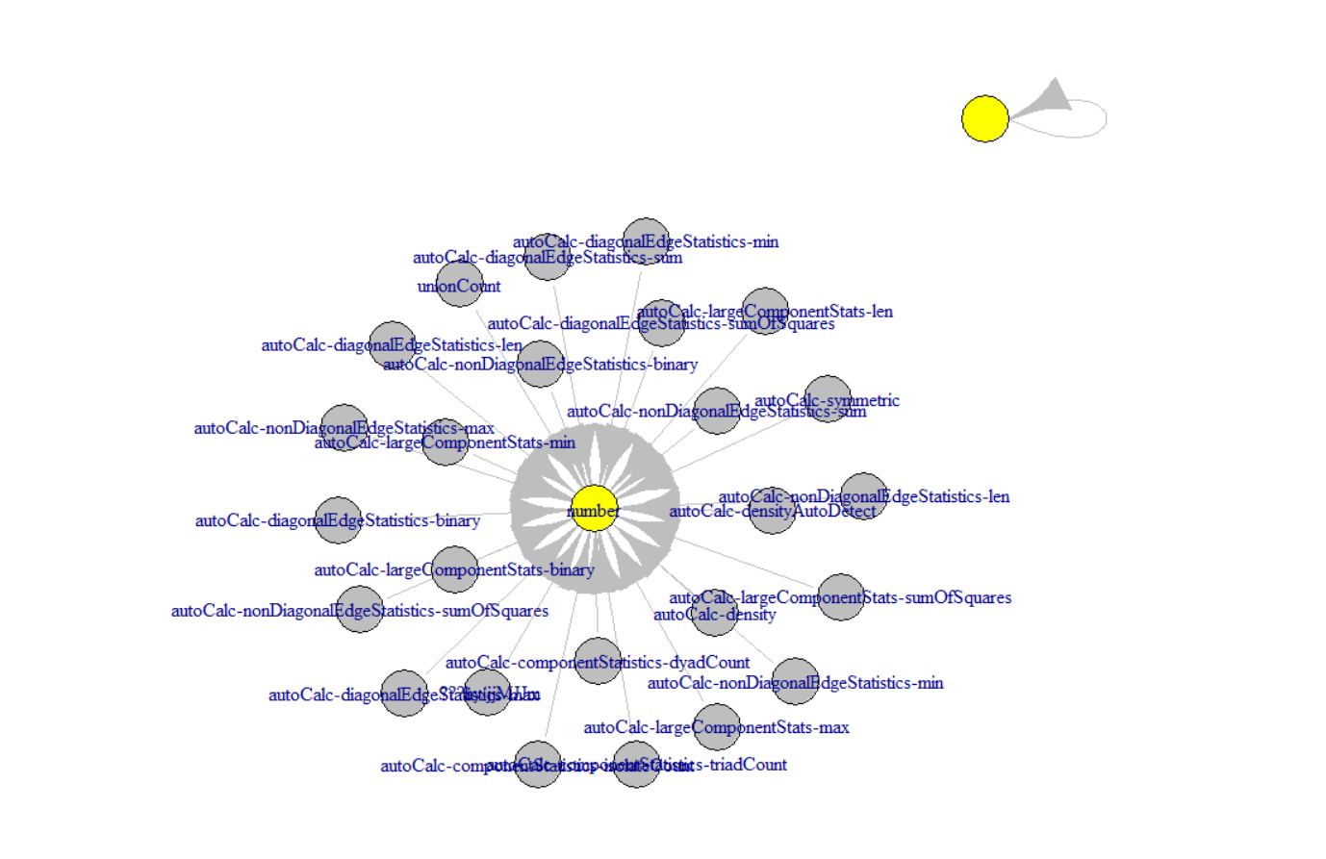

##########################

# D Networks #

##########################

#Removing Self-Loops (Repondents Nominating Themselves)

D_Graph2<-simplify(D_Graph, remove.multiple=TRUE, remove.loops=TRUE)

#Layout Options

set.seed(3952) # set seed to make the layout reproducible

layout1 <- layout.fruchterman.reingold(D_Graph2,niter=500)

#Node or Vetex Options: Size and Color

V(D_Graph2)$size=degree(D_Graph, mode = "in")/5 #because we have wide range, I am dividing by 5 to keep the high in-degree nodes from overshadowing everything else.

#V(D_Graph2)$color <- ifelse(D_Attributes[V(D_Graph2), 2] == "Researcher", "blue", "red")

#Edge Options: Color

E(D_Graph2)$color <- "grey"

#Plotting, Now Specifying an arrow size and getting rid of arrow heads

#We are letting the color and the size of the node indicate the directed nature of the graph

plot(D_Graph2, edge.arrow.size=0.25,edge.arrow.mode = "-", vertex.label = NA)

#Verdict, Maybe a different layout?

#Verdict: Maybe a bit better, but maybe not??

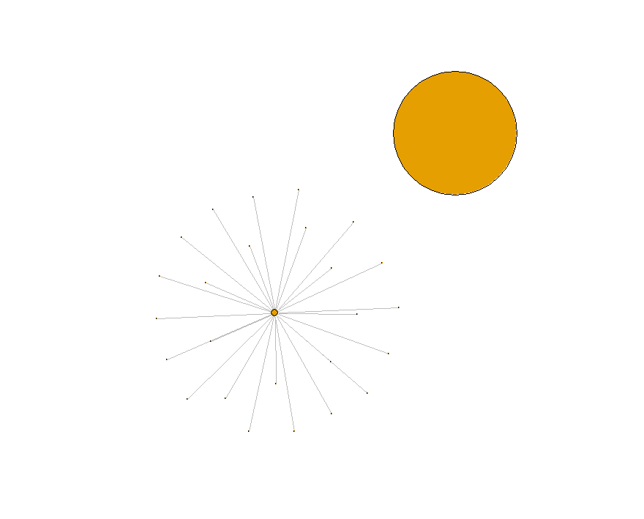

#######################################################################

# Thinking about the Network in Terms of Connectivity and Position #

#######################################################################

#CONNECTIVITY

#Density

graph.density(D_Graph2,loop=FALSE)

graph.density(C_Graph2, loop=FALSE)

#Average Path Length

mean_distance(D_Graph2)

mean_distance(C_Graph2)

#Degree Distribution

degree_distribution(D_Graph2)

D_DegreeDis <- degree_distribution(D_Graph2) #Turns this into a data object we can export

D_DegreeDis2 <- as.data.frame(D_DegreeDis)

qplot(D_DegreeDis, data=D_DegreeDis2, geom="histogram", binwidth=.001)

#Clustering Coefficeint

transitivity(D_Graph2)

transitivity(C_Graph2)

D_Trans <- transitivity(D_Graph2)

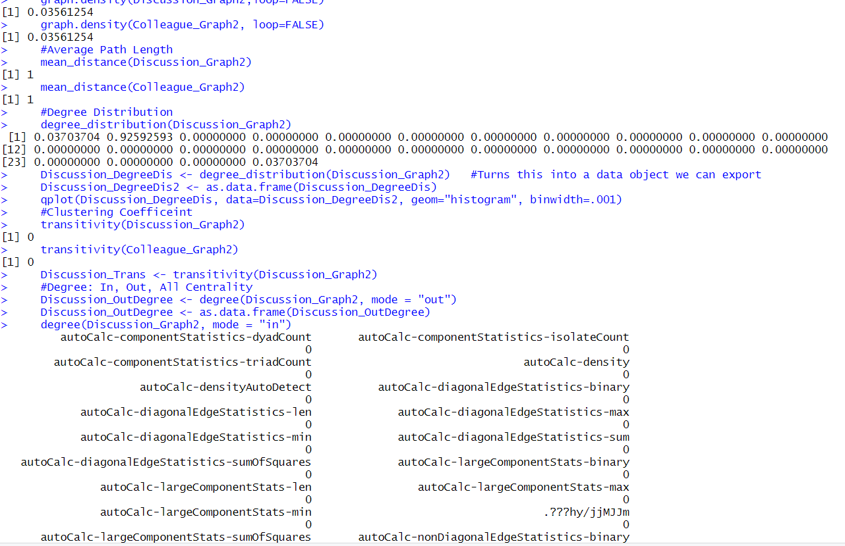

#POSITION

#Degree: In, Out, All Centrality

D_OutDegree <- degree(D_Graph2, mode = "out")

D_OutDegree <- as.data.frame(D_OutDegree)

degree(D_Graph2, mode = "in")

D_InDegree <- degree(D_Graph2, mode = "in")

D_InDegree <- as.data.frame(D_InDegree)

#Layout Options

set.seed(3952) # set seed to make the layout reproducible

layout1 <- layout.fruchterman.reingold(D_Graph2,niter=500)

#Node or Vetex Options: Size and Color

V(D_Graph2)$size=degree(D_Graph, mode = "all")/5 #because we have wide range, I am dividing by 5 to keep the high in-degree nodes from overshadowing everything else.

# V(D_Graph2)$color <- ifelse(D_Attributes[V(D_Graph2), 2] == "Researcher", "blue", "red")

#Edge Options: Color

E(D_Graph2)$color <- "grey"

#Plotting, Now Specifying an arrow size and getting rid of arrow heads

#We are letting the color and the size of the node indicate the directed nature of the graph

plot(D_Graph2, edge.arrow.size=0.25,edge.arrow.mode = "-", vertex.label = NA)

#Closeness Centrality

closeness(D_Graph2, mode="in")

D_InCloseness <- closeness(D_Graph2, mode="in")

D_InCloseness <- as.data.frame(D_InCloseness)

D_OutCloseness <- closeness(D_Graph2, mode="out")

D_OutCloseness <- as.data.frame(D_OutCloseness)

closeness(D_Graph2, mode="out")

closeness(D_Graph2, mode="all")

#Layout Options

set.seed(3952) # set seed to make the layout reproducible

layout1 <- layout.fruchterman.reingold(D_Graph2,niter=500)

#Node or Vetex Options: Size and Color

V(D_Graph2)$size=closeness(D_Graph, mode = "out")/.05#because we have wide range, I am dividing by 5 to keep the high in-degree nodes from overshadowing everything else.

# V(D_Graph2)$color <- ifelse(D_Attributes[V(D_Graph2), 2] == "Researcher", "blue", "red")

#Edge Options: Color

E(D_Graph2)$color <- "grey"

#Plotting, Now Specifying an arrow size and getting rid of arrow heads

#We are letting the color and the size of the node indicate the directed nature of the graph

plot(D_Graph2, edge.arrow.size=0.25,edge.arrow.mode = "-", vertex.label = NA)

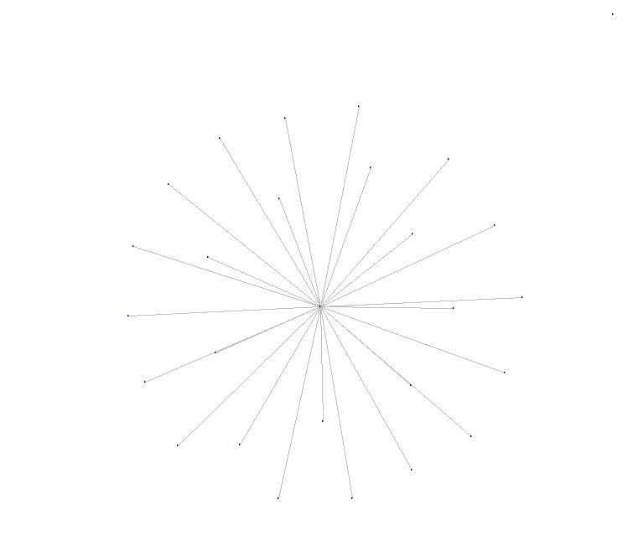

#Closeness Centrality

closeness(D_Graph2, mode="in")

D_InCloseness <- closeness(D_Graph2, mode="in")

D_InCloseness <- as.data.frame(D_InCloseness)

D_OutCloseness <- closeness(D_Graph2, mode="out")

D_OutCloseness <- as.data.frame(D_OutCloseness)

closeness(D_Graph2, mode="out")

closeness(D_Graph2, mode="all")

#Layout Options

set.seed(3952) # set seed to make the layout reproducible

layout1 <- layout.fruchterman.reingold(D_Graph2,niter=500)

#Node or Vetex Options: Size and Color

V(D_Graph2)$size=closeness(D_Graph, mode = "out")/.05#because we have wide range, I am dividing by 5 to keep the high in-degree nodes from overshadowing everything else.

# V(D_Graph2)$color <- ifelse(D_Attributes[V(D_Graph2), 2] == "Researcher", "blue", "red")

#Edge Options: Color

E(D_Graph2)$color <- "grey"

#Plotting, Now Specifying an arrow size and getting rid of arrow heads

#We are letting the color and the size of the node indicate the directed nature of the graph

plot(D_Graph2, edge.arrow.size=0.25,edge.arrow.mode = "-", vertex.label = NA)

#Betweeness Centrality

D_Betweeness <- betweenness(D_Graph2)

D_Betweeness <- as.data.frame(D_Betweeness)

#Layout Options

set.seed(3952) # set seed to make the layout reproducible

layout1 <- layout.fruchterman.reingold(D_Graph2,niter=500)

#Node or Vetex Options: Size and Color

V(D_Graph2)$size=betweenness(D_Graph)/200 #because we have wide range, I am dividing by 5 to keep the high in-degree nodes from overshadowing everything else.

V(D_Graph2)$color <- ifelse(D_Attributes[V(D_Graph2), 2] == "Researcher", "blue", "red")

#Edge Options: Color

E(D_Graph2)$color <- "grey"

#Plotting, Now Specifying an arrow size and getting rid of arrow heads

#We are letting the color and the size of the node indicate the directed nature of the graph

plot(D_Graph2, edge.arrow.size=0.25,edge.arrow.mode = "-", vertex.label = NA)

#Eigen Vector Centrality

eigen_centrality(D_Graph2)

D_EigenCentrality <- eigen_centrality(D_Graph2)

D_EigenCentrality <- as.data.frame(D_EigenCentrality)

#Layout Options

set.seed(3952) # set seed to make the layout reproducible

layout1 <- layout.fruchterman.reingold(D_Graph2,niter=500)

#Node or Vetex Options: Size and Color

V(D_Graph2)$size=eigen_centrality(D_Graph)/5 #because we have wide range, I am dividing by 5 to keep the high in-degree nodes from overshadowing everything else.

V(D_Graph2)$color <- ifelse(D_Attributes[V(D_Graph2), 2] == "Researcher", "blue", "red")

#Edge Options: Color

E(D_Graph2)$color <- "grey"

#Plotting, Now Specifying an arrow size and getting rid of arrow heads

#We are letting the color and the size of the node indicate the directed nature of the graph

plot(D_Graph2, edge.arrow.size=0.25,edge.arrow.mode = "-", vertex.label = NA)

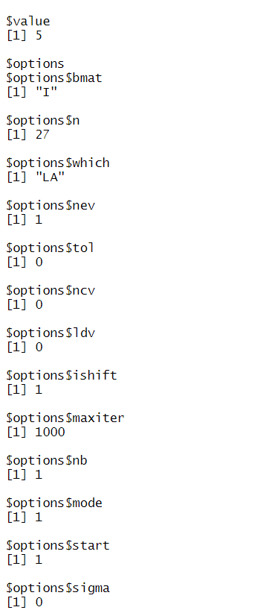

######################################################

# Segue to Advanced Network Visualization Techniques #

######################################################

GNC <- cluster_edge_betweenness(D_Graph2, weights = NULL)

V(D_Graph2)$color <-membership(GNC) #Plot setting specifying the coloring of vertices by community

D_Graph2$palette <- diverging_pal(length(GNC)) #Plot setting specifying the color pallette I am using (iGraph supports 3)

plot(D_Graph2, edge.arrow.size=0.25,edge.arrow.mode = "-", vertex.label = NA)

#Verdict: This is one answer, probably not the best one, but more on that next time.

**CONCLUSION:**

**Table 2: Hijacker Network Neighborhood**

|  |  |  |  |  |  |
| --- | --- | --- | --- | --- | --- |
| **Degrees * possible false ID** | | **Betweenness** | | **Closeness** | |
| 0.361 | Mohamed Atta | 0.588 | Mohamed Atta | 0.587 | Mohamed Atta |
| 0.295 | Marwan Al-Shehhi | 0.252 | Essid Sami Ben Khemais | 0.466 | Marwan Al-Shehhi |
| 0.213 | Hani Hanjour | 0.232 | Zacarias Moussaoui | 0.445 | Hani Hanjour |
| 0.180 | Essid Sami Ben Khemais | 0.154 | Nawaf Alhazmi | 0.442 | Nawaf Alhazmi |
| 0.180 | Nawaf Alhazmi | 0.126 | Hani Hanjour | 0.436 | Ramzi Bin al-Shibh |
| 0.164 | Ramzi Bin al-Shibh | 0.105 | Djamal Beghal | 0.436 | Zacarias Moussaoui |
| 0.164 | Ziad Jarrah | 0.088 | Marwan Al-Shehhi | 0.433 | Essid Sami Ben Khemais |
| 0.148 | Abdul Aziz Al-Omari* | 0.050 | Satam Suqami | 0.424 | Abdul Aziz Al-Omari* |
| 0.131 | Djamal Beghal | 0.048 | Ramzi Bin al-Shibh | 0.424 | Ziad Jarrah |
| 0.131 | Fayez Ahmed | 0.043 | Abu Qatada | 0.409 | Imad Eddin Barakat Yarkas |
| 0.131 | Salem Alhazmi* | 0.034 | Tarek Maaroufi | 0.409 | Satam Suqami |
| 0.131 | Satam Suqami | 0.033 | Mamoun Darkazanli | 0.407 | Fayez Ahmed |
| 0.131 | Zacarias Moussaoui | 0.029 | Imad Eddin Barakat Yarkas | 0.404 | Lotfi Raissi |
| 0.115 | Hamza Alghamdi | 0.026 | Fayez Ahmed | 0.401 | Wail Alshehri |
| 0.115 | Said Bahaji | 0.023 | Abdul Aziz Al-Omari* | 0.399 | Ahmed Al Haznawi |
| 0.098 | Khalid Al-Mihdhar | 0.022 | Hamza Alghamdi | 0.399 | Said Bahaji |
| 0.098 | Saeed Alghamdi* | 0.017 | Ziad Jarrah | 0.391 | Agus Budiman |
| 0.098 | Tarek Maaroufi | 0.015 | Ahmed Al Haznawi | 0.391 | Zakariya Essabar |
| 0.098 | Wail Alshehri | 0.013 | Salem Alhazmi* | 0.389 | Mamoun Darkazanli |
| 0.098 | Wail Alshehri | 0.013 | Salem Alhazmi* | 0.389 | Mamoun Darkazanli |
| 0.098 | Waleed Alshehri | 0.012 | Lotfi Raissi | 0.389 | Mounir El Motassadeq |
| 0.082 | Abu Qatada | 0.012 | Saeed Alghamdi* | 0.389 | Mustafa Ahmed al-Hisawi |
| 0.082 | Agus Budiman | 0.011 | Agus Budiman | 0.372 | Abdelghani Mzoudi |
| 0.082 | Ahmed Alghamdi | 0.007 | Ahmed Alghamdi | 0.372 | Ahmed Khalil Al-Ani |
| 0.082 | Lotfi Raissi | 0.007 | Ahmed Ressam | 0.365 | Salem Alhazmi* |
| 0.082 | Zakariya Essabar | 0.007 | Haydar Abu Doha | 0.361 | Hamza Alghamdi |
| 0.066 | Ahmed Al Haznawi | 0.006 | Kamel Daoudi | 0.343 | Abu Qatada |
| 0.066 | Imad Eddin Barakat Yarkas | 0.006 | Khalid Al-Mihdhar | 0.343 | Tarek Maaroufi |
| 0.066 | Jerome Courtaillier | 0.004 | Mohamed Bensakhria | 0.339 | Ahmed Alghamdi |
| 0.066 | Kamel Daoudi | 0.003 | Nabil al-Marabh | 0.335 | Waleed Alshehri |
| 0.066 | Majed Moqed | 0.002 | Jerome Courtaillier | 0.332 | Djamal Beghal |
| 0.066 | Mamoun Darkazanli | 0.002 | Mustafa Ahmed al-Hisawi | 0.332 | Khalid Al-Mihdhar |
| 0.066 | Mohamed Bensakhria | 0.002 | Said Bahaji | 0.332 | Saeed Alghamdi* |
| 0.066 | Mounir El Motassadeq | 0.002 | Wail Alshehri | 0.328 | Majed Moqed |
| 0.066 | Mustafa Ahmed al-Hisawi | 0.001 | Abu Walid | 0.324 | Ahmed Ressam |
| 0.066 | Nabil al-Marabh | 0.001 | Mehdi Khammoun | 0.323 | Ahmed Alnami |
| 0.066 | Rayed Mohammed Abdullah | 0.001 | Mohand Alshehri* | 0.323 | Nabil al-Marabh |
| 0.049 | Abdussattar Shaikh | 0.001 | Raed Hijazi | 0.321 | Haydar Abu Doha |
| 0.049 | Abu Walid | 0.001 | Rayed Mohammed Abdullah | 0.319 | Mohamed Bensakhria |
| 0.049 | Ahmed Alnami | 0.001 | Waleed Alshehri | 0.316 | Essoussi Laaroussi |
| 0.049 | Haydar Abu Doha | 0.000 | Abdelghani Mzoudi | 0.316 | Jerome Courtaillier |
| 0.049 | Mehdi Khammoun | 0.000 | Abdussattar Shaikh | 0.316 | Kamel Daoudi |
| 0.049 | Osama Awadallah | 0.000 | Abu Zubeida | 0.316 | Seifallah ben Hassine |
| 0.049 | Raed Hijazi | 0.000 | Ahmed Alnami | 0.314 | Rayed Mohammed Abdullah |
| 0.033 | Ahmed Ressam | 0.000 | Ahmed Khalil Al-Ani | 0.313 | Raed Hijazi |
| 0.033 | Bandar Alhazmi | 0.000 | Bandar Alhazmi | 0.311 | Abdussattar Shaikh |
| 0.033 | David Courtaillier | 0.000 | David Courtaillier | 0.311 | Bandar Alhazmi |
| 0.033 | Essoussi Laaroussi | 0.000 | Essoussi Laaroussi | 0.311 | Faisal Al Salmi |
| 0.033 | Faisal Al Salmi | 0.000 | Faisal Al Salmi | 0.311 | Mohand Alshehri* |
| 0.033 | Lased Ben Heni | 0.000 | Faisal Al Salmi | 0.311 | Osama Awadallah |
| 0.033 | Mohammed Belfas | 0.000 | Jean-Marc Grandvisir | 0.308 | Mehdi Khammoun |
| 0.033 | Mohand Alshehri* | 0.000 | Lased Ben Heni | 0.308 | Mohamed Abdi |
| 0.033 | Seifallah ben Hassine | 0.000 | Madjid Sahoune | 0.307 | David Courtaillier |
| 0.016 | Abdelghani Mzoudi | 0.000 | Majed Moqed | 0.307 | Mohammed Belfas |
| 0.016 | Abu Zubeida | 0.000 | Mamduh Mahmud Salim | 0.305 | Lased Ben Heni |
| 0.016 | Ahmed Khalil Al-Ani | 0.000 | Mohamed Abdi | 0.303 | Fahid al Shakri |
| 0.016 | Fahid al Shakri | 0.000 | Mohammed Belfas | 0.303 | Madjid Sahoune |
| 0.016 | Jean-Marc Grandvisir | 0.000 | Mounir El Motassadeq | 0.303 | Samir Kishk |
| 0.016 | Madjid Sahoune | 0.000 | Nizar Trabelsi | 0.281 | Mamduh Mahmud Salim |
| 0.016 | Mamduh Mahmud Salim | 0.000 | Osama Awadallah | 0.264 | Abu Walid |
| 0.016 | Mohamed Abdi | 0.000 | Samir Kishk | 0.250 | Abu Zubeida |
| 0.016 | Nizar Trabelsi | 0.000 | Seifallah ben Hassine | 0.250 | Jean-Marc Grandvisir |
| 0.016 | Samir Kishk | 0.000 | Zakariya Essabar | 0.250 | Nizar Trabelsi |
|  |  |  |  |  |  |
| **0.081** | **Average** | **0.032** | **Average** | **0.052** | **Average** |
| **0.289** | **Centralization** | **0.565** | **Centralization** | **0.482** | **Centralization** |