Team F11  
GeoStory

Forrest Scott  
Joel Veencamp  
Alexander Rinehart  
John Eganhouse

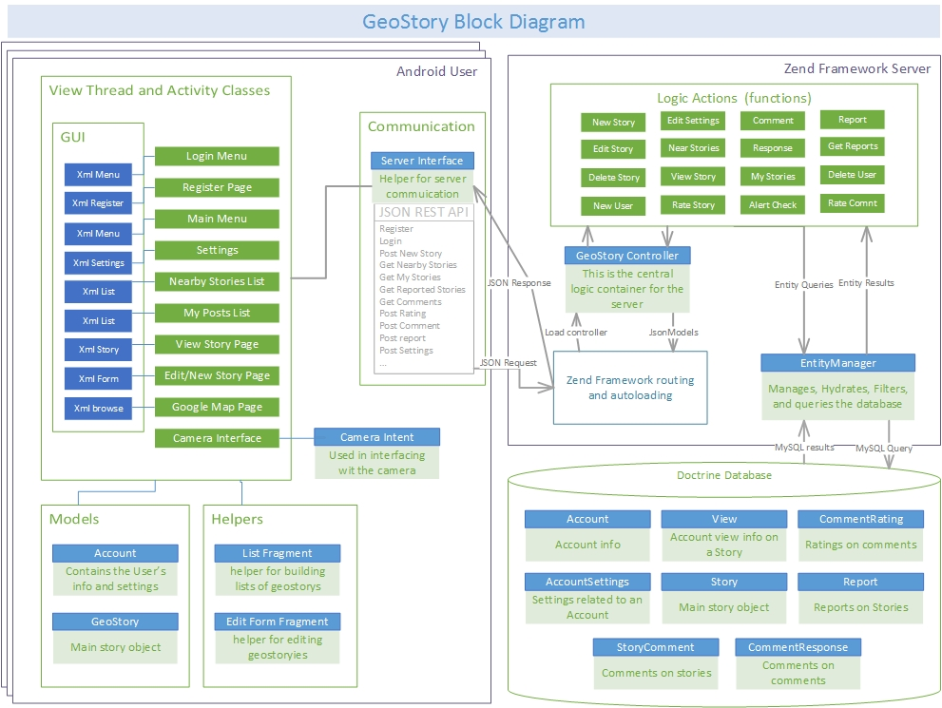

Design Descriptions

Android User GUI

The Android application will have a thread dedicated to the GUI called the “view thread”. The thread will exist within Activity Classes. Our GeoStory application will have 10 different activity classes which are all listed within the “View Thread and Activity Classes” section. Each activity will have corresponding xml files which will describe the styling of the page. The activities will contain most of the logic processing of user commands, but for some of the activities that share similar commands, we will build helpers, models, and interfaces that will be used throughout the activites.

Android Code Helpers

The two planned helpers (note, additional ones may be added to reduce code reuse) are “List Fragment” and “Edit Form Fragment”. The “List Fragment” will be used on the many pages that display lists of stories, such as the “view nearby stories”, or “my Stories” pages. Many of the repeated functionality will be placed within these helpers to help render and manipulate data

Android Models

We will also create two planned models (note, we may add more if we reach stretch goles). Listed under ‘Models’, these Java classes will contain all of the data related to its subject. Having these models will help standardize how data will be transferred within the client, as well as the classes will contain reusable functions that will help obfuscate interaction with data.

Android Communication

We will build a communication interface within the java client. This interface will handle network threads as well as obfuscate the JSON commands that will be send to the server. Almost all of the Activities will send data through the server interface at one point or another.

Zend Framework

Zend is fully object-oriented PHP framework that uses extensible MVC implementations. We will also join Zend with a Doctrine 2 database entity manager to help convert php objects into MySQL and vice versa. Most of our code will be written into Controllers which house most of the logic functions within the server called Actions. These Actions will be able to handle data creation, manipulation, and queries within an object oriented environment. The Entity Manager is in charge of obfuscating the raw MySQL tables and present a php object front-end instead.