Software Requirements Document for GeoStory

Author: Group F11

Alex Rinehart  
Joel Veencamp  
John Eganhouse  
Forrest Scott

|  |  |  |  |
| --- | --- | --- | --- |
| **Version** | **Date** | **Author** | **Change** |
| 0.1 | 09/20/14 | AR | Initial Document |
|  |  |  |  |
|  |  |  |  |
|  |  |  |  |
|  |  |  |  |

Table of Contents

1 Introduction 3

1.1 Purpose 3

1.2 Scope 3

1.3 Definitions, acronymns, abbreviations 3

1.4 References 3

1.5 Overview 3

2 Overall Description 4

2.1 Product Perspective 4

2.2 Product functions 5

2.3 User characteristics 6

2.4 Constraints 14

2.5 Assumptions and Dependencies 15

3 Specific Requirements 16

3.1 External Interface Requirements 16

3.2 FEATURES 16

3.3 Performance requirements 16

3.4 Design Constraints 16

3.5 Software System Attributes 16

3.6 Other Requirements 16

# Introduction

## Purpose

The purpose of this document is to detail the different ways in which GeoStory will be used.

## Scope

This documents covers all use cases that will be performed by lurkers, users, and administrators.

## Definitions, acronymns, abbreviations

|  |  |
| --- | --- |
| Term | Description |
| GeoStory | The application in question |
| Story | A collection of text and/or pictures linked to a geographical location. |
| SRS | Software Requirements Specification |

## References

There are no references.

## Overview

# Overall Description

GeoStory allows users to share and view stories with other users of the application. These stories are only accessible when the user is in the location where a story was shared.

## Product Perspective

Most social networking applications link users based on common interests (Pinterest, Instagram), or on existing friend groups (Facebook, Snap Chat). By contrast, GeoStory connects users based on a common location, and allows them to share experiences and memories with strangers, creating a community based on proximity, rather than established relationships or interests.

### Concept of Operations

The user will interact with an Android application to create and view stories. The application will display stories when they are within a predetermined range, based on the device’s GPS location. If the user wishes to create their own content, they can type text or use the device’s camera to take a picture.

The application in turn will communicate with a server to pull the stories or push new content to the server. The stories will be “attached” to a location based on data that is stored in the server.

### Major User Interfaces

See Appendix 4.1

#### Example Screenshot and description

See appendix 4.1 for screen.

This screen will be displayed when a user selects a story that they did not create. The user will have the option to rate the story from 1 to 5 stars for quality, as well as add comments to the story. Any pictures or text that are attached

### Hardware Interfaces

This application is accessible from any Android-enabled device.

### Software Interfaces

### Communication Interfaces

### Memory Constraints

### Operations

### Site Adaptation Requirements

## Product functions

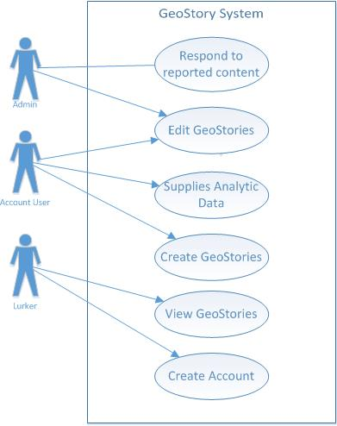

Lurker is a subclass of user than only has the permission to view GeoStories and create and account. Creating an account advances the user to the User level, which is a subclass of admin. Users gain the permissions to create Stories, edit stories that they create, and report, rate and comment on Stories that they did not create.   
 Admins have all the options of a user, except that they can edit any Story, irrespective of who created it. They are also notified about Stories that have been reported.

Users will create stories to share with other people and view stories that others made when they are in the location in which the story was created.

### Example use case

UC-01 "Report a story" (User goal / App user)

*The purpose of this use case is for a user to label offensive content to be removed.*

*Main Scenario:*

1. User opens the application

2. User navigates to a the page of a story that is near to them

3. User taps "Report this story"

4. User taps "confirm"

5. The system sends marks the story as reported and adds it to the administrators' lists.

*Extensions:*

4b. User selects cancel

4b1. The user is returned to the story's page.

UC-02 "Create account" (User goal / App user)

*Main Scenario:*

1. User opens the application

2. User selects register for account

3. User types in a user name and password

4. Application contacts the server and attempts to create a new account

5. The application logs the user in

*Extensions:*

1a1. The user has an account but is logged out

1b. User enters their credentials and selects log in.

1c. The application compares the credentials to those on the server. If they match, the user is logged in

1b1. The user is already logged in

1b. The application does not show the log in screen

2a. User selects cancel

2a1. The user is returned to the screen prompting them to log in or register

3a. Account name is taken

3a1. The server rejects the request to create a new account

3a2. The application prompts the user to enter in a different username until a unique name is chosen.

UC-03

*The purpose of this use-case is make users aware of their accounts activity by notification*

“Receive and view notifications” (User goal / App user)

*Scenario #1*

1. User opens GeoStory app and logs on
2. User receives notification that someone has comment on their story
3. User is directed towards their Story with the new comment

*Scenario #2*

1. User opens GeoStory app and logs on
2. User receives notification that their story has been taken down by an admin
3. User may get notification for story’s offense

*Scenario #3*

1. User opens GeoStory app and logs on
2. User receives notification that their story has achieved _____ rating
3. User is directed towards their Story and may view comments and rating on it

*Extensions:*

1a. User logs onto his/her account if not already logged on

1b. User is directed towards main page where their notification will be displayed

1c. User must click on individual notifications from list of notifications

UC-04

*The purpose of this use-case is to let users post their GeoStories*

“Posting new GeoStory” (User goal / App user)

*Main Scenario:*

1. User opens GeoStory (logs on if not already)
2. User is directed to the main menu
3. User wishes to Post a GeoStory, clicks on New Page
4. User types in description of Story
5. User is prompt to upload an image if they choose
6. Later user may view all previous stories by clicking “My Posts” from the main menu

*Extensions:*

1a. User logs onto his/her account if not already logged on

4a. User is prompted to fill in text field of description

5a. User may take photo to go with Story

5b. User may upload photo from their device

6a. User sees all previous posts

6b. User may edit their old posts

6c. User may click on a story and view any comments left/rating of Story

UC-05

*The purpose of this use-case is to describe how a user of the GeoStory app is able to browse stories nearby.*

“Browse stories nearby” (User goal / App user)

*Main Scenario:*

1. User opens GeoStory app.
2. User navigates to list of nearby stories
3. User clicks on nearby story

*Extensions:*

1a. Phone is in pocket

1a1. Pull out phone, turn on screen.

1b Phone is in hand and screen is on.

1b1. Unlock phone and click on Geostory app to open.

2a. User is not logged in.

2a1. User attempts to logs in.

2a2. Server receives user data and either accepts or denies credentials.

2b. User is logged in, on main page.

2b1. User clicks on nearby stories button to navigate to nearby stories page.

2b2. Server directs user to the nearby stories page.

2c. User is on any other page in app.

2c1. User navigates to main page, then does step 2b.

2c2. Server directs user to the nearby stories page.

3a. User finds nearby story to view

3a1. Server uses location to fetch nearby stories and sends them to user’s device.

3a2. User scrolls through list of nearby stories

3b. User clicks on nearby story to view

3b1. Server sends individual story page to user’s device

3b2. User is directed to page to view the story.

UC-06

*The purpose of this use-case is to describe how a user of the GeoStory app is able to delete and/or edit their own posts.*

“Delete/edit User Posts” (User goal / App user)

*Main Scenario:*

1. User opens GeoStory app.
2. User navigates to my posts page
3. User edit posts
4. User deletes posts

*Extensions:*

1a. Phone is in pocket

1a1. Pull out phone, turn on screen.

1b Phone is in hand and screen is on.

1b1. Unlock phone and click on Geostory app to open.

2a. User is not logged in.

2a1. User attempts to logs in.

2a2. Server receives user data and either accepts or denies credentials.

2b. User is logged in, on main page.

2b1. User clicks on my posts button to navigate to nearby stories page.

2b2. Server directs user to the my posts page / fetches and sends posts of current user.

2c. User is on any other page in app.

2c1. User navigates to main page, then does step 2b.

2c2. Server directs user to the my posts page.

3a. User clicks on one of his / her posts.

3a1. Server fetches individual post and sends it to user’s device.

3b. User clicks to edit post.

3b1. Server brings up edit page with typing capability.

3b2. User types to change titles / description of current post

3c. User saves changes.

3c1. User clicks on save changes.

3c2. Server fetches changes and overrides current post and saves it onto server.

4a. User clicks on one of his / her posts.

4a1. Server fetches individual post and sends it to user’s device.

4b. User clicks to delete post.

4b1. Server sends pop-up notification asking to confirm current action.

4c. User confirms to delete.

4c1. User clicks on delete button.

4c2. Server receives confirmation and deletes post and it is removed from server.

4d. User confirms to cancel

4d1. User clicks cancel button.

4e. Server removes pop-up / user can continue to edit.

UC-07

*The purpose of this use-case is to show how users rate other user’s stories*

“Rating on a story” (User goal / App user)

*Main Scenario:*

1. User opens GeoStory app.
2. User navigates to list of nearby stories
3. User clicks on nearby story
4. User clicks on a 1-5 star rating

*Extensions:*

1a. Phone is in pocket

1a1. Pull out phone, turn on screen.

1b Phone is in hand and screen is on.

1b1. Unlock phone and click on Geostory app to open.

2a. User is not logged in.

2a1. User attempts to logs in.

2a2. Server receives user data and either accepts or denies credentials.

2b. User is logged in, on main page.

2b1. User clicks on nearby stories button to navigate to nearby stories page.

2b2. Server directs user to the nearby stories page.

2c. User is on any other page in app.

2c1. User navigates to main page, then does step 2b.

2c2. Server directs user to the nearby stories page.

3a. User finds nearby story to view

3a1. Server uses location to fetch nearby stories and sends them to user’s device.

3a2. User scrolls through list of nearby stories

3b. User clicks on nearby story to view

3b1. Server sends individual story page to user’s device

3b2. User is directed to page to view the story.

4b. User chooses a rating.

4b1. User scrolls down the GeoStory till they reach the rating bar.

4b2. User selects a star that corresponds to the 1-5 rating of the story.

UC-08

*The purpose of this use-case is to show how users comment on other user’s stories*

“Rating on a story” (User goal / App user)

*Main Scenario:*

1. User opens GeoStory app.
2. User navigates to list of nearby stories
3. User clicks on nearby story
4. User clicks on the comment button
5. User writes a comment

*Extensions:*

1a. Phone is in pocket

1a1. Pull out phone, turn on screen.

1b Phone is in hand and screen is on.

1b1. Unlock phone and click on Geostory app to open.

2a. User is not logged in.

2a1. User attempts to logs in.

2a2. Server receives user data and either accepts or denies credentials.

2b. User is logged in, on main page.

2b1. User clicks on nearby stories button to navigate to nearby stories page.

2b2. Server directs user to the nearby stories page.

2c. User is on any other page in app.

2c1. User navigates to main page, then does step 2b.

2c2. Server directs user to the nearby stories page.

3a. User finds nearby story to view

3a1. Server uses location to fetch nearby stories and sends them to user’s device.

3a2. User scrolls through list of nearby stories

3b. User clicks on nearby story to view

3b1. Server sends individual story page to user’s device

3b2. User is directed to page to view the story.

4a. Users clicks on the comment button

4b1. User scrolls down the GeoStory till they reach the comment section.

4b2. User clicks on the comment button.

4b3. User is presented a text input comment dialog

5a. User writes a comment.

5b. User exits the dialog.

5a. pressing “Send” will create the comment

5b. pressing “Cancel” will exit the comment section without creating a comment.

UC-09

*The purpose of this use-case is to show how to access their settings*

“Changing Settings” (User goal / App user)

*Main Scenario:*

1. User opens GeoStory app.
2. User navigates to the settings menu
3. User changes settings

*Extensions:*

1a. Phone is in pocket

1a1. Pull out phone, turn on screen.

1b Phone is in hand and screen is on.

1b1. Unlock phone and click on Geostory app to open.

2a. User is not logged in.

2a1. User attempts to logs in.

2a2. Server receives user data and either accepts or denies credentials.

2b. User is logged in, on main page.

2b1. User clicks on settings button to access the settings page.

2c. User is on any other page in app.

2c1. User navigates to main page, then does step 2b.

3a. User Changes settings

3a1. Individual settings can be toggled (on/off) by pressing their adjacent button.

## User characteristics

The application will primarily be used by the audience that is targeted by social media, teenagers. College campuses will be hotspots for story sharing, as there is a large community of strangers united solely by location. The application will be used whenever users travel to different locations. It can also be used when vacationing to share experiences with future travelers.

## Constraints

The application must run on Android.

## Assumptions and Dependencies

Android device running 1.0 or higher. Needs location services enabled and mobile data.

# Specific Requirements

// Here you need to put in details (if any). Mark items [None] if you do not have any information.

## External Interface Requirements

### User Interfaces

### Hardware Interfaces

### Software Interfaces

### Communications Interfaces

## FEATURES

### FEATURE-1 ….

#### …

#### …..

## Performance requirements

## Design Constraints

## Software System Attributes

### Reliability

### Availability

### Security

### Maintainability

### Portability

## Other Requirements

1. 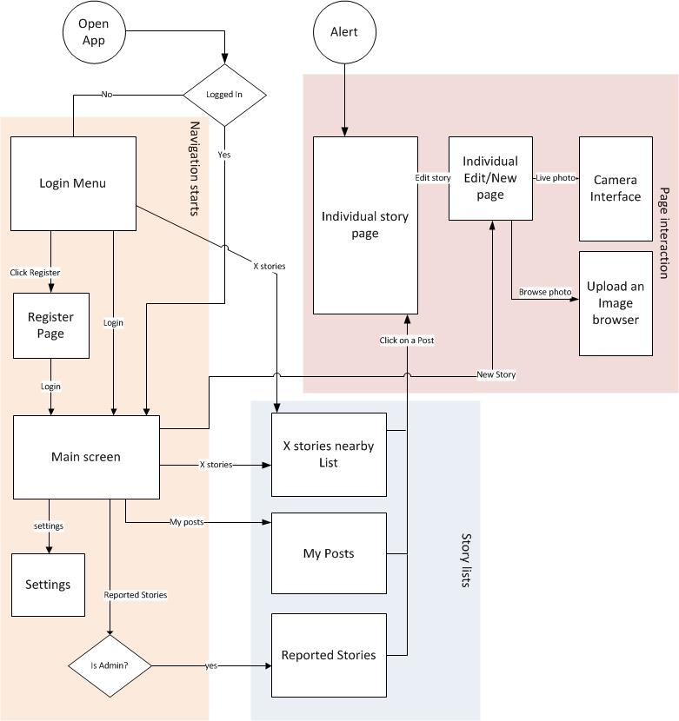

## APPENDIX

## 

// Regenerate Table of Contents