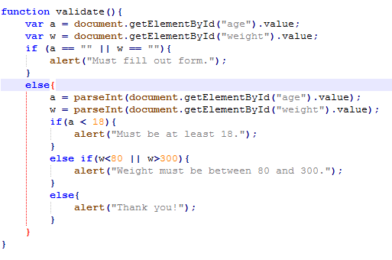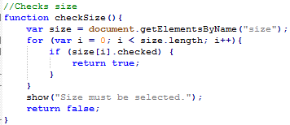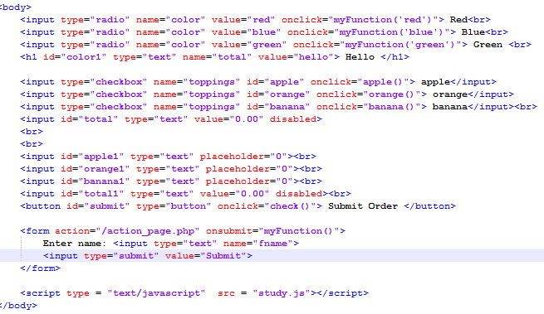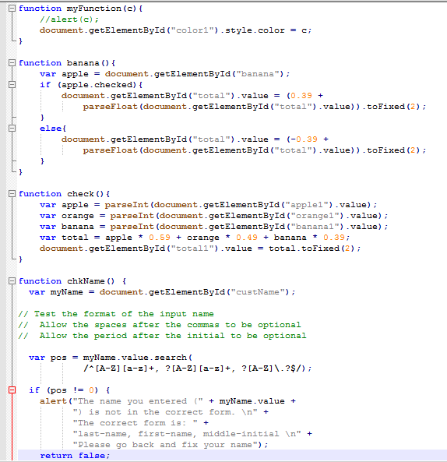

<label><input type="radio" name="size" value="Small"> Small</label>

<label><input type="checkbox" name="toppings" value="Pepperoni"> Pepperoni</label>

<input id="name" type="text" name="name" placeholder="Your name.."><br>

<select id="State"><option value="0"> State </option></select>

<button id="submit" type="button" onclick="check()"> Submit Order </button>

<textarea name = "comments" placeholder = "Enter comments here." rows = "4" cols = "36"></textarea>

Node.js

Non-blocking (asynchronous)

Single threaded

HTTP Protocols: Request and Response

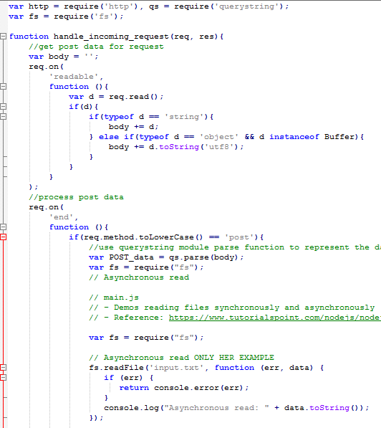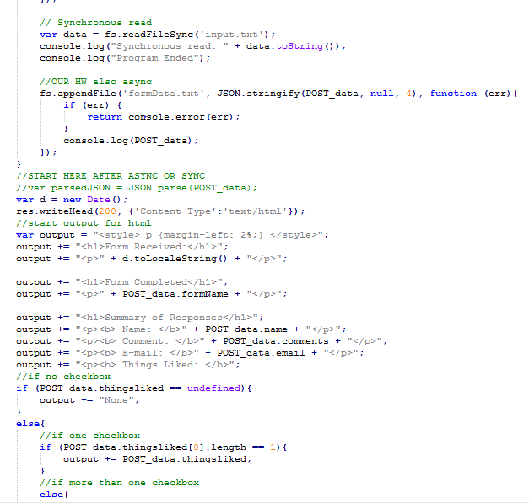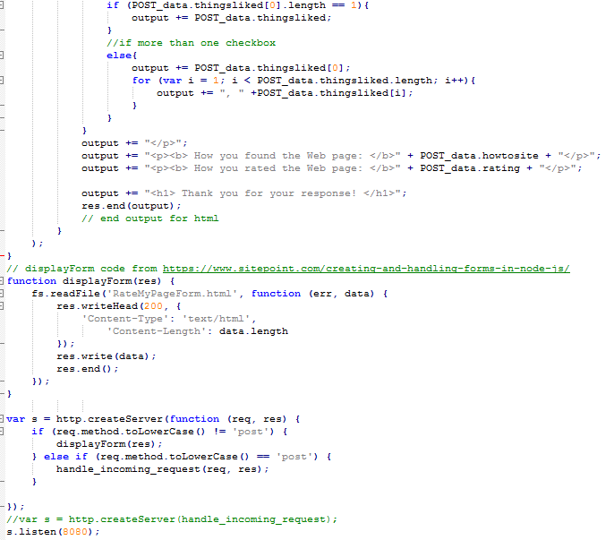

Document Object Model gives scripting access to all elements,   
can dynamically change the page with JS.  
getElementByID() returns objects called DOM Nodes

Node can have multiple children, but only one parent.  
HTML Node is the root node.   
Javascript code   
Can access with syntax: currentNode.parentNode.(could be replaceChild, appendChild etc..)  
Var newNode = createNewNode(document.getElementByID(“replace”).value );

currentNode.parentNode.replaceChild(newNode, currentChild);  
**Find and highlight an Element using** getelementbyID, setAttrbiute, and getAttribute.  
GetAtttribute and setAttribute allow modification and access of attribute value.  
**DOM has collections:** groups of related objects on a page.  
Collections are properties of DOM objects such as doc object or a DOM node.  
Collection has length property for number of items in the collection.

Var linksList = document.links; //Get the documents links, accessed with indices

Window object has setInterval and clearInterval methods. Can be combined for dynamic styles of animated effects.  
**namedItem method**  receives an element id as an argument and finds the element with that id in the collection.

**href property** of a DOM link node refers to the link’s href attribute

**Collections** allow easy access to all elements of a single type in a page

Useful for gathering elements into one place and for applying changes across an entire page