UNIVERSITY OF JAMMU

Website: jammuuniversity.ac.in


Practical File
on
P2CSPC280: Practical
(Session: 2026-27)

Submitted By:
Amit Singh
MCA -3rd Sem
Roll no: 0042MCA25

CERTIFICATE

This is certified to be the Bonafide practical work in PYTHON in Third Semester of MCA programme during the academic year 2026-27.
This file is prepared by Amit Singh , roll no. 0042MCA25, Department of Computer Science and IT.

Teachers-In-Charge:-
- Prof. Pawanesh Abrol
- Dr. Namrata Karlupia

Internal Examiner:- External Examiner:-

1.Write a program to generate the first n Fibonacci numbers and print only the even terms.
Code:
n = int(input("Enter the number of terms: "))
a = 0
b = 1

print("Even Fibonacci terms:")

for i in range(n):
if a % 2 == 0:
print(a, end=" ")

c = a + b
a = b
b = c

Output:
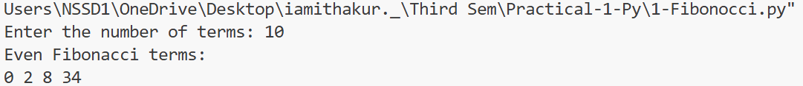
2.Write a program to input a number and print all its prime factors using loops.
Code:
n = int(input("Enter a number: "))
print("Prime factors:")
i = 2
while n > 1:
if n % i == 0:
print(i, end=" ")
n = n // i
else:
i = i + 1

Output:
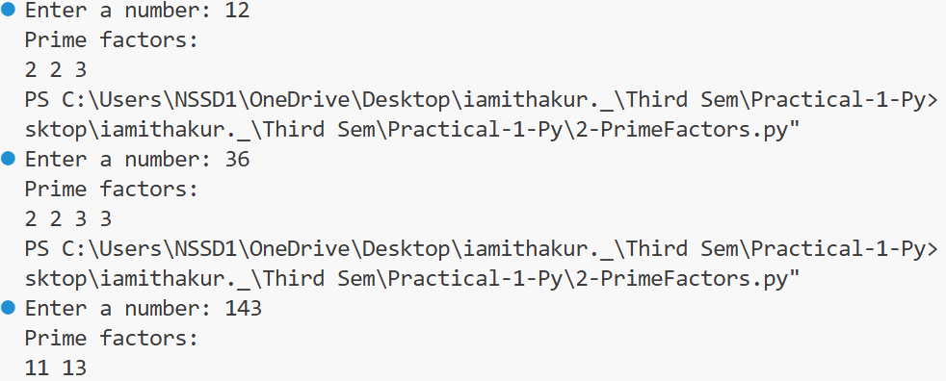
3.Write a program to reverse a given string, count the number of vowels, and check whether it is palindrome.
Code:
text = input("Enter a string: ")

# Reverse the string
reverse = text[::-1]
print("Reversed string:", reverse)

# Count vowels
count = 0
for ch in text:
if ch in "aeiouAEIOU":
count = count + 1
print("Number of vowels:", count)

# Check palindrome
if text == reverse:
print("The string is a palindrome")
else:
print("The string is not a palindrome")

Output:
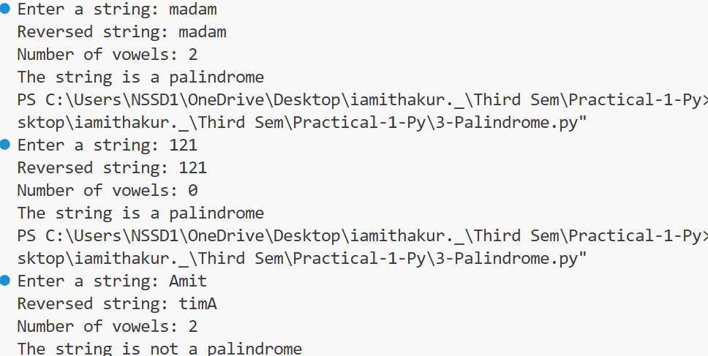
4.Write a Python program to print all even and odd numbers between 1 and 50 using a loop and conditional statements.
Code:
print("Even numbers:")
for i in range(1, 51):
if i % 2 == 0:
print(i, end=" ")

print("\n\nOdd numbers:")
for i in range(1, 51):
if i % 2 != 0:
print(i, end=" ")

Output:
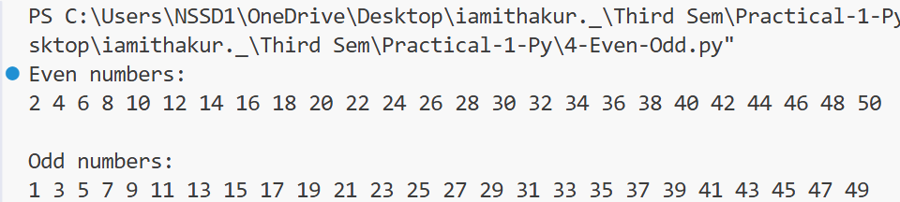
5.Write a program to remove all punctuation from a given string.
Code:
text = input("Enter a string: ")

result = ""

for ch in text:
if ch.isalnum() or ch == " ": # if ch.isalnum() or ch == " ": isalnum() =>
# checks whether a character is:Alphabet or Number
result = result + ch

print("String without punctuation:", result)

Output:

6.Create a mixed-data-type list, perform the following operations:
i. Display all elements and their data types.
ii. Find the length of the list.
iii. Access elements using indexing and slicing.
iv. Add, update, and remove elements.
Code:
my_list = [10, "Amit", 25.5, True, "Python"]
# 1. Display elements and their data types
print("Elements and their data types:")
for item in my_list:
print(item, type(item))
# 2. Find length
print("\nLength of list:", len(my_list))
# 3. Indexing
print("\nElement at index 0:", my_list[0])
print("Element at index 1:", my_list[1])
# Slicing
print("Elements from index 1 to 3:", my_list[1:4])
# 4. Add an element
my_list.append("MCA")
print("\nAfter adding:", my_list)
# Update an element
my_list[0] = 100
print("After updating:", my_list)
# Remove an element
my_list.remove(25.5)
print("After removing:", my_list)
Output:
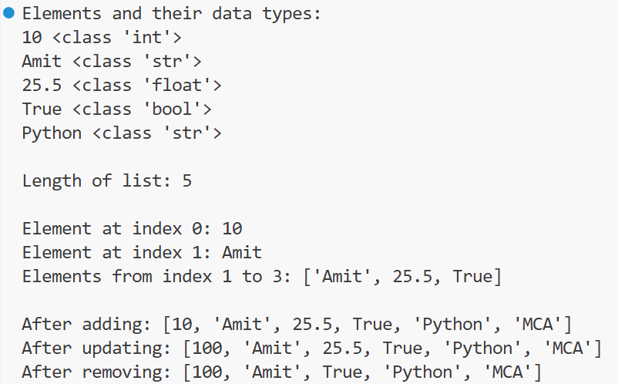
7.Write a program to merge two lists and sort the merged list and count the frequency of each element in merged list.
Code:
list1 = [10, 20, 30, 20]
list2 = [40, 10, 50, 20]

merged = list1 + list2
merged.sort()
print("Merged and sorted list:", merged)

checked = []
for item in merged:
if item not in checked:
print(item, ":", merged.count(item))
checked.append(item)

Output:
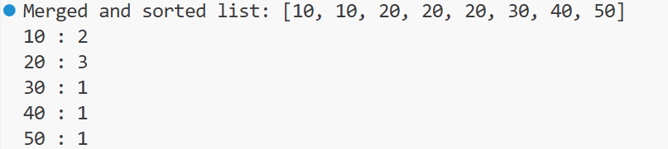
8.Create a tuple containing different data types and perform the following operations:
i. Display all elements and their data types.
ii. Access elements using indexing and slicing.
iii. Find the length of the tuple.
iv. Count the occurrences of a given element.
v. Find the index of a specified element.
# A tuple is immutable, means its elements cannot be changed after creation.
Code:
my_tuple = (10, "Amit", 25.5, True, "Python", 10)
# 1. Display elements and data types
print("Elements and their data types:")
for item in my_tuple:
print(item, type(item))
# 2. Indexing
print("\nElement at index 0:", my_tuple[0])
print("Element at index 1:", my_tuple[1])
# Slicing
print("Elements from index 1 to 3:", my_tuple[1:4])
# 3. Length
print("\nLength of tuple:", len(my_tuple))
# 4. Count occurrence
print("10 occurs:", my_tuple.count(10), "times")
# 5. Find index
print("Index of Python:", my_tuple.index("Python"))

Output:
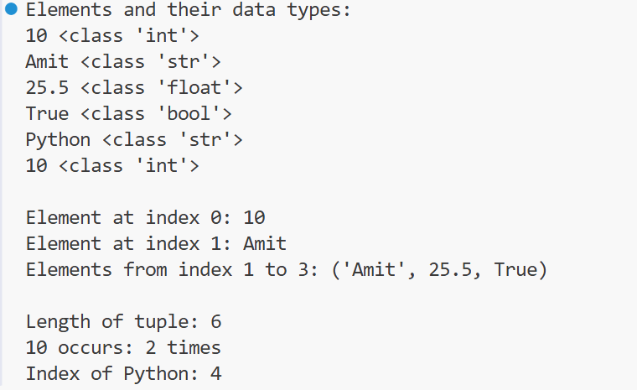
9.Create a set from a list containing duplicate elements and perform the following operations:
i. Remove duplicate elements.
ii. Add and remove elements.
iii. Find the union, intersection, and difference of two sets.
Code:
list1 = [10, 20, 30, 20, 40, 10]

# Create set
set1 = set(list1)
print("Set after removing duplicates:", set1)

# Add an element
set1.add(50)
print("After adding 50:", set1)

# Remove an element
set1.remove(20)
print("After removing 20:", set1)

# Another set
set2 = {30, 40, 50, 60, 70}

# Union
print("Union:", set1.union(set2))

# Intersection
print("Intersection:", set1.intersection(set2))

# Difference
print("Difference:", set1.difference(set2))

Output:
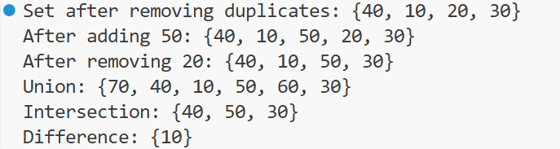
10.Create a dictionary containing student names and their marks and perform the following operations:
i. Display all keys and values.
ii. Add a new key-value pair.
iii. Update an existing value.
iv. Delete a key-value pair.
v. Find the student with the highest marks.
Code:
students = {
"Amit": 85,
"Suman": 80,
"Neha": 82,
"Priya": 88
}
# 1. Display all keys and values
print("Student names and marks:")
for name, marks in students.items():
print(name, ":", marks)

# 2. Add a new key-value pair
students["Rohit"] = 80
print("\nAfter adding Rohit:")
print(students)

# 3. Update an existing value
students["Suman"] = 89
print("\nAfter updating Suman's marks:")
print(students)

# 4. Delete a key-value pair
del students["Rohit"]
print("\nAfter deleting Rohit:")
print(students)

# 5. Find student with highest marks
highest_name = ""
highest_marks = 0
for name, marks in students.items():
if marks > highest_marks:
highest_marks = marks
highest_name = name

print("\nStudent with highest marks:", highest_name)
print("Highest marks:", highest_marks)

# 6. Calculate average marks
total = 0
for marks in students.values():
total = total + marks

average = total / len(students)
print("Average marks:", average)

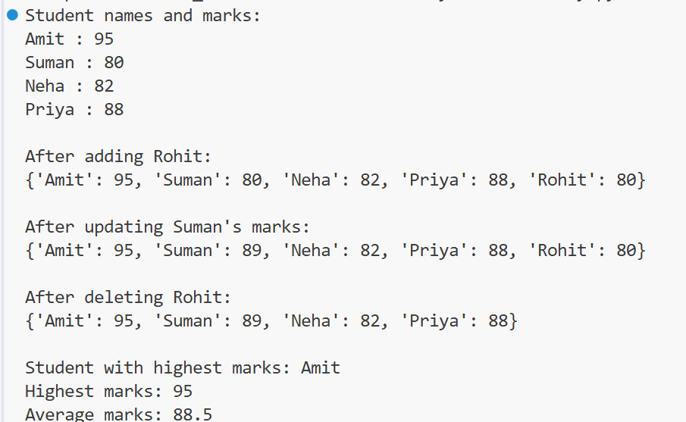
11.Write a Python program to create a frozen set of numbers and perform union, intersection, and difference operations with another set.
#A frozenset is an immutable version of a set.
# Once created, elements cannot be added or removed.
Code:
set1 = frozenset([10, 20, 30, 40])
set2 = {30, 40, 50, 60}

# Display sets
print("Frozen set:", set1)
print("Another set:", set2)

# Union
print("Union:", set1.union(set2))

# Intersection
print("Intersection:", set1.intersection(set2))

# Difference
print("Difference:", set1.difference(set2))

Output:
