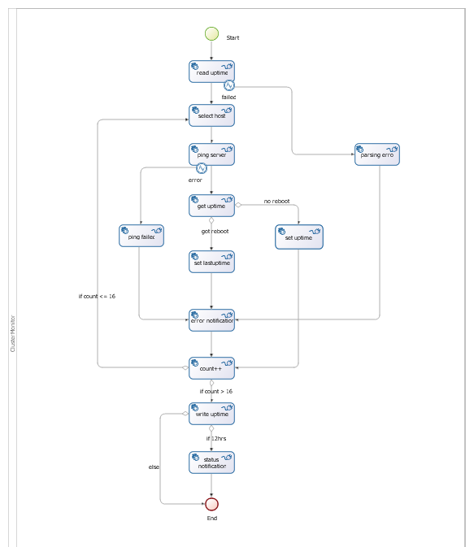
Algorithm:
------------

- read uptime from file to uptime var of each server
  - if failed/exception, go to 7
  - else go to 2

- select host server based upon count

- ping that host
  - if ping failed, go to 7
  - else 4

- exec uptime cmd to that host

- calculate uptime in days for that host

- save this uptime to uptime var of each host
  - if this uptime < last uptime, then host got reboot. Go to 7
  - else go to 8

- error notification

- count++. This is used for selecting next host
  - if count <=16 go to 2
  - else go to 9

- write uptime of all host to the file

- calculate the case runtime
  - If 12hrs then go to 11
  - Else go to 12

- Send status notification

- Exit

Description:
--------------
This algorithm runs on each host server one by one. This BOS process is called from a client app in guru machine. The java app called the Cluster_Monitor—1.5.bar process, existed in Bonita UserXP @http://guru.ece.northwestern.edu:8081/bonita

App location: /home/monitor/MonitoringApp/ClusterMonitoring.jar

This is run by a shell script named cluster_monitor.sh. And it is listed in the cronjob with 20 min interval.

Global Variables:
--------------------
- appDir: /home/monitor/MonitoringApp. This is the location of the java client application on guru machine. The client app use Bonita API in REST mode
- count: It’s the tracker of the current running host machine. Starts from 0. when its value goes to 16, its confirmed that, all host machine had run the algorithm once. Its an integer. And initial value=0
- host: Name of the current machine; like; guru.eecs.northwestern.edu
- emailList: list of email recipients, separated by comma(,)
- cmdOutput: output of the ‘uptime’ command
- lastUptime: values got after ‘uptime’ exec. It’s a float. Initially it is -1
- guru1LastUptime: individual uptime var for each host machine. They are float in type

Steps:
-------
- Read Uptime:
Read all the uptime values from a file. It is located in /home/monitor/MonitoringApp/cluster_monitor.in file. After reading they are saved to individual uptime var for each machine; like; guru2LastUptime, pulse3LastUptime etc. It uses a groovy connector to read file. For more see “read uptime_groovy.txt”

- Parsing Error:
If any file read error occurred in previous step then this step executed. It sets the cmdOutput and count var. The cmdOutput is then used by the email notificator to check what should be the email body.
cmdOutput=”parsing error”
count=${16} --be sure to use ${} here. Otherwise it will be treated as string.

- Select host:
Here host name is assigned based upon the count value. If count=0 then host=”guru.eecs.northwestern.edu”, else if count=16 then host=”pulse8.eecs.northwestern.edu”. Use groovy code here. For more see “select host_groovy.txt”

- PING server:
Ping the host, selected in the previous step. Use shell script. For more see “ping to server_shell.txt”.

- ping failed:
If ping failed on previous step, set cmdOutput var like this. cmdOutput=”ping failed”. It will be then used by the email notificator to set its message body

- Get Uptime:
Executes “uptime” command on the selected host. Use connector “Uptime_Executor”. This connector takes last_uptime as an input. Select appropriate uptime for each host using groovy code. For more see “groovy_last uptime.txt”

- Set Uptime:
After getting uptime in days, from the previous step, update the corresponding last uptime var for each host machine. Use a groovy connector. For more see “set uptime_groovy.txt”

- Error Notification:
Send email notification on each of the following case:
    - ping failed
    - ssh failed
    - authentication failed
    - server rebooted
    - parsing error
    - others
Use the connector “Email_Sender_without_Log”. As its input, use groovy code for msg_body var.

- Count:
After getting uptime from each host machine, increase the count var. It starts from 0. When its value goes to 16, all host machines uptime execution finishes.

- Write Uptime:
When count >16, this step runs. It writes down all host’s lastUptime values to the input file. So next time this can be used as last uptime for each machine. Use groovy connector. For more see “write uptime_groovy.txt”.

To make a decision to go further step, check the # of runs. In a hour, it runs 3 time, with 20 min interval. So for 12hrs it will be 36 run. Use following groovy code to decide: “processInstance.getNb()%36==0” and “processInstance.getNb()%36!=0”

- Status Notification:
After 12hrs periodic execution of the process, it sends a status notification email. If you missed any, it indicates that, there must be some problem. It uses groovy connector. For more see “Email Notification_groovy.txt”

