­RequestQueueManager

This is a process running and monitoring application.

It runs a process as soon as it gets a request for that process in a queue.

It provides an email notification whenever find any error after running the process.

Also notify when any process takes longer time to finish than a specified one.

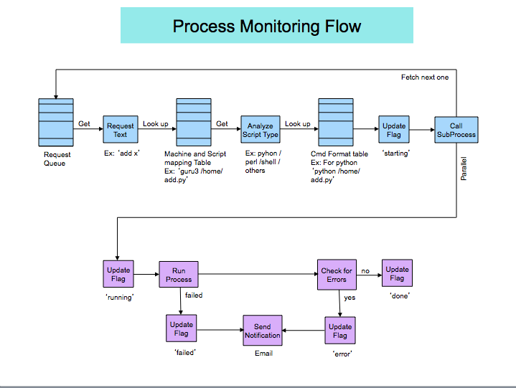Diagram:

Database(MySql on guru):

Name: procmon

Table: request_queue

Column: request

User: monitor

Pass: DBadmin

Host: guru.eecs.northwestern.edu

What user have to do:

Your process and this application have nothing common in them. So you have to make a change to your process so that it can be processed by this application.

1. Put some error message (error/failed) in your process/script; like this;

try:

//

//

except Exception as err:

print “**error** in …..”

print “**error**: processing **failed**..”

Or in any other places in your code block, where you think, error might occur. This error message provided by your script will then be identified.

1. When you have finished above step, you have to register your process/script to the system. Go to the below link and fill it out.

<http://guru.ece.northwestern.edu/fb/pmonitor/config.php>

Choose a nick name(Request Name) for your process, like ‘fbdownload’, ‘testconn’ etc. This name will be mapped to your script location later on to run and monitor your script.

Do this step only for one time.

1. Put your request to the queue table each time you want to run your process. Be sure to put the same Request Name(nick name) you set on step 2; like this;

INSERT INTO procmon.request_queue(request) VALUES(‘*nickname*’);

Your script/process should start running no later than 10sec.

Monitoring:

To see your process/scripts current status; go to <http://guru.ece.northwestern.edu/fb/pmonitor>

The application also checks the run time your process/script takes to

finish. When it crosses the threshold value(you set it in the configuration

step), will generate an email notification.