From the days of newton,we knew that any two objects having mass attract each other with a force what we call gravitational force,and the force of attraction comes out to be equal to:

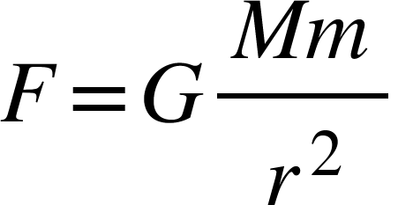

But still even after being able to calculate this force,we didn’t know how does gravitational force actually work,until einstein came up with the general theory of relativity,and the soul of the general theory of relativity was the *equivalence principle,*which says that being on the surface of a planet is equivalent of being in an elevator which is accelerating in the direction of your head with the acceleration of value same as that of present on the surface of the planet.But when we look closely if it is completely true,what we get is not something which goes completely as expected from einstein’s equivalence principle.Because in the elevator there are no tidal forces(stretching) but in the gravitational field tidal forces are present.Because acceleration is function of distance in the case of gravitational force whereas acceleration is constant throughout in the case of accelerating elevator.

Since we know that being in an elevator which is accelerating with an acceleration **a,** where **a** is equal to:

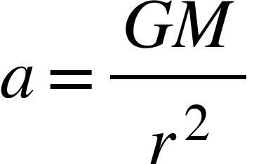

is not equivalent of being on the surface of a planet of mass M and radius r.Because in the elevator every part of the system is feeling the same acceleration, whereas on the surface of the planet acceleration varies and decreases as we go away from the surface.It proves that einstein’s assumption about the equivalence of these two systems is not completely right,as our body on the surface of earth feels different values of acceleration at different heights.

The question arises that we know there is a similarity between these two systems but they are not completely equivalent and if they are not,then what is the real equivalence principle and once we find it,we can put forward a new and better theory to explain the mechanism of gravitational force.

***GRAVITATIONAL EQUIVALENCE:***

An elevator that is moving with an acceleration same as that of present on the surface of the planet can never be equivalent of being on the surface of the planet,because on the surface of the planet time dilation is fixed,if time on the planet is n times time at infinity then it is always going to be n times time at infinity,but in the case of accelerating elevator time dilation is not same because it is accelerating so time dilation will be more and more with the passage of time,even in that case time even stops as the continuous acceleration will lead to velocity tending to velocity of light,but we know that is not something that happens in the cases of planets.but we know that if an object is moving with constant velocity then its time dilation is going to be fixed if it is n times time at infinity its always going to be so,which resembles the case of the being on the surface of the planets as there also the same thing happens.so basically equivalence principle should contain velocity instead of acceleration.As a consequence of above example.

If there is an object of mass M and another object of mass m on the surface of it which is at a distance r from the centre of it,then it will have gravitational potential energy equal to:

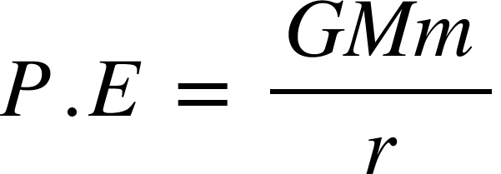

We can convert this potential energy into kinetic energy and it will gain some velocity equal to:

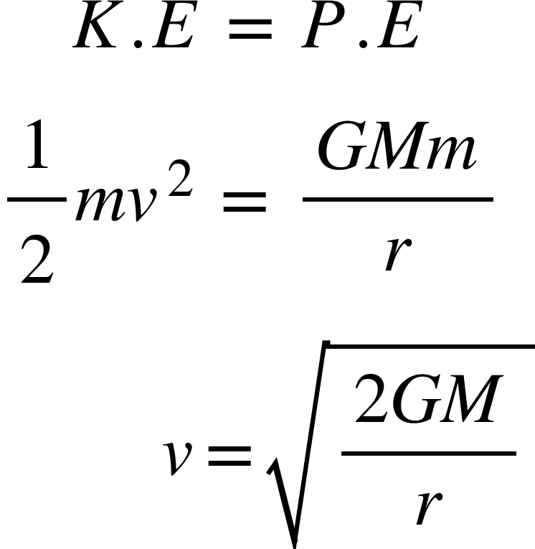

Now if there is a cuboid made up of infinitely thin square sheets aligned horizontally one on another on the surface of the earth and gravity is working on it then it is equivalent of having the same cuboid in an elevator in space such that every corresponding sheet of it is having a velocity

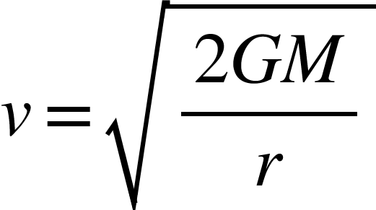

Towards the sheet with low velocity where M is the mass of earth and r is the distance of corresponding sheets from the centre of earth.

But the sheets are not changing their position with respect to each other(how does that happen will be explained later).The effect is going to be completely same in both of these cases.

***PRINCIPLE OF GRAVITATIONAL EQUIVALENCE*:** Being under the gravitational field of an object of mass M at distance r from it,is equivalent of moving with a velocity v with respect to the observer at infinity.where v is equal to :



v is called equivalent velocity and the direction of the velocity is radially outwards from the source of gravitational field.

Since equivalent velocity is function of r and increases as we go closer to the source of the gravitational field,therefore there must be acceleration in it,to get the acceleration we will differentiate it with respect to time t where t is time at infinity:

<math xmlns="http://www.w3.org/1998/Math/MathML"><mi>v</mi><mo>=</mo><msqrt><mfrac><mrow><mn>2</mn><mi>G</mi><mi>M</mi></mrow><mi>r</mi></mfrac></msqrt><mspace linebreak="newline"/><mi>d</mi><mi>i</mi><mi>f</mi><mi>f</mi><mi>e</mi><mi>r</mi><mi>e</mi><mi>n</mi><mi>t</mi><mi>a</mi><mi>i</mi><mi>a</mi><mi>t</mi><mi>e</mi><mo>&#xA0;</mo><mi>b</mi><mi>o</mi><mi>t</mi><mi>h</mi><mo>&#xA0;</mo><mi>s</mi><mi>i</mi><mi>d</mi><mi>e</mi><mi>s</mi><mo>&#xA0;</mo><mi>w</mi><mi>i</mi><mi>t</mi><mi>h</mi><mo>&#xA0;</mo><mi>r</mi><mi>e</mi><mi>s</mi><mi>p</mi><mi>e</mi><mi>c</mi><mi>t</mi><mo>&#xA0;</mo><mi>t</mi><mi>o</mi><mo>&#xA0;</mo><mi>t</mi><mspace linebreak="newline"/><mfrac><mrow><mo>d</mo><mi>v</mi></mrow><mrow><mo>d</mo><mi>t</mi></mrow></mfrac><mo>=</mo><mfrac><mo>d</mo><mrow><mo>d</mo><mi>t</mi></mrow></mfrac><msqrt><mfrac><mrow><mn>2</mn><mi>G</mi><mi>M</mi></mrow><mi>r</mi></mfrac></msqrt><mspace linebreak="newline"/><mo>&#xA0;</mo><mo>&#xA0;</mo><mo>&#xA0;</mo><mo>&#xA0;</mo><mi>a</mi><mo>=</mo><msqrt><mn>2</mn><mi>G</mi><mi>M</mi></msqrt><mfrac><mo>d</mo><mrow><mo>d</mo><mi>t</mi></mrow></mfrac><msqrt><mfrac><mn>1</mn><mi>r</mi></mfrac></msqrt><mspace linebreak="newline"/><mo>&#xA0;</mo><mo>&#xA0;</mo><mo>&#xA0;</mo><mo>&#xA0;</mo><mi>a</mi><mo>=</mo><mfrac><mrow><mo>-</mo><mn>1</mn></mrow><mrow><mn>2</mn><msup><mi>r</mi><mstyle displaystyle="true"><mfrac><mn>3</mn><mn>2</mn></mfrac></mstyle></msup></mrow></mfrac><msqrt><mn>2</mn><mi>G</mi><mi>M</mi></msqrt><mo>&#xA0;</mo><mfrac><mrow><mo>d</mo><mi>r</mi></mrow><mrow><mo>d</mo><mi>t</mi></mrow></mfrac><mspace linebreak="newline"/><mo>&#xA0;</mo><mo>&#xA0;</mo><mo>&#xA0;</mo><mi>a</mi><mo>=</mo><mfrac><mrow><mo>-</mo><mn>1</mn></mrow><mrow><mn>2</mn><msup><mi>r</mi><mstyle displaystyle="true"><mfrac><mn>3</mn><mn>2</mn></mfrac></mstyle></msup></mrow></mfrac><msqrt><mn>2</mn><mi>G</mi><mi>M</mi></msqrt><mo>&#xA0;</mo><mi>v</mi><mspace linebreak="newline"/><mi>p</mi><mi>u</mi><mi>t</mi><mi>t</mi><mi>i</mi><mi>n</mi><mi>g</mi><mo>&#xA0;</mo><mi>v</mi><mi>a</mi><mi>l</mi><mi>u</mi><mi>e</mi><mo>&#xA0;</mo><mi>o</mi><mi>f</mi><mo>&#xA0;</mo><mi>v</mi><mspace linebreak="newline"/><mo>&#xA0;</mo><mo>&#xA0;</mo><mo>&#xA0;</mo><mi>a</mi><mo>=</mo><mfrac><mrow><mo>-</mo><mn>1</mn></mrow><mrow><mn>2</mn><msup><mi>r</mi><msup><mstyle displaystyle="true"><mfrac><mn>3</mn><mn>2</mn></mfrac></mstyle><mrow/></msup></msup></mrow></mfrac><msqrt><mn>2</mn><mi>G</mi><mi>M</mi></msqrt><mo>&#xA0;</mo><msqrt><mfrac><mrow><mn>2</mn><mi>G</mi><mi>M</mi></mrow><mi>r</mi></mfrac></msqrt><mspace linebreak="newline"/><mi>a</mi><mo>=</mo><mo>-</mo><mfrac><mrow><mi>G</mi><mi>M</mi></mrow><msup><mi>r</mi><mn>2</mn></msup></mfrac><mspace linebreak="newline"/><mi>w</mi><mi>h</mi><mi>e</mi><mi>r</mi><mi>e</mi><mo>&#xA0;</mo><mi>n</mi><mi>e</mi><mi>g</mi><mi>a</mi><mi>t</mi><mi>i</mi><mi>v</mi><mi>e</mi><mo>&#xA0;</mo><mi>s</mi><mi>i</mi><mi>g</mi><mi>n</mi><mo>&#xA0;</mo><mi>s</mi><mi>h</mi><mi>o</mi><mi>w</mi><mi>s</mi><mo>&#xA0;</mo><mi>d</mi><mi>i</mi><mi>r</mi><mi>e</mi><mi>c</mi><mi>t</mi><mi>i</mi><mi>o</mi><mi>n</mi><mspace linebreak="newline"/><mspace linebreak="newline"/><mspace linebreak="newline"/></math>

This result agrees with new newtonian theory of gravitation because this has been derived from equivalent velocity concept and eventually we got acceleration due to gravitational force.

***Relativistic effects of equivalent velocity:***

Since equivalent velocity is equivalent of relativistic velocity it must show all effects shown by relativistic velocities.for example time dilation,length contraction etc.

Replacing relativistic velocity by equivalent velocity in various relativistic effects we get:

<math xmlns="http://www.w3.org/1998/Math/MathML"><mi>w</mi><mi>e</mi><mo>&#xA0;</mo><mi>k</mi><mi>n</mi><mi>o</mi><mi>w</mi><mo>&#xA0;</mo><mspace linebreak="newline"/><mi>t</mi><mo>'</mo><mo>&#xA0;</mo><mo>=</mo><mi>t</mi><mo>&#xA0;</mo><msqrt><mn>1</mn><mo>-</mo><mfrac><msup><mi>v</mi><mn>2</mn></msup><msup><mi>c</mi><mn>2</mn></msup></mfrac></msqrt><mo>&#xA0;</mo><mo>&#xA0;</mo><mspace linebreak="newline"/><mi>s</mi><mi>u</mi><mi>b</mi><mi>s</mi><mi>t</mi><mi>i</mi><mi>t</mi><mi>u</mi><mi>t</mi><mi>i</mi><mi>n</mi><mi>g</mi><mo>&#xA0;</mo><mi>t</mi><mi>h</mi><mi>e</mi><mo>&#xA0;</mo><mi>v</mi><mi>a</mi><mi>l</mi><mi>u</mi><mi>e</mi><mo>&#xA0;</mo><mi>o</mi><mi>f</mi><mo>&#xA0;</mo><mi>e</mi><mi>q</mi><mi>u</mi><mi>i</mi><mi>v</mi><mi>a</mi><mi>l</mi><mi>e</mi><mi>n</mi><mi>t</mi><mo>&#xA0;</mo><mi>v</mi><mi>e</mi><mi>l</mi><mi>o</mi><mi>c</mi><mi>i</mi><mi>t</mi><mi>y</mi><mo>&#xA0;</mo><mi>i</mi><mi>n</mi><mo>&#xA0;</mo><mi>a</mi><mi>b</mi><mi>o</mi><mi>v</mi><mi>e</mi><mo>&#xA0;</mo><mi>e</mi><mi>q</mi><mi>u</mi><mi>a</mi><mi>t</mi><mi>i</mi><mi>o</mi><mi>n</mi><mo>.</mo><mspace linebreak="newline"/><mi>v</mi><mo>=</mo><msqrt><mfrac><mrow><mn>2</mn><mi>G</mi><mi>M</mi></mrow><mi>r</mi></mfrac></msqrt><mspace linebreak="newline"/><mi>t</mi><mo>'</mo><mo>=</mo><mi>t</mi><msqrt><mn>1</mn><mo>-</mo><mfrac><mrow><mn>2</mn><mi>G</mi><mi>M</mi></mrow><mrow><mi>r</mi><msup><mi>c</mi><mn>2</mn></msup></mrow></mfrac></msqrt><mspace linebreak="newline"/><mi>s</mi><mi>i</mi><mi>m</mi><mi>i</mi><mi>l</mi><mi>a</mi><mi>r</mi><mi>l</mi><mi>y</mi><mspace linebreak="newline"/><mi>f</mi><mi>o</mi><mi>r</mi><mo>&#xA0;</mo><mi>l</mi><mi>e</mi><mi>n</mi><mi>g</mi><mi>t</mi><mi>h</mi><mo>&#xA0;</mo><mi>c</mi><mi>o</mi><mi>n</mi><mi>t</mi><mi>r</mi><mi>a</mi><mi>c</mi><mi>t</mi><mi>i</mi><mi>o</mi><mi>n</mi><mspace linebreak="newline"/><mo>&#xA0;</mo><mi>l</mi><mo>'</mo><mo>=</mo><mi>l</mi><msqrt><mn>1</mn><mo>-</mo><mfrac><msup><mi>v</mi><mn>2</mn></msup><msup><mi>c</mi><mn>2</mn></msup></mfrac></msqrt><mo>&#xA0;</mo><mo>&#xA0;</mo><mspace linebreak="newline"/><mspace linebreak="newline"/><mi>l</mi><mo>'</mo><mo>=</mo><mi>l</mi><mo>&#xA0;</mo><msqrt><mn>1</mn><mo>-</mo><mfrac><mrow><mn>2</mn><mi>G</mi><mi>M</mi></mrow><mrow><mi>r</mi><msup><mi>c</mi><mn>2</mn></msup></mrow></mfrac></msqrt><mspace linebreak="newline"/><mi>m</mi><mo>'</mo><mo>=</mo><mfrac><mi>m</mi><mrow><msqrt><mn>1</mn><mo>-</mo><mfrac><msup><mi>v</mi><mn>2</mn></msup><msup><mi>c</mi><mn>2</mn></msup></mfrac></msqrt><mo>&#xA0;</mo><mo>&#xA0;</mo></mrow></mfrac><mspace linebreak="newline"/><mi>m</mi><mo>'</mo><mo>=</mo><mfrac><mi>m</mi><msqrt><mn>1</mn><mo>-</mo><mfrac><mrow><mn>2</mn><mi>G</mi><mi>M</mi></mrow><mrow><mi>r</mi><msup><mi>c</mi><mn>2</mn></msup></mrow></mfrac></msqrt></mfrac><mspace linebreak="newline"/><mspace linebreak="newline"/></math>

Where t,l,m are time,length,mass at infinity and t’,l’,m’ are time,length,mass at distance r from an object of mass M.

Since in gravitational force we got equivalent velocity v.hence we can obtain equivalent momentum from it which is equal to **p**

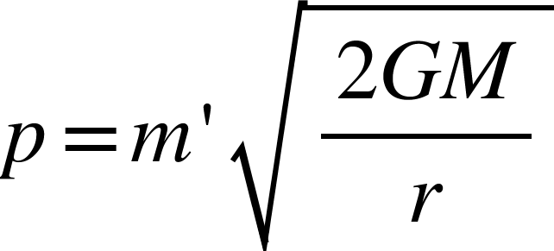

And if there is momentum there is a de broglie wave linked to it.

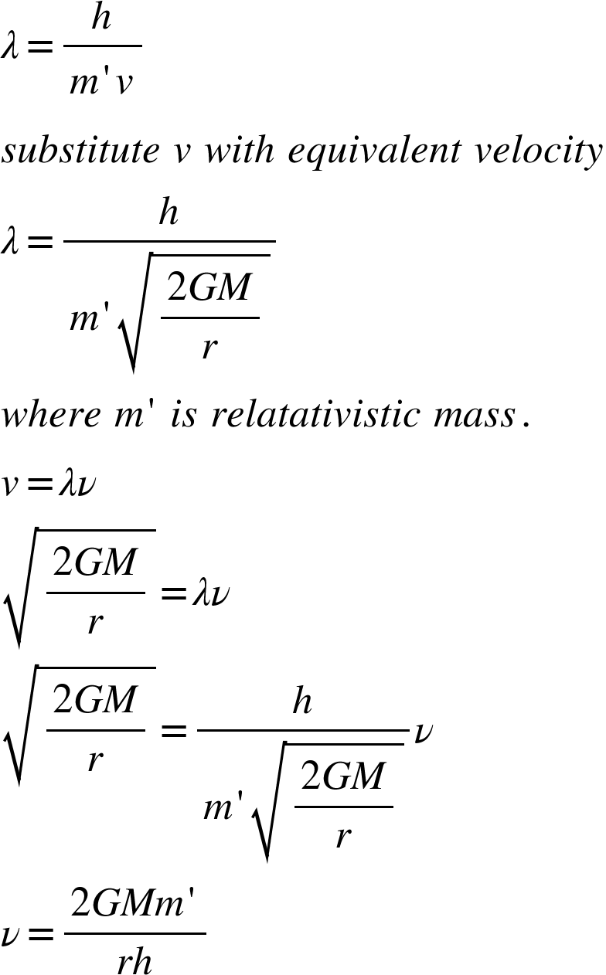

So with respect to the source of gravitational force.

Any object at distance r is oscillating horizontally with a frequency of

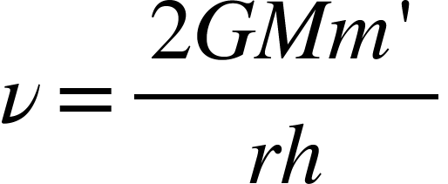

**Maximum possible equivalent velocity:**

Since being under the effect of gravitational force is equivalent of having a velocity



And there is a limit to velocities that nothing can move faster than light.putting c as a maximum possible value of v we get

<math xmlns="http://www.w3.org/1998/Math/MathML"><msqrt><mfrac><mrow><mn>2</mn><mi>G</mi><mi>M</mi></mrow><mi>r</mi></mfrac></msqrt><mo>&#x2264;</mo><mi>c</mi><mspace linebreak="newline"/><mo>&#xA0;</mo><mo>&#xA0;</mo><mo>&#xA0;</mo><mo>&#xA0;</mo><mfrac><mrow><mn>2</mn><mi>G</mi><mi>M</mi></mrow><mi>r</mi></mfrac><mo>&#x2264;</mo><msup><mi>c</mi><mn>2</mn></msup><mspace linebreak="newline"/><mfrac><mi>M</mi><mi>r</mi></mfrac><mo>&#xA0;</mo><mo>&#x2264;</mo><mo>&#xA0;</mo><mfrac><msup><mi>c</mi><mn>2</mn></msup><mrow><mn>2</mn><mi>G</mi></mrow></mfrac><mspace linebreak="newline"/><mi>s</mi><mi>o</mi><mo>&#xA0;</mo><mi>f</mi><mi>o</mi><mi>r</mi><mo>&#xA0;</mo><mi>a</mi><mi>n</mi><mi>y</mi><mo>&#xA0;</mo><mi>m</mi><mi>a</mi><mi>s</mi><mi>s</mi><mi>i</mi><mi>v</mi><mi>e</mi><mo>&#xA0;</mo><mi>o</mi><mi>b</mi><mi>j</mi><mi>e</mi><mi>c</mi><mi>t</mi><mo>&#xA0;</mo><mi>i</mi><mi>n</mi><mo>&#xA0;</mo><mi>u</mi><mi>n</mi><mi>i</mi><mi>v</mi><mi>e</mi><mi>r</mi><mi>s</mi><mi>e</mi><mo>.</mo><mo>&#xA0;</mo><mi>t</mi><mi>h</mi><mi>e</mi><mo>&#xA0;</mo><mi>r</mi><mi>a</mi><mi>t</mi><mi>i</mi><mi>o</mi><mo>&#xA0;</mo><mi>o</mi><mi>f</mi><mo>&#xA0;</mo><mi>i</mi><mi>t</mi><mi>s</mi><mo>&#xA0;</mo><mi>m</mi><mi>a</mi><mi>s</mi><mi>s</mi><mo>&#xA0;</mo><mi>t</mi><mi>o</mi><mo>&#xA0;</mo><mi>i</mi><mi>t</mi><mi>s</mi><mo>&#xA0;</mo><mi>r</mi><mi>a</mi><mi>d</mi><mi>i</mi><mi>u</mi><mi>s</mi><mo>&#xA0;</mo><mi>m</mi><mi>u</mi><mi>s</mi><mi>t</mi><mo>&#xA0;</mo><mi>b</mi><mi>e</mi><mo>&#xA0;</mo><mi>l</mi><mi>e</mi><mi>s</mi><mi>s</mi><mo>&#xA0;</mo><mi>t</mi><mi>h</mi><mi>a</mi><mi>n</mi><mo>&#xA0;</mo><mi>o</mi><mi>r</mi><mo>&#xA0;</mo><mi>e</mi><mi>q</mi><mi>u</mi><mi>a</mi><mi>l</mi><mo>&#xA0;</mo><mi>t</mi><mi>o</mi><mo>&#xA0;</mo><mfrac><msup><mi>c</mi><mn>2</mn></msup><mrow><mn>2</mn><mi>G</mi></mrow></mfrac><mspace linebreak="newline"/><mi>a</mi><mi>n</mi><mi>d</mi><mo>&#xA0;</mo><mi>r</mi><mi>a</mi><mi>d</mi><mi>i</mi><mi>u</mi><mi>s</mi><mo>&#xA0;</mo><mi>o</mi><mi>f</mi><mo>&#xA0;</mo><mi>e</mi><mi>v</mi><mi>e</mi><mi>r</mi><mi>y</mi><mo>&#xA0;</mo><mi>o</mi><mi>b</mi><mi>j</mi><mi>e</mi><mi>c</mi><mi>t</mi><mo>&#xA0;</mo><mi>i</mi><mi>n</mi><mo>&#xA0;</mo><mi>u</mi><mi>n</mi><mi>i</mi><mi>v</mi><mi>e</mi><mi>r</mi><mi>s</mi><mi>e</mi><mo>&#xA0;</mo><mi>m</mi><mi>u</mi><mi>s</mi><mi>t</mi><mo>&#xA0;</mo><mi>b</mi><mi>e</mi><mo>&#xA0;</mo><mi>r</mi><mo>&#x2265;</mo><mfrac><mrow><mn>2</mn><mi>G</mi><mi>M</mi></mrow><msup><mi>c</mi><mn>2</mn></msup></mfrac></math>

The radius at which the equivalent velocity becomes equal to the speed of light is

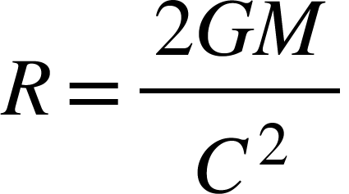

It’s also the minimum possible radius for any massive object due to its gravitational force.

**No force law:**

From infinity to radius R of a point object of mass M,equivalent velocity increases from zero to speed of light.since velocity can never be greater than velocity of light so from radius R to radius equal to zero there is no increment in equivalent velocity and object at radius R will have same equivalent velocity as that of object inside R which is the speed of light.Since there is no change is equivalent velocity which means there is no acceleration and if there is no acceleration there will be no force.

So if there is an object whose radius is less than R.Then from its centre to radius R there will be no gravitational force at all.which means force due to a point mass will not always increase as we go towards its centre,and will not tend to infinity as we tend to reach towards zero radius.but its force will increase as long as we are outside R and as we are at R acceleration will be maximum but inside R acceleration will be zero.

So the maximum possible acceleration by the gravitational effects of an object of mass M is

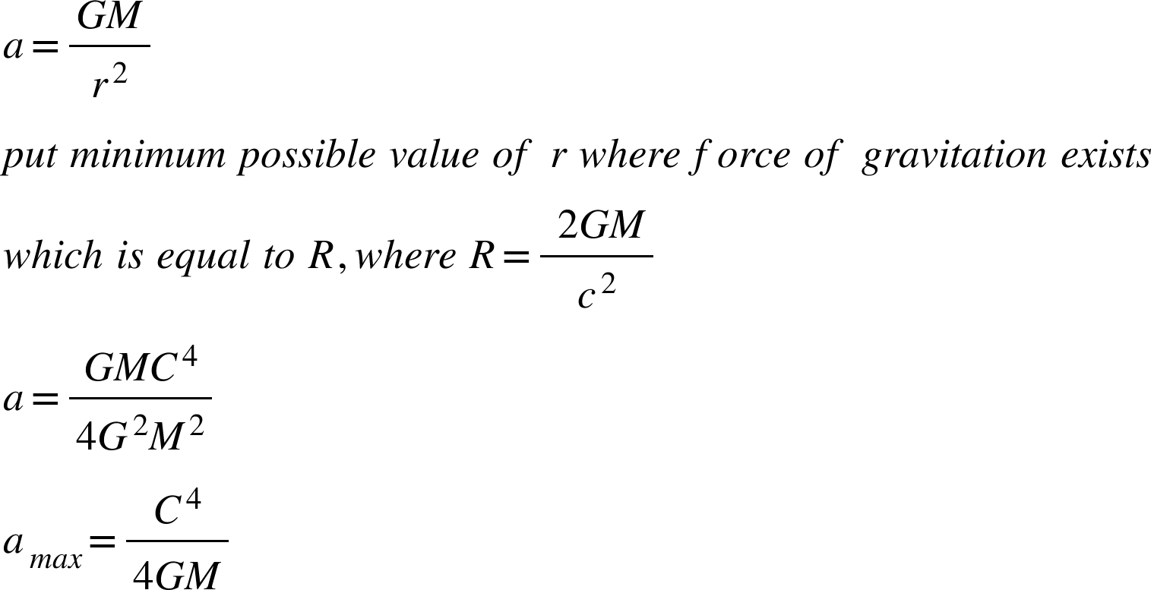

Time stops at radius R.from there onwards there is no passing of time,and if there is no time,acceleration is meaningless.as acceleration itself is function of time.

Which goes parallel to what was said above.

If a huge amount of mass is in a point size object and if it explodes,its gravitational force will not pull it back the moment it explodes.Because there is no force of gravitation.Gravitational force comes into play only once the exploded parts are outside R. then gravitational force will come into play.And that’s when objects will start identifying one another.

This is the main reason for the existence of our universe and big bang.the singularity that exploded at the time of big bang didn’t collapse the moment it happened.because there was no force at all to pull it,forces came into existence when radius of universe was already R.and for our universe R is nearly equal to 13.6 billion light years.

Since there is no force beyond R ,so gravitational force can only pull objects to radius R.

Nothing can go smaller than its R because of its own gravitational force,because there is no force beyond R.and if there is no force nothing will pull it to go smaller.hence there should be no gravitational singularities.And blackholes are then objects with radius equal to R.where R is the minimum possible radius at which escape velocity becomes speed of light.



**Vectorian consequence of equivalent velocities:**

if an object is under the gravitational field of an object of mass M at distance r.and it is also having a relative velocity v with respect to the object of mass M.then the resultant of both of these velocities will decide the net effects of relativity.

Using vector addition of vectors the Lorrentz factor would be equal to

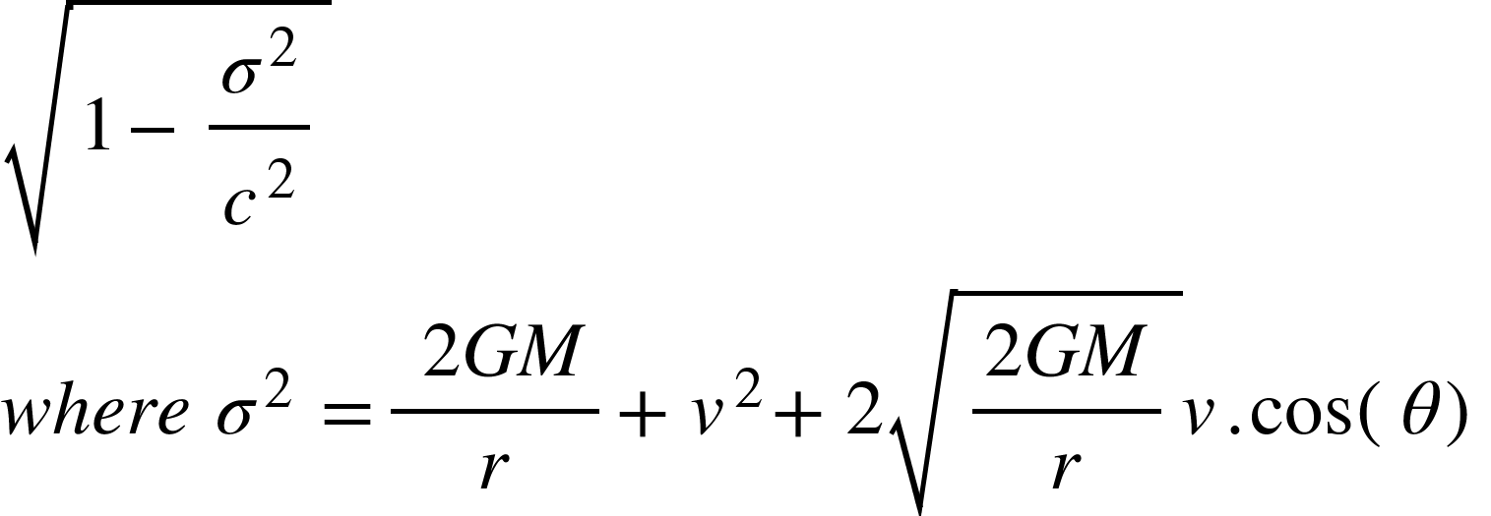

Where the direction of equivalence velocity is radially outwards.and theta is the angle between these two velocities.

If the angle between equivalence velocity and relativistic velocity is 180 degrees and both are equal in magnitude then sigma is going to be zero.

Which means there will be no time dilation if an object is moving with relativistic velocity equal to equivalence velocity in magnitude but direction wise opposite.

The time and other stuff for the observer at infinity will be same as that for the observer with sigma equal to zero.

Similarly if an object at infinity starts moving under the influence of gravitational force of a massive object of mass M,then the time dilation and other effects of its velocity and its approach towards the massive object will come out to be zero.as the relativistic and equivalence velocity will cancel each other at every point.which gives us idea about the fact how gravitational force actually works.

“*An object falling with velocity equal to its equivalent velocity will never feel any relativistic effects like time dilation mass increment et cetera.”*

**MECHANISM OF GRAVITATIONAL FORCE FROM EQUIVALENCE PRINCIPLE:**

Using equivalence principle we got two things,one that being under gravitational force is equivalent of moving with equivalent velocity radially outwards from the source of gravitational force,and having a relativistic velocity equal to equivalent velocity radially inwards in direction is equivalent of having zero velocity in space where there is no gravitational field.

Both of them are simultaneously true only if its space that moves due to the presence of matter in it towards the matter with velocity equal to equivalence velocity.

Now we can explain everything said earlier including equivalence principle.equivalence velocity exist because it is space moving with that velocity towards the source of gravitational force and velocity is all about travelling in space..

And for the object moving with equivalent velocity towards the source of gravitational field time dilation and other effects become zero because space is also moving with the same velocity in same direction,as a result relative velocity between space and falling object becomes zero,and it behaves as if it is in rest.

“*Gravitational force is nothing but the motion of space towards the mass with equivalence velocity equal to*

”

To imagine the process one can think of a room filled with water and a sink in the middle of it and the water is moving towards the sink and the velocity of water is more near the sink.sink is like matter and water is like space.whatever is in water will also flow towards the sink.that’s also why gravitational force bends light because it doesn’t actually bend it,its just space in which light is travelling is drifting towards matter.

Differentiate the equivalence velocity of space and you will get acceleration equal to acceleration due to gravitational force.which satisfies with newton’s law.

If one is moving with equivalent velocity radially inwards but so is space as a consequence ones velocity with respect to space is zero.hence no time dilation.

In contrary to this if one is at rest with respect to the source but space is moving radially inwards with equivalence velocity as a result from the reference of moving space one is moving radially outside with equivalence velocity,which is what equivalence principle at first place was all about.

**Relativistics:**

*<math xmlns="http://www.w3.org/1998/Math/MathML"><mi>w</mi><mi>e</mi><mo>&#xA0;</mo><mi>k</mi><mi>n</mi><mi>o</mi><mi>w</mi><mo>&#xA0;</mo><mi>t</mi><mi>h</mi><mi>a</mi><mi>t</mi><mspace linebreak="newline"/><mi>t</mi><mo>'</mo><mo>=</mo><mi>t</mi><msqrt><mn>1</mn><mo>-</mo><mfrac><mrow><mn>2</mn><mi>G</mi><mi>M</mi></mrow><mrow><mi>r</mi><msup><mi>c</mi><mn>2</mn></msup></mrow></mfrac></msqrt><mspace linebreak="newline"/><mi>w</mi><mi>h</mi><mi>e</mi><mi>r</mi><mi>e</mi><mo>&#xA0;</mo><mi>t</mi><mo>'</mo><mo>&#xA0;</mo><mi>i</mi><mi>s</mi><mo>&#xA0;</mo><mi>t</mi><mi>i</mi><mi>m</mi><mi>e</mi><mo>&#xA0;</mo><mi>a</mi><mi>t</mi><mo>&#xA0;</mo><mi>d</mi><mi>i</mi><mi>s</mi><mi>tan</mi><mi>c</mi><mi>e</mi><mo>&#xA0;</mo><mi>r</mi><mo>&#xA0;</mo><mi>f</mi><mi>r</mi><mi>o</mi><mi>m</mi><mo>&#xA0;</mo><mi>t</mi><mi>h</mi><mi>e</mi><mo>&#xA0;</mo><mi>s</mi><mi>o</mi><mi>u</mi><mi>r</mi><mi>c</mi><mi>e</mi><mo>&#xA0;</mo><mi>a</mi><mi>n</mi><mi>d</mi><mo>&#xA0;</mo><mi>t</mi><mo>&#xA0;</mo><mi>i</mi><mi>s</mi><mo>&#xA0;</mo><mi>t</mi><mi>i</mi><mi>m</mi><mi>e</mi><mo>&#xA0;</mo><mi>a</mi><mi>t</mi><mo>&#xA0;</mo><mi>i</mi><mi>n</mi><mi>f</mi><mi>i</mi><mi>n</mi><mi>i</mi><mi>t</mi><mi>y</mi><mspace linebreak="newline"/><mi>l</mi><mi>e</mi><mi>t</mi><mo>&#xA0;</mo><msub><mi>t</mi><mi>s</mi></msub><mo>&#xA0;</mo><mi>b</mi><mi>e</mi><mo>&#xA0;</mo><mi>t</mi><mi>i</mi><mi>m</mi><mi>e</mi><mo>&#xA0;</mo><mi>a</mi><mi>t</mi><mo>&#xA0;</mo><mi>s</mi><mi>u</mi><mi>r</mi><mi>f</mi><mi>a</mi><mi>c</mi><mi>e</mi><mo>&#xA0;</mo><mi>a</mi><mi>n</mi><mi>d</mi><mo>&#xA0;</mo><mi>R</mi><mo>&#xA0;</mo><mi>b</mi><mi>e</mi><mo>&#xA0;</mo><mi>i</mi><mi>t</mi><mi>s</mi><mo>&#xA0;</mo><mi>r</mi><mi>a</mi><mi>d</mi><mi>i</mi><mi>u</mi><mi>s</mi><mo>&#xA0;</mo><mi>t</mi><mi>h</mi><mi>e</mi><mi>n</mi><mspace linebreak="newline"/><msub><mi>t</mi><mi>s</mi></msub><mo>=</mo><mi>t</mi><msqrt><mn>1</mn><mo>-</mo><mfrac><mrow><mn>2</mn><mi>G</mi><mi>M</mi></mrow><mrow><mi>R</mi><msup><mi>c</mi><mn>2</mn></msup></mrow></mfrac></msqrt><mspace linebreak="newline"/><mi>d</mi><mi>i</mi><mi>v</mi><mi>i</mi><mi>d</mi><mi>i</mi><mi>n</mi><mi>g</mi><mo>&#xA0;</mo><mi>t</mi><mi>h</mi><mi>e</mi><mi>s</mi><mi>e</mi><mo>&#xA0;</mo><mi>t</mi><mi>w</mi><mi>o</mi><mo>&#xA0;</mo><mi>w</mi><mi>e</mi><mo>&#xA0;</mo><mi>g</mi><mi>e</mi><mi>t</mi><mspace linebreak="newline"/><mi>t</mi><mo>'</mo><mo>=</mo><mfrac><mrow><mi>t</mi><msqrt><mn>1</mn><mo>-</mo><mfrac><mrow><mn>2</mn><mi>G</mi><mi>M</mi></mrow><mrow><mi>r</mi><msup><mi>c</mi><mn>2</mn></msup></mrow></mfrac></msqrt></mrow><msqrt><mn>1</mn><mo>-</mo><mfrac><mrow><mn>2</mn><mi>G</mi><mi>M</mi></mrow><mrow><mi>R</mi><msup><mi>c</mi><mn>2</mn></msup></mrow></mfrac></msqrt></mfrac><mspace linebreak="newline"/><mi>s</mi><mi>i</mi><mi>m</mi><mi>i</mi><mi>l</mi><mi>a</mi><mi>r</mi><mi>l</mi><mi>y</mi><mspace linebreak="newline"/><mi>m</mi><mo>'</mo><mo>=</mo><mfrac><mi>m</mi><msqrt><mn>1</mn><mo>-</mo><mfrac><mrow><mn>2</mn><mi>G</mi><mi>M</mi></mrow><mrow><mi>r</mi><msup><mi>c</mi><mn>2</mn></msup></mrow></mfrac></msqrt></mfrac><mspace linebreak="newline"/><msub><mi>m</mi><mi>s</mi></msub><mo>=</mo><mfrac><mi>m</mi><msqrt><mn>1</mn><mo>-</mo><mfrac><mrow><mn>2</mn><mi>G</mi><mi>M</mi></mrow><mrow><mi>R</mi><msup><mi>c</mi><mn>2</mn></msup></mrow></mfrac></msqrt></mfrac><mspace linebreak="newline"/><mi>m</mi><mo>'</mo><mo>=</mo><mfrac><mrow><msub><mi>m</mi><mi>s</mi></msub><msqrt><mn>1</mn><mo>-</mo><mfrac><mrow><mn>2</mn><mi>G</mi><mi>M</mi></mrow><mrow><mi>R</mi><msup><mi>c</mi><mn>2</mn></msup></mrow></mfrac></msqrt></mrow><msqrt><mn>1</mn><mo>-</mo><mfrac><mrow><mn>2</mn><mi>G</mi><mi>M</mi></mrow><mrow><mi>r</mi><msup><mi>c</mi><mn>2</mn></msup></mrow></mfrac></msqrt></mfrac><mspace linebreak="newline"/><mi>s</mi><mi>i</mi><mi>m</mi><mi>i</mi><mi>l</mi><mi>a</mi><mi>r</mi><mi>l</mi><mi>y</mi><mspace linebreak="newline"/><mi>l</mi><mo>'</mo><mo>=</mo><mi>l</mi><mo>&#xA0;</mo><mfrac><msqrt><mn>1</mn><mo>-</mo><mfrac><mrow><mn>2</mn><mi>G</mi><mi>M</mi></mrow><mrow><mi>r</mi><msup><mi>c</mi><mn>2</mn></msup></mrow></mfrac></msqrt><msqrt><mn>1</mn><mo>-</mo><mfrac><mrow><mn>2</mn><mi>G</mi><mi>M</mi></mrow><mrow><mi>R</mi><msup><mi>c</mi><mn>2</mn></msup></mrow></mfrac></msqrt></mfrac></math>*

**MODIFIED NEWTON’S LAW OF GRAVITATION:**

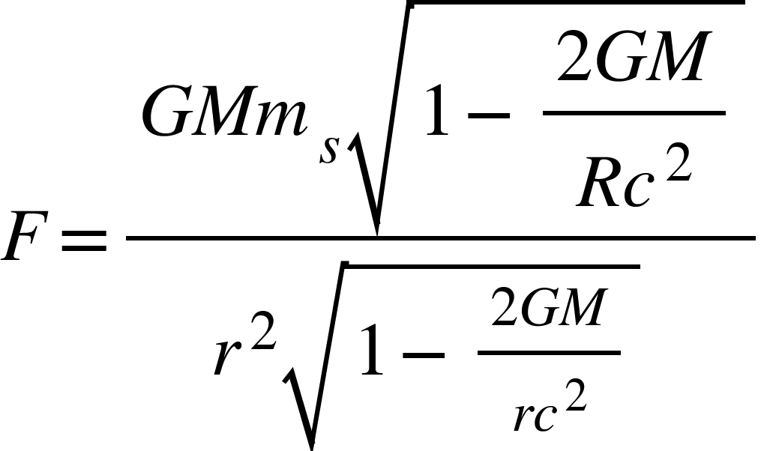

Because mass varies under the influence of equivalence velocity.

CIRCULAR MOTION:

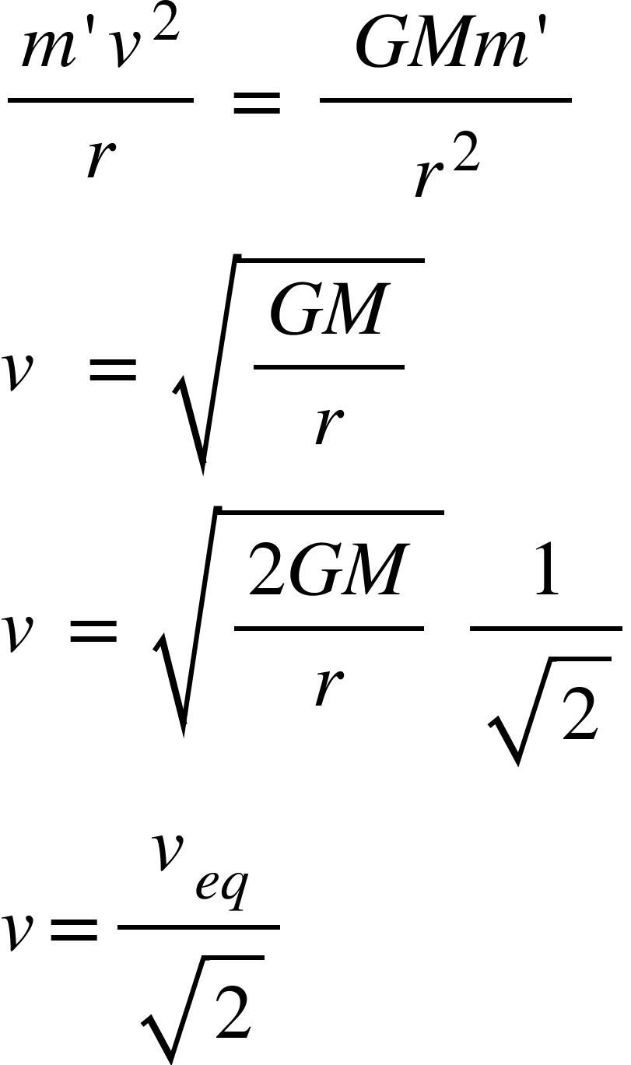

So if space is moving with equivalence velocity towards the source,to perform a circular motion one needs velocity 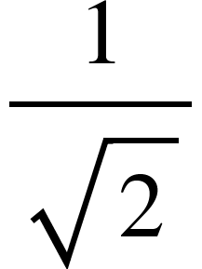times equivalence velocity.

**BLACKHOLES:**

Blackhole is anything with radius equal to



Which is minimum possible radius due to gravitational force.they should be dark ball like structure made up of dense matter.there is no inside because there is only solid surface and dense matter.there is no other side of blackhole,its just like a steel ball in water.there is no gravitational force inside it as its surface is where after force becomes zero.time on its surface becomes zero so there is no physical phenomena happening inside.the escape velocity of its surface is C,where c is speed of light.whenever something falls towards it,its size increases.

**EQUIVALENCE MASSES AND EXPANSION OF UNIVERSE:**

Since mass depends on equivalence velocity and equivalence velocity varies with the distance from the source of gravitational force by the relation:

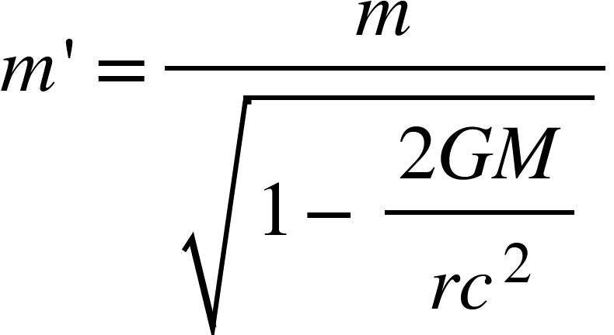

If an object is thrown upwards in a gravitational field from r1 to r2 where v1 is velocity at r1 and v2 is velocity at r2 then its mass decreases as it goes away from the source,the change in mass gets converted into the kinetic energy of the object,and if this kinetic energy is more than potential energy difference then it will accelerate and if its less than potential energy difference then it will retard.for our universe the change in mass is so high that the kinetic energy change is more than the potential energy difference as a result our universe is expanding and galaxies and stars and moving away from us with acceleration.

<math xmlns="http://www.w3.org/1998/Math/MathML"><mi>w</mi><mi>e</mi><mo>&#xA0;</mo><mi>k</mi><mi>n</mi><mi>o</mi><mi>w</mi><mo>&#xA0;</mo><mi>m</mi><mi>a</mi><mi>s</mi><mi>s</mi><mi>e</mi><mi>s</mi><mo>&#xA0;</mo><mi>v</mi><mi>a</mi><mi>r</mi><mi>y</mi><mo>&#xA0;</mo><mi>f</mi><mi>r</mi><mi>o</mi><mi>m</mi><mo>&#xA0;</mo><mi>p</mi><mi>o</mi><mi>s</mi><mi>i</mi><mi>t</mi><mi>i</mi><mi>o</mi><mi>n</mi><mo>&#xA0;</mo><mi>t</mi><mi>o</mi><mo>&#xA0;</mo><mi>p</mi><mi>o</mi><mi>s</mi><mi>i</mi><mi>t</mi><mi>i</mi><mi>o</mi><mi>n</mi><mo>&#xA0;</mo><mi>i</mi><mi>n</mi><mo>&#xA0;</mo><mi>g</mi><mi>r</mi><mi>a</mi><mi>v</mi><mi>i</mi><mi>a</mi><mi>t</mi><mi>i</mi><mi>o</mi><mi>n</mi><mi>a</mi><mi>l</mi><mo>&#xA0;</mo><mi>f</mi><mi>i</mi><mi>e</mi><mi>l</mi><mi>d</mi><mo>.</mo><mspace linebreak="newline"/><msub><mi>m</mi><mn>1</mn></msub><mo>=</mo><mfrac><mi>m</mi><msqrt><mn>1</mn><mo>-</mo><mstyle displaystyle="true"><mfrac><mrow><mn>2</mn><mi>G</mi><mi>M</mi></mrow><mrow><msub><mi>r</mi><mn>1</mn></msub><msup><mi>c</mi><mn>2</mn></msup></mrow></mfrac></mstyle></msqrt></mfrac><mspace linebreak="newline"/><msub><mi>m</mi><mn>2</mn></msub><mo>=</mo><mfrac><mi>m</mi><msqrt><mn>1</mn><mo>-</mo><mstyle displaystyle="true"><mfrac><mrow><mn>2</mn><mi>G</mi><mi>M</mi></mrow><mrow><msub><mi>r</mi><mn>2</mn></msub><msup><mi>c</mi><mn>2</mn></msup></mrow></mfrac></mstyle></msqrt></mfrac><mspace linebreak="newline"/><mo>&#x2206;</mo><mi>m</mi><mo>=</mo><msub><mi>m</mi><mn>1</mn></msub><mo>&#xA0;</mo><mo>-</mo><mo>&#xA0;</mo><msub><mi>m</mi><mn>2</mn></msub><mspace linebreak="newline"/><mo>&#x2206;</mo><mi>m</mi><mo>=</mo><mo>&#xA0;</mo><mi>m</mi><mfenced><mrow><mfrac><mn>1</mn><msqrt><mn>1</mn><mo>-</mo><mstyle displaystyle="true"><mfrac><mrow><mn>2</mn><mi>G</mi><mi>M</mi></mrow><mrow><msub><mi>r</mi><mn>1</mn></msub><msup><mi>c</mi><mn>2</mn></msup></mrow></mfrac></mstyle></msqrt></mfrac><mo>&#xA0;</mo><mo>-</mo><mo>&#xA0;</mo><mfrac><mn>1</mn><msqrt><mn>1</mn><mo>-</mo><mstyle displaystyle="true"><mfrac><mrow><mn>2</mn><mi>G</mi><mi>M</mi></mrow><mrow><msub><mi>r</mi><mn>2</mn></msub><msup><mi>c</mi><mn>2</mn></msup></mrow></mfrac></mstyle></msqrt></mfrac></mrow></mfenced><mspace linebreak="newline"/><mo>&#x2206;</mo><mi>m</mi><mo>=</mo><mo>&#xA0;</mo><mi>m</mi><mi>k</mi><mo>&#xA0;</mo><mo>&#xA0;</mo><mo>&#xA0;</mo><mo>&#xA0;</mo><mo>&#xA0;</mo><mi>w</mi><mi>h</mi><mi>e</mi><mi>r</mi><mi>e</mi><mo>&#xA0;</mo><mi>k</mi><mo>=</mo><mo>&#xA0;</mo><mfenced><mrow><mfrac><mn>1</mn><msqrt><mn>1</mn><mo>-</mo><mstyle displaystyle="true"><mfrac><mrow><mn>2</mn><mi>G</mi><mi>M</mi></mrow><mrow><msub><mi>r</mi><mn>1</mn></msub><msup><mi>c</mi><mn>2</mn></msup></mrow></mfrac></mstyle></msqrt></mfrac><mo>&#xA0;</mo><mo>-</mo><mo>&#xA0;</mo><mfrac><mn>1</mn><msqrt><mn>1</mn><mo>-</mo><mstyle displaystyle="true"><mfrac><mrow><mn>2</mn><mi>G</mi><mi>M</mi></mrow><mrow><msub><mi>r</mi><mn>2</mn></msub><msup><mi>c</mi><mn>2</mn></msup></mrow></mfrac></mstyle></msqrt></mfrac></mrow></mfenced><mspace linebreak="newline"/><mi>w</mi><mi>e</mi><mo>&#xA0;</mo><mi>c</mi><mi>a</mi><mi>n</mi><mo>&#xA0;</mo><mi>c</mi><mi>o</mi><mi>n</mi><mi>v</mi><mi>e</mi><mi>r</mi><mi>t</mi><mo>&#xA0;</mo><mi>t</mi><mi>h</mi><mi>i</mi><mi>s</mi><mo>&#xA0;</mo><mi>m</mi><mi>a</mi><mi>s</mi><mi>s</mi><mo>&#xA0;</mo><mi>i</mi><mi>n</mi><mi>t</mi><mi>o</mi><mo>&#xA0;</mo><mi>e</mi><mi>n</mi><mi>e</mi><mi>r</mi><mi>g</mi><mi>y</mi><mo>&#xA0;</mo><mi>w</mi><mi>h</mi><mi>e</mi><mi>r</mi><mi>e</mi><mspace linebreak="newline"/><mo>&#x2206;</mo><mi>E</mi><mo>=</mo><mi>k</mi><mi>m</mi><msup><mi>c</mi><mn>2</mn></msup><mspace linebreak="newline"/><mi>p</mi><mi>o</mi><mi>t</mi><mi>e</mi><mi>n</mi><mi>t</mi><mi>i</mi><mi>a</mi><mi>l</mi><mo>&#xA0;</mo><mi>e</mi><mi>n</mi><mi>e</mi><mi>r</mi><mi>g</mi><mi>y</mi><mo>&#xA0;</mo><mi>d</mi><mi>i</mi><mi>f</mi><mi>f</mi><mi>e</mi><mi>r</mi><mi>e</mi><mi>n</mi><mi>c</mi><mi>e</mi><mo>&#xA0;</mo><mi>b</mi><mi>e</mi><mi>t</mi><mi>w</mi><mi>e</mi><mi>e</mi><mi>n</mi><mo>&#xA0;</mo><msub><mi>r</mi><mrow><mn>1</mn><mo>&#xA0;</mo></mrow></msub><mo>&#xA0;</mo><mi>a</mi><mi>n</mi><mi>d</mi><mo>&#xA0;</mo><msub><mi>r</mi><mrow><mn>2</mn><mo>&#xA0;</mo></mrow></msub><mspace linebreak="newline"/><mspace linebreak="newline"/><mspace linebreak="newline"/><mspace linebreak="newline"/><mspace linebreak="newline"/><mspace linebreak="newline"/></math>

<math xmlns="http://www.w3.org/1998/Math/MathML"><mo>&#x2206;</mo><mi>P</mi><mo>.</mo><mi>E</mi><mo>=</mo><mfrac><mrow><mo>&#xA0;</mo><mi>G</mi><mi>M</mi><mi>m</mi></mrow><mrow><msub><mi>r</mi><mn>1</mn></msub><msqrt><mn>1</mn><mo>-</mo><mfrac><mrow><mn>2</mn><mi>G</mi><mi>M</mi></mrow><mrow><msub><mi>r</mi><mn>1</mn></msub><msup><mi>c</mi><mn>2</mn></msup></mrow></mfrac></msqrt></mrow></mfrac><mo>&#xA0;</mo><mo>-</mo><mfrac><mrow><mo>&#xA0;</mo><mi>G</mi><mi>M</mi><mi>m</mi></mrow><mrow><msub><mi>r</mi><mn>2</mn></msub><msqrt><mn>1</mn><mo>-</mo><mfrac><mrow><mn>2</mn><mi>G</mi><mi>M</mi></mrow><mrow><msub><mi>r</mi><mn>2</mn></msub><msup><mi>c</mi><mn>2</mn></msup></mrow></mfrac></msqrt></mrow></mfrac><mo>&#xA0;</mo><mspace linebreak="newline"/><mo>&#x2206;</mo><mi>P</mi><mo>.</mo><mi>E</mi><mo>=</mo><mi>G</mi><mi>M</mi><mi>m</mi><mfenced><mrow><mfrac><mn>1</mn><mrow><msub><mi>r</mi><mn>1</mn></msub><msqrt><mn>1</mn><mo>-</mo><mfrac><mrow><mn>2</mn><mi>G</mi><mi>M</mi></mrow><mrow><msub><mi>r</mi><mn>1</mn></msub><msup><mi>c</mi><mn>2</mn></msup></mrow></mfrac></msqrt></mrow></mfrac><mo>&#xA0;</mo><mo>-</mo><mfrac><mn>1</mn><mrow><msub><mi>r</mi><mn>2</mn></msub><msqrt><mn>1</mn><mo>-</mo><mfrac><mrow><mn>2</mn><mi>G</mi><mi>M</mi></mrow><mrow><msub><mi>r</mi><mn>2</mn></msub><msup><mi>c</mi><mn>2</mn></msup></mrow></mfrac></msqrt></mrow></mfrac><mo>&#xA0;</mo></mrow></mfenced><mspace linebreak="newline"/><mi>c</mi><mi>h</mi><mi>a</mi><mi>n</mi><mi>g</mi><mi>e</mi><mo>&#xA0;</mo><mi>i</mi><mi>n</mi><mo>&#xA0;</mo><mi>k</mi><mi>i</mi><mi>n</mi><mi>e</mi><mi>t</mi><mi>i</mi><mi>c</mi><mo>&#xA0;</mo><mi>e</mi><mi>n</mi><mi>e</mi><mi>r</mi><mi>g</mi><mi>y</mi><mspace linebreak="newline"/><mo>&#x2206;</mo><mi>K</mi><mo>.</mo><mi>E</mi><mo>&#xA0;</mo><mo>=</mo><mo>&#xA0;</mo><mo>&#x2206;</mo><mi>E</mi><mo>&#xA0;</mo><mo>-</mo><mo>&#xA0;</mo><mo>&#x2206;</mo><mi>P</mi><mo>.</mo><mi>E</mi><mspace linebreak="newline"/><mfrac><mn>1</mn><mn>2</mn></mfrac><msub><mi>m</mi><mn>2</mn></msub><msup><msub><mi>v</mi><mn>2</mn></msub><mn>2</mn></msup><mo>&#xA0;</mo><mo>-</mo><mfrac><mn>1</mn><mn>2</mn></mfrac><msub><mi>m</mi><mn>1</mn></msub><msup><msub><mi>v</mi><mn>1</mn></msub><mn>2</mn></msup><mo>&#xA0;</mo><mo>=</mo><mo>&#xA0;</mo><mo>&#x2206;</mo><mi>E</mi><mo>&#xA0;</mo><mo>-</mo><mo>&#xA0;</mo><mo>&#x2206;</mo><mi>P</mi><mo>.</mo><mi>E</mi><mspace linebreak="newline"/><msub><mi>m</mi><mn>2</mn></msub><msup><msub><mi>v</mi><mn>2</mn></msub><mn>2</mn></msup><mo>&#xA0;</mo><mo>-</mo><msub><mi>m</mi><mn>1</mn></msub><msup><msub><mi>v</mi><mn>1</mn></msub><mn>2</mn></msup><mo>&#xA0;</mo><mo>=</mo><mo>&#xA0;</mo><mn>2</mn><mfenced><mrow><mo>&#x2206;</mo><mi>E</mi><mo>&#xA0;</mo><mo>-</mo><mo>&#xA0;</mo><mo>&#x2206;</mo><mi>P</mi><mo>.</mo><mi>E</mi></mrow></mfenced><mspace linebreak="newline"/><mfrac><mrow><msub><mi>m</mi><mn>2</mn></msub><msup><msub><mi>v</mi><mn>2</mn></msub><mn>2</mn></msup><mo>&#xA0;</mo></mrow><mrow><msub><mi>m</mi><mn>1</mn></msub><msup><msub><mi>v</mi><mn>1</mn></msub><mn>2</mn></msup></mrow></mfrac><mo>-</mo><mn>1</mn><mo>&#xA0;</mo><mo>=</mo><mfrac><mrow><mn>2</mn><mfenced><mrow><mo>&#x2206;</mo><mi>E</mi><mo>&#xA0;</mo><mo>-</mo><mo>&#xA0;</mo><mo>&#x2206;</mo><mi>P</mi><mo>.</mo><mi>E</mi></mrow></mfenced></mrow><mrow><msub><mi>m</mi><mn>1</mn></msub><msup><msub><mi>v</mi><mn>1</mn></msub><mn>2</mn></msup></mrow></mfrac><mspace linebreak="newline"/><mfrac><mrow><msup><msub><mi>v</mi><mn>2</mn></msub><mn>2</mn></msup><mo>&#xA0;</mo></mrow><msup><msub><mi>v</mi><mn>1</mn></msub><mn>2</mn></msup></mfrac><mo>=</mo><mfrac><msub><mi>m</mi><mn>1</mn></msub><msub><mi>m</mi><mn>2</mn></msub></mfrac><mfenced><mrow><mn>1</mn><mo>+</mo><mfrac><mrow><mn>2</mn><mfenced><mrow><mo>&#x2206;</mo><mi>E</mi><mo>&#xA0;</mo><mo>-</mo><mo>&#xA0;</mo><mo>&#x2206;</mo><mi>P</mi><mo>.</mo><mi>E</mi></mrow></mfenced></mrow><mrow><msub><mi>m</mi><mn>1</mn></msub><msup><msub><mi>v</mi><mn>1</mn></msub><mn>2</mn></msup></mrow></mfrac></mrow></mfenced><mspace linebreak="newline"/><msub><mi>v</mi><mrow><mn>2</mn><mo>&#xA0;</mo></mrow></msub><mo>=</mo><msub><mi>v</mi><mn>1</mn></msub><msqrt><mfrac><msub><mi>m</mi><mn>1</mn></msub><msub><mi>m</mi><mn>2</mn></msub></mfrac><mfenced><mrow><mn>1</mn><mo>+</mo><mfrac><mrow><mn>2</mn><mfenced><mrow><mo>&#x2206;</mo><mi>E</mi><mo>&#xA0;</mo><mo>-</mo><mo>&#xA0;</mo><mo>&#x2206;</mo><mi>P</mi><mo>.</mo><mi>E</mi></mrow></mfenced></mrow><mrow><msub><mi>m</mi><mn>1</mn></msub><msup><msub><mi>v</mi><mn>1</mn></msub><mn>2</mn></msup></mrow></mfrac></mrow></mfenced></msqrt><mspace linebreak="newline"/><mspace linebreak="newline"/><mspace linebreak="newline"/><mspace linebreak="newline"/><mspace linebreak="newline"/><mspace linebreak="newline"/><mspace linebreak="newline"/><mspace linebreak="newline"/></math>

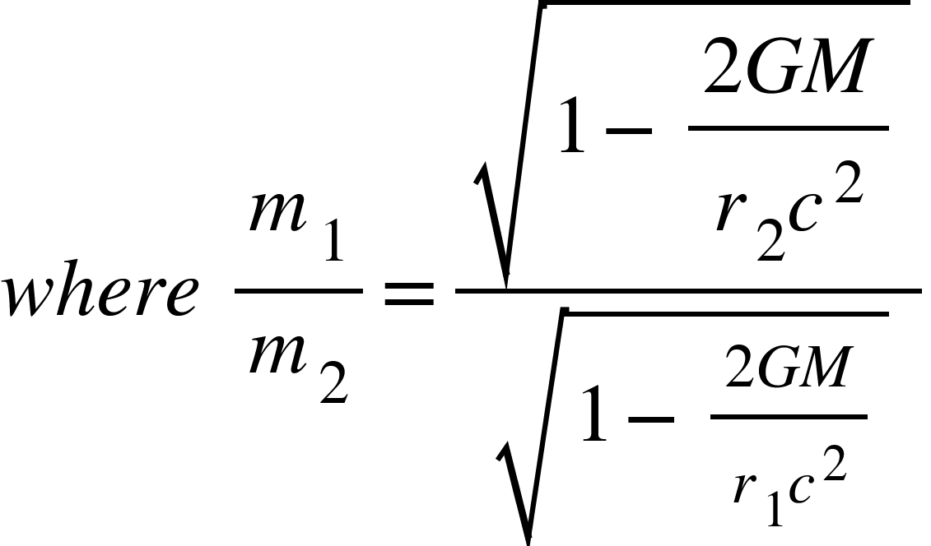

The acceleration would be equal to

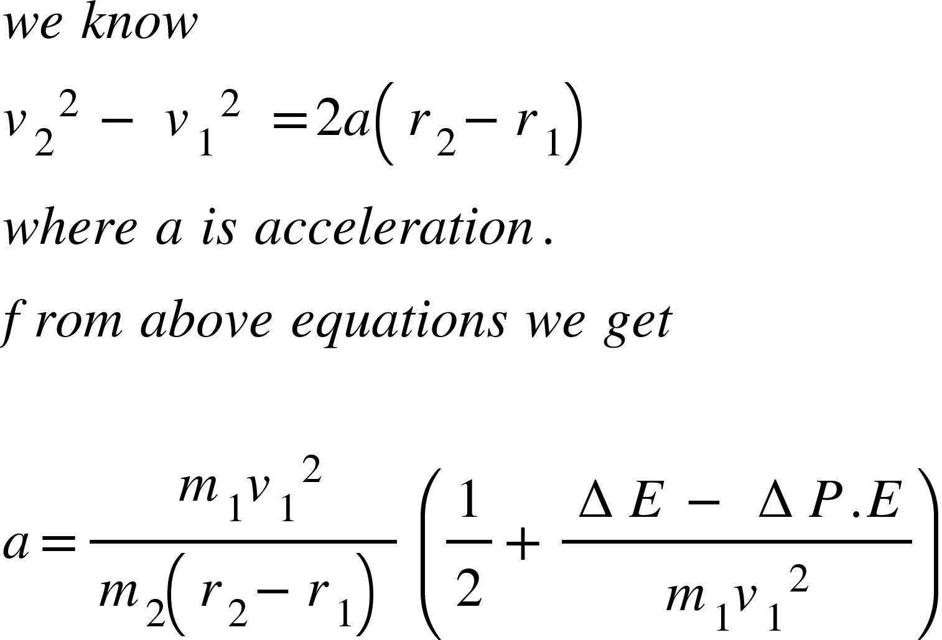

**GRAVITATIONAL SHIELDING:**

Since gravitation is all about motion of space towards matter.which is why gravitational force exist,and without any doubt this flow interacts with matter.gravitational force is like a room full of water flowing towards the sink present at the centre of the room.and this flow can be shielded by the presence of shield in the flow.

In case of gravitational force, matter acts as a shield.but since ordinary matter is almost empty space that’s why shielding is not something we see in our day to day life.but very strongly dense materials like subatomic particles can shield gravitational flow almost completely and under the shield gravitational force would be zero.

**EXPERIMENT:**

The easiest and the fastest way to check if there is any sincerity in this theory and to check if this theory is capable of replacing the general theory of relativity forever is by simply having two clocks in a spaceship which are synchronized and both are in this ship then if we throw one of the clock towards the earth then from this theory instead of time being slower time is going to be faster for the falling and closer to earth clock as compared to clock on the ship,which one can easily calculate from the formula given in vectorian consequence section. But the final data has to be taken before it hits the ground.