Midterm Task: Analysis of Expenditures

Name: Asrar Syed
Due by: March 10, 2024
Course Section: CSC 4780-002

Introduction
In this analysis, we aim to investigate whether there is any evidence of racial bias in the allocation of expenditures between Hispanic and White non-Hispanic consumers. The data shows notable differences in total expenditures between these two groups, but these disparities could potentially be due to various factors such as income, age, and other socio-economic variables.

Total Expenditures by Ethnic Group  The total expenditure for each ethnic group reveals a large disparity between White non-Hispanic consumers and other ethnic groups, with White non-Hispanic consumers spending approximately 2.4 times more than Hispanic consumers. This raises the initial question of whether this disparity is due to racial bias or other contributing factors. | 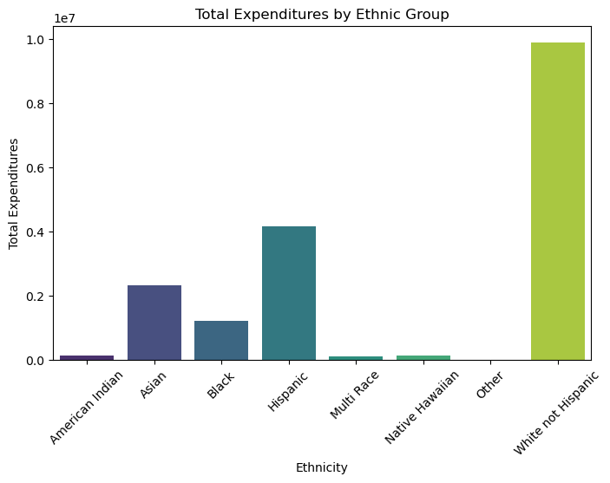
Average Expenditure Comparison
The average expenditure for Hispanic and White non-Hispanic consumers, paints a clearer image of the spending patterns when it based per an individual rather than total amounts.

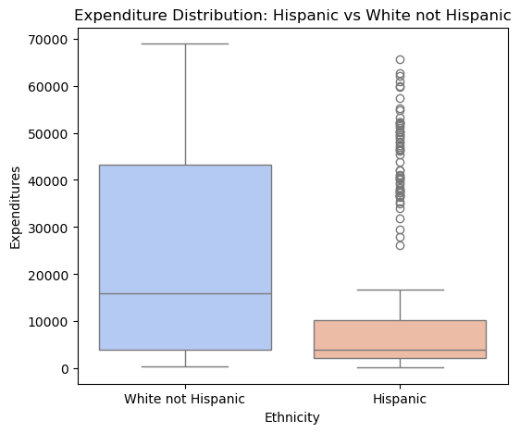 | - Average expenditure for Hispanic consumers: $11,078.01  - Average expenditure for White non-Hispanic consumers: $24,758.44  This shows a significant difference in average spending, with White non-Hispanic consumers spending more than 2.2 times the amount that Hispanic consumers spend on average.
Expenditure by Age Cohort
A few patterns in expenditure allocation reveal that some ethnic groups show higher expenditures in certain age ranges, a few key observations stand out:
- White non-Hispanic consumers spend significantly more in the 22-50 years age cohort ($5,344,954) whereas Hispanic consumers of the same age cohort have a relatively high expenditure ($1,759,737), but the difference between the two groups is substantial.
- For younger age groups, Hispanic consumers exhibit higher expenditures in certain cases i.e. the 0-5 years: $61,301 for Hispanic vs $26,998 for White non-Hispanic.

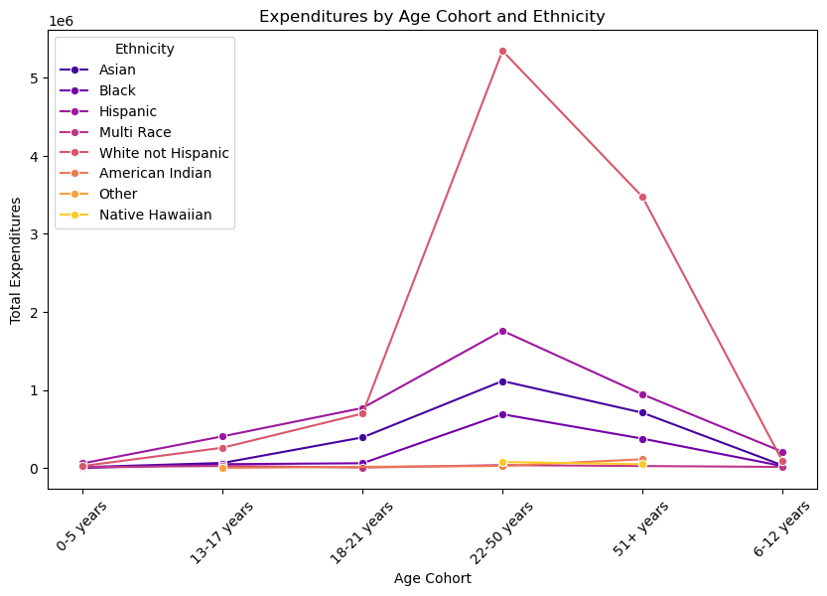

Potential Explanations for the Disparities
- Population Size and Income Levels: Disparities in expenditure could be influenced by differences in the population size and income levels between ethnic groups.
- Age Cohorts and Expenditure Patterns: The spending differences in age cohorts might reflect different purchasing behaviors or economic conditions.
- Socio-Economic Factors: Other factors such as household size, education, or geographical location might be affecting expenditure patterns.

Further Analysis
- Per Capita Expenditure: We should compute the per capita expenditure for each ethnic group to account for differences in population size.
- Income Control: Analyzing expenditure data in relation to income levels will help us assess whether the disparity in expenditure is driven by income inequality between the two groups.
- Statistical Testing: To receive a more robust conclusion, we can perform statistical tests to assess whether the differences in expenditures between Hispanic and White non-Hispanic consumers are statistically significant.

Conclusion
The disparity in total expenditures and average expenditures suggests potential racial bias, but we cannot conclude this definitively without considering other external factors such as population size and income levels.

