**Overview**

Toronto, the capital of the province of Ontario, is the most populous Canadian city. Its diversity is reflected in Toronto’s ethnic neighborhoods such as Chinatown, Corso Italia, Greektown, Kensington Market, Koreatown, Little India, Little Italy, Little Jamaica, Little Portugal & Roncesvalles. With more than half of the entire Indian Canadian population residing in Toronto it is one of the best places to start an Indian restaurant.

**Problem and Objective**

Determine the most suitable location in Toronto to set up a new Indian restaurant. The parameters that will be examined are the demographics of each district and the number of pre-existing Indian restaurants in each area.

**Criteria for an ideal location**

* The number of ethnic Indians in each district. The restaurant will be placed where there is a significant Indian community.
* However, due to competition it cannot be in same district where there at least 4 Indian restaurants.
* It should be opened in an area where there are quite a bit of Indians but the number of pre-existing Indian Restaurants are lacking.

**Target Audience**

1. Business personnel who wants to invest or open an Indian restaurant in Toronto. This analysis will be a comprehensive guide to start or expand restaurants targeting the Indian crowd.
2. Freelancer who loves to have their own restaurant as a side business. This analysis will give an idea, how beneficial it is to open a restaurant and what are the pros and cons of this business.
3. Indian crowd who wants to find neighborhoods with lots of option for Indian restaurants.
4. Business Analyst or Data Scientists, who wish to analyze the neighborhoods of Toronto using Exploratory Data Analysis and other statistical & machine learning techniques to obtain all the necessary data, perform some operations on it and, finally be able to tell a story out of it.

**Data**

To solve this problem, we will need following data:

* List of districts in Toronto, Canada
* Latitude and Longitude of these districts
* Geographic locations of Indian restaurants in districts.
* Indian population for each borough and neighborhood

**Methodology**

1. First, I need to get the list of districts in Toronto, Canada. This is possible by extracting the demographics for Toronto from Wikipedia page(<https://www.toronto.ca/ext/open_data/catalog/data_set_files/2016_neighbourhood_profiles.csv> ).
2. Next, I use Foursquare API to pull the list of top 100 venues within 500 meters radius. I have created a Foursquare developer account earlier in order to obtain an account ID and API key to pull the data. From Foursquare, I am able to pull the names, categories, latitude, and longitude of the venues. With this data, I can also check how many unique categories that I can get from these venues.
3. Then using the Toronto Demographics file I gathered data on the ethnic population by boroughs, and neighborhoods.

**Analysis**

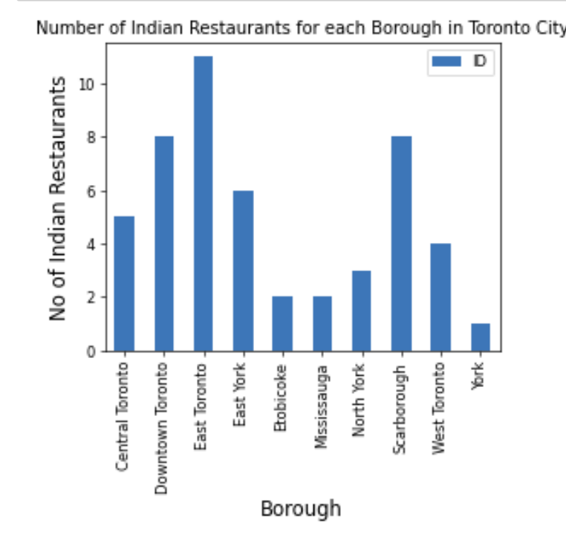

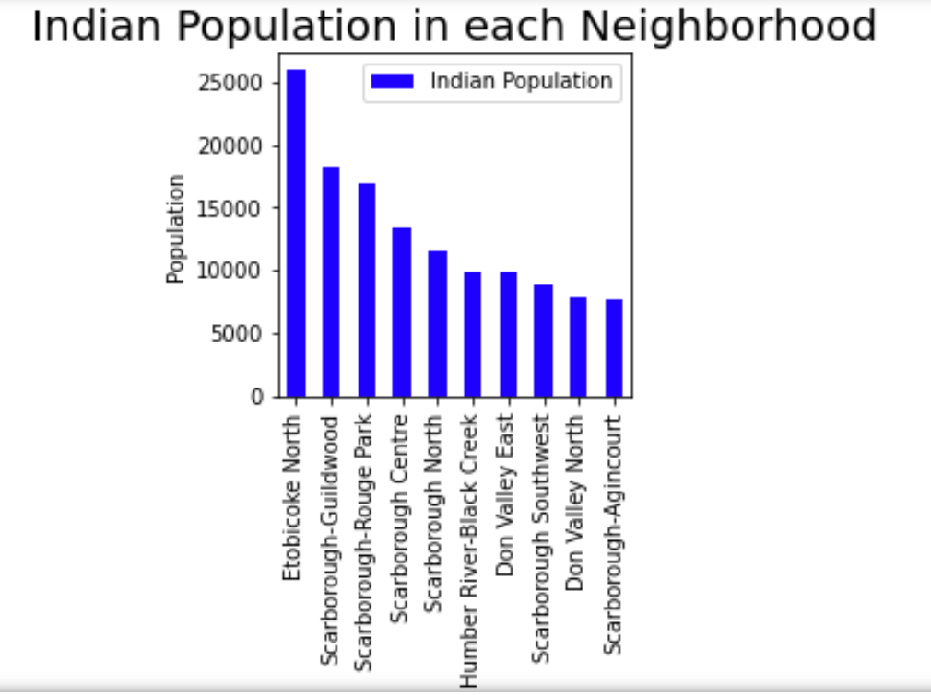

**Results**

As expected, Downtown, Central and East Toronto have the highest concentrations of Indian restaurants. Thus those locations would not be considered suitable for setting up a new Indian restaurant. Boroughs like Etobicoke, York, and Mississauga have the least concentrations of Indian restaurants. The population dataset was based off the ridings instead of the boroughs.

**Conclusions**

According to the Toronto demographics the largest concentrations of the Indian community reside in Etobicoke, Scarborough-Rouge Park, and Scarborough-Guildwood. They would be considered the top sites to set up a new Indian restaurant. Etobicoke has the most Indian population with at least 25K people followed by Scarborough-Guildwood with about 18K and Scarborough-Rouge Park with about 17K.

**Discussion and Limitations**

This is based on the assumption that only the Indian community likes Indian restaurants which I know is not the case. Just like Chinese food, Indian food is also popular. Several Americans and people of other ethnicities also love Indian food. Another factor that entrepreneurs consider is rent in certain districts as well as start up costs.