VANGUARD X
SYSTEM COORDINATE
SPECIFICATION
Geometry, reference frames, true-bearing transformation, scan control,
tracking and geographic display requirements
Document number | VX-SCS-001
Revision | Draft 0.1
Date | 27 July 2026
System | Vanguard X X-band radar prototype
Status | Engineering baseline for review
Classification | Company engineering information
Coordinate authority
Earth-referenced detections and tracks use true bearing and WGS 84 position. The X6‑60 encoder remains a vessel-relative measurement whose nominal 000° direction is aft.

Document control
Role | Name / organisation | Responsibility
Author | ASR Defence engineering | Coordinate-system definition and system integration
Technical review | Radar, navigation and software leads | Geometry, timing, tracking and control review
Approval | Vanguard X system authority | Baseline release

Revision history
Revision | Date | Description | Status
0.1 | 27 Jul 2026 | Initial system coordinate specification covering GPS/WT901, X6‑60, scanning, tracker and UI map behaviour. | Draft

Related Vanguard X documents
- VX-SSA-001 Vanguard X Software System Architecture.
- VX-MDD-001 Vanguard X Mission Design and Description.
- Vanguard X operator and hardware commissioning records.
If a conflict exists, this document is authoritative for coordinate definitions, angle signs, reference-frame conversions and coordinate-validity behaviour.

Document structure
- Purpose, scope and governing conventions
- System geometry and coordinate frames
- Transformations and time alignment
- Mission tasks, scanning limits and control implications
- Detection, tracker and UI map behaviour
- Navigation interface, integrity handling and verification

1. Purpose and scope
This specification defines how Vanguard X represents the geometry of the vessel, the X6‑60 antenna positioning unit, the radar beam, detections, tracks, mission sectors and geographic displays. Its purpose is to prevent coordinate ambiguity when the vessel changes position or heading.
The specification applies to the UI-side GPS and WitMotion WT901C232 navigation subsystem, the Ethernet navigation interface, the radar computer, X6‑60 control, radar timing, detection formation, the earth-referenced tracker, Mission tasks, the polar display and the background map.
Key system rule: The tracker must receive the radar beam angle relative to Earth at the measurement time. It must not interpret the X6‑60 encoder angle as a true bearing.

1.1 In scope
- Axis definitions, handedness, angle zeroes and positive directions.
- Magnetic-to-true heading conversion and sensor mounting correction.
- X6‑60 aft-zero conversion to vessel-relative and true beam bearing.
- Radar phase-centre position, GPS lever arm and target coordinate formation.
- Time alignment, interpolation, quality flags and stale-data response.
- Reference-frame behaviour for 360 Scan, Sector Scan, Track Update and mast blanking.
- Motor rate and scan-limit implications while the vessel turns.
- North-up and head-up map behaviour, recentering and geographic data coverage.
- Interface data, commissioning tests and verification requirements.

1.2 Out of scope
- Detailed WT901 serial protocol implementation.
- Detailed GPS receiver protocol and antenna installation procedure.
- Full three-dimensional fire-control or elevation pointing.
- Choice or licensing of a particular map-tile supplier.
- Tracker filter mathematics other than the coordinate requirements imposed on measurements.

2. Normative conventions
The words shall, must and required denote normative requirements. Should denotes a recommended implementation. May denotes an allowed option. Angles are expressed in degrees unless stated otherwise.
Convention | Definition
True bearing | Clockwise angle from geographic true north. 000°T = north, 090°T = east, 180°T = south and 270°T = west.
Vessel-relative bearing | Clockwise angle from the vessel bow. 000°V = forward, 090°V = starboard, 180°V = aft and 270°V = port.
X6‑60 angle | Calibrated encoder angle increasing clockwise when viewed from above; nominal 000°X points aft.
Heading | Direction of the vessel bow, measured clockwise from true north. GPS course over ground is not heading.
Positive yaw rate | Clockwise rotation when viewed from above; equivalent to increasing true heading.
Position datum | WGS 84 latitude, longitude and ellipsoidal altitude unless a different altitude datum is explicitly identified.
Local horizontal axes | East-North-Up (ENU): x = east, y = north, z = up.
Vessel body axes | xᵥ = forward, yᵥ = starboard, zᵥ = down; a right-handed navigation body frame.

2.1 Angle normalisation
wrap₃₆₀(a) = a modulo 360°, with result in [0°, 360°)
wrap₁₈₀(a) = ((a + 180°) modulo 360°) − 180°, with result in [−180°, 180°)
Algorithms must unwrap angles before interpolation, differentiation or rate estimation. Direct averaging of values such as 359° and 001° is prohibited because the correct mean is 000°, not 180°.
SCS-001 [Definition] All software interfaces and stored data shall identify the reference frame of every bearing-valued field; an unqualified field named angle or azimuth shall not cross a module boundary.
SCS-002 [UI] All bearings exposed to operators shall display a reference suffix or label, such as °T, °V or °X.

3. System geometry
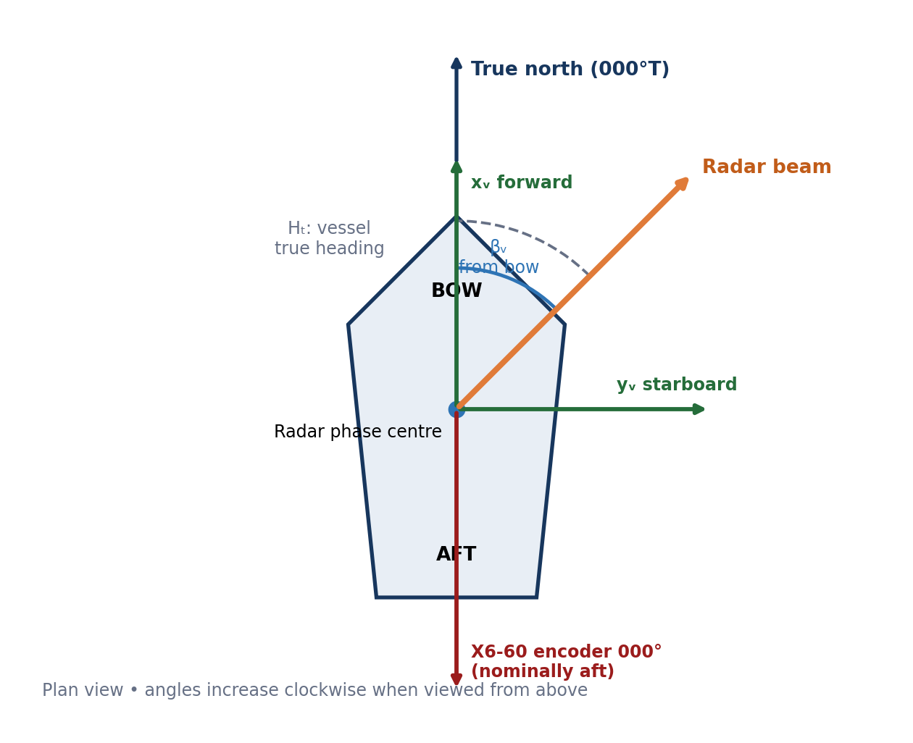
Figure 1 — Vanguard X plan-view geometry and nominal angle zeroes.
The radar antenna rotates about the X6‑60 vertical axis on the mast. The X6‑60 encoder is physically attached to the vessel and therefore reports a vessel-relative angle. Its nominal zero points aft. The WT901 reports vessel attitude at its own installation location, and the GPS reports antenna position at the GPS antenna phase centre. Calibration terms reconcile installation offsets between these physical references.

3.1 Physical reference points
Reference point | Purpose | Required survey information
Vessel reference point (VRP) | Origin for vessel-fixed lever arms and installation drawings. | Location on vessel and relation to centreline/baseline.
Radar phase centre (RPC) | Origin of measured radar range and bearing. | Forward, starboard and vertical offset from VRP.
GPS antenna phase centre | Origin of reported navigation position. | Forward, starboard and vertical lever arm from VRP.
WT901 sensor origin | Origin of measured attitude and magnetic heading. | Mounting orientation and location relative to vessel axes.
X6‑60 rotation axis | Origin of antenna azimuth rotation. | Offset from RPC if materially different.

3.2 Two-dimensional and three-dimensional use
The operational surface tracker uses a local horizontal, two-dimensional representation. Roll and pitch remain important quality inputs because vessel attitude can tilt the antenna beam and because a magnetometer can be affected by installation. The first operational implementation may calculate horizontal bearing using heading and azimuth only, but it shall preserve roll, pitch and their validity for later three-dimensional correction.
Installation caution: The WT901 magnetometer must be mounted away from the X-band transmitter, X6‑60 motor, high-current cables and ferrous structure where practical. Software cannot reliably remove a magnetic disturbance that changes with motor current or antenna position.

4. Coordinate frames
Frame / code | Origin and axes | Primary users
Geodetic / G | WGS 84 latitude, longitude and altitude. | GPS, map services, logging and data exchange.
Local Earth / E | ENU tangent plane about a declared reference position; x east, y north, z up. | Tracker, local plots, range-bearing conversion.
Vessel / V | VRP; x forward, y starboard, z down. | Installation survey, mast blanking, vessel-relative missions.
X6‑60 / X | Rotation axis; azimuth zero nominally aft; positive clockwise viewed from above. | Motor controller and encoder interface.
Radar beam / R | RPC; boresight along instantaneous antenna beam. | Detection formation and measurement uncertainty.
Display / D | Screen coordinates after map centring, projection and optional rotation. | Map and polar rendering only; never used for tracking mathematics.

SCS-010 [Architecture] The radar computer shall own the authoritative transformation from timestamped navigation data and timestamped X6‑60 angle to beam true bearing.
SCS-011 [Architecture] Display orientation shall be a rendering transform only. Changing between north-up and head-up shall not alter stored detections, tracks or mission definitions.

5. Heading and azimuth transformations

5.1 Magnetic heading to vessel true heading
The navigation service calculates vessel true heading using the WT901 magnetic heading, a location/date-dependent magnetic declination and a surveyed sensor mounting correction. East declination is positive.
Hₜ(t) = wrap₃₆₀(Hₘ(t) + D(lat, lon, date) + C_IMU)
Symbol | Meaning
Hₜ(t) | Vessel true heading at time t.
Hₘ(t) | Calibrated WT901 magnetic heading.
D(lat, lon, date) | Magnetic declination; east-positive, obtained from a controlled geomagnetic model or approved source.
C_IMU | Fixed WT901 yaw mounting correction, including sensor-axis alignment.

Do not substitute COG: GPS course over ground describes motion over the ground, not the direction of the bow. It is invalid as a general heading source, especially while stationary, moving slowly, crabbing or manoeuvring.

5.2 X6‑60 angle to vessel-relative beam bearing
After encoder direction, scale and zero calibration, let θₓ(t) be the clockwise X6‑60 angle from its aft-pointing nominal zero. The radar beam bearing relative to the vessel bow is:
βᵥ(t) = wrap₃₆₀(θₓ(t) + 180° + C_install)
C_install is the residual radar-boresight installation correction after the nominal aft zero and encoder calibration have been applied. A positive correction rotates the calculated beam clockwise when viewed from above. It shall be determined by physical commissioning, not assumed to be zero.

5.3 Vessel-relative beam bearing to true beam bearing
Bₜ(t) = wrap₃₆₀(Hₜ(t) + βᵥ(t))
Bₜ(t) = wrap₃₆₀(Hₜ(t) + θₓ(t) + 180° + C_install)
Example: with vessel heading 090°T and θₓ = 000°X, the radar points aft and Bₜ = 270°T, before any residual installation correction.

5.4 Inverse transformation for pointing
To point the antenna at a required true bearing, the radar computer performs the inverse transformation using the heading applicable to the commanded time:
θₓ,cmd(t) = wrap₃₆₀(Bₜ,cmd(t) − Hₜ(t) − 180° − C_install)
SCS-020 [Calibration] The sign of encoder rotation, the aft zero and C_install shall be verified on the installed vessel using known physical bearings.
SCS-021 [Diagnostics] The software shall retain raw encoder angle, calibrated X6‑60 angle, vessel-relative bearing and true beam bearing as distinct values in diagnostics.

6. Position transformations

6.1 GPS antenna to radar phase centre
If the GPS antenna and radar phase centre are not co-located, the navigation solution should translate the GPS position to the radar phase centre using the surveyed horizontal lever arm. Let u be forward offset and v be starboard offset from the GPS antenna to the radar phase centre.
ΔE_RPC = u sin(Hₜ) + v cos(Hₜ)
ΔN_RPC = u cos(Hₜ) − v sin(Hₜ)
At Vanguard X ranges a small lever arm may be operationally negligible, but the offsets shall be represented in configuration rather than hidden. Zero is an explicit surveyed value, not an undocumented assumption.

6.2 Detection range and bearing to Earth coordinates
For a horizontal slant-range approximation in a local ENU frame:
E_target = E_RPC + r sin(Bₜ)
N_target = N_RPC + r cos(Bₜ)
The tracker may maintain a local ENU frame for numerical stability. Stored or exported track positions shall include the ENU reference origin or be converted to WGS 84 latitude/longitude. Web Mercator coordinates are for map rendering only and shall not be used as the tracker’s physical state.
SCS-030 [Detection] Each earth-referenced detection shall contain or resolve to measurement time, radar phase-centre position, true beam bearing, range, bearing/range uncertainty and coordinate-validity state.

7. Time alignment and measurement validity
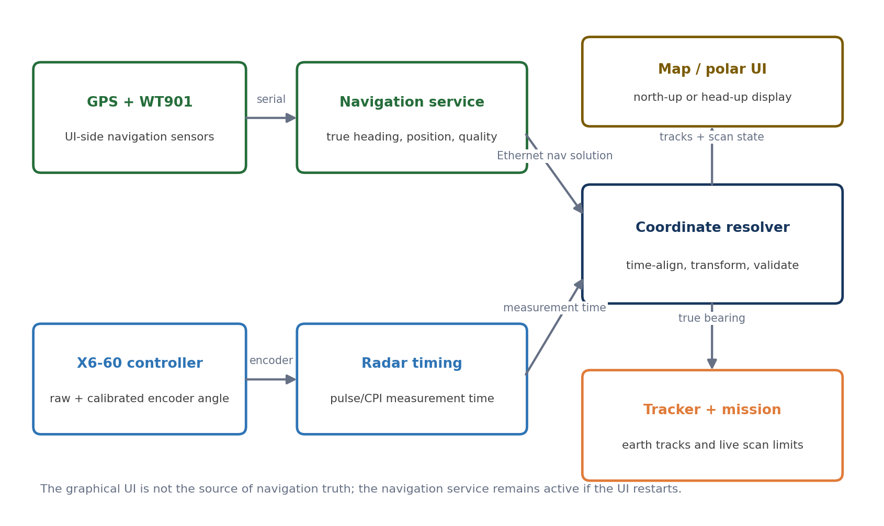
Figure 2 — Coordinate data ownership and time-aligned transformation.
Heading and X6‑60 angle change while a CPI is collected. The relevant time is the physical radar measurement time, not the time at which the UI receives a message or the processor finishes a dwell.

7.1 Required time basis
- Each navigation solution shall carry a source timestamp, sequence number, update time, validity flags and uncertainty.
- Each encoder sample shall carry a radar-computer monotonic timestamp or a timestamp mapped to the radar clock.
- Each dwell shall define a representative measurement time, normally the CPI temporal midpoint.
- Heading and encoder angle shall be interpolated to that time using unwrapped angles.
- Clock offset and synchronisation quality shall be monitored; receipt time alone is insufficient.

7.2 Heading-rate compensation
For a commanded scan rate relative to Earth, motor rate must compensate for vessel yaw rate. With clockwise-positive rates:
ωₓ,cmd = ω_true,cmd − ω_vessel
For a vessel-relative scan, ωₓ,cmd = ω_vessel-relative,cmd. A controller that only moves the sector endpoints but ignores rate compensation will distort the dwell spacing and may scan the wrong geographic rate during a turn.

7.3 Provisional freshness states
The following values are engineering defaults for initial integration and must remain configurable until sea-trial data supports final limits:
State | Navigation age at measurement time | Required behaviour
CURRENT | ≤ 250 ms | Normal true-bearing transformation; report measured age and uncertainty.
DEGRADED | > 250 ms and ≤ 1.0 s | May interpolate/extrapolate only within configured uncertainty limits; raise quality indication.
STALE / INVALID | > 1.0 s, invalid flag or clock fault | No new earth-referenced measurement; suspend tasks that require true pointing.

SCS-040 [Integrity] The tracker shall not silently use the last known vessel heading after navigation data becomes invalid.
SCS-041 [Integrity] Heading uncertainty shall be propagated into bearing uncertainty; stale-data status shall be logged with the affected dwell.

8. Mission bearing references
Every Mission task containing azimuth limits or an azimuth target shall declare its bearing reference. The supported normative values are TRUE and VESSEL. The UI may display friendly text but shall transmit the explicit enumeration.
Task / feature | Reference frame | Behaviour
360 Scan | Physical continuous rotation; detections TRUE when navigation is valid. | No angular endpoint transformation is required. Beam bearings are still earth-referenced per dwell.
Sector Scan — TRUE | Start/stop fixed relative to Earth. | Continuously convert endpoints to X6‑60 angles. Compensate scan rate for vessel yaw.
Sector Scan — VESSEL | Start/stop fixed relative to bow. | Endpoints stay fixed on vessel; true map overlay rotates as vessel heading changes.
Track Update | Track prediction is Earth-referenced. | Convert predicted target bearing and gate to live X6‑60 commands; update during vessel turns.
Mast / obstruction blanking | Always VESSEL. | Blank sectors remain aligned with mast, superstructure and installed obstructions.
Land / clutter map | Always Earth / geodetic. | Clutter cells remain fixed geographically while the vessel moves and turns.

SCS-050 [Mission] The Mission model shall store bearing_reference for each Sector Scan and any operator-entered azimuth constraint.
SCS-051 [Mission] The UI shall not infer TRUE or VESSEL from the current display orientation.

9. Scanning limits and controller implications

9.1 Sector definition and wraparound
A pair of angles does not uniquely define a sector. The task must also specify sweep sense or arc selection. For example, 350° to 010° may mean the 20° clockwise sector across north or the 340° counter-clockwise sector.
Mission field | Allowed values / meaning
bearing_reference | TRUE or VESSEL
start_bearing_deg | Normalised bearing in selected frame
stop_bearing_deg | Normalised bearing in selected frame
sweep_direction | CW, CCW or ALTERNATING
arc_policy | DIRECTED_ARC; SHORTEST_ARC may be offered only as an explicit operator choice
scan_rate_deg_s | Rate in the selected reference frame
limit_tolerance_deg | Allowed transient endpoint error before warning or suspension

Internally, the controller shall use continuous unwrapped angles for motion planning. Modulo-360 conversion is applied at interfaces and display boundaries, not during rate/trajectory calculations.

9.2 Dynamic true-sector limits
θₓ,start(t) = wrap₃₆₀(Bₜ,start − Hₜ(t) − 180° − C_install)
θₓ,stop(t) = wrap₃₆₀(Bₜ,stop − Hₜ(t) − 180° − C_install)
As the vessel turns clockwise, both relative X6‑60 limits move counter-clockwise by the same amount so that the sector remains geographically fixed.

9.3 Feasibility against X6‑60 limits
The controller must compare required relative rate, acceleration and available unwrapped travel with configured X6‑60 capabilities. For a true scan, vessel yaw consumes part of the motor rate margin. For example, a 20°/s clockwise earth scan during a 5°/s clockwise vessel turn requires only 15°/s clockwise motor motion; a 5°/s counter-clockwise turn requires 25°/s clockwise motor motion.
Limit response: If a requested true scan cannot be achieved, Vanguard X must not silently scan at a different geographic rate. It shall report the limiting quantity and either apply an explicitly configured degraded mode or suspend the task.

9.4 Continuous rotation
The current mast arrangement uses continuous azimuth rotation with an SMA rotary joint. The controller should therefore maintain an unwrapped revolution count even though operator bearings are displayed modulo 360°. Any practical rate, acceleration, exclusion-zone or cable/service-loop limitation shall be configuration data. If hardware is changed to a non-continuous installation, the travel window and unwind policy become mandatory.
SCS-060 [Control] True-sector endpoints shall be recomputed from time-aligned heading throughout task execution, not only when the task starts.
SCS-061 [Control] The scan planner shall validate earth-relative rate and acceleration feasibility using measured or bounded vessel yaw rate.
SCS-062 [Safety] Mast blanking shall be evaluated against vessel-relative beam bearing at pulse/dwell time and shall remain active even when navigation heading is invalid.

10. Track Update geometry
A Track Update interrupts or schedules around the current scan, slews to the track’s predicted true bearing, performs a small tracking-gate mini-scan and then resumes the previous task. Because Vanguard X does not use monopulse, the mini-scan geometry is part of the measurement process.
Bₜ,track(t) = wrap₃₆₀(rad2deg(atan2(E_track(t) − E_RPC(t), N_track(t) − N_RPC(t))))
θₓ,track(t) = wrap₃₆₀(Bₜ,track(t) − Hₜ(t) − 180° − C_install)
The counter-clockwise and clockwise gate edges are defined around the predicted true bearing. During the mini-scan, both ownship motion and target prediction advance with time. The controller must avoid freezing the relative encoder centre while the vessel is turning.
- Predict target state to the intended measurement time.
- Calculate radar phase-centre position and target true bearing.
- Transform the true gate centre and edges to unwrapped X6‑60 coordinates.
- Plan a feasible mini-scan including vessel yaw-rate compensation.
- Associate detections using the true gate and measurement time.
- Resume the interrupted scan with limits recomputed from current heading.
SCS-070 [Tracking] Track Update shall use the track’s earth-referenced prediction and current navigation solution; it shall not point using a previously stored vessel-relative angle.

11. Detection and tracker implications
Coordinate resolution should occur before a detection is offered to the earth-referenced tracker. This prevents vessel turns from appearing as target motion and centralises navigation age, installation correction and uncertainty handling.

11.1 Detection measurement record
Field | Unit / frame | Requirement
measurement_time | UTC and/or mapped monotonic time | Representative CPI time with clock-quality metadata.
range_m | metres from RPC | Calibrated radar range.
x6_raw_deg | encoder-native | Diagnostic source value.
x6_calibrated_deg | °X | Clockwise from aft nominal zero.
bearing_vessel_deg | °V | Clockwise from bow.
vessel_heading_true_deg | °T | Interpolated heading used for the measurement.
beam_bearing_true_deg | °T | Earth-referenced beam bearing.
radar_lat_lon | WGS 84 | RPC position used for conversion.
bearing_sigma_deg | degrees | Includes encoder, heading, timing and installation terms.
coordinate_validity | enumeration | VALID, DEGRADED or BODY_RELATIVE_ONLY/INVALID.
nav_age_ms / sequence | ms / integer | Traceability to navigation solution.

11.2 Behaviour during navigation failure
- Radar acquisition and a vessel-relative 360 or sector scan may continue if otherwise safe.
- New detections shall be marked body-relative-only and shall not update earth-fixed tracks.
- Existing earth tracks shall coast according to tracker policy and display an ownship-navigation warning.
- True Sector Scan and Track Update shall pause or abort because their pointing solution is not valid.
- Mast blanking and other vessel-fixed safety constraints shall continue.
SCS-080 [Tracking] A detection lacking valid earth coordinates shall not be inserted into the earth-fixed tracker as if its bearing were true.

12. Background map and polar UI
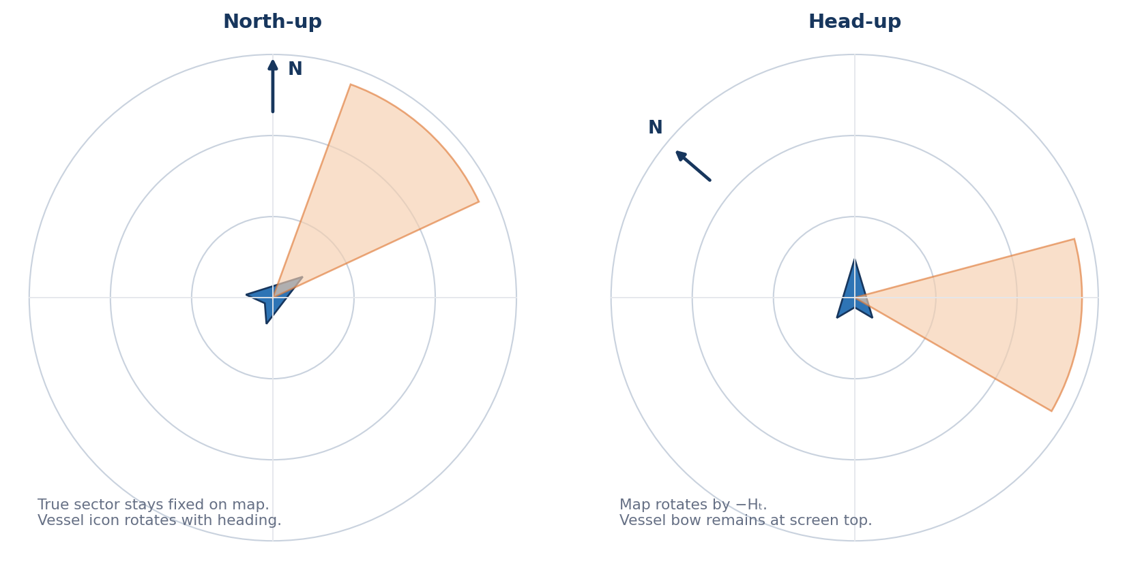
Figure 3 — Required distinction between north-up and head-up rendering.

12.1 Map centring and geographic relocation
The background map shall follow the current valid radar phase-centre position when Follow Ownship is enabled. If the GPS position changes from one operating area to another—for example, from Sydney to Wollongong—the map centre, coastline, land data and tile requests shall move to the new position. The implementation shall not depend on a static coastline image prepared for one site.
A user may manually pan the map. Manual pan suspends automatic recentering until the user selects Recenter/Follow Ownship. A clear indicator shall show whether the map is following the vessel.

12.2 Supported orientations
Mode | Display transform | Expected behaviour
North-up | Screen up = true north. | Map remains geographically fixed; vessel icon, vessel-relative sector and mast blanking rotate with heading. True sectors and earth tracks remain fixed.
Head-up | Rotate map/world by −Hₜ so bow is screen up. | Vessel icon remains upright; coastline, north arrow, true sectors and earth tracks rotate as heading changes.
Course-up (optional) | Rotate by valid GPS COG. | Only available above a configured speed/COG validity threshold; must be labelled Course-up and never presented as Head-up.

12.3 Polar display
The polar plot may remain vessel-up for marine-radar familiarity or offer north-up as an operator mode. Its orientation shall be explicit. The same detection may be rendered at βᵥ in vessel-up mode or Bₜ in north-up mode; the underlying detection record remains unchanged.

12.4 Map data and projection
- Map source must provide coverage for the current operating position and configured maximum range plus an appropriate margin.
- Online map tiles shall be requested for the current bounding box and zoom. Offline deployment shall provision the intended route/area; a single local image is insufficient.
- Vector/raster map projection shall be declared. Web Mercator is acceptable for display but not for tracker state propagation or precise range calculations.
- True-north alignment shall be maintained. Magnetic-north or grid-north displays require explicit labelling and are not the default.
- Track symbols, detection spokes, scan sectors, exclusion zones and range rings shall use the same map transform and timestamped ownship state.
- When heading is invalid, head-up rotation shall freeze with a conspicuous stale indication or fall back to north-up according to configured policy; it shall not continue to imply live heading.
SCS-090 [UI] The map shall recenter and load geographically appropriate background data when valid GPS position changes.
SCS-091 [UI] The UI shall identify map and polar orientation at all times.
SCS-092 [UI] In north-up mode, TRUE sectors shall remain fixed on screen while VESSEL sectors and mast blanking rotate with vessel heading.

13. Navigation service and Ethernet interface
The GPS and WT901 may be physically connected to the UI-side computer to improve separation from RF, motor magnetic fields and high-current wiring. The associated process is a navigation service, not a child of the graphical UI. Closing or restarting the Mission/Display application shall not stop navigation messages to the radar computer.

13.1 NavigationSolution data contract
Field group | Minimum content
Identity / time | schema_version, source_id, sequence, source_timestamp_utc, monotonic correlation, receive timestamp
Position | WGS 84 latitude, longitude, altitude, position uncertainty, GPS fix type and satellite/quality status
Attitude | heading_magnetic_deg, declination_deg, heading_true_deg, roll_deg, pitch_deg, yaw_rate_deg_s
Calibration | IMU mounting correction identifier/version, magnetic calibration state, radar lever-arm configuration identifier
Validity | position_valid, heading_valid, time_valid, magnetic_disturbance, stale/age state and uncertainty

The radar computer shall acknowledge or expose the navigation sequence used for each dwell. The UI may use the same solution locally for smooth rendering, but diagnostic views should permit confirmation that the radar computer is receiving and accepting the same navigation stream.

13.2 Update rate and transport
The navigation publication rate shall support interpolation at the radar dwell cadence and vessel manoeuvre rate. A provisional minimum of 20 Hz is recommended for integration; higher-rate WT901 samples may be filtered before publication. The final value shall be verified against heading dynamics, timestamp accuracy and acceptable bearing error.
SCS-100 [Interface] Navigation messages shall be schema-versioned and shall include explicit units, reference frames, validity and uncertainty.
SCS-101 [Availability] The navigation service shall remain available independently of the graphical UI process.

14. Uncertainty and integrity
True-bearing accuracy is limited by more than nominal sensor resolution. The coordinate resolver shall account for heading uncertainty, encoder error, installation correction uncertainty, timing misalignment and angular motion during the CPI.
σ²_B ≈ σ²_heading + σ²_encoder + σ²_install + (ω_relative · σ_time)²
This first-order expression is suitable for initial error budgeting. A full implementation may use covariance propagation. Magnetic disturbance flags and calibration state are integrity conditions, not merely informational fields.
Failure / anomaly | Detection | Required system response
Navigation link loss | Age/sequence timeout | Invalidate true bearing; pause true-pointing tasks; retain vessel-relative safety.
Clock offset fault | Synchronisation monitor | Reject interpolation across untrusted clocks; flag affected dwells.
Magnetic disturbance | WT901/status checks, heading jumps, commissioning limits | Degrade/invalidate true heading; do not substitute COG silently.
GPS jump | Position innovation / speed plausibility | Do not instantly move tracker/map truth without validation; alarm and hold/fallback.
Encoder discontinuity | Unwrapped angle/rate plausibility | Reject impossible jump; preserve raw diagnostics; stop unsafe pointing.
Heading wrap bug | 359°/000° verification cases | Use unwrapped interpolation and circular residuals.
Map data unavailable | Tile/source failure | Continue radar/tracking; show blank/limited background and data status.

15. Configuration data
Configuration item | Unit / values | Initial status
x6_encoder_direction | CW positive / CCW positive | Must be commissioned
x6_encoder_zero_deg | raw encoder units / deg | Must be commissioned
x6_nominal_zero_direction | AFT | System definition
radar_install_correction_deg | degrees | Must be commissioned
imu_mount_correction_deg | degrees | Must be commissioned
gps_to_rpc_lever_arm | forward, starboard, down metres | Survey; may be explicitly zero
declination_model | name/version/epoch | Select approved model
nav_current_limit_ms | milliseconds | Provisional 250 ms
nav_invalid_limit_ms | milliseconds | Provisional 1000 ms
navigation_publish_rate_hz | hertz | Provisional minimum 20 Hz
x6_rate_accel_limits | deg/s, deg/s² | Hardware test/configuration required
map_follow_default | on/off | Recommended on
map_orientation_default | NORTH_UP / HEAD_UP | Operator/system decision

SCS-110 [Configuration] Every calibration and coordinate-critical configuration set shall carry an identifier/version and modification record.

16. Commissioning procedure
- Survey the GPS antenna, WT901, X6‑60 axis and radar phase centre relative to the vessel centreline and selected VRP.
- Verify vessel-axis convention: bow = 000°V, starboard = 090°V, aft = 180°V and port = 270°V.
- With the antenna physically aft, record the raw encoder zero and verify the reported calibrated value is 000°X.
- Jog the X6‑60 clockwise when viewed from above and verify calibrated angle increases.
- Align the vessel or use surveyed shore bearings to determine WT901 mounting correction and radar installation correction.
- Perform WT901 magnetic calibration in the installed environment and test with the X6‑60 stationary, moving and under representative electrical/RF loads.
- Verify declination sign using a known true bearing. Record model, date and position.
- Compare calculated beam true bearing against known bearings at several vessel headings and X6‑60 angles.
- Validate north-crossing behaviour at 359°/000° and continuous encoder revolution handling.
- Record the accepted configuration identifier and retain raw test data.
RF separation: Locating the GPS and WT901 on the UI-side system is acceptable and desirable for physical separation. The sensor location and cabling—not the name of the host computer—determine magnetic/RF exposure.

17. Verification and acceptance
Test ID | Test | Pass criterion
SCS-T01 | Cardinal-heading truth table | Calculated true beam bearing matches the expected values in Appendix A within commissioned tolerance.
SCS-T02 | North wrap interpolation | Samples 359° and 001° interpolate through 000° without a 180° excursion.
SCS-T03 | True-sector vessel turn | With stationary true limits, X6‑60 relative limits counter-rotate and the sector remains earth-fixed.
SCS-T04 | Vessel-sector vessel turn | Relative limits remain fixed while the north-up map overlay rotates with heading.
SCS-T05 | True scan-rate compensation | Measured earth-relative scan rate remains within tolerance during commanded vessel yaw.
SCS-T06 | Track Update during turn | Mini-scan remains centred on predicted true target bearing and resume limits are recomputed.
SCS-T07 | Navigation stale/loss | True tasks suspend; detections do not update earth tracks; vessel-relative blanking remains active.
SCS-T08 | Map relocation | Inject/move GPS position to Wollongong; map recentres and loads the correct coastline/background.
SCS-T09 | Map orientation | North-up and head-up transforms match Section 12; data coordinates are unchanged.
SCS-T10 | GPS jump | Implausible jump is flagged and does not silently relocate tracker truth.
SCS-T11 | UI restart | Navigation service continues supplying the radar computer while the GUI is stopped/restarted.
SCS-T12 | Magnetic interference | Heading quality responds correctly to X6‑60, PA and representative electrical operating states.

17.1 Acceptance evidence
- Signed installation survey and calibration record.
- Automated unit tests for wrap, inverse transforms and truth-table examples.
- Timestamp/age logs demonstrating CPI-time interpolation.
- Mission-controller logs for dynamic limits and feasibility handling.
- Screenshots or recordings of north-up/head-up and geographic relocation tests.
- Sea-trial comparison against known landmarks and vessel manoeuvres.

18. Requirements summary
Requirement | Summary | Verification
SCS-001/002 | Explicit bearing frames and UI suffixes | Inspection + interface tests
SCS-010/011 | Radar-owned transform; display-only orientation | Architecture review + tests
SCS-020/021 | Commissioned aft zero/sign/correction; separate diagnostics | Commissioning
SCS-030 | Complete earth-referenced detection geometry | Record inspection
SCS-040/041 | No silent stale heading; uncertainty propagation | Fault injection
SCS-050/051 | Explicit task reference; no orientation inference | Mission model tests
SCS-060–062 | Live true limits, feasibility and vessel blanking | Controller tests
SCS-070/080 | Earth-predicted Track Update; invalid detections excluded | Integration tests
SCS-090–092 | Moving/reorienting geographic map | UI tests
SCS-100/101 | Versioned navigation contract and service independence | Interface/process tests
SCS-110 | Versioned coordinate configuration | Configuration audit

Appendix A — Worked angle examples
The table assumes C_install = 0° and a calibrated clockwise X6‑60 angle whose 000°X direction is aft.
Vessel Hₜ | X6 θₓ | Beam βᵥ | Expected Bₜ | Physical meaning
000°T | 000°X | 180°V | 180°T | North-heading vessel; antenna aft points south.
090°T | 000°X | 180°V | 270°T | East-heading vessel; antenna aft points west.
180°T | 000°X | 180°V | 000°T | South-heading vessel; antenna aft points north.
270°T | 000°X | 180°V | 090°T | West-heading vessel; antenna aft points east.
045°T | 180°X | 000°V | 045°T | Antenna forward along the bow.
300°T | 150°X | 330°V | 270°T | Beam 30° to port of bow points west.
355°T | 190°X | 010°V | 005°T | Correct wrap across true north.

Appendix B — Mission and message examples

B.1 True sector Mission task
task_type: "SECTOR_SCAN"
bearing_reference: "TRUE"
start_bearing_deg: 350.0
stop_bearing_deg: 10.0
sweep_direction: "CW"
arc_policy: "DIRECTED_ARC"
scan_rate_deg_s: 20.0 # earth-relative

B.2 Coordinate validity enumeration
- VALID — position, heading, encoder and time alignment meet operational limits.
- DEGRADED — coordinate available with elevated uncertainty and explicit warning.
- BODY_RELATIVE_ONLY — range and vessel-relative bearing are valid, but true position/bearing are not.
- INVALID — measurement lacks sufficient coordinate integrity for operational use.

Appendix C — Glossary
Term | Definition
COG | Course over ground; direction of translational motion reported by GPS.
CPI | Coherent processing interval; time span over which a radar dwell’s pulses are processed.
ENU | East-North-Up local tangent coordinate frame.
Heading | Direction of the vessel bow; true or magnetic as qualified.
RPC | Radar phase centre, the spatial origin of radar range and bearing measurements.
VRP | Vessel reference point used for installation surveys and lever arms.
WGS 84 | World Geodetic System 1984 geodetic datum.
WT901 | WitMotion WT901C232 attitude and magnetic-heading sensor.
X6‑60 | Vanguard X antenna motor/positioning unit; legacy software may retain PTZ class names.

