TECHNICAL DESIGN
Vanguard X Two-Dimensional Detection Processing
Range-Doppler CFAR, scan-angle association and antenna-pattern plot consolidation
Status: Draft design for simulation implementation and staged operational validation
Version: 0.1
Date: 31 July 2026
System: Vanguard X X-band radar prototype
Document reference: Unassigned

Design decision: Retain immediate 2-D CA-CFAR on every range-Doppler dwell. Add a short-duration scan-angle processor after per-dwell clustering to associate the same target across adjacent true-bearing dwells, fit the known two-way antenna pattern, and emit one consolidated plot per beam crossing.

1. Purpose
This document defines a proposed Vanguard X detection and plot-extraction architecture for resolving high-SNR angular smearing in a single-channel mechanically scanned radar. It converts groups of range-Doppler CFAR cells observed over several adjacent antenna bearings into one physically meaningful radar plot suitable for display and recursive tracking.
The design uses the built-in simulated antenna pattern initially. Installed-antenna calibration is deliberately deferred; the later calibration will replace the pattern lookup data without changing the processing interfaces or crossing logic.

2. Scope and terminology
The existing detector is already two-dimensional because it applies cell-averaging CFAR to a range-Doppler power map. The proposed addition introduces scan angle as a short-term association dimension. The complete design is therefore best described as 2-D range-Doppler detection followed by scan-angle plot consolidation, rather than a second CFAR operating over complete scans.
- In scope: per-dwell range-Doppler CFAR, per-dwell cell clustering, association over adjacent beam bearings, antenna-pattern fitting, extended-target consolidation, output plot quality, 360° scans, sector scans and track-update noddies.
- Out of scope: simultaneous monopulse processing, multi-channel beamforming, long-term non-coherent integration over multiple revolutions, installed-antenna calibration, and selection of CA-, GO-, SO- or OS-CFAR for specific clutter environments.

3. Problem statement
A high-SNR target remains above the CFAR threshold while the antenna boresight moves through several adjacent bearings. The current Detection object records the beam boresight as the target azimuth. The same vessel is consequently painted at every dwell angle for which its return exceeds threshold, producing a broad azimuthal arc even when range sidelobes have been suppressed by Golay complementary processing.
This is angular threshold broadening, not a failure of the range-Doppler CFAR. The raw CFAR cells are valid evidence that signal energy is present in particular range and Doppler cells; they are not yet finished radar plots.
delta_bearing = scan_rate × dwell_interval
At 20 deg/s and 0.1 s cadence, the beam moves about 2 deg per dwell; at 60 deg/s it moves about 6 deg.
With the current simulated antenna model, BeamwidthDeg = 5 means the first null is approximately 5° either side of boresight. The main lobe is therefore approximately 10° null-to-null. Strong returns can be detected over much of that interval, and sometimes through sidelobes.

4. Current processing baseline
The present Vanguard X scheduler labels each processed dwell with the executed Earth-referenced beam bearing and then calls CfarDetector.Detect. The detector forms linear power from the complex range-Doppler map, estimates local noise with a 2-D CA-CFAR stencil, applies range limits, retains the strongest detections, and assigns each Detection.AzimuthDeg to the executed true beam bearing.
Parameter | Current value | Design significance
CFAR type | 2-D CA-CFAR | Runs independently on every range-Doppler dwell.
Range training / guard | 12 / 4 cells each side | Approximately 45 m training and 15 m guard per side at 3.747 m bin spacing.
Doppler training / guard | 4 / 1 bins each side | Defines local Doppler noise stencil.
Threshold offset | 12.3 dB | Applied above the local linear-power estimate.
Maximum detections | 200 per dwell | Current strongest-cell cap; not a plot count.
Detection range | 2 km to 15 km operational | Near-range blanking is separate from angle consolidation.
Antenna model | one-way sinc-squared power | Two-way monostatic echo power is sinc to the fourth power.
BeamwidthDeg | 5° to first null | Approximately 10° null-to-null simulated main lobe.
Nominal dwell cadence | approximately 100 ms | Sets angular sampling for a selected scan rate.
Coordinate frame | true bearing for detections | All association and fitting shall use Earth/true bearing.

Current limitation: The existing tracker clusters detections after a completed scan using spatial distance. It does not first estimate a single target bearing from the amplitude-versus-boresight response during one beam crossing. High-SNR angular smear can therefore fragment into multiple blobs or bias a blob centroid.

5. Proposed architecture
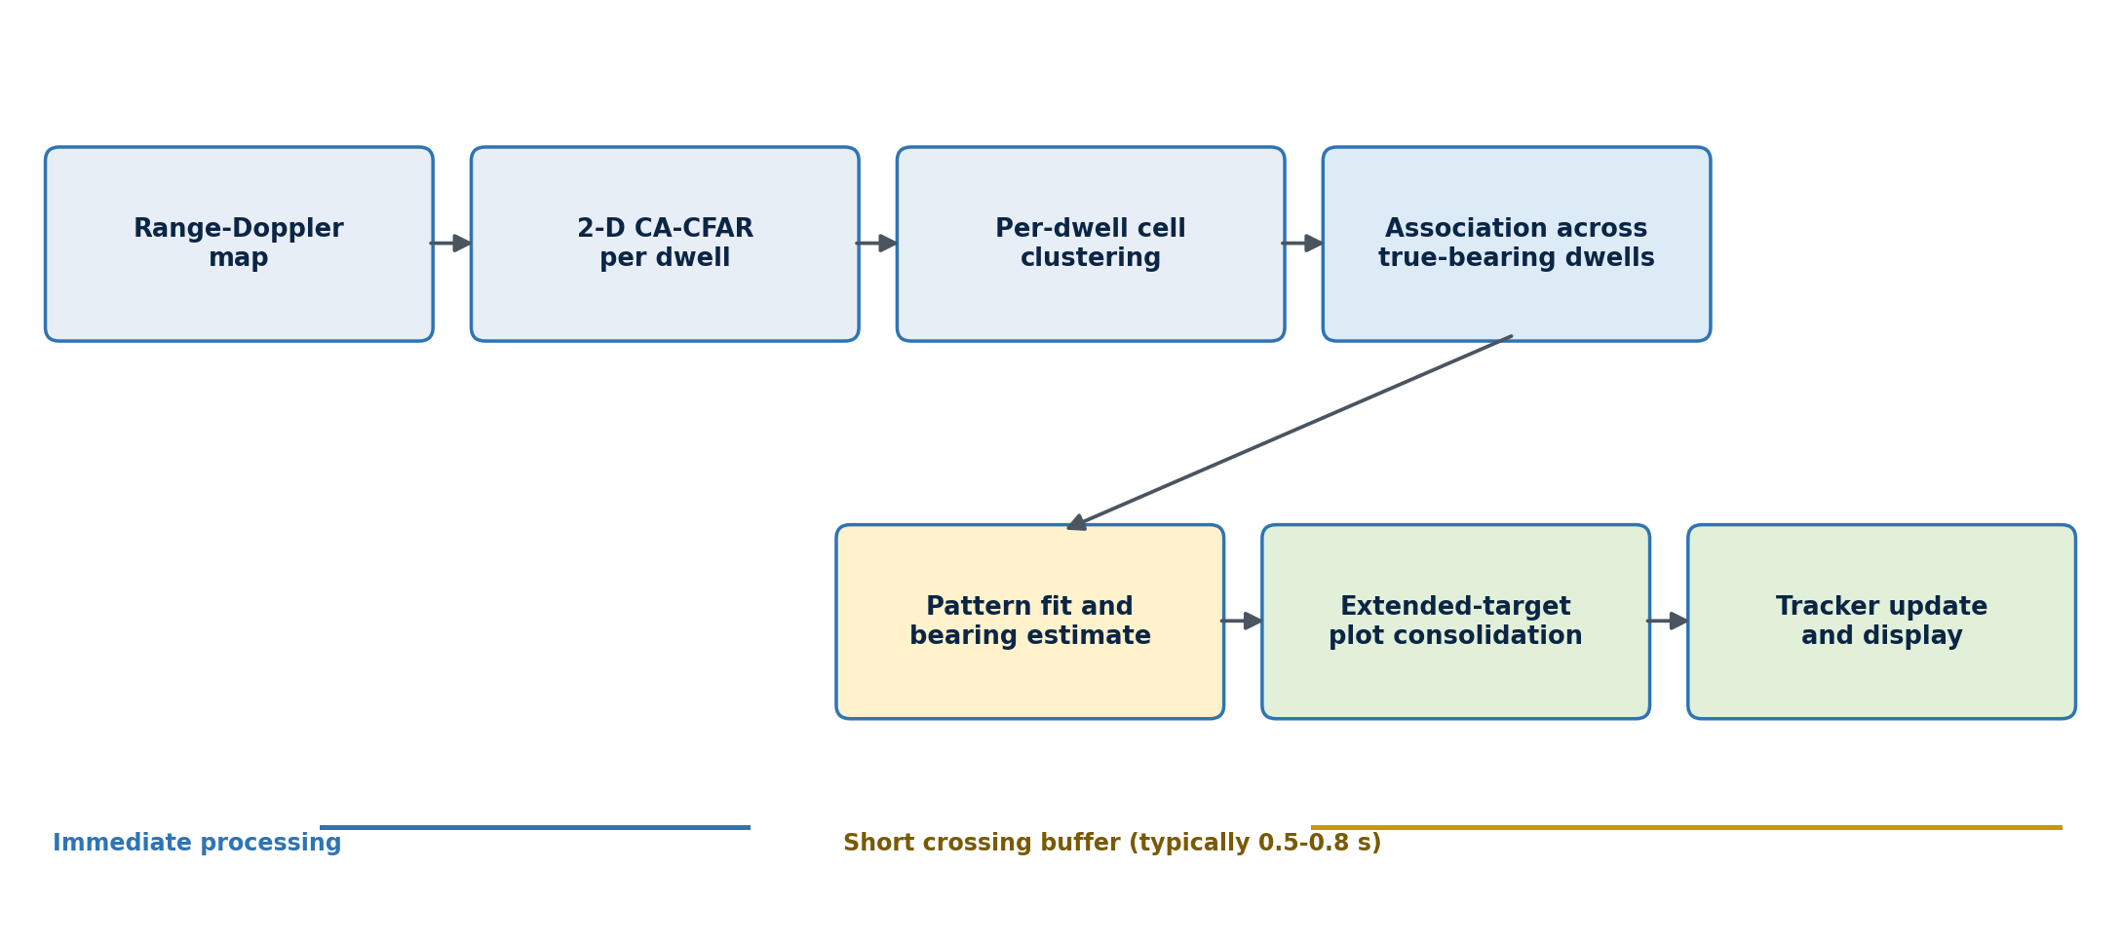
Figure 1. Proposed two-stage detection and plot-consolidation chain.
The new processor is inserted after CfarDetector and before either the legacy or Earth-referenced tracker. It receives clustered detections and the associated processed dwell, maintains a small set of active angular crossings, and emits ConsolidatedPlot objects when a crossing closes.
- Process every dwell immediately through matched filtering, Doppler processing and 2-D CFAR.
- Cluster adjacent above-threshold cells within that dwell into range-Doppler components.
- Associate compatible components across adjacent true-bearing beam samples in the same continuous crossing.
- Retain amplitude or power versus bearing, including limited below-threshold supporting samples when a component is already established.
- Fit the known two-way antenna pattern and estimate one bearing, bearing uncertainty and fit quality.
- Combine compatible range components into one extended-target plot while preserving range and Doppler extent.
- Pass consolidated plots, not raw CFAR cells, to the trackers and operational plot display.

6. Coordinate and timing model
Every angular sample shall be tagged with the executed beam bearing at the dwell timestamp. The angle is a true bearing: 000°T is North and angles increase clockwise. The X6-60 encoder remains vessel-relative and is not used directly by the angular estimator.
bearing_true = wrap360(ship_heading_true + X6_60_relative_azimuth)
Circular-angle differences shall use the shortest signed separation in [-180°, +180°). This prevents a target crossing spanning 359°T to 001°T from being split at North.
A crossing belongs to one uninterrupted scan segment with a known direction. A sector reversal, mission task change, operator abort, scan discontinuity or excessive dwell gap closes all affected crossings before a new segment begins. This prevents samples from opposite scan directions or unrelated task executions from being mixed.

7. Detailed detection processing

7.1 Per-dwell range-Doppler CFAR
CFAR remains unchanged in position and timing. For Doppler index d and range index r, the detector forms power and compares the cell under test with a local threshold derived from its training cells.
P[d,r] = |X[d,r]|²
T[d,r] = alpha × mean(P over the CFAR training cells)
detect[d,r] when P[d,r] > T[d,r]
The proposed processor should receive CellPower, NoisePower and ThresholdPower in linear units as well as their dB diagnostics. Linear values avoid repeated dB-to-power conversion during centroids and model fitting.

7.2 Per-dwell range-Doppler clustering
Above-threshold CFAR cells that are adjacent or fall within configured range and Doppler gates are grouped into one DwellDetectionCluster. Eight-connected adjacency is suitable for the first implementation, followed by an optional physical gate to join small gaps caused by windowing or CFAR threshold variation.
Cluster output | Definition
Range centroid | Power-weighted or robust centroid of member range bins.
Range minimum / maximum | Observed component extent before extended-target grouping.
Doppler centroid | Power-weighted or robust centroid of member Doppler bins.
Doppler minimum / maximum | Observed velocity extent.
Peak and integrated power | Peak cell power and sum of member-cell power above estimated noise.
SNR | Peak and integrated signal-to-noise estimates.
Beam bearing and timestamp | Executed true bearing and dwell time.
Member references | Optional range-Doppler cell indices for diagnostics and replay.

7.3 Association across adjacent beam angles
Each DwellDetectionCluster is compared with active crossings from the same scan segment. Association is based primarily on overlapping range and Doppler intervals, predicted motion over the short crossing duration, and angular continuity. Bearing alone is insufficient because every active target naturally appears at different beam bearings during the crossing.
association_cost = wR × range_error + wD × Doppler_error + wT × time_gap + wQ × shape_change
- Reject an association if range or Doppler gates are exceeded, if scan direction changes, or if the angular step is inconsistent with the measured X6-60 motion.
- Permit one or two missing above-threshold angular samples so a noisy beam edge does not split a crossing.
- When a crossing is active, sample power in its expected range-Doppler support on neighbouring dwells even if those samples fall slightly below CFAR threshold. Mark them as supporting measurements rather than independent detections.
- Do not use supporting measurements to seed a new crossing; they may only extend an already CFAR-confirmed crossing.

7.4 Crossing life cycle
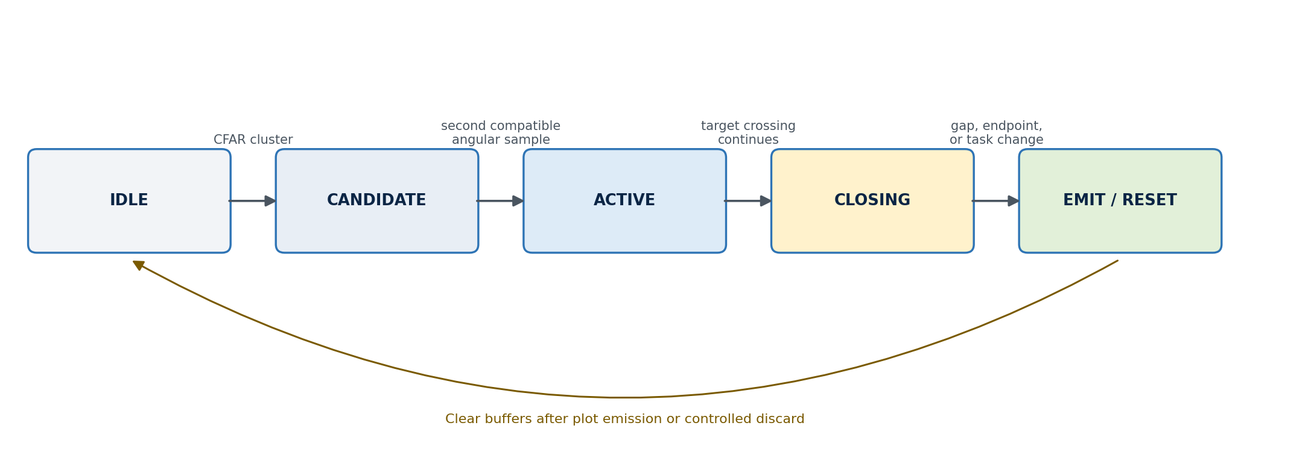
Figure 2. Angular crossing state machine.
Closure condition | Required action
No compatible cluster for the configured gap tolerance | Close after optional supporting sample collection.
Beam has moved beyond the allowed half-span from the crossing peak | Close and fit the accumulated pattern.
Sector endpoint or direction reversal | Close before accepting samples in the reverse direction.
Mission task change or track-update interruption | Close or controlled-discard using an explicit reason code.
Timestamp discontinuity or missing navigation/pointing validity | Discard affected fit; optionally emit a lower-quality centroid plot.
360° wrap through North | Continue if scan segment and signed angular progression remain valid.

7.5 Antenna-pattern bearing estimation
The current simulation defines a one-way normalised power pattern sinc²(angle_error / BeamwidthDeg). Because Vanguard X is monostatic and uses the same antenna on transmit and receive, the effective two-way echo-power pattern is the square of the one-way power pattern.
H(delta) = sinc⁴(delta / theta_null)
P_i ≈ A × H(bearing_i - target_bearing) + N
A is target strength, N is the local background term and H is the normalised two-way pattern.
A bounded grid search over candidate target bearing is adequate for the first implementation. For each candidate bearing, solve or estimate A and N, calculate the weighted residual, and select the minimum-residual solution. Use linear power, not dB, for the primary fit. Robust weighting should limit the influence of isolated antenna-sidelobe hits or scintillating scatterers.
A power-weighted circular centroid is the defined fallback when there are too few samples, the fitted amplitude is non-physical, the residual is excessive, or the estimated bearing lies outside the sampled crossing. Selecting the maximum-power dwell alone is permitted only as a lowest-quality fallback because it quantises angle to the dwell spacing.
bearing_centroid = circular_weighted_mean(bearing_i, max(P_i - N_i, 0))
Fit quality output | Purpose
BearingEstimateDegTrue | Single Earth-referenced angular centre.
BearingStdDevDeg | Measurement uncertainty for tracker weighting and display.
FitResidual | Normalised mismatch between measured and reference beam shape.
AngularSpanDeg | Observed first-to-last supporting sample span.
NumAngularSamples | Number of CFAR and supporting beam samples.
PeakSNRDb / IntegratedSNRDb | Signal quality without using CFAR-cell count as target size.
BearingMethod | PATTERN_FIT, POWER_CENTROID or PEAK_SAMPLE.
QualityFlags | Truncated crossing, reversal, sparse sampling, sidelobe risk, overlap or invalid navigation.

8. Extended-target handling
Extended targets shall not be collapsed to one range cell before angular processing. A vessel may contain several resolvable range-Doppler components, each with its own amplitude-versus-bearing sequence. The system first estimates the angular centre of each component and then groups compatible components into one ExtendedTargetPlot.
- Maintain separate range-Doppler components during the beam crossing.
- Fit a bearing for each sufficiently sampled component, or share a common bearing hypothesis when components clearly belong to one connected range profile.
- Group components whose fitted bearings, Dopplers, timestamps and range adjacency are compatible.
- Report a robust centroid together with minimum and maximum range, Doppler extent, component count and integrated power.
- Retain multiple plots when the evidence supports separate vessels; do not force all detections in one beam crossing into a single object.
physical angular extent ≈ 2 × atan(target_half_width / range)
A 200 m broadside target at 5 km subtends about 2.3°, which is genuine geometry rather than antenna smear.
Interpretation rule: The output may preserve substantial range extent and some genuine angular extent, but it should not reproduce the full approximately 10° antenna main-lobe footprint as target width.

9. Behaviour in search modes

9.1 Continuous 360° scan
Each target crossing closes as the continuously rotating beam moves beyond the target response. Plot latency is therefore the crossing duration plus the configured gap tolerance, not one full revolution. Crossings spanning 359°T to 001°T remain continuous through circular-angle handling.

9.2 Sector scan
Sector scanning uses the same matched-filter, Doppler, CFAR, clustering, angular-association and plot-consolidation path as 360° scanning. At a sector endpoint, all active crossings are closed before the scan reverses. The return traversal starts new crossings, ensuring clockwise and anticlockwise samples are not mixed until scan-direction bias has been characterised.

9.3 Scan-rate constraint
The angular estimator requires sufficient samples across the main lobe. For the current 5° first-null half-angle model, the initial target is no more than 2° between beam samples, with at least five useful samples across a normal crossing. The mission validator should warn or reject a task whose predicted angular sample spacing exceeds the configured limit.
maximum_scan_rate = maximum_angular_sample_spacing / dwell_interval
At a 100 ms dwell cadence, a 2° spacing limit implies approximately 20°/s or 3.33 rpm. A 60°/s command produces approximately 6° spacing and is unsuitable for reliable pattern fitting unless dwell cadence is increased substantially.

10. Track-update noddy processing
A track update that merely points at the predicted bearing can improve range, Doppler and amplitude but cannot independently re-estimate angular centre. A precise single-channel bearing update therefore requires a controlled mini-scan, or noddy, through the predicted target bearing.
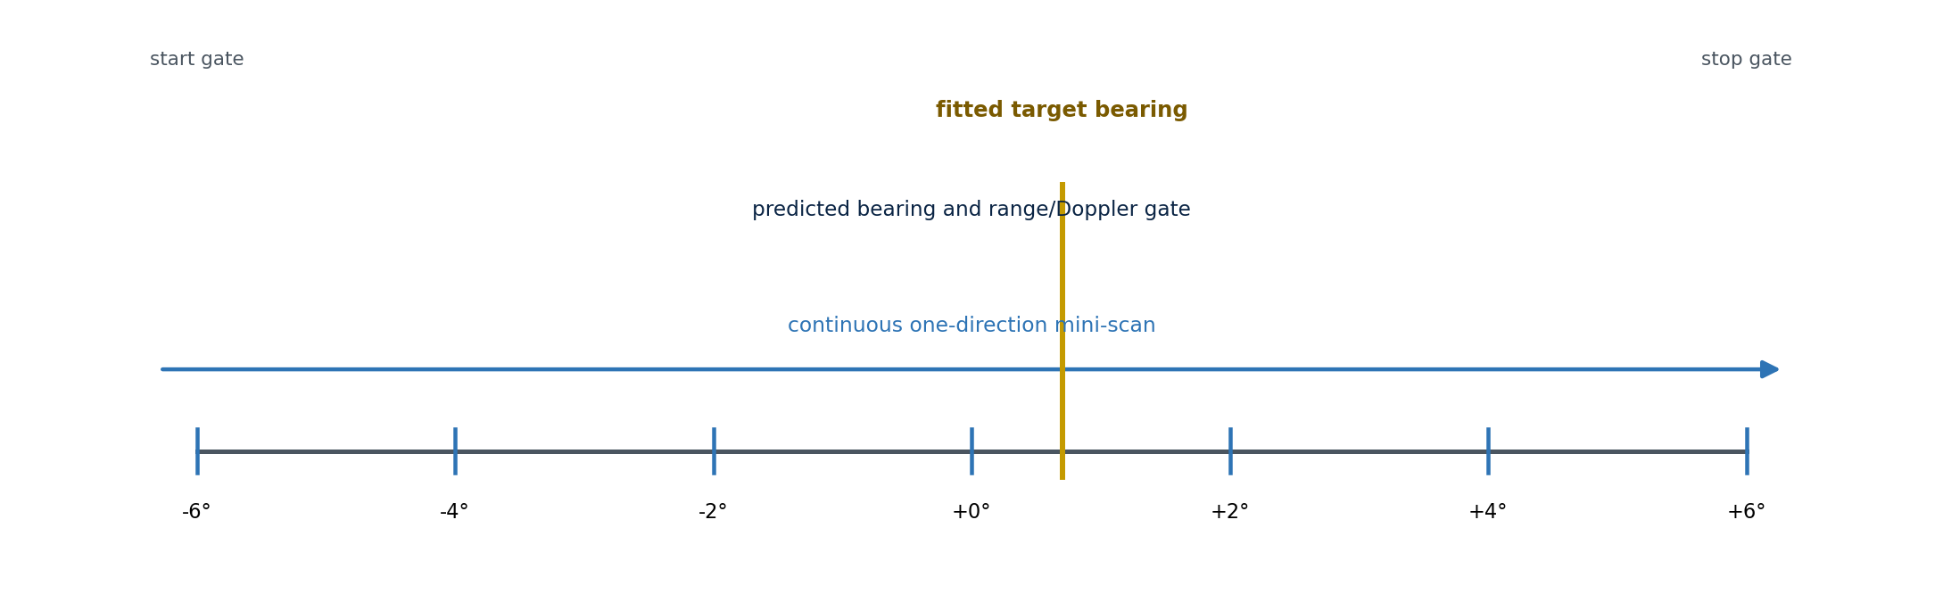
Figure 3. Initial track-update noddy geometry.
- Predict target true bearing, range, Doppler and uncertainty at the planned update time.
- Slew to the start gate, initially predicted bearing minus 6° or a larger uncertainty-derived limit.
- Scan smoothly in one direction through the predicted bearing to the stop gate, initially plus 6°.
- Run the normal range-Doppler processor and CFAR on every noddy dwell.
- Use the predicted range and Doppler as association gates, not as a substitute for CFAR confirmation.
- Close the crossing at the stop gate, fit the antenna pattern, update the track once, then resume the interrupted mission task.
Initial noddy sampling should be 1° to 2° with at least five samples and preferably seven or more. If no target is acquired, the controller may expand the angular gate once within an operationally bounded limit, then report a missed update and resume the mission.

11. Proposed software interfaces
The implementation should preserve CfarDetector.Detect for compatibility and add an AngularPlotConsolidator between detector output and tracker input. The consolidator receives the processed dwell so it can access linear range-Doppler power near established components.
Data type | Required fields
DwellDetectionCluster | DwellId; timestamp; scan segment and direction; true beam bearing; range and Doppler centroid/extents; peak and integrated linear power; noise and threshold; SNR; member-cell references.
AngularCrossing | CrossingId; task/scan segment; state; first/last timestamp; direction; associated per-dwell components; supporting samples; peak bearing; predicted range/Doppler; closure reason.
ConsolidatedPlot | PlotId; timestamp; true bearing and uncertainty; range and uncertainty/extents; Doppler/velocity and extents; peak/integrated SNR; fit method/residual; component count; quality flags; source task/track ID.
ExtendedTargetPlot | ConsolidatedPlot fields plus range minimum/maximum; optional physical angular extent; component summaries; representative centroid; target-shape diagnostics.

Raw CFAR detections may remain available as diagnostics and for the engineering display, but normal tracker updates shall consume ConsolidatedPlot measurements once the new path is validated. The Earth-referenced tracker should receive East/North measurements derived from the fitted true bearing and consolidated range at the plot timestamp.

12. Initial configuration
Configuration item | Initial value | Notes
AngularPatternSource | SIMULATED_BUILT_IN | Later replaced by an installed two-way pattern lookup table.
PatternFirstNullHalfAngleDeg | 5.0° | Matches current BeamwidthDeg semantics.
MaximumAngularSampleSpacingDeg | 2.0° | Mission validation limit for reliable fitting.
AngularCrossingHalfSpanDeg | 6.0° | Close or flag samples outside the expected main crossing.
AngularGapToleranceDwells | 2 | Permits short threshold dropouts without fragmentation.
MinimumPatternFitSamples | 5 | Prefer 7 or more for robust interpolation.
MinimumCfarSeedSamples | 2 | Supporting samples cannot seed a crossing by themselves.
SupportingSampleMarginDb | TBD by simulation | Bounded look-below-threshold margin for an established crossing.
RangeAssociationGateM | waveform/extent dependent | Must include expected target extent and motion, not Frank autocorrelation support.
DopplerAssociationGateHz | waveform/CPI dependent | Derived from Doppler resolution and target dynamics.
MaximumFitResidual | TBD by simulation | Controls centroid fallback and quality flags.
TrackNoddyHalfSpanDeg | 6.0° initial | Expand from predicted bearing uncertainty when required.
TrackNoddyStepDeg | 1° to 2° | Use a one-direction continuous mini-scan.

Configuration principle: Range and Doppler gates should be expressed in physical units and converted to bins for each waveform and CPI. Reusing the same cell counts across Frank10_20MHz, Frank10_10MHz and Golay64_20MHz does not produce equivalent physical windows.

13. CFAR interaction and future adaptation
The angular processor does not solve every CFAR problem. A very strong close target can contaminate CA-CFAR training cells, mask a nearby weak target, or produce multiple range-Doppler components. These effects remain range-Doppler detection-design issues and should be evaluated separately by waveform and environment.
- Golay complementary processing addresses pulse-compression range sidelobes but does not remove antenna-pattern angular broadening.
- Waveform-dependent range guard and training spans should be tested in metres, not only in cells.
- CA-, GO-, SO- and OS-CFAR may be selected by clutter regime later; the angular-consolidation interface should remain CFAR-algorithm agnostic.
- Strong-target sidelobe blanking or mismatched filtering may be added before plot consolidation if measured data requires it.
- Recursive integration over multiple revolutions is a separate weak-target feature and shall not be required to correct high-SNR angular smear.

14. Edge cases and controlled behaviour
Condition | Design response
Two targets overlap in range and Doppler but separate in angle | Maintain multiple pattern hypotheses where residuals support separation; otherwise flag unresolved angle overlap.
Targets overlap in angle but separate in range or Doppler | Keep separate per-dwell components and angular crossings.
Extended target scintillation | Use robust weights, integrated component power and fit-quality flags; avoid peak-only logic.
Strong antenna sidelobe hit | Exclude isolated non-contiguous samples from main-lobe fit and report sidelobe-risk quality flag.
Sector reversal through an active target | Close as truncated crossing; do not merge reverse-direction samples initially.
Task interruption | Close and emit only if minimum quality is met; otherwise controlled-discard with diagnostic reason.
Invalid heading or pointing sample | Do not mix uncertain coordinate frames; use lower-quality fallback only if explicitly allowed.
Large scan-angle step | Warn or reject mission task; mark any resulting plot as undersampled.
No CFAR seed in noddy gate | Report missed update; optionally perform one bounded gate expansion.
Target near 000°T | Use circular angular arithmetic across the wrap.

15. Performance and latency
The new processing is intentionally bounded. It buffers compact cluster summaries and a small number of supporting range-Doppler samples, not full dwell cubes. At the current approximately 100 ms cadence, a normal five-to-eight-sample crossing adds approximately 0.5 to 0.8 seconds of plot latency. This is substantially shorter than waiting for a complete 360° revolution.
Pattern fitting should use a bounded candidate-bearing grid followed by optional local interpolation. Active crossing count, samples per crossing and retained cell regions shall all have configured limits. Overload behaviour must discard the lowest-quality or stalest candidate with a diagnostic counter rather than allowing unbounded memory growth.

16. Verification and validation plan

16.1 Unit and algorithm tests
- Circular angle association across 359°T / 001°T.
- Correct state transitions for gaps, endpoints, reversals, mission interrupts and aborts.
- Recovery of injected point-target bearing from the exact simulated two-way sinc-to-the-fourth pattern.
- Centroid and peak-sample fallback behaviour under sparse or invalid fits.
- Preservation of range and Doppler extent for an extended target.
- No supporting-sample-only false crossing initiation.
- Deterministic bounded-memory behaviour under excessive CFAR detections.

16.2 Simulation scenarios
Scenario | Primary measurement
Single point target; 15 to 60 dB SNR | Bearing bias, uncertainty and fit residual versus scan step.
High-SNR point target through full main beam | One emitted plot per crossing; no approximately 10° plotted smear.
Two close targets in range, Doppler or angle | Separation and unresolved-overlap behaviour.
200 m, 25-scatterer vessel | Preserved range extent with one consolidated angular centre where appropriate.
Strong target plus nearby weak target | Masking, CFAR interaction and association robustness.
360° scan through North | No crossing split at angular wrap.
Sector endpoint at target bearing | Truncated-crossing flag and no reverse-direction mixing.
Track-update noddy | Single tracker update after mini-scan completion and correct mission resume.
20°/s versus 60°/s at 100 ms cadence | Expected quality at 2° samples and rejection/undersampling at 6° samples.

16.3 Initial engineering acceptance targets
The following are initial simulation targets to validate the architecture; they are not final operational performance claims.
- For an isolated point target with at least five main-lobe samples and adequate SNR, emit one consolidated plot and achieve no more than 1° absolute bearing error.
- Keep fitted bearing stable as target SNR increases, without allowing the number of above-threshold angular samples to become reported target width.
- For the simulated 200 m vessel, preserve the reported range interval while reducing the antenna-induced angular footprint to one centre estimate plus a separately labelled physical-extent estimate.
- Produce equivalent consolidated plots from continuous 360° scanning, each direction of a sector scan, and a correctly completed track noddy.
- Add no more than one crossing duration plus the configured gap tolerance to plot latency.

17. Implementation sequence
Stage | Implementation | Exit condition
1. Simulation algorithm | Add cluster, crossing and pattern-fit modules using the built-in pattern; retain current tracker inputs in parallel. | Replay and synthetic tests demonstrate one plot per crossing.
2. Search integration | Insert consolidator in 360° and sector paths; add raw-versus-consolidated diagnostic display and counters. | Search modes pass regression and operational simulation gates.
3. Tracker handover | Feed consolidated plots to the Earth-referenced tracker with measurement uncertainty; retain selectable legacy comparison. | Track initiation and update are stable without angular smear fragmentation.
4. Noddy update | Change track task from goto-and-hold to a bounded true-bearing mini-scan using predicted range/Doppler gates. | Track update yields one fitted-bearing measurement and resumes mission correctly.
5. Installed calibration | Measure the installed two-way antenna response and boresight offset; replace the simulated lookup source. | Field point-target scans meet bearing-bias and repeatability limits.
6. CFAR adaptation study | Sweep waveform-dependent physical guard/training spans and compare CA/GO/SO/OS-CFAR where required. | Selected CFAR profiles meet clutter and close-target requirements.

18. Design requirements
ID | Requirement
DP-001 | The system shall run range-Doppler CFAR on every completed dwell without waiting for a complete beam crossing.
DP-002 | The system shall cluster CFAR cells within each dwell before cross-angle association.
DP-003 | The system shall associate clusters over adjacent true-bearing samples using range, Doppler, time and scan-segment compatibility.
DP-004 | The system shall fit a configured two-way antenna pattern and emit one primary bearing estimate per valid target crossing.
DP-005 | The system shall provide a defined centroid fallback and quality flags when a pattern fit is invalid.
DP-006 | The system shall preserve genuine extended-target range and Doppler extent.
DP-007 | The system shall use Earth/true bearing for scan-angle processing and shall retain X6-60 relative angle only as control/diagnostic data.
DP-008 | The system shall close active crossings at scan reversals, task changes, discontinuities and configured angular or time limits.
DP-009 | The mission validator shall detect angular undersampling from scan rate and dwell cadence.
DP-010 | A track-update bearing measurement shall use a bounded mini-scan unless an explicit lower-quality hold-only update is requested.
DP-011 | Supporting below-threshold samples shall not initiate a target crossing without at least one CFAR-confirmed seed.
DP-012 | The processor shall impose bounded limits on active crossings and retained samples and shall expose diagnostic overload counters.

19. Open design decisions
- Select the exact per-dwell clustering method and physical range/Doppler gates for each waveform and CPI.
- Set the supporting-sample look-below-threshold margin and maximum fit residual from controlled Monte Carlo simulation.
- Decide whether extended-target components share one joint bearing fit or use component fits followed by robust consolidation.
- Define operational handling of unresolved multi-target crossings and antenna-sidelobe hypotheses.
- Determine when the Earth-referenced tracker becomes authoritative and how legacy comparison is retired.
- After field calibration, assess scan-direction-dependent patterns and whether separate clockwise/anticlockwise lookup tables are required.

20. Conclusion
Vanguard X should retain its existing per-dwell 2-D range-Doppler CFAR and add a short scan-angle consolidation stage before tracking. This architecture directly addresses the observed high-SNR angular blur without simulating unavailable monopulse channels and without waiting for multiple revolutions. It also provides a consistent mechanism for ordinary 360° scanning, sector scanning and deliberate track-update noddies while preserving the genuine range extent of large vessels.

