VANGUARD X
Software & System Architecture Specification
Document No. VX-SSA-001
Version 0.4
Engineering Draft
17 July 2026

Project | Vanguard X X-band Radar Prototype
Document owner | ASR Defence / Len Sciacca
Baseline | Scheduler architecture
Repository | ~/Projects/Software/docs/architecture
Status | Working engineering baseline

Document Control
Version | Date | Change | Status
0.1 | 16 Jul 2026 | Initial architecture working draft | Superseded
0.2 | 17 Jul 2026 | Added UML-style operational and coordinate diagrams | Superseded
0.3 | 17 Jul 2026 | Scheduler, navigation and pointing engineering baseline with expanded UML | Current

Architecture Decision Summary
- ADR-0001: Introduce PulsePlan, DwellPlan and ProcessingPlan.
- ADR-0002: Separate RadarScheduler from PointingManager.
- ADR-0003: Tracks and TRUE-fixed sectors use true-North coordinates; PTZ uses platform-relative coordinates.
- ADR-0004: Validate architecture against the simulator before further hardware integration.
- ADR-0005: STM32 remains a slow-control 28-bit shift engine; Ettus ATR owns fast T/R switching.

Table of Contents
1. Introduction
2. Operational Concept
3. System Context and Hardware
4. Software Architecture
5. Coordinate Frames
6. Radar Task Model
7. Radar Scheduler
8. Pointing Architecture
9. Pulse and Waveform Architecture
10. Processing and Tracking
11. Deployment and Hardware Control
12. Timing Architecture
13. Interfaces and Data Contracts
14. Verification Strategy
15. Development Roadmap
Appendix A. Architecture Decision Records
Appendix B. Acronyms and Glossary

1. Introduction

1.1 Purpose
This specification defines the software and system architecture for Vanguard X, a Python-first X-band radar prototype evolving from a simulation and display system into a multifunction radar. It is the authoritative design reference for scheduler, pointing, waveform, processing, tracking and hardware-control development.

1.2 Scope
- Continuous sector search using measured encoder angle.
- Track-while-scan tasking with search interruption and resumption.
- Fixed and moving platform coordinate frames.
- Pulse-by-pulse waveform and timing plans.
- Simulation-first development with later Ettus, TRM, PTZ and navigation integration.
- Future Barker, Frank, LFM, Golay, PRI agility and adaptive/cognitive behaviour.

1.3 Design principles
- Scheduler decides what the radar does next.
- PointingManager decides where the antenna points.
- RadarExecutor coordinates task execution.
- RadarProcessor processes IQ and does not command hardware.
- Tracker requests revisits but does not directly control pointing.
- Hardware-specific implementations conform to stable source and controller interfaces.

2. Operational Concept

2.1 Search
Search is a persistent activity. The antenna pans continuously at a commanded rate, while the encoder angle is sampled and associated with each radar dwell. Search is not modelled as a list of discrete motor positions. Sector limits may be defined relative to the platform or true North.

2.2 Track
A confirmed track may request a revisit. The scheduler converts the request into a TrackTask, pauses search, commands PointingManager to slew to the predicted true bearing, waits for readiness, executes a dedicated track dwell and then resumes the saved search state.

2.3 Track-while-scan
Track-while-scan is implemented as time-sharing of the same radar resources. Track tasks pre-empt search based on priority and deadline. The architecture supports later scheduling cost functions that include slew time, dwell duration and deadline slack.

2.4 Future modes
- Calibration and built-in test.
- Passive listen and interference assessment.
- Jammer characterisation.
- Adaptive waveform, PRI, frequency and attenuation selection.

3. System Context and Hardware
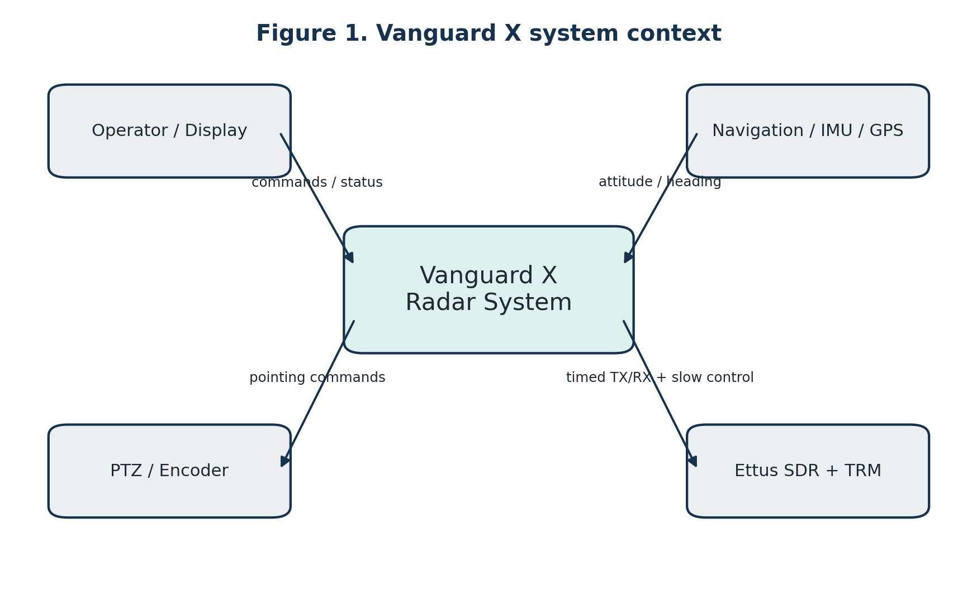
Figure 1. Vanguard X system context.

3.1 Hardware elements
- Linux MiniPC hosting the Vanguard application.
- Ettus SDR providing timed waveform transmission, receive acquisition and ATR GPIO.
- STM32 Nucleo and level-shifter HAT providing the 28-bit TRM serial interface.
- X-band TRM and antenna/radome assembly.
- PTZ or motorised pointing unit with encoder position.
- IMU/GPS/INS or simulated navigation source.

3.2 Control ownership
Slow configuration such as TRM attenuation is written before operation or when settings change. Fast pulse-by-pulse T/R switching is owned by the Ettus ATR outputs. Pointing commands are owned by PointingManager through PTZController.

4. Software Architecture
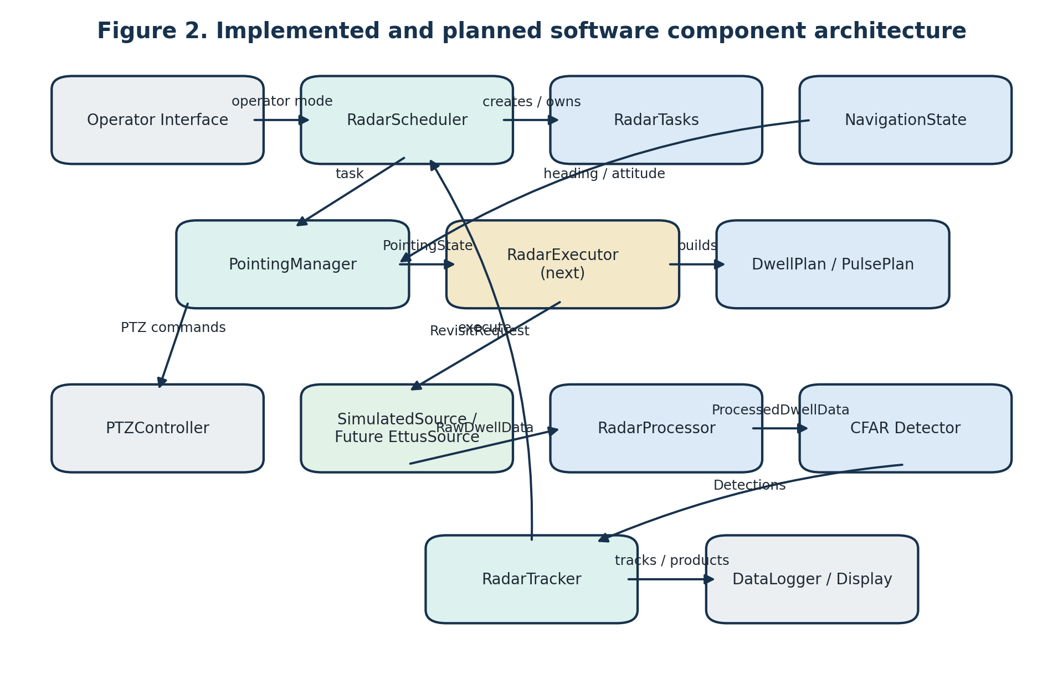
Figure 2. Implemented and planned software component architecture.

4.1 Layering
- Mission layer: operator intent, search sectors and track revisit requirements.
- Scheduling layer: RadarTasks and RadarScheduler.
- Pointing layer: NavigationState, PointingManager and PTZController.
- Execution layer: RadarExecutor and radar source implementation.
- Signal-processing layer: RadarProcessor, detector and tracker.
- Presentation and data layer: display and logger.

4.2 Current implemented modules

RadarTasks.py
Defines SearchTask, TrackTask, SearchSector, PointingRequest and RevisitRequest.

NavigationState.py
Provides timestamped platform heading, pitch and roll. Current implementation supports fixed heading and constant turn-rate simulation.

PointingManager.py
Converts between TRUE and PLATFORM frames, controls continuous search and goto-and-hold tracking, and preserves interrupted search state.

RadarScheduler.py
Owns persistent search, queues track tasks, prioritises deadline-driven revisits and resumes search after track completion.

5. Coordinate Frames
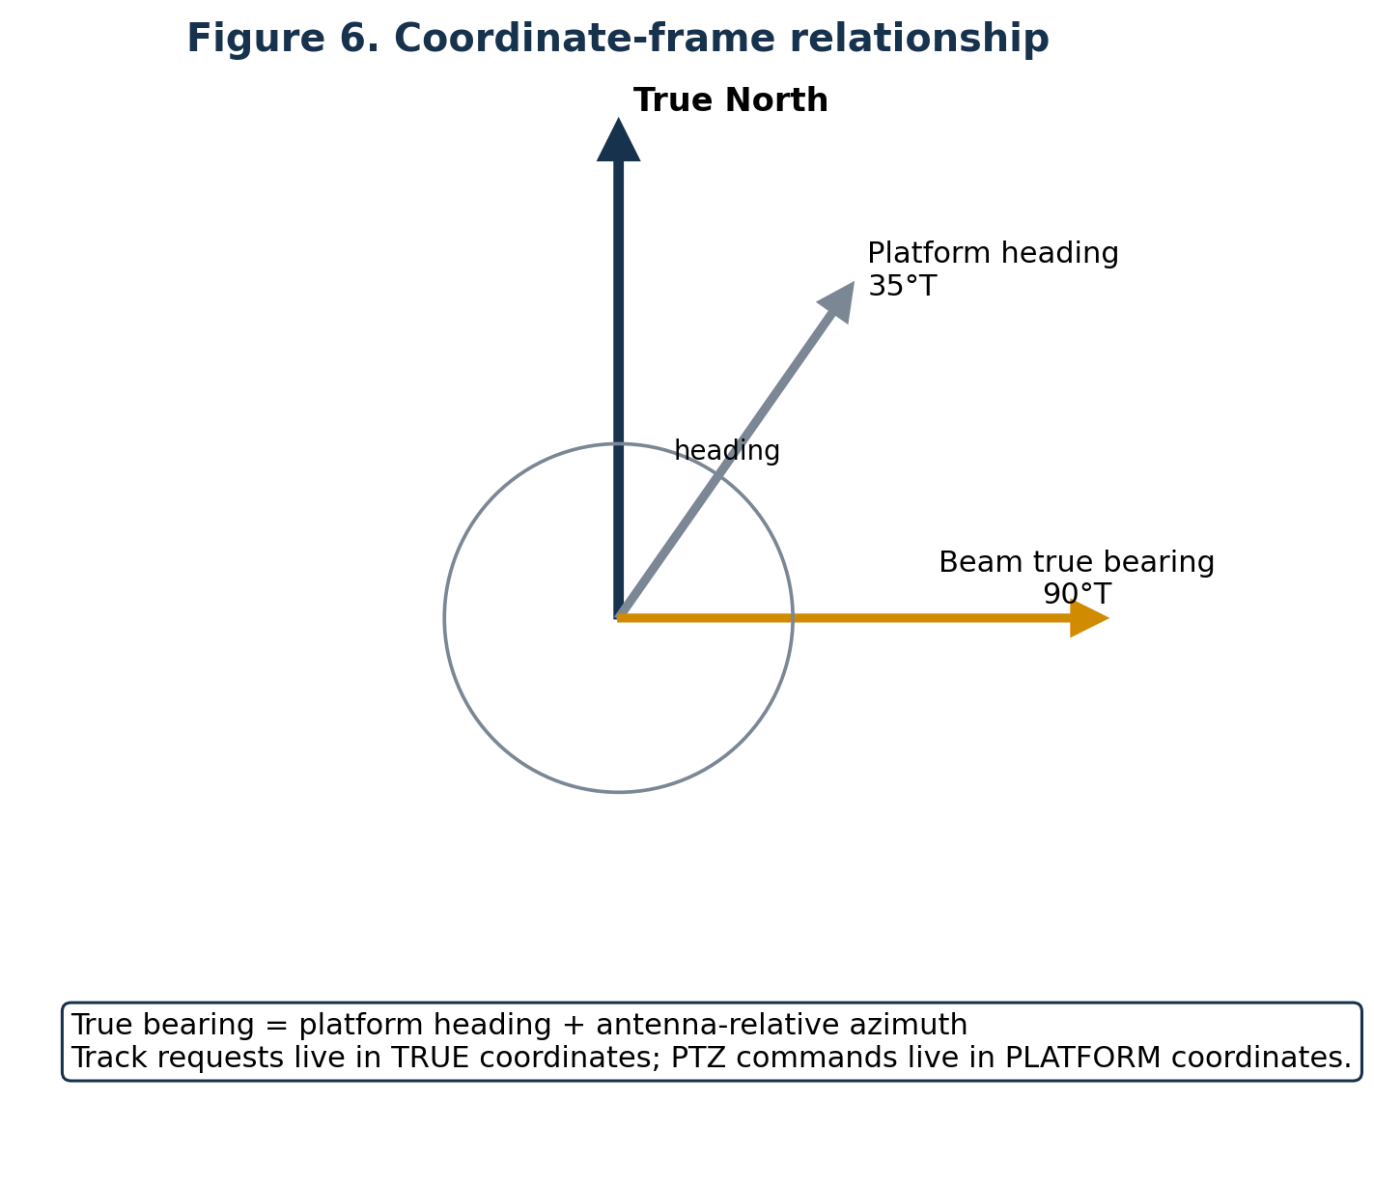
Figure 3. Coordinate-frame relationship for heading, antenna azimuth and true beam bearing.

5.1 Frames
- TRUE frame: bearings referenced to true North.
- PLATFORM frame: angles referenced to the platform body or bow.
- PTZ/antenna frame: encoder pan and tilt angles.
- BEAM frame: instantaneous illuminated line of sight.

5.2 Azimuth conversion
For the first azimuth-only implementation, true beam bearing is platform true heading plus antenna-relative azimuth, wrapped to 0-360 degrees. The inverse conversion subtracts heading from desired true bearing. Roll, pitch and tilt require a future full 3D rotation model.

5.3 Sector reference frames
- PLATFORM-fixed sector: endpoints remain fixed relative to the body and rotate in true bearing as the platform turns.
- TRUE-fixed sector: endpoints remain fixed geographically and are continuously recomputed in platform-relative motor coordinates.

6. Radar Task Model
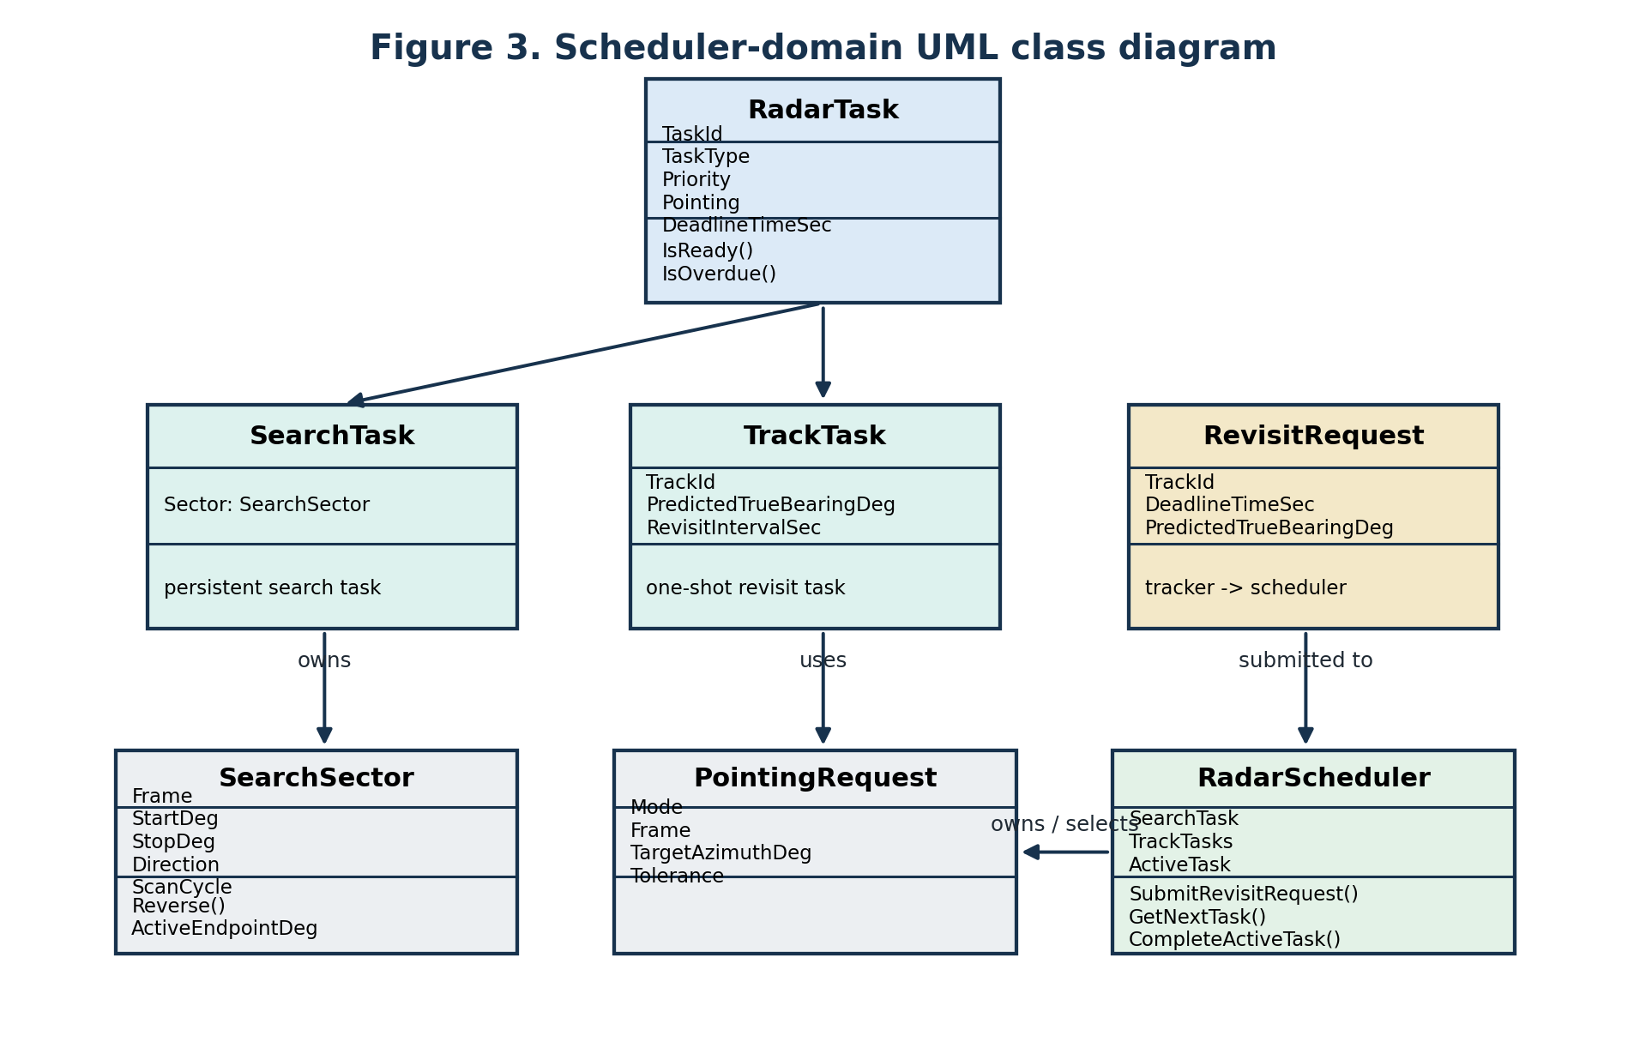
Figure 4. Scheduler-domain UML class diagram.

6.1 RadarTask
RadarTask is the common high-level representation of a radar action. It includes identity, type, priority, pointing request, waveform profile, earliest start, deadline, status and metadata.

6.2 SearchTask
SearchTask owns a SearchSector and is persistent. Completing a search dwell returns the task to the scheduler rather than permanently completing the search mission.

6.3 TrackTask and RevisitRequest
The tracker emits RevisitRequest objects with predicted range, true bearing, priority and deadline. RadarScheduler converts each request into a one-shot TrackTask. Duplicate queued requests for one track update the existing task rather than creating uncontrolled queue growth.

7. Radar Scheduler
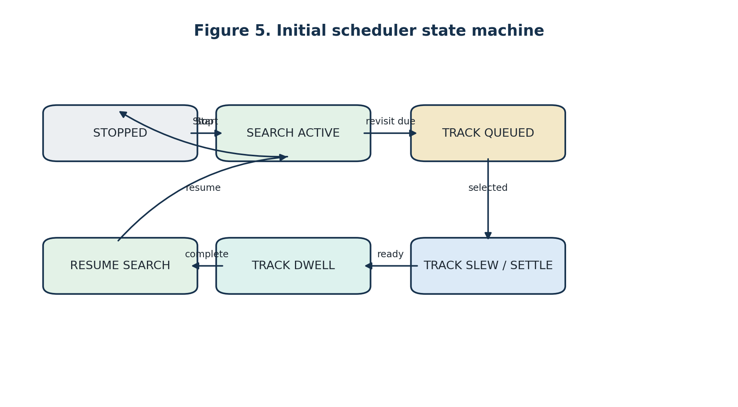
Figure 5. Initial scheduler state machine.
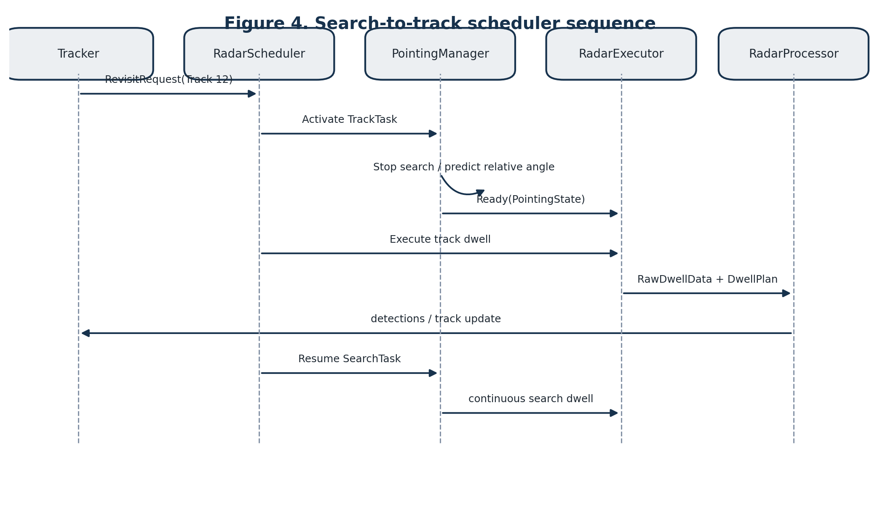
Figure 6. Search-to-track scheduler sequence.

7.1 Scheduling policy
- An active task retains ownership until completed or failed.
- Ready track tasks outrank search.
- Track selection uses base priority plus deadline urgency.
- Overdue track tasks receive a large urgency boost.
- When no track task is ready, persistent search is selected or resumed.

7.2 Search interruption and resumption
When a track task is activated, the current search state is retained, including active endpoint, direction, scan cycle and interrupted encoder angle. After track completion, PointingManager resumes the same SearchTask.

7.3 Future scheduling cost model
- Estimated slew and settling time.
- Dwell duration and processing load.
- Track quality, manoeuvre and threat priority.
- Sector coverage debt and unsearched gaps.
- Calibration, passive-listen and interference-analysis obligations.

8. Pointing Architecture

8.1 Search pointing
PointingManager commands continuous slew toward the active endpoint. It reverses when the measured beam reaches or crosses the endpoint. For a TRUE-fixed sector, the platform-relative endpoint is refreshed as heading changes.

8.2 Track pointing
Track tasks use GOTO_AND_HOLD. The desired true bearing is transformed to a platform-relative command. Readiness requires reachability, angular tolerance, low pan rate and any requested settle time.

8.3 Mechanical limits
PointingManager checks converted relative azimuth against the configured PTZ window. Unreachable commands are identified and may be clipped for safe behaviour. The scheduler will later choose a policy such as clip, reverse, defer, flag incomplete coverage or request platform manoeuvre.

8.4 Measured pointing metadata
The final dwell must carry measured encoder angle and navigation state corresponding to the illumination time. The first implementation may use before/after samples and dwell-centre interpolation; later hardware execution should use timestamped encoder and platform-attitude streams.

9. Pulse and Waveform Architecture
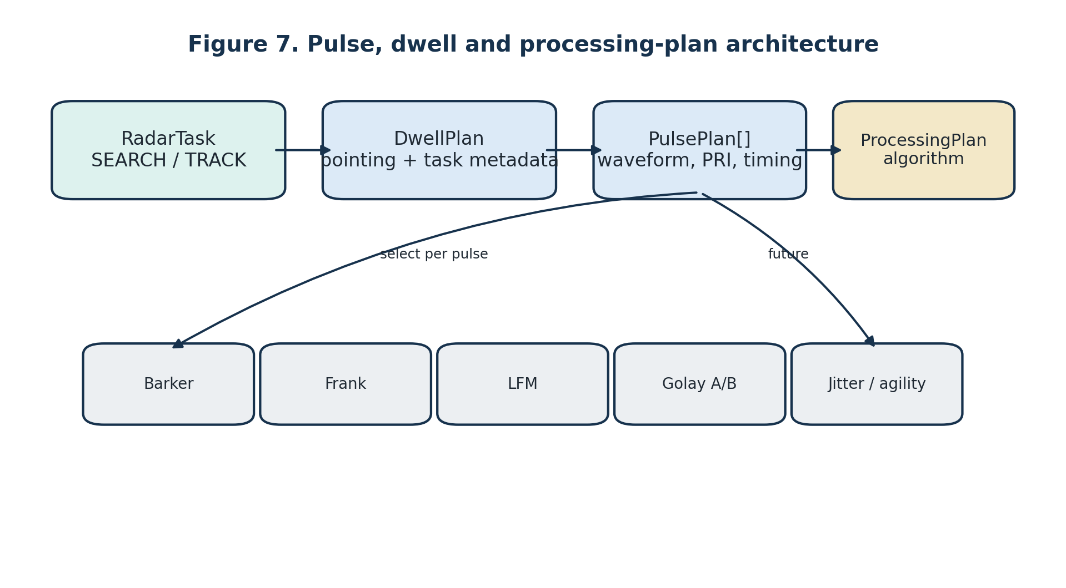
Figure 7. Pulse, dwell and processing-plan architecture.

9.1 Waveform definitions
Waveforms are reusable immutable signal definitions stored by WaveformLibrary. Search or track purpose is not embedded in the waveform itself; a waveform profile selects a waveform and processing recipe for a task.

9.2 PulsePlan
PulsePlan supports per-pulse waveform identity, PRI, transmit enable, amplitude, phase, frequency offset, receive delay and grouping metadata. This enables Golay pairs, PRI agility and future frequency agility.

9.3 DwellPlan and ProcessingPlan
DwellPlan describes one complete radar action and links task, pointing, pulse sequence, attenuation and metadata. ProcessingPlan states how returned pulses are interpreted. The current implemented mode is UNIFORM_PRI_FFT; Golay and nonuniform modes deliberately remain unimplemented until correct algorithms are added.

9.4 Golay considerations
- Complementary A/B matched-filter outputs must be combined.
- Target Doppler between A and B can degrade sidelobe cancellation.
- Processing may combine pairs before Doppler or use a Doppler-resilient complementary sequence.
- Pulse grouping metadata must identify complementary roles.

10. Processing and Tracking

10.1 Processing chain
Raw IQ is pulse-compressed, windowed in slow time and transformed by Doppler FFT for uniform-PRI dwells. The detector operates on the range-Doppler power map. The tracker currently accumulates detections over a scan pass, forms blobs, initiates 2-of-3 tracks and maintains confirmed tracks with an alpha-beta model.

10.2 Separation of concerns
- RadarProcessor does not decide search versus track.
- Detector does not command waveform or pointing.
- Tracker produces state estimates and revisit requests.
- Scheduler determines resource allocation.

10.3 Track-coordinate policy
Tracks should ultimately be maintained in Earth/true-North coordinates. Existing azimuth-only tracker data can be migrated by attaching true beam bearing to detections and preserving platform-relative measurements as provenance.

11. Deployment and Hardware Control
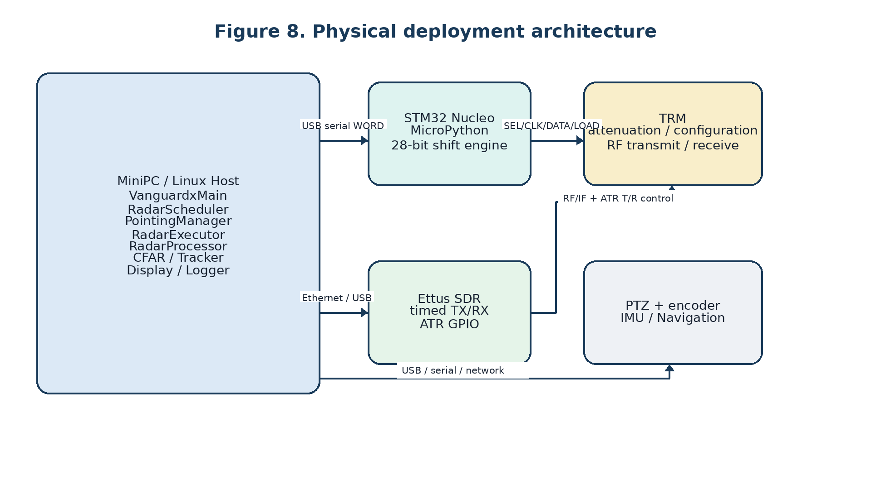
Figure 8. Physical deployment architecture.

11.1 STM32/TRM interface
The Linux host builds the full 28-bit TRM word. The STM32 receives PING, STATUS and WORD commands, shifts D0 first on DATA, presents falling CLOCK edges for sampling and pulses LOAD to latch the configuration. This interface is slow control and is not used for pulse-by-pulse T/R switching.

11.2 Ettus role
The future Ettus source will execute a complete timed burst using hardware timestamps. The host must not rely on Python timing for individual pulses. ATR GPIO controls the fast transmitter and receiver gating sequence.

11.3 PTZ and navigation
PTZController provides simulated and Pelco-D implementations behind one public interface. NavigationState currently supplies simulated attitude and will later be replaced by an IMU/GPS/INS adapter without changing scheduler or pointing interfaces.

12. Timing Architecture
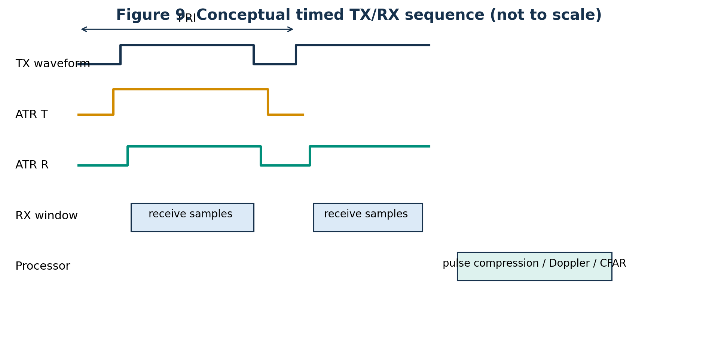
Figure 9. Conceptual timed transmit, receive and processing sequence.

12.1 Dwell timing
A dwell consists of TRM state verification, pointing readiness, timed transmit/receive execution, raw-data return and processing. TRM writes occur only when required state changes. Pointing and SDR hardware time must be recorded for provenance.

12.2 PRI agility
Uniform PRI remains the initial hardware path. Staggered and jittered PRI require actual pulse timestamps. A normal FFT is not strictly valid for nonuniform slow-time samples; later options include burst-wise FFT, nonuniform DFT, pulse-pair methods or resampling.

13. Interfaces and Data Contracts

RadarScheduler
- Input: RevisitRequest, current time, operator mode.
- Output: active RadarTask and SchedulerStatus.

PointingManager
- Input: RadarTask, PlatformAttitude and PTZ state.
- Output: PointingState including readiness, reachability, true bearing and relative encoder angle.

RadarExecutor (planned)
- Input: RadarTask, PointingState and waveform profile.
- Output: RawDwellData with pulse timing and pointing metadata.

RadarProcessor
- Input: RawDwellData and DwellPlan.
- Output: ProcessedDwellData and diagnostics.

Tracker
- Input: detections, processed dwell and dwell metadata.
- Output: track list, optional blobs and future RevisitRequest list.

13.1 Required metadata
- DwellId, TaskId, TaskType and optional TrackId.
- Requested and measured pointing.
- Platform attitude and true beam bearing.
- Pulse waveform identifiers and requested/actual pulse times.
- TRM settings, source diagnostics, dropped-sample and overflow flags.
- Processing mode and adaptation reason.

14. Verification Strategy

14.1 Simulation-first rule
Major architectural behaviour is verified with SimulatedSource, SimulatedPTZController and SimulatedNavigationSource before hardware changes. Hardware implementations replace interfaces rather than reshape the architecture.

14.2 Current regression tests
- TestRadarPlans.py validates fixed waveform and PRI plan construction.
- TestRadarTasks.py validates search, track and revisit data structures.
- TestNavigationState.py validates fixed heading and turn-rate simulation.
- TestPointingManager.py validates coordinate conversion, scanning, track goto and moving-heading correction.
- TestRadarScheduler.py validates deadlines, queueing, duplicate requests and search resumption.

14.3 Next integration test
The next milestone is an end-to-end simulator test in which the scheduler runs continuous search, accepts a synthetic Track 12 revisit, commands simulated slew and settle, executes one track dwell and resumes search without modifying the processing chain.

15. Development Roadmap
Milestone | Content | Hardware impact | Target document revision
Current | Tasks, navigation, pointing and scheduler modules | None | 0.3
Next | RadarExecutor and main-loop integration | None | 0.4
Ettus fixed dwell | Timed constant-PRI TX/RX source | Ettus integration | 0.5
Track-while-scan | Tracker revisit API and real task execution | PTZ optional | 0.6
Advanced waveform | LFM and Golay processing | Waveform validation | 0.7
Adaptive radar | Interference assessment and policy layer | Optional frequency agility | 1.x

Appendix A. Architecture Decision Records

ADR-0001: PulsePlan/DwellPlan architecture
Status: Accepted
Decision: PulsePlan/DwellPlan architecture.
Rationale: Represent pulse-by-pulse waveform, PRI and processing intent without changing source/processor API.
Consequences: Interfaces and tests must preserve this responsibility boundary.

ADR-0002: Separate scheduling and pointing
Status: Accepted
Decision: Separate scheduling and pointing.
Rationale: Scheduler chooses tasks; PointingManager owns coordinate transformation and antenna control.
Consequences: Interfaces and tests must preserve this responsibility boundary.

ADR-0003: Explicit TRUE and PLATFORM frames
Status: Accepted
Decision: Explicit TRUE and PLATFORM frames.
Rationale: Moving-platform search sectors and track pointing require unambiguous coordinate ownership.
Consequences: Interfaces and tests must preserve this responsibility boundary.

ADR-0004: Simulation-first architectural validation
Status: Accepted
Decision: Simulation-first architectural validation.
Rationale: Reduce risk and prevent hardware timing concerns from distorting software boundaries.
Consequences: Interfaces and tests must preserve this responsibility boundary.

ADR-0005: STM32 slow control; Ettus fast T/R
Status: Accepted
Decision: STM32 slow control; Ettus fast T/R.
Rationale: Keep pulse timing deterministic and leave the microcontroller as a stable shift engine.
Consequences: Interfaces and tests must preserve this responsibility boundary.

Appendix B. Acronyms and Glossary
Term | Definition
ATR | Automatic Transmit/Receive control provided by the SDR GPIO.
CPI | Coherent Processing Interval.
Dwell | One radar action containing one or more pulses and associated processing.
PRI | Pulse Repetition Interval.
PTZ | Pan-Tilt-Zoom pointing mechanism; used here primarily for pan/tilt control.
TRM | Transmit/Receive Module.
TRUE frame | Bearing referenced to true North.
PLATFORM frame | Angle referenced to the platform body or bow.
RevisitRequest | Tracker request for a future track update.
PointingState | Measured and commanded pointing solution produced by PointingManager.

Architecture Update – Version 0.4
Purpose
This revision formalises RadarExecutor as the execution boundary between task scheduling and signal processing.

RadarExecutor Responsibilities
RadarExecutor owns:
• Execution profile selection
• DwellPlan construction
• Radar source execution
• Execution metadata
• Future hardware execution interfaces (SDR/TRM)
RadarExecutor does not own:
• Task selection
• Pointing policy
• IQ processing
• Detection
• Tracking
• Display

Execution Boundary
RadarScheduler
↓ selects
RadarTask
↓
PointingManager
↓ measured pointing
RadarExecutor
↓ RawDwellData + DwellPlan
RadarProcessor
↓ ProcessedDwellData
CFAR → Tracker → Display

Migration Roadmap
Stage 1: Extract ExecuteRadarDwell() from VanguardxMain. (Completed)
Stage 2: RadarExecutor owns dwell construction and source execution.
Stage 3: VanguardxMain requests tasks only from RadarScheduler.
Stage 4: Ettus SDR and TRM integrate behind RadarExecutor without changing Scheduler or Processor.

ADR-0006 – RadarExecutor Owns Execution Semantics
Decision:
RadarExecutor is the sole owner of task-to-dwell translation, execution profile selection, dwell construction, source execution and execution metadata.
Consequences:
• Scheduler remains task-centric.
• RadarProcessor remains signal-processing only.
• Hardware integration is localised to the execution layer.

